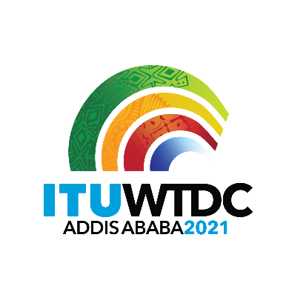 | First Inter-Regional Meeting (IRM-1) to prepare for the WTDC-21  Virtual, 11 March 2021 |  | 
 |  | Document IRM21-1/1-E
 |  | 24 February 2021
 |  | Original: English
Director, Telecommunication Development Bureau
Draft agenda

- Approval of agenda
- Appointment of chairman and vice-chairmen
- WTDC-21 Update
  - Overview
  - Documents for WTDC-21
  - COVID-19
- Update on RTO preparations
- RPM Outputs
  - RPM-EUR
    - Vision for ITU-D
    - Regional Priorities for Europe
    - Preparatory Matters
  - RPM-ASP: TBD
- Report on the work of TDAG-WG-RDTP
  - Declaration
  - Thematic Priorities (including SG Questions)
  - Streamlining Resolutions
- Report on the work of TDAG-WG-SOP
- AOB
_______________

