Telecommunication
Development Sector
Study Groups
ITU-D Study Group 1 and 2 Plenaries and Rapporteur Group Meetings
Virtual Format, 11-22 October 2021
Document SG1RGQ/ADM/64-E
Document SG2RGQ/ADM/63-E
 |  |  | 29 September 2021
 |  |  | English only
All Questions
SOURCE: | Telecommunication Development Bureau
TITLE: | Guidelines for participants in virtual ITU-D study group meetings

Abstract:
This document shares with the ITU-D Study Group 1 and 2 participants some guidelines for participants in virtual ITU-D study group meetings.
The current guidelines are confirmed for usage for the ITU-D Study Groups Rapporteur Group meetings (SG1: 11 - 15 October 2021, SG2: 18 - 22 October 2021).

Guidelines for participants in virtual ITU-D study group meetings
- Before the e-meeting:
- Participate in a test call to understand clearly how to connect to the virtual room through the Restricted Virtual Events portal and how the tool works and to ensure that you can connect properly. More information about this test call will be provided to you through a separate communication.
- If during the test call, your connection is not stable, you are invited to investigate on any connectivity issue from your side, or to contact the SG Secretariat for assistance (devsg@itu.int, +41 22 730 5999).
- During the e-meeting:
- Rename yourself so that your name, organization and country (where applicable) appear clearly to all participants. If you are having problems to rename yourself, inform the IT Moderator in a private chat.
- Please keep your video switched off and mute your audio throughout the meeting unless when intervening or asked to do so by the chairperson or IT moderator.
- All interventions will be audio only. Video should be kept switched off throughout the meeting, except at specific times (e.g. group photo).
- As far as possible, try to submit your questions and comments in the chat. Whenever possible indicate to whom specifically your question is addressed to. The chat moderator will pick up your question/comment and request a response by the relevant person during or after the e-meeting.
- Report any connectivity issue in a private chat with the IT moderator, who will provide support.
- If you are given the floor, be ready and succinct in your intervention. Speak clearly and slowly as much as possible.
- In case a connection fails or the voice quality is poor during your floor intervention:
  - The chairperson may stop your intervention and move to another participant while the ITU IT team tries to resolve the connection issue.
  - If the connection fails for a second time, please put your comment/question in the chat.
- Please note that:
  - The e-meeting focus is on the key items: output reports, new study Questions
  - Other agenda items may be skipped if no contribution has been submitted.
  - Admin documents from the SG Secretariat (e.g. list of contributions, list of liaison statements, lessons learned) may be briefly mentioned (noted for consideration) by the chairing person without giving the floor to the SG Secretariat.
  - Issues taking too much time will be delegated by the chairperson to the management team to address it offline in order to minimize the time taken during the e-meeting.
- After the e-meeting:
- Any unanswered question in the chat will be responded as soon as possible. Contact ITU-D study group secretariat by email devsg@itu.int
- Tool used for the e-meeting:
Zoom will be used for the e-meeting. Information on how to connect and use Zoom is available in the following web page: https://www.itu.int/en/general-secretariat/ICT-Services/remoteparticipation/Pages/onlinemeetingroom.aspx
This meeting will also provide interpretation (informal rapporteur group e-meetings: English and French) and human-based captioning for all sessions. Annex 1 provides more information how to enable interpretation and captioning in Zoom.
Important: To enable interpretation, you must download and install the latest version of Zoom. The latest version is available here: https://itu.zoom.us/download

Annex 1: How to enable interpretation and captioning with Zoom
To enable interpretation:
Important: To enable interpretation, you must download and install the latest version of Zoom. The latest version is available here: https://itu.zoom.us/download
- Click on the “Interpretation” button
- In the menu that appears, select the preferred language (e.g. French in this example)
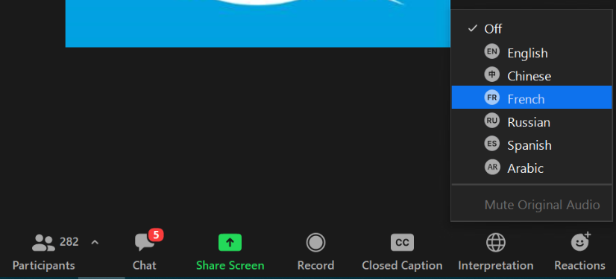
- You will hear the interpreted language, with the original language at lower volume in the background.
To enable captioning:
- Click on the “Live Transcript” button
- In the menu that appears, click on “Show Subtitle”
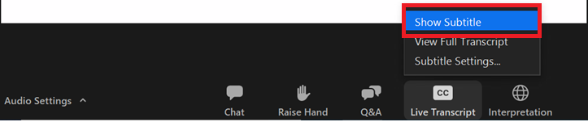
- You will see captioning on the screen
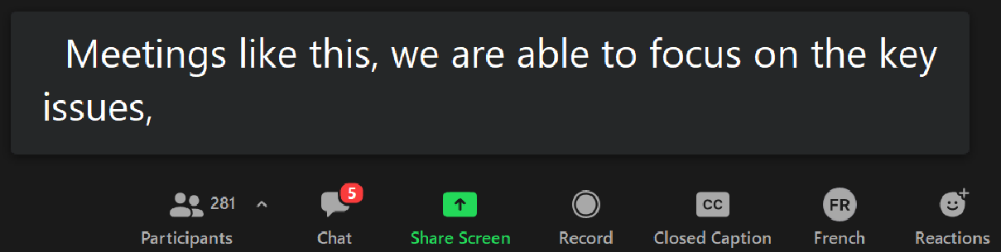

Other features for captioning:
To see the full transcript in a web browser, go to the following links from your browser:
For Study Group 1: http://streamtext.net/player?event=ITU-D-SG-1
For Study Group 2: http://streamtext.net/player?event=ITU-D-SG-2

To see the full transcript in Zoom:
- Push the “Closed Caption” button and select “View Full Transcript” item
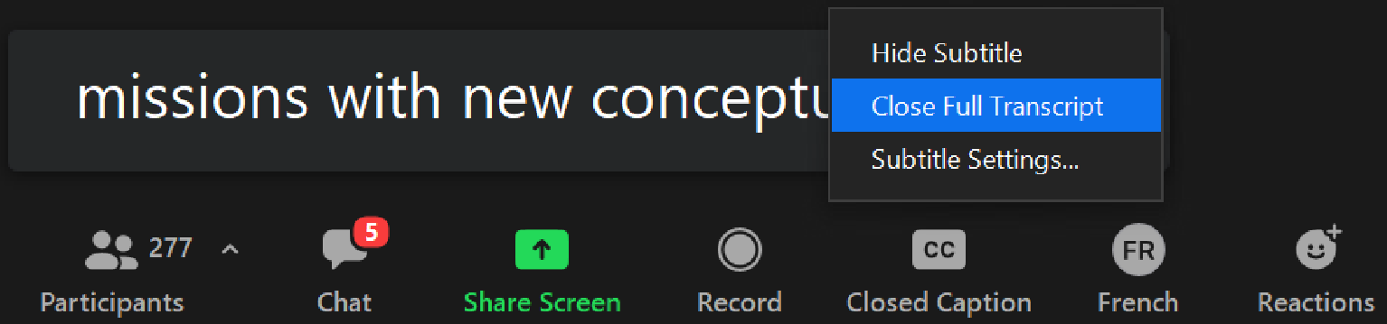

- A full captioning transcript window will appear on the right
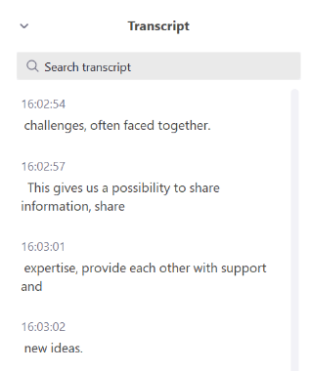

To change options (e.g. font size) for captioning:
Push the “Closed Caption” button and select “Subtitle Settings” from the menu that appears. The following window will then appear to change settings to match your preferences:



