Telecommunication
Development Sector
Study Groups
ITU-D Study Group 1 and 2 Plenaries and Rapporteur Group Meetings
Virtual Format, 11-22 October 2021
Document SG1RGQ/ADM/65-E
Document SG2RGQ/ADM/64-E
 |  |  | 29 September 2021
 |  |  | English only
All Questions
SOURCE: | Telecommunication Development Bureau
TITLE: | Guidelines for rapporteurs in virtual ITU-D study group meetings

Abstract:
This document shares with the ITU-D Study Group 1 and 2 some guidelines for Rapporteurs in virtual ITU-D study group meetings.
The current guidelines are confirmed for usage for the ITU-D Study Groups Rapporteur Group meetings (SG1: 11 - 15 October 2021, SG2: 18 - 22 October 2021).

Guidelines for rapporteurs in virtual ITU-D study group meetings
- Before the e-meeting:
- After receiving the last contributions, indicate estimated time for each agenda item and contributions (with the support of the SG Secretariat as appropriate). Indicate clearly at which point(s) and for how long you will attribute time for Q&A
  - This may be discussed with your management team e-meeting as appropriate.
  - Allocate reasonable to time to focus on the following key items: output reports, new study Questions
- Participate in a test call to understand clearly how the tool (Zoom with interpretation and captioning, see Section 4 and Annex 1) works and to ensure that you can connect properly to the virtual room through the Restricted Virtual Events portal. More information about this test call is provided through a separate communication after you register for meetings.
- Agree in advance with your fellow co-rapporteur or assign a vice-rapporteur to be on standby to convene the meeting in case your connection would fail.
- If not done yet, create a Whatsapp group with your management team members to ensure smooth offline communication (the SG Secretariat can assist in collecting the phone numbers and create a group upon request).
- Coordinate in advance who from the management team will present a document in case the author is not available or has a connection failure.
  - Note: In case an author participates in a test call and his/her connection is not stable, the SG Secretariat will contact the author to receive if possible a video recording as a backup, along with some guidance on how to intervene.
- During the e-meeting:
- Authors should not read their contributions but summarize only the key points within agenda time limit.
  - Intervene immediately if authors start reading their contributions
- In case a connection fails with an author, or the voice quality is poor:
  - Stop the presentation and move to another contribution while ITU IT team tries to resolve the connection issue
  - If connection fails for a second time, rely on video recording (if available) or request the pre-assigned person from the management team to present it
- Strictly limit time for Q&A interventions according to the time limit scheduled.
  - If time is limited, instead of giving the floor, encourage questions/comments written through the chat, which may be answered by the author during or after the e-meeting.
- Maintain focus on the following key items: output reports, new study Questions
  - Other agenda items may be skipped if no contribution has been submitted.
  - Admin documents from the SG Secretariat (e.g. list of contributions, list of liaison statements, lessons learned) may be briefly mentioned (noted for consideration) by the chairing person without giving the floor to the SG Secretariat.
- Delegate issues taking too much time to the management team to address it offline to minimize the time taken during the e-meeting.
- After the e-meeting:
- Please provide your meeting report, at latest 3 days after your e-meeting.
- Tool used for the e-meeting:
Zoom will be used for the e-meeting. Information on how to connect and use Zoom is available in the following web page: https://www.itu.int/en/general-secretariat/ICT-Services/remoteparticipation/Pages/onlinemeetingroom.aspx
This meeting will also provide interpretation (plenaries: 6 languages, rapporteur group e-meetings: English and French) and human-based captioning for all sessions. Annex 1 provides more information how to enable interpretation and captioning in Zoom.
Important: To enable interpretation, you must download and install the latest version of Zoom. The latest version is available here: https://itu.zoom.us/download

Annex 1: How to enable interpretation and captioning with Zoom
To enable interpretation:
Important: To enable interpretation, you must download and install the latest version of Zoom. The latest version is available here: https://itu.zoom.us/download
- Click on the “Interpretation” button
- In the menu that appears, select the preferred language (e.g. French in this example)
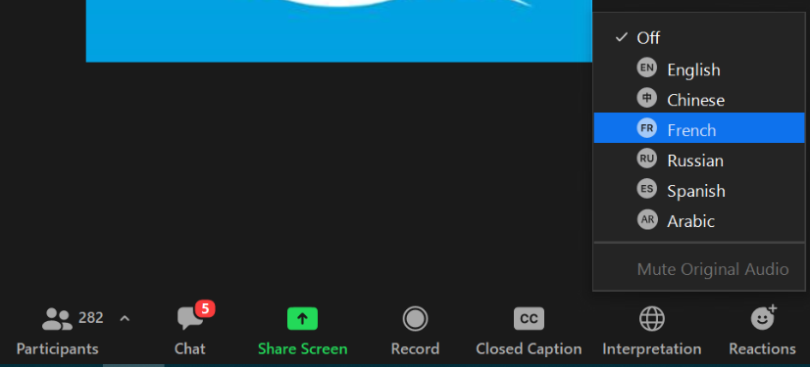
- You will hear the interpreted language, with the original language at lower volume in the background.
To enable captioning:
- Click on the “Live Transcript” button
- In the menu that appears, click on “Show Subtitle”
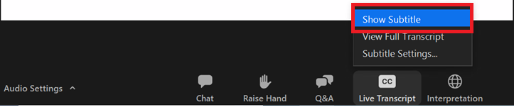
- You will see captioning on the screen
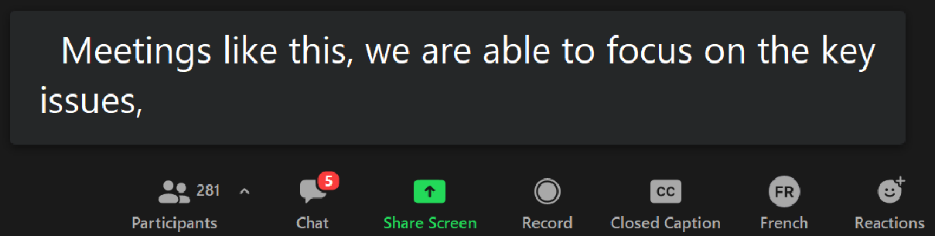

Other features for captioning:
To see the full transcript in a web browser, go to the following links from your browser:
For Study Group 1: http://streamtext.net/player?event=ITU-D-SG-1
For Study Group 2: http://streamtext.net/player?event=ITU-D-SG-2

To see the full transcript in Zoom:
- Push the “Closed Caption” button and select “View Full Transcript” item
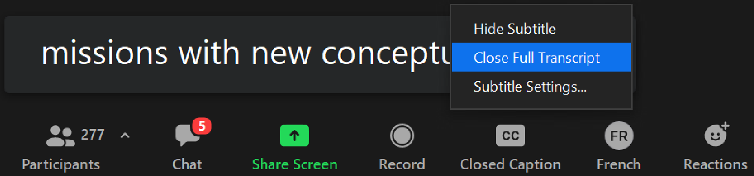

- A full captioning transcript window will appear on the right
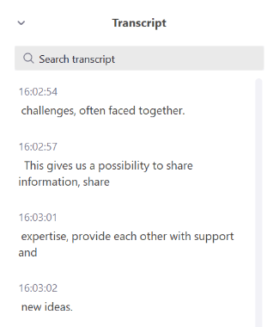

To change options (e.g. font size) for captioning:
Push the “Closed Caption” button and select “Subtitle Settings” from the menu that appears. The following window will then appear to change settings to match your preferences:



