Telecommunication
Development Sector
Study Groups
Fourth Meetings of ITU-D Study Groups 1 and 2
Geneva, Informal 22 February - 5 March 2021, Formal 15-26 March 2021
Document 1/ADM/36-E
Document 2/ADM/33-E
 |  | 10 February 2021
 |  | English only
All Questions
SOURCE: | Telecommunication Development Bureau
TITLE: | Guidelines for contributors in virtual ITU-D study group meetings

Abstract:
This document shares with the ITU-D Study Group 1 and 2 participants some guidelines for contributors in virtual ITU-D study group meetings.
The current guidelines are confirmed for usage for the ITU-D informal Rapporteur Group meetings (SG2: 22-26 February 2021, SG1: 1-5 March 2021). A revision to this document will be provided if changes are needed for the Fourth Annual Meetings of ITU-D Study Groups 1 and 2 starting on 15th March 2021.

Guidelines for contributors in virtual ITU-D study group meetings
- Before the e-meeting:
- Identify clearly at which point and for how long you will intervene while aiming to stay within the agreed allocated time for your intervention (with the guidance of the chairperson of the e-meeting and the support of the ITU-D SG Secretariat as appropriate).
- Participate in a test call to understand clearly how the tool (Zoom with interpretation and captioning, see Section 4 and Annex 1) works and to ensure that you can connect properly:
  - More information about this test call will be provided to you through a separate communication.
  - If in the test call, your connection is not stable, the SG Secretariat will liaise with you to receive if possible a video recording as a backup.
- On the day of the meeting, connect at least 10 minutes prior to the start of the meeting so that ITU can address any last minute issue.
- Inform in advance the meeting chairperson (and the ITU-D SG Secretariat) if anyone else can be on standby to intervene on your behalf in case your connection would fail.
- During the e-meeting:
- Rename yourself so that your name, organization and country (where applicable) appears clearly to all participants. If you are having problems to rename yourself, inform the IT Moderator in a private chat.
- Switch your video on and unmute your audio when given the floor by the chairperson or IT moderator. Keep your video switched off and mute your audio at other times.
- Do not read your contribution but summarize only the key points within your allocated time limit.
  - Your intervention should be succinct and convey in simple clear words, the actionable message you wish all participants to retain
  - Speak clearly and slowly as much as possible
- Report any connectivity issue in a private chat with the IT moderator, who will provide support
- In case a connection fails or the voice quality is poor during your intervention:
  - The chairperson may stop your intervention and move to another contribution while ITU IT team tries to resolve the connection issue
  - If connection fails for a second time, the video recording (if available), your pre-assigned backup person (if any), or someone from the management team will present it
- The time for Q&A interventions will be strictly according to the time limit scheduled. Instead of giving the floor, participants will be encouraged to submit questions / comments written through chat, which may be answered by the person to whom the question is addressed during or after the e-meeting. Where the chat question is clearly addressed to you, you may reply by typing your response in the chat. The chat moderator would indicate to participants that you replied in the chat.

- Please note that:
  - The e-meeting focus is on the key items: output reports, new study Questions
  - Other agenda items may be skipped if no contribution has been submitted.
  - Admin documents from the SG Secretariat (e.g. list of contributions, list of liaison statements, lessons learned) may be briefly mentioned (noted for consideration) by the chairing person without giving the floor to the SG Secretariat.
  - Issues taking too much time will be delegated by the chairperson to the management team to address it offline to minimize the time taken during the e-meeting.
- After the e-meeting:
- Please email response for any unanswered question to the chairperson and to ITU-D study group secretariat as soon as possible and at latest the next day after the e-meeting.
- Tool used for the e-meeting:
Zoom will be used for the e-meeting. Information on how to connect and use Zoom is available in the following web page: https://www.itu.int/en/general-secretariat/ICT-Services/remoteparticipation/Pages/onlinemeetingroom.aspx
This meeting will also provide interpretation (informal rapporteur group e-meetings: English and French) and human-based captioning for all sessions. Annex 1 provides more information how to enable interpretation and captioning in Zoom.
Important: To enable interpretation, you must download and install the latest version of Zoom. The latest version is available here: https://itu.zoom.us/download

Annex 1: How to enable interpretation and captioning with Zoom
To enable interpretation:
Important: To enable interpretation, you must download and install the latest version of Zoom. The latest version is available here: https://itu.zoom.us/download
- Click on the “Interpretation” button
- In the menu that appears, select the preferred language (e.g. French in this example)
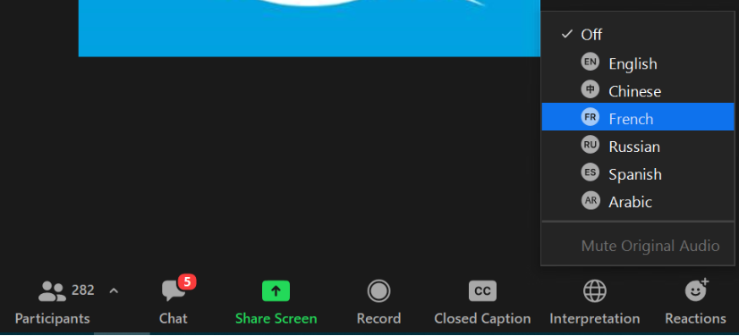
- You will hear the interpreted language, with the original language at lower volume in the background.

To enable captioning:
- Click on the “Closed Caption” button
- In the menu that appears, click on “Show Subtitle”
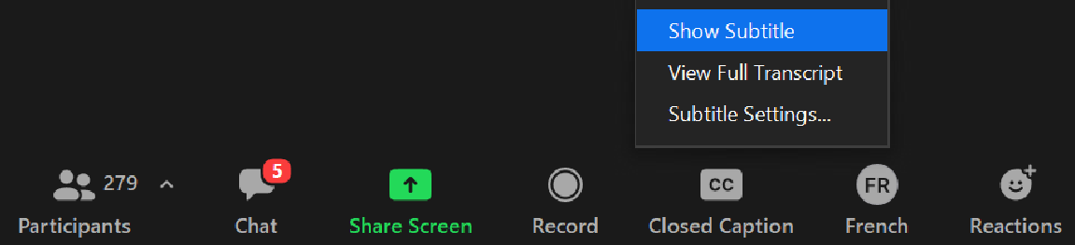
- You will see captioning on the screen
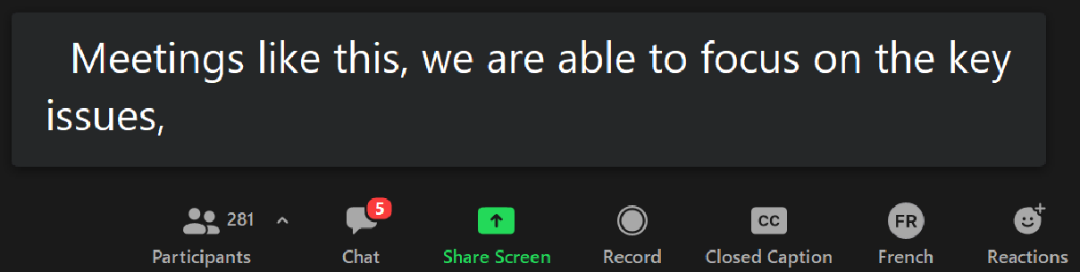

Other features for captioning:
To see the full transcript in a web browser:
Go to the following link from your browser https://www.streamtext.net/text.aspx?event=ITU-D

To see the full transcript in Zoom:
- Push the “Closed Caption” button and select “View Full Transcript” item
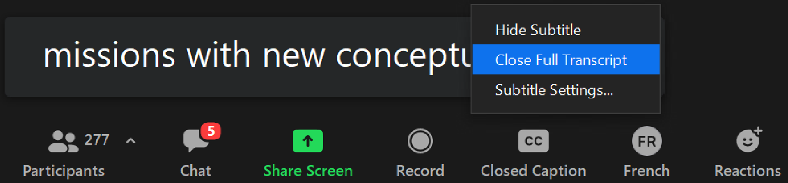

- A full captioning transcript window will appear on the right
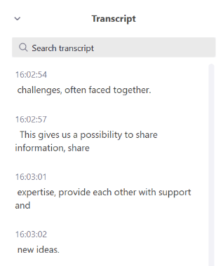

To change options (e.g. font size) for captioning:
Push the “Closed Caption” button and select “Subtitle Settings” from the menu that appears. The following window will then appear to change settings to match your preferences:



