|  |  |
| --- | --- |
| **Telecommunication Development Advisory Group (TDAG)**  **24th Meeting, Geneva, 3-5 April 2019** | C:\Users\comas\AppData\Local\Temp\Rar$DRa0.735\jpg\ITU official logo_blue_RGB.jpg |
|  | **Annex 1 to:** |
|  | **Document** **TDAG-19/****2-E** |
|  | **14 February 2019** |
|  | **Original: English** |
| Director, Telecommunication Development Bureau | |
| ANNEX 1 TO PERFORMANCE REPORT 2018 World and regional trends and implementation of regional initiatives | |
|  | |
| **Summary:**  This document contains Annex 1 to document TDAG-19/2.  Part 1 contains world and regional trends in the access to and use of ICTs from 2005 to 2018.  Part 2 contains the implementation of regional initiatives during 2018. The summary of activities undertaken during 2018 under these regional initiatives is provided by region in section 1. More details on specific activities are provided in section 2. Tables 1 and 2 provide operational and financial information on the levels of regional activities in 2018.  Annex 2 to document TDAG-19/2 is available at <https://www.itu.int/en/ITU-D/TIES_Protected/PerfReport2018.pdf>.  **Action required:**  TDAG is invited to note this document and provide guidance as deemed appropriate. | |

The purpose of this document is to provide additional information on the implementation of the objectives, outcomes and outputs defined in the ITU-D Operational Plan as described in document TDAG-19/2.

**Part 1. World and regional trends**[[1]](#footnote-1)

*Global ICT development, 2005-2018*

Chart 1 shows the most important trends in the access to and use of ICTs at the global level since 2005. There continues to be a general upward trend in the access to and use of ICTs. Except for fixed-telephone subscriptions, all indicators have been steadily increasing. The world has crossed the halfway line in 2018 in terms of Internet use, with 51.2 per cent of the world population using the Internet. In recent years, however, growth rates for most indicators have been more modest than in the first decade of the century. This is because in many countries, especially in the developed countries, penetration rates are approaching saturation levels: if not in the whole country, at least in segments of the population.

*Chart 1 – Global ICT Developments, 2005-2018\**

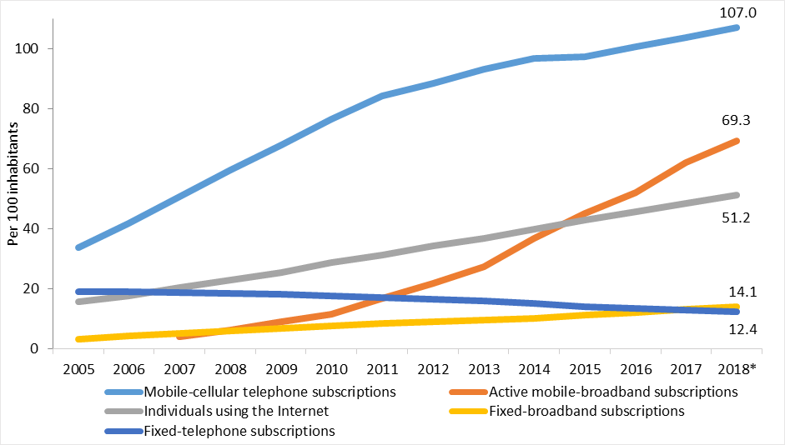

\*ITU estimate. Source: ITU

*Fixed-telephone subscriptions*

For a long time, fixed-telephone connections were one of the most important ways for people to communicate with each other. With the introduction of mobile-cellular technology, followed by the mass adoption of the Internet, multiple communication pathways opened up, leading to a decline in fixed-telephone penetration rates. Chart 2 shows that, in all regions of the world, fixed-telephone penetration rates declined. In relative terms, the largest reduction was reported for Asia and the Pacific region, with a 42.2 per cent decline from 2005 to 2018, while the lowest decline was observed in the Commonwealth of Independent States (CIS) region, at -17.1 per cent.

*Chart 2 – Fixed telephone subscriptions per 100 inhabitants, by region 2005–2018\**

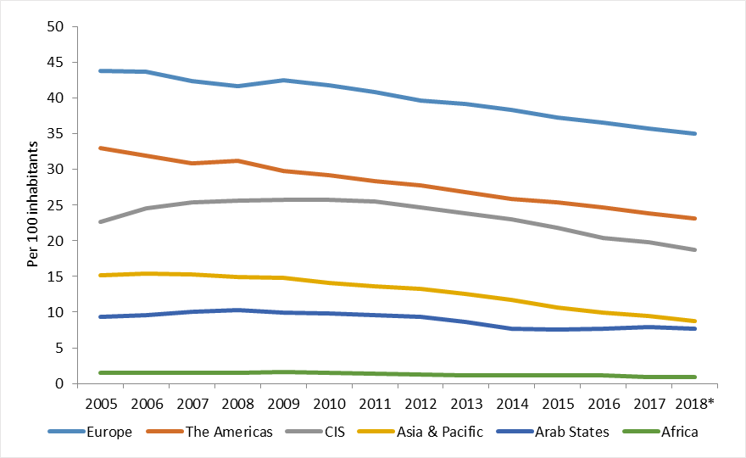

\*ITU estimate. Source: ITU

*Mobile-cellular subscriptions*

After strong increases in the number of mobile-cellular subscriptions during the early part of the century, growth seemed to be tapering off in 2014–2015. It picked up again, though, in the last three years, although at lower rates than from 2005 to 2015. There are now more mobile-cellular subscriptions than people on the planet. This is because many people have more than one subscription, to take advantage of competing voice or data plans of more than one operator, or because they may have a professional and a personal subscription. Chart 3 shows that saturation rates are being reached in developed countries, with only modest growth in the last five years. Growth in developing countries, and especially in the least developed countries (LDCs), was more sustained.

*Chart 3 – Mobile-cellular subscriptions per 100 inhabitants, by region, 2005–2018\**

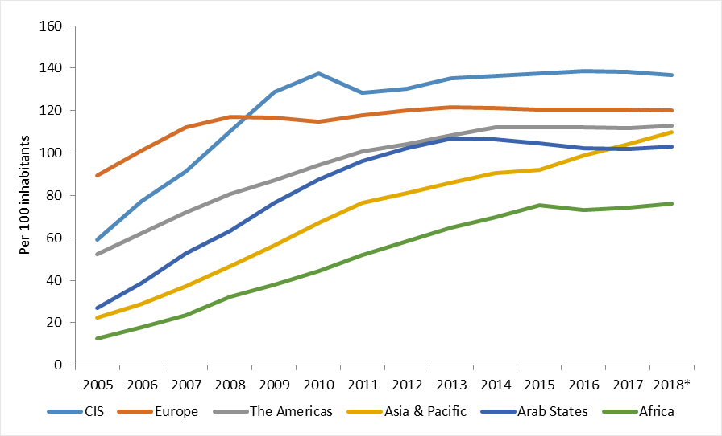

\*ITU estimate. Source: ITU

*Active mobile-broadband subscriptions*

Since its introduction about 15 years ago, mobile-broadband has become one of the defining features of today’s information society. Mobile access is more flexible and more available than fixed-broadband. Access to fast Internet is essential for many people, and has beneficial effects on the world economy. Recent research estimates that an increase of 1 per cent in mobile-broadband penetration is associated with an increase in 0.15 per cent in GDP. Chart 4 shows that in all regions of the world there was a strong growth in mobile-broadband take-up, but with a catching-up process at work. The strongest growth was observed in the three regions that started from the lowest base: Asia and the Pacific, the Arab States, and Africa.

*Chart 4 – Active mobile-broadband subscriptions per 100 inhabitants, by region, 2010–2018\**

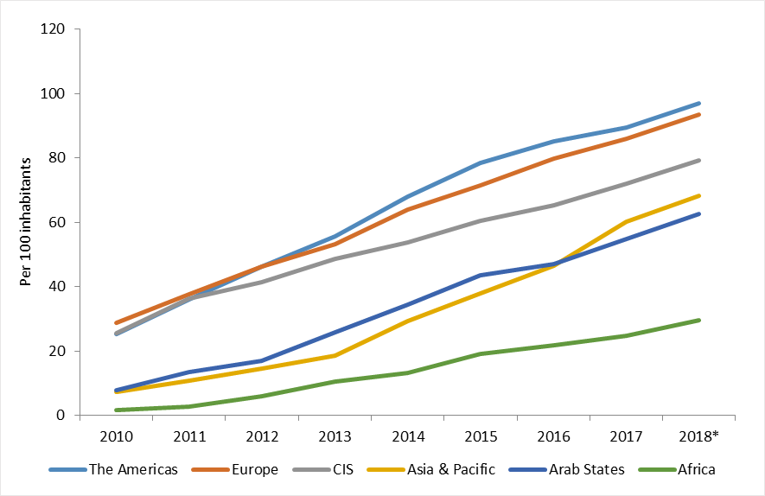

\*ITU estimate. Source: ITU

*Fixed (wired)-broadband subscriptions*

In developed countries, growth in fixed-broadband subscriptions is slowing, as these countries are getting closer to saturation levels. Since fixed-broadband connections are usually shared by all members in the household, penetration rates are unlikely to be greater than 50 per cent. By contrast, in developing countries, after slowing in 2012 and 2013, growth has accelerated in the last five years, reaching 10.4 subscriptions per 100 inhabitants in 2018. This still leaves plenty of room for further growth. In LDCs, growth was strong as well, albeit from a very low base. The distribution of fixed-broadband subscriptions by region is shown in Chart 5.

*Chart 5 – Fixed-broadband subscriptions per 100 habitants, by region, 2005-2018\**

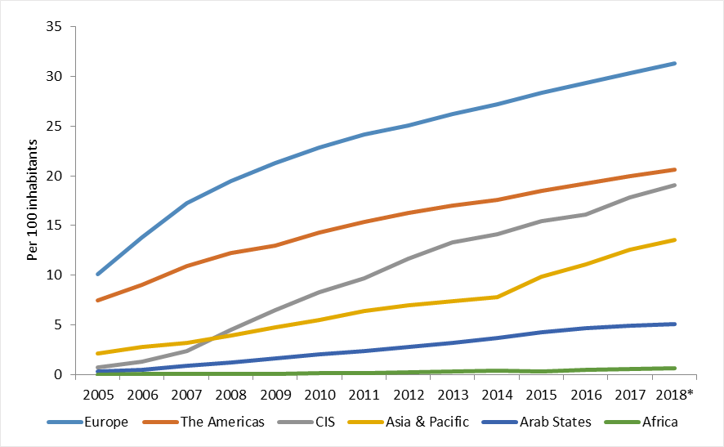

\*ITU estimate. Source: ITU

*Households with a computer*

From a regional perspective, the strongest growth rates in the percentage of households with a computer were observed in the Arab States region and the CIS region (see Chart 6). This allowed the CIS region to overtake the Americas region and almost close the gap with Europe. In the Africa region, the proportion of households with access to a computer increased from 3.6 per cent in 2005 to 9.2 per cent in 2018.

*Chart 6 – Percentage of households with a computer, by region, 2005–2018\**

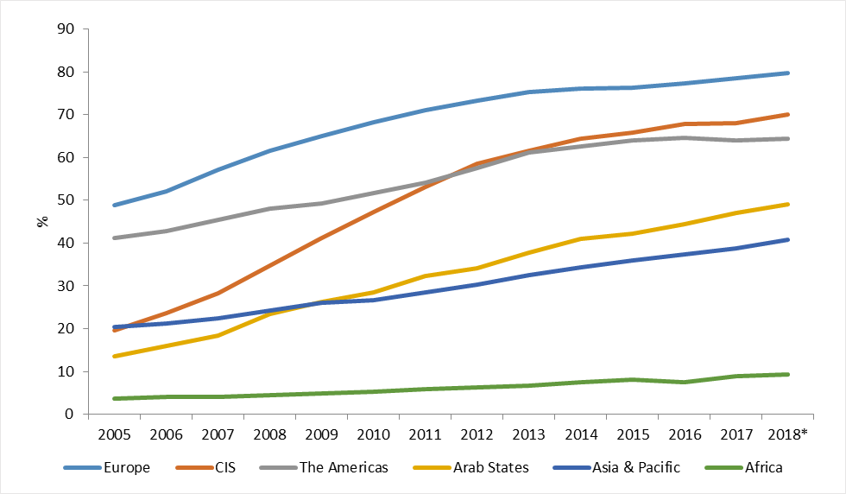

\*ITU estimate. Source: ITU

*Households with Internet access at home*

Chart 7 illustrates that regional developments broadly follow the trends observed for households with computers. Because of modest growth in Europe and the Americas regions, and strong growth in the other regions, the CIS region has overtaken the Americas region.

*Chart 7 – Percentage of households with Internet access at home, by region, 2005–2018\**

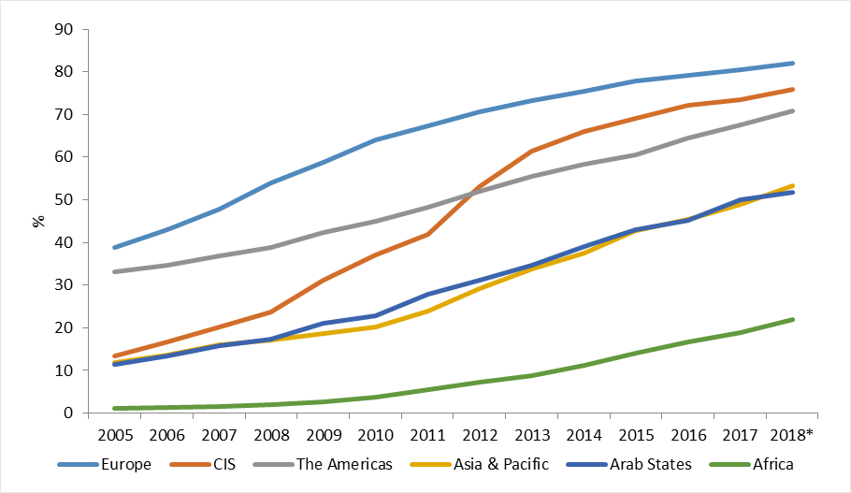

\*ITU estimate. Source: ITU

*Individuals using the Internet*

From a regional perspective, in just a few years, the CIS region made a giant leap to catch up with and overtake the Americas region (see Chart 8). Of all regions, however, the strongest growth was reported in the Africa region, where the percentage of the population using the Internet increased from 2.1 per cent in 2005 to 24.4 per cent in 2018. The regions with the lowest growth rates were Europe and the Americas, with Europe getting close to saturation rate.

*Chart 8 –Individuals using the Internet, by region, 2005–2018\**

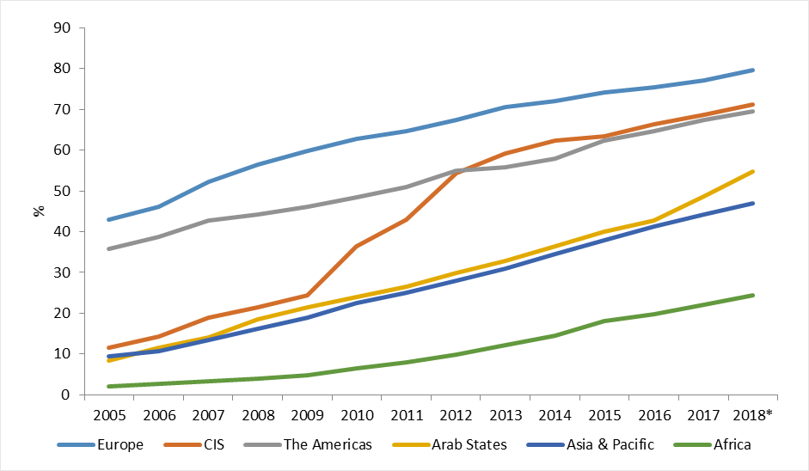

\*ITU estimate. Source: ITU

**Part 2. Implementation of regional initiatives**

In 2018, BDT continued to implement regional initiatives approved under the Dubai Action Plan (DuAP). These regional initiatives were intended to address specific telecommunication/ICT priority areas through partnerships and resource mobilization to implement small-, medium- and large-scale projects in the ITU regions.

The summary of activities undertaken during 2018 under these regional initiatives is provided by regions in section 1. More details on specific activities are provided in section 2. Tables 1 and 2 provide operational and financial information on the levels of regional activities in 2018[[2]](#footnote-2).

***Section 1. Summary***

**Africa Region**

|  |  |  |
| --- | --- | --- |
| Contact: | Name/Organization/Entity: | Mr Andrew Rugege, Regional Director for Africa |
|  | Tel: | Tel: +251 11 551 4977/4855/8328 |
|  | E-mail: | [ITU-RO-Africa@itu.int](mailto:ITU-RO-Africa@itu.int) |

In 2018, BDT implemented project activities under 13 technical cooperation projects for a total amount of 2.8 million USD in the Africa region, in collaboration with Member States. In addition, activities on 41 actions of the BDT Operational Plan were implemented for an amount of 850 thousand CHF.

ITU provided support to Africa Telecommunications Union (ATU) in organizing the preparatory meetings to build Africa region common positions to the WRC 19 and other global events. ITU also facilitated the harmonization of policies and regulatory frameworks in the region, which includes universalization of broadband, e-health using mobile devices, and regional and sub-regional IXP to provide cost reduction of traffic. Assistance was provided to countries in the region in various areas, including the model national broadband plans, development of digital economy policies, development of strategies and corporate strategic plans for institutions, etc.

A number of projects are currently ongoing in areas such as institutional reform, telemedicine, wireless broadband, judiciary training, computer incident response team (CIRT) implementation and enhancement, m-diabetes, and m-cervical cancer. Several regional workshops and forums were organized in 2018 in the region in areas such as conformance and interoperability, IPV6, cybersecurity and cyber drills, Internet of Things (IOT), ICT economics and finance, quality of service and quality of experience, international roaming, and ICT accessibility and digital inclusion. Several national workshops were organized on subjects like spectrum management, ICT measurements and indicators, CIRT management, ICT skills train of trainers, child online protection (COP), cybersecurity maturity review and strategy, crisis management plans, judiciary training, and quality of service (QoS) and quality of experience (QoE).

**Americas Region**

|  |  |  |
| --- | --- | --- |
| Contact: | Name/Organization/Entity: | Mr Bruno Ramos, Regional Director for Americas |
|  | Tel: | Tel: +55 61 2312-2730 |
|  | E-mail: | [itubrasilia@itu.int](mailto:itubrasilia@itu.int) |

In 2018, BDT implemented project activities under 12 technical cooperation projects for an amount of 1 million USD in the Americas region, in collaboration with Member States. In addition, activities under 35 actions of the BDT Operational Plan were implemented for a total amount of 589 thousand CHF. In the Americas region, 22 additional capacity building activities were also implemented to cope with the demands of membership, such as ICT policy and regulation, business and management of telecommunication technical issues, IoT communication protocols, LTE radio access technologies, radioelectric spectrum, cybersecurity, emergency communications, satellite communications, digital TV, ICTs and climate change, IXPs, optical access in network communications, among others. Over 15 of these capacity building activities were delivered through the ITU Academy, including a pilot project on digital policies that targeted civil servants of the Brazilian Administration – a similar training will be delivered in the Caribbean in 2019.

Direct assistance and support were provided to different countries in the region in areas of policy and regulatory framework for an e-waste management, development of national ICT plans, and preparation of guidelines for transition from analogue to digital broadcasting, infrastructure deployment, web accessibility training, and others. A new online training focusing on the development, management and operation an indigenous radio network was delivered to over 200 indigenous people from 16 countries. ITU also developed in 2018 a new training programme to benefit indigenous communities by training indigenous technical promoters with a critical view of ICTs to be able to choose the most convenient technology for the development of community networks and ensure its sustainability without the need of external assistance in the operation and maintenance of these networks. The programme consisted of five on-line training courses followed by a hands-on face-to-face training focusing on three main areas: broadcasting, community networks and community mobile telephony.

Several regional workshops and forums on conformance and interoperability, Internet governance, cyber bullying, ICT accessibility and digital inclusion, cybersecurity and cyber drills, emergency telecommunications, and IOT were organized and delivered in 2018 in the Americas region. A pilot project on the establishment of the Alternate Regional Emergency Telecommunications Network in the Americas region was prepared as a result of the joint effort of ITU, CITEL, and COMTELCA. A conformance and interoperability (C&I) assessment study was conducted with the main objective of creating proposals on ways forward to improve the C&I status in the region.

**Arab States Region**

|  |  |  |
| --- | --- | --- |
| Contact: | Name/Organization/Entity: | Mr Ebrahim Al-Haddad, Regional Director for Arab States |
|  | Tel: | Tel: +202 3537 1 777 |
|  | E-mail: | [ITU-RO-ArabStates@itu.int](mailto:ITU-RO-ArabStates@itu.int) |

In 2018, BDT implemented project activities under five technical cooperation projects in the Arab States region for 872 thousand USD, in collaboration with Member States. In addition, activities on 29 actions were implemented for an amount of 404 thousand CHF.

Through the ITU Arab States region centres of excellence network, 13 capacity building courses were implemented in different aspects of ICT applications and services, new technologies and broadband, with more than 183 participants trained. A cooperation agreement was signed with the Deutsche Gesellschaft für Internationale Zusammenarbeit (GIZ) represented by the Employment Promotion Project (EPP) for the organization of Girls in ICT Day events until 2019. Assistance was provided to the Arab Incubators and Technoparks Network (ARTECNET), and a study was conducted on Internet networks and IXPs development in the Arab States region.

Capacity building activities on e-waste, EMF, smart learning, IoT, lmart cities and Big Data development, spectrum pricing, cost and pricing of quadplay access, satellite communications, training needs analysis, andtraining plan development of ICT sectors were organized in the Arab States region. Direct assistance was provided to Palestine, Somalia, and Sudan on mobile number portability, ICT policy and strategy, and framework of spectrum pricing. Furthermore, capacity building assistance was provided to countries in the area of spectrum management. Efforts were continued in relation to cybersecurity through the organization of the regional Cybersecurity Week that contains annual regional summit and annual regional cyber drills as well as child online protection and cybersecurity activities. ICT accessibility was promoted regionally through the organization of regional ICT Accessibility Week.

Assistance to Sudan to develop a national ICT accessibility policy was conducted in 2018. In addition, one workshop was organized on spectrum management in collaboration with ITU-R.

**Asia and the Pacific Region**

|  |  |  |
| --- | --- | --- |
| Contact: | Name/Organization/Entity: | Mr Ioane Koroivuki, Regional Director for Asia and the Pacific |
|  | Tel: | Tel: +62 21 380 2322/2324 |
|  | E-mail: | [itujakarta@itu.int](mailto:itujakarta@itu.int) |

In 2018, BDT implemented project activities under ten technical cooperation projects for a total amount of 668 thousand USD in the Asia and the Pacific region, in collaboration with Member States and partners. The projects were funded by Department of Communications and the Arts (Australia), National Broadcasting and Telecommunications Commission (Thailand), Ministry of Science, ICT and Future Planning (Republic of Korea), Estonia, and Bill & Melinda Gates Foundation, International Telecommunications Satellite Organization (ITSO). In addition, activities on 35 actions were implemented for an amount of 402 thousand CHF.

The key emphasis was on specialized assistance, awareness raising and capacity building in the areas of radio frequency spectrum management and monitoring, developing medium to long-term spectrum management master plans, policy and regulatory frameworks, cybersecurity, implementation of CIRT, national cybersecurity strategies, and child online protection, broadband, conformance and interoperability, and type approvals, ICT applications, telecommunication sector roadmaps and e-applications for Pacific Islands, quality of service, ICT indicators and statistics, Internet of Things, implementation of IPv6, ICTs for promoting innovation and entrepreneurship, ICTs for the empowerment of women, e-governance, smart and sustainable cities, e-agriculture, emergency telecommunications, and other technical and regulatory assistances.

In the area of training, the focus was on mobile broadband QoS, Internet and IPv6 infrastructure security, monitoring radio frequency spectrum in the modern wireless era, cybersecurity, IoT technologies and applications for smart cities, conformity and interoperability and 5G planning, blockchain ecosystem and decentralization, competition analysis in digital applications environment, traffic engineering and advanced wireless network planning, IOT overview and applications, use of drones, satellite imagery and GIS for agriculture, IoT platform and application development, digital financial services and digital payments, digital skills for job creation.

**CIS Region**

|  |  |  |
| --- | --- | --- |
| Contact: | Name/Organization/Entity: | Mr Kirill Oparin, Head of Regional Office for CIS |
|  | Tel: | Tel: +7 495 926 60 70 |
|  | E-mail: | [itumoscow@itu.int](mailto:itumoscow@itu.int) |

In 2018, BDT implemented activities on 20 actions for an amount of 292 thousand CHF.

To raise awareness of membership and facilitate dissemination of best practices, ITU organized regional events on e-health, cybersecurity and COP, digital transformation, mobile number portability and C&I, Big Data and cloud computing, IoT and future networks, spectrum management, IMT-2020/5G and VoLTE/ViLTE. All regional events were organized in response to formal requests from ITU Member-States, Sector Members, and Academia in the CIS region.

ITU also developed a specialized information resource that will be used as a platform to promote regional initiative outputs, seek partnerships and consolidate membership activities on subjects related to regional initiatives.

Other tangible outputs include:

* Online training courses on e-health for students, doctors and IT professionals <https://ehealthcourses.online/info/>.
* Research: Implementing ITU-T International Standards to Shape Smart Sustainable Cities: The Case of Moscow.
* Assistance in redistributing digital dividend frequencies for new technologies including IoT in the Kyrgyz Republic.
* Assessment of readiness to implement a national Computer Incident Response Team (CIRT).

Finally, ITU mobilized partners and resources to implement the following projects in 2019:

* Creation of digital skills centres for women and youth in Uzbekistan.
* Development of multimedia online course for women and girls in Azerbaijan.
* Creation of information and training centre on IP-telephony in Belarus.
* Establishment of the Regional Laboratory on IoT and Future Networks.

**Europe Region**

|  |  |  |
| --- | --- | --- |
| Contact: | Name/Organization/Entity: | Mr Jaroslaw Ponder , Head of Regional Office for Europe |
|  | Tel: | Tel: +41 22 730 5111 |
|  | E-mail: | [eurregion@itu.int](mailto:eurregion@itu.int) |

In 2018, BDT implemented activities under two technical cooperation project for a total amount of 493 thousand USD in the Europe region, in collaboration with Member States. In addition, activities on 26 actions were implemented for an amount of 257 thousand CHF.

Efforts to strengthen the implementation mechanism for the region were continued, including the coordination of actions with relevant organizations in the region, such as CEPT, EU, EC, ECO, ENISA, Regional Cooperation Council, ICPE and the UN, including UN ECE, R-UNDG, UNIDO, ILO, UNCTAD, WHO and FAO, and some UN country teams. Throughout the year, more than 32 workshops, seminars, expert group meetings on broadcasting, broadband, accessibility, cybersecurity, innovation, human capacity building were organized, attracting more than 6 000 participants in total from 35 countries. In addition, human capacity of more than 660 professionals was built through the European region network of centres of excellence (CoEs) that offered more than 17 training opportunities in 2018.

Direct assistance was provided to Albania, Bosnia and Herzegovina, Cyprus, Georgia, Greece, Montenegro, Poland, and Serbia in the fields of innovation, broadcasting, broadband, cybersecurity, and ICT applications, and elaboration of digital innovations profiles. More than 10 publications and reports have been elaborated during the year.

Europe Regional Office continued close coordination with the UN system, while contributing to the implementation to the WSIS Action Lines and 2030 Agenda for Sustainable Development. Collaboration with European Commission and the Regional Cooperation Council has been strengthened to advance the digital integration of Merber States in the Western Balkans.

**Table 1. Implementation of BDT operational plan by region in 2018**

*(amounts in thousands of Swiss francs)*

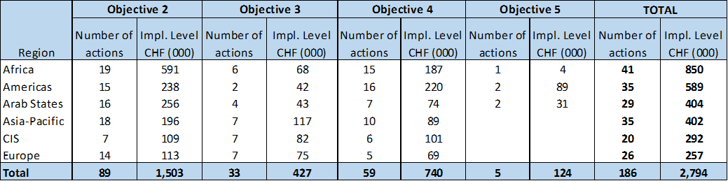

**Table 2. Implementation of projects by region in 2018**

*(amounts in thousands of US Dollars)*



**Section 2. Details of activities undertaken in 2018 under regional initiatives**

**AFRICA REGION**

**AFR RI 1: Strengthening human and institutional capacity building**

The Regional Initiative on Strengthening Human and Institutional Capacity Building was extensively implemented within the framework of the ITU centre of excellence network and ITU Academy. In 2018, about 85 professionals were trained in various subjects by the networks.

The Annual Regional Human Capacity Building Workshop for Africa, organized by ITU in Nigeria from 27 to 29 August 2018, combined with the regional training on Internet governance, attracted more than 100 participants from 14 countries and 6 international/regional organizations.

**AFR RI 2: Strengthening and harmonizing policy and regulatory frameworks for the integration of African telecommunication/ICT markets**

Least developed country (LDC) capacities were increased in the area of telecommunication/ICT standardization and statistics through national workshops held in Chad and Burundi, which provided a deeper understanding of ICT indicators and data collection to the 25 participants in each workshop. A workshop on USO was also delivered in the Central African Republic.

ITU assistance to Uganda helped the country to progress with the development of its Digital Uganda Vision and get the document validated in the workshop held on 29 November 2018. This document is expected to integrate and harmonize all policies related to ICTs from various sectors in the country.

The project on the Institutional reform and the elaboration of the broadband strategy for Burundi was achieved with a new set of laws to be adopted by the country.

**AFR RI 3: Development of broadband access and adoption of broadband**

Wireless broadband infrastructure projects under the ITU/Craig and Susan McCaw Broadband Wireless Network Project for Africa are being implemented in six countries (Burkina Faso, Burundi, Eswatini, Lesotho, Mali and Rwanda) to develop wireless broadband infrastructure and applications and enhance capacity. The projects in Eswatini, Lesotho, and Mali are ongoing, while the projects in Burkina Faso, Burundi and Rwanda have already succeeded in bringing broadband access to hospitals and schools. The same project was also launched in Madagascar with local funding.

Under the ITU and the Ministry of Science, ICT and Future Planning (MSIP), Republic of Korea wireless broadband access master plan project, the groundwork has been completed for the adoption and use of broadband in the Republic of the Congo and Malawi. In the framework of the memorandum of understanding between China, ITU and the East African Community (EAC) and following the country visits conducted by ITU and MIIT China experts, countries on joint partnership and cooperation on the acceleration of development of infrastructure for the parties continue working on the project formulation for EAC.

The continuous effort put into the development of the ITU interactive terrestrial transmission map for Africa will result in increased business potential and improved infrastructure planning (sharing of passive telecommunication infrastructure and power supply) in the region.

Burundi was assisted in the development of a broadband policy, strategy and regulatory framework that will result in an improved regulatory environment to help meet the growing demand for broadband connectivity.

A broadband universal access study was conducted for Lesotho that provided strategic guidance for implementation of the universal broadband strategy and overall development of the ICT sector in Lesotho.

Training on C&I was delivered to countries in 2018, as in previous years.

Namibia was assisted in the revision of its National Broadband Policy and associated Strategic Implementation Plan for achieving a digital economy, which will be compliant with the new guidelines, adding any new content if necessary.

Assistance was given to Africa region countries for:

* the development of ITU Interactive Terrestrial Transmission in the region;
* the ongoing implementation of phase 2 of the ITU/McCaw Foundation broadband wireless network in Burkina Faso, and an international tender organized for a similar project for Mali;
* Ongoing IPv6 testbeds in Cameroon and Sierra Leone to be used as a sub-regional testbed for IPv4 to IPv6 migration in West and Central Africa;

**AFR RI 4: Spectrum management and transition to digital broadcasting**

In 2018, a regional workshop on spectrum management and 5G was organized in Nairobi, Kenya. Another regional workshop on spectrum monitoring funding was organized in Accra, Ghana. In addition, some countries, such as Malawi, were assisted in their national spectrum management and frequency coordination. Burundi was granted fellowships to attend ABU meeting in Algiers, Algeria.

Direct assistance was given to Ethiopia to investigate and find solutions to the harmful interference of an AM broadcaster into the fixed line telephone network.

**AFR RI 5: Building confidence and security in the use of telecommunications/ICT**

In 2018, CIRT readiness assessment workshops were conducted for Niger and Democratic Republic of the Congo in July and October, respectively. These workshops helped to strengthen the concerned countries’ preparedness for their national cybersecurity policy elaboration as well as for their national CIRT implementation.

**AMERICAS REGION**

**AMS RI 1: Emergency telecommunications**

A bSmart project is under preparation for ITU to assist the Government of the Bahamas. Through this project, ITU will provide technical support, advice and guidance to contribute to the country’s agenda on diversification, improvement of public services, enhanced security, enhancement of the tourism industry, developing an advanced ICT infrastructure and improving the quality of citizens’ lives.

A needs assessment of emergency communication systems with the objective of implementing a mobile early warning system and communication platform was performed for Antigua and Barbuda, Barbados, Bahamas, and Saint Lucia during the period from 18 September to 19 October 2018. The Virtual Vision platform as a mechanism for real time, inter-agency, national and regional information sharing, reporting and early warning is being introduced to these countries. Also, an assessment survey of the resilience of broadcasters in the Caribbean in times of disaster was undertaken in collaboration with the Caribbean Broadcasting Union (CBU) and the Commission for Caribbean Communications Resilience (CCCR) through the Caribbean Telecommunications Union.

The Multi-stakeholder Forum on the Role of Telecommunications/ICTs for Disaster Management and Risk Reduction for the Caribbean Islands was organized in Roseau, Dominica, on 4 to 6 December 2018. The forum was attended by over 50 participants from different Caribbean Islands, Thailand, United Kingdom, and the United States, including national and international humanitarian agencies, private sector and academia, such as International Federation of Red Cross, Emergency Telecommunications Cluster, International Organization for Migration, as well as national firefighters, Red Cross, Police and civil defense and the Caribbean Institute of Meteorology and Hydrology. The Forum served to pave the way for enhancing the use of ICTs for disaster management in the region and addressing key questions related to the best use of ICTs for disaster risk reduction and management. It also served as a platform to exchange new experiences and best practices in the use of modern technologies for monitoring and early warning.

The III Regional Workshop: Technologies to mitigate effects of Natural Disasters was organized on 1 and 2 August in Quito, Ecuador. The event was attended by more than 200 participants.

BDT attended the 49th Annual General Assembly of the Caribbean Broadcasting Union (CBU) in Kingston, Jamaica, from 13 to 15 August 2018, and made a presentation on the work of and support provided by ITU on disaster management initiatives using ICTs and other initiatives.

A study on the Assessment of Emergency Telecommunication plans and systems in the Caribbean Region for broadcasters was organized. This is a follow-up from the study done earlier for telecommunications in the region. All these will be congruent to the Emergency Telecommunications Winlink Project which addresses in large measure “The use of ICTs for emergency and disaster situations in the Americas region”.

The BDT has supported the deployment of a mobile multi-hazard Early Warning and information-sharing platform in the Caribbean, in coordination with the Caribbean Disaster Emergency Management Agency (CDEMA). This platform allows the public and stakeholder agencies to submit reports and share information in real-time concerning hazards and disasters. All information is routed to the Disaster Management Office (DMO) and its staff via the application control panel. Once approved by DMO staff, alert notifications, early warning sirens and heat map content are then released to the public via the mobile application.

Emergency Communications for Central American countries, including communications equipment and the development of NEPTs: ITU is currently implementing the project “Pilot project in the use of ICTs in emergency and disaster situations in the Americas region”(“Proyecto piloto para el uso de las TIC para situaciones de emergencia y desastres en la región de las Américas”) to assist and support Member States in Central America (Costa Rica, Dominican Republic, El Salvador, Guatemala, Honduras, Nicaragua and Panama) in improving their capabilities in emergency telecommunications and to improve their response to emergencies and disasters. Beneficiary countries have received an emergency tool kit that will allow their integration into a regional network of emergency Winlink-based telecommunications. ITU, in cooperation with IARU and FMRE and the respective Administrations, launched operations in Costa Rica, Dominican Republic, Guatemala, Honduras, and Nicaragua. Preparations are underway to launch operations in El Salvador and Panama in 2019.

**AMS RI 2: Spectrum management and transition to digital broadcasting**

It is recalled that ITU launched in 2017 a border-area frequency coordination process for the Caribbean and Central America countries (a total of 27 countries and territories). Two meetings were organized in 2017. Most of the countries have also contributed the spectrum assignment data needed in order to run the frequency coordination simulation iterations. The 3rd meeting took place in Panama in May 2018, and the 4th and final meeting, in Belize in September 2018. It was a successful coordination, achieving average percentages of 96 per cent for UHF band and 94 per cent for VHF band of assignable digital TV channels after 40 iterations in UHF and 27 iterations in VHF, and 4 meetings. This was a joint effort by ITU-D and ITU-R.

In 2018, ITU delivered online training courses in the fields of spectrum management and digital broadcasting for the benefit of Latin American countries Commission (CITEL) through the ITU Academy platform.

A project was completed consisting in supporting and cooperating with the Ministry of Information and Communication Technologies (MinTIC) of Colombia in the development of studies, analyses and proposals related (i) to the diagnosis and updating of National Technical Plans of Radio Broadcasting (PTNRS); (ii) to defining the technological strategy for the new AM and FM broadcasting in the Republic of Colombia; (iii) to new technologies for broadcasting; (iv) to the proposal of a manual of good practices for assembly of radio stations; (v) to the technical specification of a web tool for management and control of the PTNRS and the radio broadcasting concessionaires; and (vi) to training and socialization activities.

A project was completed that consisted of assisting the Ministry of Information and Communication Technologies (MinTIC) of Colombia, in the development of a diagnosis and audit of the Spectrum Allocation by Objective Selection process in order to strengthen the management, analysis, administration, planning and allocation of the radio spectrum within the framework of the integrated management model of the ministry.

Project for a strategy design for the implementation of international best practices in the allocation of spectrum attributed to the IMT service in Colombia was completed. The main objective of this project was to combine cooperation and technical assistance efforts to contribute in the validation and improvement of spectrum assignment processes for IMT (International Mobile Telecommunications) bands in Colombia.

A meeting of the Caribbean Spectrum Management Task Force was organized from 31 January to 2 February 2018 for around 30 participants from Caribbean countries providing contributions on the relevant reports of the task force (digital broadcasting transition, cross-border frequency coordination, emergency communication, spectrum pricing).

Bolivia was assisted on establishing a basic spectrum management system from 17 to 25 May, and the final recommendation was delivered to the beneficiary country.

In 2018, ITU provided direct assistance to Guyana through its National Frequency Management Unit (NFMU) in the Ministry of Public Communications in assessing and reviewing its spectrum assignments as part of its reform process.

In the framework of the ITU and the Ministry of Science, ICT and Future Planning (MSIP), Republic of Korea development of master plans for sepectrum management project, an assessment with recommendations was prepared for Bolivia. The report included the assessment of a spectrum management scheme (i.e., spectrum policy, spectrum use, authorization, spectrum sharing, spectrum pricing, spectrum monitoring and compliance), and the provision of advice in connection with the development of relevant policies, legislation and regulations.

The 5th Annual Latin America Spectrum Management Conference and a workshop on Spectrum and Community Networks were co-organized with the Forum Global, involving 167 registered participants from 16 countries, including 12 countries from Latin America. Both events raised stakeholder capacity to understand the importance of efficiently managing spectrum resources. Visibility of community networks increased as a feasible alternative to connecting the unconnected. A project was drafted to work with the Internet Society and Fundación Getulio Vargas in the development of a toolkit and the implementation of ad hoc assistance to implement community networks.

**AMS RI 3: Development of broadband access and adoption of broadband**

Training on Conformance and Interoperability (C&I) for the Americas Region. Coordination is ongoing with countries of the Americas region to achieve a final design on the activity to be implemented. Training on C&I was delivered to countries in 2018, as in previous years.

In 2018, ITU continued to support the development of mutual recognition agreements (MRAs) for COMTELCA country members (Costa Rica, Dominican Republic, El Salvador, Guatemala, Honduras, Nicaragua, and Panama).

A forum on Conformance and Interoperability (C&I) in Innovation for Youths (25-27 June 2018) and a workshop on Establishing a Mutual Recognition Agreement (MRA) for the Caribbean Countries (28-29 June 2018) were held in Port-of- Spain, Trinidad and Tobago, attended by more than 16 developers and other participants from seven countries in the region. These events highlighted the importance of C&I for young IoT developers and served as forums for the discussion of the implementation of a MRA for the CARICOM region.

An internal technology assessment revealed that the existing IT infrastructure and platform of Caribbean Telecommunications Union (CTU) are inadequate to sustain the operations of the Secretariat at present and in the future. BDT provided assistance to CTU to enhance the technical infrastructure of the CTU Secretariat through procuring the core network, server and connectivity equipment and associated training and installation support for the IT network upgrade.

The 6th Latin American Telecommunications Congress was co-organized in Varadero, Cuba, with GSMA LA, ASIET and the Development Bank of Latin America on 11-15 June with the attendance of more than 300 participants from 30 different countries, including representative from 17 international organizations and 32 companies. A Forum on Broadband for Rural Areas was also organized on 11 June (<http://www.clt.lat/2018/eng/>).

ITU supported Member States in the Americas region in mapping long-distance terrestrial optical cable systems, a tool that helps administrations and regulators in their work of building and reviewing policies.

**AMS RI 4: Reduction of telecommunication service prices and Internet access costs**

An ITU study to determine a model for the national IXP for Suriname involved ISPs, Academia, governments, content providers, civil society, mobile providers and others during several months through online and *in situ* meetings. Three models were presented, of which one was selected. ITU developed the selected non-profit Private Model. ITU participated as secretariat to coordinate the procedures and internal rules for a further establishment of an interim executive committee that will take the responsibility of the physical implementation of the IXP.

A study was started on Interconnectivity and Reduction of telecommunication service prices and Internet access cost for some Member States in the Americas region. Coordination with ASETA and beneficiary countries for the development of the study is ongoing, and is focused on Colombia, Ecuador, Peru and Bolivia. This study is meant to determine the situation of international interconnectivity and to describe the reasons for the Internet access cost in those Member States. Additionally, it will foster international interconnectivity between the countries. The report of the study will be published in 2019.

**AMS RI 5: Capacity building to engage in global ICT policy, with special focus on improving cybersecurity and developing countries’ participation in the existing Internet governance institutions**

The events Cybersecurity from La Plata River and VI Regional Forum on Cybersecurity and Cyberdrill Applied Learning for Emergency Response Team for the America Region were held in La Plata, Argentina from 4 to 8 June 2018. The event was attended by 117 attendees, plus 15 people on child online protection, representing 10 countries of the region: Argentina, Bahamas, Brazil, Chile, Cuba, Ecuador, El Salvador, Guyana, Paraguay, and Uruguay. 50 people participated in the Cyberdrill, organized in 12 teams. Chile and Paraguay expressed interest in organizing a similar cyberdrill event in 2019.

Cybersecurity and disaster reduction programme: Further to the post-implementation review of the project on the establishment of a national CIRT in Barbados, ITU was requested and has agreed to provide support and assistance with the continuation of the project towards full operationalization of the Barbados National CIRT.

In support to the AMS regional initiative, the work carried out by ITU in the area of digital inclusion and the existing key resources available to support ITU members and stakeholders in their process of implementing ICT accessibility to create digital inclusive societies in Americas region, was shared with 214 participants of the regional event “Accessible Americas V: ICTs for ALL” (Jamaica, 28-30 November 2018). The BDT Focal Point in ICT Accessibility delivered a training session on “Fundamentals in ICT accessibility” to all participants. 90 trainees of the said training session successfully achieved the knowledge and obtained ITU certification.

The Global ICT Capacity Building Symposium (CBS-18) was successfully conducted in Santo Domingo, Dominican Republic, on 18-20 June 2018, under the theme "Developing skills for the digital economy and society." The symposium attracted 331 participants from 36 countries. The outcomes of the symposium are expected to provide strategic guidance to the national and international community on issues of skills development in the field of ICT and digital technologies.

BDT enhanced capacity and expertise in Bolivia and Paraguay, two landlocked developing countries, by sharing guidelines and best practices, and providing policy guidance through two separate country case studies (one on Bolivia and one on Paraguay on Landlocked developing countries (LLDCs) in the Americas: Connectivity challenges and opportunities).

The ITU online indigenous training course on “Communication Innovative Tools for the strengthening of Indigenous Communities of the Americas Region” has received over 600 registrations. ITU accepted enrolment of 150 in each class – only one class was planned for this year. The other 300 were invited to attend the two classes planned for 2019. See more at <https://www.itu.int/en/ITU-D/Digital-Inclusion/Indigenous-Peoples/Pages/default-bis.aspx>

Schools on Digital Policies: The School of Digital Policies (EPD) is the result of ITU partnership with Brazilian Getulio Vargas Foundation (Fundación Getulio Vargas). Its main objective is to deliver short training on the Internet, from the governance standpoint and emphasize the importance of promoting the democratization of ICT access by means of digital public policies. Civil servants from the Brazil public administration and a few representatives from the private sector (35 in total) benefitted from the course. The EPD Initiative will offer courses to the Caribbean in 2019.

Capacity building to support ITU members in the definition of global ICT policy and regulation and business and management of technical issues:

* Online training courses were delivered within the ITU centres of excellence network within the Americas region in communication protocols for IoTs and satellite communication, fibre optic networks, LTE and 5G, spectrum management, cybersecurity, and climate change.
* An online training course on smart sustainable cities was launched and delivered through the ITU Academy platform. This is an ITU initiative implemented in partnership with CITEL/OAS benefitting 12 countries (Anguilla, Argentina, Bahamas, Bolivia, Barbados, Egypt, India, Jamaica, Saint Vincent and the Grenadines, Suriname, Trinidad and Tobago, and Yemen).

An online training course in the field of digital economy was delivered through the ITU Academy platform. This is an ITU initiative implemented in partnership with CITEL/OAS benefitting 13 countries (Argentina, Bolivia, Chile, Colombia, Costa Rica, Dominican Republic, Ecuador, Guatemala, Mexico, Nicaragua, Panama, Peru, and Venezuela).

An online training course on consumer protection is under preparation. It will be a self-paced training course to be delivered through the ITU Academy platform. This is a direct assistance requested by ANATEL (Brazil).

ITU launched the strategic telecommunication management programme in partnership with UBP, and in collaboration with ANTEL, ASETA and COMTELCA. This online education programme comprises 9 modules, and is to be delivered under the ITU Academy platform in 2018 and 2019.

The ITU Regional Economic Dialogue on Telecommunications/ICTs for Latin America and the Caribbean (RED-AMS) was organized by the ITU Americas Regional Office, together with the BDT/IEE Regulatory and Market Environment Division (RME) and in close collaboration with the Federal Telecommunications Institute (IFT) of Mexico. RED is a discussion platform for Member States and Sector Members in Latin America and the Caribbean, bringing new and topical regulatory and economic issues, ideas and innovative solutions to the front, responding to the BaAP mandate. 176 delegates from 14 countries participated in the dialogue. RED brings together representatives from regulatory associations, regional consumer associations and private sector associations, such as the Eastern Caribbean Telecommunications Authority (ECTEL), the Telecommunications Regional Technical Commission - Central America (COMTELCA), la Procuraduría Federal del Consumidor de México (PROFECO), GSMA, the Asociación Interamericana de Empresas de Telecomunicaciones (ASIET) and others (<https://www.itu.int/en/ITU-D/Regional-Presence/Americas/Pages/EVENTS/2018/20570.aspx>).

An ITU/ITSO Workshop on Satellite Communications was organized in Quito, Ecuador, from 10 to 14 September for 44 delegates. Participants were formally tested at the end of the workshop with a 100 per cent success rate. Paraguayan representatives offered to host the workshop in 2019.

**ARAB STATES REGION**

**ARB RI 1: Development of broadband access and adoption of broadband**

More than 100 participants from 13 Arab States region countries participated and discussed the different themes presented during the workshop on emerging technologies held in Algiers, Algeria, on 14 and 15 February 2018.

In addition, awareness was raised among 80 participants on key issues during the regional forum on IoT and Big Data that took place on 17 December 2018, in Kuwait.

ITU launched a regional assessment study on the enabling environment for Big Data in the Arab region aiming to assess the policies, regulations and capacity building frameworks affecting Big Data in the Arab States region.

# ARB RI 2: Building confidence and security in the use of telecommunications/ICTs

Implementation of this initiative resulted in enhanced regional cooperation between relevant stakeholders in the field, including the Arab Regional Cybersecurity Centre, the national CIRTS in the Arab States region, and other relevant partners for building trust and confidence in the use of ICTs among children and young people.

Several regional training workshops and events aimed at enhancing human capacity were organized covering more than 400 professionals. The Regional Cybersecurity Week was held in Kuwait, in October 2018, during which a series of thematic events took place on cybersecurity-related issues, including the regional cyberdrill. The week also included the 6th Annual Arab Cybersecurity Cooperation Team meeting (ACCT) to foster the coordination and cooperation between Arab CIRTs.

Several countries in the region were assisted at the policy level in formulating their national cybersecurity strategy and COP strategy. In addition, the ITU toolkit on cybersecurity strategy has been promoted during the relevant regional events.

Partnerships have been established between the ITU Arab States Regional Office and academia in the region in order to ensure the availability of professionals in cybersecurity and to promote the cybersecurity culture in society. This has been demonstrated through the partnership with ASREN in the organization of the ITU High Level Regional Meeting for Building Partnership with Academia in the Field of Cybersecurity, organized on 4 December 2018 in Amman, Jordan. In addition, the partnership with Naif Arab University for Security Sciences (NAUSS) resulted in NAUSS becoming one of the centres of excellence for the Arab States region in cybersecurity. In collaboration with NAUSS, a training course for the Saudi Arabia public prosecutors commission on cybersecurity and data privacy was organized in Cairo, from 9 to 13 December 2018, for 22 trainees.

**ARB RI 3: Use of telecommunications/ICTs for smart and sustainable development and protection of the environment**

Built capacity on Electromagnetic Fields (EMF) considerations in sustainable environment, including its measurement methods and related policy at a regional ITU forum and training on “With ICTs everywhere - How safe is EMF?”, organized as part of the ITU Green Standard Week “GSW” events and kindly hosted by Universal Communications Service Access Fund (UCSAF) and Tanzania Communications Regulatory Authority (TCRA). The forum was held on 10 April 2018, and it was attended by more than 80 participants.

Built capacity on e-waste during a training workshop on e-waste statistics organized duringthe ITU Green Standards Week on 12 April 2018. The training, which was attended by 80 participants, was organized in collaboration with the Global Partnership on E-waste Statistics. It focused on providing an overview of the current statistics on e-waste and the methods of producing electronic waste statistics at a national level to help more countries to generate e-waste data.

Developed a regional project on e-waste monitor in the Arab States region. The project is to be implemented in collaboration with UNU with the aim to collect and improve e-waste statistics in the Arab States region. The project will improve data availability and quality, availability of policies and regulations and awareness through capacity building workshops and a Regional E-Waste Monitor for the Arab States region.

A model policy and regulatory frameworks on use of telecommunications/ICTs in emergency and disaster management in the Arab States region was developed with the aim to strengthen the capacity of ICT policy and regulatory institutions and to enhance regional collaboration and knowledge sharing on use of Telecommunications/ICTs in emergency and disaster management.

**ARB RI 4: Smart learning**

Smart learning policies were scoped in Sudan as part of an assistance to this country to review their national smart learning policies in collaboration with UNESCO during a mission that took place from 18 to 25 September 2018.

**ARB RI 5: Ensuring access to telecommunications/ICTs, in particular for persons with disabilities**

Capacity and awareness were increased of around 120 participants in the High Level Forum on Digital Inclusion organized during the ITU-UNESCO Digital Inclusion Week, from 24 to 28 September 2018.

Assistance was given to Sudan in formulating a national ICT accessibility policy.

Training was given to 12 web developers on web accessibility for digital financial services in a regional workshop in Cairo, Egypt, on 17October 2018.

**ASIA-PACIFIC REGION**

**ASP RI 1: Special consideration for least developed countries, small island developing states, including Pacific island countries, and landlocked developing countries**

The satellite connectivity project “Development of Satellite Communications Capacity and Emergency Communications Solutions for the Pacific Islands” is in its implementation phase. The project supported by Intelsat, Kacific Broadband, Inmarsat and ITSO will benefit 11 Pacific Island Countries for the socio-economic development of remote isolated communities in these Small Island Developing States(SIDS).

FAO and ITU assisted Afghanistan (in development of e-agriculture strategy) and Papua New Guinea (through capacity development of farmers in Jiawaka province) in improving their e-agriculture framework and capacity.

ITU and the Pacific Islands Telecommunications Association (PITA) carried out a study on [**Maximising Availability of International Connectivity in the Pacific**](https://www.itu.int/en/ITU-D/Regulatory-Market/Documents/Infrastructure_portal/Maximising-availability-of-int-connectivity-in-the-pacific.pdf)**,** with support from the Department of Communications and the Arts (DoCA), Australia.

Mongolia was provided assistance on IPv6 infrastructure deployment roadmap and related security issues, in partnership with the Asia Pacific Network Information Centre (APNIC), the Communications Regulatory Commission (CRC) of Mongolia and DoCA (Australia). Assistance was also provided in enhancing capacity to address regulatory issues in digital applications environment

Samoa and Vanuatu were provided with assistance on developing National Emergency Telecommunication Plan as part of ITU-DoCA project.

The ITU-PITA workshop on Digital Skills for the Pacific, (Nadi, Fiji, 21-23 November 2018), which was supported by DoCA (Australia), built capacity of 17 participants from the Asia-Pacific region (Australia, Cook Islands, Federated State of Micronesia, Fiji, Papua New Guinea, Tonga, Tuvalu) in the area of digital skills gap analysis and training needs. In addition, it developed a spreadsheet-based toolkit to identify digital skills challenges based on ITU Digital Skills Toolkit.

Kiribati was assisted in developing their national cybersecurity strategy.

Tonga and Samoa improved their CIRT capacity through direct country assistance provided under ITU-DoCA project in cooperation with APNIC.

Vanuatu was assisted in improving their national spectrum management framework with support from the Ministry of Science, ICT and Future Planning, Republic of Korea.

The ITU-APT-PITA Workshop on “[Enabling policies and regulations for catalyzing e-application in the Pacific](https://www.itu.int/en/ITU-D/Regional-Presence/AsiaPacific/Pages/Events/2018/appPacific2018.aspx)" (30 November 2018 at Apia, Samoa), was organized back-to-back with the 11th APT Policy and Regulation Forum for Pacific ([PRFP-11](https://www.apt.int/2018-PRFP-11)), and discussed the enabling policies and regulatory framework for catalyzing e-application in the Pacific with focus on practical cases of e-application.

The UNESCAP-ITU-PITA Asia-Pacific Information Superhighway (AP-IS) for achieving the Sustainable Development Goals in Pacific Islands Workshop was held in Nadi, Fiji from 19 to 23 November 2018, along with the workshop on ICT Statistics and IDI Indicators that enhanced the capacity of members in the Asia-Pacific region on infrastructure as well as ICT statistics and measurements.

The Solomon Islands were assisted in undertaking a review of the National Telecommunications Act.

Discussions were held with PITA under ITU‐PITA strategy framework to enhance regional interconnectivity in the Asia-Pacific region. Specialized presentations on the technology and traffic trends and its implications for the Asia-Pacific region were made during the PITA Digital Strategy Forum (15‐16 October), attended with over 100 participants, including several CEOs and high-level participation. Following the Forum, ITU‐PITA training on “Traffic engineering and advanced wireless network planning” was held, attended by 37 participants from 10 countries

**ASP RI 2: Emergency telecommunications**

ITU and the Department of Communications and the Arts (Australia) are implementing a project on “Emergency Telecommunications in Asia and the Pacific”. Samoa and Vanuatu were provided assistance on developing National Emergency Telecommunication Plan.

Pacific Regional Emergency Telecommunications Cluster (ETC) workshop was organized in Suva, Fiji from 4 – 7 December 2018. The workshop was organized under the Emergency Telecommunications Cluster (ETC) framework led by WFP of which ITU is a partner organization. ITU contributed to the workshop through ITU- DoCA project support.

**ASP RI 3: Harnessing the benefits of new technologies**

*IPv6*

Brunei Darussalam was assisted on IPv6 through (i) building capacity and awareness of 30 participants from government, regulators, industry and academia during a three-day national training on “IPv6 deployment and IPv6 Security”, organized by ITU, APNIC and the Authority for Info-communications Technology Industry of Brunei Darussalam (AITI) (13‐15 August 2018) and ii) providing customized engineering assistance and recommendations to Progresif (mobile primarily) and Telbru (fixed operator) on the possible ways to deploy. Recommendations on deployment of IPv6 was also provided.

Mongolia was assisted on IPv6 through i) building capacity and awareness of more than 50 participants from government, regulators, industry and academia through a three-day national training on “IPv6 deployment and IPv6 Security”, organized by ITU, APNIC and CRC (22‐24 October 2018) and (ii) supporting development of a national IPv6 roadmap.

*ICT Applications*

*E-agriculture*

E-agriculture related activities included the development of e-agriculture strategies in Member States in the Asia-Pacific region; supporting the development of e-agriculture solutions; building awareness and publishing case studies.

FAO-ITU E-agriculture Solutions Forum 2018 was hosted by the Ministry of Agriculture and Rural Affairs (MARA), China, and co-hosted by the Chinese Academy of Agricultural Engineering at Nanjing, China, from 15 to 17 November 2018, attended by around 235 participants from about 40 countries. The Forum shared knowledge and information on successful e-agriculture solutions and identifying ways of scaling up implementations at national level

Afghanistan and Pakistan were supported with the development of e-agriculture strategy in partnership with FAO.

FAO-ITU Publication on "E‐agriculture in Action: Drones in Agriculture” was released <http://www.fao.org/e-agriculture/news/new-publication-fao-itu-e-agriculture-action-drones-agriculture>, and work was undertaken on the next publication in the series titled “E-agriculture in Action: Blockchain for Agriculture Opportunities and Challenges”.

Regional training on The Use of Drones, Satellite Imagery and GIS for Agriculture was successfully held from 4 to 8 June 2018, at the Asian Institute of Technology, Thailand (36 participants), in partnership with FAO and GIC.

On the subjects of digital financial services and digital financial inclusion:

* Enhanced stakeholder engagement, finalization of project and start of implementation of China component of FIGI project with CAICT (China). The FIGI project is supported by Bill and Melinda Gates Foundation;
* Three training modules on DFS and Digital Payment have been developed for the Government of India though internal expertise in close collaboration between ITU-D and ITU-T. An online training was held from 1 to 15 October that enhanced the capacity of 67 participants from India in the area of understanding digital payments.

The Telecommunications Regulatory Commission of Sri Lanka (TRCSL) was assisted in developing digital skills for job creation through the event “Modern Application Design & Development for Achieving SDGs” organized in Colombo, Sri Lanka, from 10 to 14 December, 2018, attended by 42 participants from a wide range of organizations representing Afghanistan, India, and Sri Lanka.

*International Girls in ICT Day*

International Girls in ICT Day was celebrated with around 50 events reported in the Asia‐Pacific region.

In addition, three trainings were held under Girls in ICT Day in Thailand in 2018, to build capacity of more than 150 girls in the area of aggrotech using ICTs with several partners, including the Ministry of Digital Economy and Society (MDES) of Thailand, FAO, UNESCO, Total Access Communication Plc (DTAC), NECTEC, CCKDM, and others.

*Cybersecurity*

Kiribati and Bhutan was assisted in developing their national cybersecurity strategy.

Tonga and Samoa improved their CIRT capacity through direct country assistance provided under ITU-DoCA project in cooperation with APNIC.

The ITU Asia-Pacific region CoE training on cybersecurity enhanced the capacity of 50 participants.

*Child Online Protection*

A draft framework for Child Online Protection was developed for the ASEAN member states and is currently under review by the ASEAN secretariat.

A workshop was held in Myanmar on Child Online Protection in Myanmar in December 2018.

*Number Misuse*

ITU and the Department of Communications and the Arts (DoCA) implemented a project on Capacity Building for Countering Misappropriation of Telephone Numbers in Pacific Island Countries, with various partners.

*Spectrum Management*

**The 4th Annual Asia-Pacific Spectrum Management Conference on Supporting ITU Asia-Pacific Regional Initiative on Spectrum Management** was held in Bangkok, Thailand, from 17 to 19 July 2018, in collaboration with Forum Global and Ministry of Science, ICT and Future Planning, Republic of Korea.

Several countries received assistance on developing their national spectrum management frameworks.

The Pacific Radiocommunication Workshop was held from 4 to 6 September 2018, in Solomon Islands.

A number of training programs were carried out with partners (ALTTC, APNIC, CAICT, SRMC, and TRAI) to build the skills on new technologies including

* Monitoring RF spectrum in modern wireless era (16-20 April, China, 42 participants)
* Mobile Broadband QoS (1-5 May, India, 26 participants)
* Internet and IPv6 Infrastructure Security (14-18 May, Thailand, 34 participants)
* Conformity & Interoperability and 5G Planning (10-14 September, China, 50 participants)

**ASP RI 4: Development of broadband access and adoption of broadband**

ITU and the Pacific Islands Telecommunications Association (PITA) carried out a study on [**Maximising Availability of International Connectivity in the Pacific**](https://www.itu.int/en/ITU-D/Regulatory-Market/Documents/Infrastructure_portal/Maximising-availability-of-int-connectivity-in-the-pacific.pdf)**,** with support from the Department of Communications and the Arts (DoCA), Australia.

A number of training programs were carried out with partners (ALTTC, CAICT, DoCA, DoC, PITA, MCIT, MCMC, MDES, NBTC, and NECTEC) to build the skills on networks including

* DLT (Blockchain) Ecosystem and Decentralization (3-6 September, Thailand, 62 participants).
* Traffic engineering and advanced wireless network planning (17-19 October, Fiji, 37 participants).
* IoT Planning (25-28 September, Indonesia, 103 participants).
* IoT Technologies and Applications for Smart Cities (29 October-2 November, India, 46 participants).
* IoT Planning (12-15 Nov 2018, Cyberjaya, Malaysia, 35 participants).
* IoT platform and application development in Thailand (6-9 November, Thailand, 50 participants).
* IoT overview and applications (23 April-20 May, Online, 156 participants).

**ASP RI 5: Policy and regulation**

Policy and regulatory awareness was enhanced for 60 participants from 21 countries during the ITU-BTRC Asia-Pacific Regulators Roundtable (6-7 August, Dhaka) and for a further 50 participants from 21 countries during the industry roundtable. The roundtable, which was hosted by BTRC and supported by DoCA, enhanced engagement and trust with industry in building their capacity and improved their opportunity to engage with the regulators/policy makers   
(<https://www.itu.int/en/ITU-D/Regional-Presence/AsiaPacific/Pages/Events/2018/rr2018/home.aspx>).

More than 285 participants attended the event and enhanced their knowledge and engagement on smart cities and e-government through the [Asia-Pacific Regional Forum on Smart Sustainable Cities and e-Government 2018](https://www.itu.int/en/ITU-D/Regional-Presence/AsiaPacific/Pages/Events/2018/ssceg2018/home.aspx) (4-6 July, Viet Nam). The forum focused on standards and KPIs for measuring smart city case studies, and designing sustainable smart buildings and cities, and ICT architecture, services and applications for smart cities. It was hosted by the Ministry of Information and Communications (Vietnam) and supported by WeGO and DoCA.

The ITU-USF (Pakistan) Workshop on Internet Access and Adoption enhanced the knowledge of 50 participants from Bangladesh, Bhutan, China, Indonesia, Malaysia, Nepal, Pakistan and Sri Lanka, on technologies, and regulatory and policy issues for implementing projects in rural remote areas with the objective to bridge digital divide. It shared best practices and universal service strategies amongst those 8 countries on digital transformation leveraging on cross sectoral collaboration; reviewed the development, implementation and strategies, policies, and legal and regulatory frameworks for the ‘next-generation universal service obligations’ (USO 2.0) and enhanced collaboration on use of innovative solutions that could be used to form policy or develop models for dissemination in the region (<https://www.itu.int/en/ITU-D/Regional-Presence/AsiaPacific/Pages/ITU-USF-%28Pakistan%29-Workshop-on-Internet-Access-and-Adoption.aspx>). A draft framework for USO 2.0 was developed for the ASEAN countries and is currently under consideration by the ASEAN secretariat.

The ITU-APT-PITA Workshop on [Enabling policies and regulations for catalyzing e-application in the Pacific](https://www.itu.int/en/ITU-D/Regional-Presence/AsiaPacific/Pages/Events/2018/appPacific2018.aspx) (30 November 2018 at Apia, Samoa), which was organized back-to-back with the 11th APT Policy and Regulation Forum for Pacific ([PRFP-11](https://www.apt.int/2018-PRFP-11)), discussed the enabling policies and regulatory framework for catalyzing e-application in the Pacific with focus on practical cases of e-application. The activity was supported by DoCA.

Raised awareness for around 150 policy makers in China on Big Data Development and Convergence through the annual ITU-MIIT Seminar ﴾26-27 June 2018, Nanning, China﴿, which was supported by Ministry of Industry and Information Technology, China.

Mongolia was provided assistance on enhancing their capacity to address regulatory issues in digital applications environment.

Nepal was assisted in developing strategic plan, which resulted in enhanced capacity of 30 staff for drafting the strategic plan of the National Telecommunications Authority (NTA). Understanding was improved through a results based management practical session with NTA.

Philippines was helped in the development of selection criteria and other regulatory document for the introduction of third telecommunication operator. The process of award of license to the operator selected on the basis of criteria developed is under process.

A number of training programmes were carried out with partners (DoCA, MDES, NBTC, VNTA) to build the skills on policy and regulatory issues, including the following:

* Cost modelling in quadplay environment (Viet Nam, 40 participants);
* Competition analysis in digital applications environment (17-20 September, Thailand, 55 participants).
* ICT regulations (Myanmar, 20 participants)
* LTE, LTE Advanced and Road towards 5G (Myanmar, 20 participants)

**CIS REGION[[3]](#footnote-3)**

*Dubai Action Plan*

**CIS RI 1: Creating a child online protection centre for the CIS region**Organized Regional workshop for Europe and CIS on e-health, in Odessa, Ukraine, 17-19 October 2018 (jointly by ONAT and ITU Europe Office) (<https://www.itu.int/en/ITU-D/Regional-Presence/CIS/Pages/EVENTS/2018/10_Odessa/10_Odessa.aspx>).

**CIS RI 4: Development of broadband access and adoption of broadband**

Organized Regional Workshop on Broadband Development, Dushanbe, Tajikistan, 29-30 May 2018 (jointly with Communication Service under the Government of the Republic of Tajikistan) (<https://www.itu.int/en/ITU-D/Regional-Presence/CIS/Pages/EVENTS/2018/05_Dushanbe/05_Dushanbe.aspx>)

Organized Regional Workshop “Broadband Development based on 4G and 5G Technologies”, Almaty, Kazakhstan, 17-18 September 2018 (jointly with Forum Global and the Ministry of Information and Communication of the Republic of Kazakhstan) (<https://www.itu.int/en/ITU-D/Regional-Presence/CIS/Pages/EVENTS/2018/09_Almaty/09_Almaty.aspx>

**CIS RI 5: Building confidence and security in the use of ICTs**

Organized Regional cyber drill for CIS, Baku, Azerbaijan, 3-7 September 2018 (jointly with the Ministry of Transport, Communications and High Technologies of the Republic of Azerbaijan) (<https://www.itu.int/en/ITU-D/Regional-Presence/CIS/Pages/EVENTS/2018/09_Baku/09_Baku.aspx>).

*Buenos Aires Action Plan*

**CIS RI 1: Development of e-health to ensure healthy lives and promote well-being for all, at all ages**

In 2018, ITU achieved the following results within RI1 implementation:

Developed specialized multimedia training courses on e-health (jointly with Odessan National Academy of Telecommunication, ITU-D Sector Member) (<https://ehealthcourses.online/info/>).

Organized Regional workshop for Europe and CIS on e-health, in Odessa, Ukraine, 17-19 October 2018 (jointly with Odessan National Academy of Telecommunication, ITU-D Sector Member and ITU Europe Office) (https://www.itu.int/en/ITU-D/Regional-Presence/CIS/Pages/EVENTS/2018/10\_Odessa/10\_Odessa.aspx).

**CIS RI 2: Use of telecommunications/information and communication technology to ensure inclusive, equitable, quality and safe education, including the enhancement of women's knowledge of ICTs and e-government**

In 2018, ITU achieved the following results within RI2 implementation:

Mobilized partners and funding to implement a project "Creation of digital skills center for women and youth in Uzbekistan" (planned for 2019).

Mobilized partners and funding to implement a project "Development of multimedia online course for women and girls in Azerbaijan" (planned for 2019).

Mobilized partners and funding to implement a project "Creation of information and training center on IP-telephony in Belarus" (planned for 2019).

Organized Regional workshop for Europe and CIS on cybersecurity and child online protection, Odessa, Ukraine, 4-6 April 2018 (jointly with Odessan National Academy of Telecommunication, ITU-D Sector Member and ITU Europe Office) (<https://www.itu.int/en/ITU-D/Regional-Presence/CIS/Pages/EVENTS/2018/04_Odessa/04_Odessa.aspx>).

Organized Regional workshop for CIS "National Strategies of Digital Transformation", Issyk-Kul, Kyrgyzstan, 28-29 August 2018 (jointly with the State Committee of Information Technologies and Communications of Kyrgyz Republic) (<https://www.itu.int/en/ITU-D/Regional-Presence/CIS/Pages/EVENTS/2018/08_IssykKul/08_IssykKul.aspx>).

**CIS RI 3: Development and regulation of infocommunication infrastructure to make cities and human settlements inclusive, safe and resilient**

In 2018, ITU achieved the following results within RI3 implementation:

Organized Regional cyber drill for CIS, Baku, Azerbaijan, 3-7 September 2018 (jointly with the Ministry of Transport, Communications and High Technologies of the Republic of Azerbaijan) (<https://www.itu.int/en/ITU-D/Regional-Presence/CIS/Pages/EVENTS/2018/09_Baku/09_Baku.aspx>).

Conducted Research on Implementing ITU-T International Standards to Shape Smart Sustainable Cities: The Case of Moscow (jointly with the ITU Telecommunication Standardization Bureau and Government of Moscow).

**CIS RI 4: Monitoring the ecological status and the presence and rational use of natural resources**

In 2018, ITU achieved the following results within RI4 implementation:

Mobilized partners to implement projects during 2019-2021.

**CIS RI 5: Fostering innovative solutions and partnership for the implementation of Internet of things technologies and their interaction in telecommunication networks, including 4G, IMT-2020 and next-generation networks, in the interests of sustainable development**

In 2018, ITU achieved the following results within RI4 implementation:

Mobilized partners and funding to implement a project "Establishment of the Regional Laboratory on IoT and Future Networks" (planned for 2019).

Organized Regional workshop for CIS on mobile number portability, conformance and interoperability testing of telecom equipment, Moscow, Russia, 1-2 March 2018 (jointly with Central Science Research Telecommunication Institute (ZNIIS), ITU-D Sector Member) (<https://www.itu.int/en/ITU-D/Regional-Presence/CIS/Pages/EVENTS/2018/03_Moscow/03_Moscow.aspx>).

Organized Regional forum "Internet of Things, Telecommunication Networks and Big Data as Basic Infrastructure for Digital Economy", St. Petersburg, Russia, 4-6 June 2018 (jointly with Rostelecom, ITU-T Sector Member, and Saint Petersburg State University of Telecommunication, ITU Academia Member) (https://www.itu.int/en/ITU-T/Workshops-and-Seminars/20180604/Pages/default.aspx).

Organized Regional Workshop “Broadband Development based on 4G and 5G Technologies”, Almaty, Kazakhstan, 17-18 September 2018 (jointly with Forum Global and the Ministry of Information and Communication of the Republic of Kazakhstan) (<https://www.itu.int/en/ITU-D/Regional-Presence/CIS/Pages/EVENTS/2018/09_Almaty/09_Almaty.aspx>).

Organized 2nd Annual CIS and Central and South-Eastern European Spectrum Management Conference, Almaty, Kazakhstan, 19-20 September 2018 (jointly with Forum Global and the Ministry of Information and Communication of the Republic of Kazakhstan) (<https://www.itu.int/en/ITU-D/Regional-Presence/CIS/Pages/EVENTS/2018/09_Almaty/09_Almaty.aspx>).

Organized Regional Workshop on Deployment of VoLTE/ViLTE Networks based on IMS. From Standardization to Implementation, Samarkand, Uzbekistan, 2-3 October 2018 (jointly with the Ministry for Development of Information Technologies and Communications of the Republic of Uzbekistan) (<https://www.itu.int/en/ITU-D/Regional-Presence/CIS/Pages/EVENTS/2018/10_Samarkand/10_Samarkand.aspx>).

**EUROPE REGION**

For the implementation of the Europe regional initiatives, a bottom-up approach has been used, with the engagement of ITU membership and relevant stakeholders who used the Regional Development Forum for Europe as the mechanism to coordinate and provide strategic guidance. RDF-EUR 2018 was held on 11 June 2018 in Prague, Czech Republic.

Activities of the ITU Office for Europe are also part of the regional coordination and reporting at the UN level in the context of the SDG process. The ITU Office for Europe has been contributing to periodical meetings of the UN Regional Coordination Mechanisms for Europe and Central Asia as well as contributed [to the UN Regional Forum on Sustainable Development in UNECE Region on 1-2 March 2018, Geneva, Switzerland.](https://www.itu.int/en/ITU-D/Regional-Presence/Europe/Pages/Events/2018/ICT4SDG/ITU-Contribution-on-ICT4SDG-at-the-Regional-Forum-on-Sustainable-Development-for-UNECE-Region-.aspx)

**EUR RI 1: Spectrum management and transition to digital broadcasting**

A twinning programme between Hungary and Albania led to an exchange of best practices in the field of spectrum management, in addition to development of the new spectrum strategy and policy in Albania.

A series of seminars and workshops built the capacity of more than 1 100 stakeholders in the field of spectrum management and transition to digital broadcasting. This includes the following meetings (please note that some of them also contributed to the achievement of expected results of RI-2):

* [Regional Seminar for Europe and CIS on Digital Future Powered by 4G/5G, Kiev, Ukraine](https://www.itu.int/en/ITU-D/Regional-Presence/CIS/Pages/EVENTS/2018/05_Kiev/05_Kiev.aspx) (14-16 May 2018)
* Regional Seminar for Europe and CIS on [5G Implementation in Europe and CIS: Strategies and Policies Enabling New Growth Opportunities, Budapest, Hungary](https://www.itu.int/en/ITU-D/Regional-Presence/Europe/Pages/Events/2018/5G/default.aspx) (3-5 July 2018)
* [Regional Workshop for Europe and CIS on “Broadband Development based on 4G and 5G Technologies”, Almaty, Republic of Kazakhstan](https://www.itu.int/en/ITU-D/Regional-Presence/CIS/Pages/EVENTS/2018/09_Almaty/09_Almaty.aspx) (17-18 September 2018)
* [Baltic Sea Region 5G Ecosystem Forum "5G Technology", Riga, Latvia](https://www.itu.int/en/ITU-D/Regional-Presence/Europe/Pages/5G-Techritory.aspx) (27-28 September 2018)
* [Regional Regulatory Forum for Europe on "Evolving Regulatory Frameworks for Digital Future", Budva, Montenegro](https://www.itu.int/en/ITU-D/Regional-Presence/Europe/Pages/Events/2018/RF/default.aspx) (1-2 October 2018)
* [Forum on “Towards 5G Enabled Gigabit Society”, Athens, Greece](https://www.itu.int/en/ITU-D/Regional-Presence/Europe/Pages/Events/2018/5GForum/Towards_5G_Enabled_Gigabit_Society.aspx) (11-12 October 2018)

**EUR RI 2: Development of broadband access and adoption of broadband**

The following publications were made available in 2018:

* The Future of Cable TV in Europe
* ICT for Sustainable Energy
* Workshop reports

The Europe region part of the ITU Broadband Map was updated by reflecting the networks of several European operators.

A series of seminars and workshops built the human capacity of more than 1 300 stakeholders in field of development of broadband access and adoption of broadband, including:

* [Workshop on The Future of Cable TV, Geneva, Switzerland](https://www.itu.int/en/ITU-D/Regional-Presence/Europe/Pages/Events/2018/FCTV/The-Future-of-Cable-TV.aspx) (25-26 January 2018)
* [Regional Seminar for Europe and CIS on Digital Future Powered by 4G/5G, Kiev, Ukraine](https://www.itu.int/en/ITU-D/Regional-Presence/CIS/Pages/EVENTS/2018/05_Kiev/05_Kiev.aspx) (14-16 May 2018)
* Regional Seminar for Europe and CIS on [5G Implementation in Europe and CIS: Strategies and Policies Enabling New Growth Opportunities, Budapest, Hungary](https://www.itu.int/en/ITU-D/Regional-Presence/Europe/Pages/Events/2018/5G/default.aspx) (3-5 July 2018)
* [Regional Workshop “Broadband Development based on 4G and 5G Technologies”, Almaty, Republic of Kazakhstan](https://www.itu.int/en/ITU-D/Regional-Presence/CIS/Pages/EVENTS/2018/09_Almaty/09_Almaty.aspx) (17-18 September 2018)
* [Baltic Sea Region 5G Ecosystem Forum "5G Technology", Riga, Latvia](https://www.itu.int/en/ITU-D/Regional-Presence/Europe/Pages/5G-Techritory.aspx) (27-28 September 2018)
* [Regional Regulatory Forum for Europe on "Evolving Regulatory Frameworks for Digital Future", Budva, Montenegro](https://www.itu.int/en/ITU-D/Regional-Presence/Europe/Pages/Events/2018/RF/default.aspx) (1-2 October 2018)
* [Forum on “Towards 5G Enabled Gigabit Society”, Athens, Greece](https://www.itu.int/en/ITU-D/Regional-Presence/Europe/Pages/Events/2018/5GForum/Towards_5G_Enabled_Gigabit_Society.aspx) (11-12 October 2018)

The following series of events provided unique platforms for more than 600 stakeholders to exchange best practices, build capacities and partner in the field of the adoption of broadband:

* ITU Co-organized [Hague Summit for Accountability & Internet Democracy, The Hague, Netherlands](https://www.itu.int/en/ITU-D/Regional-Presence/Europe/Pages/Events/2018/HSummit/default.aspx) (31 May 2018)
* [ITU Workshop on "Multimedia applications and the future of digital society", Ljubljana, Slovenia](https://www.itu.int/en/ITU-T/Workshops-and-Seminars/20180709/Pages/default.aspx) (9 July 2018)
* [ITU Regional Workshop for Europe and CIS «Complex Aspects of eHealth Development», Odessa, Ukraine](https://www.itu.int/en/ITU-D/Regional-Presence/CIS/Pages/EVENTS/2018/10_Odessa/10_Odessa.aspx) (17-19 October 2018)

The above mentioned activities have been supplemented by a series of trainings delivered by the Europe region network of ITU centres of excellence that built capacity of more than 600 participants in field of broadband, Internet governance, cybersecurity and next generation networks.

**EUR RI 3: Ensuring access to telecommunications/ICTs, in particular for persons with disabilities**

A [self-paced online course on “ICT Accessibility: The Key to Inclusive Communication”](https://www.itu.int/en/ITU-D/Regional-Presence/Europe/Pages/Events/2018/SelfPacedOnlineTraining/default.aspx) has been developed and made available to all stakeholders. Thanks to this course, more than 200 stakeholders have built their capacity in fields of ICT accessibility policy, web accessibility and procurement. 30 stakeholders successfully completed all modules offered.

A platform for countries in the Europe region involved in ICT accessibility has been established in partnership with the European Commission, and, as a result, the first ever [ITU-EC Forum for Europe ”Accessible Europe: ICT for ALL”](https://www.itu.int/en/ITU-D/Regional-Presence/Europe/Pages/Events/2018/AE/AccessibleEurope.aspx) was held in Vienna, Austria (12-14 December 2018), attracting more than 150 stakeholders and resulting in the report identifying the challenges at the European level and possible way forwards.

The regional competition on Innovative Digital Solutions for Accessible Europe was held, attracting more than 50 stakeholders who submitted their achievements in the field of ICT accessibility. The collected information constitutes the basis for a new repository of digital solutions enhancing accessibility.

With the aim of building the community of implementers in field of ICT accessibility, the following events were held:

* [ITU forum was held on ICT Accessibility a Requisite Towards an Inclusive Digital Society, Vienna, Austria](https://www.itu.int/en/ITU-D/Regional-Presence/Europe/Pages/Events/2018/ZPC/ITU-Forum-ICT-Accessibility-a-Requisite-Towards-an-Inclusive-Digital-Society.aspx) (23 February 2018), which attracted more than 100 stakeholders.
* ITU contributed to the agenda of m-Enabling Summit for Europe, drawing attention of more than 100 stakeholders and engaging many of them in work with ITU.
* Project proposal on web accessibility of public sector websites has been developed. Pilot implementation is programmed for 2019.

**EUR RI 4: Building confidence and security in the use of telecommunication/ICTs**

A number of countries were supported in the process of strengthening of their cybersecurity capabilities:

* Cyprus: [Implementation of project on establishment of the national CSIRT, officially opened in Nicosia, Cyprus](https://www.itu.int/en/ITU-D/Regional-Presence/Europe/Pages/Events/2018/CSIRT-CY/Public-Launch-of-CSIRT-CY.aspx), on 25 June 2018.
* Bosnia and Herzegovina: Cybersecurity readiness assessment was prepared.
* Albania: Cybersecurity readiness assessment was prepared.
* Georgia: National child online safety assessment was prepared.
* Poland: ITU expert contributed to the national process of review of the national cybersecurity strategy based on the ITU National Cybersecurity Strategy Guide.

A series of seminars and workshops built the human capacity of more than 1 250 stakeholders in field of cybersecurity. This includes the following:

* + [Regional Workshop for Europe and CIS on Cybersecurity and Child Online Protection, Odessa, Ukraine](https://www.itu.int/en/ITU-D/Regional-Presence/CIS/Pages/EVENTS/2018/04_Odessa/04_Odessa.aspx) (4-6 April 2018).
  + [National Event on Child Online Protection: Awareness Day for Children and Teens, Noto, Italy](https://www.itu.int/en/ITU-D/Regional-Presence/Europe/Pages/Events/2018/NECOP/default.aspx) (9 May 2018).
  + [6th Central European Cybersecurity Public-Private Dialogue Platform, Sibiu, Romania](https://www.itu.int/en/ITU-D/Regional-Presence/Europe/Pages/Events/2018/CYBR/Cyber-Security-in-Romania.aspx)   
    (12-14 September 2018).
  + [Forum on "Keeping Children and Young People Safe Online", Warsaw, Poland](https://www.itu.int/en/ITU-D/Regional-Presence/Europe/Pages/Events/2018/COP/default.aspx)   
    (18-19 September 2018).
  + [Forum on ”The New Global Challenges in Cyber Security”, Bucharest, Romania](https://www.itu.int/en/ITU-D/Regional-Presence/Europe/Pages/Events/2018/CERT-ROForum/default.aspx)   
    (16-17 October 2018).
  + [ITU Cyber Drill - ALERT (Applied Learning for Emergency Response Teams) for Europe Region, Cyprus](https://www.itu.int/en/ITU-D/Regional-Presence/Europe/Pages/Events/2018/CYBDRILL/ITU-ALERT-Cyber-drill.aspx) (26-30 November 2018).
  + [Second Western European Cybersecurity Public-Private Dialogue Platform, Porrentruy, Switzerland](https://www.itu.int/en/ITU-D/Regional-Presence/Europe/Pages/Events/2018/CYBCONGR/Second-Western-European-Cybersecurity-Public-Private-Dialogue-Platform.aspx) (29-30 November 2018).

The above-mentioned activities have been supplemented by a series of trainings delivered by the Europe region network of ITU centres of excellence that built capacity of more than 600 participants in the field of broadband, Internet governance, cybersecurity and next generation networks.

**EUR RI 5: Entrepreneurship, innovation and youth**

The following publications were made available in 2018:

* + [Accelerating Digital Transformation. Good Practices for Developing, Driving and Accelerating ICT Centric Innovation Ecosystem in Europe](https://www.itu.int/en/ITU-D/Regional-Presence/Europe/Documents/Events/2018/WSIS/Accelerating%20Digital%20Transformation.pdf).
  + Digital Innovation Profile for Republic of Serbia.
  + Digital innovation Profile for Bosnia and Herzegovina.

Assistance in building an ICT-centric innovation ecosystem was provided to Montenegro, which included the organization of two national workshops (September and December 2018), engaging relevant stakeholders, processing a series of more than 120 interviews, building a Digital Innovation Profile, including a series of recommendations and projects.

A number of seminars and workshops built the human capacity of more than 1 000 stakeholders in field of ICT-centric innovation ecosystems and bridging digital innovation divide. This includes the following:

* + ITU Innovation Track of the WSIS Forum 2019: [Digital Transformation: Building Vibrant ICT-Centric Innovation Ecosystems, Geneva, Switzerland](https://www.itu.int/en/ITU-D/Regional-Presence/Europe/Pages/Events/2018/WSIS/default.aspx) (19 March 2018).
  + [ITU Regional Innovation Forum for Europe on Bridging The Digital Innovation Divide: Fostering Digital Entrepreneurship and Startup Ecosystems, Oslo, Norway](https://www.itu.int/en/ITU-D/Regional-Presence/Europe/Pages/Events/2018/IF/InnovationForum.aspx) (21-23 November 2018).

With the aim of strengthening digital inclusion across regions, the following actions attracting more than 700 stakeholders have been implemented:

* + [ITU and European Commission Girls in ICT Day celebration, Sofia, Bulgaria](https://www.itu.int/en/ITU-D/Regional-Presence/Europe/Pages/Events/2018/GinICT/Girls_in_ICT.aspx) (28 April 2018).
  + [ITU and Com-ITU of CEPT Celebration of the Girls in ICT Day, Bucharest, Romania](https://www.itu.int/en/ITU-D/Regional-Presence/Europe/Pages/Events/2018/GirlsinICT/default.aspx) (8 August 2018).
  + [Digital Youth Forum, Warsaw, Poland](https://www.itu.int/en/ITU-D/Regional-Presence/Europe/Pages/Events/2018/DYF/default.aspx) (17 May 2018).
  + Celebrations of Girls in ICT Day was facilitated and coordinated across the region. Stakeholders from more than 30 European countries reported on their celebrations. In total, over 40 000 girls and young women joined for around 2 000 activities in Europe.

Moreover, two project proposals were elaborated for consideration by relevant stakeholders:

* + Strengthening of digital skills through coding bootcamps in the Mediterranean: Aiming at implementation in 2019, targeting countries from Europe and Arab States regions and assisting countries in the development of their national digital skills strategies and establishing coding boot camps in some of the countries.
  + Building ICT-centric innovation ecosystem in south and eastern Europe: Aiming at assisting countries in building their strategies and institutional capacities fostering ICT-centric innovation.

\_\_\_\_\_\_\_\_\_\_\_\_\_\_\_\_

1. This part is from ITU publication on Measuring the Information Society Report, Volume 1, 2018 [↑](#footnote-ref-1)
2. All financial figures for 2018 are preliminary awaiting the final closure of accounts. Implementation figures refer to funds committed for the implementation of actions/projects. [↑](#footnote-ref-2)
3. Since membership in CIS have requested ITU-D to focus in 2018 on projects/expert assistance under the Buenos Aires Action Plan, activities under regional initiatives from the BaAP (WTDC-17) have also been included. [↑](#footnote-ref-3)