|  |  |
| --- | --- |
| **电信发展顾问组（TDAG）**  **第24次会议，2019年4月3-5日，日内瓦** | C:\Users\comas\AppData\Local\Temp\Rar$DRa0.735\jpg\ITU official logo_blue_RGB.jpg |
|  |  |
|  | **文件****：TDAG-19/7-C** |
|  | **2019年3月18日** |
|  | **原文：英文** |
| 电信发展局主任 | |
| 电信发展顾问组（TDAG）两位副主席的任命 | |
|  | |
| **概要：**  多米尼加共和国与吉尔吉斯斯坦已提名两位副主席候选人，分别取代Katrina Naut女士（多米尼加共和国）和Nurzat Boljobekova女士（吉尔吉斯斯坦）。  **需采取的行动：**  请电信发展顾问组（TDAG）审议本文件并且就两位副主席的任命酌情做出决定。  **参考文件：**  《公约》第244款、WTDC第1号决议（2017年，布宜诺斯艾利斯，修订版）和第61号决议（2014年，迪拜，修订版） | |

本文件含有多米尼加共和国和吉尔吉斯斯坦两个主管部门的来函，提名Amparo Arango女士和Aichurok Maralbek Kyzy女士为TDAG副主席职位候选人。

两份简历分别见**附件1**和**附件2**。

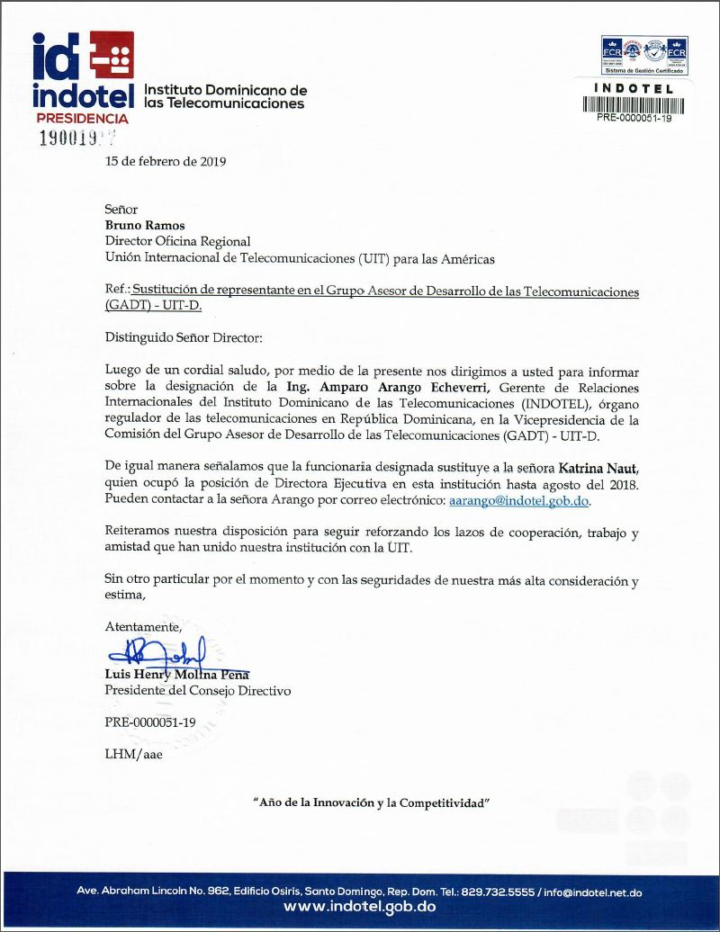

**Translation**

INDOTEL – Instituto Dominicano de las Telecomunicaciones

Presidency

15 February 2019

Mr Bruno Ramos  
Director Regional Office  
International Telecommunication Union (ITU) for the Americas

Subject: **Replacement of the representative in the Telecommunication Development Advisory Group (TDAG) – ITU-D**

Dear Sir,

We would like to present our greetings to you and, through the present letter, inform you of the designation of **Eng. Amparo Arango Echeverri**, Gerente of International Relations in the Instituto Dominicano de las Telecomunicaciones (INDOTEL), the telecommunication regulatory organism in the Dominican Republic, to the vicechairmanship in the Bureau of the Telecommunication Development Advisory Group (TDAG) – ITU-D.

We would like to indicate that the above-mentioned official replaces Ms **Katrina Naut**, who occupied the post of Executive Director in this institution until August 2018. You may contact Ms Arango by E-mail: [aarango@indotel.gob.do](mailto:aarango@indotel.gob.do).

We reiterate our willingness to continue reinforcing the cooperation, work and friendship ties that have always tied our institution to ITU.

May we present the assurance of our highest consideration and appreciation.

Yours faithfully,

[signed]

Luis Henry Molina Peña  
President of the Directing Council

PRE-0000051-19

LHM/aae



