|  |  |
| --- | --- |
| **Telecommunication Development Advisory Group (TDAG)**  **24th Meeting, Geneva, 3-5 April 2019** | C:\Users\comas\AppData\Local\Temp\Rar$DRa0.735\jpg\ITU official logo_blue_RGB.jpg |
|  |  |
|  | **Document** **TDAG-19/****7-E** |
|  | **18 March 2019** |
|  | **English only** |
| Director, Telecommunication Development Bureau | |
| Appointment of two Vice-Chairmen of TDAG | |
|  | |
| **Summary:**  The Dominican Republic and Kyrgyzstan have submitted nominations of two candidates to the posts of vice-chairmen to replace Ms Katrina Naut (Dominican Republic) and Ms Nurzat Boljobekova (Kyrgyzstan), respectively.  **Action required:**  TDAG is invited to review this document and take a decision concerning the appointment of the two new vice-chairmen as deemed appropriate.  **References:**  No. 244 of Convention, WTDC Resolution 1 (Rev. Buenos Aires, 2017) and 61 (Rev. Dubai, 2014) | |

This document contains the letters from the administrations of the Dominican Republic and Kyrgyzstan, submitting the nominations of Ms Amparo Arango and Ms Aichurok Maralbek Kyzy, as candidates to the position of TDAG Vice-Chairman.

Both CVs are available in **Annexes 1** and **2**, respectively.

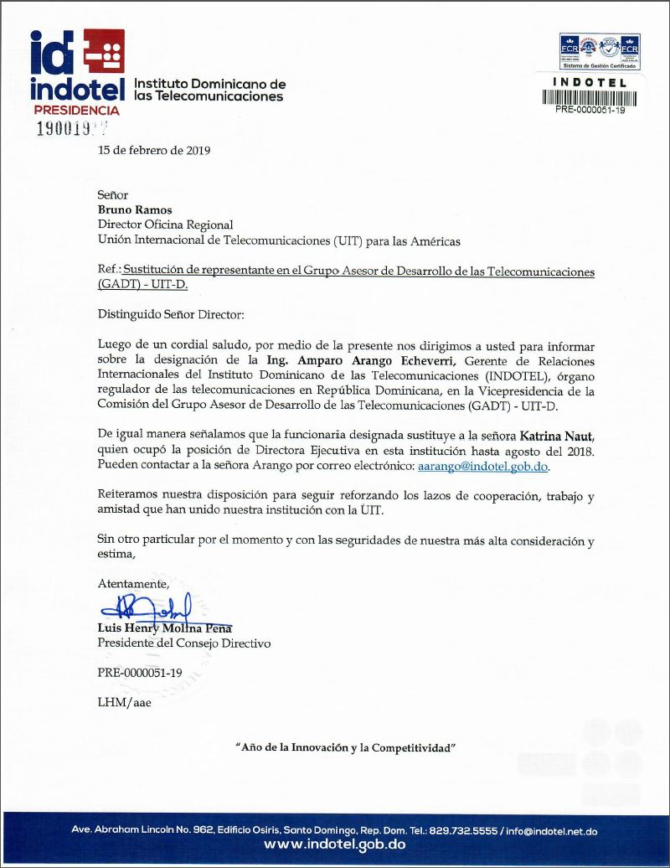

**Translation**

INDOTEL – Instituto Dominicano de las Telecomunicaciones

Presidency

15 February 2019

Mr Bruno Ramos  
Director Regional Office  
International Telecommunication Union (ITU) for the Americas

Subject: **Replacement of the representative in the Telecommunication Development Advisory Group (TDAG) – ITU-D**

Dear Sir,

We would like to present our greetings to you and, through the present letter, inform you of the designation of **Eng. Amparo Arango Echeverri**, Gerente of International Relations in the Instituto Dominicano de las Telecomunicaciones (INDOTEL), the telecommunication regulatory organism in the Dominican Republic, to the vicechairmanship in the Bureau of the Telecommunication Development Advisory Group (TDAG) – ITU-D.

We would like to indicate that the above-mentioned official replaces Ms **Katrina Naut**, who occupied the post of Executive Director in this institution until August 2018. You may contact Ms Arango by E-mail: [aarango@indotel.gob.do](mailto:aarango@indotel.gob.do).

We reiterate our willingness to continue reinforcing the cooperation, work and friendship ties that have always tied our institution to ITU.

May we present the assurance of our highest consideration and appreciation.

Yours faithfully,

[signed]

Luis Henry Molina Peña  
President of the Directing Council

PRE-0000051-19

LHM/aae



