**Annex 1 to document TDAG-19/7**

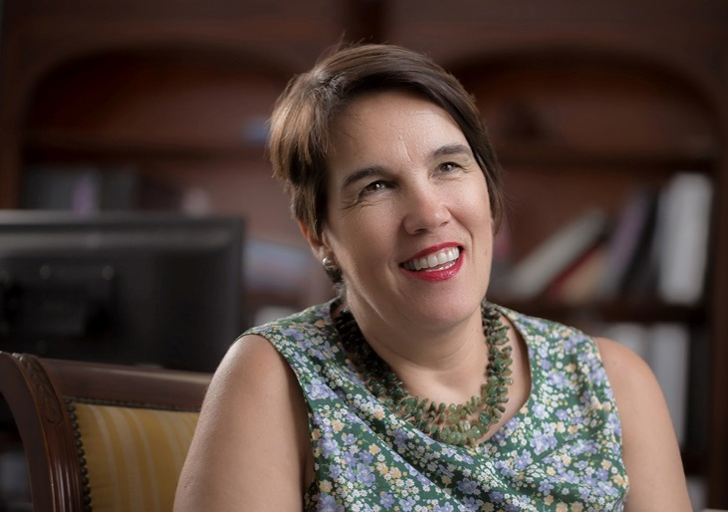**Ms Amparo Arango Echeverri**

**Correo electrónico:** [**aarango@indotel.gob.do**](mailto:aarango@indotel.gob.do)

**Dominican Institute of Telecommunications (INDOTEL)**

Social Worker and Systems Engineer with a degree in Information Technology Applied Business from the Polytechnic University of Madrid.

Currently Director of International Affairs of INDOTEL and member of the Chapter of the Internet Society of the Dominican Republic since January 2015.

She was coordinator of the Dominican Interchange Network for Development, pioneer in capacity building in NGOs and research centers on the use of new technologies in the early years of the start of the Internet in the Dominican Republic.

Former technical coordinator of the National Commission for Information Society and Knowledge (CNSIC) of the Dominican Republic.

Research associate at the Research Center for Feminist Action (CIPAF for its acronym in Spanish)

Professional experience in the design, planning and coordination of public policies related to Information Technology and Communication for Development.

Professional experience in elaborating diagnostics on ICTs and comprehensive knowledge of statistical information on the ICT sector at the regional level: Latin-America, Central America and Caribbean.

Professional experience in conducting and evaluation of ICT projects, especially in the social development at national and regional levels.

Extensive professional experience building up networking with governmental, non-governmental organizations and civil society.

Professional experience in the field of social research in gender issues, with emphasis on the use of methodologies and quantitative techniques and research with a gender perspective.

________________