|  |  |
| --- | --- |
| **Telecommunication Development Advisory Group (TDAG)**  **24th Meeting, Geneva, 3-5 April 2019** | C:\Users\comas\AppData\Local\Temp\Rar$DRa0.735\jpg\ITU official logo_blue_RGB.jpg |
|  |  |
|  | **Document** **TDAG-19/****8-E** |
|  | **19 March 2019** |
|  | **English only** |
| Director, Telecommunication Development Bureau | |
| Appointment of A NEW Vice-ChairmAn of ITU-D STUDY GROUP 1 | |
|  | |
| **Summary:**  The Russian Federation has submitted the nomination of Ms Anastasia Sergeyevna Konukhova to the post of Vice-Chairman of ITU-D Study Group 1.  **Action required:**  TDAG is invited to review this document and take a decision concerning the appointment of Ms Konukhova, as deemed appropriate.  **References:**  No. 244 of Convention, WTDC Resolution 1 (Rev. Buenos Aires, 2017) and WTDC Resolution 61 (Rev. Dubai, 2014) | |

This document contains the letter from the Administration of the Russian Federation, submitting the nomination of Ms Anastasia Sergeyevna Konukhova, as candidate to the position of SG1 Vice-Chairman.

The CV is attached in **Annex 1**.

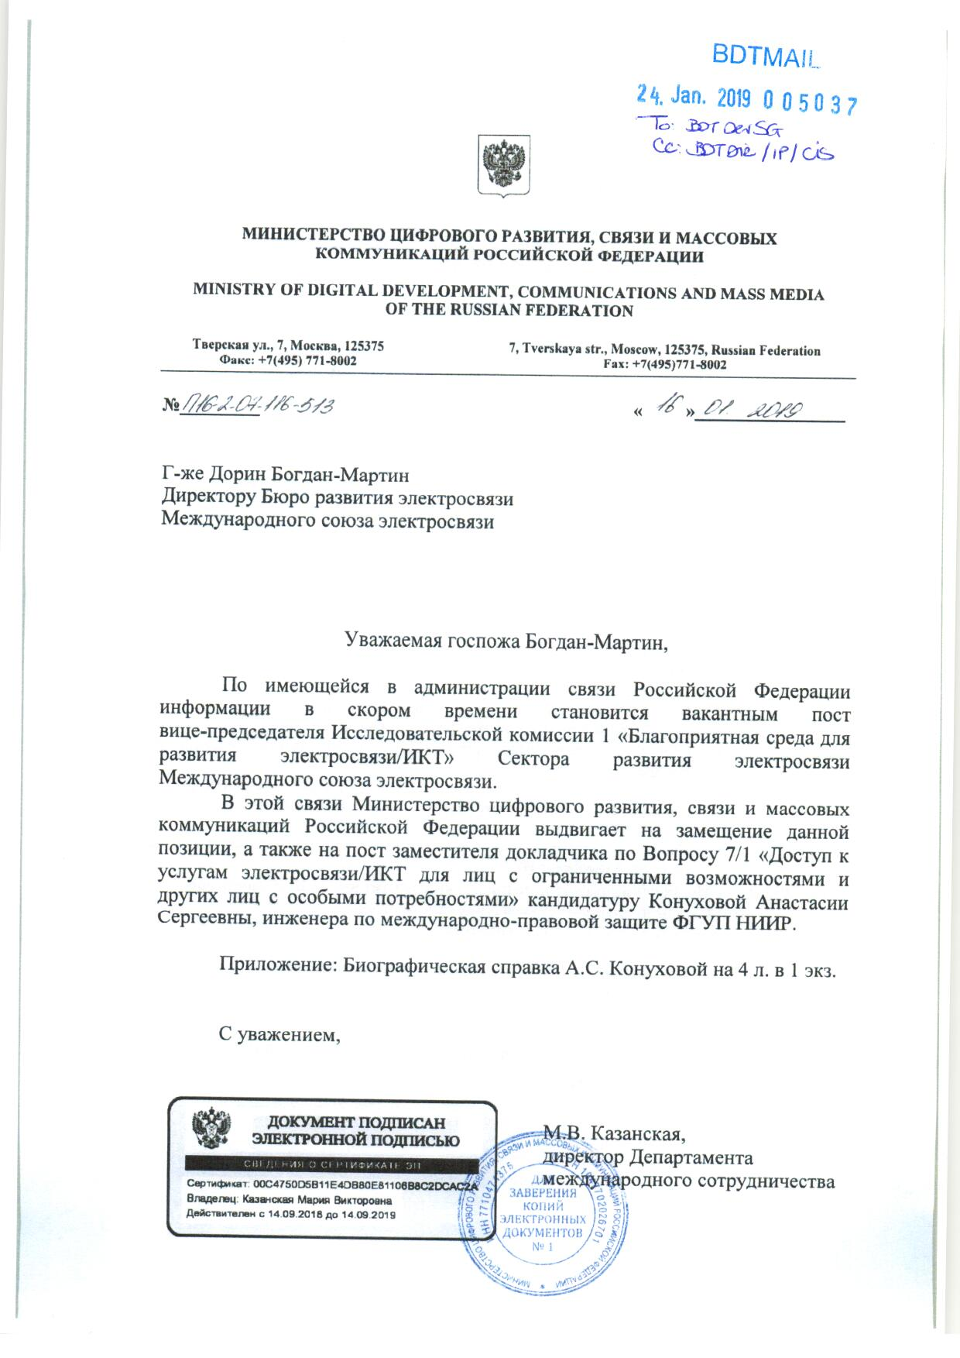

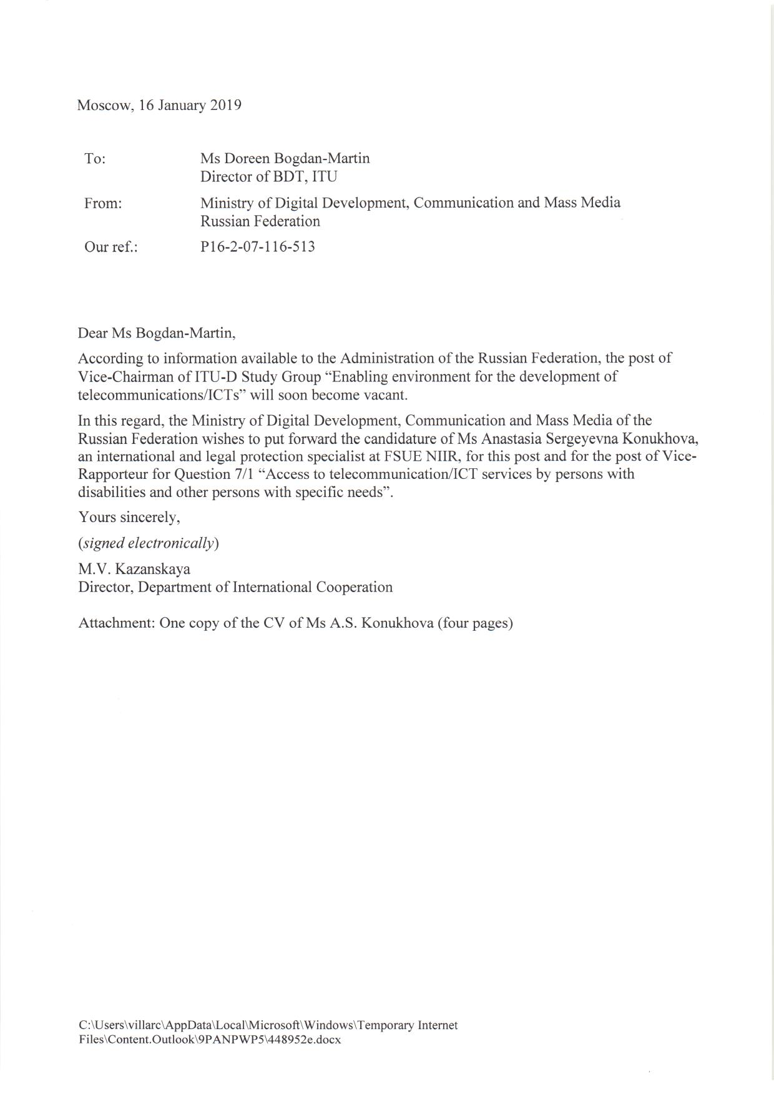

**Annex 1**

