|  |  |
| --- | --- |
| **Telecommunication Development Advisory Group (TDAG)**  **24th Meeting, Geneva, 3-5 April 2019** | C:\Users\comas\AppData\Local\Temp\Rar$DRa0.735\jpg\ITU official logo_blue_RGB.jpg |
|  | **Revision 1 to** |
|  | **Document** **TDAG-19/****8-E** |
|  | **28 March 2019** |
|  | **English only** |
| Director, Telecommunication Development Bureau | |
| Appointment of TWO NEW Vice-ChairmEn of ITU-D STUDY GROUPS | |
|  | |
| **Summary:**  One Vice-Chairman of Study Group 1 and one of Study Group 2, respectively, have stepped down and candidatures have been submitted to replace them.  This document attaches the candidature of Ms Anastasia Sergeyevna Konukhova (Russian Federation), to the post of Vice-Chairman of Study Group 1, and that of Mr Abdelaziz Alzarooni (United Arab Emirates), to the post of Vice-Chairman of Study Group 2.  **Action required:**  TDAG is invited to review this document and take a decision concerning the appointment of the two candidates, as deemed appropriate.  **References:**  No. 244 of Convention, WTDC Resolution 1 (Rev. Buenos Aires, 2017) and WTDC Resolution 61 (Rev. Dubai, 2014) | |

This document contains letters from the Administrations of the Russian Federation and the United Arab Emirates, submitting the nominations of Ms Anastasia Sergeyevna Konukhova, as candidate to the position of SG1 Vice-Chairman, and of Mr Abdelaziz Alzarooni, to the post of SG2 Vice-Chairman.

The CVs are attached in the **Annexes**.

**Letter of Nomination for Ms Anastasia Sergeyevna Konukhova**

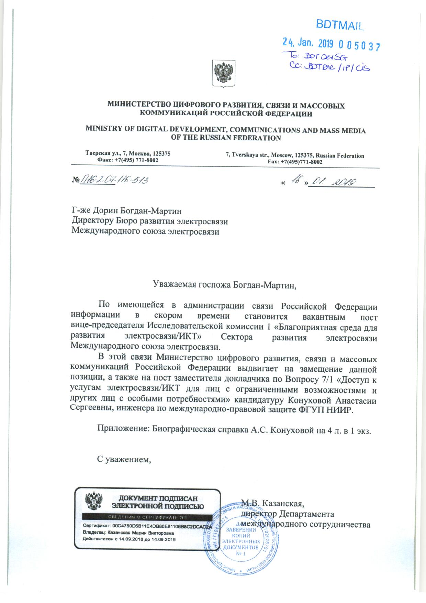

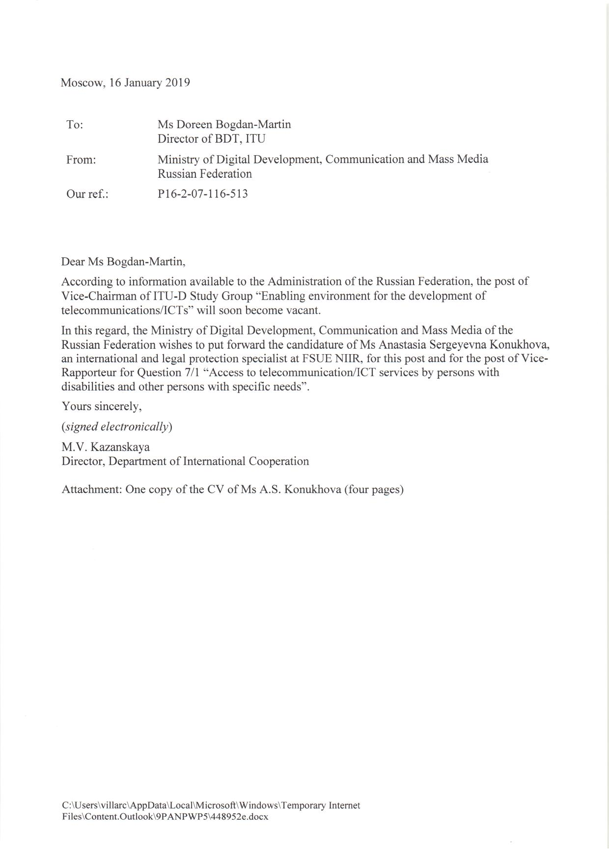

**Letter of Nomination for Mr Abdelaziz Alzarooni**

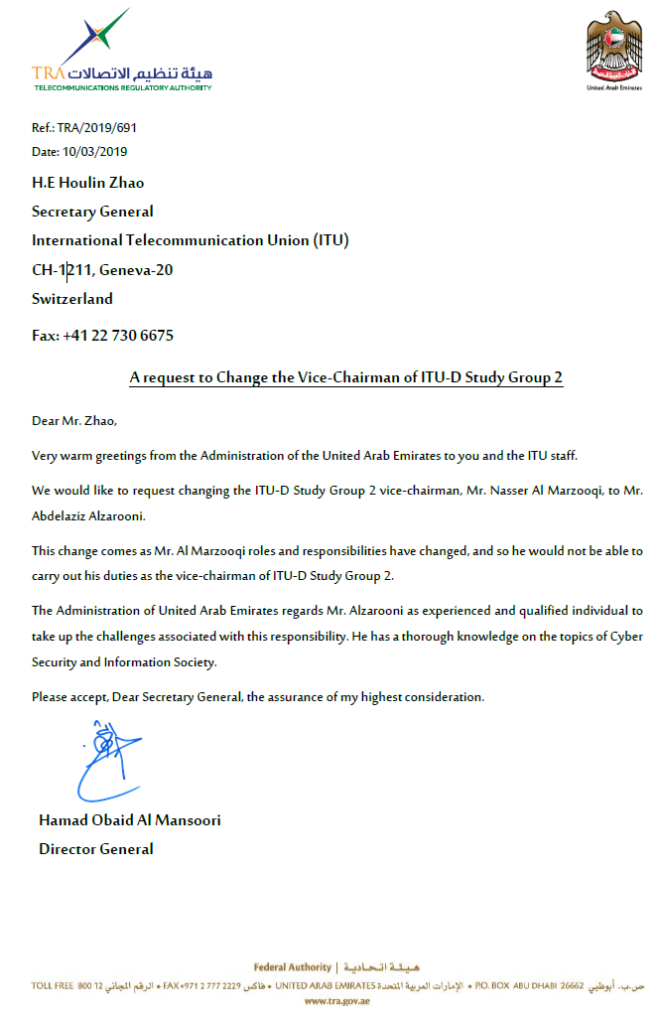

**Annex 1**



