|  |  |
| --- | --- |
| **Telecommunication Development Advisory Group (TDAG)**  **24th Meeting, Geneva, 3-5 April 2019** | C:\Users\comas\AppData\Local\Temp\Rar$DRa0.735\jpg\ITU official logo_blue_RGB.jpg |
|  |  |
|  | **Document** **TDAG-19/****39-E** |
|  | **2 April 2019** |
|  | **English only** |
| Director, Telecommunication Development Bureau | |
| PREPARATIONS FOR THE  WORLD TELECOMMUNICATION DEVELOPMENT CONFERENCE 2021 | |
|  | |
| **Summary:**  This document is to inform TDAG on the preparations for the World Telecommunication Development Conference 2021 (WTDC-21). ITU has received an invitation from the Government of the Federal Democratic Republic of Ethiopia for the hosting of WTDC-21 in Addis Ababa from 13 to 24 September 2021 (see **Annex**).  **Action required:**  TDAG is invited to note this document and provide guidance as deemed appropriate.  **References:**  [*No. 141 of the ITU Constitution*](http://www.itu.int/pub/S-CONF-PLEN-2015)*,* [*No. 42 of the ITU Convention, Chapter I of the General Rules of Conferences, Assemblies and Meetings of the Union*](https://www.itu.int/council/pd/generalrules.html) *and* [*Resolutions 77 (Rev. Dubai, 2018) and 111 (Rev. Busan, 2014)*](https://www.itu.int/dms_pub/itu-s/opb/conf/S-CONF-ACTF-2014-PDF-E.pdf) *of the Plenipotentiary Conference.* | |

**1. Background**

1.1 No. 141 of the ITU Constitution stipulates that there shall be a World Telecommunication Development Conference (WTDC) between two Plenipotentiary Conferences.

1.2 Resolution 77 (Rev. Dubai, 2018) of the Plenipotentiary Conference resolves that WTDC shall be held in the last quarter of 2021.

1.3 Resolution 111 (Rev. Busan, 2014) calls on the Union and its Member States to make every effort, as far as practicable, to ensure that the planned period of any ITU conference does not conflict with what may be considered a major religious period by a Member State.

# 2. Place, duration and dates for WTDC-21

2.1 No. 42 of the ITU Convention and Chapter I of the General Rules of Conferences, Assemblies and Meetings of the Union require, respectively, that, in the absence of a decision by the Plenipotentiary Conference, the precise place and the exact dates of a WTDC be approved by the Council with the concurrence of a majority of the Member States and that this information be included in the invitation letter to be sent to members at least one year before the opening of the conference.

2.2 ITU has received an invitation from the Government of the Federal Democratic Republic of Ethiopia for the hosting of WTDC-21 in Addis Ababa from 13 to 24 September 2021 (see **Annex**). Consultations are under way in order to agree on the requirements for holding this conference outside Geneva. This information is submitted to the Council (Geneva, 10-20 June 2019) for approval of the above place and dates in accordance with No. 42 of the ITU Convention. TDAG is invited to note this document and provide guidance as deemed appropriate.

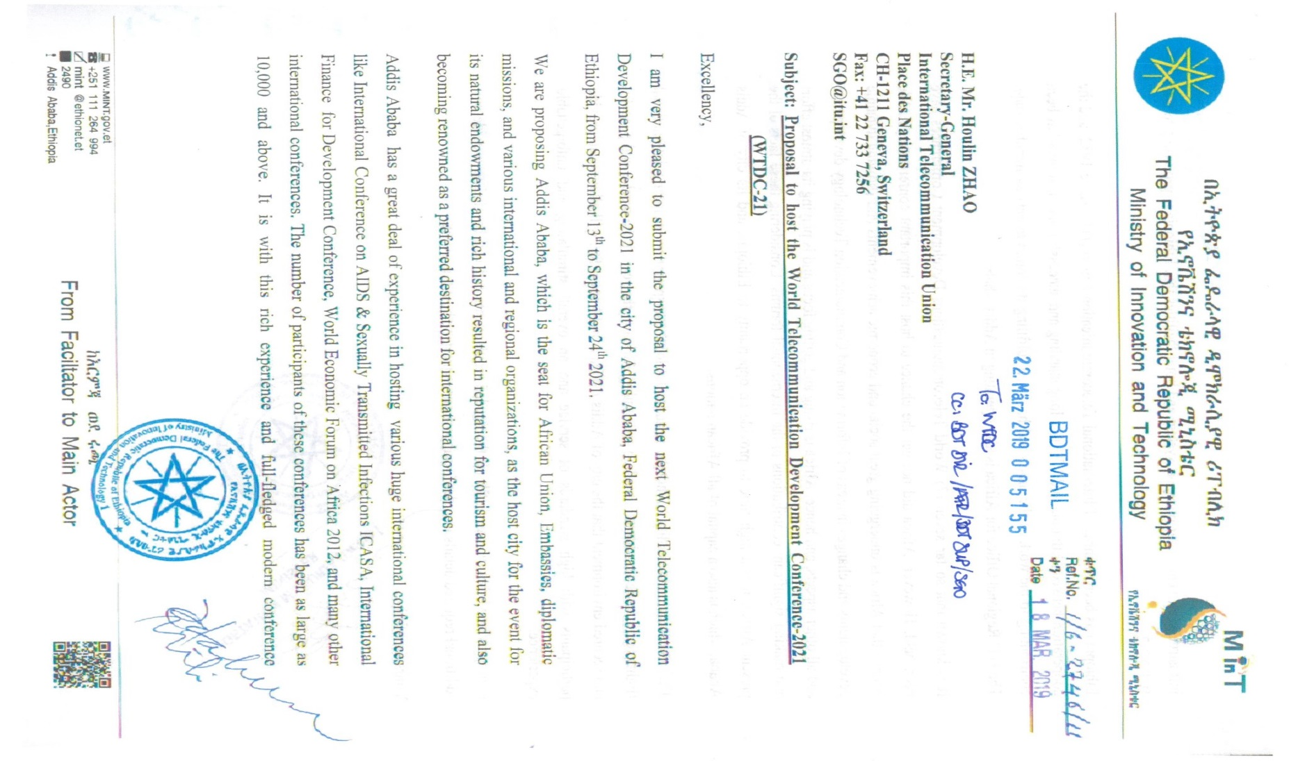**Annex  
Invitation from the government of the Federal Democratic Republic of Ethiopia   
to host WTDC-21**

