|  |  |
| --- | --- |
| **Telecommunication Development Advisory Group (TDAG)**  **25th Meeting, Geneva, 2-5 June 2020** | C:\Users\comas\AppData\Local\Temp\Rar$DRa0.735\jpg\ITU official logo_blue_RGB.jpg |
|  |  |
|  | **Document** **TDAG-20/****55-E** |
|  | **20 May 2020** |
|  | **English only** |
| Chairman, ITU-D Study Group 2 | |
| Appointment of a NEW co-rapporteur in ITU-D STUDY GROUP 2 | |
|  | |
| **Summary:**  A Co-Rapporteur for ITU-D Study Group 2 (SG2) Question 3/2 (“Securing information and communication networks: Best practices for developing a culture of cybersecurity”) has stepped down since the last ITU-D SG2 annual meeting (24-28 February 2020, Geneva, Switzerland). A new candidature has been submitted to fill the position.  Given that the next and last ITU-D SG2 annual meeting of this study period is planned in March 2021, there is no possibility until then for ITU-D SG2 to consider this new candidature for a possible appointment. This issue is therefore brought to the attention of TDAG, so that as the the parent group, it can take a decision concerning the appointment of the new candidate, as deemed appropriate.  This document attaches the candidature of Ms Aimee K. Meacham (United States of America) to the post of Co-Rapporteur for ITU-D SG2 Question 3/2.  **Action required:**  TDAG is invited to review this document and take a decision concerning the appointment of the new candidates, as deemed appropriate.  **References:**  WTDC Resolution 2 (Rev. Buenos Aires, 2017), Resolution 1 (Rev. Buenos Aires, 2017) | |

This document contains a letter from the Administration of the United States of America, submitting the nomination of Ms Aimee K. Meacham, as a candidate to the position of Co-Rapporteur for ITU‑D Study Group 2 Question 3/2.

The CV of the candidate is attached in the **Annex**.

# Letter of Nomination for Ms Aimee K. Meacham

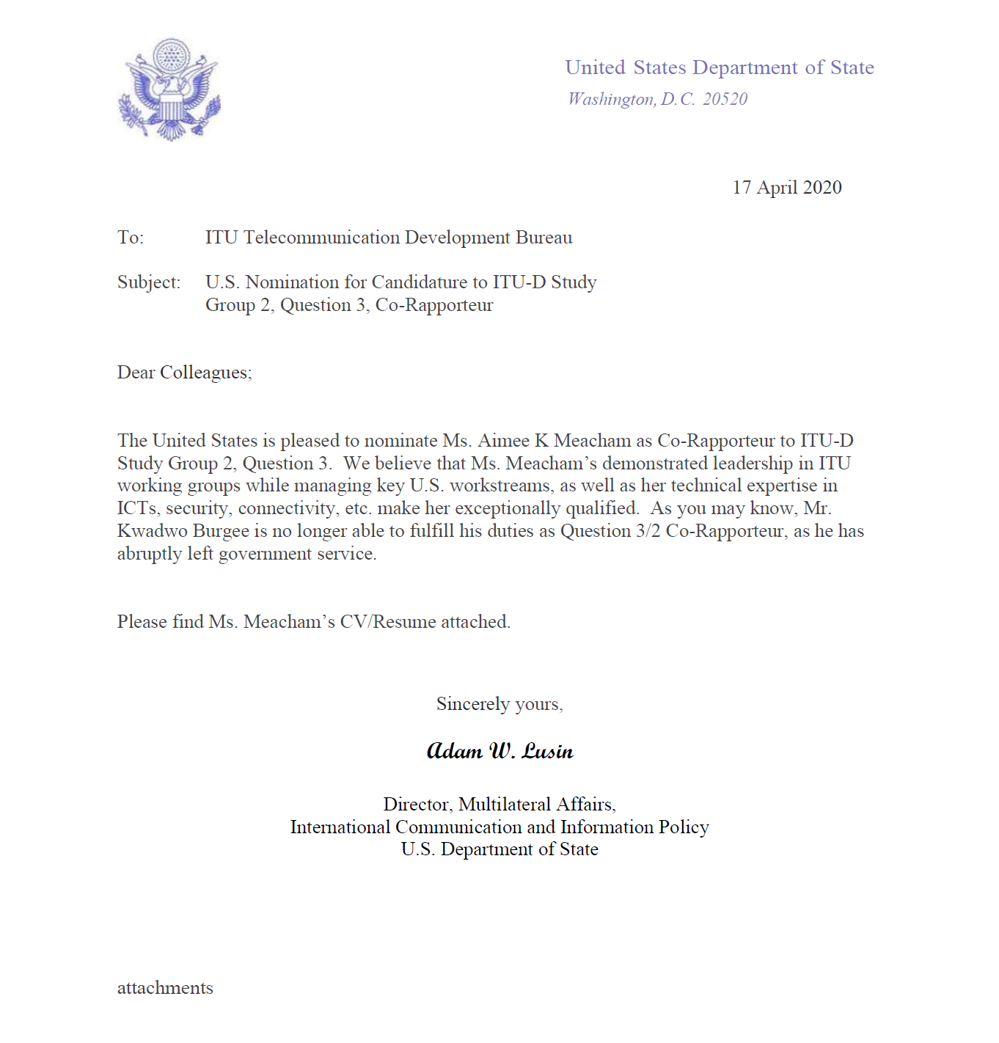

**Annex 1**

**CV of Ms Aimee K. Meacham**



