Telecommunication Development  Advisory Group (TDAG)  31st Meeting, Geneva, Switzerland, 20-23 May 2024 | 
 | Document TDAG-24/42-E
 | 8 May 2024
 | English only
Czech Republic, Poland
Human-Centric Approach for Digital Transformation
Summary:
This document provides an update on the results achieved via a special initiative focusing on Human Centric Digital Transformation, in particular the Compendium and its recommendations that were developed upon a series of national experiences shared by fourteen European countries. In the pursuit of the Sustainable Development Goals, societies and economies increasingly embrace digitalization. However, it is crucial to place humans at the heart of all aspects of digital development, from design to deployment. Thereby, a human centric approach for digital transformation wins an important meaning and requires a special attention of all stakeholders involved in building our digital future.
Action required:
TDAG is invited to note the document and provide the guidance as appropriate.
References:
WTDC-22 Resolution 17 (Rev. Kigali, 2022)

Background
In the pursuit of the Sustainable Development Goals, societies and economies increasingly embrace digitalization. However, it is crucial to place humans at the heart of all aspects of digital development, including design processes and measures as well as deployment.
In this context, a special initiative on human-centric digital transformation was proposed by the Czech Republic and Republic of Poland during the ITU Regional Development Forum for Europe (RDF-EUR), which served as a platform for dialogue and exchange of views between ITU officials, decision-makers of ITU Member States and Sector Members, and other stakeholders across the European region.
This initiative aimed to enhance the understanding of human by design digital features, which takes into consideration how technology impacts people's lives and aligns digital innovations with societal values and norms.
The Spotlight Series, which served as a key element of this initiative, was rolled out by the ITU Office for Europe in cooperation with all countries of the European Region, and comprised of 3 workshops showcasing concrete, hands-on examples of human-centric digital transformation projects in Europe, e.g., in the areas of government services, education, or health.
Insights of practitioners from Albania, Czechia, Estonia, France, Georgia, Hungary, Latvia, Lithuania, Moldova, Poland, Serbia, Slovenia, Spain and Ukraine informed a Human-Centric Digital Transformation Compendium.
While pinpointing challenges, opportunities and emerging trends in the field, the Compendium gathered best practices, recommendations and actionable, concrete guidelines for Governments and ICT Stakeholders on strengthening human-centric approaches in digital development in Europe and beyond. It also offers a checklist, to support Governments and ICT Stakeholders, regardless of which stage of human-centric digital transformation their project or programme has already achieved (see annex for the checklist).
This initiative culminated with the "Human Centric Approach to Digital Transformation" side event of the Regional Forum on Sustainable Development for the UNECE Region resulting in a call by the RFSD as follows: ‘A human-centric approach should be at the core of digital development. Fostering digital inclusion and providing new opportunities and easy access to services to disadvantaged groups of society requires special attention. Consideration should be given to the needs of people with disabilities.’
This initiative helped nurture more exchange on this topic and insights will aim to inform future digital development strategies both within the region and globally and help advance the various SDGs. More work in this field is required to ensure fully inclusive digital future. Therefore, ITU is invited to continue its work in this field, and all stakeholders are called upon to engage, sharing their experiences through multi-stakeholder dialogues, improving common understanding of the importance of this issue.

Annex: Human Centric Approach to Digital Transformation Checklist
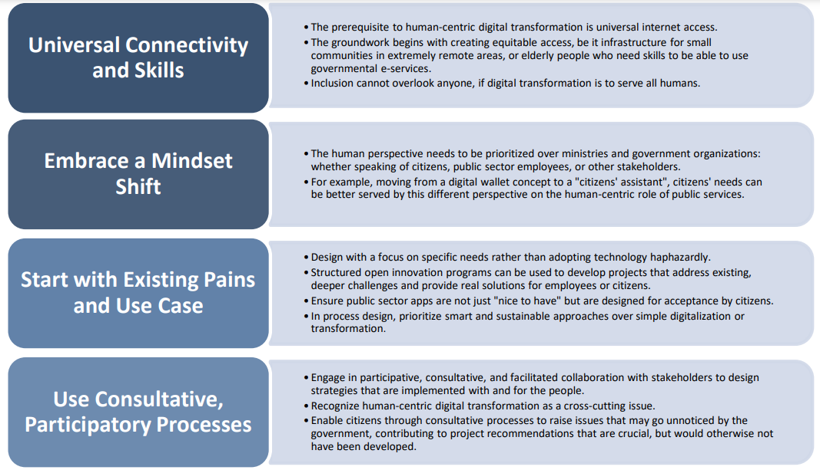
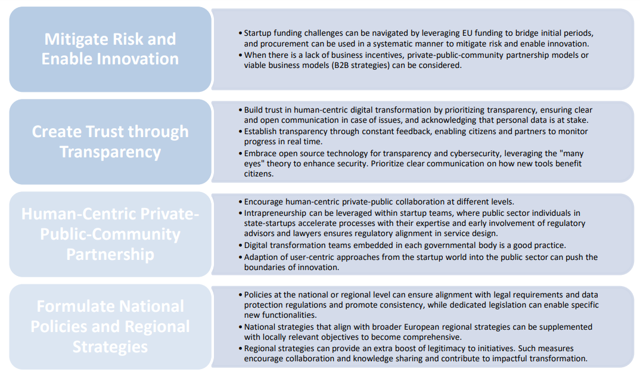
_______________

https://www.itu.int/en/ITU-D/Regional-Presence/Europe/Documents/Events/2023/0522-23%20-%20RDF/Submissions/EUR%202/Human-centered-approach-digital-development_RDF-EUR-2023-Submission.pdf
https://www.itu.int/en/ITU-D/Regional-Presence/Europe/Pages/Events/2023/Spotlight%20Series%20on%20Human-Centric%20Digital%20Transformation/Spotlight-Series-on-Human-Centric-Digital-Transformation.aspx
https://www.itu.int/en/ITU-D/Regional-Presence/Europe/Documents/Events/2024/03.11_Human%20Centric/Compendium_%20Human-Centric%20Digital%20Transformation.pdf

