Conference Proposals Interface (CPI)

TDAG17-22 User guide

Table of contents
Contents
Table of contents 1
1. CPI overview 2
2. Logging on 3
3. Languages 3
4. Searching the authoritative texts 3
5. Preparing a baseline document (“skeleton”) 5
5.1 Proposal types 5
5.2 Selecting and stacking your proposals 6
5.3 Re-ordering proposals 7
5.4 Removing a proposal 8
5.5 Action ADD 8
6 Saving your skeleton and producing a baseline Word file 8
6.1 Selecting sources 9
6.2 Example of the resulting Word document for a skeleton created in CPI 9
6.3 Example of email notification received after the saving of a skeleton created in CPI 10
7 Loading a previously saved skeleton 10
8 Finalizing your MS Word document 11
9 Submitting proposals to ITU 11
9.2 Submitting proposals using CPI 11
9.2 Example of a confirmation of submission email 12

1. CPI overview
The work of the World Telecommunication Development Conference 2017 (WTDC-17) and that of the Regional Preparatory Meetings leading to it is driven by proposals from ITU Member States, regional organizations and ITU-T Sector Members. A significant number of proposals are either changes to in-force Resolutions and Recommendations, new versions of texts that were approved at the last conference such as the Regional Initiatives and Study Group Questions, or modifications of base texts already under discussion by Membership such as the draft ITU-D contribution to the Strategic Plan 2020-2023, the draft Buenos Aires Action Plan or the draft WTDC-17 Declaration.
The Conference Proposals Interface (CPI) is a web-based tool that assists in the preparation of proposals by creating a clean baseline document (a “skeleton”) upon which proposed modifications can be indicated. CPI will be familiar to those who have submitted proposals to other major ITU events like the ITU Plenipotentiary Conference 2014 (PP-14), the World Radiocommunication Conference 2015 (WRC-15), or the World Telecommunication Standardization Assembly 2016 (WTSA-16).
CPI is now additionally being made available to delegations submitting proposals on those same authoritative texts to TDAG17-22.
Key terms:
- Authoritative texts: - WTDC-14 approved Resolutions
- WTDC-14 approved Recommendations
- WTDC-14 approved Regional Initiatives
- WTDC-14 approved Study Group Questions
- Preliminary draft ITU-D contribution to the Strategic Plan 2020-2023, further to the consultation by TDAG CG-SPOPD
- Preliminary draft Buenos Aires Action Plan, further to the consultation by TDAG CG-SPOPD
- Preliminary draft WTDC-17 Declaration, further to the consultation by TDAG CG-SPOPD
- Skeleton: Those provisions from the authoritative texts that have been selected by a submitter as a baseline for proposed modifications. Once a skeleton has been created using CPI, the system generates a corresponding Word file in the correct format.
- Proposal: A Contribution to TDAG17-22 or to WTDC-17 suggesting changes to the authoritative texts. Proposals should be based on the World file created by CPI, updated to indicate the desired modifications (using “track changes” where needed – see clause 5 below).
Useful addresses and contact details:
- CPI
- CPI resource webpage
- Secretariat for TDAG17-22 documents: bdtdocscontrol@itu.int
- WTDC-17 Secretariat: wtdc.documentcontrol@itu.int.

2. Logging on
To log on, navigate to https://www.itu.int/net4/Proposals/CPI/TDAG22/Main, and enter your TIES username and password, then click “Sign in”.
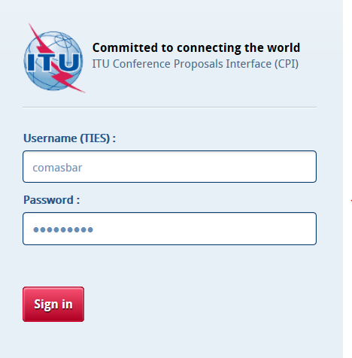

3. Languages
Your default TIES language will be used unless you select a different one from the options at the top of the screen.
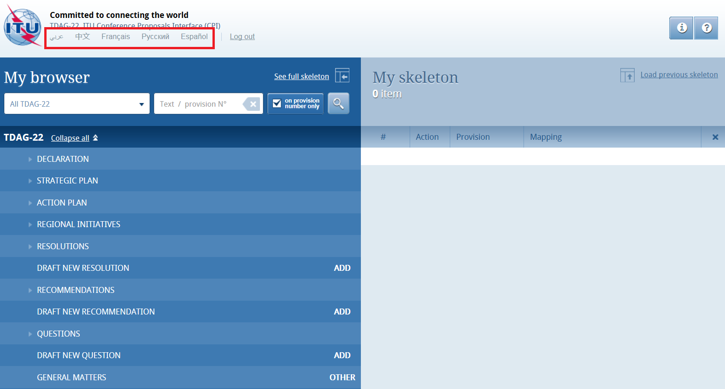

4. Searching the authoritative texts
You may search for key words/strings of words using “My browser”. Searches can be performed on the entire collection of texts or on a selected volume: simply select Strategic Plan, Resolutions, Regional Initiatives, etc.
Additionally, you may search only within the titles of the provisions/individual items, when “On provision number only” is ticked, or within the content of the entire document when it is unticked.
Or you may decide to use the “wild card” (“*”) for your search, either at the start of the search sentence, in the middle or at the end.
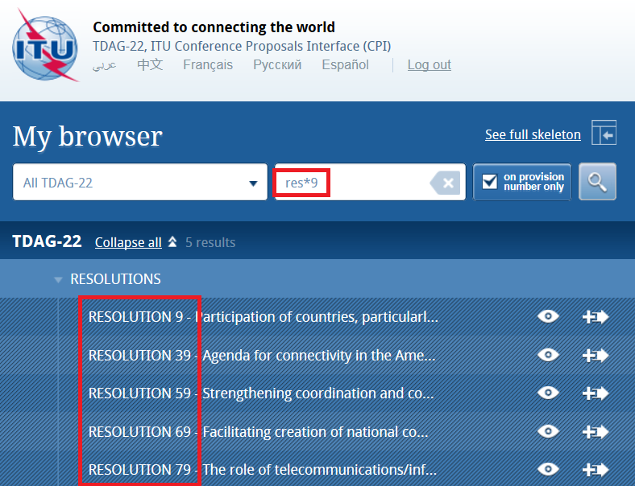
By clicking on the small arrows before the titles, you can expand the sub-sections and further browse the list.
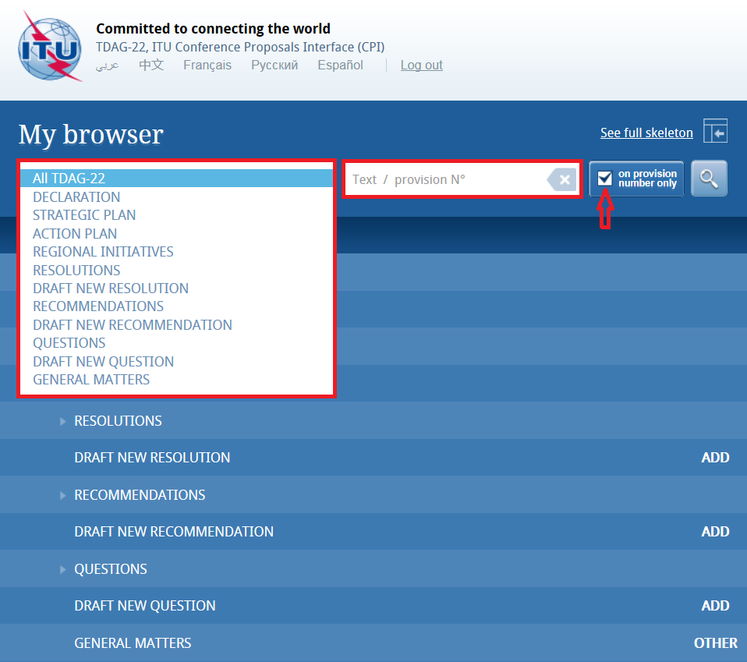
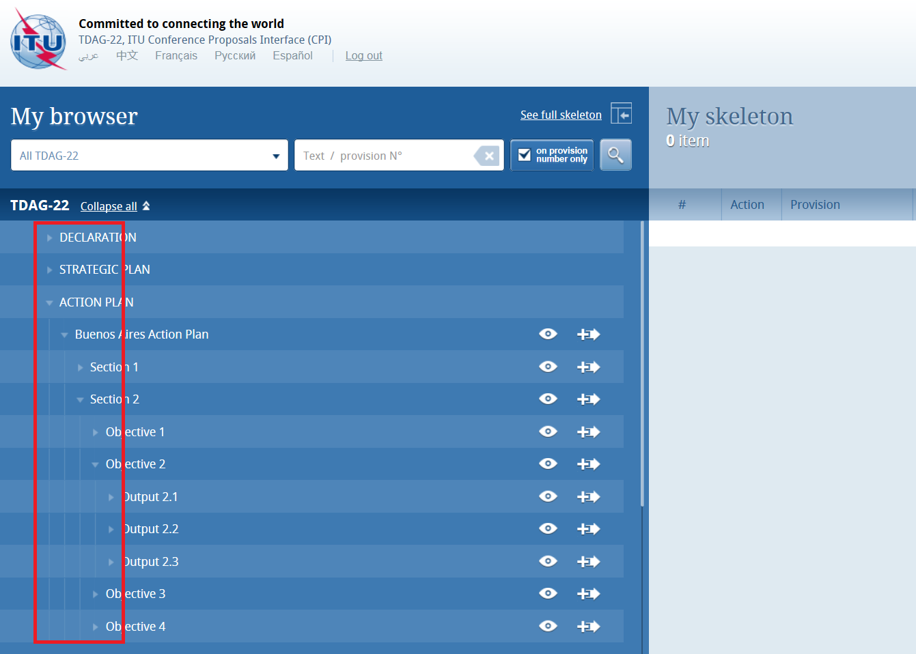You may check the content of a provision by clicking on the “eye” icon. You may also create a Word file from any provision you check.
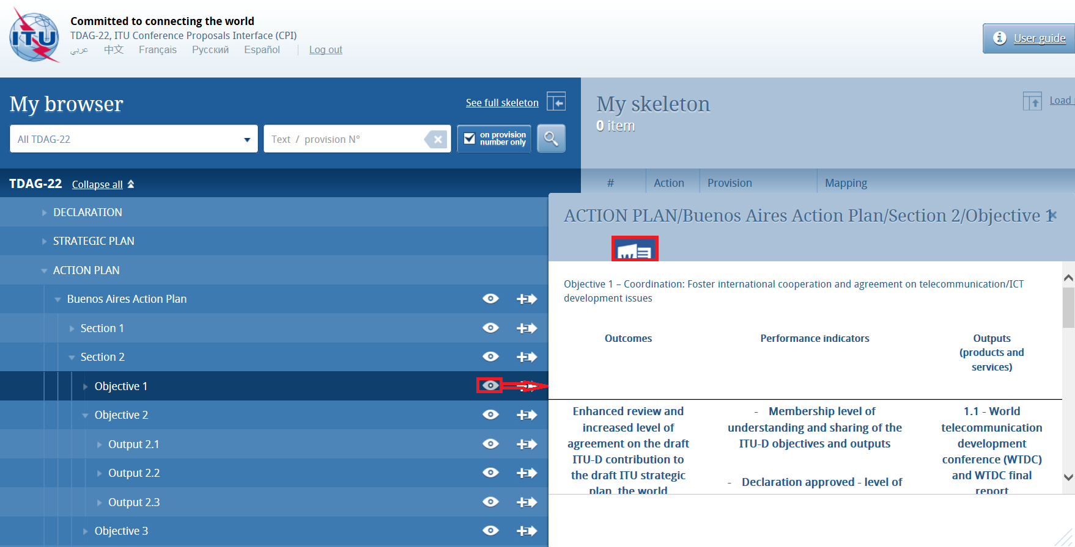

5. Preparing a baseline document (“skeleton”)

5.1 Proposal types
Each individual proposal will use one of the following “Actions”:
ADD (add) – Proposal to add a new provision, i.e. a draft new WTDC Resolution or Recommendation, Study Group Question, Regional Initiative, Strategic Plan, Action Plan or Declaration. You may not apply ADD at a lower level, as that would be considered modifying existing text and MOD would then apply.
Note: No “track changes” should be used.
ADD* - Proposal to add existing text from elsewhere.
Note: It is necessary to reproduce the texts carrying the symbol ADD*.
MOD (modify) – Proposal to modify an existing provision, i.e. adding, deleting or replacing words or figures.
Note: To modify the text, “track changes” should be turned on (Deleted text should appear as strikethrough and added text should appear as underlined).
(MOD) – Proposal to amend a text, from an editorial point of view only
Note: To modify the text, “track changes” should be turned on (Deleted text should appear as strikethrough and added text should appear as underlined).
SUP (suppress) – Propose to delete a provision. To be used only at the provision level, as is the case with ADD.
Note 1: It is not necessary to reproduce text carrying the symbol SUP.
Note 2: Where text is to be deleted from within a provision, the symbol MOD should be used.
SUP* - Proposal to transfer text elsewhere
Note: It is not necessary to reproduce text carrying the symbol SUP.
NOC – Text for which no change is proposed. This symbol may be used to clarify that no proposals are made with respect to a particular text.
Note: It is not necessary to reproduce text carrying this symbol.
NOC – Proposal for text to be maintained without change. This symbol may be used together with a proposal number to emphasize that a particular provision or provisions should remain unchanged. Normally the reasons should be provided.
OTHER – Proposal on general matters not included above.

5.2 Selecting and stacking your proposals
To create a skeleton, identify the first provision that you wish to modify, then click on the icon to select it and apply the associated Action to make a proposal. Note that you may “ADD” only at the level of Resolutions, Recommendations or Question (draft new xxx); and that you may use the other “Actions” at the level of individual provisions.
By clicking on the “Actions“ button in the top right-hand corner (if you have a small screen it may appear only as a question mark), you will be able to see a description of each Action type.
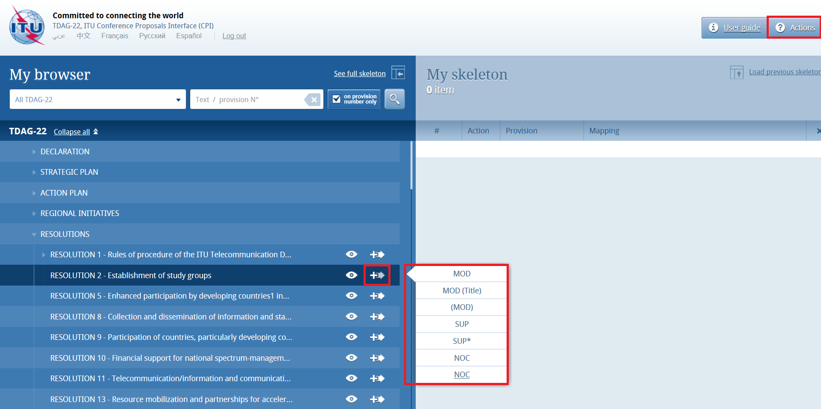
The selected provision and the associated Action will then appear under “My skeleton”. Repeat this process until all provisions have been added to your skeleton.
By default, a “reduced” skeleton is displayed. Click on “See full skeleton” to see all the information available.
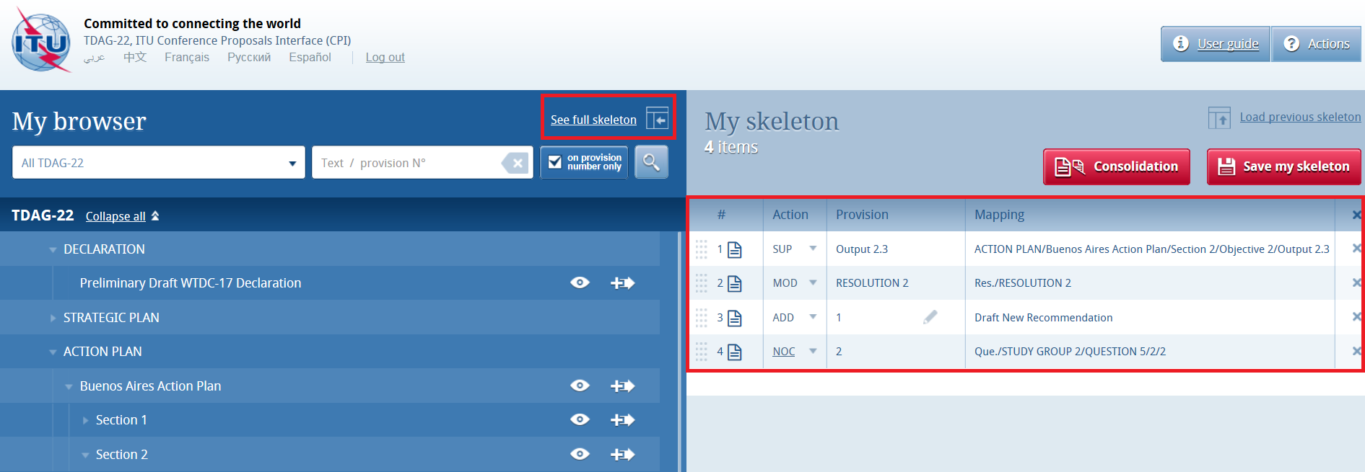
In the full skeleton, a “Reasons” clause will be added automatically immediately after each proposal by default. To remove the “Reasons” clause, unclick “Display reasons” from the full skeleton mode:
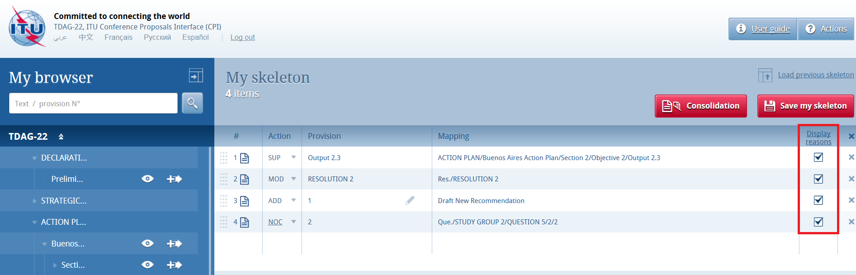
Your skeleton is now ready to be downloaded in any of the six languages.

5.3 Re-ordering proposals
Should you wish to re-order selected provisions, click on the grey squares and drag-and-drop the selected provisions.
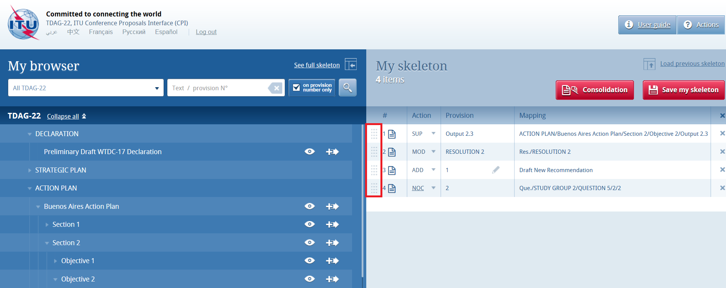

5.4 Removing a proposal
To remove a proposal from your skeleton, click on the icon located on the same row as the proposal to be removed; to remove all proposals from your skeleton, click on the icon in the header of the table.
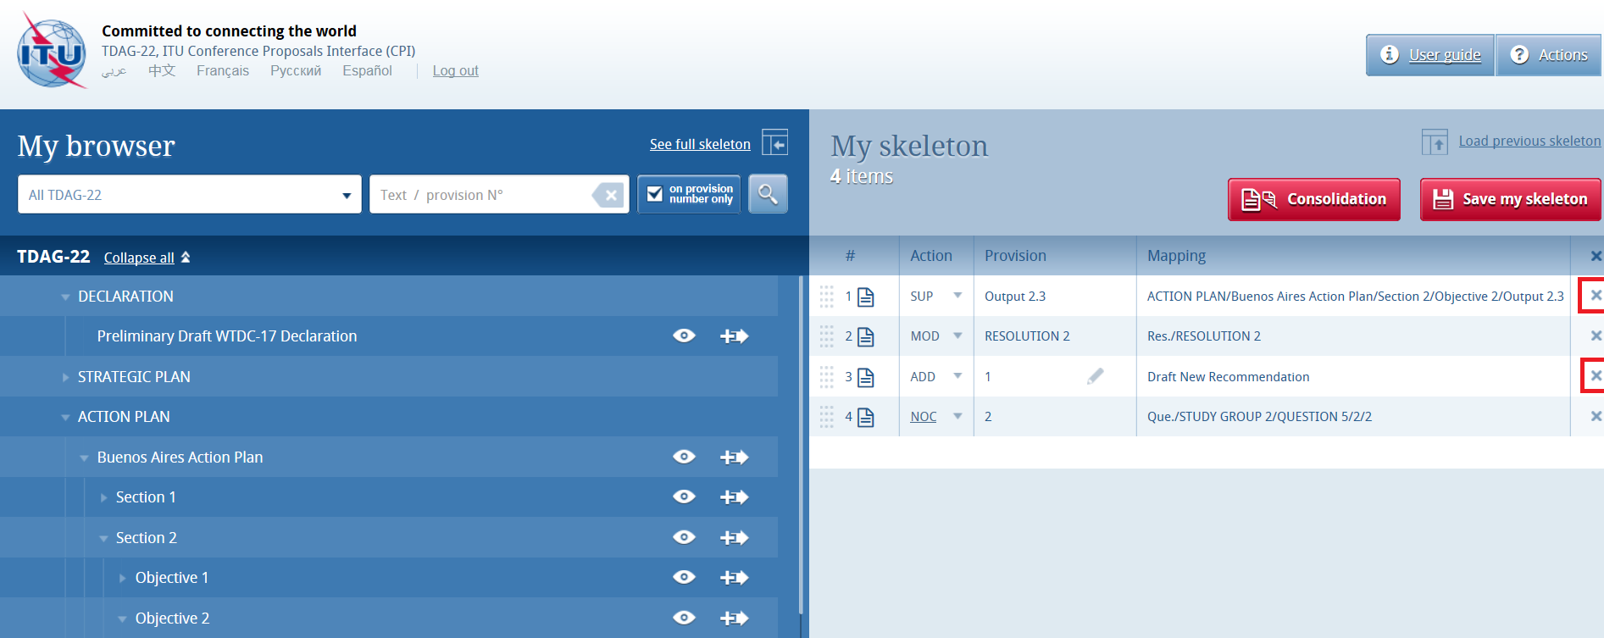

5.5 Action ADD
When you choose to create a new provision (new resolution, recommendation, SG Question or new Regional Initiative), the system automatically proposes a temporary provision letter. You may modify the title at this stage or later, once the proposal has been stacked by clicking on the icon. Now please proceed to stack your proposal.
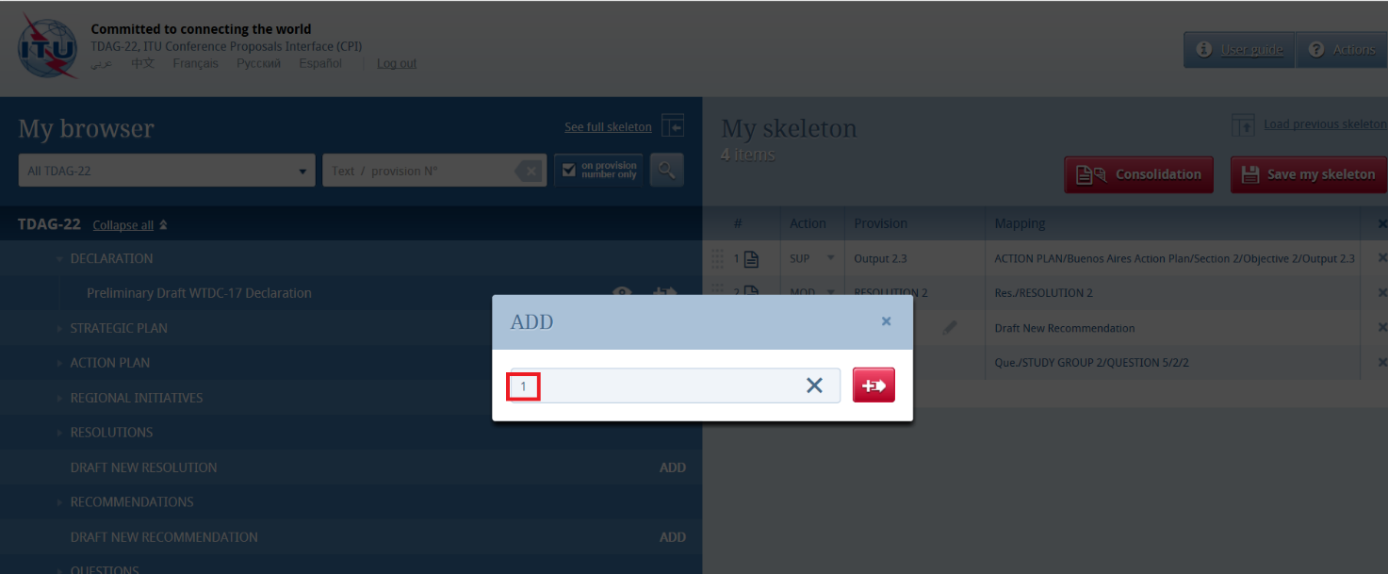

6 Saving your skeleton and producing a baseline Word file
Important: Since CPI is a web interface, do not forget to save your skeleton before leaving the application if you wish to retrieve it later.
The act of saving will generate a baseline Word file in any one of the six official ITU languages. The system will also email a copy of this file to your TIES email or your TIES forwarding address. In order to check or update your TIES email forwarding address, go to: http://www.itu.int/TIES and click on “Edit my account”, then review the information highlighted below.

6.1 Selecting sources
Upon saving your skeleton, select the source(s) of the proposal(s). Either of the following may be selected:
- The Member State associated to your TIES account;
- The Regional Group to which your Member State is associated, to create common proposals (only shown if you have been designated as coordinator for a regional group);
- Co-signatories
- Sector Member.
Now click on “Save my skeleton” to create the MS Word file which will open on your computer as well as being e-mailed to you (see below). CPI will assign a provisional number for your proposal(s). It will also assign a unique ticket number that can be found in the e-mail notification.
The output Word file should be used as the basis of your proposal(s).

6.2 Example of the resulting Word document for a skeleton created in CPI
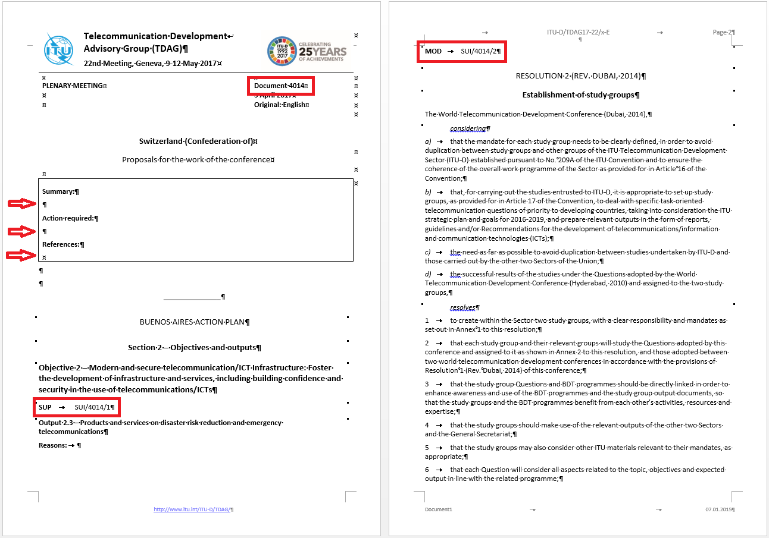
- The system has given your document a provisional number. This number will be replaced by a final contribution number under which it will be published, once submitted to ITU.
2. Please complete the “Summary” and “Action required” fields with short paragraphs not exceeding 250 words each. Under “References”, please provide any ITU documents related to the one submitted (prior version, parent document, etc.).
3. Each of your proposals will carry an identification code. In this case, MOD SUI/4037/1.
a) the first proposal is a SUP, a suppression of an existing provision and the second one is a MOD, a modification of an existing provision
b) SUI: The submitting Member State is Switzerland
c) 4037: is the provisional number of your document. As is the case with the document number in the header, this number will be replaced before publication by the final contribution number
d) 1 and 2: These are the first and second proposals, respectively, within this document

6.3 Example of email notification received after the saving of a skeleton created in CPI
The email notification includes a copy of the skeleton Word file and hyperlinks to CPI in order to allow for easier modification of the skeleton or submission of the proposal.
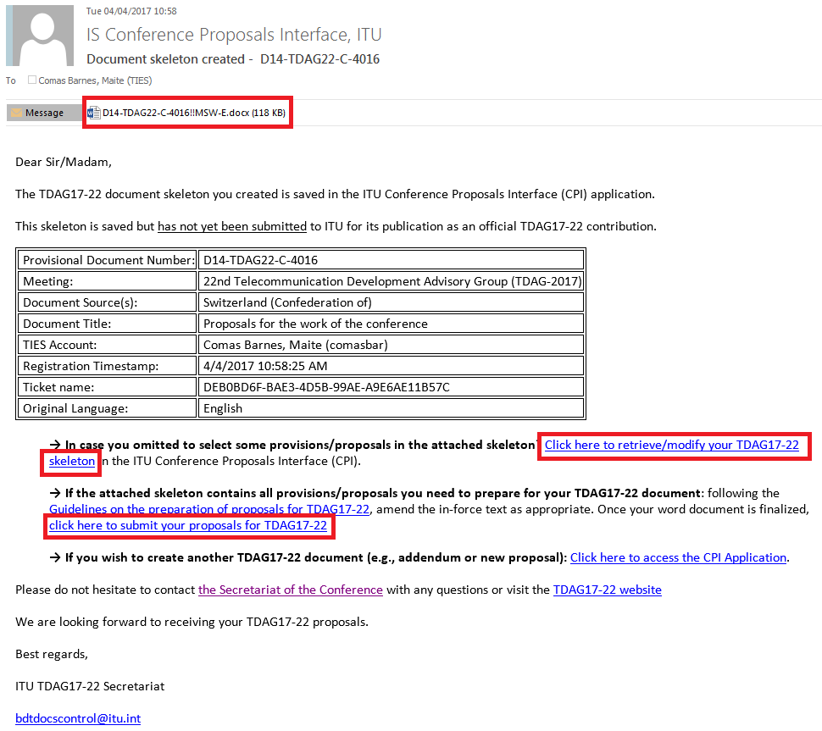

7 Loading a previously saved skeleton
If you wish to change the baseline text for your proposal(s), you may load and then modify skeletons previously saved in CPI before creating a new Word file.
To load a previously saved skeleton, either click the link in the email (see above), or click the “Load previous skeleton” button in the CPI interface. You may then select or delete any of the skeletons that you previously created.
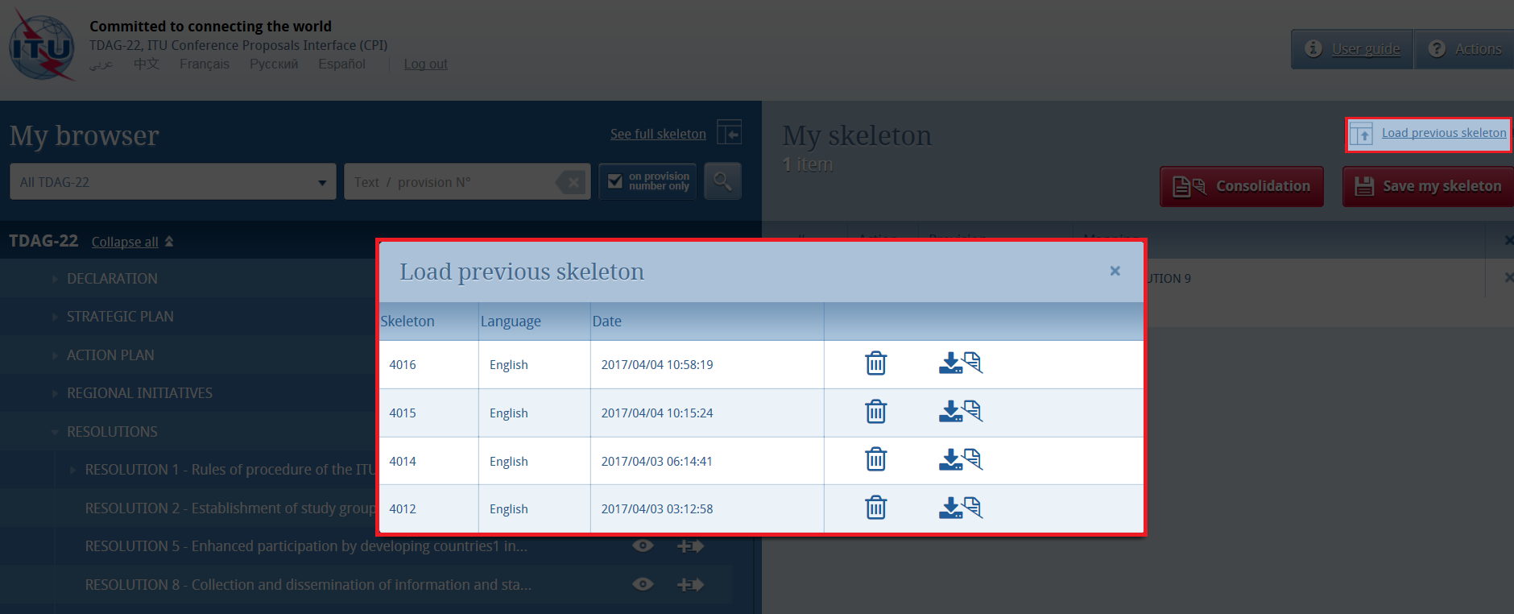
Once a skeleton has been created, a Word file can be produced in any of the six official ITU languages. Click on the desired language at the top of the page (please refer to section 3), then click “Save my skeleton”, and follow the process described above.

8 Finalizing your MS Word document
Once your Word document has been created, you may modify it as you wish before submitting it to the WTDC-17 Secretariat for posting.
Note – “MOD/(MOD)” proposals should be made with track changes switched on: new text added should then appear as underlined (underlined); existing text deleted should appear as crossed out (crossed out).
Should you wish to add, remove or reorder some proposals included in your document, you can retrieve your skeleton in CPI using the “Load previous skeleton” link (see section 7 above) or on the link provided in the email you received when you saved your skeleton (see sub-section 6.3).

9 Submitting proposals to ITU
Anyone with a TIES account can prepare and submit proposals for TDAG17-22 to the Secretariat. The Document Control Secretariat will then ensure that the submitter is indeed authorized to do so on behalf of their organization. For any clarifications, please contact the Document Control Secretariat at bdtdocscontrol@itu.int.

9.1 Submitting proposals using CPI
To submit your proposal(s) to the Document Control Secretariat, return to the email you received when successfully creating your skeleton and click on the link “click here to submit your proposals for TDAG17-22”. You will be redirected to the CPI on-line application and the associated ticket name will automatically be displayed.
Select the MS Word file containing your proposal(s) by clicking on the icon to upload your document. If required, you can add a suffix (addendum number), remarks, or additional contact emails (a copy of the confirmation of submission email will be sent to these additional contact emails).
Finally, click on “Official Submission to ITU.”
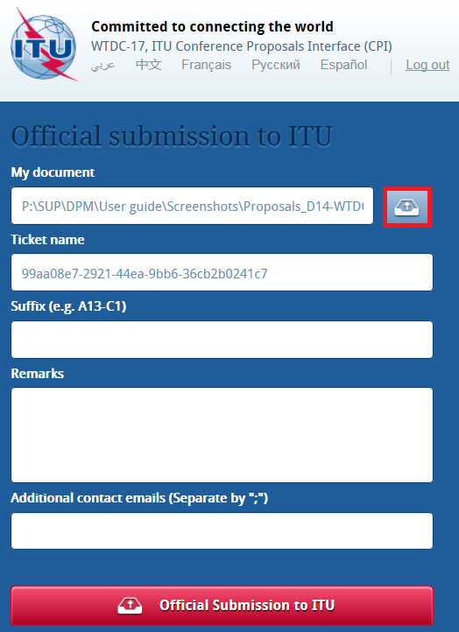

9.2 Example of a confirmation of submission email
The system will then send you and the other contacts entered in the field “Additional contact emails” a submission confirmation email. It includes all the relevant information on the submission, plus the file you submitted as an attachment.
Please keep it for your records.




