|  |  |
| --- | --- |
| INTERNATIONAL TELECOMMUNICATION UNION | sigleITU |

|  |
| --- |
| *Radiocommunication Bureau*  *(Direct Fax N°. +41 22 730 57 85)* |

|  |  |
| --- | --- |
| Administrative Circular **CA/203** | 30 March 2012 |

**To Administrations of Member States of the ITU, Radiocommunication Sector Members,   
ITU-R Associates participating in the work of a Study Group and ITU-R Academia**

**Subject**: Invitation to participate in the work of the Radiocommunication Study Groups, Radiocommunication Advisory Group (RAG), Conference Preparatory Meeting (CPM), Coordination Committee for Vocabulary (CCV) and the Special Committee on Regulatory/Procedural Matters (SC) during the study period 2012-2015

Dear Sir/Madam,

This Circular is an invitation to participate in the work of the Radiocommunication (ITU-R) Study Groups, RAG, CPM, CCV and the SC.

The 2012 Radiocommunication Assembly (Geneva, 16‑20 January 2012) approved the work programme (Resolution ITU-R 5-6), the working methods (Resolution ITU-R 1-6) and the structure (Resolution ITU-R 4-6) of the Radiocommunication Study Groups for the next study period. Please note that all ITU-R Resolutions currently in force may be found on the ITU website at:

[www.itu.int/pub/R-VADM-RES-2012](http://www.itu.int/pub/R-VADM-RES-2012)

In addition, a list of the Chairmen and Vice-Chairmen of the Radiocommunication Study Groups, the RAG, CPM, CCV, SC and the CPM, as approved at the 2012 Radiocommunication Assembly, is accessible from:

[www.itu.int/ITU-R/go/chairmen/en](http://www.itu.int/ITU-R/go/chairmen/en)

A list of all ITU-R groups is contained in Annex 1.

For reasons of economy, those participating in the work of the above-mentioned groups are invited to use electronic documentation freely accessible from the ITU website:

ITU-R Circulars: [www.itu.int/ITU-R/go/itur-circulars/en](http://www.itu.int/ITU-R/go/itur-circulars/en)

ITU-R Recommendations: [www.itu.int/pub/R-REC](http://www.itu.int/pub/R-REC)

Following Resolution 167 (Guadalajara, 2010) which encourages the ITU “to continue to develop its electronic working methods concerning the development, distribution and approval of documents, and the promotion of paperless meetings”, paper copiesof ITU-R Circulars (including draft texts for adoption and approval) **will only be dispatched, upon request, on completion of the form attached in Annex 2**, duly submitted by 30 April 2012.

Using their TIES account, administrations can choose to be informed when Circular letters, Recommendations, Questions and documents of interest have been posted on the ITU-R website. This information is provided in Annex 3.

Yours faithfully,

François Rancy  
 Director, Radiocommunication Bureau

**Annexes:** 3

1 List of ITU-R groups

2 Request form for receiving documentation of the Radiocommunication Study Groups

3 Notification of availability of texts on the ITU-R website

**Distribution:**

– Administrations of Member States of the ITU

– Radiocommunication Sector Members

– ITU-R Associates participating in the work of the Radiocommunication Study Groups

– ITU-R Academia

– Chairmen and Vice-Chairmen of Radiocommunication Study Groups and Special Committee on Regulatory/Procedural Matters

– Chairman and Vice-Chairmen of the Radiocommunication Advisory Group

– Chairman and Vice-Chairmen of the Conference Preparatory Meeting

– Members of the Radio Regulations Board

– Secretary-General of the ITU, Director of the Telecommunication Standardization Bureau, Director of the Telecommunication Development Bureau

Annex 1  
  
List of ITU-R groups

|  |  |
| --- | --- |
| **RAG** | **Radiocommunication Advisory Group** |
| CCV | Coordination Committee for Vocabulary |
| **SG 1** | **Spectrum management** |
| WP 1A | Spectrum engineering techniques |
| WP 1B | Spectrum management methodologies and economic strategies |
| WP 1C | Spectrum monitoring |
| **SG 3** | **Radiowave propagation** |
| WP 3J | Propagation fundamentals |
| WP 3K | Point-to-area propagation |
| WP 3L | Ionospheric propagation and radio noise |
| WP 3M | Point-to-point and Earth-space propagation |
| **SG 4** | **Satellite services** |
| WP 4A | Efficient orbit/spectrum utilization **for FSS and BSS** |
| WP 4B | Systems, air interfaces, performance and availability objectives for FSS, BSS and MSS, including IP-based applications and satellite news gathering |
| WP 4C | **Efficient orbit/spectrum utilization for MSS and RDSS** |
| **SG 5** | **Terrestrial services** |
| WP 5A | Land mobile service above 30 MHz (excluding IMT); wireless access in the fixed service; amateur and amateur-satellite service |
| WP 5B | Maritime mobile service including Global Maritime Distress and Safety System (GMDSS); aeronautical mobile service and radiodetermination service |
| WP 5C | Fixed wireless systems; HF and other systems below 30 MHz in the fixed and land mobile services |
| WP 5D | IMT Systems |
| **SG 6** | **Broadcasting service** |
| WP 6A | Terrestrial broadcasting delivery |
| WP 6B | Broadcast service assembly and access |
| WP 6C | Programme production and quality assessment |
| **SG 7** | **Science services** |
| WP 7A | Time signals and frequency standard emissions |
| WP 7B | Space radiocommunication applications |
| WP 7C | Remote sensing systems |
| WP 7D | Radio astronomy |
| SC | Special Committee |
| SC-WP | Working Party of the Special Committee |
| **CPM-15** | Conference Preparatory Meeting (CPM) |
| JTG 4-5-6-7 | WRC-15 Agenda items 1.1 and 1.2 |

Annex 2  
  
Request form for paper copies of ITU-R Circulars and   
draft texts for adoption and approval

**IMPORTANT:** Paper copies are only available to Administrations of Member States of the ITU and Radiocommunication Sector Members. **Paper copies will only be dispatched, upon request, on completion of this form**.

|  |  |
| --- | --- |
| **Contact information – study period 2012-2015** | |
| Administration/Organization: | |
| First name: Last name: | |
| Mailing address: |  |
| City: | State/Province: |
| Postal Code: | Country: |
| E-mail: |  |
| Telephone: | Fax: |

I wish to receive paper copies of ITU-R Circulars (including draft Recommendations for adoption and approval) as indicated in the table below:

|  |  |  |  |  |  |  |  |
| --- | --- | --- | --- | --- | --- | --- | --- |
|  | | **Only 1 copy per language will be dispatched** | | | | | |
|  | | English | French | Spanish | Arabic | Russian | Chinese |
| **ADMINISTRATIVE CIRCULAR** | | | | | | | |
| **CA** (general business of ITU-R) | |  |  |  |  |  |  |
| **CACE** (Radiocommunication Assembly, Study Groups, adoption/approval of ITU‑R texts) | CACE – SG1 |  |  |  |  |  |  |
| CACE – SG3 |  |  |  |  |  |  |
| CACE – SG4 |  |  |  |  |  |  |
| CACE – SG5 |  |  |  |  |  |  |
| CACE – SG6 |  |  |  |  |  |  |
| CACE – SG7 |  |  |  |  |  |  |
|  | | | | | | | |
| **LCCE** (Study Groups, including Working Parties and Task Groups) | | English only |
| 1/LCCE – SG1 | |  |
| 3/LCCE – SG3 | |  |
| 4/LCCE – SG4 | |  |
| 5/LCCE – SG5 | |  |
| 6/LCCE – SG6 | |  |
| 7/LCCE – SG7 | |  |

**Please return this form by 30 April 2012 to:**ITU - Radiocommunication Bureau - Conference Planning and Documentation Unit (CPDU)

E-mail: [itu-RcpduCirculars@itu.int](mailto:itu-RcpduCirculars@itu.int) / Fax: +41 22 730 6600

Annex 3  
  
Electronic notification of   
new/revised ITU-R Circulars and texts (TIES Services)

Log into your TIES Account at <http://www.itu.int/TIES/index.html>.

From the TIES services welcome page, under “Account options”, click **“Update”** your notifications.

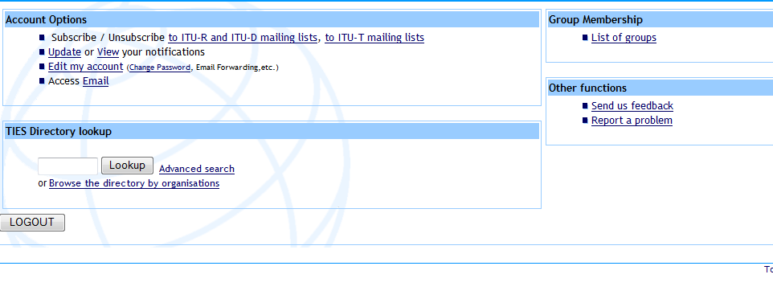

Select categories of interest and click the Change Notifications button. You will receive an e‑mail message whenever new and updated documents are available.

If so desired, you can forward TIES e-mails to the e-mail of your choice by clicking “**Edit my account**” (see above).

______________