|  |  |  |
| --- | --- | --- |
| **Radiocommunication Bureau (BR)** | | |
| Administrative Circular  **CA/238** | | 6 February 2018 |
|  | | |
|  | | |
| **To Administrations of Member States of the ITU and Radiocommunication Sector Members** | | |
|  | | |
|  | | |
| Subject: | **Discontinuation of the dispatching of BR circulars by postal mail** | |
|  |

# 1 Dispatch of BR circulars to ITU members

Following:

Annex 2 of Decision 5 (Busan, 2014) which identified a series of measures for reducing expenses, including to “discontinue to the greatest extend possible communications by fax and traditional postal mail between the Union and Member States and replace it with modern electronic communication methods”; and

BR Circular [CA/225](https://www.itu.int/md/R00-CA-CIR-0225/en) dated 6 July 2015 on the discontinuation of the dispatching of ITU-R circulars by postal mail and the ample time given to ITU Members to prepare to handle BR circulars electronically,

the effective date of application of this new directive is set to **1 March 2018**. After this date, the dispatching of all BR Administrative Circulars and Circular Letters will only be done by electronic means.

# 2 Availability of BR circulars in electronic format

All BR Administrative Circulars and Circular Letters are freely accessible from the ITU website at:

[www.itu.int/go/Rcirculars](http://www.itu.int/go/Rcirculars)

Using their ITU (TIES) account, members can be informed by email when a BR circular, as well as other ITU documents, have been posted on the ITU website.

To activate these alerts, or to retrieve or create an ITU account, please go to [www.itu.int/ties](http://www.itu.int/ties).

Further information on how to subscribe to these email notifications is provided in the **Annex**.

# 3 Mandatory correspondence

The above arrangements do not apply to mandatory correspondence as referred to in the relevant provisions of the Radio Regulations, e.g. [Circular Telegram (CTITU)](https://www.itu.int/md/R00-CTITU-CIR/en) which will continue to be sent to Administrations by fax until further notice.

François Rancy

Director

Annex: 1

**Distribution:**

* Administrations of Member States of the ITU
* Radiocommunication Sector Members
* Chairmen and Vice-Chairmen of Radiocommunication Study Groups

- Chairman and Vice-Chairmen of the Radiocommunication Advisory Group

- Chairman and Vice-Chairmen of the Conference Preparatory Meeting

- Members of the Radio Regulations Board

- Secretary-General of the ITU, Director of the Telecommunication Standardization Bureau, Director of the Telecommunication Development Bureau

**ANNEX**

**HOW TO SET EMAIL NOTIFICATIONS TO BE INFORMED  
 WHEN A CIRCULAR IS PUBLISHED ON THE ITU WEBSITE**

Go to [www.itu.int/ties](http://www.itu.int/ties) and log in using your ITU (TIES) account.

If you do not have an ITU account yet, you may create one by following the online application process.

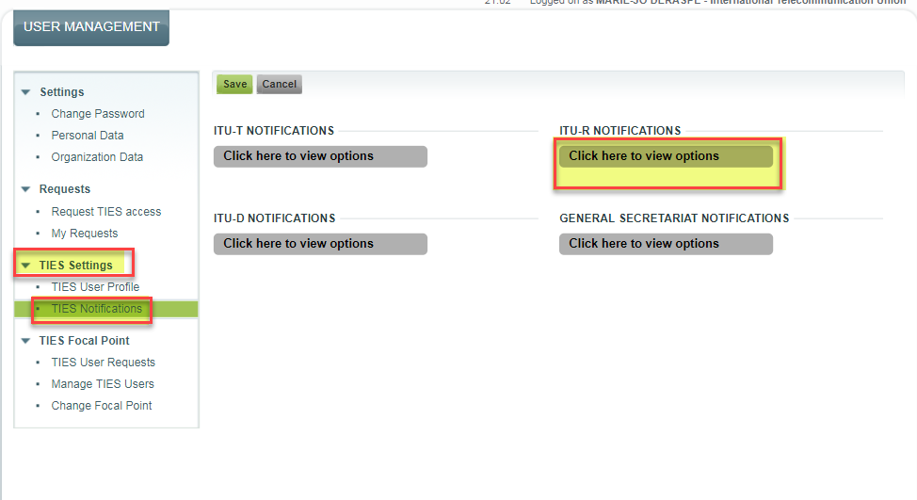Once logged in, under the "TIES settings" under the left-hand side menu, click "TIES Notifications" to expand and view the options available.

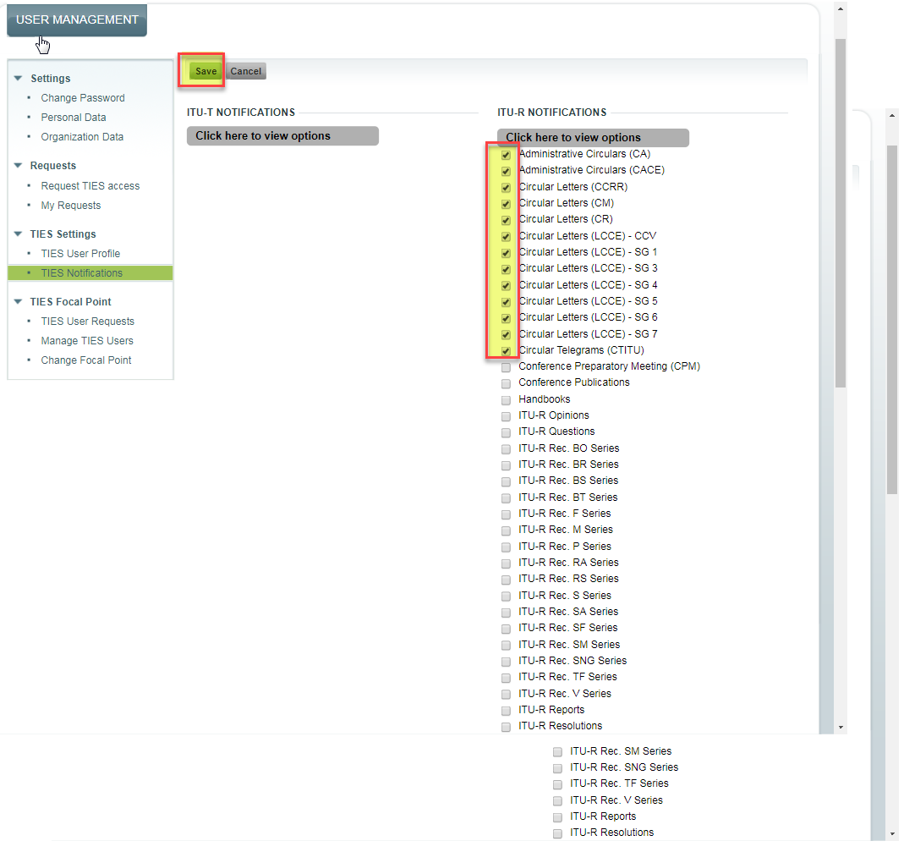Select the TIES notifications you wish to receive, and click Save.

______________