**Radiocommunication Bureau (BR)**

|  |  |  |
| --- | --- | --- |
| Circular Letter  **CR/489** | | 11 July 2022 |
|  | | |
| |  | | --- | | **To Administrations of Member States of the ITU and ITU-R Sector Members** | | | |
|  | | |
|  | | |
| Subject: | **Implementation of Resolution 186 (Rev. DUBAI, 2018) – Availability of a first pilot version of the new web application “ITU SpaceExplorer” aimed at enhancing the exploration of orbital and radio characteristics of satellite systems and publication data related to space services** | |
|  |

The Radiocommunication Bureau (BR) is pleased to report to the ITU-R members that, in response to *instructs the Director of the Radiocommunication Bureau* 4 of Resolution 186 (Rev. DUBAI, 2018), a new web application called “ITU SpaceExplorer” has been developed in order to improve the accessibility and transparency of the information contained in the Master International Frequency Register and related Space Network System databases.

This new application is part of a systemic review of the BR Space Services data system access. It aims to merge and enhance the features included in the Space Network List “Reference publications” part of SNL online and in the Space Network System SNS online to query online data related to satellite frequency assignments in an easier manner.

This application allows users to explore online the active technical and regulatory data published in its BR IFIC (Space) and the history of the publications using dedicated filter criteria.

With ITU SpaceExplorer, users can follow the status of an Administration's satellite networks, monitor the latest publications of a BR IFIC (Space) or analyse orbit and spectrum occupancy.

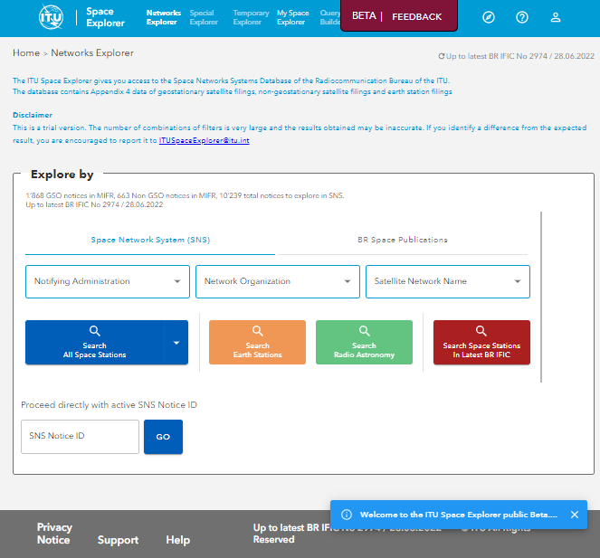

For each satellite network or system, a dashboard is also available to explore in detail its identity, history, regulatory and operational status, as well as its technical data and review results and coordination requirements.

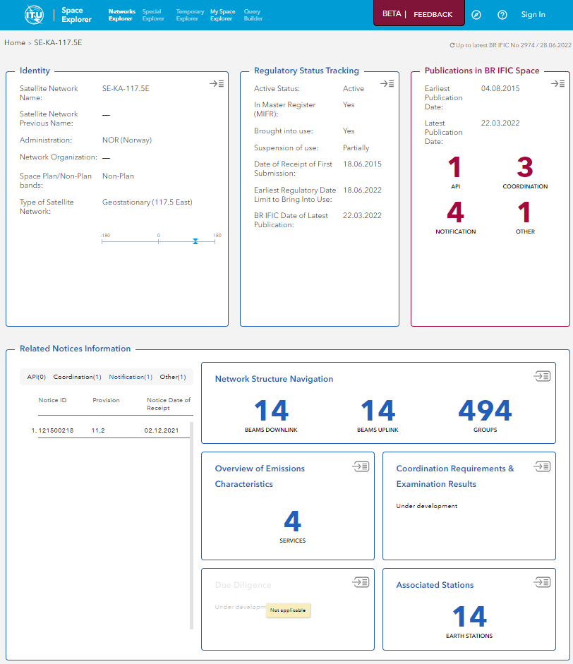

Besides, the Bureau is developing a series of new functions to assist users in browsing space-related data:

* The “Special Explorer” will contain functions on more targeted aspects of the data, such as the Master Register situation.
* The “Temporary Explorer" will be dedicated to data analyses that have a limited period of relevance because they are linked to a specific ITU-R work item or event.
* “My Space Explorer” will allow users to save, organise and, if necessary, share their favourite searches.
* The “QueryBuilder” function will guide users on a completely customised search through the Space Network System data.

**Availability of the first pilot version of ITU SpaceExplorer**

The Radiocommunication Bureau is pleased to announce that a first pilot version of the ITU SpaceExplorer application has been made available for test and review on 30 June 2022.

This version contains access to data relating only to geostationary satellite networks in the non-planned bands. The “Networks Explorer” search with filters allows the selection of lists of active networks in SNS databases or BR IFIC publications database. The individual dashboards of these networks show in cards format the identity of the network, its regulatory status, the list of publications, as well as the structure of the notice, the emissions characteristics and the associated earth stations characteristics. “My Space Explorer” is available by sign in with a TIES user account.

The pilot version is available on: <https://www.itu.int/go/ITUSpaceExplorer>

Users will be guided by messages and assistance in order to make learning this environment easier. The application is in English only at this stage. The experience of reading the information is recommended from a large enough screen for better visibility. The data is updated with each BR IFIC publication.

**Support and Contacts**

An email address has been established in case any difficulty is encountered with the pilot version or if you would like to provide suggestions for improving the online application: [ITUSpaceExplorer@itu.int](mailto:ITUSpaceExplorer@itu.int). The Bureau welcomes any feedback or suggestions from the members.

Based on the results of the pilot phase and feedback gathered from the membership, the Bureau will further improve the system and put in place a production version of the application. This will be announced in a separate circular letter.

The Bureau hopes that your Administration will find this online application helpful and remains at your disposal, via [brmail@itu.int](mailto:brmail@itu.int), for any clarification or assistance you may require on matters related to this circular letter.

Mario Maniewicz

Director

Distribution:

* Administrations of ITU Member States
* Members of the Radio Regulations Board
* ITU-R Sector Members