INTERNATIONAL TELECOMMUNICATION UNION
Radiocommunication Bureau
(Direct Fax N°. +41 22 730 57 85)

Circular Letter  1/LCCE/77 | 3 July 2006
To Administrations of Members of the ITU and other members of the
Radiocommunication Sector participating in the work of Working Parties 1A,
1B and 1C of Radiocommunication Study Group 1
Subject: Meetings of Working Parties 1A, 1B and 1C
WP 1A: Spectrum engineering techniques
WP 1B: Spectrum management methodologies and economic strategies
WP 1C: Spectrum monitoring

Introduction
By means of this Circular Letter, we wish to announce that meetings of ITU-R Working Parties 1A, 1B and 1C will take place in Munich, Federal Republic of Germany, at the kind invitation of Rohde & Schwarz, from 9-13 October 2006 (see the table below).

Groups | Meeting dates | Deadline for contributions  16:00 hours UTC | Opening session
Joint meeting of WPs 1A, 1B and 1C | 9 October 2006 |  | 09:30 hours
Working Party 1A | 9-13 October 2006 | 2 October 2006 | 10:45 hours
Working Party 1B | 9-13 October 2006 | 2 October 2006 | 14:00 hours
Working Party 1C | 9-13 October 2006 | 2 October 2006 | 10:45 hours

Services directly connected with meeting activities, such as delegate registration, document distribution, etc. will be located in the vicinity of the meeting rooms. The opening session, comprising a joint meeting of the three Working Parties, will take place at 09:30 hours and registration of delegates will start at 08:30 hours on the opening day.

Place of the meetings
The meetings will take place at:
“Technology Park”
Rohde & Schwarz
Mühldorfstrasse 15
D-81671 Munich
Germany
For further information associated with the meeting venue, transportation and hotel accommodation, see Annex 2.

Programme of the meetings
A draft agenda for these meetings is contained in Annex 1. The Questions assigned may be found on: http://www.itu.int/ITU-R/publications/download.asp?product=que01&lang=e. The Working Parties will conduct their work in English.

Contributions
Contributions in response to the work of Working Parties 1A, 1B, 1C are invited. These will be processed according to the provisions laid down in Resolution ITU-R 1-4 and posted on http://www.itu.int/ITU-R/study-groups/index.asp?link=rsg1&lang=en (see “contributions” of each relevant Working Party). A limited number of paper copies will be available at the meetings. The deadline for submission of contributions is shown in the table above. Resolution ITU-R 1-4 provides that contributions which are not available to participants at the opening of the meeting shall not be considered.
Participants are requested to submit contributions by electronic mail to:
rsg1@itu.int
A copy should also be sent to the Chairmen of the relevant Working Party and to the Chairman and Vice-Chairmen of Study Group 1. The pertinent addresses can be found on:
http://www.itu.int/ITU-R/study-groups/index.asp?lang=en
A CD-ROM containing all input contributions and the Chairmen’s Reports will be provided to each delegate. Participants are expected to bring with them to the meeting any paper copies of input documents they may require.
Participants are encouraged to use electronic working methods and to bring their laptops (equipped with a CD-ROM drive, a WLAN-card and a USB socket) with them to the meeting. Please note that paper copies of documents produced during the meeting (temporary, administrative and information documents) will be available only to participants who have requested them on the registration form.

Participation
The intended participation of your representative(s) should be advised not later than one month before the opening of the meeting, by means of the annexed form (Annex 3) (to be photocopied as required).
Valery Timofeev
Director, Radiocommunication Bureau

Annexes: 3

Distribution:

– Administrations of Member States and Radiocommunication Sector Members participating in the work of Working Parties 1A, 1B and 1C of Radiocommunication Study Group 1
– ITU-R Associates participating in the work of Radiocommunication Study Group 1
– Chairman and Vice-Chairmen of Radiocommunication Study Group 1
– Secretary General of the ITU, Director of the Telecommunication Standardization Bureau, Director of the Telecommunication Development Bureau

ANNEX 1
Draft agenda for the meetings of Working Parties 1A, 1B and 1C
(Geneva, 9 – 13 October 2006)

1 Introduction by the Chairman
2 Approval of the draft agenda
3 Chairman’s Report to the Working Party
4 Introduction and attribution of the documents
5 Appointment of Chairmen/Coordinators for Drafting Groups
6 Drafting of output documents
7 Preparation of draft Recommendations and other texts for the Study Group 1 meeting
(16-17 October 2006)
7.1 Review of the ITU-R Questions attributed to WPs
7.2 Review of the relevant ITU-R Recommendations
8 Liaison with other Groups
9 Any other business

J. WANG  Chairman, WP 1A | B. CHAUDHURI  Chairman, WP 1B | J. VERDUIJN  Chairman, WP 1C

ANNEX 2
Information for participants
Domestic information for the Meetings of Working Parties 1A, 1B and 1C of
Radiocommunication Study Group 1 in Munich, Germany, 9 to 13 October 2006

Host
Rohde & Schwarz GmbH & Co. KG, Munich, Germany.

Meeting Venue
Location: "Technology Park" at Rohde & Schwarz headquarters in Munich, Germany.
Entrance: Ampfingstrasse 7 (see map enclosed)
Address: Rohde & Schwarz, Mühldorfstrasse 15, D-81671 Munich, Germany
Telephone: +49 89 4129 1 3926
Fax: +49 89 4129 6 3926
E-mail: hans.geldern@rsd.rohde-schwarz.com
Web site: http://www.rohde-schwarz.com/

Hotel reservation
A block of rooms has been reserved at the brand-new and centrally located Fleming's Hotel München City. For the hotel reservation, please send the attached Hotel reservation form, duly filled-in, directly to the hotel via fax (fax no. +49 89 44444-599) or mail to
muenchen-city@flemings-hotels.com
The very special ITU room rates for this superior 4**** hotels are:

Room type | Room rate
Single room | € 135,00 per night, incl. 1 breakfast buffet and tax
Double room | € 150,00 per night, incl. 2 breakfast buffet and tax

IMPORTANT:
- Deadline for hotel room reservations: 31 August 2006. The hotel may reject reservation requests if they are received after the cut-off date due to important exhibitions in Munich.
- To get this special price, room reservations must be made stating "Code ITU-RS”.

Hotel data
Address: Fleming's Hotel München City, Bayerstr. 47, D-80335, Munich
Telephone: +49 89 444466-0
Fax: +49 89 44444-599
E-mail: muenchen-city@flemings-hotels.com
To ensure a hotel room reservation, it is necessary for you to completely fill-in the attached Hotel Reservation Form, including the requested Credit Card data.
Cancellation policy of hotel room reservations: Cancellations must be received by the hotel at least 7 days prior to arrival date to avoid a penalty of one night’s room and tax. Please be sure to ask for a cancellation confirmation should you need to cancel your reservation.
Responsibility: Neither ITU nor Rohde & Schwarz are responsible for the confirmation of reservations, cancellation or changing of reservations, or no-shows. Please contact the hotel directly to make any changes.

Visa requirement
Please contact Mrs. Martina Berner (martina.berner@rsd.rohde-schwarz.com) should you require an individual invitation letter for visa purposes. Please send a copy of your passport via fax to +49 89 4129 63957 or email before 15 August 2006.

Important locations in the public transportation network map

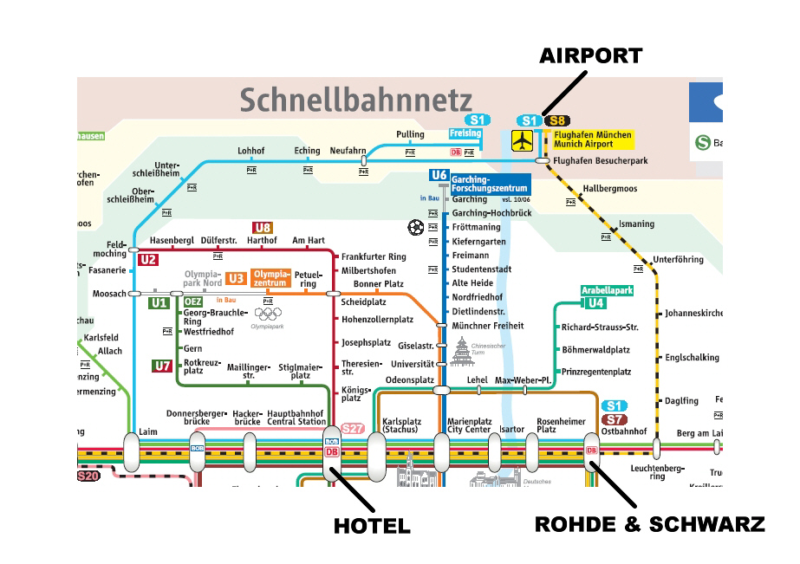

You may download the full public transportation network map of Munich as a file from here:
http://www.mvv-muenchen.de/web4archiv/objects/download/1/schnellbahnnetz_051211.pdf
Arrival Airport is Munich International Airport (MUC) "Franz Josef Strauß".
Travel from the Airport to the Hotel with public transportation: Buy a single ticket for the required 4 zones at € 8,80. Stamp the ticket to validate it before taking the train. Take the S1 or S8 train and exit at Central Station (about 50 minutes travel time). Follow the markings to "Bayerstrasse". Walking time is less than 5 minutes.
Travel from the Airport to the Hotel by Taxi: Max. 1 hour travel time, fare about € 50.
Arrival by car: Car parking in the hotel for approx. 20 cars; car can be left also at Rohde & Schwarz premises.

Location of the Fleming's Hotel München City, Bayerstr. 47

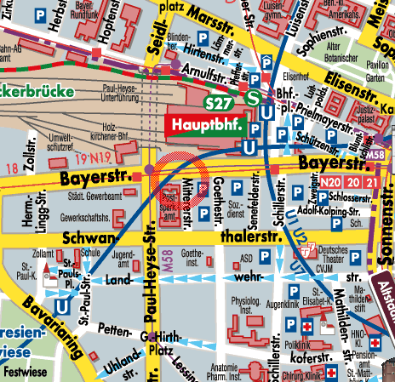

Location of Rohde & Schwarz headquarters

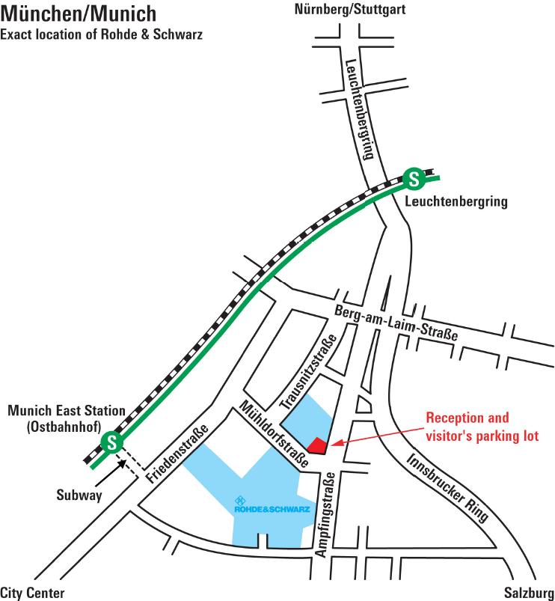

Entrance
Technology Park

Free transportation between Hotel and Rohde & Schwarz headquarters ("Technology Park")
Rohde & Schwarz will provide complimentary bus transportation to and from the Fleming's Hotel for Delegates during the meeting days. Departure time from Fleming's Hotel on 9 October 2006 will be 08:00 a.m. Further schedule of this shuttle service will be announced during the meetings.

Facilities for delegates during the meetings
The usual facilities will be available for delegates at the meeting venue: computer room, laser printers, photocopying machines, video projectors, WLAN, electric power points, pigeonholes, etc.
A registration desk will be provided to receive participants and distribute badges on the ground floor of the Technology Park, close to the meeting rooms.
A public phone and a fax terminal will be available in a guest's room at the meeting venue. Each delegate has to cover the toll charges that may be incurred by placing a call.
WLAN cards for your laptop will not be made available for loan / rent, so please bring a card along with you.

Time zone
GMT+2 hours (until 29 October 2006).

Climate
Ranging from sunny to rainy and windy, temperatures between fair and cold (18°C to 3°C).

Electricity
230 V AC, 50 Hz. Please be sure you have the correct adapter. Adapters and voltage converters will not be provided at the meeting.

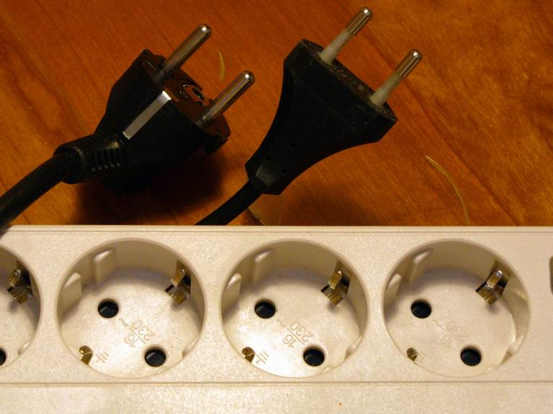

Lunch and coffee breaks
Daily lunch (buffet) and coffee breaks will be provided by courtesy of Rohde & Schwarz on meeting days, at the cafeteria of the Technology Park.

Social events
Detailed information on social event arrangements will be made available during the meetings:
Monday evening: Welcome speech by a COO/CEO of Rohde & Schwarz and welcome dinner in the Atrium of the Technology Park.
Wednesday evening: City tour by tram ending in a typical Bavarian restaurant.
Thursday evening: “R&S Jazz Night” in the Atrium of the Technology Park with farewell speech by a COO/CEO of Rohde & Schwarz.

Contact person at Rohde & Schwarz
For all organisational questions, Mrs. Martina Berner (mailto:martina.berner@rsd.rohde-schwarz.com or fax no. +49 89 4129 63957) will be pleased to assist you.
She will also be your contact person during the entire meeting in the Technology Park.
HOTEL RESERVATION FORM

Fleming's Hotel München City
Fax: +49 89 44 44 4-599

"Code ITU-RS"
Deadline for booking: 31 August 2006
Cancellation Policy: Cancellations must be received at least 7 days prior to arrival date to avoid a penalty of one night’s room and tax.

Name of the guest:

Room | □ Single room □ Double room (max. 2 persons)  □ Smoking □ Non-smoking
Date of arrival:
Date of departure:
Home address:

Company address:

Telephone number:
Fax number:
Email address:
Credit card type:
Credit card number:
Credit card holder:
Credit card expiration date:
Place, date and
guest signature:

Single room: € 135,00 per night, incl. 1 breakfast buffet and tax
Double room: € 150,00 per night, incl. 2 breakfast buffet and tax
Special wishes of the guest (to be considered by the Hotel, if possible):_________________________
__________________________________________________________________________________
___________________________________________________________________________
annex 3
Registration Form
ITU-R Working Parties 1A, 1B and 1C
Munich, Germany, 9 – 13 October 2006
Radiocommunication Bureau |  | I wish to participate in

WP 1A  9/10 – 13/10 | WP 1B  9/10-13/10 | WP 1C  9/10-13/10

Mr. Mrs. Ms. Miss: |  | …………………………………………………………. |  |  |  |  |  |  |  | …………………………………………………………………...
 |  |  |  | (family name) |  |  |  |  |  | (first name)
Accompanied by family member(s): |  |  |  | …………………………………………… |  |  |  |  |  | …………………………………………………………………...
 |  |  |  | (family name) |  |  |  |  |  | (first name)
1. REPRESENTATION
Name of Member State: |  |  |  | …………………………………………………………………………………………………………………….
❒ Head of Delegation |  |  |  |  | ❒ Deputy |  |  |  |  |  |  |  | ❒ Delegate
(to be completed by representatives of Member States only)
Name of Sector Member: |  |  |  | …………………………………………………………………………………………………………………….
r | Recognized Operating Agencies |  |  |  |  |  |  | r |  |  | Regional Telecommunication Organizations
r | Scientific or Industrial Organizations |  |  |  |  |  |  | r |  |  | Intergovernmental Organizations operating Satellite Systems
r | UN, Specialized Agencies and the IAEA |  |  |  |  |  |  | r |  |  | Other Entities dealing with Telecommunication matters
r | Regional and other International Organizations |  |  |  |  |  |  | r |  |  | Associates
2. OFFICIAL ADDRESS
Name of the Company: |  |  | …………………………………………………………………………………………………………………………
Street Address: |  |  | …………………………………………………………………………………………………………………………
City/State/Code/Country: |  |  | …………………………………………………………………………………………………………………………
Business tel.: |  |  | …………………………………………… |  |  |  |  |  | Fax: |  |  | ……………………………………………
E-mail: |  |  | …………………………………………… |  |  |  |  |  | In case of emergency: |  |  | ……………………………………………
3. DOCUMENTS
I wish to receive paper copies during the meeting: |  |  |  |  |  | r | Yes |  |  |  |  |  | r | No

Date : |  | ……………………………………………………………………… |  |  |  | Signature: | …………………………………………………………...
 | For BR Secretariat use only
 | Approved (if applicable) |  | Personal Section |  | Meeting Section |  |  | Pigeonhole
 | To be returned duly completed to the Radiocommunication Bureau |  |  | Place des Nations  CH-1211 Geneva 20  Switzerland |  |  |  |  | Telephone: +41 22 730 5802  Telefax: +41 22 730 6600  Email: linda.kocher@itu.int

