INTERNATIONAL TELECOMMUNICATION UNION
Radiocommunication Bureau
(Direct Fax N°. +41 22 730 57 85)

Circular Letter  3/LCCE/29* | 15 February 2008
To Administrations of Member States of the ITU, Radiocommunication Sector Members
and ITU-R Associates participating in the work of Working Parties 3J, 3K, 3L and 3M
of Radiocommunication Study Group 3
Subject: Meetings of Working Parties 3J, 3K, 3L and 3M
Working Party 3J: Propagation fundamentals
Working Party 3K: Point-to-area propagation
Working Party 3L: Ionospheric propagation and radio noise
Working Party 3M: Point-to-point and Earth-space propagation

Introduction
By means of this Circular Letter, we wish to announce that meetings of ITU-R Working Parties 3J, 3K, 3L and 3M will take place in Boulder, Colorado at the kind invitation of the United States of America, from 5 to 13 June 2008.

Place of the meetings
The meetings will take place at the:
The Hotel Boulderado
2115 13th Street
Boulder, Colorado 80302
Tel: +1 303-440-2880 / +1 866-826-2887
Fax: +1 303-443-7035
For further information see Annex 1.

Programme of the meetings

Group | Date | Deadline for contributions  16:00 hours UTC | Opening
Joint Meeting of Working Parties | 5 June 2008 |  | 5 June, 09:30 hours
Working Party 3J | 5-13 June 2008 | Thursday, 29 May 2008 | 5 June, 11:00 hours
Working Party 3M | 5-13 June 2008 | Thursday, 29 May 2008 | 5 June, 14:00 hours
Working Party 3L | 5-9 June 2008 | Thursday, 29 May 2008 | 5 June, 15:45 hours
Working Party 3K | 6-13 June 2008 | Thursday, 29 May 2008 | 6 June, 09:30 hours
Services directly connected with meeting activities, such as delegate registration, document distribution, etc. will be located in the vicinity of the meeting room. Registration of delegates will start at 8:30 hours on the opening day.
Delegates may wish to note that these Working Party meetings immediately follow the conference “ISART 2008/ClimDiff 2008”, (sponsored by URSI Commission F), which is to be held at the same venue, from 2 to 4 June 2008. For more information, see http://www.its.bldrdoc.gov/isart/.
A draft agenda for the meetings is contained in Annex 2. The Questions assigned may be found on: http://www.itu.int/publ/R-QUE-SG03/en. The Working Parties will conduct their work in English.

Contributions
Contributions in response to the work of Working Parties 3J, 3K, 3L and 3M are invited. These will be processed according to the provisions laid down in Resolution ITU-R 1-5, posted on http://www.itu.int/publ/R-RES-R.1/en and distributed to participants on CD-ROM at the opening of the meeting.
One copy of each contribution should be sent to the Director, Radiocommunication Bureau for processing. A copy should also be sent to the Chairman of the relevant Working Party and to the Chairman and Vice-Chairmen of Study Group 3. The pertinent addresses can be found at:
http://www.itu.int/cgi-bin/htsh/compass/cvc.param.sh?acvty_code=3.
Participants are encouraged to submit contributions by electronic mail to:
rsg3@itu.int
The deadline for submission of contributions is specified in the table above. Submissions received later than the specified deadlines cannot be accepted.

Documentation
All contributions will be made available to the delegates on CD-ROM as well as on the ITU-R Study Group 3 Web page at: http://www.itu.int/ITU-R/index.asp?category=study-groups&link=rsg3&lang=en (see “Contributions of each relevant Working Party”). Participants are expected to bring with them to the meeting paper copies of all of the input documents of interest to them (if necessary). Delegates also should indicate on the registration form whether they wish to receive paper copies of temporary, administrative and information documents during the meeting.
Participants are encouraged to use electronic working methods and to bring their laptops (equipped with a CD-ROM drive and a WLAN-card) with them to the meeting.

Hotel accommodation and arrival information
Annex 1 contains details on hotel accommodation; delegates are advised to make reservations at the earliest opportunity. Also included in Annex 1 is information concerning arrival in Boulder, together with a map indicating the conference venue.

Participation
The intended participation of your representative(s) should be advised not later than one month before the opening of the meeting, by means of the annexed form (Annex 4) (to be photocopied as required).
Valery Timofeev
Director, Radiocommunication Bureau

Annexes: 4

Distribution:

– Administrations of Members of the ITU and other members of the Radiocommunication Sector participating in the work of Working Parties 3J, 3K, 3L and 3M of Radiocommunication Study Group 3
– ITU-R Associates participating in the work of Radiocommunication Study Group 3
– Chairman and Vice-Chairmen of Radiocommunication Study Group 3
– Secretary General of the ITU, Director of the Telecommunication Standardization Bureau, Director of the Telecommunication Development Bureau
Annex 1
Information for participants

1 Meeting venue and hotel accommodation

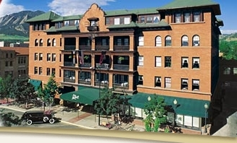
The venue of the meeting is:
The Hotel Boulderado
2115 13th Street
Boulder, Colorado 80302
Tel: +1 303-440-2880 / +1 866-826-2887
Fax: +1 303-443-7035
Home page: http://www.boulderado.com/
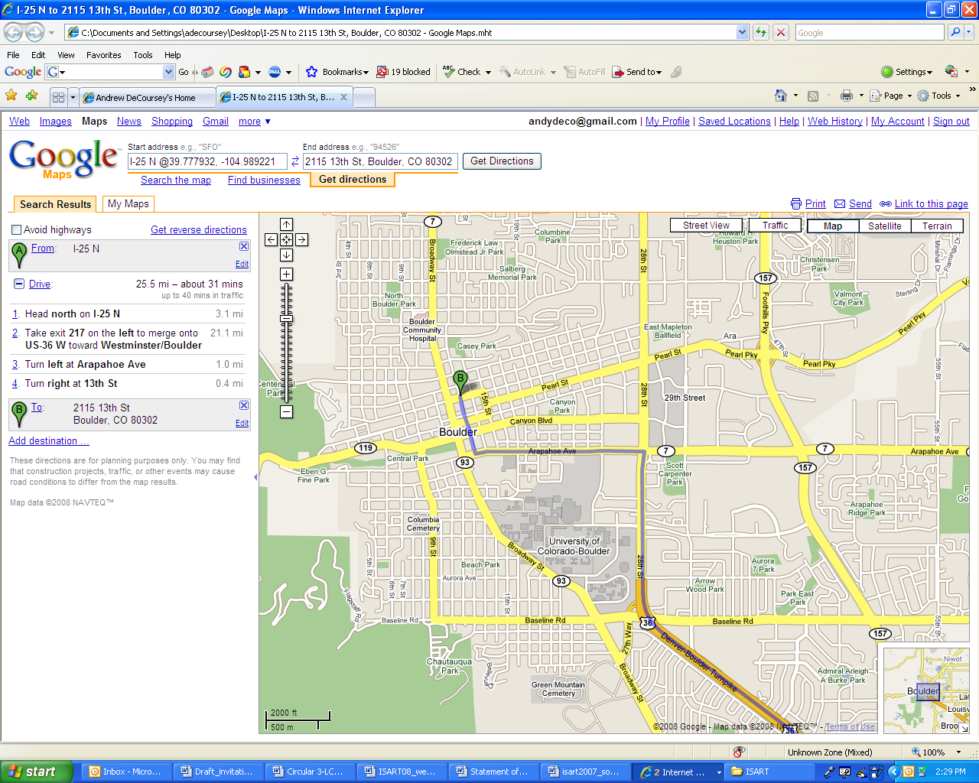

1.1 Room reservation and hotel rates
Hotel Boulderado, 2115 13th Street, Boulder, CO.
Rates: SAL2, double $154 + tax; 2 doubles $174 + tax; king $184 + tax; suite $254 + tax.
Online lodging reservations available at: www.boulderado.com.
Hotel reservations can be made by contacting the hotel directly at 1-303-442-4344 or 1-800-433-4344 (toll free) and mentioning the ISART/ClimDiff/ITU-R SG3 Conference, SAL2 Room rate.
NOTE – U.S. Government employees should provide tax exempt information.

1.2 Additional hotel accommodations

- Millennium Harvest House Hotel, 1345 28th Street, Boulder, CO.
Hotel reservations can be made by:
  - Contacting the hotel directly at: 303-443-3850 or 1-800-545-6285 (toll free) and mentioning the NIST/NTIA ISART Conference
  - By fax at 303-443-1480
  - Online at: www.millenniumhotels.com/millenniumboulder/
  - E-mail reservation request to millboulderres@mill-usa.com

- Boulder Outlook Hotel and Suites, 800 28th Street, Boulder, CO.
Hotel reservations can be made by:
  - Contacting the hotel directly at 303-443-3322 or 1-800-542-0304 (toll free)

- Best Western Boulder Inn, 770 28th Street, Boulder, CO.
Hotel reservations can be made by:
  - Contacting the hotel directly at 303-449-3800 or 1-800-233-8489 (toll free).

- Additional hotel and visitor information are located at the NIST Boulder Laboratories Visitor Information and BOULDER Colorado USA websites.

2 Transportation Shuttle travel guidelines

2.1 Transportation information to and from Denver International Airport (DIA)
Boulder is located at the eastern edge of the Rocky Mountains, about 70 km (43.5 miles) northwest of the Denver International Airport. Transportation to and from Denver International Airport (DIA) is available by rental car, limousine shuttles, or bus. Most rental car companies have facilities at DIA.
- Go to the www.flydenver.com/gt/index.asp and enter “Boulder” (upper right side of screen) to list DIA's ground transportation to Boulder.
- Round-trip and one-way shuttle is available through Boulder Super Shuttle (www.bouldersupershuttle.com) at +1-303-227-0000.
- A regional bus service, the RTD, provides transportation between DIA and Boulder. Busses leave every hour between 6:20 a.m. 11:20 p.m. with the last bus leaving at 11:20 p.m. Trip time is about 90 minutes with a final stop at the Boulder bus station located at 13th and Walnut Street in downtown Boulder. The one-way RTD fare is $10. For detailed information click on Skyride at: www.rtd-denver.com. You will probably need to arrange for a taxi to your hotel from the bus station.
- Local taxi service is available from Boulder Yellow Cab at 303-777-7777

2.2 Direction by car
From Denver International Airport:
- Exit the airport on Peña Blvd. Continue until you reach I-70 West.
- Take I-70 West to the I-270 North exit, which is exit #279, towards Fort Collins.
- Follow I-270 North to Hwy. 36 West exit, towards Boulder.
- Continue on Highway US 36 into Boulder (Hwy. 36 becomes 28th Street) until reaching Canyon Blvd (also called CO-119S and CO-7N), the third light.
- At Canyon Blvd turn left proceeding sixteen blocks to Broadway.
- At Broadway, turn right (3 blocks).
- Turn right onto Pine Street (1 block).
- Turn right onto Thirteenth Street (half a block). The Hotel Boulderado, 2115 13th Street, will be on your right. Pull into the loading zone for Valet Parking assistance.
Alternative Route: The Northwest Parkway is a toll road that can speed up your travel time.
From DIA, take the toll road exit, E-470 north from Peña Boulevard to the Northwest Parkway towards Broomfield connecting to U.S. 36. Continue west on Hwy 36 toward Boulder. The toll road costs $6.00 one-way.

3 Electricity and socket design
The standard power supply in the United States is 110 volts - 60 Hz.
Standard North American 3 pin socket:



4 Contact point
For any further information you may require or if you need a personal invitation letter or official document from the US Administration for your visa application, please contact:

National Telecommunications and Information Administration  Institute for Telecommunication Sciences  325 Broadway MC ITS.E  Boulder, CO 80305-3328 | Tel: 303-497-3568  Fax: 303-497-6982  E-mail: praush@its.bldrdoc.gov

5 Invitation
A copy of the invitation letter from the United States of America is reproduced in Annex 3.
6 Visas
Delegates are urged to apply, as soon as possible, for U.S. visas, if needed, to facilitate entrance to the United States.
Annex 2
Draft agenda for the meeting of Working Party 3J
(Boulder, 5-13 June 2008)

(opening at 11:00 hours on 5 June 2008)

1 Opening remarks
2 Approval of the agenda
3 Results of the Radiocommunication Assembly 2007 (RA-07) and the World Radiocommunication Conference 2007 (WRC-07)
4 Decisions of the Conference Preparatory Meeting (CPM11-1) for the World Radiocommunication Conference 2011 (WRC-11) related to allocation of ITU-R preparatory work for WRC-11 and for the World Radiocommunication Conference 2015 (WRC-15)
5 Chairman’s progress Report http://web.itu.int/md/R03-WP3J-C-0193/en
6 Questions assigned to the Working Party (Doc. 3/1 available on:
http://www.itu.int/publ/R-QUE-SG03/en)
7 Status of Questions assigned to the Working Party and related work
8 Introduction of input documents
9 Organization of the work during the meeting
9.1 Establishment of drafting groups
9.2 Allocation of texts and documents
9.3 Liaison statements
10 Preparation of output documents
11 Discussion of the future work plan
12 Venue of the next meetings
13 Any other business

M. PONTES
Chairman, Working Party 3J

Documentation relevant to the meeting of Working Party 3J
Question ITU-R 201-3/3 | Question ITU-R 225-5/3
Question ITU-R 202-3/3 | Question ITU-R 231/3
Question ITU-R 209/3

Chairman's Report
Contributions to agenda items, received in accordance with Resolution ITU-R 1-5.

Draft agenda for the meeting of Working Party 3K
(Boulder, 6-13 June 2008)

(opening at 09:30 hours on 6 June 2008)

1 Opening remarks
2 Approval of the agenda
3 Results of the Radiocommunication Assembly 2007 (RA-07) and the World Radiocommunication Conference 2007 (WRC-07)
4 Decisions of the Conference Preparatory Meeting (CPM11-1) for the World Radiocommunication Conference 2011 (WRC-11) related to allocation of ITU-R preparatory work for WRC-11 and for the World Radiocommunication Conference 2015 (WRC-15)
5 Chairman’s progress Report http://www.itu.int/md/R03-WP3K-C-0181/en
6 Questions assigned to the Working Party (Doc. 3/1 available on:
http://www.itu.int/publ/R-QUE-SG03/en)
7 Status of Questions assigned to the Working Party and related work
8 Introduction of input documents
9 Organization of the work during the meeting
9.1 Establishment of drafting groups
9.2 Allocation of texts and documents
9.3 Liaison statements
10 Preparation of output documents
11 Discussion of the future work plan
12 Venue of the next meetings
13 Any other business

R. GROSSKOPF
Chairman, Working Party 3K

Documentation relevant to the meeting of Working Party 3K
Question ITU-R 203-3/3
Question ITU-R 211-4/3

Chairman's Report
Contributions to agenda items, received in accordance with Resolution ITU-R 1-5.
Draft agenda for the meeting of Working Party 3L
(Boulder, 5-9 June 2008)

(opening at 15:45 hours on 5 June 2008)

1 Opening remarks
2 Approval of the agenda
3 Results of the Radiocommunication Assembly 2007 (RA-07) and the World Radiocommunication Conference 2007 (WRC-07)
4 Decisions of the Conference Preparatory Meeting (CPM11-1) for the World Radiocommunication Conference 2011 (WRC-11) related to allocation of ITU-R preparatory work for WRC-11 and for the World Radiocommunication Conference 2015 (WRC-15)
5 Chairman’s progress Report http://www.itu.int/md/R03-WP3L-C-0092/en
6 Questions assigned to the Working Party (Doc. 3/1 available on:
http://www.itu.int/publ/R-QUE-SG03/en)
7 Status of Questions assigned to the Working Party and related work
8 Introduction of input documents
9 Organization of the work during the meeting
9.1 Establishment of drafting groups
9.2 Allocation of texts and documents
9.3 Liaison statements
10 Preparation of output documents
11 Discussion of the future work plan
12 Venue of the next meetings
13 Any other business

J. WANG
Chairman, Working Party 3L

Documentation relevant to the meeting of Working Party 3L
Question ITU-R 212-1/3 | Question ITU-R 225-5/3
Question ITU-R 213-1/3 | Question ITU-R 226-3/3
Question ITU-R 214-3/3 | Question ITU-R 227-1/3
Question ITU-R 218-3/3 | Question ITU-R 229/3
Question ITU-R 221/3 | Question ITU-R 230/3
Question ITU-R 222-1/3

Chairman's Report
Contributions to agenda items, received in accordance with Resolution ITU-R 1-5.
Draft agenda for the meeting of Working Party 3M
(Boulder, 5-13 June 2008)

(opening at 14:00 hours on 5 June 2008)

1 Opening remarks
2 Approval of the agenda
3 Results of the Radiocommunication Assembly 2007 (RA-07) and the World Radiocommunication Conference 2007 (WRC-07)
4 Decisions of the Conference Preparatory Meeting (CPM11-1) for the World Radiocommunication Conference 2011 (WRC-11) related to allocation of ITU-R preparatory work for WRC-11 and for the World Radiocommunication Conference 2015 (WRC-15)
5 Chairman’s progress Report http://www.itu.int/md/R03-WP3M-C-0224/en
6 Questions assigned to the Working Party (Doc. 3/1 available on:
http://www.itu.int/publ/R-QUE-SG03/en)
7 Status of Questions assigned to the Working Party and related work
8 Introduction of input documents
9 Organization of the work during the meeting
9.1 Establishment of drafting groups
9.2 Allocation of texts and documents
9.3 Liaison statements
10 Preparation of output documents
11 Discussion of the future work plan
12 Venue of the next meetings
13 Any other business

C. WILSON
Chairman, Working Party 3M

Documentation relevant to the meeting of Working Party 3M

Question ITU-R 204-3/3 | Question ITU-R 207-3/3
Question ITU-R 205-1/3 | Question ITU-R 208-3/3
Question ITU-R 206-3/3 | Question ITU-R 228-1/3

Chairman's Report
Contributions to agenda items, received in accordance with Resolution ITU-R 1-5.
Annex 3
Copy of the invitation letter

ITU-R Block Meetings  Boulder, United States, 5-13 June 2008 | 
REGISTRATION FORM
WP 3L  5-9/6 | WP 3J  5-13/6 | WP 3M  5-13/6 | WP 3K  6-13/6
Mr. Mrs. Ms. Miss:
 |  |  |  |  |  | (family name) |  |  |  |  |  |  |  | (first name)
Accompanied by family member(s):
 |  |  |  |  |  | (family name) |  |  |  |  |  |  |  | (first name)
1. REPRESENTATION
Name of Member State:
❒ Head of Delegation |  |  |  |  |  |  | ❒ Deputy |  |  |  |  |  |  |  |  | ❒ Delegate
(to be completed by representatives of Member States only)
Name of Sector Member:
r |  | Recognized Operating Agencies |  |  |  |  |  |  | r |  |  | Regional Telecommunication Organizations
r |  | Scientific or Industrial Organizations |  |  |  |  |  |  | r |  |  | Intergovernmental Organizactions operating Satellite Systems
r |  | UN, Specialized Agencies and the IAEA |  |  |  |  |  |  | r |  |  | Other Entities dealing with Telecommunication matters
r |  | Regional and other International Organizations |  |  |  |  |  |  | r |  |  | Associates
2. OFFICIAL ADDRESS
Name of the Company:
Street Address:
City/State/Code/Country:
Business tel.: |  |  |  |  |  |  |  |  |  |  |  |  | Fax:
E-mail: |  |  |  |  |  |  |  |  |  |  |  |  | In case of emergency:
3. DOCUMENTS
I wish to receive paper copies during the meeting: |  |  |  |  |  |  |  |  |  |  |  |  | r |  | Yes |  |  |  | r | No
Date: |  |  |  |  |  |  |  |  |  |  | Signature:
 | For BR Secretariat use only
 | Approved (if applicable) |  |  | Personal Section |  |  |  |  |  | Meeting Section |  |  |  |  |  |  |  | Pigeonhole
 | To be returned duly completed to the Radiocommunication Bureau |  |  |  |  |  |  | Place des Nations  CH-1211 Geneva 20  Switzerland |  |  |  |  |  |  |  |  | Telephone: +41 22 730 5802  Telefax: +41 22 730 6600  Email: linda.kocher@itu.int

* English only

