Radiocommunication Bureau (BR)

Circular Letter  5/LCCE/100 |  | 16 March 2022
To Administrations of Member States of the ITU, Radiocommunication Sector Members,
ITU-R Associates participating in the work of Radiocommunication Study Group 5
and ITU Academia
Subject: | Forty-first meeting of Working Party 5D (Geneva, 13-24 June 2022)

1 Introduction
By means of this Circular Letter, I wish to announce that the 41st meeting of ITU-R Working Party 5D will take place in Geneva, Switzerland, on the dates indicated in the table below:
Groups | Meeting date | Deadline for contributions  1600 hours UTC | Opening session  (Geneva time)
Working Party 5D | 13-24 June 2022  Monday - Friday | Monday, 6 June 2022 | Monday, 13 June 2022  at 0930 hours CEST

The meeting arrangements have been made in alignment with the procedures being considered by the Radiocommunication Bureau for a physical meeting with remote participation (for example, Document RAG/INFO/9(Rev.1)).

2 Programme of the meetings
Draft agendas for the meetings are contained in Annex 1.
The status of texts assigned to Working Party 5D can be found on:
https://www.itu.int/md/R19-SG05-C-0001/en
The Working Party will conduct its work in English.
The working hours of the meeting will be from 0900 to 1700 hours (Geneva time), a more precise time schedule will be included in the ADM documents of the meeting.
In addition to the normal programme, Working Party 5D has planned a workshop on “IMT for 2030 and beyond” (see Annex 3).

3 Contributions
Contributions in response to the work of Working Party 5D are invited. These will be processed according to the provisions laid down in Resolution ITU-R 1-8.
The deadline for reception of contributions not requiring translation* (including Revisions, Addenda and Corrigenda to contributions) is seven calendar days (1600 hours UTC) prior to the start of the meeting. The deadline for reception of contributions for this meeting is specified in the table above. Submissions received later than this deadline cannot be accepted. Resolution ITU-R 1-8 provides that contributions which are not available to participants at the opening of the meeting cannot be considered.
Members are encouraged to submit their contributions as early as possible and possibly include a contact name and email address to facilitate the discussion (cf. § A2.2.4.4 of Resolution ITU-R 1-8).
Participants are requested to submit contributions by electronic mail to:
rsg5@itu.int
A copy of each contribution should also be sent to the Chairman and Vice-Chairman of Working Party 5D and to the Chairman and Vice-Chairmen of Study Group 5. The pertinent addresses can be found on:
http://itu.int/go/rwp5d/ch
http://itu.int/go/rsg5/ch

4 Documents
Contributions will be posted “as received” within one working day on the Working Party 5D webpage established for this purpose. The official versions will be posted on http://www.itu.int/ITU-R/go/rsg5/en (see “contributions” of the relevant Working Party) within 3 working days.

5 Participation/Visa requirements/Accommodation/Registration for the event
Registration to this event is mandatory and will be carried out exclusively on-line via Designated Focal Points (DFPs) for ITU-R event registration. Participants must first complete an online registration form and submit their registration request for approval by the corresponding focal point. Participants would require an ITU account for this purpose.
While registering for the event, please duly take into consideration the information related to the current sanitary measures, as indicated on the ITU COVID-19 free website.
Participants are strongly encouraged to register early and to indicate how they intend to attend the meeting (see Annex 2), and are further encouraged to consult the safety and security information which is regularly updated before making travel arrangements should they choose to attend the event in person.
The list of ITU-R DFPs (TIES protected) as well as detailed information on this new event registration system, visa support requirements, hotel accommodation, etc. can be found at:
www.itu.int/en/ITU-R/information/events

6 Connecting to the meeting sessions for remote participation
Access to meeting sessions is restricted to event registered participants only. Delegates wishing to connect to the meeting remotely can access the Working Party meeting sessions from the webpage for remote participation:
https://www.itu.int/en/events/Pages/Virtual-Sessions.aspx
These virtual meeting session connections will become available 30 minutes before the starting time of each session.
Delegates wishing to troubleshoot remote participation connectivity issues can do so during the 30-minute period prior to the start of the first session of each day. It is highly recommended to verify the connections, particularly for those delegates who intend to actively participate in the discussions.
Some meeting rooms may not allow for the audio of the remote participation platform to be integrated with the room audio system. In these meeting rooms, the in-person participants would be required to connect to the remote participation platform. Therefore, the in-person participants are required to bring a good quality headset with integrated microphone to the meeting sessions for use in such meeting rooms.

7 Webcast
For those interested in following the proceedings of ITU-R meetings remotely, an audio webcast of the Working Party plenary sessions will be provided through the ITU Internet Broadcasting Service (IBS). Participants do not need to register for the meeting to use the webcast facility, however TIES access is required.

8 Conversion to a virtual meeting if COVID-19 related sanitary conditions substantially worsen
Should COVID-19 related sanitary conditions worsen, the meeting organizers will inform all participants of a possible conversion of the meeting to a virtual one in due course via an addendum to this Circular Letter.
For further questions relating to this Circular Letter, please contact, Mr Uwe Löwenstein, SG 5 Counsellor, at uwe.loewenstein@itu.int.
Mario Maniewicz
Director
Annexes: 3

Annex 1
Draft agenda for the meeting of Working Party 5D
(Geneva, 13-24 June 2022)
1 Opening remarks
2 Approval of the agenda
3 Report of the 40th meeting of Working Party 5D (Document 5D/1078)
4 Reports from Rapporteurs and Correspondence Groups
5 Working structure and document assignment
6 Any other business
S. BLUST
Chairman, Working Party 5D

Annex 2
Information on registration for participants in ITU-R events
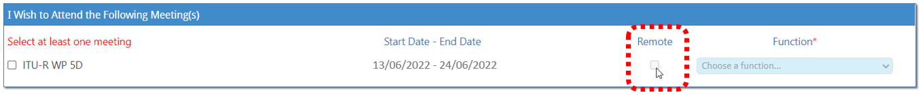
Please ensure that the box “Remote” is ticked during the registration process, if attending remotely. If the box is not ticked, physical participation will be assumed.

Annex 3
Program for Working Party 5D workshop on “IMT for 2030 and beyond”
Objective of the Workshop
The objective of the Workshop is to provide Working Party 5D (WP 5D) delegates with an overview and help in the understanding of ongoing worldwide research activities and initiatives related to future mobile communications targeting 2030 and beyond. This Workshop will also assist WP 5D in the development of the new Recommendation addressing IMT for 2030 and beyond.
Terms of Reference for Workshop
National/regional/global research groups/projects or programs and other related organizations are envisaged to present their work and/or views on the future development of mobile communication systems beyond IMT-2020, targeting year 2030 and beyond. Particularly, members who are yet to become actively involved in the work in WP 5D are encouraged to present their views.
Their views, among others, on the following topics are appreciated:
– evolution of IMT for 2030 and beyond, such as application, technology and spectrum aspects;
– views on the future role of IMT in serving users and the society;
– usage scenarios for IMT for 2030 and beyond;
– capabilities of IMT for 2030 and beyond.
Date
The workshop will be held on 14th June 2022 during the 41st meeting of WP 5D to be held from 13th to 24th June 2022. The workshop is intended to be within one day. Depending on the interest, submitted presentations (around 15-20 minutes/presentation), and logistical arrangements, the duration may be adjusted accordingly.
Workshop Organiser
Organiser: Dr. Hakan OHLSEN (hakan.ohlsen@ericsson.com)
Deadlines
The WP 5D Chairman’s Report of the 40th meeting solicits proposals on presentations for the Workshop. To prepare for the workshop at the venue, and to develop the detailed program, it is requested that presenters wishing to make a presentation at the workshop send their intention and a draft presentation to the Organiser (see email address above and include in the email header “[IMT Workshop]”) no later than 16th May 2022 (1600 hours CEST), which is four weeks prior to the start of 41st meeting of WP 5D.
All final presentation materials for the workshop should be submitted to the Organiser with the deadline being 6th June 2022 (1600 hours CEST), which is one week prior to the start of the 41st meeting of WP 5D.
Participants and Registration
A separate registration for the workshop is NOT required for registered participants of the 41st meeting of WP 5D.
Language
The workshop will be conducted in English only.
Additional information
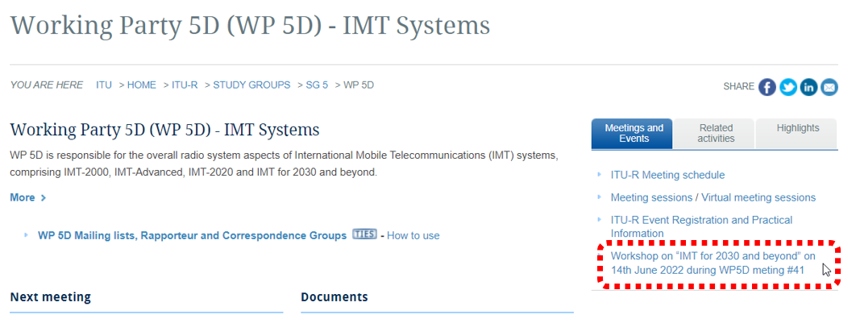
The workshop sessions Moderator will be the Chairman of Sub-Working Group Vision of WP 5D (Mr. HyoungJin CHOI). The additional workshop information will be provided and updated on the WP 5D webpage.

______________

* Where translation is required, contributions should be received at least three months prior to the meeting.

