Radiocommunication Bureau (BR)

Corrigendum 1 to  Circular Letter  7/LCCE/83 |  | 21 April 2023
To Administrations of Member States of the ITU, Radiocommunication Sector Members,
ITU-R Associates participating in the work of Radiocommunication Study Group 7 and ITU Academia
Subject: | Meeting of Working Party 7A (Sèvres, Paris, France, 26-30 June 2023)

Further to the invitation letter dated 20 February 2023, please find attached a corrigendum to Annex 2 with updated information provided by the host country.
Mario Maniewicz
Director
Annexes: 3

Annex 2
Additional information for the meeting of Working Party 7A
1 Introduction
This Annex provides both information on the meeting and guidance to the delegates for their stay in Sèvres, France.

2 Meeting Venue
The meeting will be held at:
BIPM
Address: 12 bis Grande Rue, 92310 Sèvres, Paris, France
URL: https://www.bipm.org/en/how-to-get-to-the-bipm

3 On-site Registration / Badges
Badges will be issued only to individuals who have successfully undergone the ITU-R registration procedure and have been accredited. Participants will not be admitted to the venue without the badge.
Registration (badges): 26 June 2023 from 09:00 onwards.

4 Access to the meeting venue

4.1 How to get to the BIPM
https://www.bipm.org/en/how-to-get-to-the-bipm

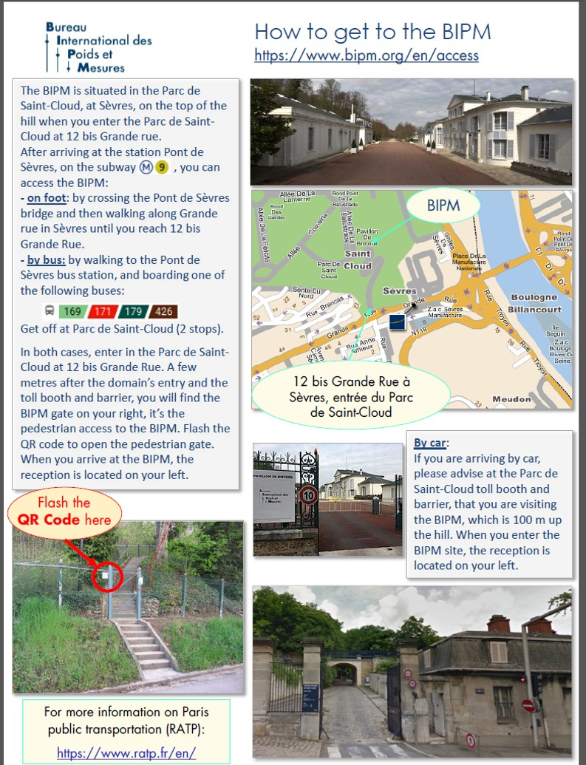

The QR Code will be communicated to the participants a few days before the meeting.

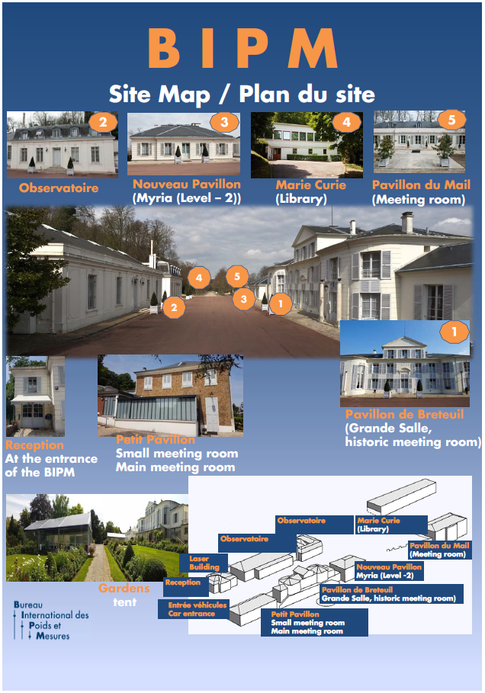
4.2 BIPM Site map

5 Accommodation
List of hotels in the vicinity of the BIPM.
Hotel Novotel****
11-13, Grande rue
92310 Sèvres
Tel: + 33 1 46 23 20 00
Fax: + 33 1 46 23 02 32
email: H1979@accor.com
Website: http://www.novotel.com/gb/hotel-1979-novotel-paris-pont-de-sevres/index.shtml
Aprt’hotel Paris/Boulogne
Résidence Lagrange City Boulogne
16, Cours de l'Ile Seguin 92200 Boulogne-Billancourt
Tel: + 33 1 46 10 01 58
Fax: + 33 1 46 21 34 55
email: boulogne@groupe-lagrange.com
Website: http://www.lagrange-city-paris-boulogne.com/
Hôtel Radisson Blu****
33, avenue Edouard Vaillant
92660 Boulogne Billancourt Cedex
Tel: + 33 1 46 08 85 00
Fax: + 33 1 46 08 87 29
email: reservations.boulogne@radissonblu.com
Website: https://www.radissonblu.com/en/hotel-parisboulogne
Ibis Styles Paris Boulogne Marcel Sembat***
92, boulevard de la République
92100 Boulogne
Tel: + 33 1 46 08 08 02
Fax:+ 33 1 46 08 27 16
email: HA039@accor.com
Website: http://www.ibis.com/gb/hotel-A039-ibis-styles-paris-boulogne-marcel-sembat/index.shtml
Hotel Villa Sorel**
20, rue Georges Sorel 92100 Boulogne Billancourt
Tel: + 33 1 46 04 91 58
Fax:+ 33 1 46 04 08 37
email : info@villasorel.com
Website: http://www.villasorel.com/en/index.php
Hotel de France**
112, av. du Général Leclerc 92100 Boulogne Billancourt
Tel: + 33 1 46 04 65 65
Fax:+ 33 1 46 04 03 16
email : resa.hoteldefrance@gmail.com
Website: https://www.hoteldefranceboulogne.fr/

Best Western Select Hotel***
66, avenue du Général-Leclerc
92100 Boulogne Billancourt
Tel: + 33 1 46 04 70 47
Fax: + 33 1 46 04 07 77
email: reception@select-hotel.fr
website: http://www.bestwestern.fr/en/hotel-Boulogne-billancourt,Best-Western-Select-Hotel,93602
Hôtel Alpha***
26, rue Emile Landrin
92100 Boulogne Billancourt
Tel: + 33 1 46 05 80 51
Fax: + 33 1 46 05 17 33
email: hotel@alpha-paris-hotel.com
Website: http://www.alpha-paris-hotel.com/English.phtml
Hôtel Ibis**
12, rue de la Ferme
92100 Boulogne Billancourt
email: h6245@accor.com
Website: http://www.ibis.com/gb/hotel-6245-ibis-paris-boulogne-billancourt/index.shtml
Hôtel Campanile
885, avenue Roger Salengro
92370 Chaville
Tel: +33 1 47 50 63 00
Fax: +33 1 47 50 69 42
email: chaville@campanile.fr
Website: http://www.campanile.com/en/hotels/campanile-paris-ouest-chaville
Please note that the BIPM is in no case liable for hotel reservation.
The BIPM cannot offer discounted rates.
In case of “no show” the visitor will be charged for it.
For visitors who would like to stay in Paris, please note that the BIPM is 15 minute walk from the line 9 of the metro (Pont de Sèvres) and 10 minute walk from the tram line T2 (Musée de Sèvres). More information is available at: https://www.bipm.org/en/how-to-get-to-the-bipm
6 VISA and immigration information
A visa may be necessary for participants from some countries to enter France. To check the visa requirements please contact the French Embassy in your country. Please see the link for more information regarding visas for France https://france-visas.gouv.fr/en_US/web/france-visas.
Participants who should require a personal Letter of Invitation for obtaining a visa are requested to contact BIPM via e-mail at meetings@bipm.org as soon as possible after registration with ITU.
7 Network
7.1 Internet Access
Local Secretariat will give you the Access SSID information on site.

8 Practical Information

8.1 Sèvres, Paris, France
Paris, France's capital, is a major European city and a global center for art, fashion, gastronomy and culture. Its 19th-century cityscape is crisscrossed by wide boulevards and the River Seine. Beyond such landmarks as the Eiffel Tower and the 12th-century, Gothic Notre-Dame cathedral, the city is known for its cafe culture and designer boutiques along the Rue du Faubourg Saint-Honoré.

8.2 Climate
Paris in France has a temperate, oceanic climate with warm summers and cold winters. There is a marked difference between seasons, but extreme hot or cold temperatures are rare.
Rainfall is moderate and steady year-round. The city is known for its sudden showers, although its annual average rainfall is low compared with other regions in France.
Monthly average values of the temperature and precipitation in Paris are given in the table below:
 | June
Average Max Temperature | 23 C
Average Minimum Temperature | 14 C
Sunshine hours | 16 hours
Average Precipitation | 42 mm
https://www.holiday-weather.com/paris

8.3 Electricity and Voltage
France uses 2 sizes of electrical outlets: type C (two round plugs) and type E (two round plugs with a male ground plug). All power sockets in France provide a voltage of 230 V with an electrical current frequency of 50 Hz.
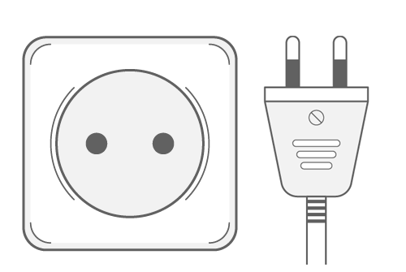
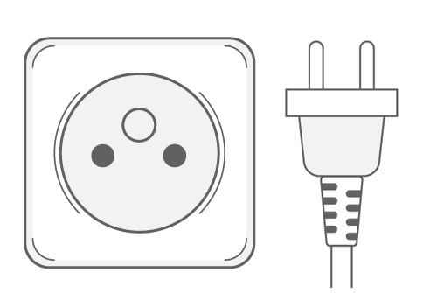

Adaptors will be made available by the BIPM in the meeting room for use at the BIPM Headquarters.

8.4 Language
French

8.5 Time Zone
UTC +2 (summertime).

9 Local Contact
If you have any questions about the meeting arrangements, please contact Ms Céline Fellag Ariouet cfellag@bipm.org.
______________

