INTERNATIONAL TELECOMMUNICATION UNION

Radiocommunication Bureau
(Direct Fax N°. +41 22 730 57 85)

Circular Letter  8/LCCE/152 | 14 February 2007
To Administrations of Member States of the ITU and
Radiocommunication Sector Members participating in the
work of Working Party 8F of Radiocommunication Study Group 8
Subject: Twenty-second meeting of Working Party 8F on IMT-2000 and systems beyond
IMT-2000

Introduction
At the kind invitation of the Administration of Japan, this letter is to announce that the 22nd meeting of ITU-R Working Party 8F will take place in Kyoto, Japan from 23-31 May 2007.

Place of the meeting
The meeting will take place at the:
Kyoto International Conference Center (ICC Kyoto)
Takaragaike, Sakyo-ku, Kyoto 606-0001, Japan
Tel: +81-75-705-1234
Fax: +81-75-705-1100
E-mail: ask@icckyoto.or.jp
Website: http://www.icckyoto.or.jp/en/index.html

For further information see Annex 2.

Program of the meeting
The draft agenda for the meeting is contained in Annex 1. The Questions assigned may be found on:
http://www.itu.int/pub/R-QUE-SG08/en
Working Party 8F will conduct its work in English.
Services directly connected with meeting activities, such as delegate registration, document distribution, etc., will be located at the meeting place. Registration will commence at 08:30 hours on the opening day. The opening session will commence at 10:00 hours.

Workshop
The Administration of Japan is also hosting a workshop on IMT-Advanced on 22 May 2007 at the same venue. Further information about the workshop is available on the Working Party 8F web page (http://www.itu.int/ITU-R/index.asp?category=study-groups&link=rwp8f&lang=en) under “Related Activities”.

Contributions
Contributions in response to the work of Working Party 8F are invited*. Contributions will be processed according to the provisions of Resolution ITU-R 1-4 and posted on the web.
The deadline for submitting contributions is Wednesday 16 May 2007, 16:00 hours UTC.
According to the ITU-R patent policy (Annex 1 to Resolution ITU-R 1-4), contributions containing a proposal for a Recommendation should draw the attention to any known patent or to any known pending patent application relating to systems or technologies considered in the proposal.
Copies of each contribution should be sent to the Study Group Department, Radiocommunication Bureau, for processing, to the Chairman of the Working Party and to the Chairman and
Vice-Chairmen of Radiocommunication Study Group 8. The pertinent addresses can be found on:
http://www.itu.int/ITU-R/go/chairmen/en
Participants are encouraged to submit contributions by electronic mail to:
rsg8@itu.int
Documentation
Contributions to this meeting are stored on the ITU web site at:
http://www.itu.int/md/R03-WP8F-C/en
A number of CD-ROMs containing all of the contributions will be available for participants at the start of the meeting. A CD-ROM containing all of the contributions and temporary documents will also be provided to each participant before the final plenary session.
Wireless LAN facilities will be provided in all meeting rooms and a cyber cafe facility will also be provided.
Participants are encouraged to use electronic working methods and to bring their laptops
(equipped with a CD-ROM drive and a WLAN-card) with them to the meeting. Please note that only a limited number of paper copies of the documents will be available at the meeting.

Participation
In order to make the necessary arrangements, it is requested that the intended participation of your representative(s) be advised no later than one month before the opening of the meeting by means of the annexed form (Annex 3). It is very important that participants requiring entry visas for Japan submit their applications at the earliest possible opportunity (see also § 5 and 6 of Annex 2).
Valery Timofeev
Director, Radiocommunication Bureau

Annexes: 3

Distribution:

– Administrations of Member States and Radiocommunication Sector Members participating in the work of Working Party 8F of Radiocommunication Study Group 8
– Chairman and Vice-Chairmen of Radiocommunication Study Group 8
– ITU-R Associates participating in the work of Radiocommunication Study Group 8
– Secretary General of the ITU, Director of the Telecommunication Standardization Bureau, Director of the Telecommunication Development Bureau
Annex 1
Draft agenda for the 22nd meeting of Working Party 8F
(Kyoto, Japan from 23-31 May 2007)

1 Opening of the meeting
2 Approval of the agenda
3 Report on the 21st meeting of Working Party 8F
4 Reports from Liaison and Special Rapporteurs
5 Proposed method of work
6 Assignment of contributions
7 Consideration of documents
8 Future work
9 Other business

S. BLUST
Chairman, Working Party 8F

Annex 2
Additional information on the 22nd meeting of Working Party 8F

1 Introduction
The Ministry of Internal Affairs and Communications of Japan is pleased to welcome participants to the 22nd meeting of the Working Party 8F which will take place in Kyoto, Japan, 23-31 May 2007.
This annex provides some information that you need to know about the meeting.
Supplemental information is available on: http://www.wp8fkyoto.jp/.

2 Meeting venue
Kyoto International Conference Center (ICC Kyoto)
Takaragaike, Sakyo-ku, Kyoto 606-0001, Japan
Tel: +81-75-705-1234
Fax: +81-75-705-1100
E-mail: ask@icckyoto.or.jp
Website: http://www.icckyoto.or.jp/en/index.html
Location: See attached map in Attachments 1 and 2 to this Annex.

3 Transportation to the meeting venue
It is recommended that you arrive at Kansai International Airport (Kanku). From Kansai International Airport, the most convenient transportation is by limousine bus at #8 bus stop for Kyoto Station. The bus fare is 2,300 Yen and it takes about 105 minutes to Kyoto Station. (See http://www.kate.co.jp/pc/english/english.html). Alternatively, the JR Express Train “HARUKA” is available from Kansai International Airport to Kyoto Station. The train fare is 2,980 Yen and travel time is about 75 minutes.
From Narita/Tokyo Airport you need one or more connections of domestic transportation to Kyoto. For details, see Attachment 1.
Maps of “ICC Kyoto” and hotels are provided in Attachment 2.
From the hotels to the meeting venue
The meeting venue is easily accessible from Kyoto Station within 25 minutes as shown on the map in Attachment 2 using the ‘Karasuma subway line’. The table in Attachment 2 shows the walking time to the nearest subway station from each recommended hotel and the time required by subway to “Kokusaikaikan Station” which is close to the meeting venue “ICC Kyoto”.

4 Hotel accommodation
JTB Western Japan has booked hotels in Kyoto for the meeting. Reservations will be made on a first-come, first-served basis. Please indicate your order of preference on the reservation form in Attachment 3 to this Annex.
Participants wishing to reserve hotel accommodation should complete the reservation form and return it by fax to JTB Western Japan no later than 2 May 2007. Credit card data should be included on the form to guarantee the hotel reservation.

5 Passports and Visas
A valid passport is required to enter Japan. Expired date of the passport shall be three months later than the arrival date in Japan. Participants who require a visa should apply for a visa at a Japanese consulate or diplomatic mission in their respective country well in advance of departure. Participants are also advised to contact their local travel agents or carriers. For more information please visit the web site of the Ministry of Foreign Affairs of Japan at:
http://www.mofa.go.jp/j_info/visit/visa/index.html.
Participants who need an invitation letter and/or visa supporting documents for entering Japan shall fill out completely the “VISA APPLICATION FORM” and “CURRICULUM VITAE” in Attachment 4 to this Annex, and fax or e-mail them and a “Copy of passport (page of photocopy)” to the contact point in Section 6 by 30 March 2007.

6 Contact point
For any further information you may require or if you need a personal invitation letter or official document for your visa application, please contact:
Ms. Erika Maki / Mr. Katsuro Ohmi
Technical Department, The ITU Association of Japan, Inc.
3rd floor Kanda KS Building, 1-8-6 Kaji-cho, Chiyoda-ku, Tokyo 101-0044, Japan
Tel: +81 3 5207 5722
Fax: +81 3 5207 5731
E-mail: tec@ituaj.jp

7 Computer facilities
A wireless network using IEEE 802.11b/g will be available within all meeting rooms and the Cyber Café. A wired LAN will be provided in the plenary room and the Cyber Café.

8 Social events
A welcome reception will be held on the evening of Wednesday, 23 May 2007. Additional event(s) will be announced during the meeting.

9 Language
Japanese is the dominant language in Japan. English is spoken in major hotels, large restaurants, department stores and other major organizations and tourist locations.

10 Currency and Banking
Only Japanese Yen (JPY) is accepted at stores and restaurants. Major foreign currencies may be exchanged to JPY at hotels and foreign exchange banks in Kyoto and at International Airports. Regular banking hours are 9 am – 3 pm, Monday through Friday.

Exchange rate as of 29 January 2007
 | JPY(¥)
1 USD $ | 121.92
1 EUR € | 157.45

Several foreign currencies (cash and/or traveller’s checks) can also be changed at the Kyoto International Conference Center: “ICC Kyoto” opens from 9 am – 5 pm every day.

11 Credit cards
Most hotels, restaurants, car rental agencies, department stores and shops accept major credit cards (American Express, Diners Club, JCB, MasterCard, VISA). Usually there is a sticker at the entrance indicating which cards are accepted.

12 Climate
Average temperature and rainfall by month in Kyoto are as follows:
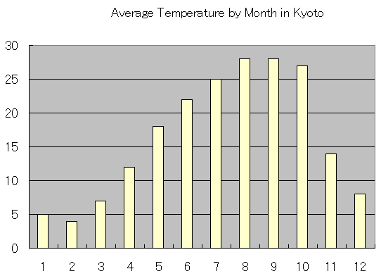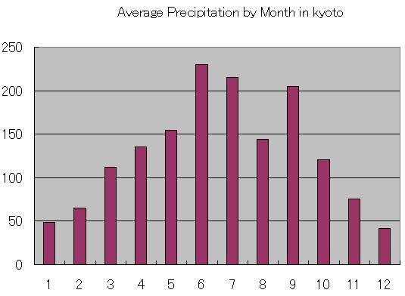
Month
C
mm
Month
Average rainfall in Kyoto
Average temperature in Kyoto

13 Local time
Local time is UTC +9h (no daylight saving in Japan.)

14 Tipping

Tipping is not customary in Japan.

15 Taxes
Sales tax in Japan is 5%.

16 Electrical appliances
The standard power supply in Japan is 100 volts. The frequency is 60 Hz in western Japan including Kyoto (50 Hz in eastern Japan including Tokyo). The type of power outlet/connector used in Japan is A type which is a two parallel pronged type.
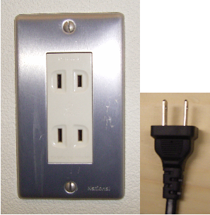
Attachment 1
Access to Kyoto International Conference Center (ICC Kyoto)
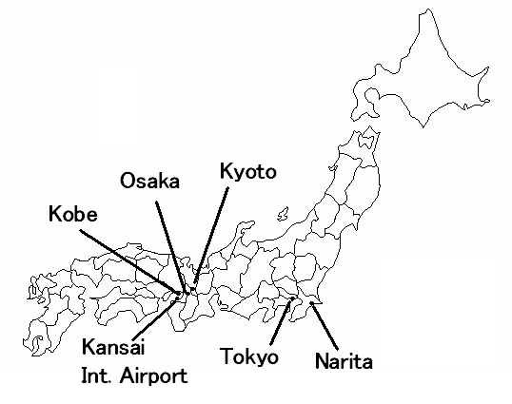
By limousine bus
Fare: ¥3,000
Travel time: 80-110 min.
Departure time: 06:55 – 23:00
(Approx. 30 min intervals)
By JR bullet train,
“NOZOMI”
Fare: ¥13,520
Travel time: 135 min.
Departure time
06:00 – 21:18
(Approx. 20 min. intervals)
Tokyo Station
By limousine bus
Fare: ¥1,280
Travel time: 55 min.
Departure time:
08:05 – 21:20
(Approx. 20 min. intervals)
2 New Miyako Hotel

3 Aranvert Hotel Kyoto

4 Hearton Hotel Kyoto

5 Hotel Hokke Club Kyoto

*1 Limousine Bus from Kansai International Airport http://www.kate.co.jp/pc/english/english.html
*2 Advance reservation is requested. For further information visit the website:
http://www.wp8fkyoto.jp/
*3 This will be called “Kyoto Takaragaike Prince Hotel” until 31 March.
Kansai International Airport (Kanku)
By JR limited express train;
“NARITA EXPRESS”
Fare: ¥2,940
Travel time: 55 min.
Departure time: 07:42 – 21:43
(Approx. 30 min intervals)
By domestic flight
Fare: ¥19,100
Travel time: 70 min.
Departure:
3 flights a day
Kyoto Station (JR Line)
about ¥800
about 5 min.
about ¥1,200
about 15 min.
By Taxi
Fare: about ¥32,000
Travel time:
about 120 min.
“Kansai Airport Shuttle”^{*2}
operated by Yasaka Taxi
Fare: ¥3,000/person
Travel time:
about 120 min.
By limousine bus *¹
Fare: ¥2,300
Travel time: 95 min.
Departure time:
07:00 – 23:30
(Approx. 60 min. intervals)
By JR Express Train,
“HARUKA”
Fare: ¥2,980
Travel time: 75 min.
Departure time:
05:30 – 20:30
(Approx.:30 min intervals)
By Taxi
5-min. walk.
5-min. walk.
about ¥3,000
about 40 min.
By Taxi
By Taxi
Osaka International
Airport (Itami)
On foot
On foot
Narita International Airport
1 Grand Prince Hotel Kyoto^{*3}

Attachment 2
Meeting venue and Hotel location
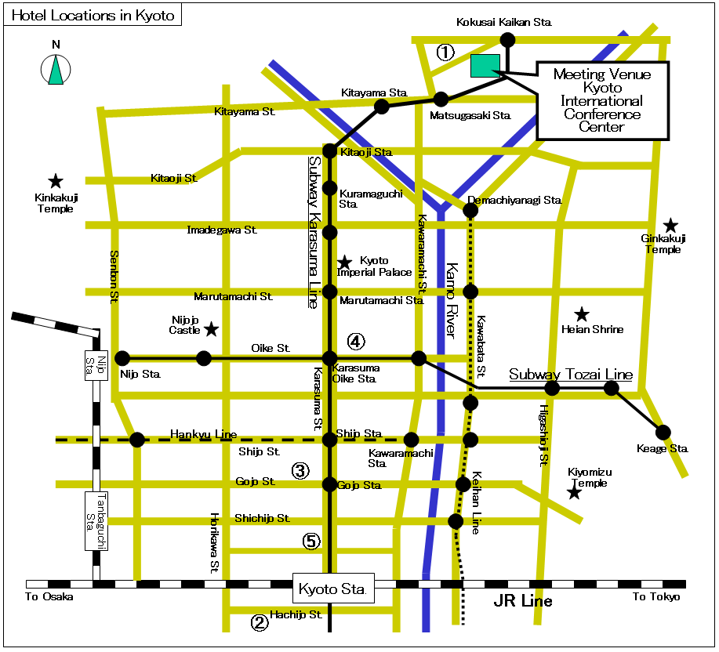
(Note) “Sta.” stands for Station
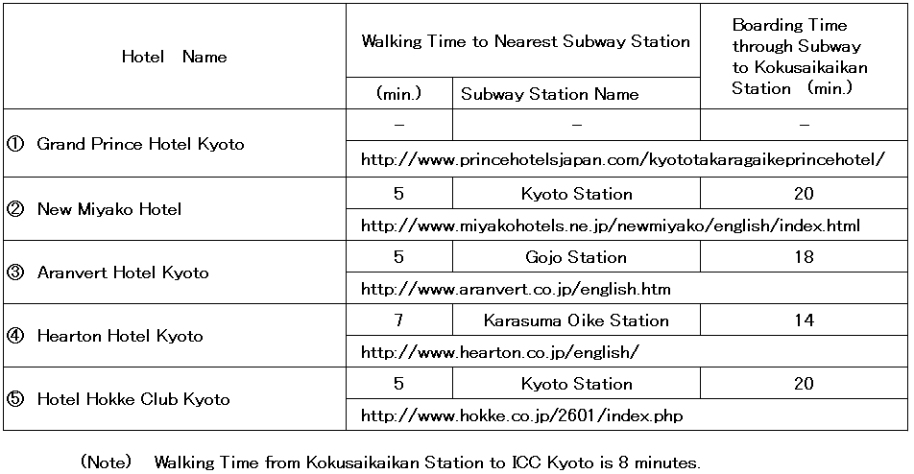
Meeting Venue vicinity

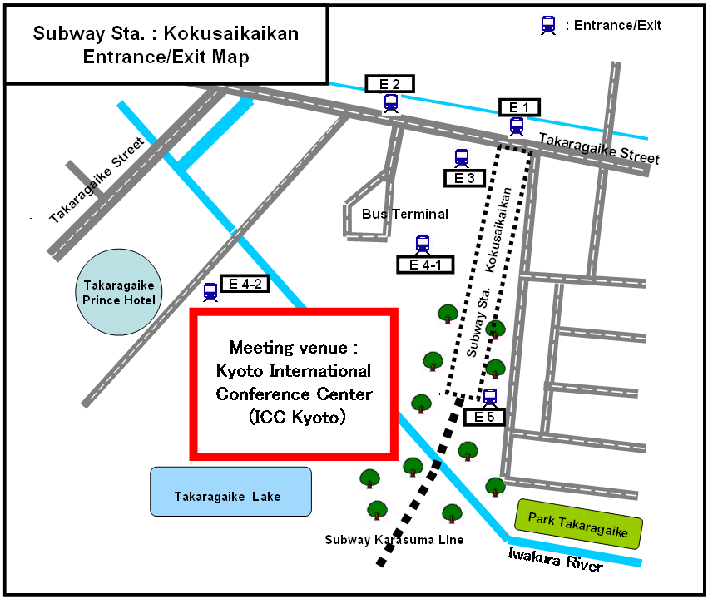
NOTE - E4-2 is nearest to ICC Kyoto, opening at 7 am and closing at 10:30 pm.

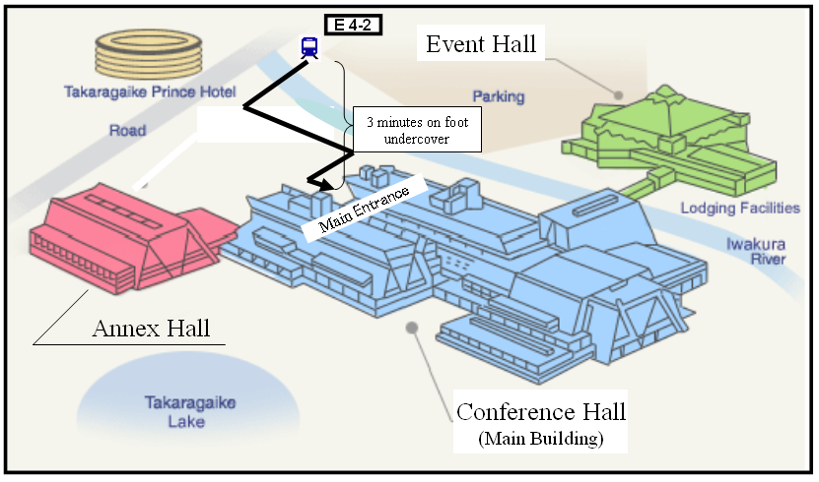

Attachment 3
Hotel accommodation for the WP 8F meeting
23-31 May 2007, Kyoto International Conference Center, Kyoto, Japan

Travel agent
JTB Western Japan handles all hotel accommodation for participants to the WP 8F meeting.
JTB Event & Convention Sale Dept.
Western Japan Regional Headquarters
Kyutaro-machi, Chuo-ku, Osaka, 541-0056 Japan
Tel: +81-6-6260-5076; Fax: +81-6-6263-0717
Hotel accommodation
JTB Western Japan has booked hotels in Kyoto at very special rates for participants to the meeting. Reservations will be made on a first-come, first-served basis. Please indicate your order of preference on the reservation form. Hotel locations in Kyoto are indicated in Attachment 2 (see previous page).
Hotel number | Name of Hotel | Room rate |  | Breakfast | Number of Available Rooms
Hotel number | Name of Hotel | Twin | Single | Breakfast | Number of Available Rooms
1 | Grand Prince Hotel Kyoto | 23,000 yen | 16,000 yen | 2,310 yen | 100
2 | New Miyako Hotel | 19,000 yen | 15,000 yen | 2,079 yen | 150
3 | Aranvert Hotel Kyoto | 16,000 yen | 9,000 yen | 1,732 yen | 20
4 | Hearton Hotel Kyoto | 15,000 yen | 8,500 yen | 1,000 yen | 25
5 | Hotel Hokke Club Kyoto | - | 7,500 yen | 1,050 yen | 45
NOTES:
1. Room rates include tax and service charge.
2. Room rates do not include breakfast.
3. Available rooms are valid from 21 to 31 May (i.e. 1 June, the checkout date).
Application and payment
Participants wishing to reserve hotel accommodation should complete the reservation form on the next page and return it by fax to JTB Western Japan no later than 2 May 2007. Credit card data should be included on the form to guarantee the hotel reservation and to pay cancellation fees.
No reservation will be confirmed in the absence of this reservation form. All payment must be in Japanese yen. For further information, visit the website (http://www.wp8fkyoto.jp/)
The following credit cards are accepted:
1. American Express 2. Diners Club 3. JCB
4. MasterCard 5. VISA
Cancellation
In the event of cancellation, written notification should be sent to JTB Western Japan. The following cancellation fees will be charged against your credit card, indicated on the next page.
Up to 21 days before the first night of stay No cancellation fee
20 to 9 days before the first night of stay 2,000 yen
8 to 2 days before the first night of stay 20% of total room charge
1 day before the first night of stay 80% of total room charge
On the day of the first night of stay or no notice given 100% of total room charge
Hotel accommodation reservation form for the meeting of
ITU-R Working Party 8F in Japan, 23-31 May 2007

Please complete and return this form by fax to: JTB Event & Convention Sale Dept. Western Japan Regional Headquarters
Deadline: 2 May 2007
(Please type or print in block letters and check appropriate boxes.)
FULL NAME: □ Prof. □ Dr. □ Mr. □ Ms.
Family name First name
ORGANIZATION:
FULL ADDRESS: □ Office □ Home

Postcode: Country:
Phone: + Fax: + E-mail:
Name of Accompanying Person(s), if any: □Mr. □Ms.
Family name First name
HOTEL ACCOMMODATION
Please select the hotel number you wish to book from the hotel numbers 1 to 5 (see table on the previous page).
Hotel Number | Number of room(s) | Date of check in and check out
1st choice . | Twin(s): .  Single(s): . | Check in May  Check out May/June
2nd choice . | Twin(s): .  Single(s): . | Check in May  Check out May/June
CREDIT CARD
□ American Express □ Diners Club □ JCB □ MasterCard □ VISA
Card number: Expiration date:
Name of card holder:
Authorized signature:
Date: Signature:
NOTES:
1. All payment must be in Japanese Yen.
2. Traveller’s check can be used depending on the hotel, please visit the website (http://www.wp8fkyoto.jp/).
3. This application will be valid upon receipt for confirmation from JTB Western Japan.
The ITU Association of Japan, Inc.
Tel: +81-3-5207-5722 Fax: +81-3-5207-5731 E-mail: tec@ituaj.jp
Attention to: Erica MAKI (Ms) and Katsuro OHMI (Mr), Technical Department
Attachment 4
Visa Application Form

Participants who need an invitation letter and/or visa supporting documents for entering Japan shall fill out COMPLETELY the “VISA APPLICATION FORM” and “CURRICULUM VITAE (on the next page)” in block letters (English). Please send them along with a “Copy of passport (page containing photograph)” to the above address by fax and/or e-mail no later than 30 March 2007.
1. FULL NAME
□ Mr. / □ Ms __________________ __________________ _________________ (English)
(Given Name) (Middle Name) (Family Name)
__________________ __________________ _________________ (Chinese)
* For those having Chinese nationality, please write clearly your full name in both Chinese and English.
2. PASSPORT INFORMATION
Nationality: _______________________ Age: as of 1 March 2007
Passport number: _______________________ Date of expiry: ______/_____/_____
(Day / Month / Year)
Date of birth: _______/______ /________ Place of birth: _________________
(Day / Month / Year)
3. COMPANY NAME, JOB TITLE and COMPANY ADDRESS
Company name: ______________________________________________________
Job Title/Department: ______________________________________________________
Company address: ______________________________________________________
* For those having Chinese nationality, please fill out the blank above clearly in both Chinese and English.
4. TELEPHONE NUMBER, FAX NUMBER and E-MAIL ADDRESS
Telephone number: _____________________ Fax number: __________________
E-mail address: _______________________________________________________
5. STAYING PLACE in Japan (HOTEL) ___________________________________________
6. FLIGHT INFORMATION (TO/FROM JAPAN)
Arrival
Flight No. ________________________________
Time/Date/Month _________/__________/____________
Name of airport (arrival) ________________________________
Departure
Flight No. ________________________________
Time/Date/Month _________/__________/____________
Name of airport (departure) ________________________________
* For visa application, planned flight schedule is also acceptable, in case your flight is not fixed.
Please inform us by fax and/or e-mail immediately after fixing.

CURRICULUM VITAE

1. FULL NAME
2. HOME ADDRESS
3. HOME TELEPHONE
NUMBER
4. NATIONALITY

5. WORK EXPERIENCE

6. EDUCATION

annex 3
Registration Form
ITU-R Working Party 8F Meeting
Japan, 23-31 May 2007
Radiocommunication Bureau |  | I wish to participate in

Working Party 8F
✓

Mr. Mrs. Ms. Miss: |  | …………………………………………………………. |  |  |  |  |  |  |  | …………………………………………………………………...
 |  |  |  | (family name) |  |  |  |  |  | (first name)
Accompanied by family member(s): |  |  |  | …………………………………………… |  |  |  |  |  | …………………………………………………………………...
 |  |  |  | (family name) |  |  |  |  |  | (first name)
1. REPRESENTATION
Name of Member State: |  |  |  | …………………………………………………………………………………………………………………….
❒ Head of Delegation |  |  |  |  | ❒ Deputy |  |  |  |  |  |  |  | ❒ Delegate
(to be completed by representatives of Member States only)
Name of Sector Member: |  |  |  | …………………………………………………………………………………………………………………….
r | Recognized Operating Agencies |  |  |  |  |  |  | r |  |  | Regional Telecommunication Organizations
r | Scientific or Industrial Organizations |  |  |  |  |  |  | r |  |  | Intergovernmental Organizations operating Satellite Systems
r | UN, Specialized Agencies and the IAEA |  |  |  |  |  |  | r |  |  | Other Entities dealing with Telecommunication matters
r | Regional and other International Organizations |  |  |  |  |  |  | r |  |  | Associates
2. OFFICIAL ADDRESS
Name of the Company: |  |  | …………………………………………………………………………………………………………………………
Street Address: |  |  | …………………………………………………………………………………………………………………………
City/State/Code/Country: |  |  | …………………………………………………………………………………………………………………………
Business tel.: |  |  | …………………………………………… |  |  |  |  |  | Fax: |  |  | ……………………………………………
E-mail: |  |  | …………………………………………… |  |  |  |  |  | In case of emergency: |  |  | ……………………………………………
3. DOCUMENTS
I wish to receive paper copies during the meeting: |  |  |  |  |  | r | Yes |  |  |  |  |  | r | No

Date : |  | ……………………………………………………………………… |  |  |  | Signature: | …………………………………………………………...
 | For BR Secretariat use only
 | Approved (if applicable) |  | Personal Section |  | Meeting Section |  |  | Pigeonhole
 | To be returned duly completed to the Radiocommunication Bureau |  |  | Place des Nations  CH-1211 Geneva 20  Switzerland |  |  |  |  | Telephone: +41 22 730 5802  Telefax: +41 22 730 6600  Email: linda.kocher@itu.int

- * Contributors are urged to reduce the length of their contributions as much as possible. The recommended maximum length of an input document is 10 pages. Long documents should be structured as a small number of cover pages (preferably one) summarizing the document and an attachment containing the detailed information. The attachments of such long documents, when submitted as delayed contributions, would only be distributed on paper to the participants at the meeting, on request.

