INTERNATIONAL TELECOMMUNICATION UNION

Radiocommunication Bureau
(Direct Fax N°. +41 22 730 57 85)

Circular Letter  8/LCCE/155 | 17 July 2007
To Administrations of Member States of the ITU and
Radiocommunication Sector Members participating in the
work of Working Party 8F of Radiocommunication Study Group 8
Subject: Special Meeting of Working Party 8F on IMT-2000 and systems beyond IMT-2000

Introduction
At the kind invitation of the Administration of Korea, this letter is to announce that the Special Meeting of ITU-R Working Party 8F will take place in Seoul, Korea, from 29-31 August 2007.

Place of the meeting
The meeting will take place at the:
Grand Hyatt Hotel
747-7 Hannam 2-Dong, Yongsan-Ku,
Seoul, Republic of Korea, 140-738
Tel: +82 2 797 1234
Fax: +82 2 798 6953
E-mail: info.grandhyattseoul@hyattintl.com
Website: http://www.seoul.grand.hyatt.com
For further information see Annex 2.

Program of the meeting
The draft agenda for the meeting is contained in Annex 1. The Questions assigned may be found on:
http://www.itu.int/pub/R-QUE-SG08/en
Working Party 8F will conduct its work in English.

Services directly connected with meeting activities, such as delegate registration, document distribution, etc., will be located at the meeting place. Registration will commence at 08:00 hours on the opening day. The opening session will commence at 09:00 hours.

Contributions
Contributions in response to the work of Working Party 8F are invited*. Contributions will be processed according to the provisions of Resolution ITU-R 1-4 and posted on the web.
The deadline for submitting contributions is Wednesday 22 August 2007, 16:00 hours UTC.
According to the ITU-R patent policy (Annex 1 to Resolution ITU-R 1-4), contributions containing a proposal for a Recommendation should draw the attention to any known patent or to any known pending patent application relating to systems or technologies considered in the proposal.
Copies of each contribution should be sent to the Study Group Department, Radiocommunication Bureau, for processing, to the Chairman of the Working Party and to the Chairman and
Vice-Chairmen of Radiocommunication Study Group 8. The pertinent addresses can be found on:
http://www.itu.int/ITU-R/go/chairmen/en
Participants are encouraged to submit contributions by electronic mail to:
rsg8@itu.int
Documentation
Contributions to this meeting are stored on the ITU web site at:
http://www.itu.int/md/R03-WP8F-C/en
A number of CD-ROMs containing all of the contributions will be available for participants at the start of the meeting.
Wireless LAN facilities will be provided in all meeting rooms and a cyber cafe facility will also be provided.
The preferred method of work for this meeting is to use electronic working methods.
Participants are encouraged to bring their laptops (equipped with a CD-ROM drive and a WLAN-card) with them to the meeting.

Participation
In order to make the necessary arrangements, it is requested that the intended participation of your representative(s) be advised no later than one month before the opening of the meeting by means of the annexed form (Annex 3). It is very important that participants requiring entry visas for Korea submit their applications at the earliest possible opportunity (see Attachment 4 of Annex 2).
Valery Timofeev
Director, Radiocommunication Bureau

Annexes: 3

Distribution:

– Administrations of Member States and Radiocommunication Sector Members participating in the work of Working Party 8F of Radiocommunication Study Group 8
– ITU-R Associates participating in the work of Radiocommunication Study Group 8
– Chairman and Vice-Chairmen of Radiocommunication Study Group 8
– Secretary General of the ITU, Director of the Telecommunication Standardization Bureau, Director of the Telecommunication Development Bureau
Annex 1
Draft agenda for the Special Meeting of Working Party 8F
(Seoul, Korea, 29-31 August 2007)

1 Opening of the meeting
2 Approval of the agenda
3 Terms of reference* (Doc. 8F/1335)
4 Proposed method of work
5 Assignment of contributions
6 Consideration of documents (Docs. 8/186, 8/193, 8/194, 8F/…)
7 Future work
8 Other business

S. BLUST
Chairman, Working Party 8F

Annex 2

Practical information on the Special Meeting of Working Party 8F

Introduction
The Ministry of Information and Communication of Korea has the pleasure of welcoming participants to the Special Meeting of Working Party 8F to be held in Seoul, Korea,
from 29-31 August 2007. This Annex provides some information that you need to know about the meeting. We look forward to seeing you in Seoul.

Meeting venue
Grand Hyatt Hotel
747-7 Hannam 2-Dong, Yongsan-Ku,
Seoul, Republic of Korea, 140-738
Tel: +82 2 797 1234
Fax: +82 2 798 6953
E-mail: info.grandhyattseoul@hyattintl.com
Website: http://www.seoul.grand.hyatt.com
Location: See Attachments 1 and 2 to this Annex.

3 Transportation to the meeting venue
It is recommended that you arrive at Incheon International Airport. The most convenient transportation from Incheon International Airport is by limousine bus. You may take the limousine bus at #2 bus stop in front of exits 4B & 11A. The bus fare is KRW 13,000 and it takes about 80 to 90 minutes to get to Grand Hyatt Hotel.
(See http://www.airport.or.kr/airport/traffic/bus/busList.iia?flag=E&fake=1183670588980 )
Alternatively, you may use chauffeured limousine services that Grand Hyatt Hotel provides via Hertz Rent-a-Car for airport pick-up and drop-off. Hertz Rent-a-Car desks are located in front of Customs Hall Exits A & F on the Arrivals Level. English-speaking Hertz personnel will be there to help you. Reservations can be made through the hotel's reservation desk. The limousine service fare is KRW 110,000 and KRW 100,000, respectively, for pick-up and drop-off.
You may also take a taxi, and it takes about an hour from the airport to the hotel Fare may vary from KRW 75,000 – KRW 150,000 depending on the type of taxis and traffic jam. For details, see Attachment 1.
Maps of “Incheon International Airport” and hotels are provided in Attachment 2.

4 Hotel accommodation
The local secretariat (TTA) has arranged hotels in Seoul for the meeting. Reservations will be made on a first-come, first-served basis. The main hotel is Grand Hyatt which is the meeting venue and an alternative hotel is Hamilton.
Participants wishing to reserve hotel accommodations should complete the reservation form and return it by fax or email directly to the proposed hotels no later than 20 August 2007. Credit card information should be included on the form to guarantee the hotel reservation (see Attachment 3).

5 Passports and visas
A valid passport is required to enter Korea. Expired date of the passport shall be three months later than the arrival date in Korea. Participants who require a visa should apply for a visa at a Korean consulate or diplomatic mission in their respective country well in advance of departure. Participants are also advised to contact their local travel agents or carriers. For more information, please visit the website of the Ministry of Foreign Affairs and Trade of Korea at:
http://www.mofat.go.kr/me/index.jsp
Participants who need an invitation letter for obtaining a visa shall fill out completely the “VISA APPLICATION FORM” in Attachment 4 of this Annex, and fax or e-mail it with a copy of passport (the page giving information about the bearer) to the contact person in Section 6
by 31 July 2007.

6 Contact point
For any further information you may require or if you need a personal invitation for your visa application, please contact:

(Ms.) Sunhye CHOI
TTA (Telecommunications Technology Association)
Standardization Dept. / Standardization Service Team
Tel: +82 31 724 0115 / Fax: +82 31 724 0119
E-mail: wonder@tta.or.kr
Address: 267-2 Seohyeon-dong, Bundang-gu, Seongnam-si, Gyeonggi-do, 463-824, Rep. of Korea

7 Computer facilities
A wireless network (IEEE 802.11b/g Wi-Fi standard) will be available in all meeting rooms and the Internet Cafe.

8 Social events
Luncheon will be held on Wednesday, 29 August 2007 to welcome all participants. Please be sure to join us. Additional event(s) may be announced during the meeting.

9 Language
Korean is the most widely spoken language in Korea. But you may find English-speaking personnel in major hotels, large restaurants, department stores and other major organizations and tourist locations.

10 Currency and banking
Only the Korean Won (KRW) is accepted at stores and restaurants. Major foreign currencies may be exchanged for KRW at hotels and banks in Seoul and at International Airports. Regular banking hours are 10:30 a.m. – 4:30 p.m., Monday through Friday.

Exchange rate as of 6 July 2007
 | KRW
1 USD $ | 938.13
1 EUR € | 1280.38

11 Credit cards
Most hotels, restaurants, car rental agencies, department stores and shops accept major credit cards (American Express, Diners Club, BC, MasterCard, Visa). Usually there are stickers at the entrance indicating which cards are accepted.

12 Climate
Average temperatures and rainfalls of each month in Seoul are as follows:

Seoul | Jan | Feb | Mar | Apr | May | Jun | Jul | Aug | Sep | Oct | Nov | Dec
Rainfall (mm) | 17 | 21 | 56 | 68 | 86 | 169 | 358 | 224 | 142 | 49 | 36 | 32
Rainfall (inches) | 0.6 | 0.8 | 2 | 3 | 3 | 6.5 | 14 | 9 | 5.5 | 2 | 1.5 | 1
Min Temp (°C) | -9 | -7 | -2 | 5 | 10 | 16 | 21 | 22 | 15 | 7 | 0 | -7
Max Temp (°C) | 0 | 3 | 8 | 16 | 22 | 27 | 29 | 31 | 26 | 19 | 10 | 3
Min Temp (°F) | 16 | 19 | 28 | 41 | 50 | 61 | 70 | 71 | 59 | 44 | 32 | 19
Max Temp (°F) | 32 | 37 | 46 | 61 | 71 | 80 | 84 | 88 | 79 | 66 | 50 | 37

13 Local time
Local time is UTC +9h (no daylight saving in Korea).

14 Tipping

Tipping is not customary in Korea.

15 Taxes
Sales tax included in the total fare.

16 Electrical appliances
The standard power supply in Korea is 220 volts. The type of power outlet/connector used in Korea is A type which is a two parallel type.

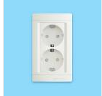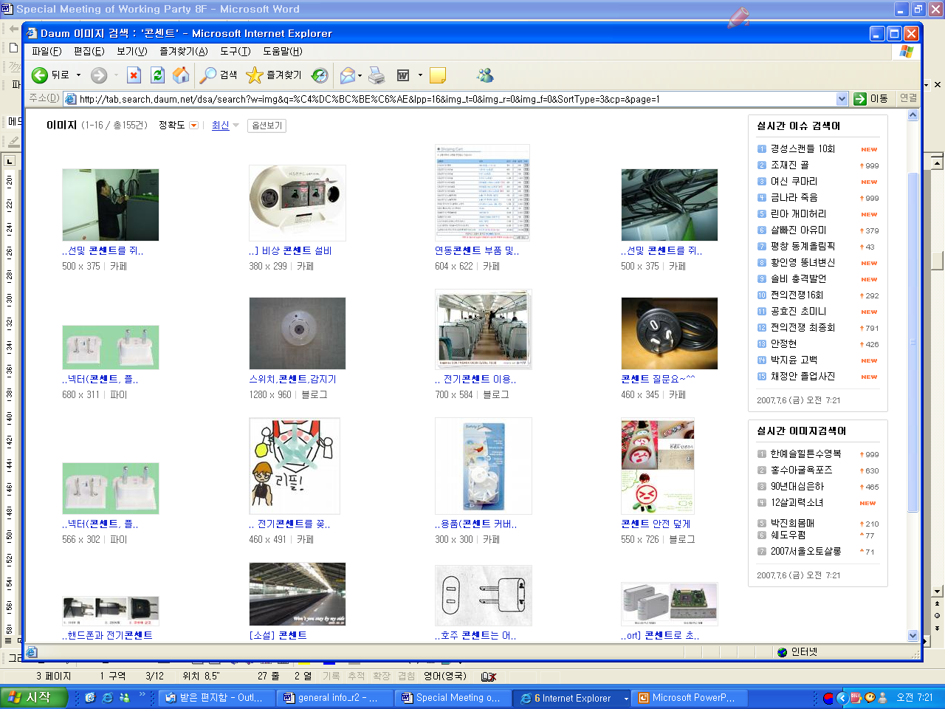

17 Experience of Mobile WiMax (WiBro)
Portable Internet service is now provided by two operators, KT and SK Telecom in Korea using one of Mobile WiMax profile (also known as WiBro in Korea) in 2.3 GHz Band. Participants may experience the WiBro during the Special WP 8F Meeting. Details are available at the information desk near the meeting room.

Attachment 1
Access to Grand Hyatt Hotel & Hamilton Hotel
Incheon International Airport
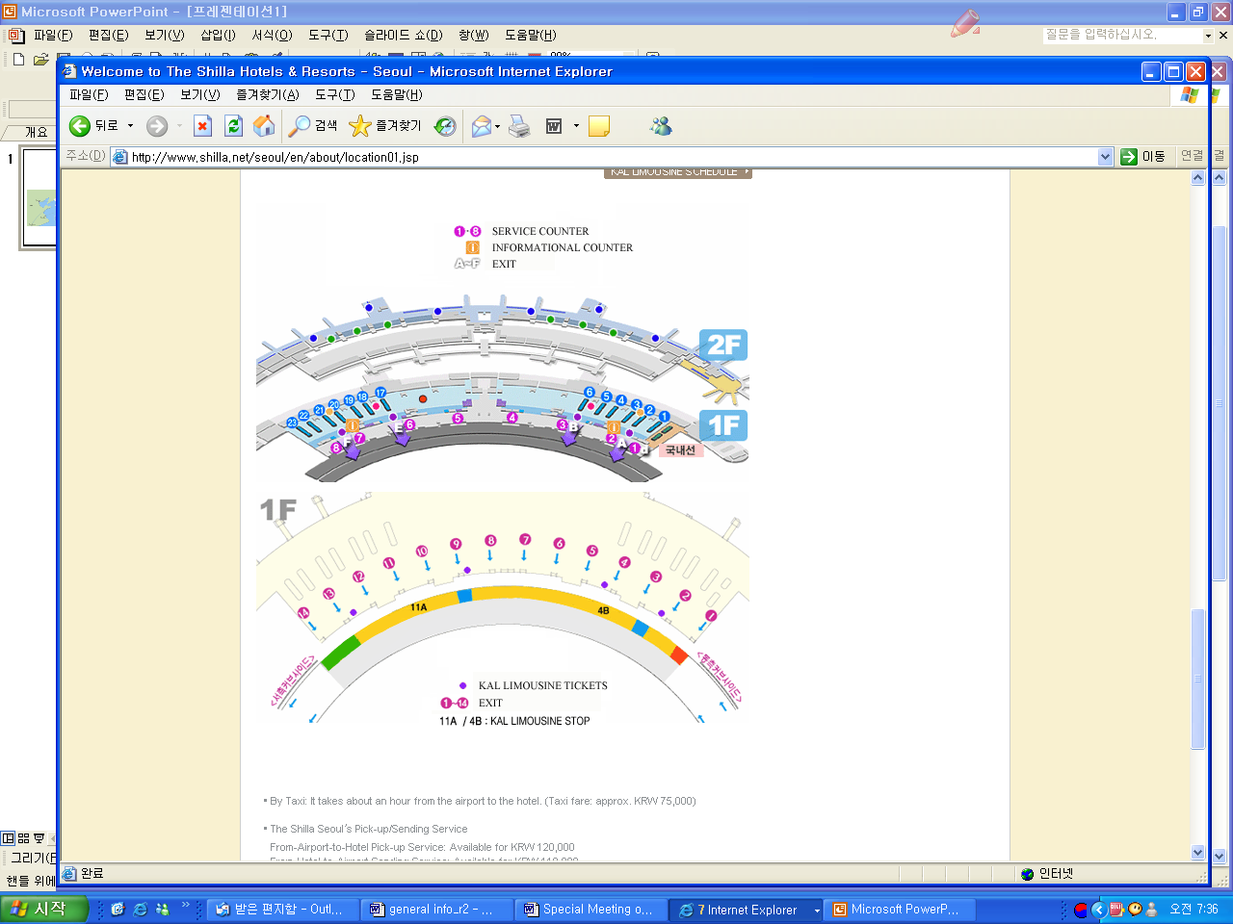

GO TO – Grand Hyatt Hotel (Meeting venue)
By Limousine Bus
Station No: 4B, 11A
Station: Incheon International Airport
- Holiday Inn -> Seoul Railroad Station -> Hilton -> Grand Hyatt Seoul Hotel
Fare: 13,000 Won
Time: 60~70 min
First Bus: Direction of Seoul - 05:45 a.m.
Direction of Airport - 21: 00 p.m.
(Approx. 20 min. interval)
By Taxi
Fare: 75,000Won -150,000Won Travel time: 50~60 min
Departure time: 24 hours
Website: http://www.airport.or.kr/airport/traffic/bus/busList.iia?flag=E&fake=1183670588980
GO TO – Hamilton Hotel (Alternative hotel)
By Limousine Bus
Station No: 5A, 11B
Station: Incheon International Airport
- Full Gospel Church -> 63 Building -> Han River Orin APT -> Hamilton Hotel
Fare: 13,000 Won
Time: 90 min
First Bus: Direction of Seoul - 05:45 a.m.
Direction of Airport - 21: 00 p.m.
(Approx. 20 min. interval)
By Taxi
Fare: 75,000 Won – 150,000Won
Travel time: 50~60 min
Departure time: 24 hours
Website: http://www.airport.or.kr/airport/traffic/bus/busList.iia?flag=E&fake=1183670588980

Attachment 2
Meeting Venue and Hotel Location
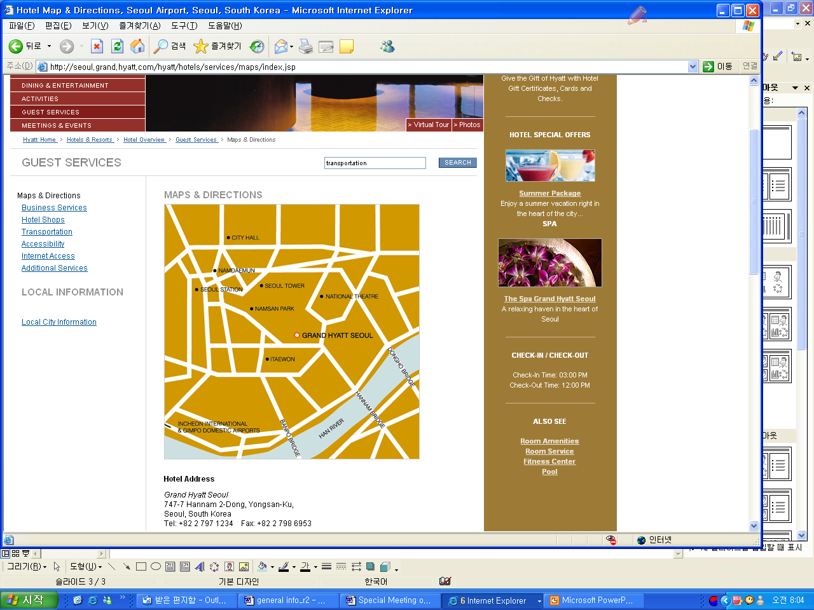
Hamilton Hotel

Meeting Venue

Transportation

Hamilton Hotel to Meeting Venue (Grand Hyatt Hotel Seoul)
Shuttle bus | Taxi | By walking
10 min | 5 min | 25 min
* Time table of the shuttle bus will be provided upon check-in.

Attachment 3
Hotel accommodation for the Special Meeting of Working Party 8F
29-31 August 2007, Grand Hyatt Hotel, Seoul, Korea
Hotel accommodation
Special rates are available for meeting participants. Reservations will be made on a first-come, first-served basis. Please indicate your order of preference on the reservation form and send it by fax or email directly to the hotel. Hotel locations in Seoul are indicated in Attachment 2 (see the previous page).

Hotels | Room Type |  | Room Rate  (Excl. VAT.) | Contact person | Website
Grand Hyatt  Seoul  (Meeting Venue) | Grand Queen | Single | KRW 140,000 | Lee, ki yeon  E-mail :  kiyeon.lee@hyattintl.com  Tel: +82 2 799 8205  Fax: +82 2 798 6953 | http://www.hyatt.com/hyatt/index.jsp  (Not include breakfast)
Grand Hyatt  Seoul  (Meeting Venue) | Grand Queen | Double | KRW 160,000
Grand Hyatt  Seoul  (Meeting Venue) | Club Queen | Single | KRW 190,000
Grand Hyatt  Seoul  (Meeting Venue) | Club Queen | Double | KRW 240,000
Grand Hyatt  Seoul  (Meeting Venue) | Not Include Breakfast
Hamilton Hotel  (Alternative hotel) | Deluxe | Twin | KRW 110,000 | Park, KyuSoo  E-mail: kspark@hamilton.co.kr  Tel: +82 2 6393 1313  Fax: +82 2 795 0457 | http://www.hamilton.co.kr/  (Include breakfast)
Hamilton Hotel  (Alternative hotel) | Deluxe | Double | KRW 110,000 |  | http://www.hamilton.co.kr/  (Include breakfast)
Hamilton Hotel  (Alternative hotel) | Extra bed or Tripple |  | KRW 30,000 |  | http://www.hamilton.co.kr/  (Include breakfast)
Hamilton Hotel  (Alternative hotel) | Breakfast free served  * All rates are inclusive of breakfast. Rates excluding breakfast are not available because this specially arranged for this occasion. |  |  |  | http://www.hamilton.co.kr/  (Include breakfast)
NOTES:
1. Room rates do not include VAT. (10 percent will be added). * It does not apply to Koreans.
2. Special rate are valid from 28 to 31 August (i.e. 1 September, the checkout date).

Cancellation
– Grand Hyatt Hotel:
Cancellation should be made within 72 hours prior to arrivals. No-shows will be charged for the entire length of stay on their respective credit card. Check in guaranteed from 3 pm onwards.
– Hamilton Hotel:
Bookings may be cancelled without penalty up to 7 days prior to arrival but there are penalty of 1 night charge if cancellations made 1 day before arrival, half day charge 2 days before.
Cancellations received after these cut-off periods or no-show on day of arrival will result in a charge amounting to one night room, inclusive all.
Payment
Credit card information should be included on the form to guarantee the hotel reservation and to pay cancellation fees.
No reservation will be confirmed in the absence of this reservation form. All payment must be made in Korean Won.
The following credit cards are accepted:
1. American Express 2. Diners Club 3. BC 4. MasterCard 5. Visa
Hotel accommodation reservation form
for the Special Meeting of Working Party 8F
29-31 August 2007, Grand Hyatt Hotel, Seoul, Korea
Please complete and return this form by fax or email to the hotel (See the previous page for the contact information). Deadline: 20 August 2007
(Please type or print in block letters and check appropriate boxes.)
FULL NAME: Prof. Dr. Mr. Ms.
Family name First name
ORGANIZATION:
FULL ADDRESS: Office Home

Postcode: Country:
Phone: + Fax: + E-mail:
Name of Accompanying Person(s), if any: □Mr. □Ms.
Family name First name
HOTEL ACCOMMODATION
* Please specify your choice of accommodation.
Hotels | Room Type |  | Room Rate (subject to 10% tax)
◻ Grand Hyatt Seoul  (Meeting venue) | Grand Queen | ◻ Single | KRW 140,000+
◻ Grand Hyatt Seoul  (Meeting venue) | Grand Queen | ◻ Double | KRW 160,000+
◻ Grand Hyatt Seoul  (Meeting venue) | Club Queen | ◻ Single | KRW 190,000+
◻ Grand Hyatt Seoul  (Meeting venue) | Club Queen | ◻ Double | KRW 240,000+
◻ Hamilton Hotel  (Alternative hotel) | Deluxe | ◻ Twin | KRW 110,000+
◻ Hamilton Hotel  (Alternative hotel) | Deluxe | ◻ Double | KRW 110,000+
◻ Hamilton Hotel  (Alternative hotel) | ◻ Extra bed or Tripple |  | KRW 30,000+
* Reservation Request
Check In Date
Check-Out Date
Early Check-In Time
Special Requirement | ◻ Non-smoking ◻ others _________________________  ◻ sharing with ____________________________________
CREDIT CARD
□ American Express □ Diners Club □ BC □ MasterCard □ VISA
Card number: Expiration date:
Name of card holder:
Authorized signature:
Date: Signature:
NOTES:
1. All payment must be in Korean Won.
2. Traveller’s check can be used depending on the hotel.
Attachment 4
Visa Application Form

TTA (Telecommunications Technology Association)
Tel: +82 31 724 0115 / Fax: +82 31 724 0119 / E-mail: wonder@tta.or.kr
Attention to: Ms. Sunhye Choi
Participants who need an invitation letter for entering Korea shall fill out COMPLETELY the “VISA APPLICATION FORM” in block letters (English). Please send it along with a copy of passport (the page giving information about the bearer) to the above address by fax or e-mail no later than 31 July 2007.
1. FULL NAME
□ Mr. / □ Ms __________________ __________________ _________________ (English)
(Given Name) (Middle Name) (Family Name)
2. PASSPORT INFORMATION
Nationality: _______________________ Passport number: _______________________
Date of issue: ______/_____/_____ Date of expiry: ______/_____/_____
(Day / Month / Year) (Day / Month / Year)
Date of birth: ______/_____/_____ Place of birth: ______/_____/_____
(Day / Month / Year) (Day / Month / Year)
3. COMPANY NAME, JOB TITLE and COMPANY ADDRESS
Company name: ______________________________________________________
Job Title/Department: ______________________________________________________
Company address: ______________________________________________________
4. TELEPHONE NUMBER, FAX NUMBER and E-MAIL ADDRESS
Telephone number: _____________________ Fax number: __________________
E-mail address: _______________________________________________________
5. STAYING PLACE in KOREA(HOTEL) ___________________________________________
6. FLIGHT INFORMATION (TO/FROM KOREA)
Arrival
Flight No. ________________________________
Time/Date/Month _________/__________/____________
Name of airport (arrival) ________________________________
Departure
Flight No. ________________________________
Time/Date/Month _________/__________/____________
Name of airport (departure) ________________________________
* For visa application, planned flight schedule is also acceptable, in case your flight is not fixed. Please inform us by fax or e-mail immediately after fixing.

annex 3
Registration Form
ITU-R Working Party 8F Special Meeting
Korea, 29-31 August 2007
Radiocommunication Bureau |  | I wish to participate in

Working Party 8F
✓

Mr. Mrs. Ms. Miss: |  | …………………………………………………………. |  |  |  |  |  |  |  | …………………………………………………………………...
 |  |  |  | (family name) |  |  |  |  |  | (first name)
Accompanied by family member(s): |  |  |  | …………………………………………… |  |  |  |  |  | …………………………………………………………………...
 |  |  |  | (family name) |  |  |  |  |  | (first name)
1. REPRESENTATION
Name of Member State: |  |  |  | …………………………………………………………………………………………………………………….
❒ Head of Delegation |  |  |  |  | ❒ Deputy |  |  |  |  |  |  |  | ❒ Delegate
(to be completed by representatives of Member States only)
Name of Sector Member: |  |  |  | …………………………………………………………………………………………………………………….
r | Recognized Operating Agencies |  |  |  |  |  |  | r |  |  | Regional Telecommunication Organizations
r | Scientific or Industrial Organizations |  |  |  |  |  |  | r |  |  | Intergovernmental Organizations operating Satellite Systems
r | UN, Specialized Agencies and the IAEA |  |  |  |  |  |  | r |  |  | Other Entities dealing with Telecommunication matters
r | Regional and other International Organizations |  |  |  |  |  |  | r |  |  | Associates
2. OFFICIAL ADDRESS
Name of the Company: |  |  | …………………………………………………………………………………………………………………………
Street Address: |  |  | …………………………………………………………………………………………………………………………
City/State/Code/Country: |  |  | …………………………………………………………………………………………………………………………
Business tel.: |  |  | …………………………………………… |  |  |  |  |  | Fax: |  |  | ……………………………………………
E-mail: |  |  | …………………………………………… |  |  |  |  |  | In case of emergency: |  |  | ……………………………………………
3. DOCUMENTS
I wish to receive paper copies during the meeting: |  |  |  |  |  | r | Yes |  |  |  |  |  | r | No

Date : |  | ……………………………………………………………………… |  |  |  | Signature: | …………………………………………………………...
 | For BR Secretariat use only
 | Approved (if applicable) |  | Personal Section |  | Meeting Section |  |  | Pigeonhole
 | To be returned duly completed to the Radiocommunication Bureau |  |  | Place des Nations  CH-1211 Geneva 20  Switzerland |  |  |  |  | Telephone: +41 22 730 5802  Telefax: +41 22 730 6600  Email: linda.kocher@itu.int

* Contributors are urged to reduce the length of their contributions as much as possible. The recommended maximum length of an input document is 10 pages. Long documents should be structured as a small number of cover pages (preferably one) summarizing the document and an attachment containing the detailed information. The attachments of such long documents, when submitted as delayed contributions, would only be distributed on paper to the participants at the meeting, on request.
* Only those documents within the terms of reference detailed in Document 8F/1335 will be considered at this meeting.

