INTERNATIONAL TELECOMMUNICATION UNION
 | WRC-03 | WORLD  RADIOCOMMUNICATION  CONFERENCE | Addendum 9 to  Document 4-E
 | WRC-03 | WORLD  RADIOCOMMUNICATION  CONFERENCE | 26 February 2003
 | WRC-03 | WORLD  RADIOCOMMUNICATION  CONFERENCE | Original: English
GENEVA, 9 JUNE – 4 JULY 2003
PLENARY MEETING
Director, Radiocommunication Bureau
report OF THE RADIOCOMMUNICATION BUREAU TO WRC-03
PART 9: Issues related to the monitoring in the bands allocated to the maritime mobile and
aeronautical mobile (R) services

1 Introduction and background information
The World Radiocommunication Conference, Istanbul 2000 (WRC-2000) revised Resolution 207 of the Radio Regulations, in recognition of the continuous need to take "measures to address unauthorized use of and interference to frequencies in the bands allocated to the maritime mobile service and to the aeronautical mobile (R) service". This Resolution instructed the Radiocommunication Bureau to organize monitoring programmes, at regular intervals, in the maritime distress and safety channels and their guardbands and in the bands allocated exclusively to the maritime mobile service between 4 063 kHz and 27 500 kHz and to the aeronautical mobile (R) service between 2 850 kHz and 22 000 kHz, with a view to ensuring the timely distribution of monitoring data and identifying the stations of other services operating on these channels or in these bands.
By means of Resolution 350 (WRC-2000), the Radiocommunication Bureau was also instructed, in consultation with administrations, to organize monitoring programmes for the support of studies on interference to the distress and safety frequencies 12 290 kHz and 16 420 kHz caused by routine calling on channels 1221 and 1621.
In addition, WRC-2000 also examined the possibility of including in the agenda of WRC-03 the question of the appropriateness of establishing frequency allocations to the HF broadcasting service from approximately 4 MHz to 10 MHz. As the Council, at its July 2000 meeting, endorsed that agenda item, and in view of supporting consideration of this agenda item by WRC-03, the Bureau envisaged suitable monitoring programmes for collecting data relating to the occupancy of the HF bands adjacent to the HFBC allocations in the range 4-10 MHz.

2 Organization of activities
The Bureau considered the possible scope of the monitoring programmes and after preliminary consultation with some administrations, it established the following working arrangement:

Programme | Week 1 | Week 2 | Week 3
1 | 13.11.2000 - 19.11.2000 | 20.11.2000 - 26.11.2000 | 27.11.2000 - 03.12.2000
2 | 18.06.2001 - 24.06.2001 | 25.06.2001 - 01.07.2001 | 02.07.2001 - 08.07.2001
3 | 07.01.2002 - 13.01.2002 | 14.01.2002 - 20.01.2002 | 21.01.2002 - 27.01.2002

This arrangement was published in Circular Letter CR/147 of 25 September 2000 and the Bureau invited administrations to participate in these special monitoring programmes. Each of the three-week programmes has been subdivided further, as follows:

Week 1 |  | Week 2 |  | Week 3
Maritime Mobile Service (*) |  | Aeronautical Mobile (R) Service |  | Bands adjacent to HFBC
Band (kHz) |  | Band (kHz) |  | Band (kHz)
4 063 | 4 438 | 2 850 | 3 025 | 5 800 | 5 950
6 200 | 6 525 | 4 650 | 4 700 | 7 300 | 7 450
8 195 | 8 815 | 5 450 | 5 480 | 9 300 | 9 500
12 230 | 13 200 | 5 480 | 5 680
16 360 | 17 410 | 6 525 | 6 685
18 780 | 18 900 | 8 815 | 8 965
19 680 | 19 800 | 10 005 | 10 100
22 000 | 22 855 | 11 275 | 11 400
25 070 | 25 210 | 13 260 | 13 360
26 100 | 26 175 | 17 900 | 17 970
 |  | 21 924 | 22 000
* With special emphasis on 12 290 kHz and 16 420 kHz.

The definition of the structure of the form and electronic files to be used by administrations for the submission of data was made in consultation with the participants in the activities of ITU-R Study Group 1 and, more specifically, Working Party 1C (see CR/147).

3 Administration participation
The following administrations have participated and provided their monitoring observations to BR: AUS, AUT, B, BEL, BUL, CZE, D, EQA, DNK, E, F, FIN, G, HNG, HOL, I, INS, IRN, J, KOR, LVA, NOR, POR, RUS, S, SUI, THA and USA.

4 Monitoring results
The results of monitoring observations submitted by administrations in response to these special monitoring programmes have been processed and compiled by BR. Since the reception of the first set of monitoring observations, the compiled files were continuously updated and made available for free download via Internet almost immediately after reception at the address http://www.itu.int/ITU-R/terrestrial/monitoring/index.html.
The Bureau analysed the observations submitted in response to these monitoring programmes and the short summary is presented hereafter.

4.1 Bands allocated to the maritime mobile service
For the purpose of analysing the situation in the bands allocated to the maritime mobile service (MMS) with a view to identifying other uses, the Bureau applied a suitable filter and excluded the observations related to the MMS. The remaining data (approximately 11 200 records) has been further analysed, based on the field "class of station", and the following distribution was found:

Class of Station (CLST) | Percentage of observations
Non identified (Ni) | 50%
FX | 30%
BC | 15%
Others | 5%

The distribution of observations for each maritime frequency band is summarized below:
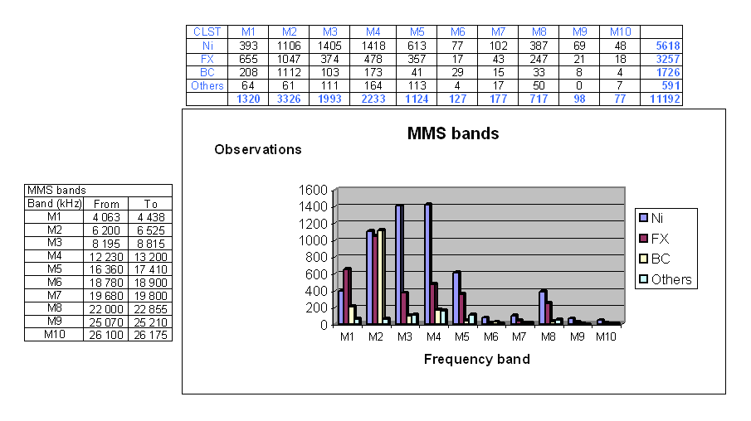
The Bureau has prepared separate files with information concerning frequencies around 12 290 kHz and 16 420 kHz in order to allow detailed evaluation of the reported use of the spectrum. The files can be downloaded from http://www.itu.int/ITU-R/terrestrial/monitoring/index.html.
Although a majority of emissions were not identified, many emissions in these two frequencies were reported to belong to the broadcasting and also to the fixed services.

4.2 Bands allocated to the aeronautical mobile service
For the purpose of analysing the situation in the bands allocated to the aeronautical mobile service (AMS) with a view to identifying other uses, the Bureau applied a suitable filter and excluded the observations related to the AMS. The remaining data (approximately 7 200 records) has been further analysed, based on the field "class of station", and the following distribution was found:

Class of Station (CLST) | Percentage of observations
Non identified (Ni) | 55%
FX | 17%
BC | 11%
Others | 17%

The distribution of observations for each aeronautical frequency band is summarized below:
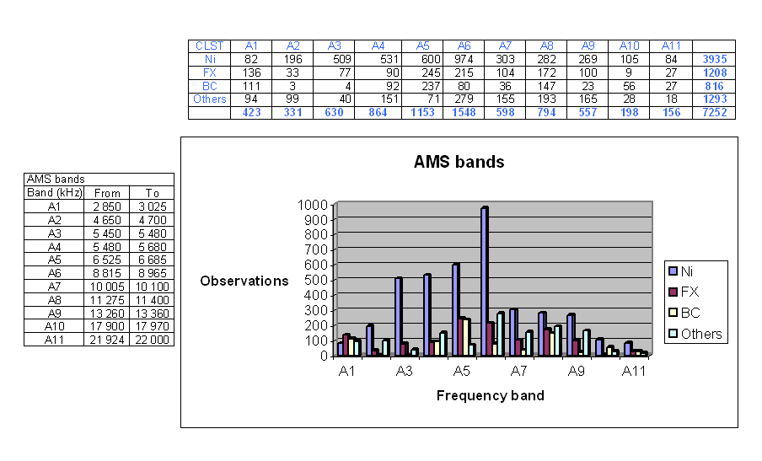

4.3 Bands adjacent to the HFBC allocations in the range 4-10 MHz
The analysis of the data based on the field "class of station" shows the following distribution from a total of approximately 19 400 records:

Class of Station (CLST) | Percentage of observations
Non identified (Ni) | 15%
FX | 6%
BC | 77%
Others | 2%

The distribution of observations for each frequency band is summarized below:
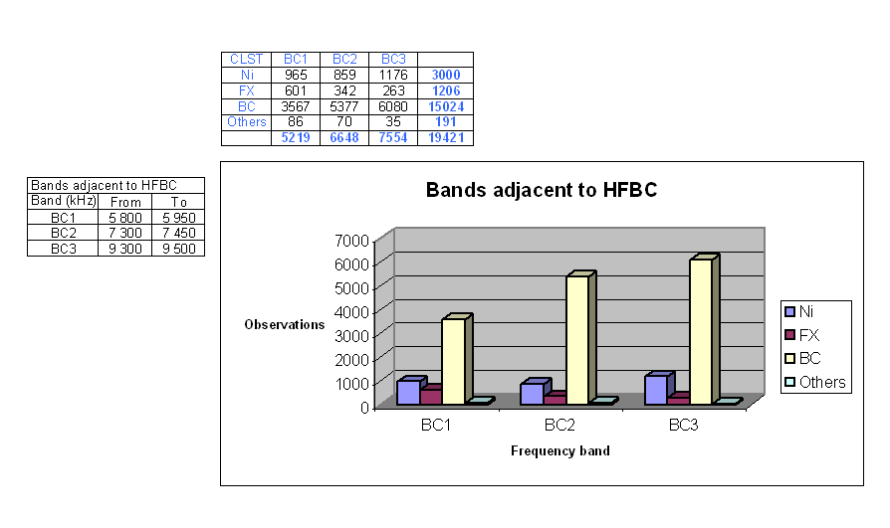
NOTE - It should be taken into account that one or several observations could correspond to one emission.

5 Concluding remarks
The volume of data submitted to the special monitoring programmes provides for the possibility of performing different types of studies, for various purposes. Administrations and other interested entities can perform their own analysis of the data available on the ITU website mentioned above, according to their needs. However, the Bureau wishes to emphasize the fact that, despite the participation of several monitoring centres, it was not possible to come to a global coverage, as some regions (e.g. Africa) are not adequately covered.
Several emissions in all frequency bands have been identified as not in conformity with the Table of Frequency Allocations.

______________

