INTERNATIONAL TELECOMMUNICATION UNION
 | WRC-03 | WORLD  RADIOCOMMUNICATION  CONFERENCE | Addendum 2 to  Document 38-E
 | WRC-03 | WORLD  RADIOCOMMUNICATION  CONFERENCE | 5 June 2003
 | WRC-03 | WORLD  RADIOCOMMUNICATION  CONFERENCE | English only
GENEVA, 9 JUNE – 4 JULY 2003
PLENARY MEETING
United States of America
information document
agenda item 1.16
TESTs, measurements and studies conducted in response to resolution 127 and relevant to agenda item 1.16
This information paper is presented in support of Document 38, the United States’ proposal related to agenda item 1.16. This report presents a detail of laboratory test and measurement results and studies conducted in response to Resolution ITU-R 127. The results of this study indicates the practicability of implementing a spaceborne transmitter that can attenuate unwanted emissions in excess of what is required to protect the passive services in the band 1 400-1 427 MHz from non-GSO narrow-band feeder links operating in the nearby bands 1 390-1 392 MHz (Earth-to-space) and 1 430-1 432 MHz (space-to-Earth). A summary of these results is provided as Addendum 1 to Document 38, the United States’ proposal.

Annex: 1
annex
Final Report
Evaluation of Containing Unwanted Emissions for a proposed
non-GSO MSS Global Telecommunications System

Task 1. Prove that a transmitter with the required dynamic range can be realized in the lab.
Task 1 Results
Output spectral plots taken on various combinations of evaluation hardware show that it is feasible to implement a GMSK transmitter which will meet the ITU requirements regarding unwanted emissions (i.e. when transmitting in the band 1 430-1 432 MHz, no emissions allowed above 86 dBsd in the adjacent 1 400-1 427 MHz band).
Table 1. Hardware combinations tested
Config | GMSK Data Source | RF Upconverter | Power Amplifier
1 | Agilent 8648D | N/A | Hughes 50-W TWTA
2 | FACS breadboard | FACS breadboard | Hughes 50-W TWTA  or WJ 0.1-W SSPA
3 | Digital STE | I-Q upconverter | Hughes 50-W TWTA
No extraordinary methods beyond standard good RF practice were required to achieve these measured results. An Agilent PSA series spectrum analyser (Model E4440A) was used to make the measurements. Auto-coupling of the analyser settings was overridden to maximize measurement range, and details of the instrument settings used to make spectrum measurements are provided in Appendix A. The signal-free noise floor of the analyser was measured at least 6 dB below the measured minimum signal, verifying adequate dynamic range for the measurements.
Minor modulator filtering (pre-TWTA) in the flight hardware may be needed to attain the 86 dBsd requirement over the entire 1 420-1 427 MHz band. In the FACS modulator, two in-band spurious images were observed, however an additional 2-3 dB of bandstop filtering would be sufficient to meet ITU requirements and increase margin. Spectral degradation of the GMSK signal floor was less than 1 dB through the SSPA or TWTA.
Configuration 1
A commercial Agilent signal generator (8648D) was configured to produce a shaped, phase modulated carrier at 1 430 MHz, with a data bandwidth of approximately 100 kbps. Figs. 1.1.1a and 1.1.1b (next page) show the modulated spectrum at the carrier frequency (1 430 MHz) and residual modulation at 1 427 MHz as measured on an Agilent E4440A spectrum analyser. The spectral attenuation at the output of the generator was ~90 dBsd at 1 427 MHz [(–15.7 dBm at 1 430 MHz) - (–105.5 dBm at 1 427 MHz)]. The measured generator spectral floor of –105.5 dBm was 9.5 dB higher than the signal-free floor of the spectrum analyser at –115.0 dBm, implying a measurement error of less than 0.5 dB.
Fig. 1.1.1a. Agilent modulator at 1 430 MHz
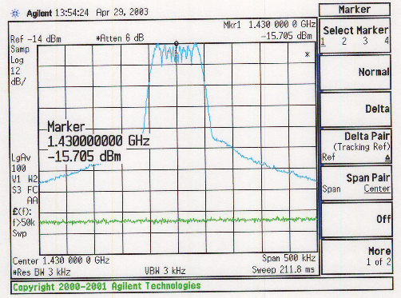
Fig. 1.1.1b. Agilent modulator at 1 427 MHz
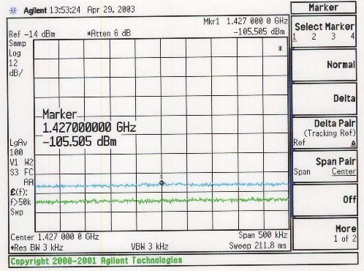
Figure 1.1.2 shows the power spectral density at the output of the Agilent modulator alone on a wider (10 MHz) span.
Fig. 1.1.2. Agilent modulator, no TWTA
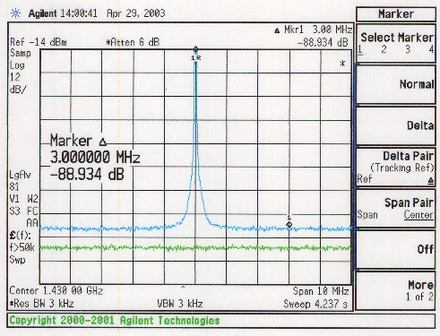

A Hughes 50-W TWTA (Model 1277H) was used to amplify the phase-modulated carrier. Little degradation was observed in the spectral attenuation when passed through the Hughes TWTA. Measurements were taken at SAT, SAT-2 dB, SAT-4 dB and SAT-10 dB (input back off), and spectral attenuation at 1 427 MHz ranged from 92 to 94 dBsd. Spectral attenuation results are summarized in Table 2.
Table 2. Spectral attenuation vs. TWTA input backoff (Agilent modulator)
Input back off from SAT  (dB) | Relative Output Power (dBm) | Density at  1 430 MHz (dBm/3 kHz) | Density at  1 427 MHz (dBm/3 kHz) | Spectral Attenuation (dBsd)
0 | 17.3 | –9.0 | –102.3 | 93.3
2 | 17.1 | –9.2 | –102.1 | 92.9
4 | 16.6 | –9.6 | –103.3 | 93.7
10 | 12.9 | –9.4 | –101.6 | 92.2
Figures 1.1.3a and b (next page) show compliance of the Agilent modulator-TWTA configuration against the ITU 86 dBsd requirement in the 1 420-1 427 MHz band. The peak spectral density at 1 430 MHz was measured at –6.9 dBm in a 3 kHz BW. Measured spectral attenuation against this peak ranged from 90 to 94 dBsd across the restricted band, and no spurious tones were observed.
Fig. 1.1.3a. Peak spectral density at 1 430 MHz
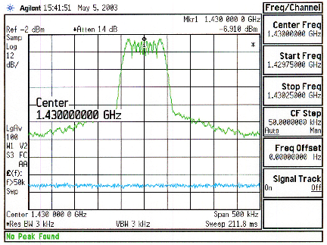

Fig. 1.1.3b. Spectral density from 1 420 MHz to 1 427 MHz
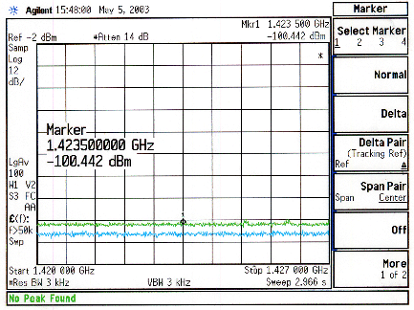

Figures 1.1.4a and 1.1.4b (next page) show medium span (10 MHz) views of the power spectral density after going through the Hughes 50-W TWTA at SAT and SAT-10dB (input backoff). We note that since the modulation waveform was not precisely constant amplitude, that spectral regrowth was noticeable at the output of the TWTA. However, the regrowth was not significant enough to violate the 86 dBsd interference requirement at 1 427 MHz, or anywhere in the 1 420-1 427 MHz band.
Fig. 1.1.4a. Agilent modulator, TWTA at SAT
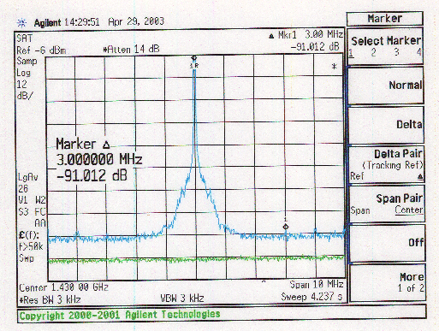

Fig. 1.1.4b. Agilent modulator, TWTA at SAT-10
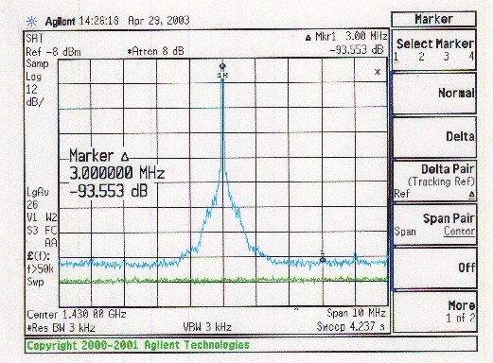
Figures 1.1.5a through 1.1.8b show details of the spectral output at various input backoff levels, and do not measurably change as a function of TWTA input drive.

Fig. 1.1.5a. Agilent modulator at 1 430 MHz, TWTA at SAT
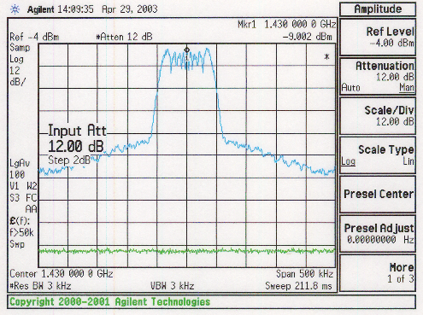

Fig. 1.1.5b. Agilent modulator at 1 427 MHz, TWTA at SAT
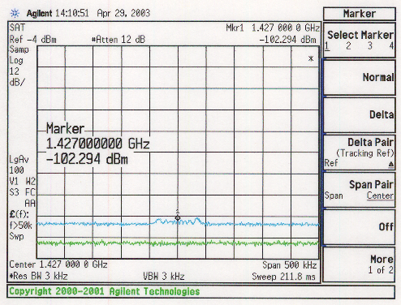
Fig. 1.1.6a. Agilent modulator at 1 430 MHz, TWTA at SAT-2
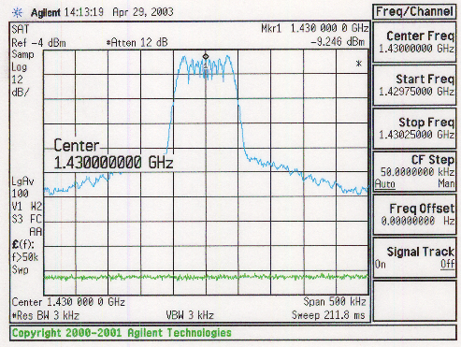

Fig. 1.1.6b. Agilent modulator at 1 427 MHz, TWTA at SAT-2
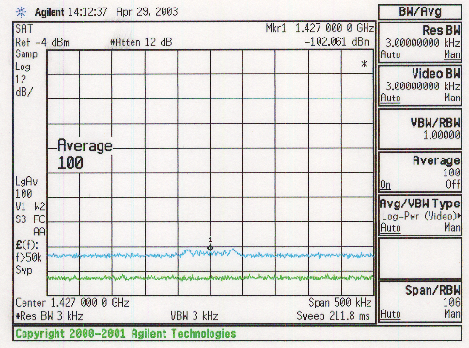
Fig. 1.1.7a. Agilent modulator at 1 430 MHz, TWTA at SAT-4
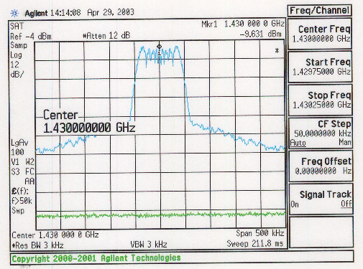

Fig. 1.1.7b. Agilent modulator at 1 427 MHz, TWTA at SAT-4
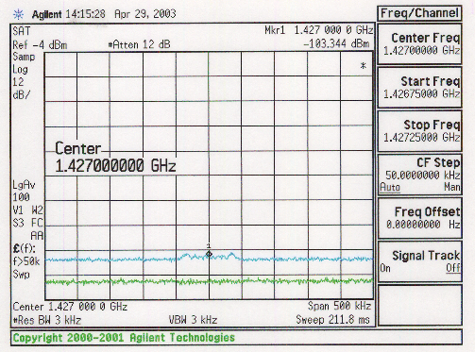
Fig. 1.1.8a. Agilent modulator at 1 430 MHz, TWTA at SAT-10
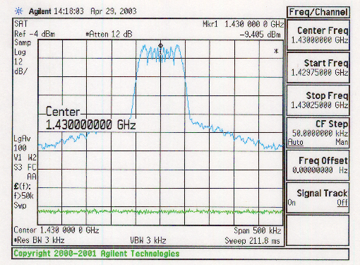

Fig. 1.1.8b. Agilent modulator at 1 427 MHz, TWTA at SAT-10
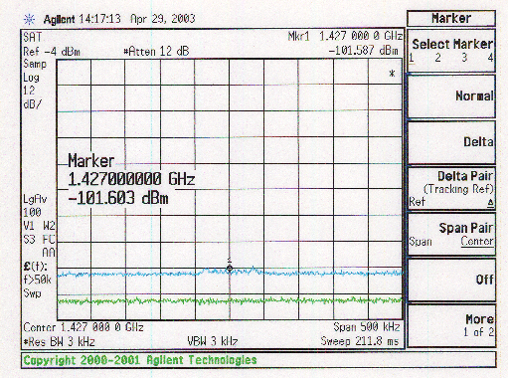
Configuration 2
A FACS modulator breadboard (S/N 002) was connected first to a WJ medium-power (100 mW) SSPA, and then to the Hughes 50-W TWTA. The FACS breadboard generated a GMSK modulated L-band carrier (at 1 430 MHz). Some spectral energy was observed at a spacing of 2 MHz and 3.6 MHz away from 1 430 MHz (Fig. 1.2.1). At close inspection, this energy appeared to be spurious images of the main modulated signal as opposed to discrete clock or frequency lines.

Fig. 1.2.1. FACS modulator #2, no TWTA
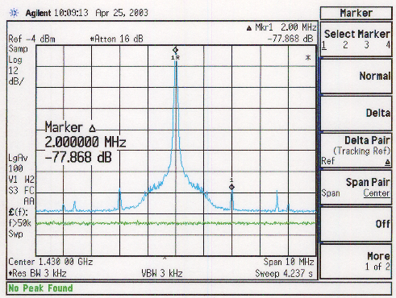
Measured spectral attenuation at the output of the FACS breadboard was approximately 90 dBsd at 1 427 MHz (relative to spectral density at 1 430 MHz). The measured GMSK spectral floor of
–98.8 dBm was 6.4 dB higher than the signal-free floor of the spectrum analyser at –105.2 dBm, implying a measurement error of less than 0.9 dB. Figures 1.2.2a and 1.2.2b (next page) show the spectral output of FACS modulator #002 prior to external amplification.
Fig. 1.2.2a. FACS modulator #2 at 1 430 MHz
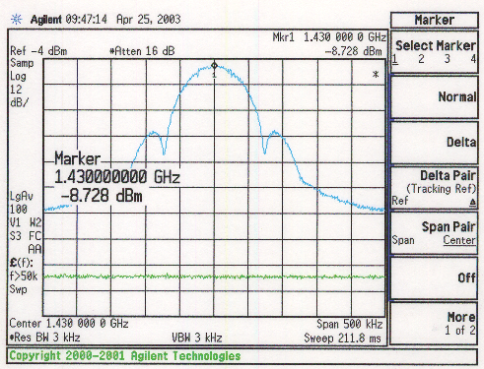

Fig. 1.2.2b. FACS modulator #2 at 1 427 MHz
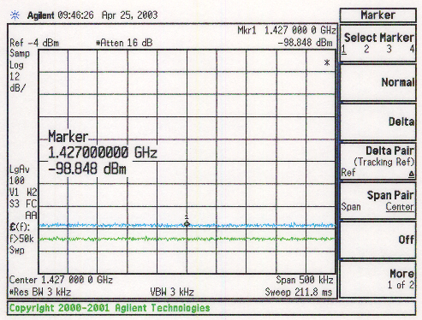
Little degradation was observed in the spectral attenuation when passed through the Hughes TWTA. Measurements were taken at SAT, SAT-2 dB, SAT-4 dB and SAT-10 dB (input back off), and spectral attenuation at 1 427 MHz was still approximately 90 dBsd in all cases. Spectral attenuation results are summarized in Table 3.

Table 3. Spectral attenuation vs. TWTA input backoff (FACS modulator)
Input back off from SAT  (dB) | Relative Output Power (dBm) | Density at  1 430 MHz (dBm/3 kHz) | Density at  1 427 MHz (dBm/3 kHz) | Spectral Attenuation (dBsd)
0 | 17.3 | –7.9 | –99.5 | 91.6
2 | 17.0 | –7.9 | –99.2 | 91.3
4 | 16.5 | –9.1 | –99.5 | 90.4
10 | 12.4 | –7.8 | –97.0 | 89.2
Figure 1.2.3 shows the spectrum after the TWTA operating at SAT. There is no noticeable spectral regrowth, indicating that the FACS modulation is constant amplitude, as would be expected with properly implemented GMSK.

Fig. 1.2.3. FACS modulator #2, TWTA at SAT
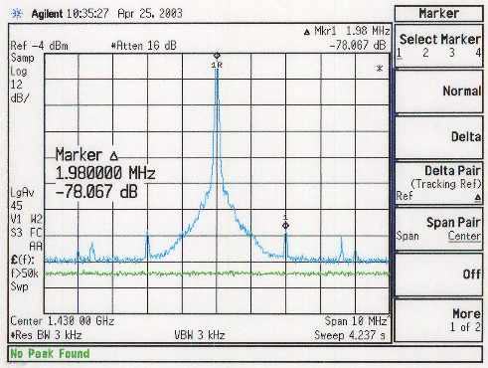
Figures 1.2.4a through 1.2.4d (following pages) show nearly complete compliance of the FACS modulator-TWTA configuration against the ITU 86 dBsd requirement in the 1 420-1 427 MHz band. No spurious discrete tones were observed, however two peaks (assumed to be modulation images) were detected at 1 426.0 MHz and 1 426.4 MHz and were approximately 0.5 and 2.0 dB above the ITU requirements, respectively. Otherwise, measured spectral attenuation ranged from 89 to 92 dBsd across the restricted band.
Fig. 1.2.4a. Peak spectral density at 1 430 MHz
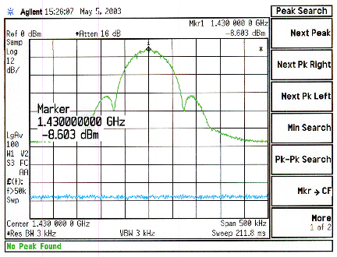

Fig. 1.2.4b. Spectral density from 1 420 MHz to 1 427 MHz
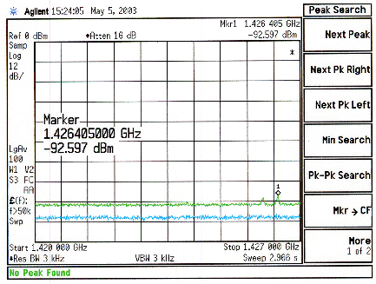
Fig. 1.2.4c. Spectral density around 1 426 MHz
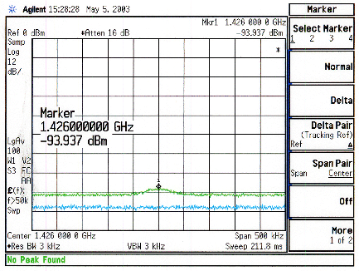

Fig. 1.2.4d. Spectral density around 1 426.4 MHz
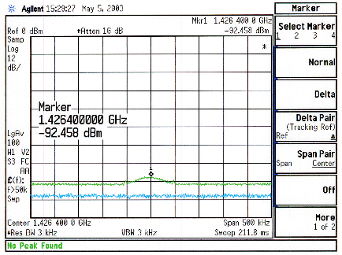
Figures 1.2.5a through 1.2.8b on the following pages show details of the spectral output after passing through the TWTA at various input backoff levels; output results do not measurably change as a function of TWTA input drive.
Fig. 1.2.5a. FACS modulator #2 at 1 430 MHz, TWTA at SAT
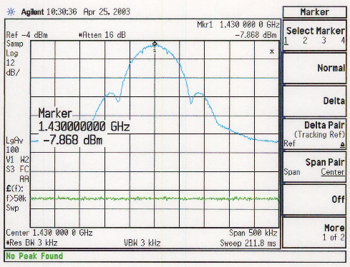

Fig. 1.2.5b. FACS modulator #2 at 1 427 MHz, TWTA at SAT
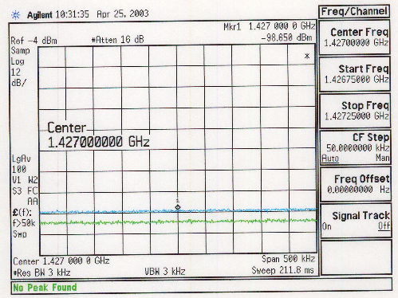
Fig. 1.2.6a. FACS modulator #2 at 1 430 MHz, TWTA at SAT-2
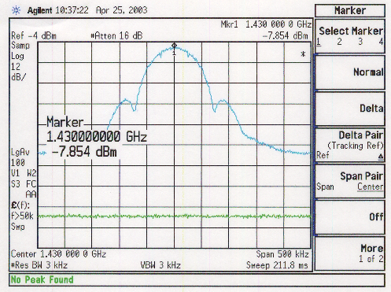

Fig. 1.2.6b. FACS modulator #2 at 1 427 MHz, TWTA at SAT-2
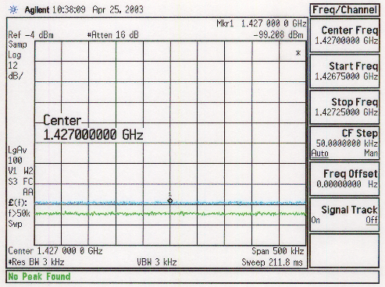

Fig. 1.2.7a. FACS modulator #2 at 1 430 MHz, TWTA at SAT-4
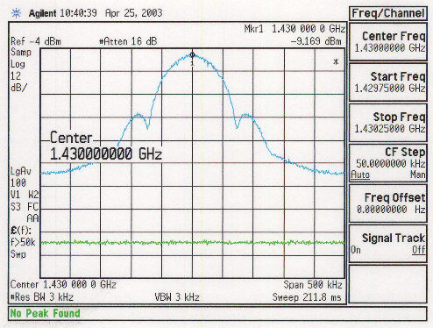

Fig. 1.2.7b. FACS modulator #2 at 1 427 MHz, TWTA at SAT-4
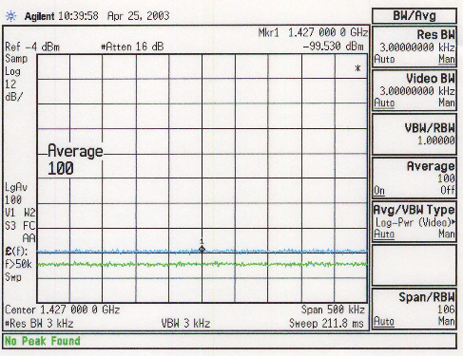
Fig. 1.2.8a. FACS modulator #2 at 1 430 MHz, TWTA at SAT-10
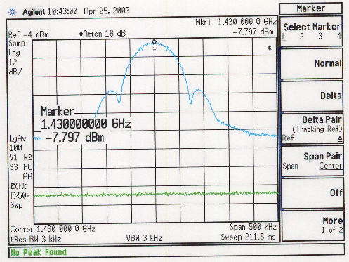

Fig. 1.2.8b. FACS modulator #2 at 1 427 MHz, TWTA at SAT-10
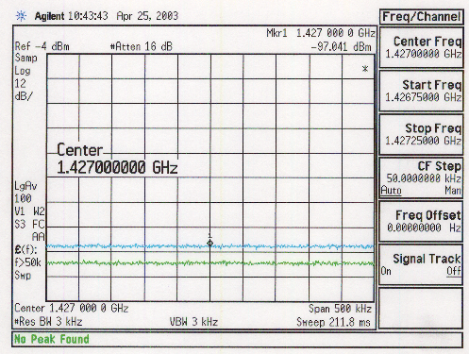
Similarly, little degradation was observed in spectral attenuation when passed through a medium power (100 mW) Watkins-Johnson Versa-amp SSPA. The amplifier was operated at 1 dB output compression, and spectral attenuation was 92.2 dBsd at 1 427 MHz, relative to spectral density at 1 430 MHz.
Figure 1.2.9 shows spectral output after the SSPA. This output signal appears very similar to the TWTA amplified signal (SAT) in Fig. 1.2.3, providing additional test evidence that spectral degradation through a properly operating power amplifier is minimal and does not appear to be a limiting factor in meeting ITU requirements in the 1 420-1 427 MHz band.

Fig. 1.2.9. FACS modulator #2, SSPA at 1 dB compression
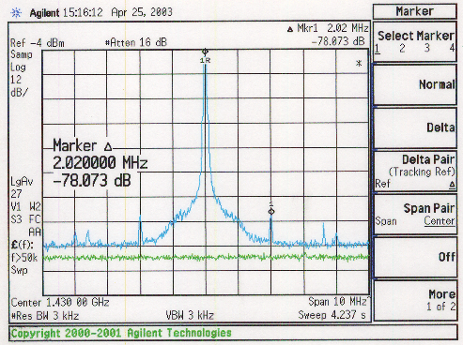

Figures 1.2.10a and 1.2.10b (next page) show details of the spectral output after passing through the SSPA operating at 1 dB output compression.
Fig. 1.2.10a. FACS modulator #2 at 1 430 MHz, SSPA at 1 dB compression
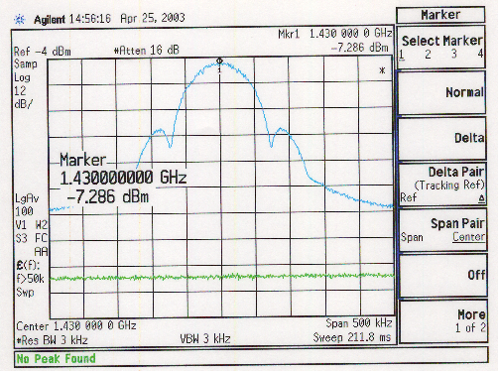

Fig. 1.2.10b. FACS modulator #2 at 1 427 MHz, SSPA at 1 dB compression
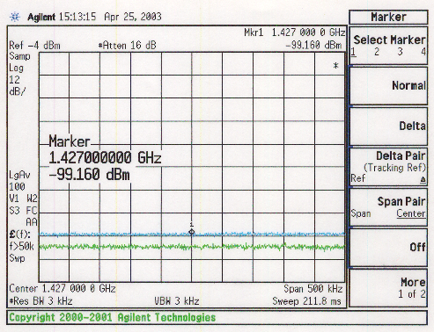
An initial attempt was made to observe the demodulated GMSK eye pattern, to determine if any obvious corruption of the data was present. An unmodulated 1 430 MHz carrier (Fig. 1.2.11) was located at SMA port J16 on the FACS breadboard, and it was used to demodulate the modulated signal back to baseband. However it was difficult to observe the eye pattern without a clock recovery circuit to consistently trigger an oscilloscope, and this measurement was postponed until a Vector Signal Analyser or other appropriate test equipment could be located.

Fig. 1.2.11. FACS modulator #2 LO at 1 430 MHz
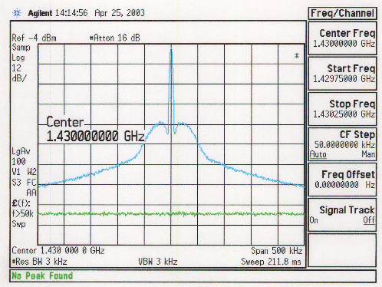

As a quick alternative to the eye pattern test, I and Q recovered data was sent into an oscilloscope operating in X-Y mode. A clean, generally constant amplitude X-Y pattern was recovered, consistent with GMSK modulation. No discernable degradation of the constant amplitude circle was observed after passing through the TWTA power amplifier at SAT. A plotted representation of the recovered I vs. Q pattern is shown in Fig. 1.2.12 on the next page.
Fig. 1.2.12. Recovered I vs. Q

Fig. 1.2.13a. FACS modulator #1
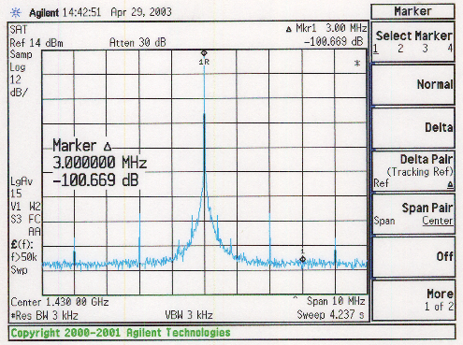

Fig. 1.2.13b. FACS modulator #1 at 1 430 MHz
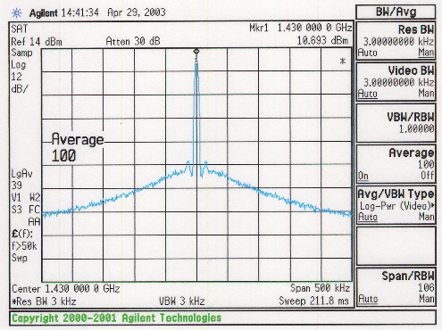

Task 2. Assert that the technology is available to implement a spaceborne transmitter with a dynamic range of greater than 86 dBsd. The use of a transmit filter in order to meet this requirement is allowed.
Task 2 Results
A summary of path-to-flight issues (Table 4) addresses potential beginning-of-life (BOL) performance issues as the modulator-transmitter design evolves into space-qualified hardware from the breadboards measured on this task.

Table 4. Summary of path-to-flight issues
Building Block | Comments | Projected  performance delta
L.O. carrier | Breadboards use either lab test equipment synthesizer or RFIC source; flight equivalent likely would use crystal oscillator with multiplier chain | No expected degradation
Digital modulation | Company breadboard uses 16-bit dual DACs; FACS board uses 10-bit DACs, which are available as flight qualified | No expected degradation
RF upconverter/modulator | Breadboard uses RFIC or RF mixers and hybrids; flight equivalent would use similar technology | No expected degradation
Output power amplifier | Breadboard uses 50-W TWTA; flight equivalent would use smaller TWTA or SSPA | No expected degradation
Pre- and post-amplifier filter | None used in breadboard measurements; high power flight filters from other satellite programs show availability if necessary | Additional 30 dB of positive margin towards ITU spectral density interference specification

A small number of building block components can be assumed to have the potential to contribute to degradation of spectral density attenuation of a GMSK modulator-transmitter as a flight hardware configuration evolves from the breadboard designs tested at our facility.
In discussions with a US licensee regarding likely limitations on the mechanical design of the flight modulator-transmitter, we understand that the anticipated Russian booster vehicle which will be used to launch the FACS satellite has sufficient capacity to minimize the need to impose stringent size (volume), weight and power constraints. The result of this excess launch capacity is a positive simplification of the flight hardware design, as a wider selection of components becomes available to choose from.
L.O. carrier
Tested hardware configurations #1 and #3 use Agilent test equipment synthesizers to generate the L-band carriers. Agilent synthesizers typically have excellent carrier phase noise performance, above what would be expected in a flight LO. However the FACS breadboards (configuration #2) use a commercial quality RFIC synthesizer, and the measured GMSK spectral performance did not appear to be limited by the performance of that LO source (synchronized against a laboratory
10 MHz standard), as spectral attenuation performance was very similar in all configurations measured at our facility. In the flight hardware configuration, the RFIC would be synchronized against a received GPS (atomic clock) reference, which would have better long-term stability than a lab standard.
Specified and measured performance of space quality oscillators indicate that at a distance of 3 MHz from the centre frequency, the phase noise of a multiplied crystal oscillator should typically be better than –140 dBc, which would provide greater than 40 dB of margin over what is needed to avoid contributing to degradation of the GMSK spectrum.
Digital modulation
The projected 100 kbps data rate is well within the range of available space-qualified digital ICs in bipolar or CMOS technologies, thus the translation of the digital designs used in the GMSK breadboards to flight qualified implementations is straightforward, with the exception of the 16-bit dual D-to-A converters used in the output stage of our company’s testbed digital modulator.
The AD9731 12-bit high-speed DACs used in the FACS breadboard modulator are available as space-qualified devices for use in the flight modulator design, thus no degradation of the performance of the digital subsection is expected as compared to the tested FACS breadboard.
RF upconverter
Test configuration #3 uses conventional RF components (double balanced mixers, passive hybrids, passive splitters) to configure the RF upconverter/modulator. The implementation is identical to those used in space military and commercial hardware and has no flight performance degradation issues.
The Agilent signal generator and FACS breadboard both utilize RFIC modulators. In the case of the FACS RFIC modulator (AD8346) a path to flight is expected to be available through the specific vendor’s space qualified fabrication process. In the worst case, this component may require individual qualification if no equivalent heritage part built in the same fab process is located before the design is fixed.
Output power amplifier
The Hughes 50-W TWTA used in the testing of all modulator breadboards has extensive flight heritage from the Boeing EDD (formerly Hughes) organization. FACS transmitter requirements are understood to be significantly lower (1-W space, 10-W ground) than the tested TWTA, however the measured performance of the spectral interference pre- and post-TWTA shows that there is insignificant performance degradation of the GMSK waveform in this major component, even at the higher (50-W) power level.
1-W or 10-W L-band solid-state amplifiers were not readily available to support these tests; however no significant difference in degradation is expected if SSPAs were selected for use over TWTAs. The 100 mW SSPA that was tested with the FACS breadboard had slightly less spectral interference degradation as compared against the performance seen with the 50-W TWTA.
Pre- and post-amplifier filter
No tests were performed with post-amplifier, high power filters, as all tested configurations met the 86 dBsd spectral interference requirement without filtering (other than the two 0.5 dB and 2.0 dB violations noted previously in the breadboard FACS modulator). Minor bandstop filtering at the low power output of the modulator can easily be implemented to meet the ITU interference requirements, as no spectral degradation was observed through either the TWTA or SSPA. This extra filtering would provide margin against the ITU requirements over the mission life.
If high power filtering was necessary after the power amplifier, we have direct experience in specifying high-power, flight bandpass filters at a similar L-band frequency for another satellite program. Based on interpolation of existing high-power filter specifications and the same vendor’s response to specific FACS requirements, an additional minimum attenuation of 30 dB (nominal vendor specs) could be achieved at 1 427 MHz, the closest worst-case spacing from a modulated downlink signal centred at 1 430 MHz. For the FACS ground-based uplink configuration, the vendor specifies a minimum attenuation of 42 dB at 1 400 MHz, the closest worst-case spacing from a modulated signal centred at 1 392 MHz.
Test relevance to proposed 1 390-1 392 MHz uplink
All laboratory tests were performed at a modulated carrier of 1 430 MHz, looking at potential interference in the 1 400-1 427 MHz band reserved for radio astronomy. There was no rise in interference observed up to 30 MHz away from the modulated carrier, and there is a reasonable expectation that an identical GMSK-modulated carrier operating on the low side of the 1 400-1 427 MHz band would perform similarly (i.e. comply with the 86 dBsd requirement). The two differences between the proposed uplink and downlink signals are in separation distance from the 1 400-1 427 MHz band, and amplifier power. A 1 300-1 392 MHz uplink would have a larger guardband (8 MHz vs. 3 MHz) to the radio astronomy band, leading to simpler filtering requirements. The proposed uplink of 10 W is five times lower than the tested 50 W laboratory signal. No spectral regrowth was observed in the 1 430 MHz tests, thus none is expected with a 10 W power amplifier.
Task 3. Address reliability issues related to ensuring that the required level of performance is achieved over a seven-year period when on orbit.
Task 3 Results
Well-understood and documented environmental and aging effects affect the long-term, on-orbit satellite payload performance. The breadboard test results performed thus far by our company require extrapolation to ensure compliance with ITU requirements at the end of the seven-year mission life (EOL) due to normal aging effects and exposure to radiation, temperature and the space environment.
The same process through which components are selected for the flight design is also critical to ensuring compliance with overall performance specifications at EOL.
Analog components (including oscillator)
Long-term stability of the master crystal oscillator in space environments is well understood and generally not a problem in the satellite if specified prior to acquisition for flight. Typical frequency drift of less than 10⁻⁸ is reasonable to expect and well within the necessary performance to stay within ITU requirements. Phase noise degradation does not occur to the levels where it would impact spectral interference, other than in the event of catastrophic component failure.
Digital components (GMSK shaping)
Digital circuits have less sensitivity to aging and temperature effects as compared with analogue circuits, and most necessary digital circuit building blocks are available in space qualified versions. The most common problem with digital circuitry in space is the effect of single event upsets (SEU) due to radiation. Where necessary, the selection of rad-hard digital devices (such as processors, memories and gate arrays) or the use of selective mechanical shielding provides the means to mitigate sensitivity to radiation. The FACS digital modulator will be used to process a constant flow of data, and as such is much less sensitive (from a system and practical user standpoint) to the effects of SEUs.
RF components (upconverter)
The most common degradation seen in RF components is a loss of gain in active amplifiers as characteristics change over time and exposure to radiation. The satellite industry mitigates these effects upon the overall system through the choice of properly designed and tested components with minimal sensitivity to these changes.
Power components
As with the above RF components, the satellite industry has much experience in designing and producing power amplifiers for 10-15 year life in orbit, and a graceful degradation is expected in a properly designed power amplifier. The use of redundant blocks mitigates unexpected random failures due to components or workmanship issues.
Appendix A
Spectral Interference Test Configuration

Figure A1. Test configuration

Freq Source
GMSK Test Modulators
Attenuators

E4440A
Spectrum
Analyser
L-band TWTA
or SSPA
Attenuator

Power
Metre

E4440A Spectrum Analyser settings
Parameter | Setting | Comment
Internal Attenuation | 14 dB typ | Adjusted for maximum analyser input signal before “IF limiting” warning
Ref Level | –6 dBm | Adjusted to keep peak power density of signal at 1 430 MHz below top of screen
Span | 500 kHz, 10 MHz or 27 MHz | 500 kHz span used for close-in measurements to minimize measurement time (100 averages used)
Res BW | 3 kHz | Set lower than “auto” to increase measurement range
Video BW | 3 kHz | Set lower than “auto” to increase measurement range
Sweep | Auto
Averaging | 100
Vertical Scale | 12 dB/div | Increased from 10 to 12 dB/div to allow potential 120 dB range to be displayed

These nominal analyser settings were determined through experimental testing, reference to Agilent application notes and discussions between Ralph Crenshaw of FACS and us on 14 April 2003. Mr Crenshaw had made spectrum measurements at FACS previously with similar test equipment.
Appendix B
Communications Testbed

Current block diagram

L-band
Synthesizer

16-bit DAC
GMSK Digital Modulator
Timing Clock
I-Q (RF) Modulator
16-bit DAC

Preamplifier
L-band TWTA
Spectrum
Analyser
Attenuators

Major testbed components

- Data Clock Generator
- Digital Modulator (programmed for GMSK)
- Dual DACs (16-bit AD9777)
- Agilent L-Band Synthesizer (for LO)
- I-Q Upconverter (convert to L-band using RF components)
- L-Band Preamplifiers
- Variable Attenuators
- L-Band TWTA (Hughes EDD, covers 1 390-1 430 MHz)
- Spectrum Analyser (~110 dB input dynamic range)

_______________

