INTERNATIONAL TELECOMMUNICATION UNION
 | WRC-03 | WORLD  RADIOCOMMUNICATION  CONFERENCE | Document 136-E
 | WRC-03 | WORLD  RADIOCOMMUNICATION  CONFERENCE | 10 June 2003
 | WRC-03 | WORLD  RADIOCOMMUNICATION  CONFERENCE | Original: English
GENEVA, 9 JUNE – 4 JULY 2003
STEERING COMMITTEE
schedule for wrc-03

The schedule is annexed.

Annex: 1
Annex
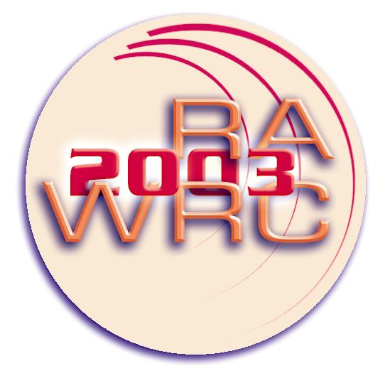 | World Radiocommunication Conference  Geneva, 9 June - 4 July 2003 | WEEK 1  From Monday, 9 June 2003  To Sunday, 15 June 2003

Monday - 9 | Tuesday - 10 | Wednesday - 11 | Thursday - 12 | Friday - 13 | Saturday - 14 | Sunday - 15
0930 hours  Heads of Delegation | 0900 hours  FIRST MEETING COM 6  – COM 4 and 5 working groups | 0900 hours  – COM 6  – COM 4 and 5 working groups | 0900 hours  – COM 6  – COM 4 and 5 working groups | 0900 hours  – COM 6  – COM 4 and 5 working groups
1030 hours  FIRST PLENARY | 1040 hours  – COM 6  – COM 4 and 5 working groups | 1040 hours  – COM 6  FIRST MEETING COM 2  – COM 4 and 5 working groups | 1040 hours  – COM 4 and 5 working groups | 1040 hours  – COM 4  – COM 5 working groups
1430 hours  FIRST MEETING COM 4 | 1400 hours  FIRST MEETING COM 3  COM 4 and 5 working groups | 1400 hours  – COM 4  FIRST MEETING COM 7  – COM 5 working groups | 1400 hours  – COM 6  – COM 4 and 5 working groups | 1430 hours  – COM 5  – COM 4 working groups
1610 hours  FIRST MEETING COM 5 | 1540 hours  – COM 4 and 5 working groups | 1540 hours  – COM 5  – COM 7  – COM 4 working groups | 1540 hours  – COM 6  – COM 4 and 5 working groups | 1610 hours  SECOND PLENARY
1745 hours  – Steering Committee |  | 1715 hours  – Steering Committee |  | 1745 hours  – Steering Committee
NOTE – This draft weekly schedule is subject to revisions made by the Steering Committee.

 | World Radiocommunication Conference  Geneva, 9 June - 4 July 2003 | WEEK 2  From Monday, 16 June 2003  To Sunday, 22 June 2003

Monday - 16 | Tuesday - 17 | Wednesday - 18 | Thursday - 19 | Friday - 20 | Saturday - 21 | Sunday - 22
0900 hours  – COM 4 and 5 working groups and subgroups | 0900 hours  – COM 3  – COM 4  – COM 7 | 0900 hours  – COM 4 and 5 working groups and subgroups | 0900 hours  – COM 6  – COM 4 and 5 working groups and subgroups | 0900 hours  – COM 5  – COM 6  – COM 4 working groups and subgroups
1040 hours  – COM 4 and 5 working groups and subgroups | 1040 hours  – COM 4 and 5 working groups and subgroups | 1040 hours  – COM 4 and 5 working groups and subgroups | 1040 hours  – COM 6  – COM 4 and 5 working groups and subgroups | 1040 hours  – COM 2  – COM 6  – COM 4 and 5 working groups and subgroups
1400 hours  – COM 6  – COM 4 and 5 working groups and subgroups | 1400 hours  – COM 5  – COM 6  – COM 4 working groups and subgroups | 1400 hours  – COM 4 and 5 working groups and subgroups | 1400 hours  – COM 4 and 5 working groups and subgroups | 1430 hours  – COM 4  – COM 7  – COM 5 working groups and subgroups
1540 hours  – COM 6  – COM 4 and 5 working groups and subgroups | 1540 hours  – COM 6  – COM 4 and 5 working groups and subgroups | 1540 hours  – COM 4 and 5 working groups and subgroups | 1540 hours  THIRD PLENARY MEETING | 1610 hours  – COM 7  – COM 4 and 5 working groups and subgroups
1715 hours
– Steering Committee
NOTE – This draft weekly schedule is subject to revisions made by the Steering Committee.

 | World Radiocommunication Conference  Geneva, 9 June - 4 July 2003 | WEEK 3  From Monday, 23 June 2003  To Sunday, 29 June 2003

Monday - 23 | Tuesday - 24 | Wednesday - 25 | Thursday - 26 | Friday - 27 | Saturday - 28 | Sunday - 29
0900 hours  – COM 6  – COM 4 and 5 working groups and subgroups | 0900 hours  – COM 4  – COM 7  – COM 5 working groups and subgroups | 0900 hours  FOURTH PLENARY MEETING | 0900 hours  – COM 4  – COM 7 | 0900 hours  – COM 4  – COM 7  – COM 6
1040 hours  – COM 6  – COM 4 and 5 working groups and subgroups | 1040 hours  – COM 7/COM 3 (Joint)  – COM 4 and 5 working groups and subgroups | 1040 hours  – COM 3 (Final)  – COM 7  – COM 4 and 5 working groups and subgroups | 1040 hours  – COM 7  – COM 4 working groups and subgroups | 1040 hours  – COM 4 (Final)  – COM 7 (Final)  – COM 6 (Final)
1400 hours  – COM 4 and 5 working groups and subgroups | 1400 hours  – COM 5  – COM 6  – COM 4 working groups and subgroups | 1400 hours  – COM 6  – COM 4 working groups and subgroups  – COM 5 | 1400 hours  – COM 7  – COM 6  – COM 4 working groups and subgroups | 1430 hours  FIFTH PLENARY MEETING
1540 hours  – COM 4 and 5 working groups and subgroups | 1540 hours  – COM 6  – COM 4 and 5 working groups and subgroups | 1540 hours  – COM 6  – COM 5 (Final)  – COM 4 working groups and subgroups | 1540 hours  – COM 6  – COM 7  – COM 4 working groups and subgroups (Final) | 1610 hours  FIFTH PLENARY MEETING (continued)
 | 1715 hours  – Steering Committee |  |  | 1745 hours  – Steering Committee
NOTE – This draft weekly schedule is subject to revisions made by the Steering Committee.

 | World Radiocommunication Conference  Geneva, 9 June - 4 July 2003 | WEEK 4  From Monday, 30 June 2003  To Friday, 4 July 2003

Monday - 30 | Tuesday - 1 | Wednesday - 2 | Thursday - 3 | Friday - 4 | Saturday - 5 | Sunday - 6
0900 hours  SIXTH PLENARY MEETING | 0900 hours  EIGHTH PLENARY MEETING | 0900 hours  TENTH PLENARY MEETING | 0900 hours  TWELFTH PLENARY MEETING | 0900 hours  PLENARY4
1040 hours  SIXTH PLENARY MEETING  (continued) | 1040 hours  EIGHTH PLENARY MEETING  (continued) | 1040 hours  TENTH PLENARY MEETING  (continued) | 1040 hours  TWELFTH PLENARY MEETING1 (continued)
1400 hours  SEVENTH PLENARY MEETING | 1400 hours  NINTH PLENARY MEETING | 1400 hours  ELEVENTH PLENARY MEETING | 1400 hours  2
1540 hours  SEVENTH PLENARY MEETING  (continued) | 1540 hours  NINTH PLENARY MEETING  (continued) | 1540 hours  ELEVENTH PLENARY MEETING  (continued) | 1540 hours  PLENARY3 | 1600 hours  SIGNING CEREMONY
1715 hours
– Steering Committee
NOTE – This draft weekly schedule is subject to revisions made by the Steering Committee.
__________

1 Final adoption of texts (second reading).
2 Deadlines for declarations/reservations.
3 Plenary to note declarations/reservations and deadline for additional declarations. 4 To note additional declarations.

