|  |  |
| --- | --- |
| **Radiocommunication Study Groups** |  |
|  |  |
|  |  |
| Source: Document 4A/TEMP/171  Reference: Documents 4A/278 (Annex 11) and 4A/329  Subject: Recommendation ITU-R S.732 | **Annex 1 to Document 4A/368-E** |
| **23 April 2010** |
| **English only** |
| Annex 1 to Working Party 4A Chairman’s Report | |
| PRELIMINARY DRAFT REVISION Of RECOMMENDATION ITU-R S.732 | |
| Method for statistical processing of earth-station antenna side-lobe peaks | |

# 1 Summary of the proposed revision

At the March 2010 meeting of Working Party 4A, proposals for the revision of working document towards a preliminary draft revision of Recommendation ITU-R S.732 were received. The proposed revisions, as contained in Attachment 1 to this document, were intended to provide clarification on the scope of the Recommendation. It was proposed that the scope be concerned with not only the issue of design and performance objectives but also for interference analysis and coordination as well. Clarifications on the circumstances where it is permissible for a certain percentage of side-lobe peaks to exceed the reference pattern were provided for the case of reference patterns for interference analysis and coordination. In addition, a solution for a preferable angular resolution for antenna side-lobe measurements was proposed. Supporting background information for this proposed solution is provided in Attachment 2.

# 2 Future work

Since the deficiencies in Recommendation ITU-R S.732 have been made known, a revision to Recommendation ITU-R S.465 has been adopted and a new reference antenna pattern (Recommendation ITU-R S.1855) has also been adopted. Both Recommendations ITU-R S.465 and ITU-R S.1855 are used for the purpose of interference analysis and coordination. In order to remove any doubt that surrounds how antenna measurements should be made and what types of antenna reference patterns they should apply to, it has become increasingly important that any proposals for the revision of Recommendation ITU-R S.732 be finalized and approved by the July 2010 Working Party 4A meeting in time for consideration by Study Group 4 at its meeting in July 2010.

**Attachments:** 2

**Attachment 1**

PRELIMINARY DRAFT REVISION Of RECOMMENDATION ITU-R S.732

Method for statistical processing of earth-station antenna side-lobe peaks

(1992)

*Editor’s Note: A scope should be added.*

The ITU Radiocommunication Assembly,

considering

a) that in determining the coordination distance or for assessing the interference between earth stations and radio-relay stations, and for coordination studies between earth stations and space stations of different satellite systems sharing the same frequency bands, it is necessary that the gain of the earth-station antenna be known in the relevant direction;

b) that in the case of interference calculations between satellite systems, it may be desirable to know the radiation characteristics of the antenna in planes other than the principal plane;

c) that in calculating mutual interference between radio-relay systems and satellite communication systems, particularly when there is more than one interference source, it is preferable that the statistical properties of antenna side-lobe levels, as well as side-lobe peaks, be known;

d) that, in compiling statistical data, it is necessary to guarantee the integrity of such data from experimental errors;

e) that adequate measured data of several earth station antenna types can be extracted from the database associated to Recommendation ITU-R S.1717, ensuring an appropriate off-axis increment in order to allow a sufficient resolution and the identification of the side-lobe peaks;

f) that ITU-R Recommendations dealing with antenna design objectives allow a certain percentage of side-lobe peaks to exceed the reference pattern whereas reference antenna patterns used for interference analysis and coordination between geostationary satellite networks allow side-lobe peaks to exceed the reference pattern only under specified circumstances (e.g., in the spillover regions and local ground reflections at large off-axis angles);

g) that, measurement resolution is most important near the main-lobe due to interference considerations,

recommends

**1** that the angular resolution of antenna side lobes measurement should be between 0.05° to at most 0.5° and should be determined as a function of equivalent diameter-to-wavelength ratio in accordance with Table 1;

TABLE 1

Required measurement resolution



|  |  |  |
| --- | --- | --- |
| Antenna size | Measurement resolution for off-axis angle φ, φmin ≤ φ ≤ 30° | Measurement resolution for off-axis angle φ, 30° ≤ φ ≤ 180° |
| D/λ < 25 | 0.5° | 1.0° |
| 25 ≤ D/λ < 50 | 0.25° | 0.5° |
| 50 ≤ D/λ < 250 | 0.1° | 0.2° |
| 250 ≤ D/λ | 0.05° | 0.1° |

**2** that measurement samples affected by experimental errors should be disregarded when applying the method described in *recommends* 3;

**3** that the following method should be used for processing measured data on side lobes of earth‑station antennas in the case where the reference antenna radiation pattern allows a certain percentage of side-lobe peaks to exceed the pattern:

**3.1** that a side-lobe peak in each measured plane should be defined as a local gain maximum for which an increase or a decrease in off-axis angle shows a reduction in gain level of at least 2 dB, while observing the required off-axis measurement angular resolution mentioned in *recommends* 1;

**3.2** the angular regions (sample windows) in each measured plane within which side-lobe peak samples are taken should be defined as those shown in Table 2 and illustrated in Figure 1. A side-lobe peak exactly on the border of two angular regions or windows is included in the lower window. Within each of these windows, the level of each peak should be normalized to the mid-angle  inside the window by using a normalization factor Δ (dB) which can be calculated by the following expression, taking into account the function f(φ) of the reference pattern that relates to this window, thus:



and



where:

φP : off-axis angle of the measured side-lobe peak *P*(*L* < *P*  *H*)

φN : off-axis angle of the normalized side-lobe peak *P´* 

*P* : measured side-lobe peak amplitude (dB)

 normalized peak amplitude (dB)

*L*, *H* : angular limits of sample window W*i.*

For the particular cases where the reference pattern f(φ) has a constant slope “m” {f(φ) = A – m log(φ)} inside the entire sample window from φL to φH the normalization factor Δ (dB) can be calculated by:



These particular cases also include the situation where m = 0 thus resulting in a constant level f(φ) = A for the reference pattern function inside the entire range of some of the sample windows.

The statistical data in specific angular regions is then drawn in the angle φN of the respective angular region of each measured plane. In this case, the measured side-lobe peaks sampled in both sides (right and left) of the particular measurement plane shall be included in the statistical analysis for each off-axis angular region (or sample window), for all existing antenna measurement polarization angles (if applicable).

Table 2

Angular regions (sample windows) for processing   
measured side-lobe peak samples

|  |  |
| --- | --- |
| Angular regions/ sample windows | Angular limits |
| W1 | L = min  H = 9.2° |
| W2 | L = 9.2°  H = 48° |
| W3 | L = 48°  H = 180° |

In Table 2 the lower limit of the first angular region W1 is min = 15.85(D/λ)−0.6 or 118(D/λ)−1.06 degrees, whichever is greater;

**4** that when the number of side-lobe peak samples is less than 10 in the specified angular regions of the same measured plane, side-lobe peak samples should be statistically processed through the following method . The percentage (X%) of side-lobe peaks of the earth-station antenna that do not comply with the reference pattern shall be obtained by comparing the sum of the angular widths *i* occupied by those side-lobe peaks exceeding the reference pattern with the total sampled window angular width W, as shown in Figure 2:



Figure 1

Example of distribution of side-lobe peaks

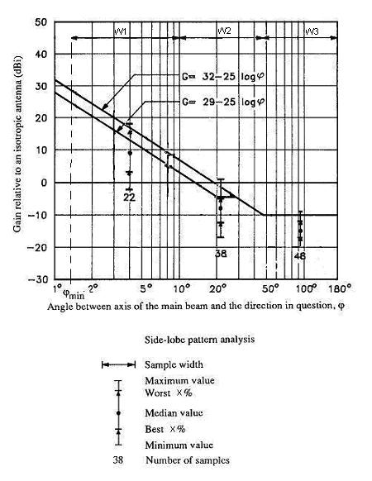

Figure 2

Angular width of side-lobe peaks exceeding the reference pattern

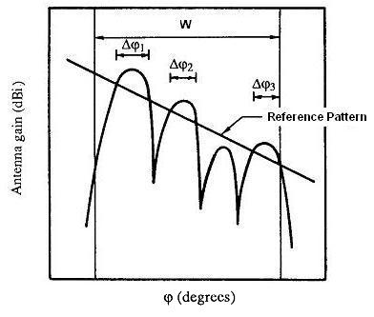

**5** that the following Note should be regarded as part of this Recommendation:

NOTE 1 – Allowing a certain percentage of side-lobe peaks to exceed a given reference antenna pattern may result in actual interference being greater than expected.

Attachment 2  
  
Determination of an appropriate angular measurement resolution

Borrowing from the same reasoning used for establishing a simulation time increment in Recommendation ITU-R S.1325 for determining statistics of short-term interference, a desirable angular measurement resolution will ensure that there can be at least 5 measurements between antenna nulls. The theoretical angular separation between antenna nulls can be determined as a function of antenna size (*D/*λ). The antenna main beam and side-lobes of a parabolic reflector type antenna can be modelled using the following formula taken from Recommendation ITU-R S.1857.



where:

ϕ: off-axis angle

*Jn* + 1: Bessel function of the first kind and order (*n* + 1)

*d*: diameter of the circular aperture

λ: wavelength.

In the above, *n* is the aperture illumination parameter that corresponds to the following aperture illuminations:

*n* = 0, ideal uniform

*n* = 1, parabolic

*n* = 2, parabolic squared.

For the purposes of this exercise, parabolic illumination (i.e., *n* = 1) was selected as a representative pattern. For this side-lobe representation, the angular separation between antenna nulls is equal to 59.74/(*D/*λ). Figure 1 depicts an antenna with a *D/*λ ratio of 100.

FIGURE 1



Though the actual angular separation of the antenna nulls and side-lobe peaks will vary from theory, it is thought that it is better to base a proposed angular measurement resolution on theory than on nothing at all. Figure 2 plots the proposed angular measurement resolution against 1/5th of the theoretical value of the angular separation of the nulls.

FIGURE 2



It can be noted that the proposed range over which a measurement resolution of 0.1° can be used is actually a compromise as 1/5th of the null spacing is actually less than 0.1° for D/λ > 115. It is proposed that the smallest angular measurement resolution of 0.05° only be considered for the largest antennas where D/λ ≥ 250, as a requirement to consider such a small measurement resolution over such a wide range of commonly used antenna sizes seems to be quite onerous. Additionally, to further reduce the measurement burden, it is proposed that the measurement resolution be reduced by one half for angles greater than 30° off-axis. Table 1 summarizes the proposed values of angular measurement resolution.

TABLE 1

Required measurement resolution



|  |  |  |
| --- | --- | --- |
| Antenna size | Measurement resolution for off-axis angle φ, φmin ≤ φ ≤ 30° | Measurement resolution for off-axis angle φ, 30° ≤ φ ≤ 180° |
| D/λ < 25 | 0.5° | 1.0° |
| 25 ≤ D/λ < 50 | 0.25° | 0.5° |
| 50 ≤ D/λ < 250 | 0.1° | 0.2° |
| 250 ≤ D/λ | 0.05° | 0.1° |