Radiocommunication Advisory Group
Geneva, 24-27 June 2014
Document RAG14-1/xx-R
...2014
Original: ....
Russian Federation
The russian version of the itu-r web-pages
Introduction
The Russian administration has appreciated the efforts of the International Telecommunication Union to implement Resolution 154 (Rev. Guadalajara, 2010) of the Plenipotentiary Conference on the use of the six official languages of the Union on an equal footing, when developing its web-site.

To assist the Radiocommunication Bureau in designing the Russian version of the web-site (ITU-R), we have reviewed its existing translation.

Review

1). Main web-page of ITU-R (Russian version): http://www.itu.int/ru/ITU-R/pages/default.aspx
1.1. The quick link “join ITU-R” in the web-page header contains inaccuracy in the translation to the Russian language (translated as “Членом МСЭ-R”. It is an erratum and should be corrected as “Стать Членом МСЭ-R” or “Члены МСЭ-R”).
1.2. All links of the page headers are provided in English, as well as the tabs (e.g. “entities”, “news” etc.)
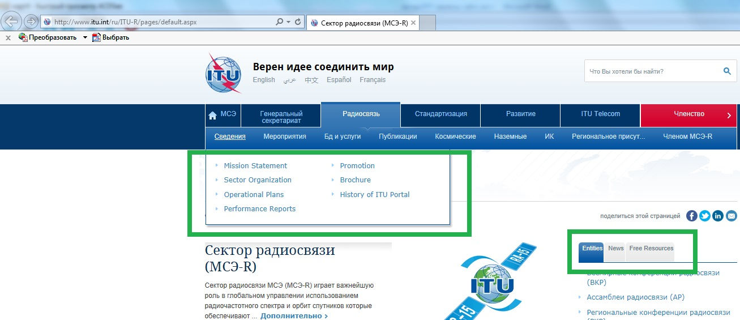
1.3. There is some inaccuracy in the Russian version of “Radio Regulations” section (in Russian the section is translated as “Радиорегламентарным”, being an erratum).
1.4. Tabs under “entities” and “quick links/radiocommunication sector” are actually mirrored, however, the “entities” quick links are translated into the Russian and provide Russian web-pages, but the latter link does not provide them.

2) Study Groups web-pages (e.g. http://www.itu.int/en/ITU-R/study-groups/rsg3/Pages/default.aspx)
2.1. When browsing web-pages of Study Groups, only English version is available, providing no opportunity for translation into another language.
Also, updated document “Guidelines for the working methods of the Radiocommunication Assembly, the Radiocommunication Study Groups and related groups” uploaded to the pages of Study Groups according to the RAG-2013 Decision could be downloaded in English only.
It could be possible, for the period when the page translation is not available, to make a quick link to any other of the six languages for user convenience.

2.2. In some cases, when opening the List of Study Groups Chairmen and Vice-Chairmen in English and trying to go to the page in any other languages, the page provides message of no information on the Chairmen and Vice-Chairmen. Moreover, when going back (via link at the top of the page) to the English version, the message is still displayed.
For example:
2.2.1. Web-page with Study Group 3 Chairmen and Vice-Chairmen
http://www.itu.int/online/compass/cvc.v2.sh?topic=SG3&head_title=List%20of%20Study%20Groups%20Chairmen%20and%20Vice-Chairmen
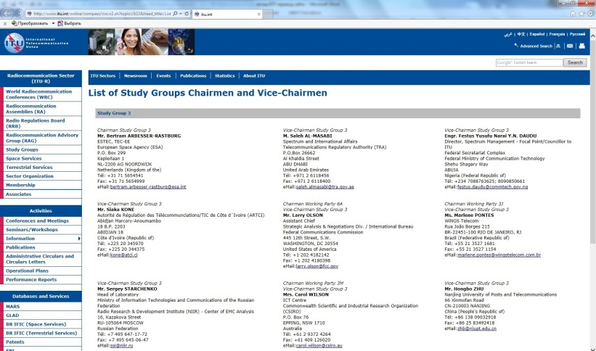
2.2.2. Going to the Russian page:
http://www.itu.int/online/compass/cvc.v2.sh?lang=ru&3&head_title=List%20of%20Study%20Groups%20Chairmen%20and%20Vice-Chairmen
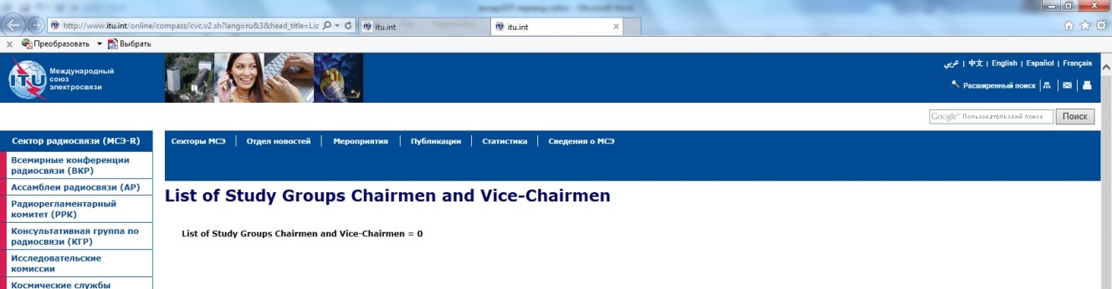
2.2.3. Going back to the English page (via link in the top of the page):
http://www.itu.int/online/compass/cvc.v2.sh?lang=en&3&head_title=List%20of%20Study%20Groups%20Chairmen%20and%20Vice-Chairmen
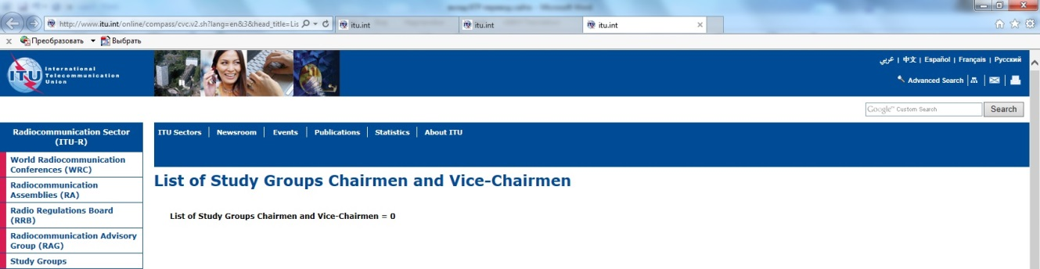

Proposals
To advise Director of Radiocommunication Bureau to define a contact at the BR for receiving comments and proposals on language-related issues of ITU-R web-pages.
BR Director is invited to regularly inform RAG about the activities concerning language-related issues of ITU-R web-pages.

