Radiocommunication Study Groups | 
Received: 16 August 2021  Source: Wireless World Research Forum | Document 5D/743-E
 | 17 August 2021
English only
TECHNOLOGY ASPECTS
Wireless World Research Forum
Evaluation Report on the Candidate Technology Submission For IMT-2020 “EUHT” As Part of the Re-engagement in Step 4 Evaluation
This contribution contains the evaluation report from the Independent Evaluation Group Wireless World Research Forum (WWRF) for EUHT, IMT-2020/17 Submission. Following the finalisation of Step 7 in the IMT-2020 Process, EUHT submission evaluation was granted an extension in the IMT-2020 Process, for re-engagement and re-evaluation.
The evaluation is based on the characteristics defined in Reports ITU-R M.2410 [1], M.2411 [2] and M.2412 [2] using a methodology described in Report ITU-R M.2412-0 [3].
The report is organized as follows:
• Part I: Administrative Aspects of the WWRF
• Part II: Technical Aspects of the work of WWRF
• Part III: Conclusions

Part I: Administrative aspects of the Independent
Evaluation Group

I-1 Name of the Independent Evaluation Group (IEG)
Wireless World Research Forum (WWRF).

I-2 Introduction and background of the Independent Evaluation Group
WWRF’s goal is to encourage research that will achieve unbounded communications to address key societal challenges for the future. The term “Wireless World” is used in this broad sense to address the support of innovation and business, the social inclusion, and the infrastructural challenges. This will be achieved by creating a range of new technological capabilities from wide-area networks to short-range communications, machine-to-machine communications, sensor networks, wireless broadband access technologies and optical networking, along with increasing intelligence and virtualization in networks. This will support a dependable future Internet of people, knowledge and things and the development of a service universe. WWRF is the unique forum where the wireless community can tackle the key research challenges. By searching out the issues, flagging them up to opinion leaders, and then working with liaison partners to deal with them, WWRF drives the development of the Wireless World. WWRF organizes two major events each year combining inputs from industry and academic experts, the exchange of ideas and the evolution of the research agenda and technology roadmaps. WWRF’s has a strong publication programme, working with partners such as IEEE and Wiley, makes the key messages and results available to the wireless research sector. To ease standardization, WWRF disseminates and harmonizes views, and together with our major liaison partners, we initiate collaborative research, and develop the global vision.
Over the last ten years, WWRF has championed several activities focused on the wireless evolution to and beyond 5G, including workshops and special sessions, presentations, white papers, and journal special issues. WWRF has been very supportive of the ITU’s evaluation process for
IMT-2020 and participates as an independent evaluation group (IEG).

I-3 Method of work

I-3-1 Background
The step 4 of IMT-2020 evaluation process was conducted to identify if the candidate RIT met the requirements set by the ITU. However, the step 4 didn’t conclude the decision-making process and an extension was agreed upon, where the steps 4-7 will be carried out to ascertain if the RIT meets the ITU requirements.

I-3-2 Organizational Issues
The work was organized using the following channels:
1 Regular online meetings of the steering board
2 Weekly meetings of the technical team
3 File sharing through secure shared space
4 Workshops/Seminars organised by the WWRF
5 Monitoring of the ITU Discussion Forum

I-4 Administrative contact details
Name & Affiliation: Dr Nigel Jefferies, WWRF Chairman.
Email: chairman@wwrf.ch

I-5 Technical contact details
Name | Affiliation | e-mail
Prof. Christos Politis | Kingston University, UK | c.politis@kingston.ac.uk
Dr. Rafay Iqbal Ansari | Kingston University, UK | rafay.ansari@kingston.ac.uk
Dr. M Arslan Usman | Kingston University, UK | m.usman@kingston.ac.uk
Mr. Nuwan Weerasinghe | Kingston University, UK | nuwan.weerasinghe@kingston.ac.uk
Dr. Yuhui Luo | National Physical Laboratory (NPL) | yuhui.luo@npl.co.uk
Dr. Yungsong Gui | National Physical Laboratory (NPL) | Yungsung.gui@npl.co.uk
Dr. David Humphreys | National Physical Laboratory (NPL) | david.humphreys@npl.co.uk

Part II: Technical aspects of the work of the Independent Evaluation Group

II-A What candidate technologies or portions of the candidate technologies this IEG is or might anticipate evaluating?
The IEG has evaluated the following scenario for EUHT:
• URLLC for urban macro environment (By Simulation)

II-B Confirmation of utilization of the ITU-R evaluation guidelines in Report ITU-R M.2412
The IEG has followed the ITU-R evaluation guidelines and the evaluation is conducted under the light of those guidelines.

II-C Summary of Results

II-C-1 Requirements from ITU
For any candidate technology, ITU has laid down the minimum requirements for reliability i.e.,
1-10⁻⁵ success probability of transmitting a layer 2 PDU (protocol data unit) of 32 bytes within 1 ms in channel quality of coverage edge for the Urban Macro-URLLC test environment, assuming small application data (e.g., 20 bytes application data + protocol overhead).

II-C-2 Evaluation methodology
The evaluation methodology followed to evaluate the candidate technology EUHT can be found in section 7.1.5 of ITU-R M.2412.

II-C-2A System-level simulation parameters and technical assumptions
Network Configuration & Layout:
We have setup the layout for EUHT system-level simulator network as per the guidelines of ITU. A summary of system configuration is provided in Table 1 and a network layout of one test cycle is shown in Fig. 1.
Table 1
System configuration
Parameter | Value
Number of Sites | 19
Number of Sectors per Site | 3
Frequency reuse factor | 3
Total Number of Cells | 19 * 3 = 57
Number of UE devices per Cell | 10
Total UE devices | 57 * 10 = 570
UE antenna height | 1.5 m
BS antenna height | 25 m
Inter-site distance | 500 m

FigURE 1
System Level Simulation Network, Layout: Urban Macro – URLLC test environment
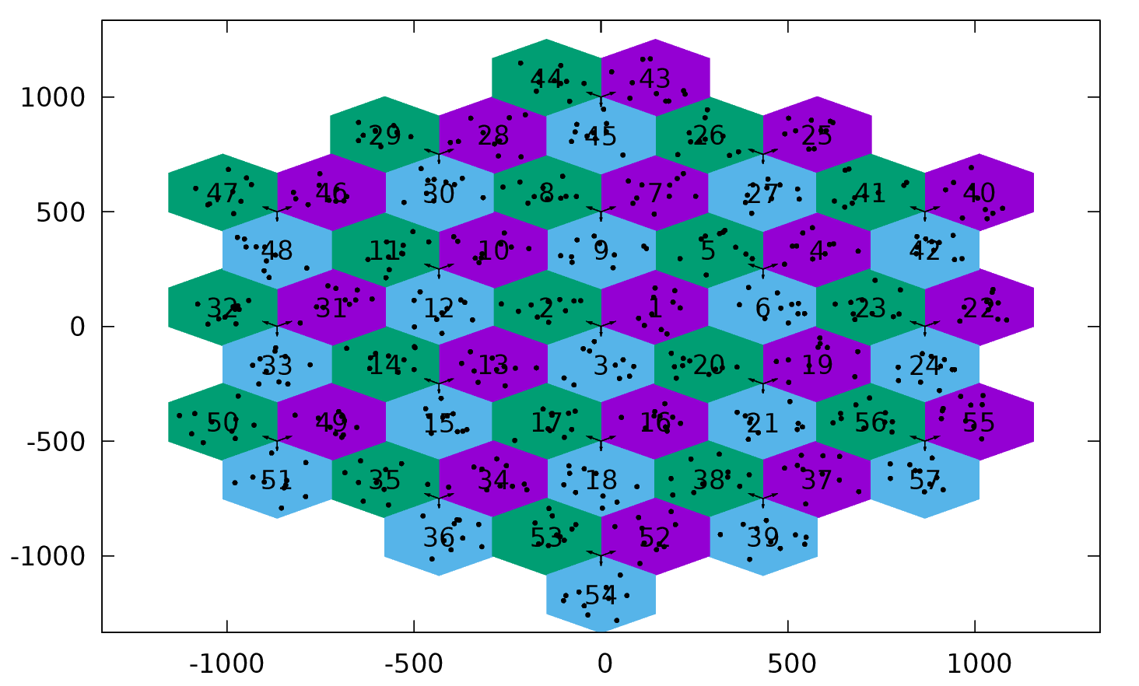
Table 2
System level Technical Assumptions & Parameters (Downlink)
Parameter | Value
Base Station noise figure | 5 dB
UE noise figure | 7 dB
BS antenna element gain | 8 dBi
UE antenna element gain | 0 dBi
Total transmit power per TRxP | 46 dBm for 10 MHz bandwidth
UE power class | 23 dBm
Thermal noise level | ‒174 dBm/Hz
Traffic model | Full buffer
Simulation bandwidth | 20 MHz
Percentage of high loss and low loss building type | 100% low loss
Number of antenna elements per TRxP | 8
Number of UE antenna elements | 2, 4 and 8
Mechanic tilt | 90° in GCS
Electronic tilt | 99° in LCS
UE mobility model | Fixed and identical speed |v| of all UEs, randomly and uniformly distributed direction
UE speeds of interest | 3 km/h
Carrier Frequency for evaluation | 4 GHz
Numerology | 78.125 kHz SCS
Duplexing | TDD

II-C-2B Link Simulation parameters and workflow
The link level simulation parameters have been taken from the EUHT specifications provided by Nufront and have been cross verified with the Self Evaluation Report of EUHT.
Table 3
Link level simulation parameters (Downlink)
Parameter | Value
Scenario | Dense Urban
Carrier Frequency | 4 GHz (Sub 6 GHz Bands)
Bandwidth | 20 MHz
Signalling Waveform | CP-OFDM (SU-MIMO)
Subcarrier Spacing | 78.125 KHz
Delay Spread | 363 ns
Cyclic Prefix | FFT Size/4
Guard Band | True
Propagation Channel | Tap Delay Line (TDL)
Mobility | True
Errors Considered | Block Error Rate (BLER)
Channel Coding | LDPC, code rate 4/7  (as per EUHT Self Evaluation Report)
Modulation | QPSK
Channel Estimation | Imperfect, Non-Ideal
Number of Transmit Antennas | 8
Number of Receiver Antennas | 2, 4 and 8

A stepwise workflow of the simulator is explained as follows:
1 Update the receiver process: Checks the FCS in MAC layer for any required transmissions.
2 Resource grid generation: Channel Coding and Modulation
3 Waveform generation: OFDM Modulation is performed.
4 Channel modelling: Pass the waveform through a channel.
5 Perform synchronization and OFDM demodulation: Perfect or practical synchronisation is performed.
6 Perform channel estimation: Perfect or practical channel estimation is performed by using the demodulation reference signals or common reference signal. Then OFDM demodulation is performed.
7 Perform equalization and CPE compensation.
8 Precoding matrix calculation: Generate the precoding matrix for the next transmission.
9 Decode the TCH: Demodulation and descrambling of the recovered TCH symbols for all transmit and receive antenna pairs, along with a noise estimate is performed.
10 Decode DL-TCH

II-C-2C Channel Model
The channel model is based on 3GPP TR 38.901 [1] implementation of a channel model [2][3]. Which is a 3D statistical Spatial Channel Model supporting different propagation environments (e.g., urban, rural, indoor), multi-antenna operations and the modelling of wireless channels between 0.5 and 100 GHz.
The implementation focused on:
• Path loss and shadowing models (3GPP TR 38.901, Sec. 7.4.1)
• Autocorrelation of shadow fading (3GPP TR 38.901, Sec. 7.4.4)
• Channel condition models (3GPP TR 38.901, Sec. 7.4.2)
For authenticating our channel model, we compared the 3GPP TR 38.901 specification with IMT 2020 channel specification. After careful consideration we observed only a few minor parameter differences which have negligible to zero impact on the simulation results. Hence, we have developed the EUHT channel based on 3GPP channel model.
The detailed study for this comparison is available upon request.

II-C-3 Results
The 5%-tile SINR applied for link level simulation is -2.675 dB as it can be seen in the following figure. It can be seen in Table 4 that the candidate technology does not pass the reliability requirements of ITU.
FigURE 2
Downlink SINR distribution obtained from System-Level simulations
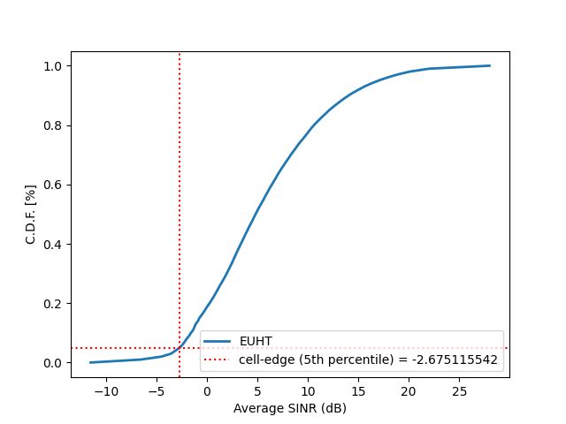

II-C-4 Updated results
This section contains the updated results for reliability analysis of EUHT. It can be seen in Table 4 that the RIT does not meet the reliability criteria for urban macro URLLC scenario. There are several observations that WWRF has compiled using the report ITU-R M.2412 and technical specifications for EUHT provided by Nufront.
Observations from ITU-R M.2412 and EUHT specification document:
• For meeting the reliability criteria (> 99.999%), channel estimation is one of the key processes. In EUHT technology, channel estimation is performed using the common reference signal (CRS).
• As per ITU-R M.2412, there are 19×3 cells in Urban Macro-URLLC test environment and all the user terminals will be evaluated in the URLLC evaluation assumptions.
• This means all these terminals have the URLLC traffic with at least 99.999% success probability in 1 millisecond.
• In low error mode, the CRS consists of one unique sequence without any identification.
• During the transmission of one frame, all the cells operate in the same mode i.e., either normal mode or low error mode. Therefore, it can be assumed that all the cells in Urban-Macro URLLC simulations should be in the low error mode.
• This results in all cells sending the same CRS at the same time, which means for any cell, the CRS in the low error mode would be polluted by signals of the neighbouring cells and result in wrong channel estimation. This will lead to CCH performance degradation in URLLC mode. The frame structure is given in Fig. 3.
FigURE 3
Frame structure of EUHT in physical layer (EUHT Specification)

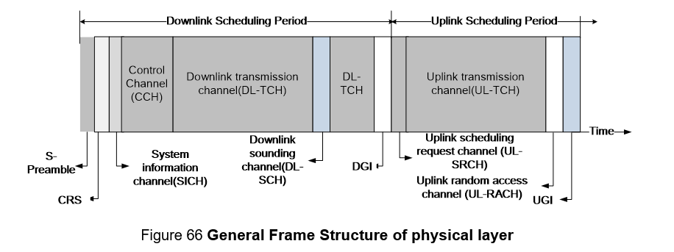
• This forms the basis of EUHT Technology not being able to meet the reliability criteria. WWRF further analysed the Downlink TCH (DL-TCH) performance under the same set of conditions.
• As per the self-evaluation report of Nufront for EUHT technology, there are 12 number of repetitions for DL-TCH. WWRF has followed the same test environment in their simulations. As per the Section 8.5.3 in EUHT specification document, a single RU-OFDMA scheme supports up to 4 repetitions in time domain. WWRF’s simulations are also based on RU-OFDMA.
• As per the EUHT specification document, for RU-OFDMA scheme, CRS is used for channel estimation which means DL-TCH will encounter the same problem like CCH. This will lead to wrong channel estimation and performance degradation for DL-TCH.
• Considering all these assumptions, WWRF concludes that even if antennae elements are increased at the receiver end (2, 4 and 8), wrong channel estimation leads to performance degradation in both CCH and DL-TCH and becomes the basis for EUHT not passing the reliability requirements.
• The results are provided in the Table 4 as follows.
Table 4
Final and updated results for Downlink (Antennae Config 8×8)
Minimum technical performance requirements (ITU-R M.2410) | Category |  |  | Required value | Value | Meets the Requirement? | Remarks
 | Usage scenario | Test environment | Downlink or Uplink
Reliability | URLLC | Urban macro-URLLC | Downlink | 99.999% | 99.955% | No | The candidate under evaluation does not meet the reliability criteria due to the provided antenna configuration.

• Additionally, in URLLC mode, energy efficiency at the receiver end is one of the key concerns. WWRF has not evaluated EUHT technology for energy efficiency, but it is a well-known and well-researched fact that increasing the number of antennae elements at the receiver leads to degradation in energy efficiency.
• Furthermore, it should be noted that as per ITU-R M. 2410-0 (Section 4.9), following are the requirements for energy efficiency. It can be observed that the ITU report does not define a numerical value for energy efficiency requirements, instead it is mainly relying on measurement of Spectral Efficiency. Furthermore, the requirement is defined mainly for eMBB usage scenario only highlighted as follows.

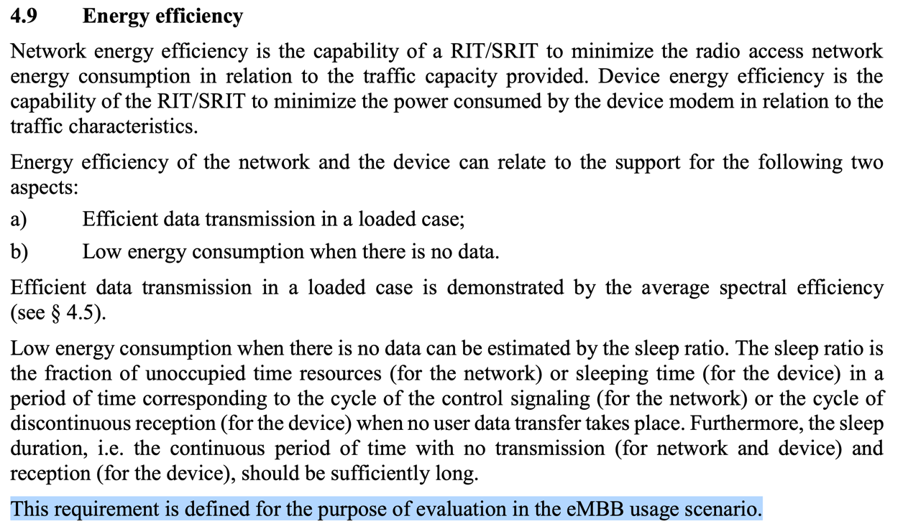

II-C-5 Correspondence with Nufront
After the WP 5D meeting in June 2021, WWRF approached Nufront to clarify the antennae configurations used in URLLC Urban Macro Scenario for Configuration A. Nufront responded with reference to EUHT specification document and ITU-R M. 2412.
Based on this clarification, WWRF has provided the updated results and several observations in the previous section and the preliminary results from previous report are available in Appendix A-I.

II-C-6 Overall summary of results for EUHT technology
In this section, the IEG has provided a summary of all the results to date, including submitted reports from last year’s round of evaluations. It can be observed that the RIT does not meet the requirements for reliability in Urban-macro-URLLC scenario, based on WWRF’s last year’s conclusion. The IEG continued to develop its link and system level simulators by further refining the results based on EUHT self-evaluation report and technical specifications. Based on two rounds of simulation-based analysis, the EUHT technology does not meet the reliability requirements from [1].
Whereas, in case of mobility in rural-eMBB scenario, the RIT passes the ITU requirements (as seen in the table below) which was presented in last year’s submission. The IEG was satisfied with the information provided for Mobility evaluation in Rural-eMBB scenario, to have correct and meaningful simulations. Therefore, the IEG would like to keep the evaluation results for Mobility (rural-eMBB scenario) as they are, by concluding that EUHT technology meets the requirements.
Table 4
Overall Results for EUHT technology (Reliability & Mobility)
Date (Report submitted) | Minimum technical performance requirements (ITU-R M.2410) | Category |  |  | Required value | Value | Meets the Requirement? | Remarks
 |  | Usage scenario | Test environment | Downlink or Uplink
August 2021  (Current) | Reliability | URLLC | Urban macro-URLLC | Downlink | 99.999% | 99.955% | No | The IEG concludes that candidate under evaluation does not meet the reliability criteria.
June 2021 |  |  |  |  |  | 99.875% |  | The IEG requested further information from Nufront for EUHT’s receiver design.
Feb 2020 |  |  |  |  |  | 99.9942% |  | The IEG concluded that candidate under evaluation does not meet the reliability criteria.  *System level simulations needed further investigation.
 | Mobility  (Pedestrian, Vehicular, High speed vehicular) | eMBB | Rural | Uplink | 0.45 bits/s/Hz  @ 500 Km/h | 0.16 bit/s/Hz | No | This simulation result is based on a single stream.  ITU Requirements achieved only 1% of simulation time.
 |  |  |  |  |  | 0.29 bit/s/Hz |  | This simulation result is based on two streams.  ITU Requirements achieved only 10% of simulation time.
 |  |  |  |  |  | 0.42 bit/s/Hz |  | This simulation result is based on three streams.  ITU Requirements achieved only 45% of simulation time.
 |  | eMBB | Rural | Uplink | 0.45 bits/s/Hz  @ 500 Km/h | 0.56 bit/s/Hz | Yes | Only the iteration with 4 streams (0.58 bit/s/Hz) can achieve ITU requirements (0.45 bit/s/Hz as defined in Report ITU-R M.2410 TABLE 4).  ITU Requirements achieved 77% of simulation time.

II-E Verification as per Report ITU-R M.2411 of the compliance templates and the self-evaluation for each candidate technology as indicated in A)
The verification of compliance templates and the self-evaluation is considered as per ITU-R M. 2411.

II-F Assessment as per Reports ITU-R M. 2410, ITU-R M. 2411 and ITU-R M. 2412 for each candidate technology as indicated in A)
The assessment has been carried out as per ITU-R M. 2410, M. 2411, and M. 2412.

II-G Questions and feedback to WP 5D and/or the proponents or other IEGs
This IEG has referred to the self-evaluation report provided by the EUHT and utilized the parameters used by the EUHT self-evaluation to cross verify the findings. Also, the IEG formally contacted Nufront for clarification on some parameters in the receiver design.

II-H Proposed next steps
The IEG aims to assess the EUHT technology for Mobility Interruption Time (by inspection).

Part III: Conclusions
In this report, we present the methodology that we have used for evaluating the RIT for urban macro URLLC scenario. We have detailed the system and link-level simulation parameters, technical assumptions, and the network layout. Based on our simulation results, we conclude that EUHT technology does not pass the reliability criteria for Urban-Macro URLLC. Several observations were made and they are detailed in the previous sections.
References & Additional Material
[1] ITU-R: Minimum requirements related to technical performance for IMT-2020 radio interface(s). Report ITU-R M.2410-0, (11/2017).
[2] ITU-R: Requirements, evaluation criteria and submission templates for the development of IMT-2020. Report ITU-R M.2411-0, (11/2017).
[3] ITU-R: Guidelines for evaluation of radio interface technologies for IMT-2020. Report ITU-R M.2412-0, (10/2017).

Appendix A

A-I Previous Results
These results follow an antennae configuration of 8x2 i.e., 8 Tx and 2 Rx antennae elements. For this antennae configuration the RIT does not meet the reliability criteria, however, even after increasing the number of Rx antenna elements, the RIT does not meet the reliability criteria as shown in Section II-C-4 of this report.
Table 4
Previous results (Antennae Config 8×2)
Minimum technical performance requirements (ITU-R M.2410) | Category |  |  | Required value | Value | Meets the Requirement? | Remarks
 | Usage scenario | Test environment | Downlink or Uplink
Reliability | URLLC | Urban macro-URLLC | Downlink | 99.999% | 99.875% | No | The candidate under evaluation does not meet the reliability criteria due to the provided antenna configuration.  *Increasing the number of receiver antenna elements may result in better reliability as Diversity increases.

______________

