Radiocommunication Study Groups
Received: 3 October 2022 | Document 5D/1462-E
 | 4 October 2022
 | English only
 | TECHNOLOGY ASPECTS
Director, Radiocommunication Bureau*
FINAL Evaluation Report from 5G India Forum Independent Evaluation Group for EUHT Technology under
IMT-2020 submission and evaluation process for M.2150
“Revision after year 2021” planned to complete in 2023 (Revision 4.0)
Part I
Name of the Evaluation Group: 5G India Forum (5GIF)
About the IEG
5G India Forum (5GIF) has been established under the aegis of the Cellular Operators Association of India (COAI), aiming to become the leading force in the development of next generation communications and will enable synergizing national efforts and will play a significant role in shaping the strategic, commercial and regulatory development of the 5G ecosystem in India.
5GIF is one of the registered as Independent Evaluation Group (IEG) for contributing to IMT-2020 development of ITU-R through independent evaluation of the IMT2020 candidate technologies. This group was formed by the COAI to evaluate the IMT-2020 candidates from the perspective of Indian network deployments.
This is a group of operators, OEM’s, universities and individual experts participating in a collaborative manner, in the evaluation of the candidate IMT-2020 technologies of interest. This is a contribution driven activity, with decisions made through a consensus seeking approach.
Method of work
The 5GIF IEG comprises operator, industry, and university members, knowledgeable on the subject matter, and committed to the IMT 2020 evaluation. Over 30 individuals have contributed to the evaluation process. The group employed both online and offline means for meetings. This group was formed to evaluate the IMT 2020 candidates from the perspective of Indian network deployments. The group worked through online and offline means, while strictly adhering to the ITU processes, and sincerely focuses on consensus-based decision making.
Two industry workshops were facilitated by COAI, which discussed the candidate technologies of interest. A special 48-hour hackathon with mentorship provide by industry experts helped our members get involved actively, especially those joining us from academia. The 5GIF IEG has had five workshops to help in deliberation and consensus building. We have a robust mechanism in place to track the evaluation progress and ensure that the ITU timelines are adhered to.
The final evaluation report from 5G India Forum IEG for EUHT Technology under IMT-2020 submission and evaluation process for M.2150 “Revision after Year 2021” planned to complete in 2023, is based on the new/ revised submission made by Nufront to the WP5D#40 meeting (IMT-2020/76).
Contact: Vikram Tiwathia  Deputy Director General, COAI | E-mail: vtiwathia@coai.in  Tel.: +91-11-2334-9275
Technical contact | E-mail: imt2020@5gindiaforum.in  https://5gif.github.io

Acknowledgements
The individual members listed below are acknowledged for their valuable contribution to the 5GIF IEG IMT-2020 evaluation activity.
Sl. No. | Name | Affiliation
1 | Divyang Rawal, Prof. | LNMIIT Univ.
2 | Navin Kumar, Prof. | Amrita Univ.
3 | Ashwani Kumar, Mr. | Huawei India
4 | Niranth Amogh, Mr. | Huawei India
5 | Sendil Devar, Dr. | Ericsson India
6 | Vikram Tiwathia, Mr. | COAI
7 | Vinosh Babu James, Dr. | Qualcomm India

Part II
Technical Report
In 2020, 5GIF had submitted its final report on EUHT of IMT-2020/18(Rev.1) in the IMT-2020 evaluation for first release of IMT-2020, and then in 2021, the report which contains the evaluation areas which are reviewed by 5GIF based on further interaction with EUHT proponents under Option-2 process.
Currently, the final report on IMT-2020/76 based on further interactions and review of clarifications received from EUHT proponents, is submitted in ITU-R WP5D#42 meeting.
A. Candidate technologies or portions Evaluated by the IEG
5GIF had carried out the evaluation of some scenarios/test environments for EUHT of IMT-2020/76.
The 5GIF IEG utilized the ITU-R Guidelines for evaluation of radio interface technologies for IMT-2020 provided in Report ITU-R M.2412. The evaluation has been conducted based on IMT-2020/76 submission documentation under Step 3) of IMT-2020 process and also, taken into account the clarifications provided by the proponents.

Summary table of the EUHT IMT-2020 candidate technology submission
RIT/SRIT Proponent | Submission of documents & acknowledgement of submission (IMT-2020/76)
Nufront | Submission IMT-2020/75(Rev.1)  Received for proposals of candidate radio interface technologies from proponent ‘Nufront’ under step 3 of the IMT-2020 process.
Acknowledgement IMT-2020/76
Acknowledgement of candidate RIT submission from Nufront under Step 3 of the IMT-2020 process.

B. Confirmation of utilization of the ITU-R evaluation guidelines in Report ITU-R M.2412
The 5GIF IEG confirms that it has evaluated the candidate technologies as well as evaluated the submissions from proponents based on Reports ITU-R M.2410, ITU-R M.2411 and ITU-R M.2412.
Characteristic for evaluation | High-level assessment method | Evaluation methodology (M.2412) | Related section of Reports  ITU-R M.2410-0 and ITU-R M.2411-0
Peak data rate | Analytical | § 7.2.2 | Report ITU-R M.2410-0, § 4.1
Peak spectral efficiency |  | § 7.2.1 | Report ITU-R M.2410-0, § 4.2
User experienced data rate* |  | § 7.2.3 | Report ITU-R M.2410-0, § 4.3
Area traffic capacity |  | § 7.2.4 | Report ITU-R M.2410-0, § 4.6
User plane latency |  | § 7.2.6 | Report ITU-R M.2410-0, § 4.7.1
Control plane latency |  | § 7.2.5 | Report ITU-R M.2410-0, § 4.7.2
Mobility interruption time |  | § 7.2.7 | Report ITU-R M.2410-0, § 4.12
Energy efficiency | Inspection | § 7.3.2 | Report ITU-R M.2410-0, § 4.9
Bandwidth |  | § 7.3.1 | Report ITU-R M.2410-0, § 4.13
Support of wide range of services |  | § 7.3.3 | Report ITU-R M.2411-0, § 3.1
Supported spectrum band(s)/range(s) |  | § 7.3.4 | Report ITU-R M.2411-0, § 3.2
Average spectral efficiency | Simulation | § 7.1.1 | Report ITU-R M.2410-0, § 4.5
5th percentile user spectral efficiency |  | § 7.1.2 | Report ITU-R M.2410-0, § 4.4
Connection density |  | § 7.1.3 | Report ITU-R M.2410-0, § 4.8
Reliability |  | § 7.1.5 | Report ITU-R M.2410-0, § 4.10
Mobility |  | § 7.1.4 | Report ITU-R M.2410-0, § 4.11

C. Documentation of any additional evaluation methodologies that are or might be developed by the Independent Evaluation Group to complement the evaluation guidelines
Not applicable.
D Verification as per Report ITU-R M.2411 of the compliance templates and the self-evaluation for each candidate technology as indicated in A.
Aspects |  | Nufront
1) | Identify gaps/deficiencies in submitted material and/or self-evaluation | Refer section 1
2) | Identify areas requiring clarifications
3) | General Questions to Proponents | Questions were raised and clarifications received. All relevant documents posted to the Evaluation area

E. Assessment as per Reports ITU-R M.2410, ITU-R M.2411 and ITU-R M.2412 for each candidate technology as indicated in A.
Aspects
Detailed analysis/assessment and evaluation by the IEGs of the compliance templates submitted by the proponents per the Report ITU-R M.2411 section 5.2.4;
Provide any additional comments in the templates along with supporting documentation for such comments;
Analysis of the proponent’s self-evaluation by the IEG;

F. Questions and feedback to WP 5D and/or the proponents or other IEGs
The following documents involving observations from 5GIF and clarifications received from the proponents, as below, are uploaded to the IMT-2020 evaluation discussion area.
5GIF interim observations to 5D#41 in June and Nufront clarifications.
5GIF interim observations to IEG-Proponents workshop held on 2 September 2022 and Nufront clarifications.
5GIF Conclusions on Nufront Clarifications to IEG Workshop on 24 September 2022.
Table of contents
Page
1 Verification of compliance templates of candidate technologies 6
2 Carrier aggregation and handover in CA mode with 0 ms mobility interruption 6
3 Issues with dual connection for 0ms mobility interruption 14
4 Compliance assessment for other miscellaneous issues 16
5 Assessment of Candidate technology - IMT-2020/76 17
5.1 Compliance Templates 17
5.2 Detailed Technical Evaluation 21
6 Conclusions 48
7 Annexes 49

1 Verification of compliance templates of candidate technologies
In this chapter, we report our observations on the submissions of the EUHT candidate technology at the end of step 3) of the IMT-2020 process.
For the EUHT candidate technology from Nufront (IMT-2020/76), we referred their new specifications as contained in the submission in IMT-2020/75R1.
This chapter verifies the following aspects like – gaps and deficiencies in the templates – link budget, characteristic and compliance templates as well as ambiguous parts of the submissions which needs sufficient clarifications from the proponents so as to independently evaluate the technology as per M.2412 recommendations.
Observations based on the specification of EUHT RIT as per the submission in IMT-2020/76 is as follows:
In this chapter, we report the final conclusions on the submission of the EUHT candidate technology at the end of step 3) of the IMT-2020 process.
For the EUHT candidate technology from Nufront (IMT-2020/76), 5GIF referred their new specifications as contained in the submission in IMT-2020/75R1 (acknowledged by WP5D in IMT-2020/76).
5GIF submitted its initial observations to WP5D#41 in June 2022, and subsequently in IEG Workshop held on Sep 02, 2022. 5GIF conducted detailed analysis of the clarifications provided by the proponents during the WP5D#41 meeting as well as the clarifications received after IEG workshop (held on Sep 02, 2022) on Sep 11, 2022.
This document provides the final conclusions of 5GIF IEG concerning various aspects of the EUHT candidate technology.
5GIF raised observations and sought clarifications from Nufront about several key aspects of EUHT to evaluate relevant KPIs:
1 Support for Carrier Aggregation (CA) functionality in the EUHT technology.
2 Support for Hand Over (HO) with CA functionality.
3 Support for 0ms mobility interruption with CA.
4 Support for 1024-QAM modulation order for both codewords.
5 Some miscellaneous aspects about the specific behaviour with respect to licensed IMT-2020 technology
Accordingly, various questions were raised to seek the clarifications from the proponents, only with due references to EUHT specifications. The clarifications have been analysed to the extent of their description in the specifications, and accordingly the final conclusions drawn.

2 Carrier aggregation and handover in CA mode with 0 ms mobility interruption
A) Issues with System acquisition - Synchronization and Initial Access
Background
Based on the Section 1.6.4: The Network Join process involves three key steps:
a) System Synchronization
b) Random Access
c) Capability Negotiation
1 To complete the Network join process, the STA needs to first successfully complete the System synchronization step. As per the EUHT specifications, all necessary System Information about all the CCs in the cell is contained in the Broadcast Control Frame (BCF), and BCF can be transmitted on any CC.
2 For this, the STA needs to know the channel bandwidth of the CC to receive the BCF frame, when it tries for System synchronization during Initial Access phase. Otherwise, STA would not be able to receive the BCF in a CC, if it is not aware of the CCs configuration. However, as per EUHT specifications, the configuration (bandwidth, working bandwidth 1, SCS etc.) of each CC is only available in Broadcast Control Frame (BCF), decoding which is possible only after successful Synchronization of STA to a CAP. Furthermore, the BCF can be transmitted on “any CC” transmitted in the cell.
3 If STA could not successfully decode the BCF, the following steps, such as Random-Access procedure, Capability Negotiation procedure etc., will not be performed.
4 As per the EUHT specifications and further clarifications from the Nufront, this becomes clear that the STA does not know Basic Bandwidth (Working Bandwidth 1) or Channel Bandwidth “essential” information before successful BCF reception. Same issue applies to all applicable CCs used in the CA.
5GIF raised queries to Nufront to provide clarification and their respective references in EUHT specifications as to how STA would precise locate Synchronization signal and BCF in time and frequency domain, given that the above mentioned essential details comprising which CCs and their configurations (bandwidth, working bandwidth 1, SCS etc.) are being transmitted in the cell are not known to STA. And, there are no specifications on detailed design of the Synchronization and Broadcast signals, procedures, the details on default scanning bandwidth where these signals should be looked for in the CC (in time and frequency domain). This is critical for further steps like Random Access (RA) and further connection setup. This is essential to conclude successful System acquisition and operations of CA, as CA is aggregation with multiple such CCs.
5GIF analysis of Nufront response shared on 11 September
1 By nature, Initial System acquisition by a user terminal is a highly complex process. Given that IMT-2020 is a very large bandwidth system covering a large number of frequency bands with multiple associated sub-carrier spacings unless the System acquisition process defined with minutest details, in terms of complete details and algorithms for a STA to precisely locate the Synchronization signal in time and frequency on a CC, there cannot be deterministic outcome of this process in time bound manner. User terminal shall be stuck in a loop.
2 Upon switching on, the STA is clueless about the CCs being used in the cell and their configuration (channel bandwidth, SCS, basic bandwidth etc.) in the cell. It has to perform cell search beginning with downlink Synchronization (for starting of frame and symbols, and frequency location of the carrier, and the location of Synchronization signal in the CC bandwidth). It also needs to know a default “Scanning bandwidth” at this stage, across which to hunt for this Synchronization signal. Fundamentally, therefore there has to be clear definition of well-designed Synchronization and Broadcast signal with clear and deterministic location of these signals in time and frequency domain in resource grid for all CCs, and associated “default scanning bandwidth”, for all spectrum bands and all CC configurations. It is not clearly defined in the specifications. Without this STA cannot perform this System synchronization according to specifications.
3 All that EUHT specifications describe is that, the STA has to scan the channels i.e. CCs to carry out System acquisition (locating Synchronization signal and BCF). At the same time, EUHT specifications state that all necessary System Information about all the CCs (their configuration) in the cell, is contained in the BCF, and BCF can be transmitted on any CC by the CAP. That is the only information available in specifications. Based on the EUHT specifications and further clarifications from the proponents, this becomes clear that the STA does not know the “essential” information like, Basic Bandwidth (Working Bandwidth 1) or Channel Bandwidth before successful BCF reception. Nor comprehensive details on exact location (time and frequency domain) of Synchronization signal and BCF in the CCs for all configurations is specified in EUHT specifications. There has to be a well-designed Synchronization signal structure and its location in the CC, in order for STA to locate it, in deterministic and timely manner. Hence in our assessment, STA would only be left in a loop.
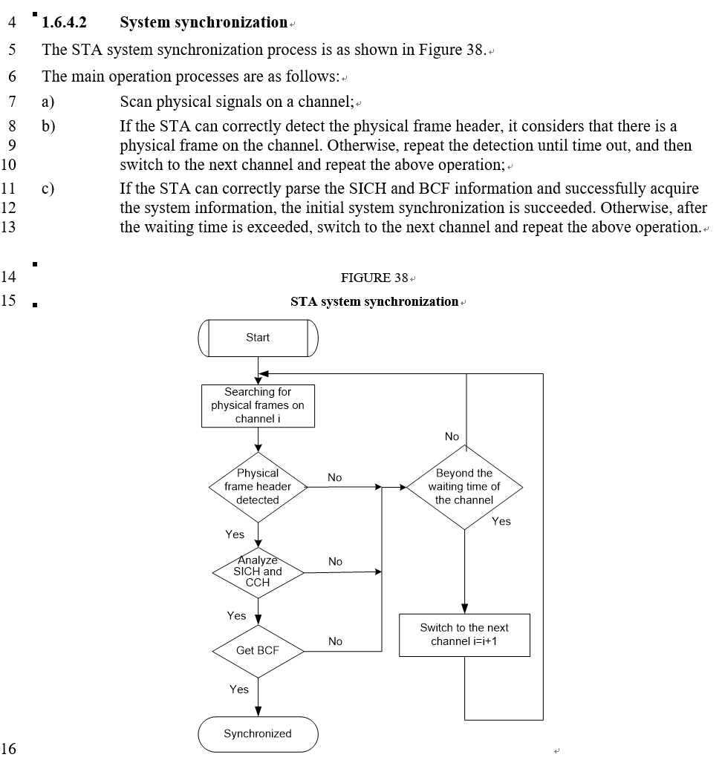
4 If STA could not successfully decode the BCF, the following steps, such as Random-Access procedure, Capability Negotiation procedure etc., and subsequent Connection phase will not be performed. Same applies to all applicable CCs used in the CA, therefore this deficiency has direct bearing on successful support of the CA functionality by EUHT.
On specific clarifications from Nufront, 5GIF response is as follows:
5 Nufront’s response on 11th September mentions, “Referring to Figure 38 in section 1.6.4.2, STA try to scan physical signals on different channels with different basic bandwidths….”. However, if we see the contents in Section 1.6.4.2 of the EUHT specifications (IMT-2020/76), also reproduced below, the yellow highlighted “interpretation” is not captured as per Figure 38 of this section, in the EUHT specifications IMT-2020/76.
6 To respond to 5GIF objections, Nufront clarified that Synchronization signal or Preamble, BCF, SICH “can” be duplicated on the sub-channels. We have to go by the definition in the specifications only. This is not valid since Figure 38 explicitly specifies scanning the channels and specifications nowhere define to extract the Synchronization signal or BCF from sub-channels. Therefore, this clarification is not acceptable. Nor we find any details where to locate it scanning bandwidth in specifications.
7 Different sets of CAP Working Bandwidths / Channel Bandwidths (Five Working Bandwidth Sets each with a specific Basic Bandwidth 1 or Working Bandwidth 1), are defined for CCs. Firstly, the STA is not aware of the Basic Bandwidth of CCs being transmitted by the CAP in a cell. It has to blindly try with all Basic Bandwidths supported by itself, which is too time consuming. Secondly, there is no guarantee that STA should support the Basic Bandwidth of a CC being transmitted by CAP. EUHT specifications do not explicitly mandate that all Working Bandwidths 1 will be supported by an STA. Therefore, there is no guarantee that STA should necessarily support all the Basic Bandwidths used by a CAP in the cell. There are different capability devices (Reduced STA example) in which vendors can implement different Basic / Working Bandwidths 1 per application needs. We see serious challenge is receiving Synchronization signal and BCF in a CC under these given conditions, and hence performance of System synchronization cannot be achieved by STA. Furthermore, CAP also does not know STA capability (Working Bandwidths 1 and Channel Bandwidths supported), before Capability Negotiation phase, which can occur only after successful completion of System synchronization and RACH processes. With the explanation in previous points, when the System synchronization is ridden with challenges, there is no possibility for successful execution of RA process and Capability negotiation process by the STA. Therefore, CAP also cannot align the Working Bandwidth 1 of the CCs to align with STA supported ones.
8 Regarding the Nufront’s responses on 11th September mentioned to section 1.7.3, therefore STA should support all basic bandwidths….. However, the yellow highlighted “interpretation” is not at all mentioned in the EUHT specifications of IMT-2020/76, including section 1.7.3 below.
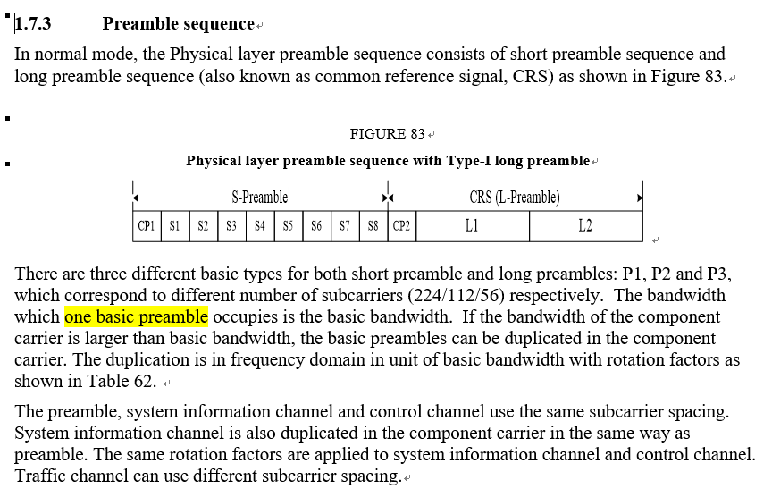
9 The Basic Bandwidth / Working Bandwidth 1 is essential element for successful initial access for all STAs. As the definition about basic bandwidth in section 1.7.3, this is the bandwidth occupied by “one” basic preamble, out of P1, P2, and P3. So, there would be only three basic bandwidths as 5, 10 and 20 MHz as below Table 62. Maximum basic bandwidth is supported in 20 MHz for P1.
Besides, in normal mode (sub-6GHz band), even if the STA can support these three basic bandwidths, considering the EUHT system can’t forecast when a STA accesses the network. The EUHT system should operate the bandwidth of one subchannel as one of the three basic bandwidths, which used by STA to access network. So, the maximum operation bandwidth of EUHT system should be 80 MHz, due to there is up to 4 subchannels in one component carrier. This is inconsistent with 100MHz as claimed in the EUHT specifications.
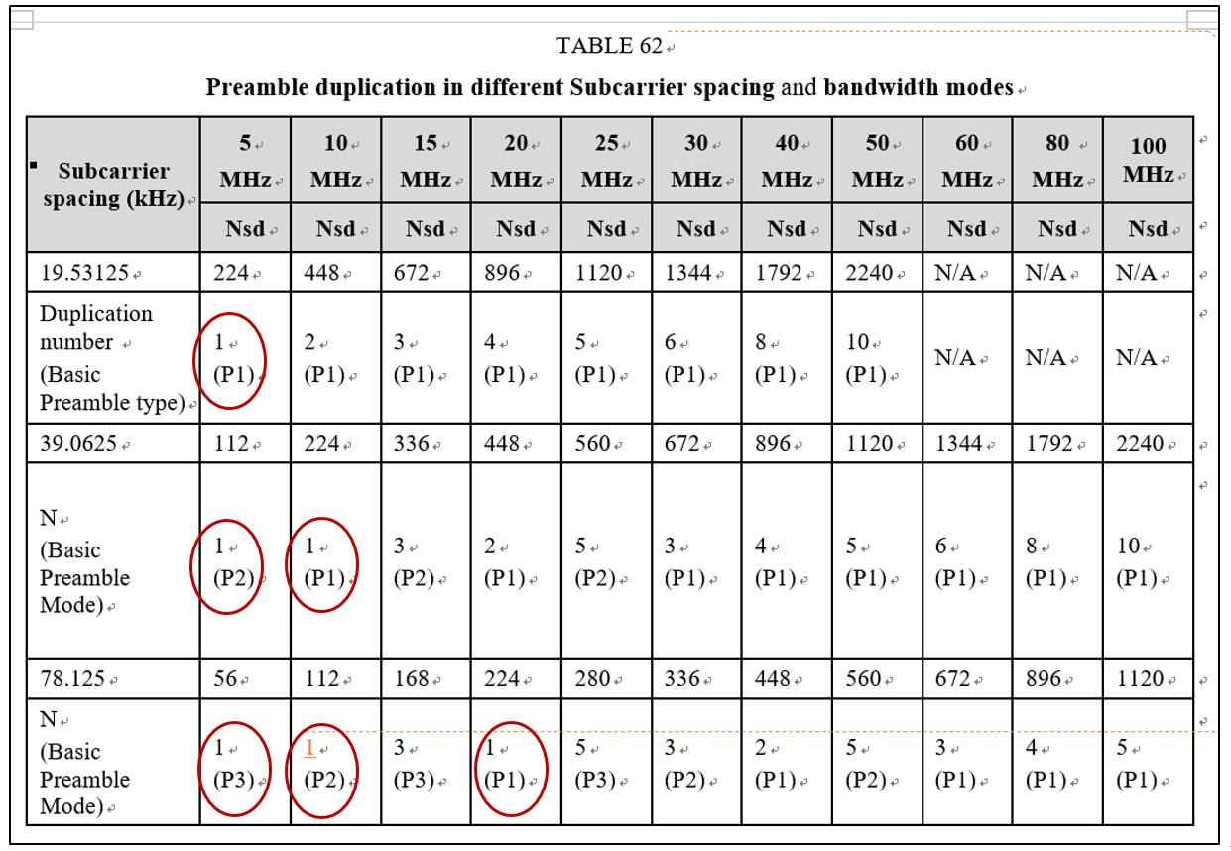
10 In mmWave mode (mmWave band), the EUHT specification doesn’t specify any basic bandwidth. The initial process isn’t able to process at all, lacking of the definition of basic bandwidth. So, the STA isn’t able to access any CAP in mmWave band.
11 As per Nufront clarifications, on the “BCF frame in the TCH” as per the slide, it states that the BCF transmission method in the slides are duplicated on the subchannels and the TCH can be independently scheduled. It only adds to confusion and hence difficult to understand the scheme of BCF transmission clearly.
5GIF’s Conclusion:
1 Based on above discussion and analysis, 5GIF would fail to conclude on initial access essential to conclude basic operations and subsequent CA support by EUHT technology.
2 Also, maximum bandwidth of one carrier is 80MHz in sub-6GHz band (20x4MHz sub-channels) and not 100MHz as claimed in the specifications.
3 The EUHT specification doesn’t specify any basic bandwidth for initial synchronization and access in mmWave band. So, 5GIF would fail to conclude on initial access in mmWave band.
B) Issue in successful connection of CCs post Initial access
5GIF raised many queries for clarifications in this context:
1 After successful RA on a specific CC out of the ones transmitted by a CAP, there is capability negotiation request and response frame exchange. There is only communication from STA about CCs supported and directions to STA by CAP about which CCs to be connected to, where is confirmation signalling back from STA to CAP, in call flow of successful reception of specific CCs by STA to CAP???
2 How can CAP simply assume that a specific CC is received well above threshold by an STA???
3 Same will apply to all CCs of an STA with respect to handover. How will the destination CAP know which of the CCs are received well and it would also do the same addition of all CCs as per STA Capability response frame by default
Nufront’s response on 11 September mentions that:
After “capability negotiation” process, CAP will know which CCs are supported by the STA.
In the data traffic process later, CAP can learn the condition of each CC by channel measurements, or simply by counting the ACK frame successfully received from STA.
If some CCs are in bad condition, CAP may decide not to schedule traffic on that CCs or even to de-activate the bad CCs for specific STA.
Ref. section 1.6.15.2, before joining the CAP-D, STA only knows one of the CCs used by CAP-D through HO-CMD message from CAP-S. Therefore, CAP-D doesn’t need to know which CCs are received well by STA.
After joining the CAP-D, STA will have information of all CCs supported by CAP-D by BCF and capability negotiation.
5GIF Conclusion
1 We are talking about the stage after RACH, when STA is supposed to enter in connected mode, which Radio Resource Connection set up with a regular CC. Before this all steps are performed on default shared UL/DL-SCHs in RACH phase. This is based on the RSSI measurements on the CCs by STA, only those CCs / Cells are added to an STA which are above threshold. CAP is not expected to connect all CCs to STA based on its capability
2 We don’t find any measurement procedure on the CC in RRC stage, to ensure connection of appropriate CCs being received above threshold
3 The ACK message in capability negotiation phase to convey that capability response message from CAP is received by STA
4 All the above, are essential missing steps to conclude basic operations and subsequent CA support by EUHT technology
As explained in the analysis of Sections A) and B), 5GIF is not able to conclude that CA functionality is supported in EUHT.
C) Handover in CA Mode
5GIF raised many queries for clarifications in this context –
1 Do all CC’s perform independent RACH to CAP for initial access?
2 All CC’s are independent, and expected to initiate and complete HO interpedently, as per specs
3 Different CC’s might go below threshold at different points of time, and all CC’s may not complete the HO and RACH in destination CAP at same time
4 Does EUHT has collective HO’s of all CC’s together or independently?
– If STA is in CA mode and uses multiple CCs, the RSSI value should be averaged over all CCs it uses??? Why average of all CC’ when all CC’s do independent HO? Why the average RSSI of all CCs together, rather than RRSI of individual CCs???
5 Do all CC’s perform independent RACH in destination CAP?
6 Do all CAPs transmit all and same CCs? Specs says #CCs may be different in different cells 1.6.15.2 Carrier aggregation management
7 Conflicting statement – EUHT specifications state that “CAP will decide to transmit BCF on which CC(s) since BCF contains information of all CCs. To speed up the network join process, the better practice is to transmit BCF on ALL CCs”. What is the factual implementation? Ref. 1.6.15.2 Carrier aggregation management
8 EUHT Specs says STA can send CM_REQ and CM_REP on any CC, and similarly CAP can send CM_RSP on any CC to STA. Reasons for this random approach?
9 How HO delays would be controlled, if both STA and CAP have to scan all CCs to locate on which CC, messages are sent?
10 Why average RSSI of all CCs instead of RSSI of individual CC, when the HO is independent for all CCs?
Nufront’s response on Sep 11 states that “For initial access or handover, performing RACH on one CC is needed”.
5GIF Conclusion:
Given that all CCs are independent and undergo independent handover and there is no concept of Primary Cell in EUHT, this argument is not commensurate with the specifications nor justifiable. All CCs would have to undergo RACH process upon handover since all CCs are independent. Nor does the specifications define this anywhere. Therefore, this is not acceptable clarification.
Nufront’s response on Sep 11 states that “If CAP-S has multiple CCs, the RSSI values of multiple CCs should be averaged to reflect the overall channel quality of CAP-S. Then CAP and STA can trigger the handover process based on overall channel quality”.
5GIF Conclusion:
1 Handover is independent for all CCs. Current RSSI level of all CCs is the rightly applicable parameter to triggering handover and not the overall channel quality.
2 On point no. 7) of 5GIF queries, that “EUHT specifications state that “CAP will decide to transmit BCF on which CC(s) since BCF contains information of all CCs. To speed up the network join process, the better practice is to transmit BCF on ALL CCs”. What is the factual implementation?”, Nufront’s response provided on Sep 11 states that “The detailed implementation is up to the manufacturers and out of scope for the specification”. This is an essential element for handover how can this be left to implementation. Both the STA and CAP need to make sure both ends have same implementation and not necessarily both are sourced from same vendor. Therefore, this clarification is not acceptable.
3 On points 8 and 9 of 5GIF, Nufront’s response on Sep 11 states “STA and CAP can choose the CC to carry CM_REQ and CM_RSP message which is more flexible. It should be noted that selection strategy is implementation related. For example, CC with better condition may be selected to improve the reliability”
5GIF Conclusion:
This is an essential element for handover how can this be left to implementation. We don’t see any such signaling specification in the EUHT specifications that STA and CAP are exchanging such information. Since there is no straight forward specification about directly spotting which CC is used for HO_REQ and HO_CMD, this would be blind decoding at both ends to extract this, and would involve delays. Both the STA and CAP need to make sure both ends have same implementation and not necessarily both are sourced from same vendor. Therefore, this clarification is not acceptable.
Nufront’s responses on 11th September mentioned as “Ref. section 1.6.15.2, before joining the CAP-D, STA only knows one of the CCs used by CAP-D through HO-CMD….”
5GIF Analysis
As per section 1.6.15.2 on Carrier aggregation management reproduced below, HO-CDM is very important message for handover and activation/deactivation of CCs in CA mode. CAP-S uses HO-CMD message to activate the CCs of CAP-D for handover process. As per paragraph 4), the CC list of HO-CMD is related with the current CC list of STA. So, considering the current CC list of STA is configured by CAP-S, so the working CC of CAP-D may not be included into this CC list. In this case, the STA can’t process handover. Even if all CAPs transmit same CCs, which can never be the case, the configurations of CCs (channel bandwidth and working bandwidth 1) will be different in CAP-S and CAP-D. STA is required to know the configuration of CCs in CAP-D to perform handover.
5GIF Conclusion:
The current CC list in HO-CDM will not support the case that working CC of CAP-S is flexible and not different from the CCs in the CC list. We don’t see any such signaling or behavior specification in the EUHT specifications that STA and CAP are in the handover process.
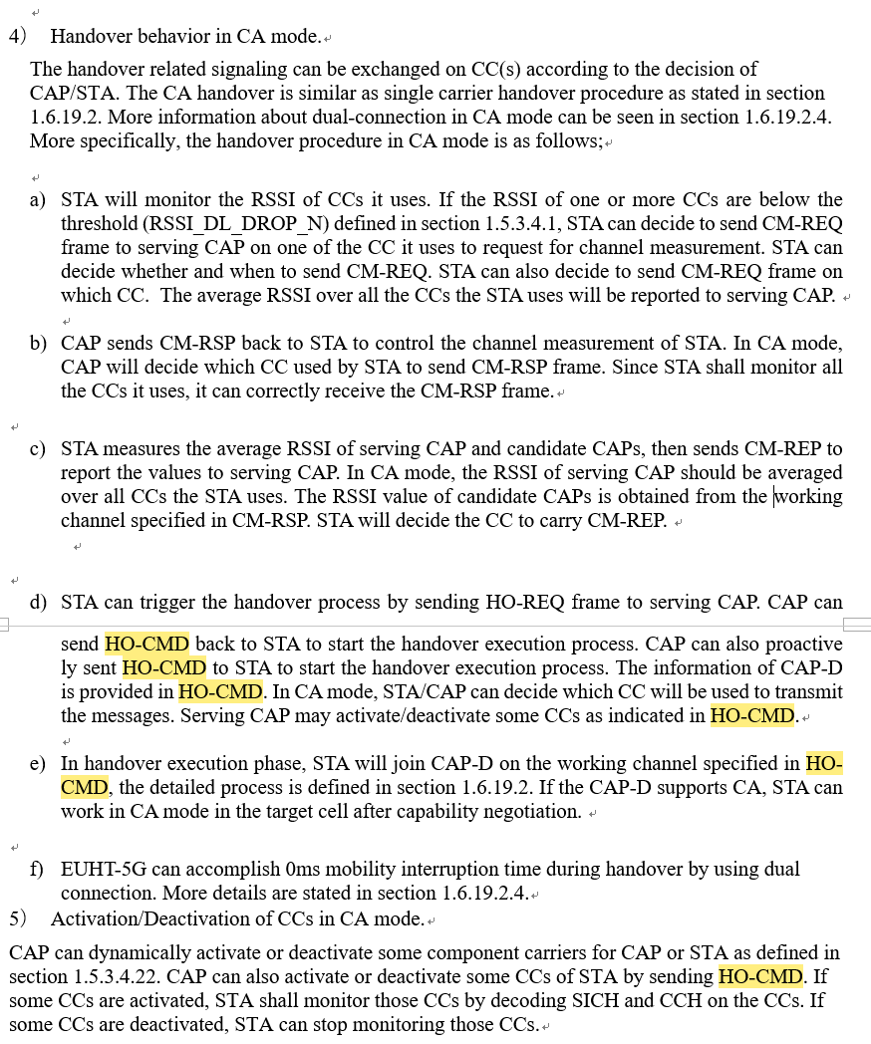
To sum up, as explained in the detailed analysis of Sections C), 5GIF is not able to conclude that Handover, even in single carrier mode would be proper in EUHT. Same will apply to multi-carrier CA operations.

3 Issues with dual connection for 0ms mobility interruption
Data collection in CA during dual connection
5GIF shared an observation, on Fragmentation and Reassembly in Section 1.6.8 of EUHT specifications -
Larger payload by MAC layer into multiple PDU’s which are transmitted on multiple CCs. There is lack of clarity on how can CAP ensure that all MPDU’s transmitted on various CC’s would be successfully received and integrated back at STA when some of the CC’s are not actually connected or in receivable condition??
The Nufront’s responses on 11th September confirms that one MPDU cannot be split and transmitted on different CCs.
The response also mentions that “Multiple MPDUs can be transmitted on multiple CCs. If we refer sections 1.7.11 & 1.6.19.2.4 phase 2 in detail, there is a unique sequence number in each MPDU, which can be used to correctly reassemble MAC data unit in all scheduled CCs.….”
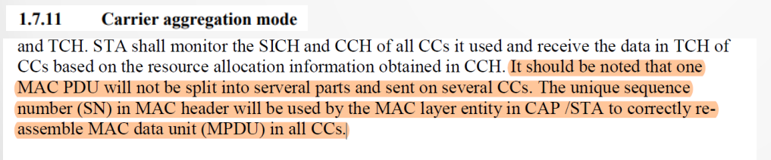
5GIF Analysis
Based on the below-mentioned process of the Section 1.4.2 in EUHT specification, MAC layer includes Adaptation sublayer and MAC sublayer, in which an SDU from higher layers can be segmented by Adaptation sublayer in to multiple MPDUs (are transmitted in MAC sublayer). Furthermore, as per section 1.4.2, for dual connection, these multiple copies of same message are assigned same “unique MAC sequence numbers” in one MAC layer. This leads to conclusion that – Adaptation sublayer and MAC sublayer are using the common MAC Sequence numbering schema. In other words, the MAC numbering in the EUHT specification doesn’t differentiate the SDUs and MPDUs under the unique MAC sequence for a STA or a CAP. This eventually creates serious complications in system operations.
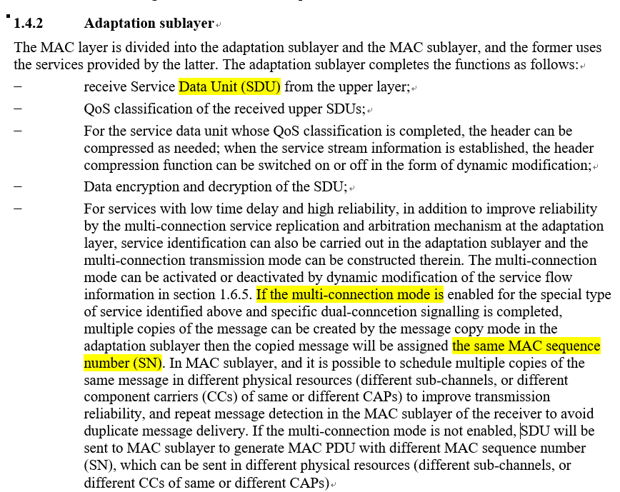0
Further, if we follow section 1.5.1.2.8, Sequence numbering is from 0-4095 (12 bits long) to indicate the numbering of SDU/MPDU. The first SDU/MPDU “essentially” starts with 0 and subsequent ones in a flow are identified by 1, 2, 3…….. . Since both SDU and MPDU are using same numbering schema, in case one SDU fragmented in to multiple MPDUs, this is not possible that multiple MPDUs from a single SDU will start with 0. We can make two interpretations,
1 Both sublayers using the complete range for their respective numbering i.e. SDU and MPDU numbering
2 Both sublayers partition the entire range and use exclusive numbering ranges in their partition
However, the specification is completely silent on these details.
For example - In uplink, an SDU is counted as No. 0 in the unique sequence of MAC layer, and MPDUs that are segmented from the SDU are also counted as the Numbers in this unique sequence of MAC layer. When the STA sends these MPDUs to CAP, the following case would happen in the data transmission process.
– Case 1: If the MPDUs includes the MPDU using No. 0 in the unique MAC sequence, the MPDU would be named as the same number as the PDU using as No. 0. It leads that the CAP misunderstands the data using the same number as duplicated data, based on Section 1.6.19.2.4 on 0ms Mobility interruption time below. Then, the CAP will discard one of them, so it will result in the data loss according to the CA feature in EUHT specification. So Dual connection would not work.
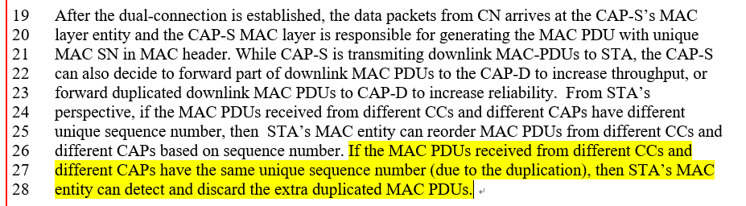
– Case 2: If all the MPDUs that are segmented from the SDU would always be not counted as No. 0 in the unique MAC sequence, the CAP can’t confirm whether the SDU transmission is complete or not since the No. 0 is essential as the first number in MPDU order, based on Section 1.5.1.2.8 Sequence number field below.
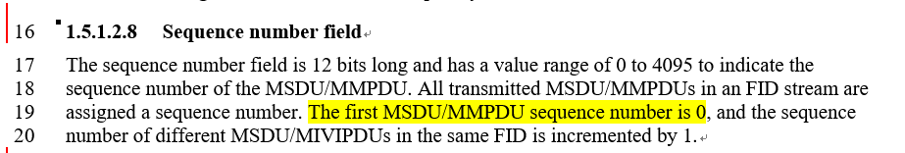
Furthermore, in dual connection, different CAPs exchange the MPDUs by using the unique sequence to ensure proper data order for 0ms handover. But, as above discussion there would be some misunderstanding about the count order of SDUs and MPDUs during the exchanged data at CAP side, according the EUHT specification that one unique sequence is defined in MAC layer at STA/CAP side.
5GIF Conclusion:
The EUHT specification specified the unique sequence, which would result in the conflicting statement of count order of SDUs and MPDUs during the process of data collection in CA. And therefore, 0ms handover and CA feature cannot be concluded in EUHT as per the specifications provided.

4 Compliance assessment for other miscellaneous issues
A) Idle channel detection by CAP
5GIF raised a query -
1 In section 1.6.3, there is a concept of Idle channel. In scheduled or allocation-based technologies, the base station is expected to be completely aware of the radio resource management and currently utilized resources. What is the purpose of this scanning by CAP?
2 Where is the need to sensing / scanning by base station / CAP for the available or Idle channel?
Nufront’s response on 11 September states, “For example, is customized small network and private network, CAP may select best available channel to use by detecting idle channels and achieve network performance self-optimization”
5GIF Conclusion:
Our point remains that in a scheduled or allocation-based technology, the base station is expected to be completely aware of the assigned radio resource management and available radio resources every TTI. There is no role of scanning by CAP? This creates an aspersion about EUHT being purely an allocation-based technology with licensed operations.
Moreover, the target application as stated by Nufront is not mentioned in EUHT specification and also not ruled out in EUHT specifications clearly that for commercial networks, it is not used. Nor it is marked as “optional”. As per specs, this is mandatory normative part.
B) Uplink scheduling – Radio resources request
With respect to Section 1.6.6.2 on Collision-based reservation request, 5GIF raised query as to why polling of STAs by CAP?? CAP is aware of the Buffer Status of all STAs and SRs from STAs as well as the status of all CCs in use / or to say Radio resources available for scheduling in an upcoming TTI. We fail to get this mode of uplink scheduling in EUHT.
Nufront’s response to 5GIF on Sep 11 states that “CAP needs polling of STA to be aware of buffer status of that STA…. Therefore, the CAP is aware of the buffer status”
5GIF Conclusion:
While the definition in section 1.6.6.1 is confusing, however 5GIF drops this point.
C) Highest modulation order MCS for both Code words
Information to establish that all Spatial streams of both Codeworks I and II support 1024 QAM modulation scheme is missing. 5GIF cannot conclude on 1024-QAM support for all Spatial streams.
In the light of Nufront’s clarifications provided on Sep 11, 5GIF analysis concludes that:
MCS Indication as per Table 67 and Attachment 1 is:
1 In EQM Mode, for Nss = 4 streams, Maximum MCS Order supported is 256 QAM by all 4 streams (MCS Indication 0-55)
2 In UEQM Mode, for Nss = 2 streams, Maximum MCS Order supported is 256 QAM by both streams (MCS Indication 56-61)
3 In NEQM Mode, for Nss = 3 streams, Maximum MCS Order supported for Stream 1 is 64, Stream 2 is 64 QAM, and Stream 3 is 16 QAM (MCS Indication 62-75)
4 In NEQM Mode, for Nss = 4 streams, Maximum MCS Order supported is Stream 1 is 64, Stream 2 is 64 QAM, Stream 3 is 64 QAM, and Stream 4 is 16 QAM (MCS Indication 76-99)
5 In EQM Mode, for Nss = 4 streams, Maximum MCS Order supported is 1024-QAM by all 4 streams (MCS Indication 100-110)
6 In NEQM Mode, for Nss = 4 streams, Maximum MCS Order supported is Stream 1 is 1024, Stream 2 is 256 QAM, Stream 3 is 64 QAM, and Stream 4 is 16 QAM (MCS Indication 111-119)

5 Assessment of Candidate technology - IMT-2020/76
Proponents: Nufront

5.1 Compliance Templates
This section provides templates for the responses that are needed to assess the compliance of a candidate EUHT RIT with the minimum requirements of IMT-2020. This assessment is independently done based on the characteristic template and EUHT specifications referred in the submission by the proponents in IMT-2020/76. The compliance templates are based on ITU-R M.2411:
– Compliance template for services.
– Compliance template for spectrum; and,
– Compliance template for technical performance
As per Report ITU-R M.2411, Section 5.2.4, the summary based on our evaluation is as below:

5.1.1 Services
(M.2411 - Compliance template for services 5.2.4.1)
 | Service capability requirements | 5GIF comments
5.2.4.1.1 | Support for wide range of services  Is the proposal able to support a range of services across different usage scenarios (eMBB, URLLC, and mMTC)?   YES / 🗹 NO  Specify which usage scenarios (eMBB, URLLC, and mMTC) the candidate RIT or candidate SRIT can support. | a) The proposal of EUHT component RIT does not support eMBB services.  Spectral Efficiencies and other KPI do not meet IMT-2020 the minimum requirements.  b) The proposal of EUHT component RIT does not support URLLC services.  Reliability does not meet the IMT-2020 minimum requirements.  c) The proposal of EUHT component RIT does not support mMTC services.  Connection density does not meet the IMT-2020 minimum requirements.

5.1.2 Spectrum
(M.2411 - Compliance template for spectrum - 5.2.4.2)
 | Spectrum capability requirements
5.2.4.2.1 | Frequency bands identified for IMT  Is the proposal able to utilize at least one frequency band identified for IMT in the ITU Radio Regulations?   YES /  NO  Specify in which band(s) the candidate RIT or candidate SRIT can be deployed.
5.2.4.2.2 | Higher Frequency range/band(s)  Is the proposal able to utilize the higher frequency range/band(s) above 24.25 GHz?:  YES / 🗹 NO  Specify in which band(s) the candidate RIT or candidate SRIT can be deployed.  NOTE 1 – In the case of the candidate SRIT, at least one of the component RITs need to fulfil this requirement.  5GIF Observations  Unable to determine from the EUHT Specification, if both STA and CAP can communicate using the mmWave band  For e.g.: In mmWave mode (mmWave band) of EUHT, the EUHT specification doesn’t specify any basic bandwidth for STA capability, so the STA can’t access network when its capability isn’t aligned with the working bandwidth of CAP in mmWave band, whereas the section 1.7.3 Preamble mentions only many candidate bandwidths application for mmWave mode

5.1.3 Technical Performance
(M.2411 - Compliance template for technical performance from 5.2.4.3)
 | Minimum technical performance requirements item (5.2.4.3.x), units, and Report  ITU-R M.2410-0 section reference ⁽¹⁾ | Category |  |  | Reqd. value |  | Value ⁽²⁾ | Requirement met? | 5GIF Comments
 |  | Usage scenario | Test environment | Downlink or uplink
 | 5.2.4.3.1  Peak data rate (Gbit/s)  (4.1) | eMBB | Not applicable | Downlink | 20 |  | 2.06~3.36 | No | Refer Section 2.2.1.2 (Analysis Aspects)  Specification support for carrier aggregation is not adequate, the spectrum aggregation mode support aggregation of four sub-channel each with bandwidth equal to 20 MHz to get a maximum aggregated system bandwidth of 80 MHz (From section 1). Also, it’s not clear for the application of mmwave mode.
 |  |  |  | Uplink | 10 |  | 0.71~1.06 | No
 | 5.2.4.3.2  Peak spectral efficiency (bit/s/Hz)  (4.2) | eMBB | Not applicable | Downlink | 30 |  |  |  | Refer Section 2.2.1.1 (Analysis Aspects)
 |  |  |  | Uplink | 15
 | 5.2.4.3.3  User experienced data rate (Mbit/s)  (4.3) | eMBB | Dense Urban – eMBB | Downlink | 100 |  |  | No | Refer Section 2.2.1.3 (Analysis Aspects)  5th percentile user spectral efficiency does not meet the requirement even with maximum supported system bandwidth of 80 MHz.  Config A and B, (4GHz and 30GHz,8T16R)
 |  |  |  | Uplink | 50 |  | 1.146 Mbps (config A)  0 Mbps (config B) | No
5.2.4.3.4  5th percentile user spectral efficiency (bit/s/Hz)  (4.4) |  | eMBB | Indoor Hotspot – eMBB | Downlink | 0.30 |  |  | No | Refer Section 2.2.3.1 (Simulation Aspects)  Config A (4G) with 12 TRxP
 |  |  |  | Uplink | 0.21 | 0.083 (config A) |  | No
 |  | eMBB | Dense Urban – eMBB | Downlink | 0.225 |  |  | Yes | Refer Section 2.2.3.1 (Simulation Aspects)  Config A (4G) and Config B (30G)
 |  |  |  | Uplink | 0.15 | 0.043 (config A)  0.000 (config B) |  | No
 |  | eMBB | Rural – eMBB | Downlink | 0.12 |  |  |  | Refer Section 2.2.3.1 (Simulation Aspects)  Config A (700M)
 |  |  |  | Uplink | 0.045 | 0.013 (config A)
 |  |  |  | Downlink | 0.12 |  |  |  | Refer Section 2.2.3.1 (Simulation Aspects)  Config B (4G)
 |  |  |  | Uplink | 0.045 | 0.029 (config B)
5.2.4.3.5  Average spectral efficiency (bit/s/Hz/ TRxP)  (4.5) |  | eMBB | Indoor Hotspot – eMBB | Downlink | 9 |  |  | No | Refer Section 2.2.3.1 (Simulation Aspects)  Indoor Hotspot: Config A (4GHz) with 12TRxP  Dense Urban: Config A: 4GHz, TDD; Config B (30G) , TDD
 |  |  |  | Uplink | 6.75 | 2.78 (config A) |  | No
 |  | eMBB | Dense Urban – eMBB | Downlink | 7.8 |  |  | No
 |  |  |  | Uplink | 5.4 | 3.54 (config A)  1.6 (config B) |  | No
 |  | eMBB | Rural – eMBB | Downlink | 3.3 |  |  |  | Refer Section 2.2.3.1 (Simulation Aspects)  Config A: 700MHz, TDD
 |  |  |  | Uplink | 1.6 | 4.30 (config A) |  | Yes
 |  |  |  | Downlink | 3.3 |  |  |  | Refer Section 2.2.3.1 (Simulation Aspects)  Config B: 4GHz, TDD
 |  |  |  | Uplink | 1.6 | 4.86 (config B) |  | Yes
5.2.4.3.6  Area traffic capacity (Mbit/s/m²)  (4.6) |  | eMBB | Indoor-Hotspot – eMBB | Downlink | 10
5.2.4.3.9  Connection density (devices/km²)  (4.8) |  | mMTC | Urban Macro – mMTC | Uplink | 1,000, 000 | Outage rate 5.5% (config A)  Outage rate 12.4% (config B) |  | No | Refer Section 2.2.3.4 (Simulation Aspects)
5.2.4.3.11  Reliability  (%)  (4.10) |  | URLLC | Urban Macro –URLLC | Downlink | 99.999% | 99.57% |  | No | Refer Section 2.2.3.2 (Simulation Aspects)  Config A (4GHz, TDD):
 |  |  |  | Uplink | 99.999% | 56.65% |  | No
5.2.4.3.13  Mobility  Traffic channel link data rates (bit/s/Hz)  (4.11) |  | eMBB | Dense Urban – eMBB | Uplink | 1.12 (30 km/h) | 0.65 |  | No | Refer Section 2.2.3.3 (Simulation Aspects)
5.2.4.3.14  Mobility interruption time (ms)  (4.12) |  | eMBB and URLLC | Not applicable | Not applicable | 0 |  |  |  | Refer Section 2.2.1.2 (Analysis Aspects)  It is not clear how the CA based mobility works in case of mobility between source CAP and target CAP.
5.2.4.3.15  Bandwidth and Scalability  (4.13) |  | Not applicable | Not applicable | Not applicable | At least 100 MHz | 100 MHz and more |  | No | See Section 2.2.2 (Inspection Aspects)  It is not clear how STA to access mmWave mode, and the maximum bandwidth of one carrier in normal mode should not exceed 80 MHz for avoiding the STA can’t access.
 |  |  |  |  | Up to 1 GHz | 1 GHz and more |  | No
 |  |  |  |  | Support of multiple different bandwidth values⁽⁴⁾ | Supported |  | Yes
⁽¹⁾ As defined in Report ITU-R M.2410-0.
⁽²⁾ According to the evaluation methodology specified in Report ITU-R M.2412-0.
⁽³⁾ Proponents should report their selected evaluation methodology of the Connection density, the channel model variant used, and evaluation configuration(s) with their exact values (e.g. antenna element number, bandwidth, etc.) per test environment, and could provide other relevant information as well. For details, refer to Report ITU-R M.2412-0, in particular, § 7.1.3 for the evaluation methodologies, § 8.4 for the evaluation configurations per each test environment, and Annex 1 on the channel model variants.
⁽⁴⁾ Refer to § 7.3.1 of Report ITU-R M.2412-0.

5.2 Detailed Technical Evaluation

5.2.1 Analysis Aspects

5.2.1.1 Peak Spectral Efficiency
Requirements
Performance Measure | ITU Requirements
Peak Spectral Efficiency | DL: 30 bps/Hz  UL: 15 bps/Hz

Section 4.2 of ITU-R M.2410 states that these values were defined assuming an antenna configuration to enable eight spatial layers (streams) in the downlink and four spatial layers (streams) in the uplink. Proponents must demonstrate that the peak spectral efficiency requirement can be met for, at least, one of the carrier frequencies assumed in the test environments under the eMBB usage scenario.
Evaluation methodology
Refer to section 7.2.1 of M.2412.
Results
The below given formula is used to calculate Peak Spectral Efficiency (SEpeak ) for a specific component carrier
(1)
wherein:
R_{max} is the maximum code rate of LDPC
For the i-th CC, is the maximum number of layers
is the maximum modulation order
is the Frame length
is the duration of Downlink/Uplink in a frame (type)
is the number of subcarriers allocation in bandwidth with Frame length, where is the STA supported maximum bandwidth in the given band or band combination
$OH^{ (i)}$ is the overhead calculated as the average ratio of the number of OFDMs or subcarriers occupied by L1/L2 control, synchronization signal, sounding signal, demodulation reference signal and guard period, etc.
For guard period (GP), 50% of GP symbols are considered as downlink overhead, and 50% of GP symbols are considered as uplink overhead.
Using the Tables 44-51 from EUHT specifications, the number of subcarriers for a given supported Bandwidth (N_{sd}) for the possible Subcarrier Spacing (SCS) have been provided in the Table 5-1 and Table 5-2 below.
Table 5-1
Normal Mode (Sub-6GHz band)
SCS (kHz) | 5 MHz | 10 MHz | 15 MHz | 20 MHz | 25 MHz | 30 MHz | 40 MHz | 50 MHz | 60 MHz | 80 MHz | 100 MHz
 | N_{SD} | N_{SD} | N_{SD} | N_{SD} | N_{SD} | N_{SD} | N_{SD} | N_{SD} | N_{SD} | N_{SD} | N_{SD}
19.53125 | 224 | 448 | 672 | 896 | 1 120 | 1 344 | 1 792 | 2 240 | N/A | N/A | N/A
39.0625 | 112 | 224 | 336 | 448 | 560 | 672 | 896 | 1 120 | 1 344 | 1 792 | 2 240
78.125 | 56 | 112 | 168 | 224 | 280 | 336 | 448 | 560 | 672 | 896 | 1 120
Table 5-2
mmWave band
SCS [kHz] | 50 MHz | 100 MHz
 | N_{SD} | N_{SD}
390.625 | - | -
976.5625 | - | -
NOTE: As per Section 1, maximum bandwidth supported by STA is 80 MHz in sub-6 GHz, and not clear about UE behaviour in mmWave mode

Downlink
The number of layers considered as per SER are eight for normal mode and mmWave mode but there is a maximum support of only four spatial streams which is equivalent to the number of layers. Depending on the parameters as defined in Table 5-3 the calculated DL SE_{peak} is given Table 5-5.
Table 5-3
Technical Parameters used for DL (without OH)
Parameter | Value |  | Remark
 | Normal mode | mmWave mode
V_{Layer} | 4 per CW  Max 8 layers | 4 per CW  Max 8 layers | As per Section 1, maximum bandwidth supported by STA is 80 MHz in sub-6 Ghz, and not clear for mmWave mode
Q_{m} (1024 QAM) | 10 | 10
R_{max} | 7/8 = 0.875 | 7/8 = 0.875
(ms), (Frame Duration) | 4 | 30
 | 896 | --
(MHz) | 80 | --
SCS (kHz) | 78.125 | 390.625/976.5625

The SE_{peak} considers symbol duration time as per equation (1), in the SER of EUHT the symbol duration considered is with Short CP. Here we consider both Short and Normal CP in the symbol time given in Table 5-4 for SE_{peak} calculations as given in the EUHT Specification
Table 5-4
Cyclic Prefix values
 |  | Short Cyclic Prefix | Normal Cyclic Prefix
(us) | Normal mode | 14.4 | 16
 | mmWave mode | 2.88 | 3.2

Table 5-5
Peak Spectral Efficiency DL
Parameter |  |  | Formula |  | Value
 |  |  |  |  | Normal mode |  | mmWave mode
Peak Spectral Efficiency, SE_{peak}  (without OH) | Normal CP | $$\frac{v_{Layer}^{(i)}×Q_{m}^{(i)}×Rmax ×\frac{N_{SD}^{BW(i),ρ(i)}}{T_{Link}^{ρ(i)}}}{BW^{(i)}}$$ |  | 24.5 for 4 layers single CW  49.0 for 8 layers 2 CW transmission |  | -
 | Short CP |  |  | 27.222 for 4 layers single CW,  54.444 for 8 layers 2 CW |  | -
Max % of OH to meet requirement | Normal CP | 30 = maximum SE_{p} × (1-DL_OHmax)  DL_OHmax = 1-30/(maximum SE_{p}) |  | 38.78% |  | -
 | Short CP |  |  | 44.90% |  | -

Uplink
The number of layers considered as per SER are four for normal mode and mmWave mode. Depending on the parameters as defined in Table 5-6 the calculated UL SE_{peak} is given in Table 5-7.
Table 5-6
Technical Parameters used for UL (without OH)
Parameter | Value |  | Remark
 | Normal mode | mmWave mode
V_{Layer} (see Note) | 4 | 4 | As per Section 1, maximum bandwidth supported by STA is 80MHz in sub6Ghz, and not clear for mmWave mode
Q_{m} (1024 QAM) | 10 | 10
R_{max} | 0.875 | 0.875
(ms), (Frame Duration) | 4 | 30
 | 896 | --
(MHz) | 80 | --
SCS (kHz) | 78.125 | 390.625/976.5625

Table 5-7
Peak Spectral Efficiency UL
Parameter |  | Formula | Value
 |  |  | Normal mode | mmWave mode
Peak Spectral Efficiency, SE_{peak}  (without OH) | Normal CP | $$\frac{v_{Layer}^{(i)}×Q_{m}^{(i)}×Rmax ×\frac{N_{SD}^{BW(i),ρ(i)}}{T_{Link}^{ρ(i)}}}{BW^{(i)}}$$ | 24.5 for 4 layers | -
 | Short CP |  | 27.222 for 4 layers | -
Max % of OH to meet requirement | Normal CP | 15= maximum SE_{p} × (1-UL_OHmax)  UL_OHmax = 1-15/ (maximum SE_{p}) | 38.78% | -
 | Short CP |  | 44.90% | -

DL OH margin – As depicted in the Figure 69 (Frame structure), each frame has uplink and downlink OFDM symbols. During the portion of downlink transmission, the data channel DL-SCH is time multiplexed. As per the M.2412, the peak spectral efficiency should account for the OH duration. To meet the target requirement of peak spectral efficiency, the OH symbols will be limited by the minimum Peak Spectral Efficiency requirements.
Table 5-8
Maximum Downlink OH%
Parameter | CP type | Normal mode | mmWave mode
Max % of DL_OH to meet requirement | Normal CP | 38.78% | -
 | Short CP | 44.90% | -

UL OH margin – As depicted in the Figure 69 (Frame structure), each frame has uplink and downlink OFDM symbols. During the portion of uplink transmission, the data channel UL-SCH is time multiplexed. As per the M.2412, the peak spectral efficiency should account for the OH duration. To meet the target requirement of peak spectral efficiency, the OH symbols will be limited by the minimum Peak Spectral Efficiency requirements.
Table 5-9
Maximum Uplink OH%
Parameter | CP type | Normal mode | mmWave mode
Max % of UL_OH to meet requirement | Normal CP | 38.78% | -
 | Short CP | 44.90% | -

Performance Measure | ITU Requirements | Comments
Peak Spectral Efficiency | DL: 30 bps/Hz  UL: 15 bps/Hz | The evaluation was performed for idea zero OH Peak Spectral Efficiency due to gaps in the OH calculations. The maximum overhead percentages were calculated for both DL and UL.

5.2.1.2 Peak data rate
Requirements
The minimum requirements for peak data rate are as follows:

Performance Measure | ITU Requirements
Peak data rate | DL: 20 Gb/s  UL: 10 Gb/s

NOTE: Peak Data Rate = Aggregated Bandwidth × SE_{peak}
Peak Data Rate is the maximum achievable data rate under ideal conditions.
For Peak Data Rate the maximum possible bandwidth for each band is provided in Table 5-10:
Table 5-10
Maximum Bandwidth
 | Normal mode  (sub6GHz) | mmWave mode  (mmWave)
Maximum Bandwidth supported (MHz) | 80 | -
Note: Refer to section 1, Maximum aggregated system bandwidth of 80 MHz is in sub6GHz bandwidth, and not clear about UE behaviour in mmWave bandwidth.

Evaluation Methodology
Refer to section 7.2.2 of M.2412.
Results
For a single CAP, let W denote the channel bandwidth and SE_{p} denote the peak spectral efficiency in that band. Then the user peak data rate R_{p} is given by:
In case bandwidth is aggregated across multiple bands, the peak data rate will be summed over the bands. Therefore, the total peak data rate is:
(2)
where and (i = 1,…, Q) are the effective bandwidth and spectral efficiencies on component carrier i, respectively,is the normalized scalar on component carrier i considering the downlink/uplink ratio on that component carrier, is the carrier bandwidth of component i.
As following, Table 5-11 and Table 5-12 would be generated by the frame assumption of EUHT self-evaluation report. Table 5-11 shows peak data rate values (DL: UL= 0.8: 0.2) calculated for maximum bandwidth of 80 MHz for normal mode do not meet the minimum ITU-R requirements.
Table 5-11
Peak Data Rate for := 0.8: 0.2
Parameter |  | Formula | ITU Requirement | Value
 |  |  |  | Normal Mode  (80MHz) | mmWave Mode
Peak Data Rate (Gbps) | Downlink | Maximum Bandwidth×SE_{peak} | 20 | 3.36 | --
 | Uplink |  | 10 | 0.41 | --
Note: The SE_{peak} values are calculated with OH considerations (L1 signaling and frame structure).

Table 5-12 shows the peak data rate values (DL: UL= 0.5: 0.5) calculated for maximum bandwidth of 80 MHz for normal mode do not meet the minimum ITU-R requirements.
Table 5-12
Peak Data Rate for := 0.5: 0.5
Parameter |  |  | Formula |  | ITU Requirement |  | Value
 |  |  |  |  |  |  | Normal Mode  (80MHz) |  | mmWave Mode
Peak Data Rate (Gbps) | Downlink | Maximum Bandwidth×SE_{peak} |  | 20 |  | 2.06 |  | --
 | Uplink |  |  | 10 |  | 1.06 |  | --
Note: The SE_{peak} values are calculated with OH considerations (L1 signaling and frame structure).

Also, according to the section 7.2.1 of ITU-R M.2412, “Layer 1 and Layer 2 overhead should be accounted for in time and frequency, in the same way as assumed for the “Average spectral efficiency”. Proponents should demonstrate that the peak spectral efficiency requirement can be met for, at least, one of the carrier frequencies assumed in the test environments under the eMBB usage scenario.”
In eMBB usage scenario, the proponent only provided the frame structure is DL:UL= 2:1 in self-evaluation report. So, Table 5-13 shows the peak data rate values (DL: UL= 0.67: 0.33) calculated for maximum bandwidth of 80 MHz for normal mode do not meet the minimum ITU-R requirements.
Table 5-13
Peak Data Rate for := 0.67: 0.33
Parameter |  | Formula | ITU Requirement | Value
 |  |  |  | Normal Mode  (80MHz) | mmWave Mode
Peak Data Rate (Gbps) | Downlink | Maximum Bandwidth×SE_{peak} | 20 | 2.74 | --
 | Uplink |  | 10 | 0.71 | --
Note: The SE_{peak} values are calculated with OH considerations (L1 signaling and frame structure).

5GIF Observations
– The DL and UL peak data rate does not meet the ITU requirement
– Specification support for carrier aggregation is not adequate, the spectrum aggregation mode support aggregation of four sub-channel each with bandwidth equal to 20 MHz to get a maximum aggregated system bandwidth of 80 MHz (From section 1).

5.2.1.3 User experienced data rate
Requirements
The system performance in terms of user-experienced data-rate is to be evaluated in the DU geographic environment. The target values are set as:

Performance Measure | ITU Requirements
User Experienced Data rate | DL: 100 Mbps  UL: 50 Mbps

Evaluation Methodology
Refer to Section 7.2.3 of ITU-R M.2412
The evaluation is conducted in Dense Urban-eMBB test environment.
For one frequency band and one TRxP layer, user experienced data rate is derived analytically from the 5th percentile user spectral efficiency according to equation (3) defined in Report ITU-R M.2410-0. The bandwidth used should be reported by the proponent.
Results
R_{user} = W × SE_{user} (1)
User Experienced Data Rate has been evaluated for the Dense Urban eMBB test environment for configuration A (4GHz) and configuration B (30GHz). Table 5-14 shows the UL 5th percentile user spectral efficiency results for Dense Urban environment.
Table 5-14
UL 5th percentile user spectral efficiency of Dense Urban eMBB
Scheme and antenna configuration |  | Sub-carrier spacing (kHz) | 5th-tile [bit/s/Hz]
 |  |  | Channel Model A
8x16, SU-MIMO | UL-Config A (4GHz) | 78.125 | 0.043
8x16, SU-MIMO | UL-Config B (30GHz) | 390.625 | 0

The SE_{user} values from Table 5-14 are used to calculate the User Experienced Data Rate as given in Table 5-15.
Table 5-15
User Experienced Data Rate for 80 MHz bandwidth
Parameter |  | Calculation | R_{user} [Mbps]
Config A, Channel model A
BW = 80 MHz, Frame structure DL: UL= 2:1 is the same as Section 2.2.3.1
User Experienced Data Rate, R_{user} | UL | 80 × 10⁶ × 0.333 x 0.043 | 1.146 Mbps

Evaluation Report
Scenario | Performance Measure | ITU Requirements | 5GIF Results | Conclusion  Meets Requirement (Yes/No) | Remarks
 |  |  | Eval. A
Dense Urban | User experienced data rate | DL: 100 Mbps  UL: 50 Mbps | DL: -  UL: 1.146 Mbps | -  No | Spectral Efficiencies do not meet minimum requirements, and Maximum Bandwidth support is 80 MHz in sub-6GHz.

5GIF Observations
– The User experienced data rate does not meet the UL of ITU requirement
– Specification support for carrier aggregation is not adequate, the spectrum aggregation mode support aggregation of four sub-channel each with bandwidth equal to 20 MHz to get a maximum aggregated system bandwidth of 80 MHz (From section 1).

5.2.1.4 Mobility Interruption Time
Requirements
For seamless transition, 0 ms mobility interruption time is an essential requirement.

Performance Measure | ITU Requirements
Mobility Interruption time | 0ms
Evaluation Methodology
Refer Section 7.2.7 of ITU-R M.2412
Results
As defined in Report ITU-R M.2410, mobility interruption time is the shortest time duration supported by the system during which a UE/STA cannot exchange user plane packets with any BS/CAP during mobility transitions.
The mobility interruption time includes the time required to execute any radio access network procedure, radio resource control signalling protocol, or other message exchanges between the UE/STA and BS/CAP, as applicable to the candidate RIT/SRIT.
There are some properties support 0ms interrupt time in EUHT, such as:
– Carrier aggregation (CA) can be used for STA to connect with both CAP-S and CAP-D during handover to implement dual connection. In CA mode, CAP-S and CAP-D need to communicate to decide which CCs of CAP-S and CAP-D can be used by the STA during handover. The indication of CCs of CAP-S to STA is defined in HO-CMD. If the total number of CCs STA used in CAP-S already reaches the maximum capability of STA, CAP-S may need to de-activate some CCs used by STA to release the RF channels for the connection with CAP-D. The indication of CCs STA used to connect with CAP-D is defined in the basic capability response frame sent by CAP-D, see section 1.5.3.4.5.
– RACH-less is used in EUHT-5G, the CAP-D can pre-allocate resources for STA to reduce handover latency.
– EUHT-5G can accomplish 0ms interrupt handover by entering / leaving dual connection mode. 0ms Interruption handover procedure consists of three phases:
Figure 5-1
0 ms interrupt time procedure in EUHT
5GIF Observations
Regarding - “Carrier aggregation (CA) can be used for STA to connect with both CAP-S and CAP-D during handover to implement dual connection.”
– Refer to section 1 “C) Handover in CA” and” D) CA”, it is not clear how the CA based mobility works in case of mobility between source CAP and target CAP (in 3GPP, different layer uses different order sequence for the CA operation and handover based on P-cell).

5.2.2 Inspection Aspects

5.2.2.1 Bandwidth
Bandwidth is the maximum aggregated system bandwidth. The bandwidth may be supported by single or multiple radio frequency (RF) carriers.
Requirements

Performance Measure | ITU Requirements
 | Sub6GHz | In higher frequency bands (e.g. above 6 GHz)
Bandwidth | 100 MHz | 1 GHz

Evaluation Methodology
Refer to Section 7.3.1 of ITU-R M.2412
Result
It has been observed that EUHT does not support carrier aggregation and bandwidths greater than 100MHz (Refer to section 1) Bandwidth)
Table 5-16
Bandwidth
SCS [kHz]  (Frequency Range) | Maximum bandwidth for one component carrier (MHz) | Maximum number of component carriers for carrier aggregation | Maximum aggregated bandwidth (MHz) | Minimum Requirement as per ITU-R M.2410-0 | Requirement Met ?
78.125  (Normal mode, <6GHz) | 80 | 1 | 80 | 100MHz | NO
390.625  (mmWave mode, > 24GHz) | / | / | / | > 1GHz | It is not clear how STA to access mmWave mode

5GIF Observations
Due to lack of specification for carrier aggregation and STA bandwidth support in mmWave mode, EUHT does not meet the ITU-R bandwidth requirements of up to 1 GHz aggregated bandwidth and at least 100MHz bandwidth.

5.2.3 Simulation Aspects

5.2.3.1 Spectral efficiency
Requirements
eMBB | 5th percentile user spectral efficiency |  | Average spectral efficiency
Test Environment | DL (bit/s/Hz) | UL (bit/s/Hz) | DL (bit/s/Hz) | UL (bit/s/Hz)
Indoor Hotspot | 0.3 | 0.21 | 9 | 6.75
Dense Urban – eMBB | 0.225 | 0.15 | 7.8 | 5.4
Rural – eMBB | 0.12 | 0.045 | 3.3 | 1.6
Note:
For rural-eMBB, Requirement of 5% SE is not applicable for Config-C (700MHz, ISD=6000m)
For rural-eMBB, Requirment of Avg SE is mandatory for Config-C and one of Config A (700MHz, ISD=1732m) or B (4GHz, ISD=1732m)
Evaluation Methodology
Refer to Section 7.1.1 and 7.1.2 of ITU-R M.2412
Results
Indoor Hotspot – eMBB
EUHT Self Evaluation Report provides for the assumption under which to evaluate various configurations in their respective scenario. 5GIF has used those assumptions and where not possible has mentioned the same in the remarks. For Indoor Hotspot the Configuration A has been evaluated.
Table 5-17
Technical Assumptions Indoor Hotspot
Indoor Hotspot - eMBB | Uplink
Technical configuration Parameters
Multiple access | OFDMA
Carrier Frequency | For configuration A: 4GHz
Duplexing | TDD
Network synchronization | Synchronized
Modulation | Up to 1024 QAM
Coding on TCH | LDPC
Subcarrier spacing | For configuration A: 78.125 kHz
Simulation bandwidth | For configuration A: 20MH
Frame structure | DL:UL = 2:1
Transmission scheme | SU-MIMO
SU dimension | Up to 8 layers
Re-transmission delay | Next available frame
Antenna configuration at TRxP | 16Rx, (8,4,2,1,1; 2,4)
Antenna configuration at UE | 8Tx, (1,4,2,1,1; 1,4)
Scheduling | PF
Receiver | MMSE - IRC
Channel estimation | Non-ideal
Power control parameter | P0=-45, alpha=0.6
TRxP number per site | 1 TRxP per site
Mechanic tilt | 180° in GCS
Electronic tilt | 90° in LCS
Handover margin (dB) | 1
Wrapping around method | No wrap around
Criteria for selection for serving TRxP | Maximizing RSRP where the digital beamforming is not considered

Table 5-18
UL Overhead Assumptions in Indoor Hotspot
Indoor Hotspot - eMBB |  | EUHT TDD Overhead (PER FRAME)
Overhead assumption
IMT bands | UL-SCH | 6
 | DRS | 4
 | GI | 1
 | Total data symbols | 35
 | Total OH | 11
 | Total OH (%) | 23.91%

As per the above considered assumptions and the ITU-R guidelines, the following simulation results have been obtained.
Table 5-19
Uplink Spectral efficiency for EUHT in Indoor Hotspot – eMBB
(Evaluation configuration A, CF=4 GHz, for 12TRxP)
Scheme and antenna configuration | Sub-carrier spacing (kHz) | Frame structure | ITU Requirement |  | Channel model A
 |  |  |  |  | BW=20MHz
8x16 SU-MIMO | 78.125 | DL: UL = 2:1 | Average [bit/s/Hz/TRxP] | 6.75 | 2.78
 |  |  | 5th-tile  [bit/s/Hz] | 0.21 | 0.083

5GIF used fixed overhead as same as self-evaluation report of IMT-2020/76 to evaluate EUHT, but the decoding error probability of signaling/feedback channel and CCHs based on the SINR is considered in the current simulation. The above results show that the requirements are not being met under the current assumptions.
5GIF Observations
– The UL Spectral Efficiencies value obtained for EUHT fails to meet the requirements for Indoor Hotspot Configuration A.
– The possible reasons can be the broadcast CCH for indicating signaling/feedback channel is not reliable enough. SU-MIMO applied in EUHT UL may improve TCH performance of cell-edge users, but it is not good for the SE of EUHT system by lacking of MU-MIMO gain. Also, no detail description about broadcast CCH can be found in the EUHT specification’s Section 1.7.5.6 “Signaling/feedback transmission channel”.
– Also, the number of RxRUs are 16 at CAP side in case of EUHT as compared to 32 or more in case of 3GPP NR which can lead to lower capacity and digital beamforming gains.
– Also, the number of TxRUs at STA side are capped at 8 in case of EUHT which can be a limiting factor. The antenna gains seen in EUHT are higher than that in 3GPP NR.
Dense Urban – eMBB
Table 5-20
Technical Assumptions – Dense Urban
Dense Urban - eMBB | Uplink
Technical configuration Parameters
Multiple access | OFDMA
Duplexing | TDD
Network synchronization | Synchronized
Modulation | Up to 1024 QAM
Carrier Frequency | For configuration A: 4GHz  For configuration B: 30GHz
Coding on TCH | LDPC
Numerology | For configuration A: 78.125 kHz  For configuration B: 390.625 kHz
Simulation bandwidth | For configuration A: 20MHz  For configuration B: 100MHz
Frame structure | DL:UL = 2:1
Transmission scheme | SU-MIMO
SU dimension | Up to 8 layers
Re-transmission delay | Next available frame
Antenna configuration at TRxP | 16Rx, (8,8,2,1,1; 1,8)
Antenna configuration at UE | 8Tx, (1,4,2,1,1; 1,4)
Scheduling | PF
Receiver | MMSE - IRC
Channel estimation | Non-ideal
Power control parameter | P0=-77, alpha = 0.9
TRxP number per site | 3
Mechanic tilt | 90° in GCS
Electronic tilt | 105° in LCS
Handover margin (dB) | 1
Wrapping around method | Geographical distance-based wrapping
Criteria for selection for serving TRxP | Maximizing RSRP where the digital beamforming is not considered

Table 5-21
UL Overhead Assumptions in Dense Urban for Config A and Config B
Dense Urban - eMBB |  | UL_OH_Para
Overhead assumption |  | EUHT TDD
IMT bands | UL-SCH | 6
 | DRS | 4
 | GI | 1
 | Total data symbols | 31
 | Total OH | 11
 | Total OH (%) | 26.19%

Evaluation Configuration A
Table 5-22
UL Spectral efficiency for EUHT in Dense Urban – eMBB
(Evaluation configuration A, CF=4 GHz)
Scheme and antenna configuration | Sub-carrier spacing (kHz) | Frame structure | ITU  Requirement |  |  | Channel model A
 |  |  |  |  |  | BW=20MHz
8x16 SU-MIMO | 78.125 | DL:UL = 2:1 | Average [bit/s/Hz/TRxP] | 5.4 | 3.54
 |  |  | 5th-tile [bit/s/Hz] | 0.15 | 0.043

Evaluation Configuration B
Table 5-23
UL Spectral efficiency for EUHT in Dense Urban – eMBB
(Evaluation configuration B, CF=30 GHz)
Scheme and antenna configuration | Sub-carrier spacing (kHz) | Frame structure | ITU  Requirement |  |  | Channel model A/B
 |  |  |  |  |  | BW=100MHz
8x16 SU-MIMO | 78.125 | DL:UL = 2:1 | Average [bit/s/Hz/TRxP] | 5.4 | 1.6
 |  |  | 5th-tile [bit/s/Hz] | 0.15 | 0.000

5GIF used fixed overhead as same as self-evaluation report of IMT-2020/76 to evaluate EUHT, but the decoding error probability of signaling/feedback channel and CCHs based on the SINR is considered in the current simulation. The above results show that the requirements are not being met under the current assumptions.
5GIF Observations
– The UL Spectral Efficiencies value obtained for EUHT fails to meet the requirements for Dense Urban Configuration A and Configuration B.
– The possible reasons can be the as similar with Indoor Hotspot.
– Also, at high frequencies, the signal propagation attenuation is severe, resulting in poor signal quality at the cell edge.
Rural – eMBB
Table 5-24
Technical Assumptions – Rural
Dense Urban - eMBB | Uplink
Technical configuration Parameters
Multiple access | OFDMA
Duplexing | TDD
Network synchronization | Synchronized
Modulation | Up to 1024 QAM
Carrier Frequency | For configuration A: 700MHz  For configuration B: 4GHz
Coding on TCH | LDPC
Numerology | For configuration A: 78.125 kHz  For configuration B: 78.125 kHz
Simulation bandwidth | For configuration A:20MHz  For configuration B: 20MHz
Frame structure | DL:UL = 2:1
Transmission scheme | SU-MIMO
SU dimension | Up to 8 layers
Re-transmission delay | Next available frame
Antenna configuration at TRxP | For configuration A: 16Rx, (4,8,2,1,1; 1,8)  For configuration B: 16Rx, (8,8,2,1,1; 1,8)
Antenna configuration at UE | For configuration A: 4Tx, (1,2,2,1,1; 1,2)  For configuration B: 8Tx, (1,4,2,1,1; 1,4)
Scheduling | PF
Receiver | MMSE - IRC
Channel estimation | Non-ideal
Power control parameter | For configuration A: P0=-67, alpha = 0.8  For configuration B: P0=-46, alpha = 0.6
TRxP number per site | 3
Mechanic tilt | 90° in GCS
Electronic tilt | For configuration A: 100° in LCS  For configuration B: 95° in LCS
Handover margin (dB) | 1
Wrapping around method | Geographical distance-based wrapping
Criteria for selection for serving TRxP | Maximizing RSRP where the digital beamforming is not considered

Table 5-25
UL Overhead Assumptions in Rural
Dense Urban - eMBB |  | UL_OH_Para
Overhead assumption |  | EUHT TDD
IMT bands | UL-SCH | 6
 | DRS | 4
 | GI | 1
 | Total data symbols | 35
 | Total OH | 11
 | Total OH (%) | 23.91%

Evaluation Configuration A
Table 5-26
UL Spectral efficiency for EUHT in Rural – eMBB
(Evaluation configuration A, CF=700 MHz)
Scheme and antenna configuration | Sub-carrier spacing (kHz) | Frame structure | ITU  Requirement |  |  | Channel model A
 |  |  |  |  |  | BW=20MHz
4x16 SU-MIMO | 78.125 | DL:UL = 2:1 | Average [bit/s/Hz/TRxP] | 1.6 | 4.30
 |  |  | 5th-tile [bit/s/Hz] | 0.045 | 0.013

Evaluation Configuration B
Table 5-27
UL Spectral efficiency for EUHT in Rural – eMBB
(Evaluation configuration B, CF=4 GHz)
Scheme and antenna configuration | Sub-carrier spacing (kHz) | Frame structure | ITU  Requirement |  |  | Channel model A
 |  |  |  |  |  | BW=20MHz
8x16 SU-MIMO | 78.125 | DL:UL = 2:1 | Average [bit/s/Hz/TRxP] | 1.6 | 4.86
 |  |  | 5th-tile [bit/s/Hz] | 0.045 | 0.029

5GIF used fixed overhead as same as self-evaluation report of IMT-2020/76 to evaluate EUHT, but the decoding error probability of signaling/feedback channel and CCHs based on the SINR is considered in the current simulation. The above results show that the requirements are not being met under the current assumptions.
5GIF Observations
– The UL Spectral Efficiencies value obtained for EUHT fails to meet the requirements for Rural Configuration A and Configuration B.
– The possible reasons can be the as similar with Dense Urban. Also, high speed in Rural will introduce estimation error of Doppler shift and channel estimation error in non-ideal receiver, resulting in the poor reception performance.
Evaluation Report
Table 5-28
Evaluation for spectral efficiency in eMBB
Scenario | Performance Measure | ITU Requirements | 5GIF Results-  Channel A | Conclusion Meets Requirement (Yes/No) | Remarks
Indoor  (12 TRxP) | Average spectral efficiency | DL:9  UL: 6.75 | DL: -  UL: 2.78 | -  No | Due to the broadcast CCH for indicating signaling/feedback channel is not reliable enough, the digital beamforming gain is limited to less number of TXRUs at CAP side, this has resulted in EUHT technology does not meet the ITU minimum requirements.
 | 5th % user spectral efficiency | DL:0.3  UL: 0.21 | DL: -  UL: 0.083 | -  No
Dense Urban | Average spectral efficiency | DL:7.8  UL: 5.4 | DL: -  UL: 3.54(Config A); 1.60(Config B); | -  No
 | 5th % user spectral efficiency | DL:0.225  UL: 0.15 | DL: -  UL: 0.043(Config A); 0.000(Config B); | -  No
Rural | Average spectral efficiency | DL:3.3  UL: 1.6 | DL: -  UL: 4.30(Config A); 4.86(Config B); | -  Yes
 | 5th % user spectral efficiency | DL: 0.12  UL: 0.045 | DL: -  UL: 0.013(Config A); 0.029(Config B); | -  No

5.2.3.2 Reliability
Requirements
The minimum requirement for the reliability is 1-10⁻⁵ success probability of transmitting a layer 2 PDU (protocol data unit) of 32 bytes within 1 ms in channel quality of coverage edge for the Urban Macro-URLLC test environment, assuming small application data (e.g. 20 bytes application data + protocol overhead).
Evaluation Methodology
Refer to Section 7.1.5 of ITU-R M.2412
Results
Table 5-29
System Level Parameters
Technical configuration Parameters | Downlink | Uplink
Multiple access | OFDMA | OFDMA
Carrier Frequency for evaluation | 4 GHz | 4 GHz
Duplexing | TDD | TDD
Modulation | QPSK | QPSK
Coding on TCH | LDPC | LDPC
Numerology | 78.125 kHz SCS | 78.125 kHz SCS
Simulation bandwidth | 20 MHz | 20 MHz
Transmission scheme | SU-MIMO | SU-MIMO
Antenna configuration at TRxP | 16Tx, (8,8,2,1,1; 1,8) | 16Rx, (8,8,2,1,1; 1,8)
Antenna configuration at UE | 8Rx,(1,4,2,1,1;1,4) | 8Tx, (1,4,2,1,1; 1,4)
Scheduling | PF | PF
Receiver | MMSE - IRC | MMSE - IRC
Channel estimation | Non-ideal | Non-ideal
Power control parameters | - | P0=-83, alpha=0.8
TRxP number per site | 3
Mechanic tilt | 90° in GCS
Electronic tilt | 94° in LCS
Handover margin (dB) | 1
Wrapping around method | Geographical distance-based wrapping
Criteria for selection for serving TRxP | Maximizing RSRP where the digital beamforming is not considered
Table 5-30
Link Level Parameters
Technical configuration Parameters | Downlink | Uplink
Carrier frequency for evaluation | 4 GHz | 4 GHz
Waveform | CP-OFDM | CP-OFDM
Numerology | 78.125 kHz SCS | 78.125 kHz SCS
Simulation bandwdith | 20 MHz | 20 MHz
Channel model | TDL-iii | TDL-iii
Scaled delay spread | 363ns | 363ns
UE Speed | 30 km/h | 30 km/h
Antenna configuration at TRxP | 16T | 16R
Antenna configuration at UE | 8R | 8T
TCH Transmission mode | SU-MIMO | SU-MIMO
TCH Modulation and coding | LDPC with code rate = 4/7, QPSK  Repetition 16 | LDPC with code rate = 4/7, QPSK Repetition 24
Channel estimation | Non-Ideal | Non-Ideal
CCH transmission scheme | 56-bit payload includes CRC | -
CCH Modulation and coding | TBCC with code rate = 1/2, QPSK  Repetition 12 | -
Packet size | 256 bits | 256 bits

The downlink SINR distribution obtained from system level simulation is illustrated in the Figure 5-2. The 5%-tile SINR applied for link level simulation is -4.47 dB.
Figure 5-2
Downlink SINR distribution obtained from system level simulation
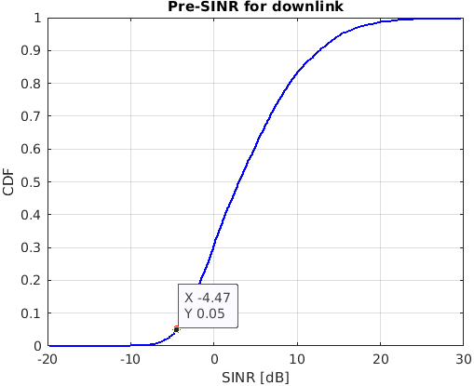
Based on the system level simulation and link level simulation, the evaluation result for downlink reliability is provided in Table 5-31.
Table 5-31
Downlink
Scheme and antenna configuration | Subcarrier Spacing [kHz] | Channel condition | Reliability | ITU Req.
16x8 SU-MIMO | 78.125 | NLOS | 99.57% | 99.999%

The uplink SINR distribution obtained from system level simulation is illustrated in the Figure 5-3. The 5%-tile SINR applied for link level simulation is -7.06 dB.
Figure 5-3
Uplink SINR distribution obtained from system level simulation
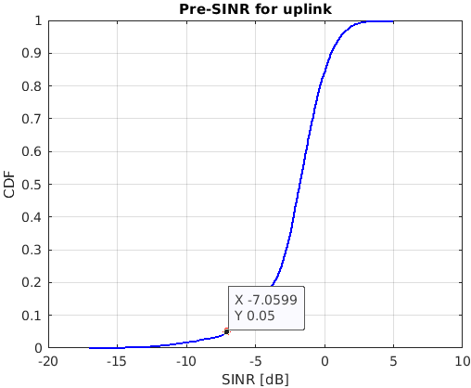
Based on the system level simulation and link level simulation, the evaluation result for uplink reliability is provided in Table 5-32.
Table 5-32
Uplink
Scheme and antenna configuration | Subcarrier Spacing [kHz] | Channel condition | Reliability | ITU Req.
8x16 SU-MIMO | 78.125 | NLOS | 56.65% | 99.999%

5GIF Observations
– EUHT technology is not able to meet the UL and DL reliability requirements for URLLC.
– RS pollution issue would be still here based on the selecting criteria of PN sequence in EUHT specification. In DL, 57 CAPs select its PN sequence from one of eight PN sequences as DL RS; in UL, there would be 570 STAs selecting its PN sequence from one of eight PN sequences as UL RS. DL RS position in low-error mode is in the same DL resource among all cells, and UL RS position in low-error mode is in the same UL resource among all users.
– The direct interference comes from same PN sequence used by interfering cells. Also, the residual interference is generated by the cross-correlation impact from different PN sequences used by interfering cells from serving cells.
– These RS interferences in the layout of Urban Macro-URLLC would accumulate in receiver, and have resulted in the poor channel estimation for UL and DL separately, and therefore EUHT technology is not able meet the reliability requirements for URLLC.
Evaluation Report

Scenario | Performance Measure | ITU Requirements | 5GIF Results | Conclusion Meets Requirement (Yes/No) | Remarks
 |  |  | Eval. A
URLLC | Reliability (%) | DL: 99.999%  UL: 99.999% | DL: 99.57%  UL: 56.65% | No  No | Due to the RS interference from neighbors’ cell to destroy the channel estimation performance.  This has resulted in EUHT technology does not meet the ITU minimum requirements.

5.2.3.3 Mobility Traffic channel link data rates
Requirements
This requirement is defined for the purpose of evaluation in the eMBB usage scenario.

Traffic channel link data rates normalized by bandwidth
Test environment | Normalized traffic channel link data rate (bit/s/Hz) | Mobility  (km/h)
Indoor Hotspot – eMBB | 1.5 | 10
Dense Urban – eMBB | 1.12 | 30
Rural – eMBB | 0.8 | 120
 | 0.45 | 500

Evaluation Methodology
Refer Section 7.1.4 of ITU-R M.2412
In addition, according to section 7 of ITU-R M.2412, the evaluation parameters used for the system-level simulation used in the mobility evaluation should be the same as the parameters used for system-level simulation for average spectral efficiency and 5th percentile user spectral efficiency.
Results
Table 5-33
System-level Assumptions – Dense Urban (config A)
Dense Urban - eMBB | Uplink
Technical configuration Parameters
Multiple access | OFDMA
Duplexing | TDD
Network synchronization | Synchronized
Modulation | Up to 1024 QAM
Carrier Frequency | 4GHz
Coding on TCH | LDPC
Numerology | 78.125 kHz
Simulation bandwidth | 20MHz
Frame structure | DL:UL = 2:1
Transmission scheme | SU-MIMO
UE speeds of interest | 30 km/h
SU dimension | Up to 8 layers
Re-transmission delay | Next available frame
Antenna configuration at TRxP | 16Rx, (8,8,2,1,1; 1,8)
Antenna configuration at UE | 8Tx, (1,4,2,1,1; 1,4)
Scheduling | PF
Receiver | MMSE - IRC
Channel estimation | Non-ideal
Power control parameter | P0=-77, alpha = 0.9
TRxP number per site | 3
Mechanic tilt | 90° in GCS
Electronic tilt | 105° in LCS
Handover margin (dB) | 1
Wrapping around method | Geographical distance-based wrapping
Criteria for selection for serving TRxP | Maximizing RSRP where the digital beamforming is not considered

Table 5-34
Link Level parameters
Technical configuration Parameters | Uplink
Carrier frequency | 4 GHz
Waveform | CP-OFDM
Duplexing | TDD
Subcarrier spacing | 78.125 kHz
Simulation bandwdith | 10 MHz
Frame structure | DL:UL=2:1
Channel model | TDL-iii
UE Speed | 30 km/h
Antenna configuration at TRxP | 16R
Antenna configuration at UE | 8T
Tx scheme | SU-MIMO, OFDMA
TRxP receiver type | MMSE-IRC
Channel estimation | Non-Ideal
Data allocation | 33 symbols for one frame(2ms)
Channel coding scheme for TCH | LDPC
DRS configuration | 4 symbols for one frame(2ms)
Other overhead | 5 symbols per 2ms

Evaluation configuration A (carrier frequency = 4 GHz) is applied for the evaluations of Dense Urban – eMBB test environment for EUHT-5G. The mobility class of 30km/h are considered. The uplink SINR distribution obtained from system level simulation is illustrated in the below Figure 5-4. The 50%-tile SINR applied for link level simulation is 5.33 dB.
Figure 5-4
Uplink SINR distribution obtained from system level simulation for mobility
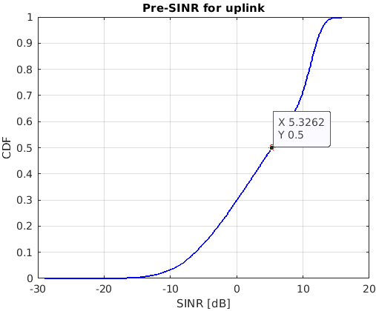
Based on the system level simulation and link level simulation, the evaluation results of mobility for EUHT-5G for evaluation configuration A for mobility class of 30 km/h are provided in Table 5-35.
Table 5-35
EUHT mobility in Dense Urban – eMBB
(Evaluation configuration A, CF=4 GHz, Mobility class of 30km/h)
Scheme and antenna configuration | Sub-carrier spacing (kHz) | Frame structure | ITU Requirement (bit/s/Hz) | Channel model A
 |  |  |  | Channel condition | Normalized traffic channel link data rate (bit/s/Hz)
8x16 SU-MIMO | 78.125 | DL:UL=2:1 | 1.12 | NLOS | 0.65

The above results show that the requirements are not being met under the current assumptions, even without considering the false probability of ACK transmission via signaling/feedback channel and RS pollution as low-error mode. To explore and verify the 5GIF simulator outcome system level analysis was done which gave possible reasons for such results. The analysis is described below.
5GIF Observations
– EUHT technology is not able meet the mobility requirements for Dense Urban.
– Considering the decoding of DL SICH and CCH before receiving the uplink TCH, the spectral efficiency is degraded by the poor detection performance of SICH and CCH.
– For the mobility scenario, the Doppler shift error and channel estimation error would further decrease the spectral efficiency

5.2.3.4 Connection density
Requirements
The minimum requirement for connection density is 1 000 000 devices per km².
Connection density is the total number of devices fulfilling a specific quality of service (QoS) per unit area (per km²). The target QoS is to support delivery of a message of a certain size within a certain time and with a certain success probability, as specified in Report ITU-R M.2412-0.
Especially, the requirement is fulfilled if the 99th percentile of the delay per user Di is less than or equal to 10s. So, the transmission delay of one packet should be less than or equal to 10s, and then the total packet outage rate should be less than or equal to 1%.
Evaluation Methodology
Refer to Section 7.1.3 of ITU-R M.2412, the non-full buffer system-level simulation method is utilized.
The synchronization, random access, capability negotiation, stream establishment, and data transmission procedures of EUHT-5G are considered in the evaluation. The relevant process are modelled based on the specification of IMT-2020/76, and the response during the workshop on Sep 2. The detailed procedures are illustrated in below Figure 5-5.
Figure 5-5
The procedures modelling of EUHT in mMTC evaluation
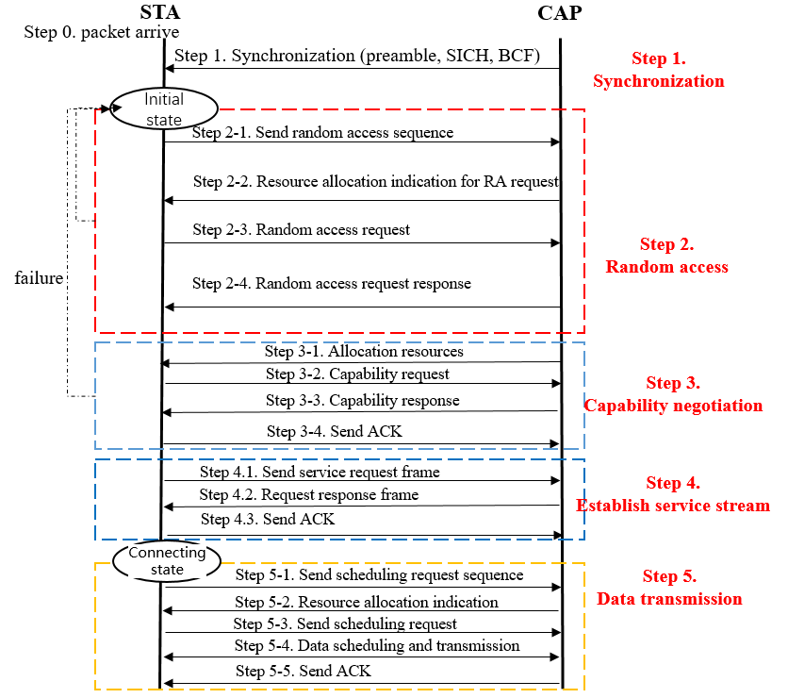
Results
Table 5-36
System-level Simulation Assumption -mMTC
Urban Macro-mMTC | Downlink | Uplink
Technical configuration Parameters
Inter-site distance | For configuration A: 500 m  For configuration B: 1732 m | For configuration A: 500 m  For configuration B: 1732 m
Carrier frequency for evaluation | 700 MHz | 700 MHz
Duplexing | TDD | TDD
Numerology | 39.0625 KHz SCS | 39.0625 KHz SCS
Simulation bandwidth | For configuration A: 10 MHz  For configuration B: 40 MHz | For configuration A: 10 MHz  For configuration B: 40 MHz
DL Transmission scheme | SU-MIMO | SU-MIMO
Antenna configuration at TRxP | 8Tx, (8,4,2,1,1; 1,4) | 8Rx, (8,4,2,1,1; 1,4)
Antenna configuration at UE | 2Rx,(1,1,2,1,1;1,1) | 2Tx, (1,1,2,1,1; 1,1)
Scheduling | PF | PF
Receiver | MMSE-IRC | MMSE-IRC
Channel estimation | Non-ideal | Non-ideal
Power control parameter | N/A | P0=-92, alpha=1
TRxP number per site | 3 | 3
Mechanic tilt | 90° in GCS (pointing to horizontal direction) | 90° in GCS (pointing to horizontal direction)
Electronic tilt | For configuration A: 99° in LCS  For configuration B: 95° in LCS | For configuration A: 99° in LCS  For configuration B: 95° in LCS
Handover margin (dB) | 1 | 1
Traffic model | N/A | With layer 2 PDU (Protocol Data Unit) message size of 32 bytes:1 message/day/device  Packet arrival follows Poisson arrival process
Note: Refer to section 1, the basic subchannel is 5/10/20MHz in sub6GHz. The BW of Configuration B is assumed as 40MHz, by 10MHz per subchannel x 4 subchannels.
Others assumptions are based on ITU-R M.2412

The evaluation results of connection density and the corresponding packet outage rate for EUHT-5G with configuration A and B are provided in Table 5-37.
Table 5-37
EUHT connection density in Urban Macro-mMTC
(Evaluation configuration A, CF= 700 MHz, ISD=500m)
Scheme and antenna configuration | Sub-carrier spacing (kHz) | Frame structure | ITU  Requirement (/km2) | Channel model A
 |  |  |  | Connection density (/km2) | Outage
2x8 SU-MIMO | 39.0625 | DL:UL=2:1 | 1,000,000@outage<1% | 1,000,000 | 5.5%

Table 5-38
EUHT connection density in Urban Macro-mMTC
(Evaluation configuration B, CF= 700 MHz, ISD=1,732 m)
Scheme and antenna configuration | Sub-carrier spacing (kHz) | Frame structure | ITU  Requirement (/km2) | Channel model A
 |  |  |  | Connection density (/km2) | Outage
2x8 SU-MIMO | 39.0625 | DL:UL=2:1 | 1,000,000@outage<1% | 1,000,000 | 12.4%

It is observed that when the connection density is 1 000 000 devices/km², the packet outage rate exceeds 1% for both Configuration A and Configuration B, which cannot satisfy the “the requirement is fulfilled if the 99th percentile of the delay per user Di is less than or equal to 10s” of connection density specified in the ITU-R M.2412.
5GIF Observations
– EUHT technology is not able to meet the connection density requirements in config A and config B of mMTC.
– The signalling exchange of the whole procedures illustrated in Figure 5-5 based on EUHT specification is too long. That would introduce a large package transmission delay, backoff delay and waiting delay, resulting in the packet transmission timeout (i.e. exceed the delay requirement 10s).
– Also, due to the poor decoding performance for cell-edge users, the random backoff mechanism of the random access/ schedule request process would increase the total delay of some packet transmission.
– Also, the broadcast CCH for indicating resource allocation of common signaling/feedback channel (e.g. carrying ACK) and independent resource request frame are not reliable enough, which would increase the delay of some packet transmission or enlarging the outage rate.

6 Conclusions
5GIF evaluated the candidate technology EUHT IMT-2020/76 based on the available information provided by the proponent.
Overall, we found inconsistencies with the information given in the specification provided in the submission. We also noticed inconsistencies and a lack of clarity on the assumptions used in the self-evaluation report of EUHT. Our detailed observations on the submissions are provided in Section 1.
As per our evaluation, the
– EUHT technology does not meet the requirements for spectral efficiency in eMBB scenario at least in the three test environments –eMBB Rural, eMBB Dense Urban and eMBB-InH.
– EUHT does not meet the minimum requirements for peak spectral efficiency, peak data rate, user experience data rate in eMBB.
– EUHT does not meet the minimum requirements of Reliability for URLLC scenario.
– EUHT does not meet the minimum requirements of Connection density for mMTC scenario.
– EUHT does not meet the requirements to satisfy the eMBB, URLLC, as well as mMTC scenarios.

7 Annexes
Scenarios and Configurations as per ITU-R M.2412
Table A
Evaluation configurations for Indoor Hotspot-eMBB test environment
Parameters | Indoor Hotspot-eMBB
 | Spectral Efficiency, Mobility, and Area Traffic Capacity Evaluations
 | Configuration A | Configuration B | Configuration C
Baseline evaluation configuration parameters
Carrier frequency for evaluation | 4 GHz | 30 GHz | 70 GHz
BS antenna height | 3 m | 3 m | 3 m
Total transmit power per TRxP | 24 dBm for 20 MHz bandwidth  21 dBm for 10 MHz bandwidth | 23 dBm for 80 MHz bandwidth  20 dBm for 40 MHz bandwidth  e.i.r.p. should not exceed 58 dBm | 21 dBm for 80 MHz bandwidth  18 dBm for 40 MHz bandwidth  e.i.r.p. should not exceed 58 dBm
UE power class | 23 dBm | 23 dBm  e.i.r.p. should not exceed 43 dBm | 21 dBm  e.i.r.p. should not exceed 43 dBm
Additional parameters for system-level simulation
Inter-site distance | 20 m | 20 m | 20 m
Number of antenna elements per TRxP | Up to 256 Tx/Rx | Up to 256 Tx/Rx | Up to 1024 Tx/Rx
Number of UE antenna elements | Up to 8 Tx/Rx | Up to 32 Tx/Rx | Up to 64 Tx/Rx
Device deployment | 100% indoor  Randomly and uniformly distributed over the area | 100% indoor  Randomly and uniformly distributed over the area | 100% indoor  Randomly and uniformly distributed over the area
UE mobility model | Fixed and identical speed |v| of all UEs, randomly and uniformly distributed direction | Fixed and identical speed |v| of all UEs, randomly and uniformly distributed direction | Fixed and identical speed |v| of all UEs, randomly and uniformly distributed direction
UE speeds of interest | 100% indoor, 3 km/h | 100% indoor, 3 km/h | 100% indoor, 3 km/h
Inter-site interference modelling | Explicitly modelled | Explicitly modelled | Explicitly modelled
BS noise figure | 5 dB | 7 dB | 7 dB
UE noise figure | 7 dB | 10 dB | 10 dB3
BS antenna element gain | 5 dBi | 5 dBi | 5 dBi

Parameters | Indoor Hotspot-eMBB
 | Spectral Efficiency, Mobility, and Area Traffic Capacity Evaluations
 | Configuration A | Configuration B | Configuration C
UE antenna element gain | 0 dBi | 5 dBi | 5 dBi
Thermal noise level | ‒174 dBm/Hz | ‒174 dBm/Hz | ‒174 dBm/Hz
Traffic model | Full buffer | Full buffer | Full buffer
Simulation bandwidth | 20 MHz for TDD, 10 MHz+10 MHz for FDD | 80 MHz for TDD, 40 MHz+40 MHz for FDD | 80 MHz for TDD,  40 MHz+40 MHz for FDD
UE density | 10 UEs per TRxP  randomly and uniformly dropped throughout the geographical area | 10 UEs per TRxP  randomly and uniformly dropped throughout the geographical area | 10 UEs per TRxP  randomly and uniformly dropped throughout the geographical area
UE antenna height | 1.5 m | 1.5 m | 1.5 m

Table B
Evaluation configurations for Dense Urban-eMBB test environment
Parameters | Dense Urban-eMBB
 | Spectral Efficiency and Mobility Evaluations |  | User Experienced Data Rate Evaluation
 | Configuration A | Configuration B | Configuration C
Baseline evaluation configuration parameters
Carrier frequency for evaluation | 1 layer (Macro) with 4 GHz | 1 layer (Macro) with 30 GHz | 1 or 2 layers (Macro + Micro).  4 GHz and 30 GHz available in macro and micro layers
BS antenna height | 25 m | 25 m | 25 m for macro sites and 10 m for micro sites

 | Dense Urban-eMBB
 | Spectral Efficiency and Mobility Evaluations |  | User Experienced Data Rate Evaluation
 | Configuration A | Configuration B | Configuration C
Total transmit power per TRxP | 44 dBm for 20 MHz bandwidth  41 dBm for 10 MHz bandwidth | 40 dBm for 80 MHz bandwidth  37 dBm for 40 MHz bandwidth  e.i.r.p. should not exceed 73 dBm | Macro 4 GHz:  44 dBm for 20 MHz bandwidth  41 dBm for 10 MHz bandwidth  Macro 30 GHz:  40 dBm for 80 MHz bandwidth  37 dBm for 40 MHz bandwidth  e.i.r.p. should not exceed 73 dBm  Micro 4 GHz:  33 dBm for 20 MHz bandwidth  30 dBm for 10 MHz bandwidth  Micro 30 GHz:  33 dBm for 80 MHz bandwidth  30 dBm for 40 MHz bandwidth  e.i.r.p. should not exceed 68 dBm
UE power class | 23 dBm | 23 dBm, e.i.r.p. should not exceed 43 dBm | 4 GHz: 23 dBm  30 GHz: 23 dBm, e.i.r.p. should not exceed 43 dBm
Percentage of high loss and low loss building type | 20% high loss, 80% low loss | 20% high loss, 80% low loss | 20% high loss, 80% low loss
Additional parameters for system-level simulation
Inter-site distance | 200 m | 200 m | Macro layer: 200 m  (NOTE – Density and layout of Micro layer are in § 8.3)
Number of antenna elements per TRxP | Up to 256 Tx/Rx | Up to 256 Tx/Rx | Up to 256 Tx/Rx
Number of UE antenna elements | Up to 8 Tx/Rx | Up to 32 Tx/Rx | 4 GHz: Up to 8 Tx/Rx  30 GHz: Up to 32 Tx/Rx

Parameters | Dense Urban-eMBB
 | Spectral Efficiency and Mobility Evaluations |  | User Experienced Data Rate Evaluation
 | Configuration A | Configuration B | Configuration C
Device deployment | 80% indoor, 20% outdoor (in-car)  Randomly and uniformly distributed over the area under Macro layer | 80% indoor, 20% outdoor (in-car)  Randomly and uniformly distributed over the area under Macro layer | 80% indoor, 20% outdoor (in-car)  Randomly and uniformly distributed over the area under Macro layer
UE mobility model | Fixed and identical speed |v| of all UEs of the same mobility class, randomly and uniformly distributed direction. | Fixed and identical speed |v| of all UEs of the same mobility class, randomly and uniformly distributed direction. | Fixed and identical speed |v| of all UEs of the same mobility class, randomly and uniformly distributed direction.
UE speeds of interest | Indoor users: 3 km/h  Outdoor users (in-car): 30 km/h | Indoor users: 3 km/h  Outdoor users (in-car): 30 km/h | Indoor users: 3 km/h  Outdoor users (in-car): 30 km/h
Inter-site interference modeling | Explicitly modelled | Explicitly modelled | Explicitly modelled
BS noise figure | 5 dB | 7 dB | 4 GHz: 5 dB  30 GHz: 7 dB
UE noise figure | 7 dB | 10 dB | 4 GHz: 7 dB  30 GHz: 10 dB4
BS antenna element gain | 8 dBi | 8 dBi | 4 GHz: 8 dBi  30 GHz:  Macro TRxP: 8 dBi
UE antenna element gain | 0 dBi | 5 dBi | 4 GHz: 0 dBi  30 GHz: 5 dBi
Thermal noise level | ‒174 dBm/Hz | ‒174 dBm/Hz | ‒174 dBm/Hz
Traffic model | Full buffer | Full buffer | Full buffer
Simulation bandwidth | 20 MHz for TDD,  10 MHz+10 MHz for FDD | 80 MHz for TDD,  40 MHz+40 MHz for FDD | 4 GHz: 20 MHz for TDD, 10 MHz+10 MHz for FDD  30 GHz: 80 MHz for TDD, 40 MHz+40 MHz for FDD

Parameters | Dense Urban-eMBB
 | Spectral Efficiency and Mobility Evaluations |  | User Experienced Data Rate Evaluation
 | Configuration A | Configuration B | Configuration C
UE density | 10 UEs per TRxP  Randomly and uniformly distributed over the area under Macro layer | 10 UEs per TRxP  Randomly and uniformly distributed over the area under Macro layer | 10 UEs per TRxP for multi-layer case, randomly and uniformly dropped within a cluster. The proponent reports the size of the cluster
UE antenna height | Outdoor UEs: 1.5 m  Indoor UTs: 3(n_{fl} – 1) + 1.5;  n_{fl} ~ uniform(1,N_{fl}) where  N_{fl} ~ uniform(4,8) | Outdoor UEs: 1.5 m  Indoor UTs: 3(n_{fl} – 1) + 1.5;  n_{fl} ~ uniform(1,N_{fl}) where  N_{fl} ~ uniform(4,8) | Outdoor UEs: 1.5 m  Indoor UTs: 3(n_{fl} – 1) + 1.5;  n_{fl} ~ uniform(1,N_{fl}) where  N_{fl} ~ uniform(4,8)

Table C
Evaluation configurations for Rural-eMBB test environment
Parameters | Rural-eMBB
 | Spectral Efficiency and Mobility Evaluations |  | Average Spectral Efficiency Evaluation
 | Configuration A | Configuration B | Configuration C (LMLC)
Baseline evaluation configuration parameters
Carrier frequency for evaluation | 700 MHz | 4 GHz | 700 MHz
BS antenna height | 35 m | 35 m | 35 m
Total transmit power per TRxP | 49 dBm for 20 MHz bandwidth  46 dBm for 10 MHz bandwidth | 49 dBm for 20 MHz bandwidth  46 dBm for 10 MHz bandwidth | 49 dBm for 20 MHz bandwidth  46 dBm for 10 MHz bandwidth
UE power class | 23 dBm | 23 dBm | 23 dBm
Percentage of high loss and low loss building type | 100% low loss | 100% low loss | 100% low loss
Additional parameters for system-level simulation
Inter-site distance | 1732 m | 1732 m | 6000 m
Number of antenna elements per TRxP | Up to 64 Tx/Rx | Up to 256 Tx/Rx | Up to 64 Tx/Rx
Number of UE antenna elements | Up to 4 Tx/Rx | Up to 8 Tx/Rx | Up to 4 Tx/Rx

Parameters | Rural-eMBB
 | Spectral Efficiency and Mobility Evaluations |  | Average Spectral Efficiency Evaluation
 | Configuration A | Configuration B | Configuration C (LMLC)
Device deployment | 50% indoor, 50% outdoor (in-car)  Randomly and uniformly distributed over the area | 50% indoor, 50% outdoor (in-car)  Randomly and uniformly distributed over the area | 40% indoor,  40% outdoor (pedestrian), 20% outdoor (in-car)  Randomly and uniformly distributed over the area
UE mobility model | Fixed and identical speed |v| of all UEs, randomly and uniformly distributed direction | Fixed and identical speed |v| of all UEs, randomly and uniformly distributed direction | Fixed and identical speed |v| of all UEs, randomly and uniformly distributed direction
UE speeds of interest | Indoor users: 3 km/h;  Outdoor users (in-car): 120 km/h;  500 km/h for evaluation of mobility in high-speed case | Indoor users: 3 km/h;  Outdoor users (in-car): 120 km/h;  500 km/h for evaluation of mobility in high-speed case | Indoor users: 3 km/h;  Outdoor users (pedestrian): 3 km/h;  Outdoor users (in-car): 30 km/h
Inter-site interference modeling | Explicitly modelled | Explicitly modelled | Explicitly modelled
BS noise figure | 5 dB | 5 dB | 5 dB
UE noise figure | 7 dB | 7 dB | 7 dB
BS antenna element gain | 8 dBi | 8 dBi | 8 dBi
UE antenna element gain | 0 dBi | 0 dBi | 0 dBi
Thermal noise level | ‒174 dBm/Hz | ‒174 dBm/Hz | ‒174 dBm/Hz
Traffic model | Full buffer | Full buffer | Full buffer
Simulation bandwidth | 20 MHz for TDD, 10 MHz+10 MHz for FDD | 20 MHz for TDD, 10 MHz+10 MHz for FDD | 20 MHz for TDD, 10 MHz+10 MHz for FDD
UE density | 10 UEs per TRxP  Randomly and uniformly distributed over the area | 10 UEs per TRxP  Randomly and uniformly distributed over the area | 10 UEs per TRxP  Randomly and uniformly distributed over the area
UE antenna height | 1.5 m | 1.5 m | 1.5 m

Table D
Evaluation configurations for Urban Macro-mMTC test environments
Parameters | Urban Macro–mMTC
 | Connection Density Evaluation
 | Configuration A | Configuration B
Baseline evaluation configuration parameters
Carrier frequency for evaluation | 700 MHz | 700 MHz
BS antenna height | 25 m | 25 m
Total transmit power per TRxP | 49 dBm for 20 MHz bandwidth  46 dBm for 10 MHz bandwidth | 49 dBm for 20 MHz bandwidth  46 dBm for 10 MHz bandwidth
UE power class | 23 dBm | 23 dBm
Percentage of high loss and low loss building type | 20% high loss, 80% low loss | 20% high loss, 80% low loss
Additional parameters for system-level simulation
Inter-site distance | 500 m | 1732 m
Number of antenna elements per TRxP | Up to 64 Tx/Rx | Up to 64 Tx/Rx
Number of UE antenna elements | Up to 2 Tx/Rx | Up to 2 Tx/Rx
Device deployment | 80% indoor, 20% outdoor  Randomly and uniformly distributed over the area | 80% indoor, 20% outdoor  Randomly and uniformly distributed over the area
UE mobility model | Fixed and identical speed |v| of all UEs of the same mobility class, randomly and uniformly distributed direction. | Fixed and identical speed |v| of all UEs of the same mobility class, randomly and uniformly distributed direction.
UE speeds of interest | 3 km/h for indoor and outdoor | 3 km/h for indoor and outdoor
Inter-site interference modelling | Explicitly modelled | Explicitly modelled
BS noise figure | 5 dB | 5 dB
UE noise figure | 7 dB | 7 dB
BS antenna element gain | 8 dBi | 8 dBi
UE antenna element gain | 0 dBi | 0 dBi
Thermal noise level | ‒174 dBm/Hz | ‒174 dBm/Hz

Table E
Evaluation configurations for Urban Macro-mMTC test environments
Parameters | Urban Macro–mMTC
 | Connection Density Evaluation
 | Configuration A | Configuration B
Traffic model | With layer 2 PDU (Protocol Data Unit) message size of 32 bytes:  1 message/day/device  or  1 message/2 hours/device  Packet arrival follows Poisson arrival process for non-full buffer system-level simulation | With layer 2 PDU (Protocol Data Unit) message size of 32 bytes:  1 message/day/device  or  1 message/2 hours/device6  Packet arrival follows Poisson arrival process for non-full buffer system-level simulation
Simulation bandwidth | Up to 10 MHz | Up to 50 MHz
UE density | Not applicable for non-full buffer system-level simulation as evaluation methodology of connection density  For full buffer system-level simulation followed by link-level simulation, 10 UEs per TRxP  NOTE – this is used for SINR CDF distribution derivation | Not applicable for non-full buffer system-level simulation as evaluation methodology of connection density  For full buffer system-level simulation followed by link-level simulation, 10 UEs per TRxP  NOTE – this is used for SINR CDF distribution derivation
UE antenna height | 1.5m | 1.5 m

Table F
Evaluation configurations for Urban Macro-URLLC test environments
Parameters | Urban Macro–URLLC
 | Reliability Evaluation
 | Configuration A | Configuration B
Baseline evaluation configuration parameters
Carrier frequency for evaluation | 4 GHz | 700 MHz
BS antenna height | 25 m | 25 m
Total transmit power per TRxP | 49 dBm for 20 MHz bandwidth  46 dBm for 10 MHz bandwidth | 49 dBm for 20 MHz bandwidth  46 dBm for 10 MHz bandwidth
UE power class | 23 dBm | 23 dBm
Percentage of high loss and low loss building type | 100% low loss | 100% low loss

Table G
Evaluation configurations for Urban Macro-URLLC test environments
Parameters | Urban Macro–URLLC
 | Reliability Evaluation
 | Configuration A | Configuration B
Additional parameters for system-level simulation
Inter-site distance | 500 m | 500 m
Number of antenna elements per TRxP¹ | Up to 256 Tx/Rx | Up to 64 Tx/Rx
Number of UE antenna elements | Up to 8 Tx/Rx | Up to 4 Tx/Rx
Device deployment | 80% outdoor,  20% indoor | 80% outdoor,  20% indoor
UE mobility model | Fixed and identical speed |v| of all UEs, randomly and uniformly distributed direction | Fixed and identical speed |v| of all UEs, randomly and uniformly distributed direction
UE speeds of interest | 3 km/h for indoor and 30 km/h for outdoor | 3 km/h for indoor and 30 km/h for outdoor
Inter-site interference modelling | Explicitly modelled | Explicitly modelled
BS noise figure | 5 dB | 5 dB
UE noise figure | 7 dB | 7 dB
BS antenna element gain | 8 dBi | 8 dBi
UE antenna element gain | 0 dBi | 0 dBi
Thermal noise level | ‒174 dBm/Hz | ‒174 dBm/Hz
Traffic model | Full buffer  NOTE – This is used for SINR CDF distribution derivation | Full buffer  NOTE – This is used for SINR CDF distribution derivation
Simulation bandwidth | Up to 100 MHz  NOTE – This value is used for SINR CDF distribution derivation | Up to 40 MHz  NOTE – This value is used for SINR CDF distribution derivation
UE density | 10 UEs per TRxP  NOTE – This is used for SINR CDF distribution derivation | 10 UEs per TRxP  NOTE – This is used for SINR CDF distribution derivation
UE antenna height | 1.5 m | 1.5 m

______________

* Submitted on behalf of 5G India Forum Independent Evaluation Group (5GIF) for EUHT technology.
10 dB for 30 GHz / 70 GHz is assumed for high performance UE. Higher UE noise figure values can be considered by the proponent, e.g. 13 dB for 30 GHz / 70 GHz.
10 dB for 30 GHz is assumed for high performance UE. Higher UE noise figure values can be considered by the proponent, e.g. 13 dB for 30 GHz.
This/these parameter(s) is/are used for cell association.
Higher traffic loads are encouraged.

