|  |  |  |  |
| --- | --- | --- | --- |
|  | **Radiocommunication Study Groups** | |  |
| **INTERNATIONAL TELECOMMUNICATION UNION** | |  | |
|  | |  | |
| Source: Document 5A/TEMP/49 | | **Annex 19 to Document 5A/114-E** | |
| **23 May 2016** | |
| **English only** | |
| Annex 19 to Working Party 5A Chairman’s Report | | | |
| working document towards a preliminary draft new  report ITU-R M.[rail.RSTT] | | | |
| Technical and operational characteristics, implementation and spectrum needs of railway radiocommunication systems between train and trackside | | | |

TABLE OF CONTENT

1 Introduction 3

2 Scope 3

3 Overview of the RSTT 3

3.1 Definition/Description 3

3.2 Architecture 3

3.3 Applications 3

3.4 Deployment scenarios 3

4 Technical and operational characteristics of RSTT 3

4.1 [xxx] band RSTT 3

4.1.1 Technical characteristics 3

4.1.2 Operational characteristics 4

4.2 [yyy] band RSTT 4

4.3 Other frequency bands 4

4.3.1 Inductive Train Radio Systems in the [XX] band 4

5 Spectrum needs of RSTT 4

6 Summary 4

7 References 4

Annex 1 – RSTT in Japan 5

A1.1 Overview 5

A1.2 Train radio system for train operation and control in the VHF/UHF band 5

A1.2.1 Architecture of the train radio system in the VHF/UHF band 5

[A1.2.2 VHF/UHF MHz band transceivers characteristics for train operation   
and control 5](#_Toc451782820)

A1.2.2.1 RSTT in the 150 MHz band 5

A1.2.2.2 RSTT in the 300 MHz band 6

A1.2.2.3 RSTT in the 400 MHz band 6

A1.2.3 VHF/UHF MHz band propagation characteristics for the RSTT 7

A1.3 LCX train radio system in the 400 MHz band 7

A1.3.1 Architecture of the LCX train radio system in the 400 MHz band 7

A1.3.2 Transceivers characteristics for the LCX train radio system 7

A1.3.3 Propagation characteristics of the LCX train radio system 7

A1.4 RSTT in the 40 GHz band 7

A1.4.1 Architecture of RSTT in the 40 GHz band 7

A1.4.2 Transceivers characteristics in the 40 GHz band 7

A1.4.3 Propagation characteristics in the 40 GHz band 8

A1.5 W-band RSTT 8

A1.5.1 Architecture of W-band RSTT 8

A1.5.2 W-band transceivers characteristics 9

A1.5.3 W-band propagation characteristics 10

[Annex 2 – Consideration of the Doppler Effect in railway radiocommunication   
systems between high-speed trains and tracksides 12](#_Toc451782837)

A2.1 Introduction 12

[A2.2 Evaluation of the Doppler shift for different frequency bands and different   
train speeds 12](#_Toc451782840)

A2.3 Conclusions 16

# 1 Introduction

[This Report intends to provide technical and operational characteristics, implementation and spectrum needs between train and trackside under WRC-19 agenda item 1.11.]

# 2 Scope

[TBD]

# 3 Overview of the RSTT

## 3.1 Definition/Description

RSTT carry train control, command, operational information as well as monitoring data between on-board radio equipment and related radio infrastructure located along trackside.

## 3.2 Architecture

## 3.3 Applications

## 3.4 Deployment scenarios

*[Editor’s note: there is a need to decide whether this section could be a new chapter]*

# 4 Technical and operational characteristics of RSTT

*[Editor’s notes: As more contributions are expected to future meetings of WP 5A, agreement was reached within SWG 5A2-1 to i) retain only general information in this section 4 ii) move or keep all country-specific information in appropriate annexes to the Report]*

## 4.1 [xxx] band RSTT

### 4.1.1 Technical characteristics

Table 4.1.1-1

Examples Technical characteristics

|  |  |  |  |
| --- | --- | --- | --- |
| Parameter | System x: (name) | Systems y  (name) | …  (name) |
| Frequency Range (MHz) |  |  |  |
| Channel separation (kHz) |  |  |  |
| Antenna gain (dBi) |  |  |  |
| Polarization |  |  |  |
| Transmitting radiation power (dBm) |  |  |  |
| e.i.r.p. (dBm) |  |  |  |
| Receiving noise figure (dB) |  |  |  |
| Transmission data rate (kb/s) |  |  |  |
| Transmission distance (km) |  |  |  |
| Modulation |  |  |  |
| Multiplexing method |  |  |  |
| … |  |  |  |

### 4.1.2 Operational characteristics

## 4.2 [yyy] band RSTT

## 4.3 Other frequency bands

### 4.3.1 Inductive Train Radio Systems in the [XX] band

# 5 Spectrum needs of RSTT

# 6 Summary

# 7 References

ANNEX 1

RSTT in Japan

# A1.1 Overview

The frequency 100 kHz-band, 150 MHz-band, 300 MHz-band and 400 MHz-band have been allocated to the RSTT for safety and stable train operation since 1960s. Regarding the requirement to the conventional RSTT, the broadband transmission capability has become one of important functions to provide high-speed data to the train crews and passengers to realize more secure and comfortable railway transport services. To realize these requests, digital train radio systems have been introduced to the high speed railway. And now many digital radio systems are used for RSTT. Furthermore, Japan has begun to study millimetre-wave. Microwave as well as millimetre-wave frequencies are well known as the spectrum resources supporting the broadband data signal transmission.

# A1.2 Train radio system for train operation and control in the VHF/UHF band

## A1.2.1 Architecture of the train radio system in the VHF/UHF band

## A1.2.2 VHF/UHF MHz band transceivers characteristics for train operation and control

### A1.2.2.1 RSTT in the 150 MHz band

(1) Digital train radio system for train operation

Table A1.2.2.1-1

Preliminary system parameters

|  |  |
| --- | --- |
| Frequency Range (MHz) | 140-150 (use pair frequencies of 4 MHz separation in this band) |
| Channel separation (kHz) | 6.25, 12.5 |
| Antenna gain (dBi) | Base station: 11, Mobile station: 1 |
| Polarization | Vertical |
| Transmitting radiation power (dBm) | Base station: 36, Mobile station: 30 |
| e.i.r.p. (dBm) | Base station: 47, Mobile station: 31 |
| Receiving noise figure (dB) | <10 |
| Transmission data rate (kb/s) | 9.6 |
| Transmission distance (km) | 4-5 |
| Modulation | /4QPSK, 4FSK, FM |
| Multiplexing method | FDD, TDMA |

### A1.2.2.2 RSTT in the 300 MHz band

(1) Digital radio system for train operation and control

Table A1.2.2.2-1

Preliminary system parameters

|  |  |
| --- | --- |
| Frequency Range (MHz) | 330-360 (use pair frequencies of 16.5 MHz separation in this band) |
| Channel separation (kHz) | 6.25 |
| Antenna gain (dBi) | Base station: 11, Mobile station: 1 |
| Polarization | Vertical |
| Transmitting radiation power (dBm) | Base station: 34.7, Mobile station: 30 |
| e.i.r.p. (dBm) | Base station: 45.7, Mobile station: 31 |
| Receiving noise figure (dB) | <10 |
| Transmission data rate (kb/s) | 9.6 |
| Transmission distance (km) | 2-3 |
| Modulation | /4QPSK |
| Multiplexing method | FDD, TDMA |

### A1.2.2.3 RSTT in the 400 MHz band

(1) LCX train radio system for high speed train operation

Table A1.2.2.3-1

Preliminary system parameters

|  |  |
| --- | --- |
| Frequency Range (MHz) | 410-420, 450-460 |
| Antenna type | Base station: LCX (Coupling loss = 55 dB, 60 dB, 70 dB, 80 dB)  Mobile station: Slot array antenna |
| Polarization | Vertical |
| Transmitting radiation power (dBm) | 36 |
| Reception quality | SNR > 40 dB, BER < 1×10-4 |
| Transmission distance (km) | 35 |
| Modulation | /4 QPSK, SS-PM, GMSK |
| Multiplexing method | TDMA, FDD |

(2) Train radio system (“C type”)

Table A1.2.2.3-2

Preliminary system parameters

|  |  |
| --- | --- |
| Frequency Range (MHz) | 410-420 |
| Antenna gain (dBi) | Base station: 11, Mobile station: 1 |
| Polarization | Vertical |
| Transmitting radiation power (dBm) | 30 |
| e.i.r.p. (dBm) | Base station: 4, Mobile station: 31 |
| Receiving noise figure (dB) | <10 |
| Transmission distance (km) | 2-3 |
| Modulation | FM |
| Multiplexing method | none |

## A1.2.3 VHF/UHF MHz band propagation characteristics for the RSTT

# A1.3 LCX train radio system in the 400 MHz band

## A1.3.1 Architecture of the LCX train radio system in the 400 MHz band

## A1.3.2 Transceivers characteristics for the LCX train radio system

## A1.3.3 Propagation characteristics of the LCX train radio system

# A1.4 RSTT in the 40 GHz band

## A1.4.1 Architecture of RSTT in the 40 GHz band

## A1.4.2 Transceivers characteristics in the 40 GHz band

Table A1.4.2-1

Preliminary system parameters

|  |  |
| --- | --- |
| Frequency Range (GHz) | 43.5-47.0 |
| Antenna gain (dBi) | 32 |
| Antenna beamwidth (degree) | 1.0-1.5 |
| Polarization | Circular |
| Transmitting radiation power (dBm) | 10 |
| e.i.r.p. (dBm) | 42 |
| Receiving noise figure (dB) | <10 |
| Transmission data rate (Mb/s) | 100 |
| Transmission distance (km) | 0-3.5 |
| Modulation | 64QAM, OFDM |
| Multiplexing method | FDD |

## A1.4.3 Propagation characteristics in the 40 GHz band

# A1.5 W-band RSTT

## A1.5.1 Architecture of W-band RSTT

A network topology of a typical broadband TCN with a radio access system is shown in Fig. 1. A central unit (CU) located in an operation direction center (ODC) transmits, receives and manages all the communication signals. The signals are transmitted to an optical carrier station (OCS) via an optical fiber link; the OCS is worked as a repeater. Typical distance between the OCSs will be much longer than 10 km, whose length will be limited by an optical transceiver output power. A node base station (NBS), which is controlled by a control station (CS) directly connected to the OCS, is worked as a radio base station to transport the signal to track-side radio access units (TS‑RAUs) located along a railway trackside. The network for connection between the NBS and TS-RAUs is a bus-type wireline network, a passive-single-star-type network, or point-to-point links to each TS-RAU. The TS-RAU is a frontend to transmit and receive radio signals from/to radio transceivers on the train. In general, distance between the TS-RAUs depends on a coverage size of the TS-RAU; for instance, the distance will be much longer than 1 km if microwave-band radio systems are implemented. In this configuration, an optical fiber network will be suitable for configuring network for between CS and NBSs, and between NBS and TS-RAUs for high-speed railway systems.

Figure A1.5.1-1

Conceptual diagram of a broadband TCN using W-band RSTT

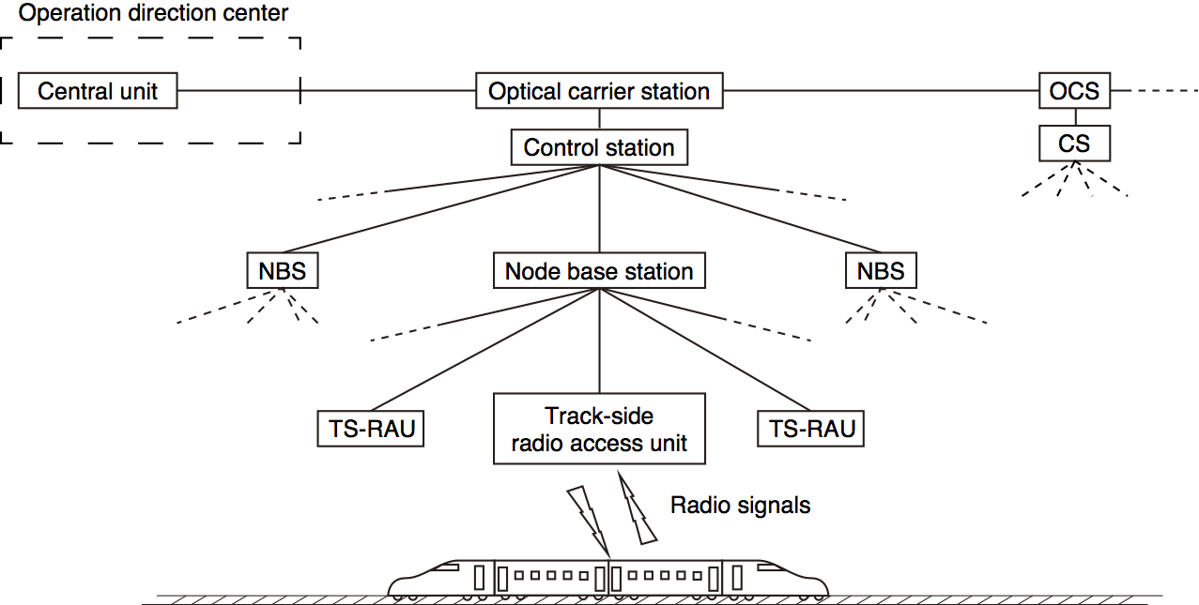

## A1.5.2 W-band transceivers characteristics

*[Japan’s note: The block diagram and external view of W-band transceiver are shown in Figure A1.5.2-1 and A1.5.2-2, but the detail characteristics will be discussed at the next meeting.]*

Table A1.5.2-1

Preliminary system parameters

|  |  |
| --- | --- |
| Frequency Range (GHz) | 92-94. 94.1-100, 102-109.5 |
| Antenna gain (dBi) | 44 |
| Antenna beamwidth (degree) | 1 |
| Polarization | Linear |
| Transmitting radiation power (dBm) | 0 |
| e.i.r.p. (dBm) | 44 |
| Receiving noise figure (dB) | <10 |
| Transmission data rate (Gb/s) | 5-10 |
| Transmission distance (km) | 0.5-1 |
| Modulation | PSK, QPSK, 16QAM |
| Multiplexing method | FDD |

Figure A1.5.2-1 shows a block diagram of W-band track-side radio access unit. The transmitter (Tx unit) consists of a multiplier (MP), amplifiers and an up-converter. The IF signals are up‑converted by a broadband up-converter to W-band signals. The LO signal of the receiver is also supplied from the node base station through an optical fiber. It is also multiplied by a multiplier and then supplied to a mixer to down-convert the received W-band signals to IF signals (Rx unit). Figure A1.5.2-2 shows the external view of W-band track-side radio access unit.

Figure A1.5.2-1

Block diagram of W-band transceiver for track-side radio access unit



Figure A1.5.2-2

External view of W-band track-side radio access unit

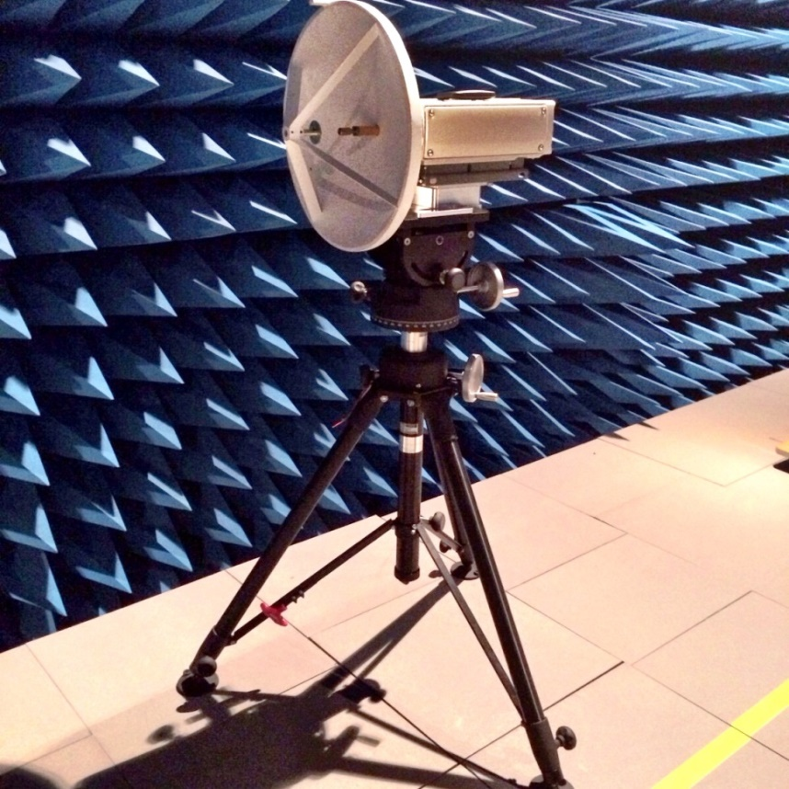

## A1.5.3 W-band propagation characteristics

#### A1.5.4 Table of frequency allocation of W-band

86-111.8 GHz

| Allocation to services | | |
| --- | --- | --- |
| Region 1 | Region 2 | Region 3 |
| 86-92 EARTH EXPLORATION-SATELLITE (passive)  RADIO ASTRONOMY  SPACE RESEARCH (passive)  5.340 | | |
| 92-94 FIXED 5.338A  MOBILE  RADIO ASTRONOMY  RADIOLOCATION  5.149 | | |
| 94-94.1 EARTH EXPLORATION-SATELLITE (active)  RADIOLOCATION  SPACE RESEARCH (active)  Radio astronomy  5.562 5.562A | | |
| 94.1-95 FIXED  MOBILE  RADIO ASTRONOMY  RADIOLOCATION  5.149 | | |
| 95-100 FIXED  MOBILE  RADIO ASTRONOMY  RADIOLOCATION  RADIONAVIGATION  RADIONAVIGATION-SATELLITE  5.149 5.554 | | |
| 100-102 EARTH EXPLORATION-SATELLITE (passive)  RADIO ASTRONOMY  SPACE RESEARCH (passive)  5.340 5.341 | | |
| 102-105 FIXED  MOBILE  RADIO ASTRONOMY  5.149 5.341 | | |
| 105-109.5 FIXED  MOBILE  RADIO ASTRONOMY  SPACE RESEARCH (passive) 5.562B  5.149 5.341 | | |
| 109.5-111.8 EARTH EXPLORATION-SATELLITE (passive)  RADIO ASTRONOMY  SPACE RESEARCH (passive)  5.340 5.341 | | |

ANNEX 2

Consideration of the Doppler Effect in railway radiocommunication systems between high-speed trains and tracksides

*[Editor’s note: This Annex is based on one Contribution Document (5A/48) of WP 5A in May 2016, and need to be further considered in WP 5A’s November meeting in 2016.]*

# A2.1 Introduction

WRC-15 (November 2015) adopted Resolution ITU-R **СОМ6/12 (WRC-15)** which included new item 1.11 in the Agenda of the next WRC-19: "To take appropriate measures, as the case may be, facilitating harmonization of frequency bands on global and regional levels, in order to ensure operation of railway radiocommunication systems between train and tracksides within existing allocations to mobile service".

This Resolution "*invites ITU-R* to undertake a study of spectrum requirements, technical and operational characteristics and implementation issues for railway radiocommunication systems between train and tracksides". In addition, during the 2012-2015 study period, Chinese Administration submitted to the ITU-R WP 3K the Document [R12-WP3K-C-0059](http://www.itu.int/md/R12-WP3K-C-0059/en) "Draft new ITU‑R Question for SG 3. Methods for propagation prediction for high-speed train radio services". The document noted the need to study possible impact of the Doppler shift on the operation of railway radiocommunication systems between high-speed trains and tracksides. In the previous study period, the Chinese Administration submitted to ITU-R WP 3K the Document [R12-WP3K-C-0093](http://www.itu.int/md/R12-WP3K-C-0093/en) "Preliminary draft new Recommendation ITU-R P.XXXX-VERSION. Method for propagation prediction for wireless radio systems on high-speed trains". This document also proposes to take into account possible impact of the Doppler shift on signal fading in railway radiocommunication systems between high-speed trains and tracksides.

The Documents R12-WP3K-C-0059 and R12-WP3K-C-0093 of the Chinese Administration did not get further consideration most likely due to the fact that there were no appropriate items in the WRC-15 agenda concerning the development of wireless radiocommunication systems for high‑speed trains. Currently, agenda item 1.11 which is directly related to such systems is included in the Agenda of the forthcoming WRC-19.

The purpose of the contribution is the initial analysis of the need to take into account possible impact of the Doppler shift on the propagation prediction process for wireless communication links between high-speed trains and tracksides. This approach is based on approximate evaluation of the Doppler shift for different carrier frequencies and different train speeds. The evaluation of the Doppler shift is based on the known mathematical equation describing the Doppler Effect.

# A2.2 Evaluation of the Doppler shift for different frequency bands and different train speeds

The Doppler shift (*Fd*) for the case of moving objects (transmitter or receiver) relative each other with a certain speed (*V*), is calculated using the well-known equation:

*Fd* = ﴾│*V*×*cos*(θ)│×*f*﴿ **/***c,* Hz. (1)

where:

*V* – speed of an object, m/s;

θ – angle between direction of an object motion (velocity vector) and the direction towards a stationary object, degrees (see Figure A2.2-1);

*f* – carrier frequency, Hz;

*с* – light velocity in free space, 3×108 m/s.

FIGURE A2.2-1

The Doppler shift measurement layout.



It can be seen from the equation (1) and Figure A2.2-1, that the Doppler shift has a maximum value when the angle θ has a minimum value, i.e. when the distance between two objects is sufficiently large. In general, this condition is mostly met as applied to the geometry of high-speed train motion, and the angle θ could be taken zero.

The Doppler shift was calculated using the equation (1) for train speeds in the range from 300 to 560 km/h and for carrier frequencies corresponding to the central frequency of the frequency bands allocated to the land mobile service in Region 1, i.e. 800 MHz, 1 800 MHz, 1 950 MHz, 2 100 MHz, 2 350 MHz, 2 595 MHz and 3 475 MHz. Calculated Doppler shifts for wireless radio systems between high-speed trains and tracksides are summarized in Table A2.2-1 and shown in Figure A2.2-2. It should be noted that Doppler shifts in Table A2.2-1 are absolute values. That is total Doppler shift in wireless radio systems between high-speed trains and tracksides will be twice the value of Table A2.2-1.

ТАBLE A2.2-1

**Calculated Doppler shift in wireless radio systems between high-speed trains and tracksides**

| Train speed *V*,  km/h | Carrier frequency *f*, GHz | | | | | |
| --- | --- | --- | --- | --- | --- | --- |
| 0.8 | 1.8 | 2.1 | 2.235 | 2.595 | 3.475 |
| Doppler shift *Fd*, kHz | | | | | |
| 300 | 0.222 | 0.5 | 0.583 | 0.653 | 0.721 | 0.965 |
| 320 | 0.237 | 0.533 | 0.622 | 0.696 | 0.769 | 1.03 |
| 340 | 0.252 | 0.567 | 0.661 | 0.74 | 0.817 | 1.094 |
| 360 | 0.267 | 0.6 | 0.7 | 0.783 | 0.865 | 1.158 |
| 380 | 0.281 | 0.633 | 0.739 | 0.827 | 0.913 | 1.223 |
| 400 | 0.296 | 0.667 | 0.778 | 0.87 | 0.961 | 1.287 |
| 420 | 0.311 | 0.7 | 0.817 | 0.914 | 1.009 | 1.351 |
| 440 | 0.326 | 0.733 | 0.856 | 0.957 | 1.057 | 1.416 |
| 460 | 0.341 | 0.767 | 0.894 | 1.001 | 1.105 | 1.48 |
| 480 | 0.356 | 0.8 | 0.933 | 1.044 | 1.153 | 1.544 |
| 500 | 0.37 | 0.833 | 0.972 | 1.088 | 1.201 | 1.609 |
| 520 | 0.385 | 0.867 | 1.011 | 1.131 | 1.249 | 1.673 |
| 540 | 0.4 | 0.9 | 1.05 | 1.175 | 1.298 | 1.738 |
| 560 | 0.415 | 0.933 | 1.089 | 1.219 | 1.346 | 1.802 |

FIGURE A2.2-2

The Doppler shift in a wireless radio system between high-speed trains and tracksides   
vs train speed for different carrier frequencies

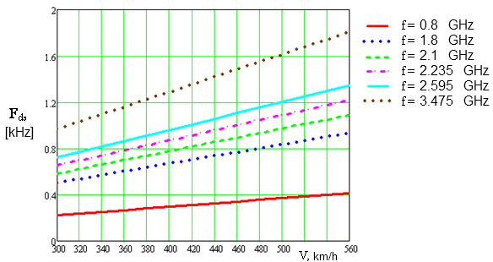

Let us see Figure A2.2-3 to analyze the impact of the Doppler shift on the operation of land mobile radio systems in a high-speed train.

FIGURE A2.2-3

Analysis of impact of the Doppler shift on the operation of wireless radio systems   
between high-speed trains and tracksides



Let us assume that a user terminal (UT) is located in a high-speed train, and a base station (BS) is fixed. Let us also assume that for the certain moment of time radio communication is established using radio frequency *f0n* between UT and BS. Due to the Doppler effect, fixed BS will receive UT carrier frequency *f0n* subject to the Doppler shift *Fd*, i.e. *f0n + Fd*. Accordingly, the bandwidth of the wanted UT signal will be also shifted to the right on the frequency scale by the same value *Fd*, as it is shown in Figure A2.2-3. Since the channel carrier frequencies are located in such a way that their spectra are side-by-side to each other (as it is shown in the upper part of Figure A2.2-3), then with such Doppler shift of n-*th* channel to the right, a part of the wanted spectrum of UT channel could fall into the bandwidth of the adjacent (n+1)-*th* BS channel receiver (as it is shown in the lower part of Figure A2.2-3). This share of the wanted signal power of n-*th* channel in the bandwidth of the adjacent (n+1)-*th* channel is highlighted by shadowing in the lower part of Figure A2.2-3. It is obvious, that the share of this power is proportional to the shift of the wanted signal spectrum, that is, to the *Fd*. Therefore, this share of the power (percentage of the total power of the wanted signal spectrum) could be evaluated by the ratio of the Doppler shift *Fd* to the spectrum of wanted signal *Δfs* (assuming that the bandwidth of the BS receiver is equal to this value). Table A2.2-2 shows such evaluations for different standards of land mobile communications (and, accordingly, for different central frequencies and parameters of signal) with maximum train speed (500 km/h, or 139 m/s).

TАBLE A2.2-2

Summary of calculated impact of the Doppler shift on wireless radio systems   
between high-speed trains and tracksides

|  |  |  |  |  |  |  |  |  |  |
| --- | --- | --- | --- | --- | --- | --- | --- | --- | --- |
| Land mobile system (center frequency, МHz) | GSM-R   (800) | GSM-1800  (1 800) | UMTS- 2100  (2 100) | WiMAX   (2 350) | WiMAX   (2 595) | WiMAX   (3 475) | LTE   (1 950) | LTE   (2 350) | LTE   (2 595) |
| max(*Fd*), (kHz) | 0.37 | 0.833 | 0.972 | 1.088 | 1.201 | 1.609 | 0.904 | 1.088 | 1.201 |
| Δ*fs* (MHz) | 0.2 | 0.2 | 3.84 | 9.2 | 9.2 | 9.2 | 9.0 | 9.0 | 9.0 |
| max(*Fd*)/Δ*fs*, (%) | 0.185 | 0.417 | 0.025 | 0.012 | 0.013 | 0.017 | 0.01 | 0.012 | 0.013 |

# A2.3 Conclusions

Based on data from Table A2.2-1, Table A2.2-2, and Figure A2.2-2 we can make the following conclusions:

– carrier frequency shift due to the Doppler effect becomes noticeable only for train speeds about 500 km/h and for frequency 2 GHz and higher. Carrier frequency is shifted by ±1.609 kHz from its nominal value (for the WiMAX land mobile system);

– taking into account the Doppler shift of the carrier frequency and bandwidth of one radio channel in the up-to-date land mobile systems, the share of the UT signal power falling into the bandwidth of receiver of adjacent BS channel does not exceed 0.18% for all considered standards of land mobile systems;

– when developing propagation models for radio communication scenarios between high-speed train and trackside, the effect of the Doppler shift is negligible to be taken into account.