|  |  |  |  |
| --- | --- | --- | --- |
|  | **Radiocommunication Study Groups** | |  |
| **INTERNATIONAL TELECOMMUNICATION UNION** | |  | |
|  | |  | |
| Source: Document 5A/TEMP/58 | | **Annex 24 to Document 5A/114-E** | |
| **24 May 2016** | |
| **English only** | |
| Annex 24 to Working Party 5A Chairman’s Report | | | |
| WORKING DOCUMENT TOWARDS A PRELIMINARY DRAFT NEW REPORT ITU-R M.[RLAN REQ-PAR] | | | |
| Technical characteristics and operational requirements of WAS/RLAN  in the 5 GHz frequency range | | | |

# 1 Introduction

This Report provides technical characteristics and operational requirements of WAS/RLAN in the 5 GHz frequency range.

*[****Editor’s note****: It is intended to represent the response to Invites ITU-R a) of Resolution* ***239 (WRC-15)*** *and to serve, as appropriate, as a basis for sharing and compatibility studies and consideration of mitigation techniques under WRC-19 agenda item 1.16.]*

*[****Editor’s note****: The technical and operational parameters contained in this document are based mainly on Wi-Fi usage and discussions associated with the 5 350–5 470 MHz band from the previous study cycle. There will need to be a review of all of these parameters to take account of possible parameters to be used in the other bands under the agenda item and for other types of RLAN technologies (e.g. LTE/LAA etc.)]*

# 2 WAS/RLAN requirements

## 2.1 Spectrum requirements

Revised WAS/RLAN spectrum requirements were addressed during previous study period in relevant ITU-R groups under WRC-15 agenda item 1.1 and are duly considered in *recognising* b) of Resolution **239 (WRC-15)**. As such, the present Report is not aimed as reconsidering these spectrum requirements.

*[****Editor’s note****: For reference only, the detailed calculations related to these spectrum requirements can be found in Document 4-5-6-7/137.]*

## 2.2 Operational requirements

WAS/RLAN operational requirements have to be considered over the whole 5 GHz range, taking into account existing regulations in current RLAN bands (5 150-5 350 MHz and 5 470-5 725 MHz) as well as those for possible extension bands (5 350-5 470 MHz and 5 725-5 925 MHz).

*[****Editor’s note*** *: see also Documents 5A/64, 5A/92]*

## 2.2.1 E.I.R.P. requirements

a) Current situation in existing bands

See Resolution 229 (Rev. WRC-12)

See Resolution 239 (WRC-15) *invites ITU-R c)*

b) E.i.r.p. requirements over the whole 5 GHz range

c) Consideration of potential e.i.r.p. requirements on a sub-band basis

d) Current equipment conducted power limits.

## 2.2.2 Outdoor usage

a) Current situation in existing bands

See Resolution 229 (Rev. WRC-12)

b) Outdoor usage requirements over the whole 5 GHz range

c) Consideration of potential outdoor usage requirements on a sub-band basis

*[****Editor note****: it would be convenient to include references on potential deployment scenarios of RLAN]*

## 2.2.3 Channel plan and potential cross-band issues

The following Figure 1 describes the baseline channelization scheme for WiFi type WAS/RLAN applications, considering the existing bands and possible extension bands.

Consideration should be given to confirm such channel plan for WiFi type WAS/RLAN, including possible use by other technologies.

Figure 1

Baseline Channelization Scheme

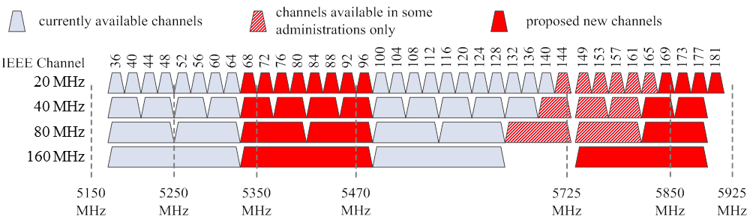

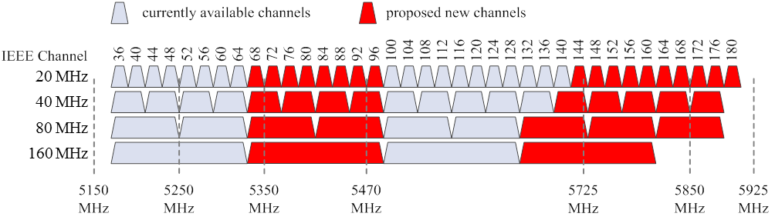

## 2.2.4 Other requirements

TBD

## 2.2.5 Consideration of potential cross-band issues

*[****Editor’s note****: this section is aimed at considering the potential cross-band issues and impact on WAS/RLAN technical and operational characteristics that could be caused by use of large WAS/RLAN bandwidth covering different 5 GHz range sub-bands (5 150-5 250 MHz, 5 250‑5 350 MHz, 5 350-5 470 MHz, 5 470-5 725 MHz, 5 725-5 850 MHz and 5 850-5 925 MHz bands)]*

TBD

# 3 WAS/RLAN technical characteristics

WAS/RLAN applications covers a number of different technologies and in particular WiFi type applications and LTE systems (LAA-LTE or LTE-U).

Over the previous study period, only WiFi type applications were considered, leading to the technical characteristics as given in section 3.1 below. Additional and consistent work will be needed to address other technologies and in particular LTE systems.

*[****Editor’s note****: see Document 4-5-6-7/715 (Annex 35)]*

## 3.1 Wifi type WAS/RLAN

## 3.1.1 e.i.r.p. level distribution for the 5350-5470 MHz band

|  |  |  |  |  |
| --- | --- | --- | --- | --- |
| RLAN e.i.r.p. Level | 200 mW  (Omni-Directional) | 80 mW  (Omni-Directional) | 50 mW  (Omni-Directional) | 25 mW  (Omni-Directional) |
| RLAN device percentage | 19% | 27% | 15% | 39% |

*[****Editor’s Note****: The e.i.r.p distributions shown above were used in the previous studies related to the 5 350–5 470 MHz band these will have to be reviewed either on a band by band basis or an overall generic value for all bands.]*

NOTE - RLAN devices are assumed to be indoors only, based on the requirement to help facilitate coexistence. For the purposes of sharing studies, 5% of the devices should be modelled without building attenuation.

Alternatively administrations may choose to carry out a parametric analysis in any range between 2% and 10%.

These e.i.r.p. values apply across the entire RLAN channel bandwidth.

Alternatively administrations may choose to use a single e. i. r. p. level.

*[****Editor’s Note*** *: these figures are given for bands in which WAS/RLAN are limited to indoor use. Impact of outdoor usage on this distribution is to be addressed.]*

## 3.1.2 Channel bandwidths distribution

|  |  |  |  |  |
| --- | --- | --- | --- | --- |
| **Channel bandwidth** | **20 MHz** | **40 MHz** | **80 MHz** | **160 MHz** |
| RLAN device percentage | 10% | 25% | 50% | 15% |

## 3.1.3 Building attenuation

Gaussian distribution with a 17 dB mean and a 7 dB standard deviation (truncated at 1 dB).

Alternatively administrations may choose to use a 17 dB fixed value.

## 3.1.4 Propagation model

The model sums losses (in dB) from the free space loss model in Recommendation ITU-R P.619, the angular clutter loss model in Recommendation ITU-R P.452 and the building attenuation model that is described above.

The angular clutter loss model provided by the “RLAN User Defined Height” column of the attached worksheet were used in conjunction with the antenna heights as described below.   
The clutter loss values calculated for the "sparse houses", "suburban" and "urban" clutter  
(ground-cover) categories were applied in the rural, suburban and urban zones of the RLAN deployment model, respectively.

Theta max (°) provides the angle from the RLAN transmitter to the top of the clutter height. Therefore, if the spacecraft is at an elevation angle at or below theta max (°), clutter loss should be added. If the spacecraft is above theta max (°) of the respective clutter category, there is no clutter loss.



Antenna height

|  |  |
| --- | --- |
| **RLAN deployment region** | **Antenna height (metres)** |
| Urban | 1.5 to 28.5 |
| Suburban | 1.5, 4.5 |
| Rural | 1.5, 4.5 |

The antenna heights are randomly selected using a uniform probability distribution from the set of floor heights at 3 meter steps.

## 3.1.5 Antenna gain/discrimination

Omnidirectional in azimuth for all scenarios.

**Option A1**: Omnidirectional in elevation with 0 dBi gain In one study this option was used as   
a baseline, but further considered losses by developing 3 dB cross-polarisation loss for systems without building attenuation, and then considered 0-4 dB random “other” losses.

## Option A3: An average 4 dB antenna discrimination is applied to the e.i.r.p. level distribution above in the direction of the satellite

*[****Editor’s Note****: these antenna discrimination figures are given for compatibility analysis with satellite services. Antenna patterns for compatibility with other services may need to be described.]*

*[****Editor’s Note****: The parameters and general effect of RLANS employing multi-mimo and beamforming technology could be addressed in future studies.]*

## 3.1.6 WAS/RLAN device density relevant to sharing studies

The following RLAN device densities are to be used as simultaneously transmitting with the e.i.r.p. distribution as given above (no ranking implied).

*[****Editor’s note****: this has to be carefully discussed and agreed to with regards to the assumptions and applicability in each of the sub band studies]*

**[Option D1**: 9 365 active devices per 20 MHz channel or 11 279 active devices per 100 MHz channel per 5.25 million inhabitants.

**Option D2**: From 0.000 8 to 0.008 active devices per 20 MHz channel per inhabitant (0.004 to   
0.04 per 100 MHz channel) (based on 3% to 30% activity factor) applied to any population size.

**Option D3**: Take into account the EESS interference threshold in order to determine the number of simultaneous RLAN connections which can be tolerated. The RLAN density can then be determined for a given population.]

*[****Editor’s Note****: these density options are given for 20 and 100 MHz bandwidth victim receiver bandwidth but would have to be scaled, as appropriate, for other incumbent services bandwidth.]*

*[****Editor’s note****: see also Document 5A/100 for busy hour and activity factors]*

### 3.1.7 RLAN busy hour analysis and measurements

TBD

Could take suitable elements from EC JRC Doc 100 on Busy Hour analysis and any terrestrial measurement campaigns looking at busy hour.

*[****Editor’s note****: Different views were expressed on whether or not LTE type WAS/RLAN systems should be included in these studies.]*

## [3.2 LTE type WAS/RLAN

TBD (eirp distributions, bandwidth distributions, antenna discrimination/patterns, devices densities, …)]

*[****Editor’s note****: see also Documents 5A/64, 5A/92]*