|  |  |
| --- | --- |
| **Radiocommunication Study Groups** |  |
|  |  |
|  |  |
| Source: Document 5A/TEMP/234 | **Annex 22 to**  **Document 5A/650-E** |
| **16 November 2017** |
| **English only** |
| Annex 22 to Working Party 5A Chairman’s Report | |
| WORKING DOCUMENT TOWARDS A PRELIMINARY DRAFT NEW  REPORT ITU-R M.[AGGREGATE RLAN MEASUREMENTS] | |
| Use of aggregate RLAN measurements from airborne and terrestrial platforms to support studies under WRC-19 agenda item 1.16 | |

# 1 Introduction

The present ITU-R Report introduces a methodology for comparing RLAN measurement results in both the 2.4 GHz and 5 GHz bands with RLAN aggregate interference modelling over a defined geographical area. The Report also includes the results of various airborne measurement campaigns looking at measurement of RLAN usage in the 2.4 GHz and 5 GHz bands in various parts of the world.

Due to the lack of evidence being available, there has been a lot of debate on how aggregate interference from a mature rollout of WAS/RLAN would look like in the future to satellite and airborne platforms. This has led to a large range of results being predicted when looking at possible aggregate interference models to predict possible future RLAN usage across the 5 GHz range. This is due largely to the number of variables that can be introduced into the models to be studied which makes it is difficult to come to any conclusions for results of studies to an acceptable range of accuracy.

This report highlights one possible way forward to address this uncertainty by looking at the results of airborne measurements campaigns that attempt to compare actual RLAN use with the predicted results from the different models proposed for a defined geographical area in a view to determine a baseline with limited range of assumptions to be used is sharing analysis between RLAN 5 GHz and satellite services under agenda item 1.16 (WRC-19).

# 2 Relevant ITU-R Recommendations and Reports

TBD

# 3 Background on models used to estimate aggregate RLAN interference

*[****Editor’s note****: To be developed by taking some information from the Report on technical characteristics and operational requirements of WAS/RLAN in the 5 GHz frequency range (ITU-R M.[RLAN REQ-PAR]).]*

# 4 Relationship between measurements and interference predicted based on models

## 4.1 Relationship between 2.4 GHz measurements and interference models

Measurements carried out in the 2.4 GHz band can be used to provide a baseline to demonstrate what a mature RLAN rollout looks like in various parts of the world in either urban, suburban and/or rural environments. It is expected that these results could be extrapolated to give an estimate of what aggregate emissions may look like in the future with a mature rollout in the 5 GHz frequency range to airborne/satellite platforms.

## 4.2 Relationship between 5 GHz measurements and interference models

Measurements carried out in the 5 GHz band can be used to provide a baseline to demonstrate what initial trends in RLAN rollout looks like in each of the current sub bands of the 5 GHz band: can be used to identify and estimate any trends and what their effect may be based on any different rules and restrictions we may place on RLANs in the future.

# 5 Comparing Airborne Measurements with the Theoretical Emissions Model

*[****Editor’s note****: To be developed using relevant parts of the content of Annex 1 and from UK and France documents contained in Appendices 1 and 2.]*

## 5.1 Comparing 2.4 GHz Airborne Measurements with theoretical Emissions Models

### 5.1.1 Adapting the theoretical RLAN/satellite coexistence models for airborne measurements

### 5.1.2 Adapting the existing RLAN aggregate emissions models to accommodate 2.4 GHz airborne measurements

### 5.1.3 Estimating the measurement footprint using the antenna pattern and further calibration measurements

### 5.1.4 Comparison of the results of Wi-Fi emissions predicted by the model with those measured

## 5.2 Extrapolation of the 2.4 GHz measurements results and analysis to 5 GHz theoretical Emissions Models

*[Editor’s note: To be developed using relevant parts of the content from UK and France documents contained in Annex 1]*

## 5.3 Comparing 5 GHz Airborne Measurements with the Theoretical Emissions Model

*Editor’s note: To be developed using relevant parts of the content from UK documents contained in Annex B Appendix 2*

### 5.3.1 Adapting the theoretical RLAN / satellite coexistence model for airborne measurements

### 5.3.2 Adapting the existing RLAN aggregate emissions model (including various sub‑band estimated load) to accommodate 5 GHz airborne measurements

### 5.3.3 Estimating the measurement footprint using the antenna pattern and further calibration measurements

### 5.3.4 Comparison of the results of RLAN emissions predicted by the model with those measured, including sub-band analysis

# 6 Conclusions

Based on the assumptions and methodology developed in this Report, the following table provides the list of parameters to be used for the RLAN 5 GHz sharing studies, in particular to determine the number of active RLAN in the case of aggregate scenario with satellite receivers.

|  |  |  |
| --- | --- | --- |
|  | **5 GHz** | **Comments** |
| **Nb of AP** | 400000000 | For a total population of 701083818 |
| **Mean eirp** | 19 dBm |  |
| **Busy hour population** | 62.7% |  |
| **5 GHz factor** | 38% and 59% |  |
| **Activity factor** | 10% |  |
| **40 MHz victim channelisation factor** | 12.90% | For FSS case |
| **Bandwidth factor** | 3.55 dB | For FSS case |
| **Antenna discrimination** | 2 dB and 4 dB |  |

This set of assumptions may be complemented, when appropriate, by additional assumptions relevant to the scenario under study (e.g. clutter losses, higher power outdoor RLAN systems, ....).

Annex 1

2.4 GHz measurement campaigns and comparison   
with 5 GHz deployment model

This Annex document various measurements carried out of aggregate WiFi emissions in the 2.4 GHz band as seen from an airborne platform (see Appendix 1). The measurements were carried out for the 2.4 GHz band in order to provide a baseline for future analysis under WRC-19 agenda item 1.16 studies to demonstrate:

1) what a mature RLAN rollout could look like;

2) what aggregate emissions may look like in the future with a mature rollout in the 5 GHz frequency range to airborne/satellite platforms.

Further measurement campaigns are encouraged so ITU-R could add to the data needed to refine the comparison process. Such data would also provide an avenue to gain more confidence and some agreement on an appropriate model to be used for studies looking at aggregate interference from WAS/RLAN.

These measurements are used for a comparison analysis of the measurements to the expected 2.4 GHz RLAN deployment against that would be given using the RLAN deployment model, in order to subsequently estimate the relevant 5 GHz RLAN deployment model to be used in sharing/compatibility studies under agenda item 1.6.

Such comparison analysis principles and details are described in Appendices 1 and 2.

1. Basics of the analysis

The 2.4 GHz measurements described in Appendix 1 are compared with the RLAN deployment/parameters model used in ECC report 244. This model, derived for the 5 GHz range, takes into account a number of assumptions, which, for a majority, are given with a range of values. As detailed in principle in Appendix 1, for comparison purpose, a similar set of assumptions has been derived at 2.4 GHz.

The following table provides the list of elements related to this model and corresponding range of values for both the 2.4 GHz and 5 GHz bands.



1. Mean eirp

The mean eirp figure at 5 GHz (19 dBm) used in the present analysis is based on the following eirp distribution:

|  |  |  |  |  |
| --- | --- | --- | --- | --- |
| 5 GHz RLAN e.i.r.p. Level | 200 mW  (Omni-Directional) | 80 mW  (Omni-Directional) | 50 mW  (Omni-Directional) | 25 mW  (Omni-Directional) |
| RLAN device percentage | 19% | 27% | 15% | 39% |

The mean eirp figure at 2.4 GHz (17.6 dBm) value is based on the following estimated eirp distribution derived from the 5 GHz eirp distribution and for which the maximum eirp level has been changed from 200 mW to 100 mW:

|  |  |  |  |  |
| --- | --- | --- | --- | --- |
| 2.4 GHz RLAN e.i.r.p. Level | 100 mW  (Omni-Directional) | 80 mW  (Omni-Directional) | 50 mW  (Omni-Directional) | 25 mW  (Omni-Directional) |
| RLAN device percentage | 19% | 27% | 15% | 39% |

1. Building entry loss (BEL)

ITU-R Study Group 3 has very recently adopted Recommendation ITU-R [P.2109](https://www.itu.int/rec/R-REC-P.2109-0-201706-I/en) on “Prediction of Building Entry Loss” providing a model valid in the 80 MHz to 100 GHz frequency range.

This model leads to very small difference in BEL for the 2.4 GHz and the 5.4 GHz bands, with in particular average values at 0° elevation of 10.47 dB and 10.89 dB, respectively (for traditional buildings). Similar difference is depicted at all elevation and a figure of 0.5 dB difference has been used in the analysis.

It was agreed that, instead of using the model for “traditional building” only, a mix of 70% (traditional building) and 30% (thermally efficient building) be used.

The following figure compares the BEL model at 2.4 GHz and 5.8 GHz for “Traditional”, “Thermally efficient” and combined 70% (traditional)/30%(thermally efficient) scenarios.

This figure first confirms the small difference between the BEL values at 2.4 GHz and 5.8 GHz for all scenarios and all elevations.

It also shows that the difference between the “traditional” scenario and the “combined 70% (traditional)/30% (thermally efficient)” is small, within a 1 to 1.5 dB range. Considering the 2.4 GHz measurement footprint (see below) as given in Appendix 1 and the 7 km altitude of the plane used for the measurements, it is possible to determine the average elevation over the footprint at which the measurements have been performed.



This leads to an average elevation of 13.4° and hence to the following average BEL figures (based on Recommendation ITU-R [P.2109](https://www.itu.int/rec/R-REC-P.2109-0-201706-I/en) and a “combined 70% (traditional)/30% (thermally efficient)”):

* Average BEL at 2.4 GHz = 12.9 dB
* Average BEL at 5.8 GHz = 13.4 dB

It is to be noted that the use of these figures should limited to the comparison of the models at 2.4 GHz and 5 GHz but that for subsequent sharing analysis at 5 GHz, the average BEL will have to be based on the Recommendation ITU-R P.2109 model using the elevation corresponding to the case under study (e.g. FSS, EESS, MSS).

1. Victim bandwidth overlap (or channelization factor)

The method to calculate the number of overlapping RLAN in the victim bandwidth and the corresponding average bandwidth factor was derived and agreed during previous ITU-R work.

Similar calculations have been made at 2.4 GHz, under 2 baseline assumptions, differing on the number of possible non-overlapping 20 MHz channels usable in this band (either 3 or 4). These calculations are given in the following excel file.



The results are the following :

* Baseline 1 (4 times 20 MHz channels)
  + % of Overlapping RLAN = 87.5%
  + Average bandwidth factor = 2.43 dB
* Baseline 2 (3 times 20 MHz channels)
  + % of Overlapping RLAN = 100%
  + Average bandwidth factor = 2.34 dB

The most conservative case is the Baseline 2 and it has been agreed to retain a 100% of Overlapping RLAN and an average bandwidth factor of 2.34 dB in the analysis of the 2.4 GHz measurements.

1. Busy hour measurement factor

The measurements at 2.4 GHz were performed in the middle afternoon, hence not representing a busy hour. It was further agreed that this could be solved by an additional factor of 90% to be applied to the “busy hour population factor”, hence representing a correction factor of 0.45 dB on the measurements.

For simplification purposes, it was agreed to maintain the “busy hour population factor” as they were initially considered for the 5 GHz band and then to apply the busy hour measurement factor after all calculation by shifting the measurement by + 0.45 dB.

1. Summary of findings

Based on the above elements, the following figures provides comparison of the 2.4 GHz RLAN deployment model (showing the minimum, medium and maximum values) with the UK measurements results in dotted green lines (for both the “Central London” and “West London” cases)

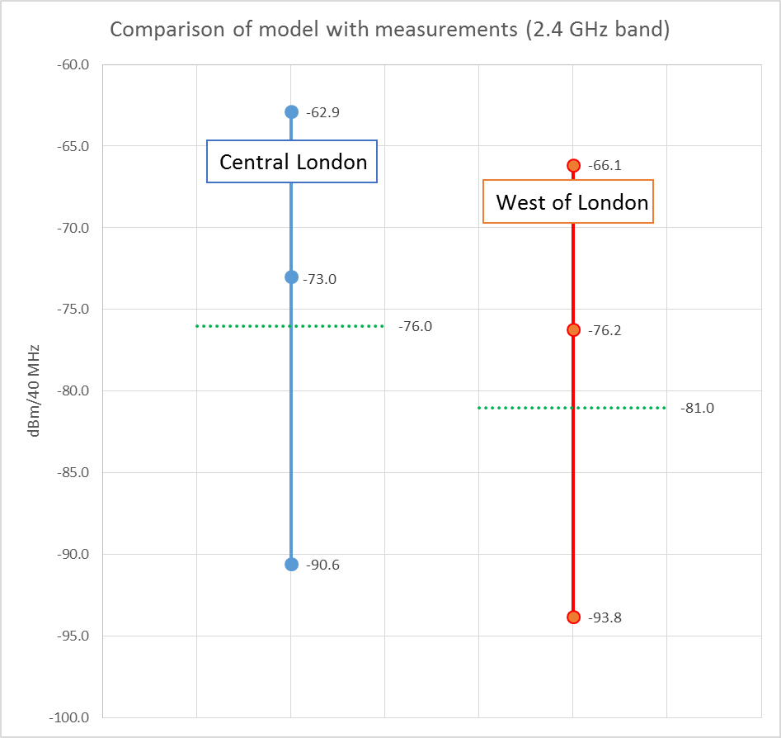

This figure shows that the measurements are representative of scenarios slightly below the model with medium parameters at 2.4 GHz.

It was agreed to consider the “central London” case as a reference, showing a measurement Figure 3 dB below the model with medium parameters at 2.4 GHz, hence justifying similar set of “medium parameters – 3 dB” as a reference point for the 5 GHz band.

In addition, to take into account a certain level of uncertainty on the measurements and also allow discussion on the final results, it was agreed to apply a +- 2 dB safety margin on the above reference point.

Accordingly, based on the assumptions and methodology developed in this Report, the following table provides the list of parameters to be used for the RLAN 5 GHz sharing studies, in particular to determine the number of active RLAN in the case of aggregate scenario with satellite receivers. This set of parameters depicts a 4 dB variation range.

|  |  |  |
| --- | --- | --- |
|  | **5 GHz** | **Comments** |
| **Nb of AP** | 400000000 | For a total population of 701083818 |
| **Mean eirp** | 19 dBm |  |
| **Busy hour population** | 62.7% |  |
| **5 GHz factor** | 38% and 59% |  |
| **Activity factor** | 10% |  |
| **40 MHz victim channelisation factor** | 12.90% | For FSS case |
| **Bandwidth factor** | 3.55 dB | For FSS case |
| **Antenna discrimination** | 2 dB and 4 dB |  |

On this basis, it is then possible to calculate the density of active RLAN overlapping a victim bandwidth (e.g. for the FSS case) as follows:

Upper case = 400000000/701083818 x 62.7% x 59% x 10% x 12.9% = 0.0027 RLAN / inh.

Lower case = 400000000/701083818 x 62.7% x 38% x 10% x 12.9% = 0.0018 RLAN / inh.

Appendix 1

UK 2.4 GHz Measurement Report and Analysis



Appendix 2

Further analysis of the 2.4 GHz Measurement Report



Annex 2

5 GHz Measurement Campaigns

*Editor’s note: Current elements in this annex were not discussed at May 2016 WP 5A meeting and should not be considered as agreed WP 5A elements.*

In this Annex we document various measurements carried out of aggregate WiFi emissions in the 5 GHz band as seen from an airborne platform. The measurements were carried out for the 5 GHz band in order to provide a baseline for future analysis under WRC-19 agenda item 1.16 studies to demonstrate: what we think initial trends in each of the 5 GHz sub-bands look like; what the current aggregate emissions look like in the in the 5 GHz frequency range to airborne/satellite platforms; how these trends may be able to guide future decisions on regulations and restrictions on 5 GHz RLANs. Further measurement campaigns are encouraged so ITU-R could add to the data needed to refine the comparison process. Such data would also provide an avenue to gain more confidence and some agreement on an appropriate model to be used for studies looking at aggregate interference from WAS/RLAN.

**Appendix**: UK 5 GHz measurement Report



______________