|  |  |
| --- | --- |
| **Radiocommunication Study Groups** |  |
|  |  |
|  |  |
| Received: 30 October 2017 | **Document 5A/554-E** |
| **1 November 2017** |
| **English only** |
| Globalstar, Inc. | |
| PROPOSED REVISION OF THE WORKING DOCUMENT TOWARDS A PRELIMINARY DRAFT NEW REPORT ITU-R M.[AGGREGATE RLAN MEASUREMENTS] | |
| Use of aggregate RLAN measurements from airborne and terrestrial platforms to support studies under WRC-19 agenda item 1.16 | |

In 2014, the U.S. Federal Communications Commission issued a Report and Order (FCC 14-30) allowing potentially unlimited outdoor deployment of unlicensed RLAN access points in the U.S. U-NII-1 band, spectrum which includes RLAN channels in 5.170-5.250 GHz, and which overlaps the licensed 5.091-5.250 GHz LEO-D’s Mobile Satellite Service (MSS) frequency spectrum.

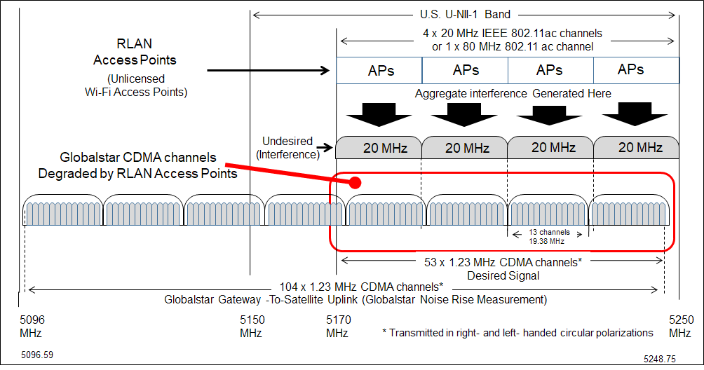As a result of the U.S. Administration decision to allow the deployment of an unknown number of U-NII-1 (Outdoor RLAN) devices, LEO-D decided to commission a project to characterize, calibrate, and document the details of the 5.096–5.250 GHz feeder uplink.

The purpose of this contribution is to describe the Test Methodology utilized to first capture the state of the LEO-D 5 GHz Spectrum, and secondly to track any rise or changes in the 5 GHz baseline noise levels associated with its Second Generation satellites.

A proposed revision of preliminary draft new Report ITU-R M.[AGGREGATE RLAN MEASUREMENTS] is shown in the attachment and is intended to form a new Section 6.3 and a new Annex.

**Attachment:** 1

## 6.3 Satellite Measurements of Noise Floor Increase due to Outdoor RLAN Deployment

Summary

In 2014, the U.S. Federal Communications Commission (the U.S. Administration) issued a Report and Order (FCC 14-30) allowing potentially unlimited outdoor deployment of unlicensed RLAN access points in the U.S. U-NII-1 band, spectrum which includes RLAN channels in 5.170‑5.250 GHz, and which overlaps the licensed 5.091- 5.250 GHz feeder uplink of LEO-D’s Mobile Satellite Service (MSS) as shown in Figure 1: LEO-D Frequency Plan and U-NII-1 Band Overlap.

Prior to the publication/release of FCC Report & Order 14-30 on April 1, 2014, LEO-D had informed the U.S. Administration that the potential rise of 2 dB, or greater, in the 5 GHz Noise Floor could cause substantial damage to the Capacity and Quality of Service (QOS) for the LEO-D Duplex Voice Service. During the negotiations with the U.S. Administration, LEO-D requested that a 2 dB “Backstop” be defined such that further outdoor deployment of the U-NII-1 band devices would be limited once the 2 dB noise rise threshold was reached. The U.S. Administration subsequently declined to set any “backstop” on the 5 GHz Noise Floor, but did reaffirm that LEO-D’s licensed MSS operations are protected against harmful interference from unlicensed operations and said that it would continue to monitor developments in the U-NII-1 band. The U.S. Administration also acknowledged LEO-D’s capability to monitor increases in noise levels at its satellites, and stated its expectation that LEO-D would report any significant changes in these noise levels and provide specific details as to how such changes are affecting its MSS operations.

Figure 1

LEO-D Frequency Plan and U-NII-1 Band Overlap

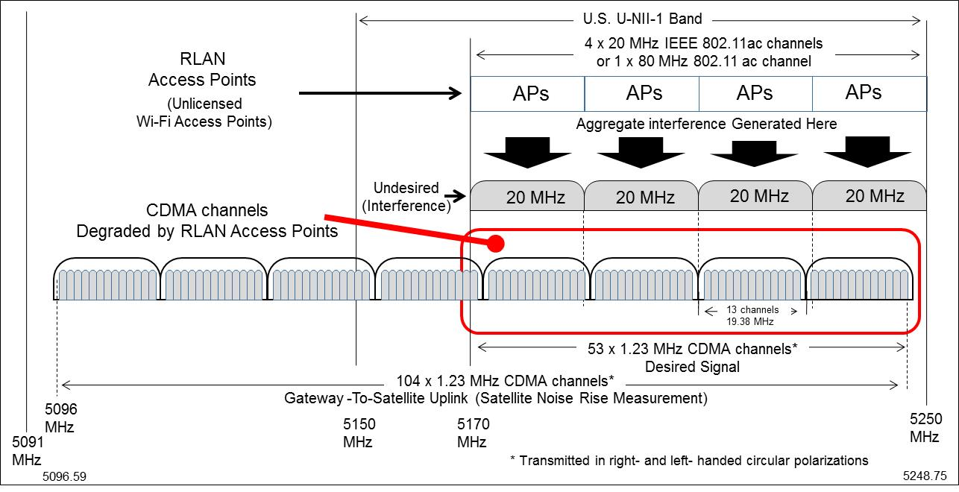

As a result of the U.S. Administration’s decision to allow the deployment of an unknown number (potentially millions) of U-NII-1 (Outdoor RLAN) devices outdoor at higher power, LEO-D decided to commission a project to characterize, calibrate, and document the details of the 5.096‑5.250 GHz frequency spectrum.

The purpose of this Contribution is therefore to describe the Test Methodology utilized to first capture the state of the LEO-D 5 GHz Spectrum, and secondly to track any rise, or changes in the 5 GHz baseline noise levels associated with each of the LEO-D satellites.

Since April 2014, LEO-D has measured and documented at least 2 dB rise in the noise floor in the 5.096–5.250 GHz band over North America where outdoor, higher power RLAN deployments have been permitted. LEO-D has not detected similar rise over Europe, where no such deployments have been permitted. This increase in the noise floor is expected to continue at an accelerated pace if the proliferation of RLAN deployments continued.

Table of contents

Introduction 4

1LEO-D 5 GHz Characterization and Test System Description 4

1.1 5 GHz Forward Link Spectrum Description 5

1.2 Satellite Forward Link Transponder Description 5

1.3 Clifton Ground Station IOT System Description 6

25 GHz Noise Floor Characterization and Monitoring Methodology 7

2.1 Development of the Ground-to-Space Uplink Calibration Procedure 7

2.2 Noise Floor Calibration Measurement Definition 7

3RLAN Access Point (AP) Analysis 8

3.1 Analysis Point Definition 8

3.2 RLAN Noise Floor Measurement Archive 8

4Noise Floor Measurement Scheduling 11

4.1 Satellite Outage Scheduling 11

4.2 Satellite Outage Definition 12

4.3 5 GHz Long Term Monitoring of the LEO-D Constellation Noise Floor 12

55 GHz Noise Floor Monitoring Over Western Europe 13

**List of Figures**

Figure 1: LEO-D  Frequency Plan and U-NII-1 Band Overlap

Figure 2:  LEO-D  Forward Link Frequency Spectrum

Figure 3:  LEO-D Forward Link Transponder Block Diagram

Figure 4:   5 GHz Noise Floor Characterization Testing – Ground Hardware Block Diagram

Figure 5:  802.11 RLAN Interference Signal Measurement Definition

Figure 6:  Satellite #1  Noise Floor Calibration Test Example (April 11, 2014)

Figure 7:   Master 5 GHz Noise Floor Database  -  RHCP/LHCP

Figure 8:  LEO-D  Satellite #6, Located Over Lincoln, KS,  -  June 6, 2017  @ 15:17:00 GMT

# Introduction

The 5 GHz Noise Floor Monitoring Project is being accomplished by utilizing existing components and capabilities that were included in the original design of the LEO-D Satellite and Ground Systems. The system components described herein are the LEO-D Satellite Forward Link Transponders and In-Orbit Test Equipment (IOTE). Although not specifically designed to monitor the noise levels of the satellite transponders, we are able to periodically configure the system to remove traffic and collect Forward Link Telemetry representing the 5 GHz Noise Floor. This process is further described below.

# 1 LEO-D 5 GHz Characterization and Test System Description

## 1.1 5 GHz Forward Link Spectrum Description

The LEO-D 5 GHz Forward Link Frequency Spectrum, as shown in Figure 2 below, is 5.091 GHz to 5.250 GHz. The lower 5 MHz of the spectrum is dedicated to the satellite Command Uplink and is not addressed in this Contribution. The upper portion of this spectrum consists of 16 x 16.5 MHz beams. These beams employ frequency reuse, with 8 beams on the RHCP polarization and 8 beams on the LHCP polarization. As shown in Figure 2, the 16.5 MHz beams are set on 19.38 MHz centers, providing a 2.88 MHz guard band between adjacent beams.

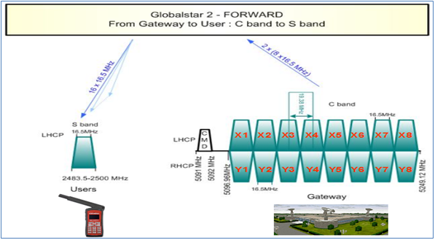

Figure 2: LEO-D Forward Link Frequency Spectrum

## 1.2 Satellite Forward Link Transponder Description

The LEO-D Satellite Forward Link Payload, as shown in Figure 3 below, contains 16 individual 5 GHz Transponders which are used to translate the 5 GHz Feeder Uplink from the Ground Gateway to the 2.5 GHz User Downlink. Each transponder is divided into 4 sections, namely Input LNA Section, Down Converter Section, Power Amplification Section, and Output Section. For the purpose of this Contribution, we are primarily interested in the S-Band Power Amplification section.

The design in the S-band Amplifier Section also includes an additional capability, specifically helpful to the 5 GHz Monitoring project. Since the Input Multiport Couplers (MPC) for each polarization (LHCP & RHCP) spreads the energy for each input beam across all of the S-band Amplifiers, this means that we can obtain a representative sample of the noise floor for all eight beams at any one of the S-band Amplifier inputs.

Figure 3

LEO-D Forward Link Transponder Block Diagram

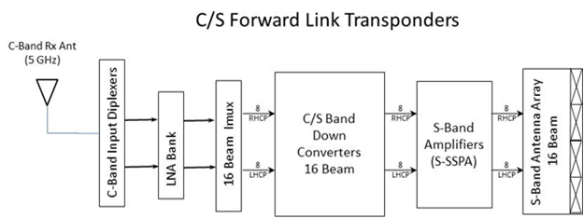

## 1.3 Clifton Ground Station IOT System Description

The LEO-D In-Orbit Test Equipment (IOTE), located at the Clifton, Texas Gateway site in the United States, contains the hardware and software that was required to perform the 5 GHz Noise Floor Characterization testing. The IOTE system was originally designed to perform the initial In-Orbit Testing and Qualification of the LEO-D 2nd Generation Satellite Constellation following the four Launches from 2010 through 2013.

In 2013, during the planning stages of the 5 GHz Characterization and Monitoring Project, we determined that we could reconfigure the In-Orbit Test Equipment (IOTE) to provide uplink signals that could simulate the interfering signal. The RLAN simulated signal is generated using an Anritsu MG3700A Arbitrary Waveform Generator/Upconverter (AWG), executing an RLAN Waveform file.

Figure 4 shown below contains a partial Block Diagram of the Clifton Gateway C-Band Antenna to IOTE Rack Interface signals that were used during the 5 GHz Noise Floor Characterization Testing.

Figure 4

5 GHz Noise Floor Characterization Testing – Ground Hardware Block Diagram

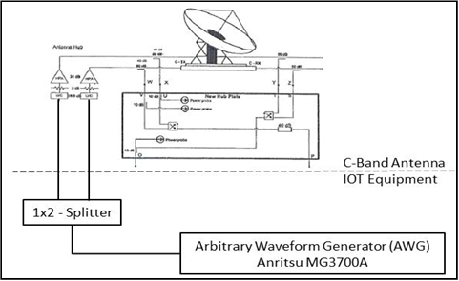

# 2 5 GHz Noise Floor Characterization and Monitoring Methodology

The 5 GHz Characterization Testing consists of three (3) primary tasks, as follows:

1. Characterization Test Procedure Development

2. Characterization of the LEO-D Constellation 5 GHz Noise Floor

3. Initiation of the Long Term Monitoring Survey of the Constellation 5 GHz Noise Floor

## 2.1 Development of the Ground-to-Space Uplink Calibration Procedure

The basic requirement for the calibration procedure is to perform the Uplink of the test RLAN Single Channel (20 MHz) simulated stair step RLAN signal to the satellite under test at the time when a “No Traffic” period has been previously scheduled. The power level stepping of the RLAN test signal will then be captured in Satellite Telemetry as defined in Figure 5: RLAN Interference Measurement Definition.

## 2.2 Noise Floor Calibration Measurement Definition

When we had completed the development of the Calibration Procedure, we performed a Noise Floor Survey of eight of the satellites in the LEO-D 2nd Generation Constellation. The selection of the eight satellites chosen was based on one each from the eight Orbital Planes in the LEO-D Constellation. The survey consisted of performing at least five (5) Noise Floor Measurements on each of the C/S forward Link Transponders in the LEO-D Constellation. During each measurement, the following data was collected (See Figure 6):

1. RHCP – Baseline “No Traffic” Noise Level

2. RHCP – Power level of 1st Detection of an RLAN Interfering Signal

3. RHCP – Power level of 2nd Detection of an RLAN Interfering Signal

4. LHCP – Baseline “No Traffic” Noise Level

5. LHCP – Power level of 1st Detection of an RLAN Interfering Signal

6. LCHP – Power level of 2nd Detection of an RLAN Interfering Signal

During the tests, the LEO-D Satellite Operations Control Center (SOCC) collected the S-Band SSPA Input Power Telemetry, which constituted the satellite response for each test. Also collected during the tests were the complete sequence of ground test equipment power level settings vs. test time. These uplink power level settings allow us to perform a direct comparison of the amount of RLAN ground EIRP, as follows:

# 3 RLAN Access Point (AP) Analysis

## 3.1 Analysis Point Definition

The following analysis is performed in order to determine the aggregate number of RLAN Access Points that are required to produce a 1 dB (1st Detection), or 2 dB (2nd Detection) rise in the satellite 5 GHz Noise Floor.

a. Assume that all RLAN Access Points meet FCC Report & Order, FCC 14-30 requirements related to Outdoor Antenna patterns.

b. Assume that all RLAN Access Point per unit emissions greater than 30 degrees elevation shall be equal to, or less than 21.0 dBm (i.e. -9.00 dBw)

c. The equation then for calculating the aggregate number of RLAN RLAN Access Points at the 1st Detection point (1 dB rise) or 2nd Detection point (2 dB rise) shall be:

Average RLAN radiated EIRP (dBw) at 1st Detection, or 2nd Detection power levels (Figure 7), divided by the individual Access Point Emission level as defined by Assumption b. above.

1. 1st Detection (1 .0 dB Rise) on RHCP Transponders = 133,660

2. 2nd Detection (2.0 dB Rise) on RHCP Transponders = 271,019

3. 1st Detection (1.0 dB Rise) on LHCP Transponders = 184,502

4. 2nd Detection (2.0 dB Rise) on LHCP Transponders = 366,438

## 3.2 RLAN Noise Floor Measurement Archive

The results for each measurement are then archived into a database. These results are recorded in the RHCP and LHCP Databases shown in Table 1: RHCP Noise Floor Database and Table 2: LHCP Noise Floor Database.

Figure 6: Satellite #1 Noise Floor Calibration Test Example (April 11, 2014), as shown below is a typical example of the 5 GHz Noise Floor Measurements performed during the Calibration phase of the project. Once completed, the data from the survey was analyzed in order to establish a “Reference” power level Database for each of the Transponders in the constellation. These Reference Noise Floor Power Levels and RLAN Interference Power Levels for the RHCP and LHCP Transponders are collected in two (2) Excel Database Files shown in Figure 7:

Figure 5

802.11 RLAN Interference Signal Measurement Definition

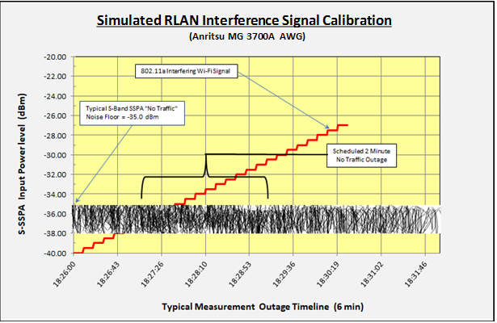

Figure 6

Satellite #1 Noise Floor Calibration Test Example (April 11, 2014)

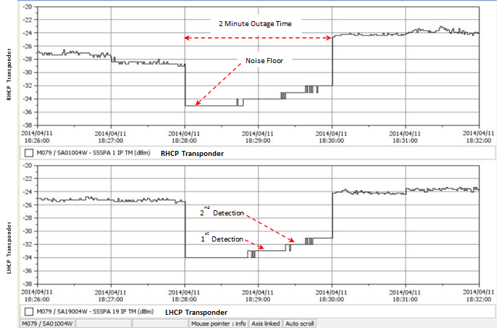

Figure 7

Master 5 GHz Noise Floor Database - RHCP/LHCP Transponders

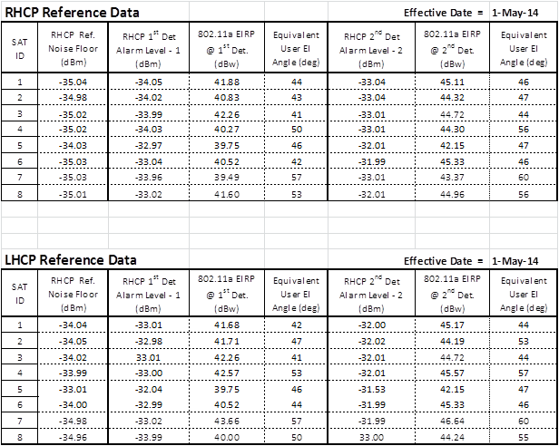

# 4 Noise Floor Measurement Scheduling

In support of both the 5 GHz Procedure Development and Long Term 5 GHz Constellation Survey, it was necessary to create a process to temporarily interrupt ground station commercial service operations in North America to prevent any transmit power from the ground stations in the 5 GHz Band in the satellite footprint.

## 4.1 Ground Station Commercial Service Operation Interruption Scheduling

On a monthly basis LEO-D temporarily interrupts its ground station operations in North America in order to suppress communications traffic and allow the LEO-D satellites to measure the 5GHz noise levels. In order to support this study, the following requirements have to be met:

1 Satellites must be one of the calibrated subset of operational LEO-D satellites.

2 Satellite field of view must completely covers the continental United States during the measurement period.

3 The measurement period must be two minutes in duration and fall on one minute boundaries.

4 The measurement must be between the hours of 9:00am ET and 8:00 pm ET so that normal daily noise floor in the U.S. is measured.

## 4.2 Ground Station Commercial Service Interruption Definition

Four satellites are selected for the monthly Noise Floor measurements. We also attempt to use a different set of satellites from the previous month so a valid statistical sample is retrieved from all satellites.

Commercial service interruption intervals are determined using AGI’s Satellite Toolkit (STK) software configured with all of the LEO-D satellite orbits. It was determined that a two-minute pass (with margin) over any hypothetical ground point can be achieved by inserting a “sensor” on the satellite with a 23-deg cone half-angle, and each LEO-D satellite is so configured in STK. Measurement intervals are then determined as a coverage report from the center of the continental United States, commonly known as Lincoln, KS, as shown in Figure 8: below. This coverage report is then fed into a script which imposes the above timing requirements, places the measurement on a one minute boundary, and filters the list to a small set of candidates.

Ground station commercial service operation interruption windows are then selected manually and, to the extent possible, different satellites are used from the previous month for the monthly noise floor measurement.

Figure 8

LEO-D Satellite #6, Located Over Lincoln, KS - June 6, 2017 @ 15:17:00 GMT

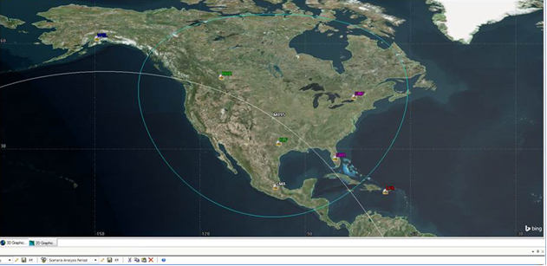

## 4.3 5 GHz Long Term Monitoring of the LEO-D Constellation Noise Floor

The long term monitoring of the 5 GHz forward link noise floor was initiated on May 1, 2014. Since that date, we have repeated the 5 GHz noise floor measurements on a monthly basis consisting of measurements at 4 satellites with 8 transponders each month. During the 34 month time period from May 2014 to February 2017, the LEO-D 5 GHz measured noise floor remained unchanged.

In February 2017, one LEO-D satellite’s Left Hand Circular Polarization (LHCP) transponder indicated that the noise floor on that satellite had increased by 1.07 dB which represented a “1st Detection” of a 1 dB rise in the 5 GHz noise floor over North America. During the next 6 months, from February through July, 6 additional LEO-D satellites also indicated “1st Detections” of a 1 dB rise in the 5 GHz noise floor.

In August 2017, a LEO-D satellite flagged a “2nd Detection” event indicating that the 5 GHz noise floor had experienced a 2 dB rise. As of October 24, 2017, measurements on four other LEO-D satellites have confirmed the “2nd Detection” of a 2 dB increase in the 5 GHz noise floor.

It took almost 3 years from May 2014 to February 2017 for the noise floor to rise by 1 dB. In comparison, it only took 6 months for the noise floor to rise another dB, for an overall 2 dB noise rise. It is apparent that the noise floor rise resulting from RLAN deployments is accelerating.

# 5 5 GHz Noise Floor Monitoring Over Europe

Starting in August 2017, LEO-D extended the Long Term 5 GHz Monitoring task to include Europe. The measurements over Europe currently take place when the satellites are located over Dresden, Germany, as this insures that the satellite footprint covers all of Europe, Western Russia, Turkey, and North Africa. The European measurements are being conducted using the same group of LEO-D satellites as those chosen for the North American testing. At the present time, same as the blue ocean, there is no indication that there is any increase in the 5 GHz noise floor over Europe.

_______________