|  |  |
| --- | --- |
| **Radiocommunication Study Groups** |  |
|  |  |
|  |  |
| Received: 14 May 2017  Subject: AI 1.16 (WRC-19) | **Document 5A/420-E** |
| **16 May 2017** |
| **English only** |
| France | |
| ELEMENTS of discussion on UK aggregate RLAN measurements from airborne platforms to support studies under WRC-19 agenda item 1.16 | |
|  | |

# 1 Introduction

During the work on agenda item (WRC-19), and facing the quite large range of different assumptions considered in the sharing analysis with FSS, UK OFCOM made a proposal to make use of measurements performed at 2.4 GHz for comparison with the model used at 5 GHz in order to provide a more limited range of assumptions.

This analysis has been presented in ITU-R WP 5A (see Document [5A/298](https://www.itu.int/md/R15-WP5A-C-0298/en) Annex 26) but a number of details are still to be finalised.

The present document provides further analysis on the measurement performed by UK OFCOM for 2.4 GHz WIFI. The following main elements are analysed:

– Indoor/outdoor attenuation

– 2.4 GHz mean EIRP

– Nb of RLAN over the measurement area

It provides additional calculations and proposes consequential conclusions for the assumptions used at 5 GHz.

# 2 General considerations on the model

The RLAN 5 GHz deployment/parameters model used in ECC report 244 takes into account a number of assumptions, which, for a majority, are given with a range of values. This model forms the basis for the analysis of the 2.4 GHz measurements and, for comparison purposes, UK OFCOM proposed to consider similar deployment/parameters model at 2.4 GHz.

The following table provides the list of elements related to this model and corresponding range of values. It also provides in its last column, for each of these elements, comments by France on the agreement or need for additional considerations.



It can be seen that such panel of assumptions is quite complicated and lead to a high number of different scenarios of 243 (5 elements presenting 3 different values) and a large difference in dB on the results. This gives additional support to the UK OFCOM initiative to find a relevant way to limit these assumptions in a view of shrinking the final range of results.

# 3 Indoor/outdoor attenuation

The current figures used in the analysis at 5 GHz are 12 dB, 14.5 and 17 dB, applied to all indoor RLAN, i.e. on an average basis.

The rationale for these figures are the following:

– the initial proposal made in JTG 4-5-6-7 (by US and RLAN industry) was to apply an indoor/outdoor attenuation following a Gaussian distribution with a mean of   
17 dB + 7 dB standard deviation. Such distribution, applied to a high number of RLAN corresponds to an average fixed value of 12 dB.

– alternatively, some administrations proposed in JTG to used the 17 dB figure as an average fixed value.

– Subsequently, for the measurement analysis purpose, UK OFCOM proposed to use a medium value of 14.5 dB.

At 2.4 GHz, the figures of 5.9, 8.4 and 10.9 dB were proposed by the UK OFCOM, based on the figure of 8.6 dB used in previous analysis at national level, together with a dispersion of ± 2.5 dB similar as the one at 5 GHz.

Since then, ITU-R Study Group 3 has very recently adopted Draft new Recommendation ITU-R P.[BEL] on “Prediction of Building Entry Loss” as given in Document [3/57rev1](https://www.itu.int/md/R15-SG03-C-0057/en)) providing a model valid in the 80 MHz to 100 GHz frequency range.

The following figures provides the corresponding Building Entry Loss (BEL) distributions at  
 2.4 GHz and 5.4 GHz at 0° elevation, with the corresponding median and average values.

Figure 1

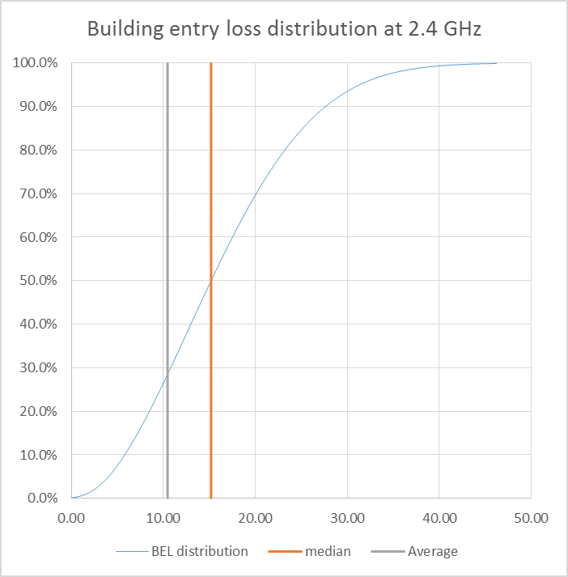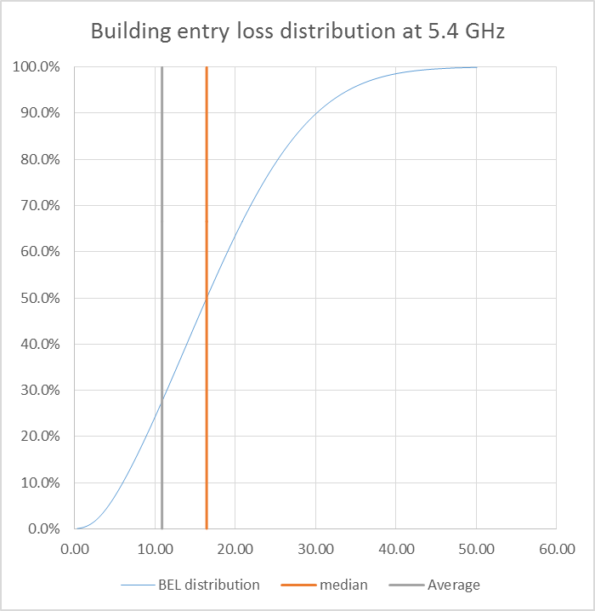

These figures depict a very small difference in BEL for the 2.4 GHz and the 5.4 GHz bands, with in particular average values of 10.47 dB and 10.89 dB, respectively.

In addition, the following figure provide a comparison of the BEL at 2.4 GHz and 5.4 GHz for all elevations.

Figure 2

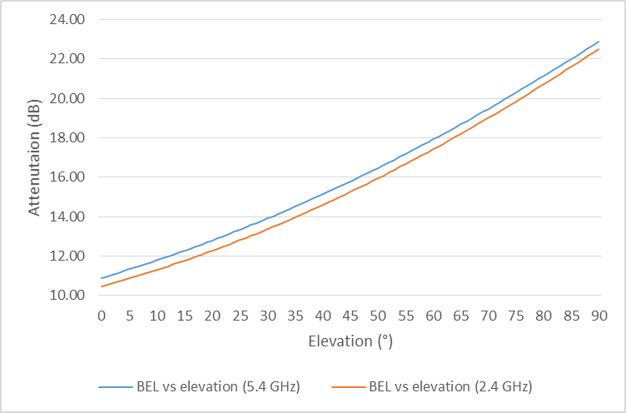

This figure confirms the small difference between the BEL for the 2 bands, actually ranging 0.37 to 0.54 dB. For the following considerations, it is proposed to use a fixed difference of 0.5 dB.

This shows that the values of indoor/outdoor attenuation used by UK OFCOM at 2.4 GHz (i.e. 8.6 dB medium) are too optimistic. The figures used at 2.4 GHz should hence be only shifted by 0.5 dB compared to those used at 5 GHz.

Further, since Draft new Recommendation ITU-R P.[BEL] provides the basis for a single value, it now becomes useless to maintain a range of values and it is therefore proposed for the analysis of the 2.4 GHz measurements, to only consider a single value for both bands.

To do so, it is proposed to consider the 2.4 GHz measurement footprint (see below) as given in the UK OFCOM study.

Figure 3



Considering this footprint and the 7 km altitude of the plane used for the measurements, it is possible to calculate the average elevation over the footprint at which the measurements have been performed and to deduce the corresponding average BEL at 2.4 GHz:

– Average elevation = 13.4 °

– Average BEL at 2.4 GHz (based on ITU-R P.[BEL] model) = 11.62 dB

– Average BEL at 5.4 GHz (based on ITU-R P.[BEL] model) = 12.12 dB

On this basis, it is proposed to undertake the 2.4 GHz measurements analysis with building entry losses of 11.6 dB at 2.4 GHz and 12.1 dB (i.e. 0.5 dB higher) at 5 GHz.

It is however to be noted that the use of these figures should limited to the comparison of the models at 2.4 GHz and 5 GHz.

For subsequent sharing analysis at 5 GHz, the average BEL will have to be based on the   
ITU-R P.[BEL] model using the elevation corresponding to the case under study (e.g. FSS, EESS, MSS).

# 4 2.4 GHz mean EIRP

The mean e.i.r.p. used at 5 GHz is 19 dBm, based on the following distribution.

|  |  |  |  |  |
| --- | --- | --- | --- | --- |
| RLAN e.i.r.p. Level | 200 mW  (Omni-Directional) | 80 mW  (Omni-Directional) | 50 mW  (Omni-Directional) | 25 mW  (Omni-Directional) |
| RLAN device percentage | 19% | 27% | 15% | 39% |

It can be noted that it represents a difference of 4 dB compared to the maximum e.i.r.p (23 dBm).

For the 2.4 GHz band, UK OFCOM initially performed its analysis using the maximum e.i.r.p   
(20 dBm) and is now proposing a mean e.i.r.p of 17.6 dBm (i.e. 2.4 dB below the max), considering a similar distribution as at 5 GHz, only replacing the value of 200 mW by 100 mW.

France expresses doubt about such value, taking into account the following main elements:

– 5 GHz RLAN are designed to provide very high data rates over very large bandwidth (in particular 80 and 160 MHz) whereas 2.4 GHz RLAN are limited to 20 and 40 MHz bandwidths

– Propagation conditions are obviously more favourable at 2.4 GHz compared to 5 GHz

– ECC Report 244 RLAN deployment model, based on JRC work, makes the assumption that no additional 5 GHz AP will be needed compared to 2.4 GHz, all AP being bi-band, hence considering that coverage of both bands will be the same.

– Current literature show that, at same data rate, S/N required at 5 GHz is higher than at 2.4 GHz (see CISCO CUWSS quick reference guide):

|  |  |  |  |  |
| --- | --- | --- | --- | --- |
| Data rate for 20\40 MHz | 2.4 GHz Min RSSI | 2.4 GHz Min SNR | 5 GHz Min RSSI | 5 GHz Min SNR |
| 14.4\30 | -82 | 11 | -79 | 14 |
| 28.9\60 | -79 | 14 | -76 | 17 |
| 43.3\90 | -77 | 16 | -74 | 19 |
| 57.8\120 | -74 | 19 | -71 | 22 |
| 86.7\180 | -70 | 23 | -67 | 26 |
| 115.6\240 | -66 | 27 | -63 | 30 |
| 130\270 | -65 | 28 | -62 | 31 |
| 144.4\300 | -64 | 29 | -61 | 32 |

On this principle, it is proposed below to make compared simulations of mean e.i.r.p. in both bands considering similar coverage under different configurations.

The following assumptions are taken into account:



The principles of the simulations are:

– To set-up simulation layout with a central AP and UE distributed within a certain radius,

Figure 4

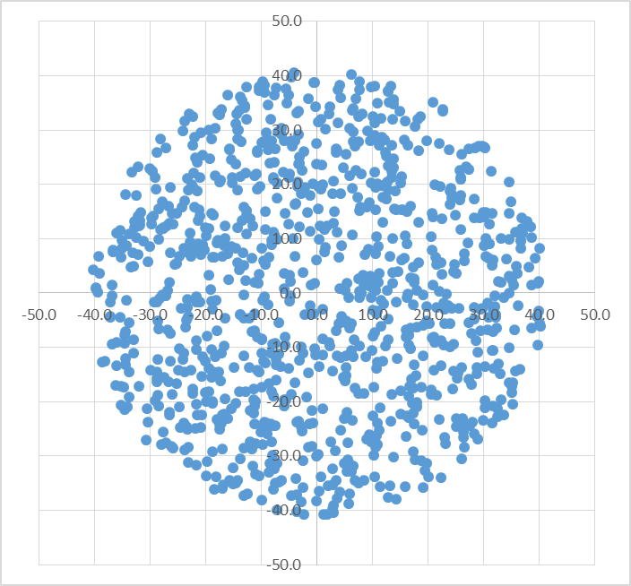

– For each UE case, determine the bandwidth based on the distribution above and calculate the required e.i.r.p. for both AP and UE to reach the required S/N taking into the different AP, UE (gain, NF, interference noise) and simulations parameters (radius, possible additional losses or building attenuation)

– Propagation model used is the ITU model for indoor attenuation, i.e.:

º L = 20log(f) + N log(d) + Pf(n) – 28

º N = 30 for both bands (although it can vary from 28 at around 2 GHz to 31   
at 5 GHz)

º Pf(n), representing the additional loss due to floor penetration is not used, replaced by a fixed 6 dB figure in some simulations

– Run sufficient calculations to obtain a stable value for the mean e.i.r.p. (1 000 run has been considered)

– Determine the simulation layout to obtain a mean e.i.r.p. of 19 dBm at 5 GHz over AP and UE

– Calculate the mean e.i.r.p. at 2.4 GHz based on similar layout.

First layout conditions:

– Open space without any additional losses

– Layout radius of 33 m to obtain 19 dBm mean e.i.r.p at 5 GHz

– Mean e.i.r.p at 2.4 GHz calculated at 8.5 dBm, i.e. a mean/max ratio of 11.5 dB

Second layout conditions:

– Space with 6 dB floor/wall losses after 5 m

– Layout radius of 21 m to obtain 19 dBm mean e.i.r.p at 5 GHz

– Mean e.i.r.p at 2.4 GHz calculated at 8.7 dBm, i.e. a mean/max ratio of 11.3 dB

Third layout conditions:

– Space with indoor/outdoor attenuation losses after 12 m

– Layout radius of 17 m to obtain 19 dBm mean e.i.r.p at 5 GHz

– Mean e.i.r.p at 2.4 GHz calculated at 9.5 dBm, i.e. a mean/max ratio of 10.5 dB

Fourth layout conditions:

– Space with indoor/outdoor attenuation losses after 12 m and floor/wall losses after 5 m

– Layout radius of 15 m to obtain 19 dBm mean e.i.r.p at 5 GHz

– Mean e.i.r.p at 2.4 GHz calculated at 13 dBm, i.e. a mean/max ratio of 7 dB

Fifth layout conditions:

– Space with indoor/outdoor attenuation losses and floor/wall losses after 5 m

– Layout radius of 9.5 m to obtain 19dBm mean e.i.r.p at 5 GHz

– Mean e.i.r.p at 2.4 GHz calculated at 8.5 dBm, i.e. a mean/max ratio of 11.5 dB

Although these 5 simulations may not represent a full set of possibilities, it can already be shown that a mean e.i.r.p of 17.6 dB at 2.4 GHz (i.e. 2.4 dB mean/max ratio) is not representative to similar condition leading to a 19 dBm mean e.i.r.p at 5 GHz. On the contrary, these simulations, considering various cases, lead to a mean/max ratio at 2.4 GHz of 7 to 11.5 dB.

One could argue that similar simulations could be made considering a mean e.i.r.p of 17.6 dB at   
2.4 GHz to assess the maximum coverage at this frequency. This indeed show a much higher coverage radius, but means that to ensure similar coverage at 5 GHz, additional AP would be required. Corresponding calculations are provided below.

First layout conditions:

– Open space without any additional losses

– Layout radius of 33 m to obtain 19 dBm mean e.i.r.p at 5 GHz

– Layout radius to obtain 17.6 dBm mean e.i.r.p at 2.4 GHz = 74 m

– Ratio of area = 5 i.e. 7 dB increase in number of 5 GHz AP

Second layout conditions:

– Space with 6 dB floor/wall losses after 5 m

– Layout radius of 21 m to obtain 19 dBm mean e.i.r.p at 5 GHz

– Layout radius to obtain 17.6 dBm mean e.i.r.p at 2.4 GHz = 46 m

– Ratio of area = 4.8 i.e. 6.8 dB increase in number of 5 GHz AP

Third layout conditions:

– Space with indoor/outdoor attenuation losses after 12 m

– Layout radius of 17 m to obtain 19 dBm mean e.i.r.p at 5 GHz

– Layout radius to obtain 17.6 dBm mean e.i.r.p at 2.4 GHz = 33 m

– Ratio of area = 3.77 i.e. 5.8 dB increase in number of 5 GHz AP

Fourth layout conditions:

– Space with indoor/outdoor attenuation losses after 12 m and floor/wall losses after 5 m

– Layout radius of 15 m to obtain 19 dBm mean e.i.r.p at 5 GHz

– Layout radius to obtain 17.6 dBm mean e.i.r.p at 2.4 GHz = 21.5 m

– Ratio of area = 2 i.e. 3 dB increase in number of 5 GHz AP

Fifth layout conditions:

– Space with indoor/outdoor attenuation losses and floor/wall losses after 5 m

– Layout radius of 9.5 m to obtain 19 dBm mean e.i.r.p at 5 GHz

– Layout radius to obtain 17.6 dBm mean e.i.r.p at 2.4 GHz = 20.5 m

– Ratio of area = 4.65 i.e. 6.7 dB increase in number of 5 GHz AP

These calculations show that, if a 17.6 dBm mean e.i.r.p at 2.4 GHz is considered in the measurement analysis, between 2 and 5 times more AP would be required to ensure similar coverage at 5 GHz. These factor (between 3 and 7 dB) would bave to be considered when translating the results of the 2.4 GHz measurement analysis into assumptions at 5 GHz.

As a conclusion, it is therefore necessary to set-up the mean e.i.r.p at 2.4 GHz at a level allowing comparison with assumptions used at 5 GHz. Although the above calculations depicts a mean/max ratio in the range 7 to 11.5 dB, it is proposed to take into account the more conservative assumption with a mean/max ratio of 7 dB, i.e. a 13 dBm mean e.i.r.p at 2.4 GHz.

# 5 Victim bandwidth overlap (or channelization factor)

The method to calculate the number of overlapping RLAN in the victim bandwidth and the corresponding average bandwidth factor was derived and agreed during the work of JTG.

Similar calculations have been made at 2.4 GHz, under 2 baseline assumptions, differing on the number of possible non-overlapping 20 MHz channels usable in this band (either 3 or 4). These calculations are given in the following excel file.



The results are the following:

– Baseline 1 (4 times 20 MHz channels)

* + % of Overlapping RLAN = 87.5%
  + Average bandwidth factor = 2.43 dB

– Baseline 2 (3 times 20 MHz channels)

* + % of Overlapping RLAN = 100%
  + Average bandwidth factor = 2.34 dB

The most conservative case is the Baseline 2 and it is hence proposed to retain a 100% of Overlapping RLAN and an average bandwidth factor of 2.34 dB in the analysis of the 2.4 GHz measurements.

# 6 Other parameters

## 6.1 Translating the “5 GHz factor” into “2.4 GHz factor”

In ECC report 244, the “5 GHz factor” represents the ratio of RLAN operating in the 5 GHz range over the total number of RLAN.

The UK OFCOM proposed to use a similar factor for the 2.4 GHz band, assuming that in this band, it is the complement to 1 of the “5 GHz factor”.

This is fully correct in principle and in particular for the case of the maximum and medium “5 GHz factor” of 97% and 74 %, respectively, leading to minimum and medium factors of 3% and 26% at 2.4 GHz.

However, when considering the minimum “5 GHz factor” of 50%, this is not correct anymore, since the argument for this 50% figure is that part of the total RLAN number will use the 2.4 GHz as well as the 60 GHz bands. It is therefore not correct to translate the “5 GHz factor” of 50% into a “2.4 GHz factor” of 50%.

For this case, it is proposed to set the maximum “2.4 GHz factor” at the same level as the medium value, i.e. 26%.

## 6.2 Buzy hour measurement factor

The measurements performed by the UK OFCOM were made in the middle afternoon, hence not representing a busy hour.

UK OFCOM has been proposing to use an additional factor of 90% to be applied to the “busy hour population factor”, hence representing a factor of 0.45 dB on the measurements.

In the absence of any other evidence, France agrees with this approach and value. It is however proposed to maintain the “busy hour population factor” as they are for the 5 GHz band and then to apply the busy hour measurement factor after all calculation by shifting the measurement   
by + 0.45 dB.

## 6.3 Population deployment over measurement area

The UK OFCOM analysis of the 2.4 GHz measurements are considering 5 different areas, based on the 2.4 GHz measurement footprint (see below).

Figure 5



For the “Central London” scenario, the UK OFCOM has considered the following number of 2.4 GHz RLAN AP.

|  |  |  |  |  |  |  |
| --- | --- | --- | --- | --- | --- | --- |
| Contour | 1 | 2 | 3 | 4 | 5 | TOTAL |
| Composite antenna levels | -121 to -118 | -124 to -121 | -127 to -124 | -130 to -127 | -133 to -130 |  |
| NB of RLAN (millions) | 1.03 | 0.79 | 1.13 | 1.66 | 1.28 | 5.89 |

These figures were based on an estimated RLAN AP density of 4.3 thousands RLAN per km² for area 1 and 2.7 thousands RLAN per km² for area 2 to 5.

In the UK OFCOM analysis, these ratio were derived from specific zones as follows:

|  |  |  |
| --- | --- | --- |
| Zone | Inner London | Lewisham |
| Population (inh.) | 3 241 000 | 276 900 |
| Area (km²) | 327.9 | 35.1 |
| Density of RLAN / km² | 4.3 | 2.7 |
| Total NB of RLAN AP | 1 396 900 | 95 900 |

This hence further allows to determine a density of RLAN AP per inhabitant.

|  |  |  |
| --- | --- | --- |
| Zone | Inner London | Lewisham |
| RLAN AP density / inh. | 0.431 | 0.346 |

As a comparison, the following table provides the number of inhabitants (source : European Commission GEOSTAT grid) for each of the contour zone considered by UK OFCOM for the “central London” scenario (centered on Soho) in order to determine the corresponding density of RLAN AP per inhabitant.

|  |  |  |  |  |  |  |
| --- | --- | --- | --- | --- | --- | --- |
| Contour | 1 | 2 | 3 | 4 | 5 | TOTAL |
| Inhabitants (thousands) | 1871 | 1815 | 2365 | 2968 | 1775 | 10794 |
| Area (km²) | 270 | 464 | 915 | 1793 | 3163 | 6605 |
| NB of RLAN (millions) | 1.03 | 0.79 | 1.13 | 1.66 | 1.28 | 5.89 |
| RLAN AP density / inh. | 0.551 | 0.435 | 0.478 | 0.559 | 0.721 | 0.546 |

It can be seen that the density of RLAN AP per inhabitant, either globally or on a contour zone basis, is much higher compared to the one determined by UK OFCOM and has an impact on the measurement analysis.

As an example, when using the maximum density of RLAN AP determined by UK OFCOM (i.e. 0.431 for urban area), the following table provides the number of RLAN that should be used in the analysis and the corresponding difference in dB.

|  |  |  |  |  |  |  |
| --- | --- | --- | --- | --- | --- | --- |
| Contour | 1 | 2 | 3 | 4 | 5 | TOTAL |
| Inhabitants (thousands) | 1871 | 1815 | 2365 | 2968 | 1775 | 10794 |
| RLAN AP density / inh. | 0.431 | 0.431 | 0.431 | 0.431 | 0.431 |  |
| NB of RLAN (millions) | 0.81 | 0.78 | 1.02 | 1.28 | 0.77 | 4.66 |
| NB of RLAN (millions) from UK OFCOM | 1.03 | 0.79 | 1.13 | 1.66 | 1.28 | 5.89 |
| Difference (dB) | -1.04 | -0.06 | -0.44 | -1.13 | -2.21 | -1.02 |

These calculations show that the number of RLAN used in the 2.4 GHz measurement analysis is probably too optimistic, leading to an underestimation of the corresponding modelled power by at least 1 dB.

It is however not proposed to include this difference in the following summary but to keep this difference in mind when discussing all other parameters.

# 7 Summary and comparative analysis

The following table provides a summary of assumptions to be considered for the analysis of the   
2.4 GHz UK measurements.



On this basis and taking into account the methodology developed by UK OFCOM in their last analysis, the following figure provides the summary of results, for both the “Central London” and “West of London” scenario.

This figures compares the range of values (min, medium and max) obtained with the model using the figures in the table above for the 2.4 GHz band with the values measured by UK OFCOM in both scenarios, i.e. -76 dBm/40 MHz (central London) and -81 dBm/40 MHz (West London).

figure 6

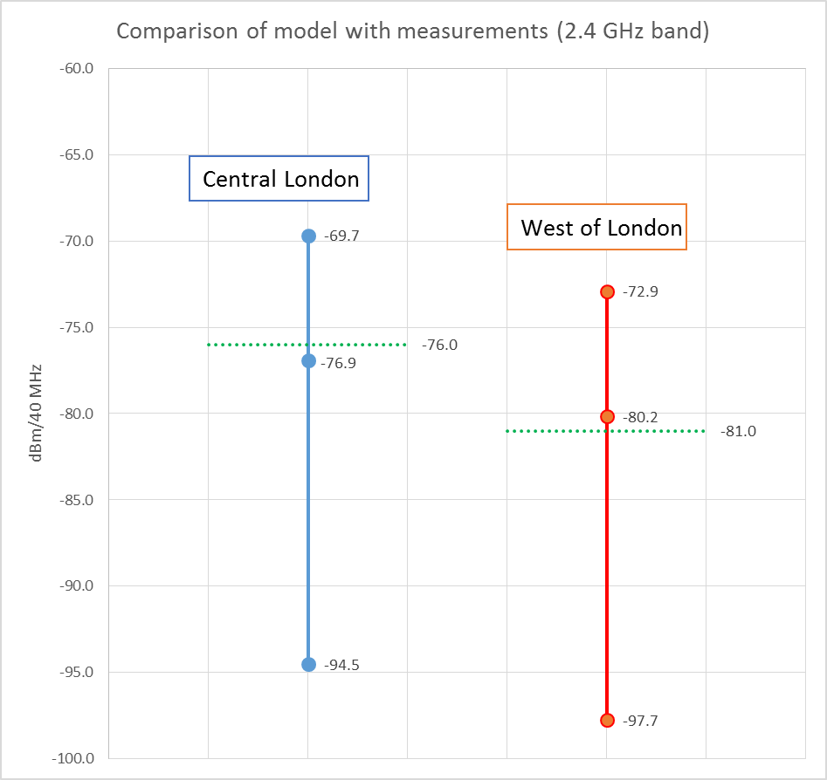

It clearly shows that the measurements are representative of scenarios close to the model with medium parameters at 2.4 GHz and hence provides justification for using similar set of medium parameters for the 5 GHz band. The following considerations are also to be taken into account:

– to allow for a certain level of discussion on the final results, it is proposed for the antenna discrimination to also consider, in addition to the medium 2 dB value, the initial figures of 0 and 4 dB.

– The building losses will depend on the elevation(s) for each scenarios (FSS, EESS, …) but will have to be calculated based on Recommendation ITU-R P.[BEL]

– The channelization and bandwidth factors will also depends on the victim service case (e.g. 12.9% and 3.55 dB for FSS)

Accordingly, the following table provides the list of parameters to be used for the RLAN 5 GHz sharing studies to determine the number of active RLAN.



On this basis, it is then possible to calculate the number of active RLAN overlapping a victim bandwidth (for the FSS case) and provides figures consistent with those given in section 3.1.6 of WORKING DOCUMENT TOWARDS A PRELIMINARYDRAFT NEW REPORT ITU-R M.[RLAN REQ-PAR].

Density (FSS) = 400000000 x 62.7% x 74% x 10% x 12.9% /701083818 = 0.0034 RLAN / inh.

Similar calculations will have to be considered for other scenarios (EESS, MSS, ..)

# 8 Conclusions

The present document provides further analysis on the measurement performed by UK OFCOM for 2.4 GHz WIFI and provides additional calculations and proposes consequential conclusions for the assumptions used at 5 GHz.

Consequential changes are proposed in the attachment to the Preliminary Draft New Report ITU-R M.[RLAN REQ-PAR] (5A/298 annex 25).



It is also proposed to include the findings of the present document in Preliminary Draft New Report ITU-R M.[AGGREGATE RLAN MEASUREMENTS] (5A/298 annex 26)

______________