|  |  |
| --- | --- |
| **Radiocommunication Study Groups** |  |
|  |  |
|  |  |
| Source: Document 5A/TEMP/408  Subject: Question [ITU-R 37-6/5](https://www.itu.int/pub/R-QUE-SG05.37) | **Annex 5 to**  **Document 5A/1065-E** |
| **10 May 2019** |
| **English only** |
| Annex 5 to Working Party 5A Chairman’s Report | |
| Working document towards a preliminary draft new Report on utility communication systems | |
|  | |

Table of contents *(to be updated)*

1 Scope 3

2 Related documents 3

3 List of definitions, acronyms and abbreviations 3

3.1 Definitions 3

3.2 Acronyms 5

4 Overview of smarter electricity networks 6

4.1 Distribution network assets [1] 8

5 Smart Network Applications & Services 9

5.1 Supervisory Control and Data Acquisition (SCADA) 9

5.2 Advanced Metering Infrastructure (AMI) 10

5.3 Demand Response (DR) 11

5.4 Distribution Automation (DA) 12

5.5 Distributed Generation (DG) 12

5.6 Distributed Storage (DS) 13

5.7 Electric Vehicle Charging Stations (EVCS) 13

5.8 Synchrophasors 14

5.9 Dynamic Line Rating (DLR) 14

5.10 Utility Engineering and Operations 14

5.11 Closed Circuit Television (CCTV) 14

5.12 Mobile Workforce (MWF) 14

5.13 Protection 15

5.14 Utility Business Voice 15

5.15 Utility Business Data 15

6 Utilities Integrated Communications Network Architecture [6] 15

[6.1 General technical and operational considerations of mission critical utility applications from survey of utilities 20

7 Utility Communications Requirements 25

[8 Spectrum Related Aspects [6] 33

8.1 Utility spectrum bands and applications 35

8.2 Shared use of existing bands 35

9 Conclusions 38

10 References 39

# 1 Scope

This Report describes radiocommunication systems that can be used by utilities and highlights how utilities can utilize these systems to support their need for mobile voice and data communications as well as fixed wireless access.

# 2 Related documents

ITU-R Recommendations:

ITU-R [F.755](https://www.itu.int/rec/R-REC-F.755/en) – *Point-to-Multipoint Systems in the Fixed Service*

ITU-R [F.701](https://www.itu.int/rec/R-REC-F.701/en) – *Radio-frequency channel arrangements for digital point-to-multipoint radio systems operating in the frequency range 1 350 to 2 690 MHz*

ITU-R Reports:

ITU-R [M.2014](https://www.itu.int/pub/R-REP-M.2014) – *Digital Land Mobile Systems for dispatch traffic*

ITU-R [SM.2351](https://www.itu.int/pub/R-REP-SM.2351) – *Smart grid utility management systems*

Draft new Report ITU-R M.[IMT.BY.INDUSTRIES] – *The use of terrestrial component of International Mobile Telecommunication (IMT) by industry sectors* (cf. Section 4.4 in [Attachment 3.13](https://www.itu.int/dms_ties/itu-r/md/15/wp5d/c/R15-WP5D-C-0875!H03!MSW-E.docx) to Doc. [5D/875](https://www.itu.int/md/R15-WP5D-C-0875/en)).

[Working document towards a] preliminary draft new Report ITU-R M.[CDLMR] – Conventional digital land mobile radio systems” (Annex 16 to Doc. [5A/844](https://www.itu.int/md/R15-WP5A-C-0844/en))

ITU-R Handbooks:

Land Mobile (including Wireless Access) - Volume 3: Dispatch and Advanced Messaging Systems

ITU-T Reports and Recommendations:

ITU-T Technical Paper: Applications of ITU-T G.9960, ITU-T G.9961 transceivers for Smart Grid applications: Advanced metering infrastructure, energy management in the home and electric vehicles.

# 3 List of definitions, acronyms and abbreviations

## 3.1 Definitions

Table 1

Definitions

|  |  |
| --- | --- |
| [**Smart Grid**](https://www.cpqd.com.br/en/innovation/smart-grid/) | This platform comprises the technologies applied to electrical grids (generation, transmission and distribution) with the purpose of improving decision making, data generation and managing information based on the increased level of automation and communication |
| **Demand response** | Consists of methods and algorithms to minimize the energy load by reducing consumption during high demand peaks. |
| **Advanced energy measurement** | Technology to electronically measure energy consumption, allowing consumers to interact with the supply system (active participation in managing electricity). |
| **Power Line Communication – PLC** | Technology for communication over the electrical grid’s transmission and distribution lines. |
| **Electrical grid automation** | Algorithms and methods that allow the optimization and automatic restoration of power after power outages or load redistributions |
| **Alternative renewable energy sources** | Technology to generate electric energy using natural sources such as the sun, the wind and geothermal energy, which are alternative renewable (naturally replenished) resources. |
| **Energy efficiency** | Methods, equipment, and algorithms for improving the efficiency of electrical equipment and networks, minimizing technical losses (electrical) and increasing efficiency |
| **Power quality** | Monitoring and evaluating electrical parameters of energy networks to characterize the quality of the service and of the distributed energy |
| **IEC 61850** | International standard for power systems substations automation based on Ethernet LANs |
| **Monitoring of the electrical infrastructure and equipment** | Methods, sensors and algorithms used to monitor electrical equipment parameters to evaluate the operating conditions and useful life of assets |
| **Distributed Generation** | Generation of electricity located close to the load (or consumers) they serve, typically using renewable energy sources. |
| **Information and Communications Technology (ICT) Networks** | Telecommunications networks that carry data, video, and other services. Utilities provision these networks to underpin their transmission and distribution infrastructure for daily reliability needs, situational awareness, grid modernization, cyber and physical protection, Supervisory Control and Data Acquisition (SCADA) communications, storm response and recovery, and much more. |
| **Mission Critical Applications** | An application is mission-critical when it is essential to operation. Mission-critical applications should not experience any downtime when end users are likely to utilize them. |
| **Supervisory Control and Data Acquisition (SCADA) System** | Often referred to only as its acronym, Supervisory Control and Data Acquisition (SCADA) Systems are computerized industrial control systems that connect large industrial pieces of equipment with centralized facilities to transmit data. For utilities, SCADA systems refer to the data networks that connect remote pieces of infrastructure to control centers, providing utilities with real-time situational awareness on the status of their systems. Utilities deploy ICT networks to run these SCADA systems. SCADA systems can include Energy Management Systems which optimize generation and high-voltage transmission of energy, for example. |
| **Resilient Communications** | The ability of a utility’s ICT network to prepare for, withstand, and recover from natural or manmade disasters. Utility ICT networks are essential for daily reliability along with the ability to safely restore service after an event. These networks are intended to be, and are, more reliable than those operated by traditional telecommunications providers. |
| **Synchrophasors** | Sensors and algorithms to provide additional information currently not available via standard SCADA installation allowing to operate the bulk electric system more efficiently |
| **[Utilities]** | [Entities that provide electricity, gas and water services as public services. These entities include public energy services that are owned or controlled by the government, cooperative public services that are owned by members (for example, customers) in a certain area, and public services owned by investors that are owned and operated by them.] |

## 3.2 Acronyms

Table 2

Acronyms

|  |  |
| --- | --- |
| Abbreviation | Definition |
| 3GPP | The 3rd Generation Partnership Project |
| ADR | Automated Demand Response |
| AMI | Advanced Metering Infrastructure |
| AR | Access Router |
| BPS | Bits Per Second |
| BAN | Building Area Network |
| BR | Backbone Router |
| CCTV | Closed Circuit TV |
| C&I | Commercial & Industrial |
| CDMA | Code Division Multiple Access |
| CIP | Critical Infrastructure Protection |
| CEPT | European Conference of Postal and Telecommunications Administrations |
| DA | Distribution Automation |
| DMS | Distribution Management System |
| DCC | Distribution Control Center |
| DLR | Dynamic Line Rating |
| DNP | Data Network Protocol |
| DG | Distributed Generation |
| DR | Demand Response |
| DS | Distributed Storage |
| DSO | Distribution System Operator |
| ECC | Electronic Communications Committee |
| EEI | Edison Electric Institute |
| ER | Edge Router |
| ETSI | European Telecommunications Standards Institute |
| EVCS | Electric Vehicle Charging Station |
| FAN | Field Area Network |
| FCC | Federal Communications Commission |
| GPON | Gigabit Passive Optical Network |
| GPS | Global Positioning System |
| HAN | Home Area Network |
| IAN | Industrial Area Network |
| IEEE | Institute of Electrical and Electronics Engineers |
| IED | Intelligent Electronic Device |
| ISM | Industrial, Scientific and Medicine |
| ISO | International Organization for Standardization |
| LAN | Local Area Network |
| LTE | Long Term Evolution |
| MDMS | Meter Data Management System |
| MWF | Mobile Work Force |
| NAN | Neighborhood Area Network |
| NASPINet | North American Synchrophasor Initiative Network |
| NERC | North American Electric Reliability Corporation |
| PMU | Phasor Measurement Unit |
| PLC | Power Line Carrier |
| PTT | Push-to-Talk |
| RF | Radio Frequency |
| RLAN | Radio Local Area Network |
| RTU | Remote Terminal Unit |
| SCADA | Supervisory Control and Data Acquisition |
| TDM | Time Division Multiplex |
| TSO | Transmission System Operator |
| TSS | Transmission Substations |
| UHF | Ultra High Frequency |
| VHF | Very High Frequency |
| VoIP | Voice over Internet Protocol |
| WAMPC | Wide Area Measurement Protection and Control |

# 4 Overview of smarter electricity networks

In general terms, the electric network is divided into several parts. Power plants and the high voltage transmission lines that send the power into the grid comprise the generation and transmission systems. The distribution network delivers power to homes and businesses. Home area networks allow customers to control their energy usage and communicate with the utility.

The distribution system is characterized mainly by a radial configuration where there is an identifiable single path to a source of power for every load, though new grid configurations are beginning to change this model. This radial configuration simplified the engineering to account for one-way power flow in the monitoring, protection and control of the power grid.

Figure 1 below schematically illustrates the legacy electricity network configuration.

Figure 1

Electricity network infrastructure

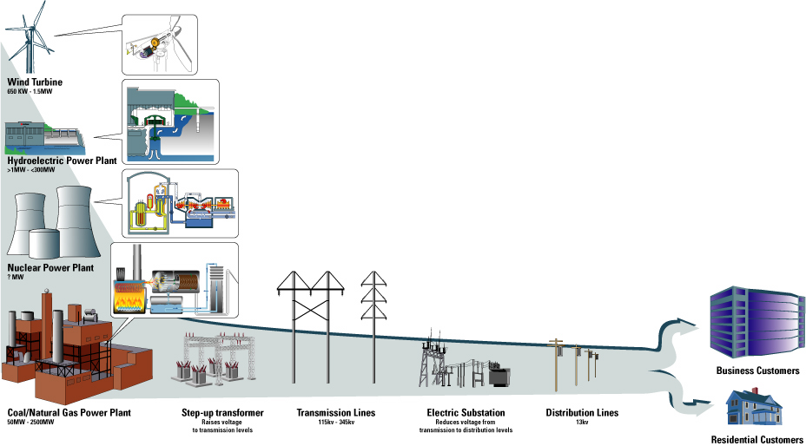

Today’s paradigm is vastly different, with the expectation that generation, storage, and mobile vehicle load, among other newer applications, create two-way power flows on those same lines, and that the end customer is extremely participative in the overall stability and functioning of that network.

Figure 2 below illustrates the major changes taking place in the energy sector as companies are required to develop smarter networks in order to accommodate very large numbers of renewable and low carbon energy sources. The traditional generation plants, very large power stations using fossil fuels are being replaced with much higher number of smaller units using wind, solar and natural gas. These smaller power stations are distributed over a large geographical area.

In addition, individual companies and individual homes can also generate power from wind and solar and this energy is fed into the energy grid.  This has the effect of creating millions of small energy sources which utilities need to manage and control.

Figure 2

Smarter electricity network

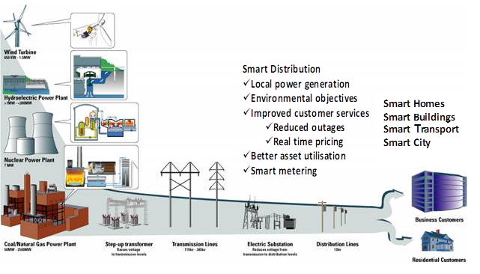

The need to create smart distribution grids is universal across the world. Smart distribution energy networks will be integrated with smart homes, buildings, transport and cities. The key issue for the energy sector is connectivity to the many thousands of assets and energy sources in distribution networks. The information and communications technologies (ICT) needed to manage and control complex smart energy networks demands very high availability and reliability and needs to provide communications connectivity when the energy supply fails. The communications capacity and coverage required in the distribution network is not in place today and energy companies are planning new communications networks and services to meet the needs of smart grids. Many technologies will be used but the grid assets are spread over a large geographical area and in remote locations and therefore wireless communications will play a key role.

Specifically, utilities are deploying real-time, two-way communications networks that extend beyond the distribution substations all the way to the customer premises. These networks must be highly reliable and provide low latency communications. Moreover, the networks must support higher capacity to enable smart grid data traffic from a proliferation of devices that reside on the grid and in the home. Finally, the networks must provide high security to protect against cyber security and other external vulnerabilities.

## 4.1 Distribution network assets [1]

A study by consultants in the UK devised the following representation of utility asset management for a typical distribution company with 4 million customers serving an area of 29 000 km2 through a network of 80 000 km of underground cables and 48 000 km of overhead lines; see figure 3 below. Compared to 2011, the increase in connected end points was forecast to grow by 775% by 2021 and 1199% by 2031.

Although the degree of communications connectivity required at the 11 kilovolt (kV) level (or alternative equivalent Medium Voltage (MV) level) is still uncertain, most utility commentators consider it will have to be between 50% and 100% of all end points, plus monitoring in real-time of many distributed assets to deliver the capacity increases required by low-carbon energy solutions.

Since this model is typical of most electricity distribution networks across Europe, it can provide a first level approximation of the increase in connections that will be required. European data indicates approximately 200 million households across Europe, and although this does not precisely mirror the data above, it can be scaled to suggest 4.5 million assets at Medium Voltage level across the EU, indicating:

– 2011: connectivity of 315 000 units

– 2021: connectivity of 2.4 million devices

– 2031: connectivity of 4 million devices

Figure 3

Distribution network assets

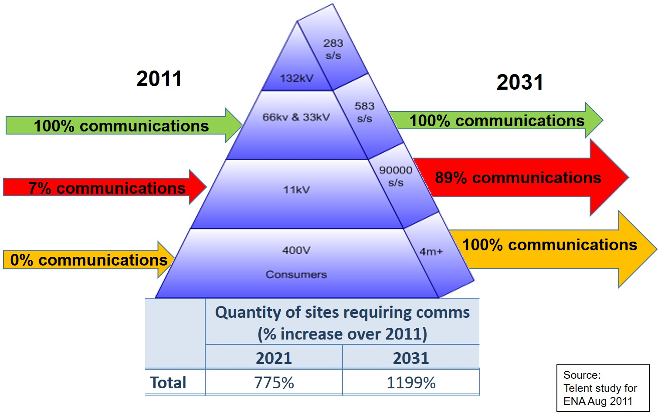

# 5 Smart Network Applications & Services

Smart Electric Network applications are briefly described below. We have included traditional power grid applications such as SCADA because the traffic for these traditional applications also has to be carried over the communications networks [4].

## 5.1 Supervisory Control and Data Acquisition (SCADA)

In this report, SCADA refers to communication between Remote Terminal Units (RTU) or Intelligent Electronic Devices (IED) deployed in a substation (or a generation plant) with the SCADA Master (Control) in the utility DCC. An RTU in the substation collects measurement and status information from some or all measurement devices, relays, and other elements in the substation. In response to periodic polls received from the Master, the RTU sends measurement + status messages to the SCADA Master. In addition, events generated at the relays and other instrumentation are transmitted to the SCADA Master as they occur (asynchronously). The RTU also receives controls from the SCADA Master that are delivered to the relays, bay controller, or other devices for necessary action.

For substation automation based on IEC 61850 standards, IEDs deployed at the substation replace traditional relays, bay controllers, other measurement devices, and switchgear. In this case, each IED is capable of direct communication with the SCADA Master Control: direct communication is used for periodic polls from the SCADA Master, measurement + status responses, event reports, and control signals.

## 5.2 Advanced Metering Infrastructure (AMI)

Utilities are deploying smart meters at consumer locations. Smart meters report electrical measurements (energy, voltage, power, etc.) at frequent intervals (e.g., once every 15 minutes). In addition to billing, these frequent meter measurements are used by many new and emerging applications including Automated Demand Response (ADR), energy management, rate management, power quality, and asset management systems.

Figure 4

Smart meter network configuration

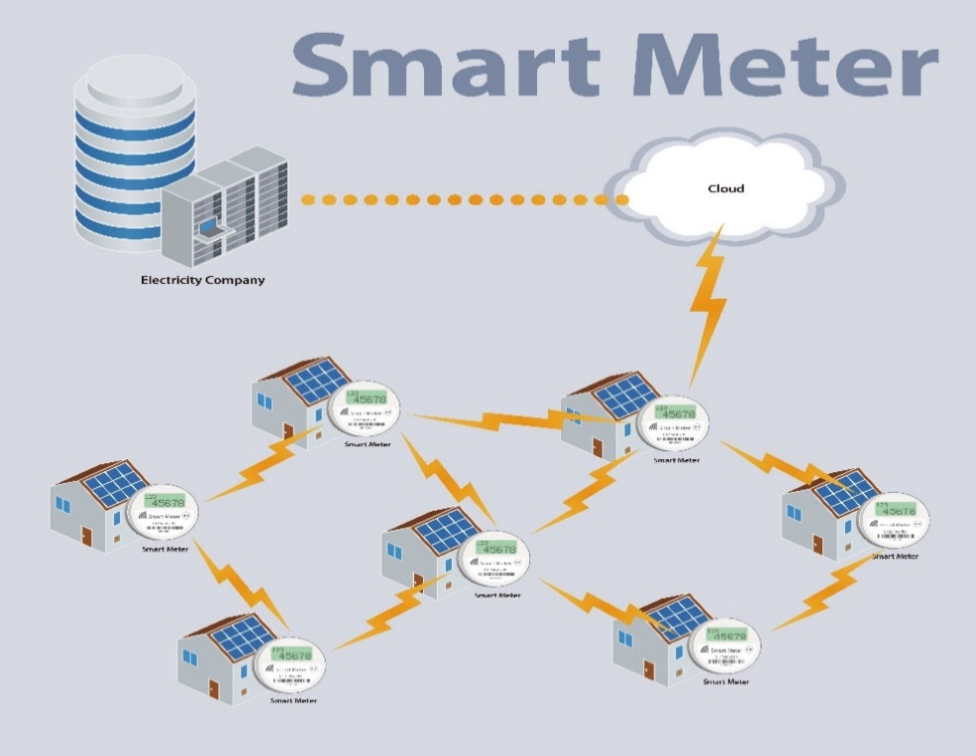

In an AMI solution, meters communicate with the utility Meter Data Management System (MDMS) located at the utility DCC. Meters send periodic measurement + status information to the MDMS, often in response to periodic polling from the MDMS. Asynchronous events such as voltage alarms are also sent to the MDMS. The MDMS may also send control signals to the meters (e.g., disconnecting the meter). Currently, there are three different prevalent AMI solution architectures. A utility may deploy one or more AMI solutions in its service area (illustrated in Figure 5).

Direct Meter Connection (Figure 5A):

In this approach, communication between each individual meter and the MDMS is carried directly over a communications network to the FAN (such as a 3G/4G wireless broadband connection, utility-owned wireless connections over licensed or license-exempt spectrum, and/or Gigabit Passive Optical Network —GPON— connection).

Power Line Communication (PLC) Neighborhood Area Network (NAN) (Figure 5B): In this AMI architecture, meters at consumer locations connected to a distribution transformer communicate with a meter data concentrator located near the distribution transformer. The data concentrator aggregates traffic from the individual meters connected to it and connects to the AMI solution´s head end over a FAN connection. On the other hand, the MDMS sends control signals to the head end to be forwarded to the meters.

Radio Frequency (RF) Mesh NAN (Figure 5C): An AMI solution over RF mesh uses wireless communication between the meters and a meter data concentrator over licensed or license-exempt spectrum. The meter concentrator is usually deployed at a substation. However, it is not necessary that the data concentrator support only the meters at the customer locations connected to that substation. Communication between a meter and the data concentrator goes over zero or more intermediate meters with each intermediate meter forwarding data received from its neighboring meter(s) to another meter or to the data concentrator.

To extend the range of an AMI solution (and thus increasing the number of meters in the RF mesh), data forwarder elements may also be deployed on rooftops or poles, for example, as intermediate mesh nodes. Like the PLC AMI solution, the meter concentrator connects to the head end through the substation router or over its own FAN connection. A data concentrator in these solutions can support a large number of meters (up to 10 000 or more).

Figure 5

AMI solution architecture

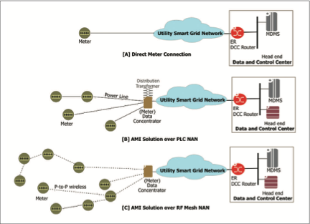

## 5.3 Demand Response (DR)

Demand Response refers to actions taken by a utility to adapt to changes in demand. Some DR methods, such as ADR, occur over the timescale of seconds. New Demand Response solutions require the deployment of new wireless infrastructure to facilitate the increase in generation, transmission, and/or distribution capacity.

Currently, ADR is most prevalently used for commercial and industrial (C&I) consumers. It is expected that use of ADR will be extended more prevalently to residential and small business consumers in the near future. In general, third-party data communication services or the Internet is used for ADR communication today. In the future, DR traffic will likely be carried over the Smart Grid communications network, possibly using the same links supporting communication between the utility’s AMI solution the meter.

## 5.4 Distribution Automation (DA)

DA refers to monitoring and control of IEDs deployed in the utility distribution system outside of the distribution substation. These IEDs may be deployed at reclosers, switches, and capacitor banks installed along feeders (distribution lines) and possibly, in the future, at distribution transformers. The DA IEDs are assumed to use DNP3 to communicate with the DA control system in the DCC. We will refer to this control system as the DA Master. DA IED functions are similar to those of substation IEDs, possibly with larger interval between sending of the successive measurement+status message.

Each DA IED can connect directly to the DA Master over its individual FAN connection. An RF or a medium voltage PLC NAN can be used to connect the DA IEDs in a neighborhood to a DA Data Concentrator, typically located at the distribution substation connecting the respective feeders. The DA concentrator, in turn, connects to the DA Master through the substation router or over its individual FAN connection.

## 5.5 Distributed Generation (DG)

Large-scale distributed generation (solar, wind, fuel cells, biomass and biogas, etc.) are an integral part of Smart Grid evolution. DG deployments that require monitoring and control by the utility generate network traffic. These DG sources will be equipped with IEDs. DG IEDs are assumed to use DNP3 to communicate with the systems in the DCC. The DG IED functions are similar to those of substation IEDs, possibly with larger intervals between successive measurement + status.

Figure 6

Solar and wind generation

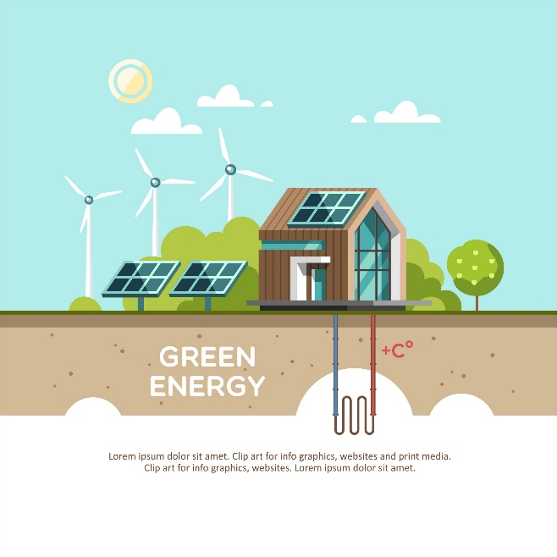

Figure 7

Large scale distribution generation

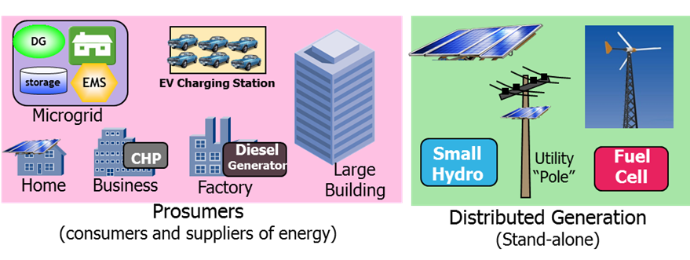

## 5.6 Distributed Storage (DS)

In addition to electric energy storage necessary at many DG deployments to mitigate voltage transients, the utility may deploy stand-alone storage facilities such as large batteries, flywheels, super capacitors, and pumped hydro systems. For the purpose of traffic estimation, the DS IED characteristics will be assumed to be the same as those for the DG IEDs.

Figure 8

Storage

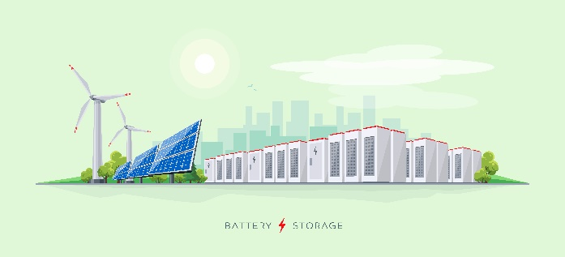

## 5.7 Electric Vehicle Charging Stations (EVCS)

Electric Vehicle Charging Stations that allow EVs parked at the station to discharge energy from vehicle batteries into the grid (in addition to charging EV batteries) can be considered standalone DS deployments. For the purpose of traffic estimation, EVCS IED characteristics will be assumed to be the same as those for DG IEDs. Note that in addition to the periodic measurement+status traffic, there may be (asynchronous) traffic related to authentication (and billing-related) traffic between the EVCS and utility DCC for the vehicles parked at EVCS for battery charging and/or discharging.

Figure 9

Charging station

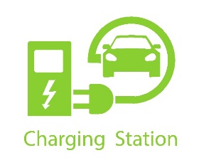

## 5.8 Synchrophasors

Synchrophasors are Phasor Measurement Units (PMU) that measure electrical properties (voltages and currents) of their respective phasor components as well as other quantities (such as line frequency deviation). PMUs are special purpose, state-of-the art IEDs that report measurement+status at very short intervals (e.g. 60 or 50 times a second).

These reporting intervals are significantly shorter than the several second long intervals used by SCADA IEDs. PMUs are deployed at transmission substations (TSS). PMU measurements from transmission substations are collected and analyzed to support wide area situational awareness and control of the regional power system. Each measurement+status message from each PMU carries a Global Positioning System (GPS)-derived timestamp. The North American Synchrophasor Initiative Network (NASPInet) is the first network deployed for Wide Area Situational Awareness in regions of North America. While Synchrophasor deployment is currently limited to transmission substations, their deployment at distribution substations (DSS) for management and control of distribution systems (including power quality control) is also possible in the future.

## 5.9 Dynamic Line Rating (DLR)

Increasingly, DLR systems are being deployed to monitor environmental conditions at transmission lines using IEDs deployed at or close to transmission towers. DLR IEDs measure ambient temperature, wind, solar radiation, ice accumulation, sag, and other parameters. By closely monitoring transmission lines, DLR helps utilities optimize power delivery and enhance operational safety. DLR IEDs are assumed to use DNP3 to communicate with systems in the DCC. DLR IED functions are similar to those of SCADA IEDs, possibly with a larger interval between sending of the successive measurement+status messages.

## 5.10 Utility Engineering and Operations

In addition to the periodic traffic and asynchronous control traffic between the sensors (IEDs, PMUs, or meters) and their respective operations and control systems at the DCC, other types of data transfer are required for operations and engineering needs. Examples of such data transfer include the retrieval of sensor data for analysis, software/firmware upgrades, remote programming, and configuration of sensors, and, in the case of meters, re-registration of meters after blackouts.

## 5.11 Closed Circuit Television (CCTV)

Utilities are increasingly deploying CCTV cameras at substations, DCCs, and other locations to support physical and operational security. Video feeds from cameras are typically stored in local Digital Video Recorders (DVR). At any time, several feeds are also streamed, as necessary, to the (security operations center within the) DCC. When required (such as during an incident at a substation), one or more live video feeds may also be uploaded to the DCC.

## 5.12 Mobile Workforce (MWF)

Utility mobile workforce requires ubiquitous voice and data communications. Conversational (person-to-person) voice communication between MWF personnel, as well as between MWF personnel and anyone outside the MWF is assumed to have the mission critical communication characteristics. Similarly, the “data” needs (including video) of MWF will be assumed to have the same characteristics. MWF frequently uses Mapping and Geographical Information System applications. Finally, MWF personnel may need to stream live video (from an MWF camera) during an incident.

## 5.13 Protection

Protection relays in two transmission substations connected over a transmission line communicate with each other to detect faults. When a fault is detected, a control signal is sent to trip a circuit breaker. While a fault may be detected and circuit breaker tripped locally at a substation, in many cases, the tripping of a circuit breaker will be triggered by a remote substation. Protection is a very critical application requiring very short communication delays (about 10 ms). Further, for high reliability, two independent connections are used to support communication between the relays. Protection is also used between a DG, DS, and EVCS location and the connecting distribution substation. Protection relays at such locations communicate over a FAN. Protection is typically only used at high capacity DG, DS, EVCS locations.

## 5.14 Utility Business Voice

The Smarter Electricity Network architecture of Figure 2 supports voice traffic for utility personnel located in business offices, field offices, and other sites as well as for MWF personnel. Support of voice communication over the smart grid requires the use of IP-based interfaces.

## 5.15 Utility Business Data

The Smarter Electricity Network architecture of Figure 2 supports business data traffic for utility personnel located in business offices, field offices and other sites as well as for MWF personnel. Business video traffic (including videos over the Internet or corporate intranet and video conferencing from user data devices) are considered as a part of the business data needs.

# 6 Utilities Integrated Communications Network Architecture [6]

Currently, communication network needs for most utilities are supported by disparate networks, each supporting a utility application such as SCADA, physical security (CCTV), or mobile workforce communication. With smarter electricity network evolution as well as the expected growth with a large number of new applications supporting a large number of endpoints, creation of a purpose-built network for each application cannot be sustained. It is extremely important that the utility ICT needs including that of connectivity to distributed generation are supported by an integrated network.

A practical, flexible, and scalable target communication network architecture supporting all smarter electricity network applications is illustrated in Figure 10.

IP is assumed to be the underlying network protocol for the integrated network with support for connecting legacy endpoints and protocols (such as TDM) using tunnels, circuit emulation, and/or gateways.

Given the expanse of the utility service territory, the number of endpoints that need to be connected into the network, and since communications for most applications are predominantly between sensors and/or remote endpoints and the central application control or processing servers, an edge-core network architecture is preferred as illustrated in Figure 10. Another important aspect of this architecture is traffic aggregation at intermediate points in the network rather than direct communication between the endpoints, thus facilitating ease of traffic routing, reliability, QoS implementation, and reduced costs.

To avoid complexity in the figure, not every possible application or network connectivity option is included in Figure 10. In any case, the actual physical connections will be dictated by network design.

Figure 10

Architecture for Integrated Communications Network for the Smart Grid

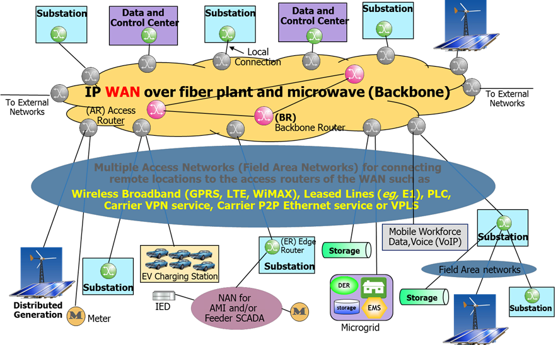

While the enterprise voice and data applications or utility enterprise offices are not included in Figure 10, they can be easily supported by the architecture based on a utility’s preference about integrating the OpTel and business applications on the same network.

Traffic Aggregation at Network Endpoints

An Edge Router (ER) at an endpoint location aggregates traffic from multiple sources and applications at that location. For a location with a single endpoint or only a few endpoints, there may not be an ER at that location that aggregates their traffic and these endpoints may be connected directly into the network. Depending on network design, an ER may also be used to aggregate traffic from other locations in the vicinity. For example, an ER at a (large) substation may aggregate traffic from other (smaller) substations as well as traffic from other locations in the vicinity, in addition to the traffic generated at that substation itself.

Core Network (WAN)

Depending on the network expanse and end points, the core network (sometimes called WAN – Wide Area Network) may vary from a single router up to a mesh of (redundant) interconnection of backbone routers (BR) and access routers (AR). ERs not connected to other ERs and endpoints not connected to an ER connect to the ARs for network connectivity. Based on the reliability requirement, an endpoint (such as the data and control center or a “important” substation may connect to two different access routers. An AR aggregates traffic to/from the endpoints that connect to the ARs, possibly through the ERs. The WAN must be a reliable network with very high reliability (e.g., there must be at least two physical paths between every pair of ARs). For that purpose additional routers BRs may be deployed in the core network based on the network design.

Often, the core network will be close to the utility data and control centers as well as to the substations in metro areas. Thus, some of the ARs may be collocated with these utility sites. For such a collocated site, its endpoints may connect to the corresponding AR over the LAN in that site. If required for redundancy, ER at this site may additionally connect to an AR at another location over a FAN.

Based on security policies and security designs, firewalls and IDS/IPS systems are deployed at ARs and BRs.

In many cases the WAN will be owned and operated by the utility but that may not always be the case. Even the utility-owned WAN may lease or share basic physical resources such as fiber plants and spectrum.

Optical fiber is used extensively in the majority of Europe’s transmission system operator (TSO) companies. However due to the fact that they link the main electricity generators with the consumers centers, their capacity to contribute to distributed generation in medium voltage networks is limited.

Only a small number of distribution system operators (DSOs), mainly in Western Europe, have any substantial amount of optical fiber. Nevertheless, most of them think they will need to install in the future as smart grids deploy, mainly in medium voltage networks. This will contribute to the deployment of highly reliable, cost efficient and secure networks.

Access Networks (FANs)

Access networks (often called Field Area Networks – FANs) provide connections between utility locations and the ARs. After presenting a brief overview of the wireline and wireless FANs, we present a few more details on the Power Line Communication (PLC) technology which is being increasingly used in smart metering access and being explored for deployment in FANs including connectivity to DG.

The utility may use multiple wireline and wireless technologies for FANs. The FANs may be owned and operated by the utility (self-provided) or service provider networks may be used as FANs. Wireline technologies may include PLC, private lines, Layer 2 technologies as Ethernet and Frame Relay, and MPLS VPN service. The wireless broadband technologies may include GPRS and HSPA with a migration path to LTE and WiMAX.

The mix of utility-owned and service provider network FANs depends on the service level agreements (SLA) provided by the service provider networks consistent with utility requirements, networking technology availability in an area, costs and other considerations. The choice of FAN technologies and ownership mix can evolve over time depending on the emergence of new technologies, utility access to spectrum, and network expansion with new applications and endpoint.

While strictly not FANs, and based on AMI communication technology, local Neighborhood Area Networks (NAN) such as over 2.4 GHz or 900 MHz RF mesh over license-exempt spectrum or over PLC may be used for concentrating smart meter traffic at substations or near distribution transformers. The NANs may also be used for concentrating the SCADA traffic from the IED deployed over feeders to RTU/IED in the substation. Note that meters and feeder IEDs may also directly connect to the ARs, depending on the vendor product communication technologies.

Power Line Communication

Power Line Communication over the power lines themselves as communication medium has been in use since early 20th century, initially for voice communication. In the last fifty years or so, PLC was also used for low data rate communication over HV and MV lines for applications such as protection and SCADA. PLC was not considered a useful technology by many for data communication because of its low range, susceptibility for interference with other communication applications, costly solutions to overcome the problem of communication through transformers (requiring coupling equipment to bypass transformers), and very low data rates.

However lately, PLC technology has taken its roots in smart grid evolution as one of two Neighborhood Area Networking (NAN) technologies for AMI. In the last several years, many countries (particularly in Europe) are looking to deploy PLC FANs connecting to DG, meter concentrators, and other smart grid endpoints. Many standards bodies and industry forums have developed and are developing standards for supporting PLC communication.

Evolution of Substation LAN Architecture

Currently communication within most substations is limited to SCADA. IEDs and RTUs in the substation use point-to-point communication between them, often through a “data concentrator”. Most protocols are proprietary. The SCADA communication link between the substation and the SCADA control center are often point to point TDM connections. If there are other applications located at the substations (such as protection, synchrophasors, and CCTV), they each have a separate communication links to their respective counterparts.

The substation LAN evolution will be on two different levels. At one level, the substation architecture of the utility operations applications such as SCADA and protection will evolve to the architecture specified in IEC 61850 standard. On another level, traffic generated by many new smart grid and other applications that will be resident at the substation such as the meter concentrators and CCTV will be aggregated at the substation router along with the SCADA and other operations traffic. The substation router is an ER in our integrated architecture of Figure 11. The router at a (large) substation may additionally aggregate traffic generated in the vicinity of the substation.

Figure 11

Evolution of substation architecture based on IEC 61850 standards

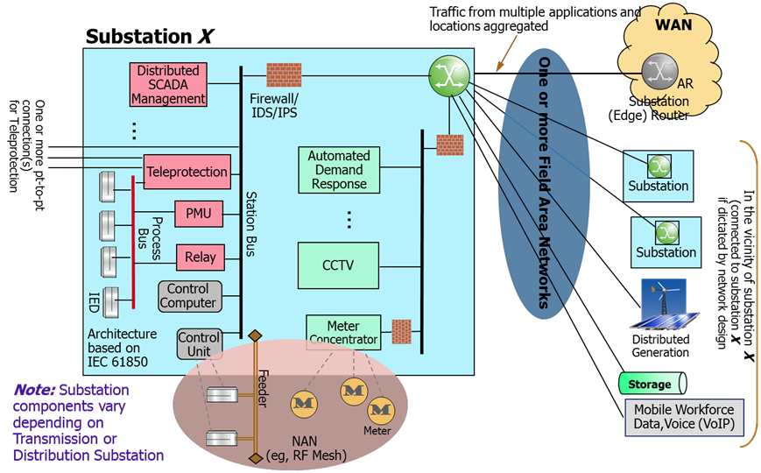

IEC 61850 defines a *process bus* that is an Ethernet bus. All SCADA IEDs and optionally the protection IEDs and PMUs connect to the process bus. For legacy equipment gateways may be used to connect into the process bus. There may be more than one process bus.

The *station bus* is used to connect the process busses as well as other operation systems such as the distribution automation traffic concentration from the feeder IEDs (if thus designed).

Access to all these operation elements is protected by protecting the station bus behind firewall and/or Intrusion detection and protection (IDS/IPS) systems.

The substation may use another Ethernet network for connecting other smart grid and utility systems such as the CCTV, meter concentrators, and demand response systems; access to these systems is protected by another firewall and/or IDS/IPS system.

Finally, the substation router aggregates all traffic generated at the substation and possibly traffic generated at (smaller) substations in the vicinity as well as traffic from other endpoints in the vicinity – examples of which are shown in Figure 11.

Note that the utility may continue to use its existing TDM networks and/or possibly Ethernet connections for the protection traffic. The protection traffic may not be carried over the IP network for a period of time.

Connectivity to home area networks (HAN)is an important aspect of smart electricity network evolution in actively incorporating the consumer in energy management. Depending on the utility policies, the home networks *may* be allowed to be a part of the utility’s integrated communication networks either with the connection through the smart meter or through a “home gateway”.

Utilities are implementing new systems to automate operations and enhance their monitoring and control capabilities. These systems support a variety of applications, including advanced metering, demand response, distribution automation, and wide area measurement, protection and control (WAMPC). Overall, these systems will improve operational efficiency, safety and reliability by extending communications further into the distribution network and improving their performance.

The network architectures for these systems are varied. Some utilities deploy networks using centralized network architecture, such as point-to-multipoint networks; while others rely on decentralized network architecture, such as mesh networks. There are also hybrid networks that include combinations of network architectures, as well. The FAN is expected to bridge the backhaul network to the field devices.

The Figure 12 below shows a combination of networks in a suburban configuration. A utility must manage the spectrum needs of its applications across the entire geographic footprint and account for the different device densities, geography, zoning regulations, and other technical and non-technical limitations [2].

Figure 12

Networks in a suburban configuration

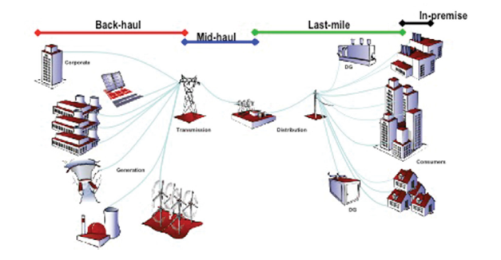

In Figure 13 below, we have mapped how the smart network applications and communications technologies can be layered onto the different elements of the energy network physical infrastructure. The communication requirements applicable to generation, transmission, distribution and customer premises have some differences and these are explained in greater detail in the following section.

Figure 13 also illustrates how the communications layer elements, the wide area network, neighborhood and field area network and the home networks overlap the different power systems elements which make up the energy system.

Figure 13

Utilities communications physical architecture

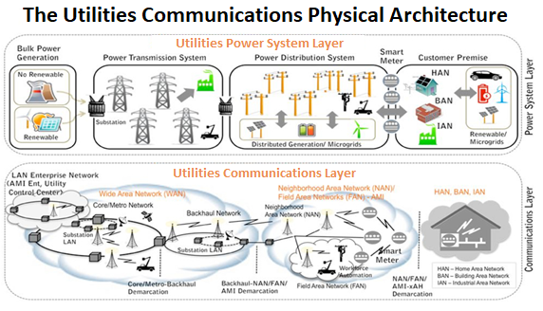

There will be numerous applications, including several that require significantly greater bandwidth. While utilities may not implement all of these applications, they will need to design the FAN so that all of the applications that they do implement can be supported both now and, in the future, as demands increase.

In addition, the network needs to be designed so that it is reliable and provides coverage and low latency to meet their functional requirements effectively.

Flowing from the applications and their functional requirements, utilities may choose the network architecture that best supports their needs —and there are advantages and disadvantages to each.

## [6.1General technical and operational considerations of mission critical utility applications from survey of utilities

Utility systems are composed of various applications that depend on communications. Some of these applications are mission critical, which means that they are used to guarantee security, quality, availability, resilience and reliability in the provision of essential services to society, whose loss or unavailability can generate not only financial but also social disorders. Other non-mission critical applications help to support utility operations, but do not affect safety, reliability and security. In general, utilities support mission critical applications using their own private internal communications networks in order to ensure meeting requirements for reliability, availability and low latency. They may use commercial communications networks and services to support non-mission critical applications.

Some examples of utility mission critical applications that require low latency and high reliability include: protection, SCADA, remote measurement, mobile voice communications, fixed voice communications, digital disturbance recorders (DDR), synchrophasors, and distribution automation networks.

The following data was gathered in response to a recent survey of utilities.presented in the following graphics. The survey was conducted by UTC/UTCAL with thirty-six (36) utility companies in the Americas, Europe and Africa. It encompasses information gathered from different types of utilities, namely generation, transmission and distribution companies.

Each of these utility mission critical applications are described below in more detail, including their requirements for communications reliability and latency.

Protection

Protection applications are designed to ensure electrical equipment safety and reliability in substations and transmission lines, acting quickly and accurately the detect and isolate faults and minimizing the possibility of spreading disturbances to the rest of the interconnected electrical system.

When questioned about the maximum latency supported by the protection applications, 69% of the companies participating reported to accept delays of up to 10 ms (33% from 6 to 10 ms and 36% up to 5 ms), while 25% reported to accept delays between 11 ms to 50 ms. More details can be found in Figure 14. In the case of Brazil, the ONS network procedures document, in its sub-module 13.2, establishes value smaller than or equal 140 ms as minimum requirement for the communication channels latency.

figure 14

**Maximum Latency supported by protection applications**

Concerning the minimum availability required for telecommunication systems for protection applications, most of the utilities surveyed reported that they require a percentage equal to or greater than 99%. As can be seen in Figure 14, twenty-four (24) companies consider availability of at least 99.99% for this type of application.

figure 15

Minimum availability for protection applications

To ensure such availability, the companies use redundant telecommunications solutions typically duplicated fiber optic routes, or a fiber route backed up by a radio link (SHF or UHF) or even a PLC connection.

SCADA

The SCADA (Supervisory Control and Data Acquisition) systems are aimed to supervise, to perform data acquisition and to enable the visualization of a particular process, with the objective of controlling it, providing a high interface level to the system operator, informing in real time about all events of importance occurred in the industrial plant.

When asked about maximum latency supported by this type of application, 78% of the respondents stated considering a maximum of 100 ms. Among them, 39% claim that the maximum accepted is 10 ms. Figure 16 shows that 17% of the participants accept latencies higher than 100 ms in SCADA systems. Only one company informed (in “others”) that consider a latency of 2 ms as the maximum accepted to support this type of application.

figure 16

**Maximum latency allowed by SCADA applications**

In Figure 17, most of the participant companies consider adequate an availability higher than 99%, and 83% reported that an availability higher than 99,9% is required.

Figure 17

Minimum availability required by SCADA applications

Operational voice and data

When asked about the minimum availability required for operational voice and data applications, the answers were diverse. Thirty-three (33) of the companies do not accept an availability index lower than 99%. The answers can be seen in Figure 18.

figure 18

Minimum availability required by operational voice and data applications

As it can be seen in Figure 19, the majority of the respondents (25 companies) informed that remote metering can work with a maximum latency of 3 minutes. Other eleven (11) companies accept latencies higher than 3 minutes.

figure 19

Maximum latency permitted by remote metering applications

When asked about minimum availability, 31% of companies answered that 99% is the required availability index and 22% consider 95% as the minimum. More details can be seen in Figure 20.

figure 20

Minimum availability permitted by this type of application

Digital Disturbance Recorder (DDR)

Digital disturbance recorders register the operation of the electric system and its protection during important events, such as electric failures, frequency oscillations and operational failures.

Digital Disturbance Recorders (DDR), also known as digital oscillographs, are utilized in most of the installations of power electric systems and perform a constant surveillance of the system, recording significant disturbances, such as voltage and current out of the standard

When asked about the maximum latency supported by DDR applications, participants responded a variety of answers. Nine (9) of them informed that 1 s is sufficient for this type of application. Six (6) considers that a latency no higher than 5 ms is necessary. More information can be seen in Figure 21.

figure 21

Maximum latency permitted by DDR applications

Regarding the minimum availability, most of the companies (22) work with an availability between 95% and 99,9% for their DDR applications, as it can be seen in Figure 22. One (1) company required availabilities above 99,999% for this type of application.

figure 22

Minimum availability permitted by this type of application

As utilities implement grid modernization more densely and deeper into their infrastructure, their communications networks are expected to need additional capacity and coverage as they shift towards two-way, real-time communications systems that would provide increased control, for example, to turn on/off systems remotely, automatically and dynamically without the need to send out a truck to manually reclose circuits, or when breakers have tripped for example. Moreover, those communication networks will be used to automatically detect a power outage and restore power instantly where, for example, a tree has fallen across a power line or a power transformer has failed. This kind of automation would benefit from additional capacity and coverage functions that would be provided by certain types of radiocommunication systems.]

# 7 Utility Communications Requirements

Utility systems are characterized by high reliability, high availability and low latency. Utilities typically operate their own operational communications networks in order to ensure communications reliability during extended power outages or other situations when public commercial communications networks may become adversely affected. This includes extended back-up power and diverse and redundant routing of backhaul communications networks at every wireless site. They also communicate in areas that commercial communications networks do not cover but where utilities may have critical assets, such as remote areas where generation or transmission infrastructure is located.

Utilities communicate with very low latency, depending on the type of utility application as low as 20 milliseconds or less. Some applications, as protection and synchrophasors, needs extremely low latency services to prevent faults on the grid from cascading and causing widespread outages and/or safety issues. Hence, utility communications networks can be characterized as highly reliable, available, and operate at low latency, as shown in Table 1 below.

Table 1

|  |  |  |  |  |
| --- | --- | --- | --- | --- |
| Smart network communications parameter matrix | | | | |
| Smart network sub-system | Coverage | Reliability | Latency Time | Security |
| Meter reading - AMI | Medium | Medium | High | High |
| Field area network | High | High | Medium | High |
| Phase measurement | Medium | High | Low | Medium |
| Protection | Medium | High | Low | Medium |

As utilities implement grid modernization more densely and deeper into their infrastructure, they are expected to need additional capacity and coverage as they shift towards two-way, real-time communications systems to provide increased control to turn systems on and turn off remotely, automatically and dynamically without the need to send out a truck and manually reclose circuits when breakers have tripped. Moreover, they will be able to automatically detect a power outage and restore power instantly by rerouting it, instead of having to attempt to triangulate a power outage based upon customer calls that a power outage has occurred and then sending a truck into the area to determine the exact location where a tree has fallen across a line or a transformer has failed. All of this automation would benefit from additional capacity and coverage.

Communications Requirements of Smart Grid Communications Technologies

The following tables list the various different utility applications and provide the requirements for latency as well as their relative priority. For example, protection applications, such as breaker reclosers and PMUs, which have extremely low latency and relatively high priority requirements, cannot generally be reliably supported using commercial wireless broadband networks. However, advanced metering and some monitoring applications, such as AMI periodic measurements and fault recordings, could potentially be supported over existing commercial networks [2] [6].

Table 2

Application latency requirements

|  |  |  |
| --- | --- | --- |
| Application | Minimum Delay Allowance  (ms) | Priority:  0 = Max to 100 = Min |
| **Delay ≤ 10 ms** | | |
| (High Speed) Protection Information | 8, 10 | 2 |
| Load Shedding for Under Frequency (under 50-60 Hz) | 10 | 20 |
| **10ms < Delay ≤ 20 ms** | | |
| Breaker Reclosures | 16 | 15 |
| Lockout Functions | 16 | 12 |
| Many Transformer Protection & Ctrl Apps | 16 | 12 |
| System Protection (PMU) | 20 | 12 |
| **20 ms < Delay ≤ 100 ms** | | |
| Synchrophasor Measurements (Class A) | 60 | 10 |
| SCADA Data Poll Response | 100 | 25 |
| PTT Signaling (critical) | 100 | 30 |
| PMU Clock Synchronization | 100 | 20 |
| **100 ms < Delay ≤ 250 ms** | | |
| VoIP Bearer (inc. PTT) | 175 | 50 |
| VoIP Signaling (inc. PTT – normal) | 200 | 60 |
| Dynamic Line Rating (DLR) | 200 | 40 |
| Real-time Video (mobile WF) | 200 | 55 |
| On Demand CCTV video | 200 | 55 |
| Other SCADA Operation | 200 | 45 |
| Enterprise Data – Preferred | 250 | 70 |
| Most Distribution and SCADA Apps. | 250 | 65 |
| AMI – Critical | 250 | 60 |

Traffic for these applications is only between two substations connected with transmission line. This traffic must be designed to be only single hop. Thus, the corresponding delay requirements must be considered only single hop. All other delay requirements may have to be satisfied over multiple network hops.

Table 3

Application latency requirements (cont.)

|  |  |  |  |  |
| --- | --- | --- | --- | --- |
| Application | |  | Minimum Delay Allowance (ms) | Priority: 0=Max to 100=Min |
|  | **250 ms < Delay ≤ 1s** | | | |
| AMI – Priority | |  | 300 | 70 |
| CCTV Stream – Normal | |  | 400 | 75 |
| PMU (Class C) | |  | 500 | 80 |
| Some Transformer Protection & Ctrl Apps | |  | 500 | 80 |
| Enterprise Data - Other | |  | 500 | 80 |
|  | **1 s ≤ Delay** | | | |
| Image Files | |  | 1 000 | 90 |
| Fault Recorders | |  | 1 000 | 90 |
| (Medium Speed) Monitoring and Ctrl Info | |  | 1 000 | 90 |
| (Low Speed) O&M Info | |  | 1 000 | 90 |
| Fault Isolation and Service Restoration | |  | 1 000 | 90 |
| Distribution Applications | |  | 1 000 | 90 |
| AMI Periodic Measurements | |  | 1 000 | 85 |
| Text Strings | |  | 1 000 | 90 |
| Audio and Video Data Streams | |  | 1 000 | 78 |
| Fault Recorders | |  | 1 000 | 90 |
| Best Effort, Default | |  | 2 000 | 100 |

Ensuring that these systems are secure and can be delivered in a cost-effective way is a high priority within the industry.

Finally, some of the key characteristics the operational communications components of utility networks are highly ruggedized for extreme conditions within the substation environment and have traditionally used extended depreciation cycles; so that the equipment must last for an extended period of time. These key characteristics to maintain utility networks and their functions are detailed in Table 4 below.

Table 4

Network requirements

| Application | Bandwidth | Latency | Reliability | Security | Backup Power | |
| --- | --- | --- | --- | --- | --- | --- |
| AMI | 10-100 kbps/node, 500 kbps for backhaul | 2-15 sec | 99-99.99% | High | | Not necessary |
| Demand Response | 14 kbps- 100 kbps per node/device | 500 ms-several minutes | 99-99.99% | High | | Not necessary |
| Wide Area Situational Awareness | 600-1 500 kbps | 20 ms-200 ms | 99.999-99.9999% | High | | 24 hour supply |
| Distribution Energy Resources and Storage | 9.6-56 kbps | 20 ms-15 sec | 99-99.99% | High | | 1 hour |
| Electric Transportation | 9.6-56 kbps, 100 kbps is a good target | 2 sec-5 min | 99-99.99% | Relatively high | | Not necessary |
| Distribution Grid Management | 9.6-100 kbps | 100 ms-2 sec | 99-99.999% | High | | 24-72 hours |

Getting the data from field devices to the electric utility’s back office system, or getting commands to devices from back office systems, relies upon a secure, reliable network covering a geographical footprint that can vary from dense urban areas to remote locations with virtually no population. This data is often critical in managing the power system.

Simultaneously being able to respond to events via central commands adds to the complexity needed to manage the communications network. Thus, the network needs to be able to support the increased bandwidth requirements, as well as ongoing wide-area coverage and low-latency communications requirements necessary to effectively monitor and control operations.

[Operational Requirements for Modern Utilities

[Editor’s note: This section is supposed to describe how utilities are evolving and their communication needs.]

[Editor’s note: The following sections provide additional information in response to the Editor’s Note.]

[Since the 1950s, utilities have been using telecommunications to monitor and control their electricity, water and gas networks.

Electricity is at the top of essential services list to society, whose unavailability or even temporary interruption can negatively affect whole chain of other public services that are also essential to society, such as transportation, health, banking and telecommunications.

The chain that makes up the electricity system is composed of three important sectors: generation, transmission and distribution. These segments operate in an integrated way, being extremely important the management, control, automation and monitoring of the events resulting from human actions and nature that constantly impact the electrical system.

The electrical networks "intelligence" is mainly based on the exchange of real-time information on measurement, supervision and control data, installed in strategic positions in generation, transmission and distribution networks, as well as in homes, offices, companies, with the purpose of making it capable of automatically detecting, analysing, responding and restoring faults in the network.

Utilities around the world use communications networks in their operations to support the safe, secure and reliable delivery of essential electric, gas and water services to the public at large. Such operational communications networks facilitate utility networks and are desired to be resilient with low latency to enable the use of certain utility applications.

Utilities use wireless technologies, for voice, control and data communications to support the operation of their critical systems. However, as described more in detail below, a wireless solution would need to support the ever-growing demand for the utilities services and certain performance characteristics associated with utility’s system availability, operation and management, (e.g. performance requirements for smart grids).

Non-wireless telecommunications alternatives may be impractical for many applications that would need wide service area coverage and low-cost implementation. For example, it is usually difficult to enable fibre and wired technologies for millions of smart grid devices, many of which may be located in remote and otherwise inaccessible areas across the wide service area of a utility.

Suitable communications technologies can enable more efficient management and control to flow of energy onto the distribution infrastructure. Some utilities are also implementing newer distribution automation technologies thereby enabling utilities to maintain power resilience and restore power more quickly after an outage and protect the utilities’ critical assets against physical and cyber-attacks. These are just some of the utility applications that are creating additional demand for new wireless communications capacity and coverage.

[Utility Radiocommunication Systems

[Editor´s note: Title to be added.]

[Editor´s note: Need to seek input on current systems in use by various utility users across the world. data collection is a prerequisite for any conclusions in the sections that follow.]

Overview.

Utilities utilize highly reliable and resilient communications in order to ensure operational safety, reliability and security of the underlying electric, gas and water services that they support. This includes extended back-up power and diverse and redundant routing of backhaul communications networks at every wireless site. In addition, energy networks utilize extremely low latency services in order to ensure that utility protection systems and synchrophasors operate to prevent faults on the grid from cascading and causing widespread outages and/or safety issues. Ensuring that these systems are secure and can be delivered in a cost-effective way is becoming a high priority within the utilities industry. Finally, some of the key characteristics of the operational communications components of utility networks are highly ruggedized for extreme conditions within the substation environment and have traditionally used extended depreciation cycles; so that the communications network devices must last for an extended period of time.

These systems support voice applications, such as routine dispatch and emergency restoration, and for data applications, such as supervisory control and data acquisition (SCADA), distribution automation (DA) and advanced metering infrastructure (AMI). Collectively, these systems comprise the [field] area network, and they are characterized by wide area coverage, high reliability and availability, and redundancy/resiliency. Details of communication systems supporting those applications are described in Report [ITU-R M.2014](https://www.itu.int/pub/R-REP-SM.2014) Digital land mobile systems for dispatch traffic and Report [ITU-R SM.2351](https://www.itu.int/pub/R-REP-SM.2351).

While utilities also use fixed wireless access systems that provide point-to-multipoint communications with high capacity backhaul that operate across different platforms, access to higher capacity licensed spectrum in the mobile service could be better suited to offer wide area coverage, not just on a point-to-point or point-to-multipoint basis.

Many of the utility applications described in the previous section of this report would be accommodated under fixed service, but there are other applications that could also be accommodated under mobile service, as well.

[Editor’s note: The following sections provide additional information in response to the above editor’s note.]

Utility grid modernization represents a fundamental change in the way that utility networks currently operate; for example, dynamically responding to an isolated fault and rerouting power before it leads to a widespread and extended outage or anticipating the fault before it occurs and changing out a transformer before it fails. In addition to fixed operations for intelligent electronic devices on the grid, grid modernization also envisions mobile data applications to trucks and personnel so that they can access files with information about utility infrastructure as they are restoring power and then communicate back remotely to the utility when the work is completed, and power has been restored. Such developments could dramatically reduce the time it takes to restore power and improve the safety and efficiency of operations overall.

Grid modernization depends on the underlying communications systems that would support the operational requirements for this modernized grid. The introduction of grid modernization will increasingly require telecommunications networks capable of securing real-time traffic and meeting stringent security, ubiquity, resilience, reliability and availability requirements, inherent in the provision of mission critical services, essential to society. These new applications and intelligent devices, commonly referred to as smart grid, will require utilities to upgrade their existing communications networks. Existing communications systems are characterized by a variety of wireline and wireless systems.

***[Description of Existing Communications Systems to Support Utility Applications from Survey of Utilities***

Figure 23 shows the different telecommunication solutions used by energy companies to support their mission-critical applications. It should be clarified at the outset that each utility may use multiple different technologies to support different utility applications. As a result, the number of utilities reporting about the technologies that they use for certain applications, such as protection or SCADA, may exceed the total number of utilities that actually responded to the survey.

Figure 23

Number of companies that use different telecom solutions to support their mission critical applications

Although optical fiber is widely used in the electrical sector to support utilities’ mission critical applications, the use of the wireless solution is also essential, so much in the backbone as in the access to power plants, substations, etc. Wireless solutions ensure that a great number of decentralized resources can be connected more easily and quickly. Wireless solutions are also essential for maintaining communication with the field team in activities related to maintenance and repair of the power grid.

Due to the applications’ criticality and the need for the electrical system operational safety, the use of wireless solutions by electric power companies will always be conditioned upon the availability of radio frequency spectrum. The availability of radio frequency spectrum becomes an extreme factor of importance for the reliability and safety of these companies’ operation.

Utilities use a variety of spectrum bands to support their various mission critical applications. For protective relaying, utilities report that they use a mix of microwave and land mobile UHF and VHF systems, as well as optical fiber and power line communications. Similarly, for SCADA systems, utilities report that they rely more heavily on wireless communications, using a mix of microwave and land mobile systems. For operational voice and data communications utilities report that they use a combination of fixed and mobile communications systems for substations, power plants, control centers and field staff, and they use land mobile UHF and VHF systems to a greater degree for field area communications with staff compared to substations, power plants and control centers that predominately use fixed microwave and wireline communications systems. Utilities also reported that they use wireless services from commercial providers as an alternative to private wireless communications. For remote meter reading, utilities reported that they mainly use a combination of optical fiber, microwave and land mobile UHF radio systems, and to a lesser degree they use VHF, cellular and 700/900 MHz licensed radio systems. For DDR communications, utilities report that they mainly use fixed microwave and optical fiber, followed by UHF, VHF and other communications systems to a much lesser extent. For distribution automation, utilities report that they use a mix of optical fiber, microwave, UHF and VHF communications systems.

[The table below illustrates the various different utility mission critical applications and the frequency ranges that utilities use for their communications systems to support those applications.

table 5

**Frequency bands used in mission critical applications**

|  |  |  |  |  |  |
| --- | --- | --- | --- | --- | --- |
| Mission Critical Applications | Microwave (SHF)  (GHz) | UHF  (MHz) | VHF  (MHz) | Satellite (Band) | Not Licensed Frequencies (MHz) |
| Protection | 6; 6,5; 7; 8; 15 | 380; 400; 430; 450; 470; 1500; 2200 | 148; 150; 250 |  | 900; 2400; 5400 |
| SCADA | 6; 6,5; 7; 8; 8,5; 15 | 380; 400; 430; 450; 470; 700; 1500; 2200 | 140; 150; 170; 250 | C; L; Ka; Ku | 900; 2400; 5400 |
| Remote metering | 2,4; 4,5; 6; 6,5; 7; 8; 8,5; 15 | 380; 400; 430; 450; 470; 700 | 145; 170; 250 | Ku; L; C | 900; 2400; 5400 |
| Operational voice and data - Fixed | 2,4; 4,5; 6; 6,5; 7; 8; 8,5; 15 | 360; 380; 430; 450; 700; 1500; 2000 | 140; 150; 170; 250 | C; L; Ku | 900; 2400; 5400 |
| Operational voice and data - Mobile |  | 350; 380; 400; 430; 450; 700 | 140; 150; 170; 250 | C; Ku; Ka | 900; 2400; 5400 |
| DDR | 6; 6,5; 7; 8; 8,5; 11; 15; 23 | 350; 360; 380; 400; 430; 450; 470; 700 | 170; 250 | C; Ku | 900 |
| Automation of the distribution network |  | 350; 360; 380; 400; 430; 450; 470; 700 | 145; 150; 170; 250 | C; L; Ku | 900; 2400; 5400 |
| Video Monitoring | 6; 6,5; 7; 8; 8,5; 11; 15; 23 | 450; 700; 1500; 2000; 2200 | 250 | Ku; Ka; L; C | 900; 2400; 5400; 5800 |

# [8 Spectrum Related Aspects [6]

The key ingredient to maintaining these Smarter Utilities Networks is radio frequency spectrum. Energy and water providers use spectrum in various bands to operate mission-critical functions like Supervisory Control and Data Acquisition (SCADA) systems that are used to manage industrial control systems such as electric grids, protective relaying and smart grid applications. Additionally, utility workers use mobile radio devices to communicate when repairing lines or restoring service after an outage. The inability of utility personnel to communicate in the field could have catastrophic consequences for utility employees and public safety.

[In order to provide additional capacity and cost-effectiveness, utilities would benefit from access to wideband spectrum with channel sizes of 200 kHz or more in a frequency range below 2 GHz to provide favorable propagation and to avoid line of site issues, such as trees and buildings that can degrade or block services in higher frequency bands. Finally, to maintain low latency, high reliability communications utilities would benefit from access to existing spectrum bands that are not subject to interference to avoid complex and costly operational communications networks.]

[Editor´s note: The paragraph above was requested to be suppressed.]

While some applications are non-mission critical and can be supported using license-exempt spectrum or commercial communications networks and services, many of the applications must meet higher standards for reliability and latency due to their impact on operational safety and security – and will demand access to licensed spectrum for utility communications networks. Licensed spectrum is generally less susceptible to interference, operates at higher power and provides greater overall reliability. However, certain applications require greater bandwidth than can be supported using available licensed spectrum. For these applications, utility access to licensed spectrum with greater bandwidth is necessary to support increasing communications requirements.

[Editor’s note: The following sections provide additional information in response to the above editor’s note]

The energy companies that were surveyed reported they are finding difficulties in expanding services of applications that use wireless solutions in UHF and VHF bands, with a bandwidth of 12,5 kHz. For each new requirement, especially in existing sites, utilities often require the licensing of a new channel. If the adjacent channel is unavailable, a new frequency shall be requested to the telecommunication’s regulatory agency, which causes the use of a great variety of frequencies without an optimization of the spectrum. If frequency bands with a larger channel bandwidth were made available it could optimize the spectrum (50 kHz – 2 channels, or 100 kHz – 4 channels). Because of the increase in the demand by applications for grid modernization, smart grid, distributed generation, IoT, demand management, etc., the availability of spectrum with higher bandwidths will be crucial to utilities.

Figure 24 shows the responses about the interest of utilities on prospective wireless technology solutions for various utility applications.

figure 24

**Telecommunication solutions by type of application**

Use of the public mobile service was limited to supporting applications for distribution network automation and only one of the respondents reported that they utilized it. By contrast, use of a private LTE solution by utilities was considered by all respondents as an alternative to most of their utility applications, with the exception of protection. Mesh, according to the respondents, was not used for protection or operational voice and data.

Figure 25 shows the minimum data rate, in kbps, required for various utility applications, according to the respondents.

figure 25

**Bandwidth required to each mission critical application – Energy companies’ vision]**

## 8.1 Utility spectrum bands and applications

Utilities operate their fixed and mobile communications systems using licensed spectrum, and they use these systems to support various voice and data applications. Utilities also use license-exempt spectrum to provide additional capacity.

Many of the utility applications considered in this document are fixed, but some utility applications also are mobile. The fixed applications include remote terminal units and other devices that operate across utility transmission and distribution networks; and unlike older one-way relatively slow speed devices that utilities have used in the past, these devices enable two-way, real-time communications that would provide utilities with much better visibility and control over their entire critical infrastructure delivery networks.

In addition to fixed operations for intelligent electronic devices on the grid, grid modernization also envisions mobile data applications to trucks and personnel so that they can access files with information about utility infrastructure as they are restoring power and then communicate back remotely to the utility when the work is completed, and power has been restored. Such developments could dramatically reduce the time it takes to restore power and improve the safety and efficiency of operations overall.

Grid modernization depends on the underlying communications systems, which in turn are dependent upon access to sufficient and suitable spectrum, particularly for field area networks.

## 8.2 Shared use of existing bands

The intent here is to make more effective use of existing land mobile service spectrum bands without disrupting incumbent operations (e.g. neither by interference nor relocation). Instead, sharing existing bands could facilitate more timely access to spectrum.

In addition, sharing the existing bands could open up the potential for the development of shared systems that could allow existing passive network infrastructure, such as sites and active components such as fiber connectivity to be shared thus reducing overall costs relative to operating separate networks.

Research of current uses for international electricity, gas and water utility communication systems has identified a typical common set of spectrum characteristics as shown below:

– VHF spectrum – for resilient voice communications and distributed automation for rural and remote areas.

– UHF spectrum for tele-protection, control, automation and metering.

– Lightly regulated or deregulated shared spectrum for smart meters.

– L-Band for more data intensive smart grid, security and point-to-multipoint applications.

– Public microwave and satellite bands for access to the core fiber networks of utilities or strategic backhaul.

Although utilities make extensive use of copper and fiber-based communications systems – and in the case of electricity, communicating down the electrical supply cables in some instances, radio also plays an essential role. Radio is valuable in this role because:

– the communications network can be independent of the assets being managed;

– radio is flexible and can be deployed more quickly than fixed assets;

– if radio services are interrupted, they can usually be restored more quickly than wired systems; and

– radio is more cost effective in many applications.

Radio systems need spectrum in which to operate. Some services may be able to operate in license-exempt bands designed for short range devices (SRDs), but no protection is available for services in license-exempt spectrum bands if they suffer interference.

Suitable radio spectrum

Radio spectrum is undeniably important to running a Smarter Electricity Network. Smarter Electricity Networks will require communications as much as computerization to successfully monitor and control the electricity network and provide communications for personnel working on the grid.

Smarter Electricity Network communications are necessary for the day-to-day functionality and the administrative savings to be made, UTC citing regular functions in the Critical Infrastructure Industries (CII) as ‘voice and data, mobile applications, monitoring and control of remote facilities, the extension of circuits to areas unserved by commercial carriers, security, video surveillance and emergency response. Furthermore, the communications are highly valuable during a crisis.

In Europe, the European Utility Telecom Council (EUTC) is proposing a portfolio of spectrum to address utility requirements, including a total of 16 MHz of licensed spectrum in the vital 400 MHz to 3 GHz ~~space~~ range.

[Infrastructure Utility Operations requirements for Smart Grid systems, other radio systems, and future radio spectrum access arrangements below 1,5 GHz, highlights the general and essential requirements of electricity systems, e.g. identifying that the resilience requirements for Smart Grids are typically significantly more stringent than those for Smart Meters. It also highlights the future spectrum requirements below 1,5 GHz for mission critical electricity systems, e.g. 18 MHz of spectrum within the VHF, 400 MHz UHF anchor band, and 1,35/1,4 GHz bands.] [8]

Canadian utilities have been granted access to 30 MHz of spectrum in the band 1 800-1 830 MHz for intelligent electricity networks.

The ETSI technical report 103492 V1.1.1 (2019-01) estimates that the functionality of the Smarter Electricity Network could be facilitated within 20 MHz of spectrum, utilizing 4G technology. This provides a guarantee that will allow companies to make efficient investment decisions in appropriate technologies by removing the uncertainty in current spectrum-based planning.

The Case for Sharing Spectrum

An alternative to using dedicated spectrum for private networks would be for utilities to share spectrum with other network users. A solution such as this would alleviate the issues around finding spectrum n and the difficulty for utilities to compete for access to spectrum at auction. However, sharing spectrum involves some trade-offs, because utilities would no longer solely control the network, and that may limit functionality and degrade the quality of service.

Commercial Network Providers

Another alternative would be for utilities to approach a commercial carrier to manage their utility telecommunication networks. Commercial providers would aim to reduce the cost of building and maintaining the network. While reducing the cost would be a benefit, key issues face commercial providers about the quality of service they would be able to provide.

Firstly, the utility networks need to provide full coverage of their asset base with 99.999% availability, something that has proven to be commercially unviable for public mobile. Current utility networks are built to cover the entire geographic area with overlap redundancy, power redundancy, strict maintenance schedules and emergency group talk functions. Despite the poor financial case, a commercial provider would have to provide a network that fulfilled all of these criteria.

Another issue is reliability and resiliency during adverse conditions. Maintaining and re-establishing communications during crises has always been fundamental in recovery plans for utility providers. The recent emergence of a report by the FCC on the impact of the June 2012 Derecho casts a certain amount of doubt as to whether commercial operators would provide sufficient communications reliability and resilience.

Socio-economic benefits [5]

In 2011 UTC/European UTC and JRC UK carried out a study to assess the socio-economic benefits of utilities use of radio spectrum to support the complex smart networks of the future. The Executive Summary of the report is included here for information [5].

– When commercial entities are faced with decisions on whether or not invest in assets, their decisions are based purely on an economic assessment of the value of such assets to the entity. Where those assets also have a social value, it is for society, through the proxy of government, to assess any additional societal benefits and attribute a financial value to them.

– Public safety organizations and elements of the critical national infrastructure have traditionally used radio communications to underpin their operations. The allocation of this spectrum has historically been made by governments who have implicitly taken into account the socio-economic value in making allocations of spectrum to these sectors.

– With the modern tend towards the application of market mechanisms for the award of spectrum to all entities, including the public sector, utilities will assess the economic value of radio spectrum to them in judging the amount of money to commit to spectrum access in any competitive award process, and the associated business risks. Any societal value will thus be ignored.

– The purpose of this study was to investigate whether there might be an element of socio-economic value attributable to radio spectrum deployed by utilities in the conduct of their business; and if this is the case, to place an indication of the amount of socio-economic value which might thus be overlooked if an award is made purely on the basis of the economic value of the radio spectrum to the utilities concerned.

– There are limitations due to the sources of data used in the report. The data is mainly based around research in the UK and USA and relates to power interruptions to electricity networks stretching back several decades in some cases.

– More study is required on the socio-economic value of radio spectrum used to support utility operations in Europe. This new study should look forward to valuations based on Smart Grid Deployment to facilitate renewable energy generation, greenhouse gas reduction and enhance security of supply.

– On the basis of the available data, the report concludes that the societal benefit of spectrum used by the electricity industry to ensure reliable operation of the electricity supply network may have a societal benefit 50 to 150 times the economic value of the electricity itself.

– Within the resources available for the study, it has not been possible to produce equivalent figures for the gas and water utilities, although it is probable that a similar situation pervades these industries. The impact of disruption to these industries is most probably at the lower end of the multiplier ratio due to much less economic impact from disruption to gas and water supplies, although the social impact of loss of gas and water may be greater under certain climatic conditions.

# 9 Conclusions

In conclusion, it is critical for policymakers and utilities to understand the enormous amount of data that Utility Communications Networks will need to carry in order to enable the vision of the next generation utility network. There will be numerous applications, including several that require significantly greater bandwidth. While utilities may not implement all of these applications, they should design their networks so that all of the applications that they do implement can be supported both now and in the future as demand increase. In addition, the network needs to be designed so that it is reliable and provides coverage and low latency to meet their functional requirements effectively. Flowing from the applications and their functional requirements, utilities may choose the network architecture that best supports theirs needs – and there are advantages and disadvantages to each. Thus, different utilities have deployed different network architectures and have gained lessons learned along the way. Key issues going forward include the need for radio spectrum to support these various network architecture and standardization/interoperability of utility networks – which must be addressed in order to ensure operational safety, reliability and efficiency.

To recap, the utilities services network, including the field area network (FAN), bridges the gap between energy consumers and energy providers by connecting monitoring and control technologies with robust command, control, and information processing enterprise applications. There is no single reference design for a FAN: the technologies cover a wide range of radio spectrum and designs philosophies, from mesh to star to hybrid. The choice between licensed or unlicensed technology is made based on traceable requirements, as is the one between private or public network infrastructures. There is little doubt that the multitude of new smart electricity applications will require greater use of radio spectrum, whether in existing frequency bands or in new allocations of different frequency bands.

Interoperable systems and their benefits to society can be seen in many of today´s technologies, including the IEEE 802.11 family of Wi-Fi products and the IEEE 802.15 family of Bluetooth products. The utility industry and the smart electricity networks have not reached this level of interoperability, though frameworks and standards are being refined daily. Before a utility assumes a vendor´s claim of interoperability for smart electricity products, the vendor should demonstrate test results that confirm any claims. Many vendors will not be able to meet this requirement at this time, as smart electricity device testing for interoperability is in its infancy. In some instances, the utility´s one choice is creating its own test facilities.

Utilities that were early adopters of smart electricity applications and FAN connectivity are providing valuable insight from their experiences that should be leveraged by subsequent adopters. The industry learned that smart grid applications have a wide range of system requirements in the amount of data to be transmitted and the speed at which the data received and acted upon. Network designers must be familiar with detailed use case information in order to plan traffic load. The use cases must include normal, start up and emergency modes. RF modelling prior to final design and purchase decisions, often complex and tedious, is key to understanding the day-to-day operation of these systems. While no single network design will meet all requirements for the industry, let alone a single utility, the technologies are maturing and real-world experiences is being added into current standards activities.

Smart electricity applications are presented in a number of categories and the requirements of each of the categories are discussed. The backhaul FAN is critical in overall smart grid performance and this document includes a discussion of backhaul, the use of commercial or private back haul options and some guidelines for making these choices. Standards continue to play a role on FAN designs and a discussion of standards, a few examples of standard families are provided. Finally, a wireless FAN relies on radio spectrum, so a summary of spectrum options is also included.

There are different architectures, each with advantages and limitations. The design of the FAN communications network to support day-to-day grid operations must be completed with the same amount of care and diligence as the grid itself. The utility creates its vision of the smart electricity networks by selecting which applications to deploy. These applications have use cases that must be clearly understood. Use cases lead to FAN architecture options and ultimately data throughput needs. Data throughput will determine spectrum requirements and the choice between licensed and license-exempt spectrum. The bandwidth requirements are going to be different for each technology, depending on the applications and the functional requirements for those applications.

Finally, given the critical nature of electric utility services, providers must make complex and sophisticated choices regarding the communications networks over which the various applications can run. Without flexibility to choose the nature of the technology and the structure of the networks, the continued stability of the power grid will be compromised. These choices are also influenced by the size of utilities and their consumers. Some smaller distribution utilities, for example, may consider reliance on commercial networks a necessity, due to their size, staffing requirements and trade-off between reliability and cost.

# 10 References

[1] Why Utilities Need Access to Radio Spectrum (Mar. 2013), European Utility Telecom Council, Radio Spectrum Strategy Group.

[2] Field Area Networks, Utilities Telecom Council and Edison Electric Institute (Jan. 2014), visited at <http://www.eei.org/about/meetings/Meeting_Documents/Field%20Area%20Networks.pdf>.

[3] Communications Requirements of Smart Grid Communications Technologies, Department of Energy (Aug. 2010), visited at <http://energy.gov/gc/downloads/communications-requirements-smart-grid-technologies>.

[4] Estimating Smart Grid Communication Network Traffic (Mar. 2014), Utilities Telecom Council and Edison Electric Institute – EEI.

[5] The Socio-Economic Value of Radio Spectrum used by Utilities in support of their operations, Report by Joint Radio Company Ltd on behalf of European UTC, January 2012.

[6] Thematic Networks on ICT Solutions to enable Smart Distributed Generation, visited at <http://www.ict4smartdg.eutc.org>.

[7] Spectrum for Utilities´ Mission Critical Applications (Feb. 2019), Utilities Telecom Council America Latina - UTCAL

[8] ETSI Technical Report 103 492 V1.1.1 (Jan 2019) - Critical Infrastructure Utility Operations requirements for Smart Grid systems, other radio systems, and future radio spectrum access arrangements below 1,5 GHz,

______________