|  |  |
| --- | --- |
| **Radiocommunication Study Groups** |  |
|  |  |
|  |  |
| Source: Document 5A/TEMP/413 (Rev.1) | **Annex 10 to Document 5A/1065-E** |
| **10 May 2019** |
| **English only** |
| Annex 10 to Working Party 5A Chairman’s Report | |
| PRELIMINARY DRAFT NEW REPORT  ITU-R M.[RLAN SHARING 5 350-5 470 MHz] | |
| Sharing and compatibility studies of WAS/RLAN  in the 5 350-5 470 MHz frequency range | |

# 1 Introduction

This Report includes the sharing and compatibilities studies of WAS/RLAN in the 5 350-5 470 MHz frequency range.

The frequency band 5 350-5 470 MHz was studied in ITU-R under WRC-15 agenda item 1.1 for possible sharing of the band between incumbent services and WAS/RLAN. Several mitigation techniques including Dynamic Frequency Selection (DFS), changing the RLAN channeling arrangements, dedicated ground sensors network, e.i.r.p. mask, and geolocation database were studied. The results of these studies demonstrated that operation of WAS/RLAN in the frequency band 5 350-5 470 MHz would severely impact EESS (active) and the studied mitigation techniques were insufficient to protect certain radars. Sharing may only be feasible if additional mitigation measures are implemented. As a result, WRC-15 decided not to allocate the frequency band 5 350‑5 470 MHz to the mobile service. However, WRC-15 adopted Resolution **239 (WRC‑15)** and defined agenda item 1.16 to further study the sharing potential with a focus to exploring any additional mitigation techniques which could provide compatibility between WAS/RLAN systems and incumbent services.

This Report is intended to represent the response to invites ITU-R d*)* of Resolution **239 (WRC‑15)** under WRC-19 agenda item 1.16.

# 2 Overall view of allocations in the 5 350-5 470 MHz range

| Allocation to services | | | Expected studies | |
| --- | --- | --- | --- | --- |
| Region 1 | Region 2 | Region 3 |
| **5** **350-5** **460** EARTH EXPLORATION-SATELLITE (active) 5.448B  RADIOLOCATION 5.448D  AERONAUTICAL RADIONAVIGATION 5.449  SPACE RESEARCH (active) 5.448C | | | Further sharing and compatibility studies between WAS/RLAN applications and incumbent services addressing whether additional mitigation techniques would provide coexistence between WAS/RLAN systems and EESS (active), radio determination and SRS (active) systems (see invites ITU-R d*)* of Res. 239) |
| **5** **460-5** **470** EARTH EXPLORATION-SATELLITE (active)  RADIOLOCATION 5.448D  RADIONAVIGATION 5.449  SPACE RESEARCH (active)  5.448B | | |

# 3 Assumptions on technical and operational elements for the sharing and compatibility of WAS/RLAN with other services

## 3.1 Technical and operational characteristics of the WAS/RLAN operating in the 5 350-5 470 MHz ranges

The technical and operational characteristics of the WAS/RLAN operating in the 5 350-5 470 MHz ranges can be found in Report ITU-R M.[RLAN REQ-PAR].

## 3.2 Technical and operational characteristics of the Aeronautical Radionavigation service operating in the 5 350-5 460 MHz

Recommendation ITU-R [M.1638-1](http://www.itu.int/rec/R-REC-M.1638/en) contains description of one radar (Radar 16) of the aeronautical radionavigation service operating in the frequency band 5 350-5 460 MHz. Its technical characteristics and protection criterion are given in Table 3.2-1.  Recommendation ITU-R M.1638‑1recommends 3 provides *I/N* protection criteria of -6 dB. Additionally, Section 4 states that the protection criteria of Annex 1 of Recommendation ITU-R М.1638-1: *“For the radionavigation service and meteorological radars considering the safety-of-life function, an increase of about 0.5 dB would constitute significant degradation. Such an increase corresponds to an I /N ratio of about –10 dB. However, further study is required to validate this value.”* The protection criterion *I/N* assumed in this study is of minus 10 dB as shown in the Table.

TABLE 3.2-1

Technical characteristics and protection criteria of radars in the aeronautical radionavigation service   
operating in the frequency bands 5 350-5 460 MHz

|  |  |
| --- | --- |
| Radar | Radar 16 |
| Location | Airborne |
| Frequency band, MHz | 5 440 |
| Antenna gain, dB | 34 |
| Noise figure, dB | 5 |
| IF bandwidth, MHz | 1 |
| *I/N*, dB | -10 |

These characteristics were used for estimation of thermal noise level, noise power and permissible interference power for the given radars using the following equations:

 К (1)

 dBW (2)

where:

*k* – Boltzmann constant;

*NF* – radar receiver noise figure;

 – radar receiver IF operational pass-band.

Maximum permissible noise power at the front end was assessed such as:

, dBW (3)

The estimated thermal noise level, noise power and permissible interference power are given in Table 4.1.

## 3.3 Technical and operational characteristics of the Earth Exploration Satellite service operating in the frequency ranges 5 350-5 470 MHz

The band 5 350-5 470 MHz, allocated to EESS (active) on a primary basis, is currently used by many Administrations operating EESS (active) sensors and is planned to be used by a number of additional sensors. Typically, this band is used by the following type of sensors:

– Synthetic aperture radars (SAR)

– Altimeters

– Scatterometers with small bandwidths.

Studies under WRC-15 AI 1.1 mainly focused on SAR missions, however all types of EESS (active) sensors require relevant protection. Therefore, all mitigation techniques have to assess protection of all existing and planned SAR, altimeters and scatterometers sensors. Each sensor type has different technical characteristics. Within each sensor type, however, the characteristics present similar modes of operation. The table in Annex 1 provides a non-exhaustive listing of existing and planned EESS (active) systems known to date and Annex 2 provides detailed characteristics of some of these EESS (active) systems.

Prior studies included in Annex 35 to Document [4-5-6-7/715](http://www.itu.int/md/R12-JTG4567-C-0715/en) (Chairman’s Report) depicted substantial negative margins for EESS (active) SAR systems, while additional studies are needed for altimeters and scatterometers. The interference from RLANs to EESS (active) is a function of the sensor’s antenna gain and the number of active RLANs within the sensor footprint. Altimeters and scatterometers present lower antenna gain but, by direct effect, larger footprint and hence higher number of active RLAN to be considered in the aggregation calculations.

In case more detailed dynamic studies with altimeters and scatterometers were found necessary, the relevant EESS (active) protection criteria to be used for these sensors (from Recommendation ITU‑R [RS.1166-4](http://www.itu.int/rec/R-REC-RS.1166/en)) are given below, together with the SAR interference criteria:

Table 3.2

|  |  |  |  |  |
| --- | --- | --- | --- | --- |
| Sensor type | Interference criteria | | Data availability criteria (%) | |
| Performance degradation | *I*/*N* (dB) | Systematic | Random |
| Scatterometer | 8% degradation in measurement of normalized radar backscatter to deduce wind speeds | –5 | 99 | 95 |
| Altimeter | 4% degradation in height noise | –3 | 99 | 95 |
| Synthetic Aperture Radar | 10% degradation of standard deviation of pixel power | -6 | 99 | 95 |

*Note*: Since interference is most likely to be produced by an aggregation of RLAN interferers, it would be related to population densities and interference would hence more than likely be systematic.-

*Note:* Systematic interference is defined as the loss of coverage at the same points on the oceans for most passes over those points.

## 3.4 Technical and operational characteristics of the Radionavigation service operating in the 5 460-5 470 MHz

Recommendation ITU-R [M.1638-1](http://www.itu.int/rec/R-REC-M.1638/en) contains description of two radars of the radionavigation service. The technical characteristics and protection criterion are given in Table 3.3. Recommendation ITU-R M.1638-1 recommends 3provides an I/N protection criteria of -6 dB. Additionally, section 4 states that the protection criteria of Annex 1 of Recommendation ITU-R М.1638-1: *“For the radionavigation service and meteorological radars considering the safety-of-life function, an increase of about 0.5 dB would constitute significant degradation. Such an increase corresponds to an I /N ratio of about –10 dB. However, further study is required to validate this value.”* These characteristics were used for estimation of thermal noise level, noise power and permissible interference power for the given radars using equations (1)-(3). The estimated results are also presented in Table 3.3. The protection criterion *I/N* assumed in this study is of minus 10 dB as shown in the Table.

TABLE 3.3

Technical characteristics and protection criteria of radars in the radionavigation service   
operating in the frequency bands 5 460-5 470 MHZ

|  |  |  |
| --- | --- | --- |
| Radar | Radar 10 | Radar 10A |
| Location | Shipborne, ground | Ground (bistatic) |
| Frequency band, MHz | 5 250-5 875 | 5 250–5 875 |
| Antenna gain, dBi | 33 | 33 |
| Noise figure, dB | 3 | 3 |
| IF bandwidth, MHz | 11.0 | 11.0 |
| *I/N*, dB | -10 | -10 |

## 3.5 Technical and operational characteristics of the Radiolocation service operating in the 5 350-5 470 MHz

### 3.5.1 Technical characteristics of Radiolocation systems operating in 5 350‑5 470 MHz band

Recommendation ITU-R M.1638-1 contains description of 15 radars of the radiolocation service operating in the frequency bands 5 350-5 470 MHz. The technical characteristics and protection criterion are given in Table 3.5.1-1. The protection criterion I/N is of minus 6 dB as shown in the Table and it corresponds to *recommends 3* of Recommendation ITU-R М.1638-1. These characteristics were used for estimation of thermal noise level, noise power and permissible interference power for the given radars using equations (1)-(3). The estimated results are also presented in Table 3.5.1-1.

TABLE 3.5.1-1

Technical characteristics and protection criteria of radars in the radiolocation service   
 operating in separate frequency bands 5 350-5 470 MHz MHz

|  |  |  |  |  |  |  |
| --- | --- | --- | --- | --- | --- | --- |
| Radar | Radar 2 | Radar 3 | Radar 4 | Radar 5 | Radar 7 | Radar 9 |
| Location | Ground | Ground | Ground | Ground | Ground, shipborne | Airborne | |
| Frequency band, MHz | 5 350-5 850 | 5 350-5 850 | 5 400-5 900 | 5 400-5 900 | 5 450-5 825 | 5 250-5 725 | |
| Antenna gain, dBi | 54 | 47 | 45.9 | 42 | 30 | 40 | |
| Noise figure, dB | 5 | 5 | 11 | 5 | 10 | 3.5 | |
| IF bandwidth, MHz | 0.25 | 1.0 | 2.0 | 8.0 | 1.0 | 1 | |
| *I/N*, dB | -6 | -6 | -6 | -6 | -6 | -6 | |
| Radar | Radar 12 | Radar 13 | Radar 15 | Radar 17 | Radar 19 | Radar 20 |
| Location | Ground, shipborne | Ground | Ground | Airborne | Ground | shipborne |
| Frequency band, MHz | 5 400-5 900 | 5 450-5 850 | 5 400-5 850 | 5 370 | 5 300-5 700 | 5 400-5 700 |
| Antenna gain, dB | 25 | 43 | 42 | 37.5 | 44.5 | 40 |
| Noise figure, dB | 4 | 3 | 2.3 | 6 | 3 | 2 |
| IF bandwidth, MHz | 7.0 | 2.75 | 20 | 0.6 | 0.75 | 0.5 |
| I/N, dB | -6 | -6 | -6 | -10 | -6 | -6 |
| Radar | Radar 21 | Radar 22 | Radar 23 |  |  |  |
| Location | Ground | Ground | Ground |  |  |  |
| Frequency band, MHz | 5 300-5 750 | 5 400-5 850 | 5 250-5 850 |  |  |  |
| Antenna gain, dBi | 44.5 | 35 | 31.5 |  |  |  |
| Noise figure, dB | 3 | 5 | 13 |  |  |  |
| IF bandwidth, MHz | 0.8 | 4 | 5 |  |  |  |
| I/N, dB | -6 | -6 | -6 |  |  |  |

Six meteorological radars operating in the frequency band 5 350-5 470 MHz are given in Recommendation ITU-R [М.1849-1](http://www.itu.int/rec/R-REC-M.1849/en). Their technical characteristics and protection criteria are reflected in Table 3.5.1-2. The protection criterion I/N is of minus 10 dB as specified in Table 3.5.1-2 and it corresponds to recommends 2of Recommendation ITU-R М.1849-1. These characteristics were used for estimation of thermal noise level, noise power and permissible interference power for the given radars using equations (1)-(3). The estimated results are also presented in Table 3.5.1-2.

TABLE 3.5.1-2

Technical characteristics and protection criteria of ground based meteorological radars

|  |  |  |  |  |  |  |
| --- | --- | --- | --- | --- | --- | --- |
| Radar | Radar 1 | Radar 4 | Radar 8 | Radar 12 | Radar 13 | Radar 14 |
| Location | Ground | | | | | |
| Frequency band, MHz | 5 300-5 700 | 5 300-5 700 | 5 250-5 725 | 5 330-5 370 | 5 250-5 370 | 5 430-5 470 |
| Antenna gain, dBi | 39 | 40 | 35- 45 | 42-45 | 48-50 | 45 |
| Noise figure, dB | 7 | 3 | 3 | 1,9-3 | 1-2 | 1,8 |
| IF bandwidth, MHz | 0,5 | 0,6 | 10 | 0,4-1.4 | 1,0-1,4 | 2,0 |
| I/N, dB | -10 | -10 | -10 | -10 | -10 | -10 |

#### 3.5.1.1 Technical characteristics of frequency hopping radars

Frequency Hopping Radar (FH):

This type of radar typically divides its allocated frequency band into channels. The radar then randomly selects a channel from all radar channels for transmission. This random occupation of a channel can occur on a per beam position basis where many pulses on the same channel are transmitted, or on a per pulse basis.

The RLAN device must be agile (flexible) in such a way that the various combinations of frequency hopping and pulse repetition frequencies (PRF) will be taken into account and consequently be detected, even for FH Pulse Doppler radars, with high PRF.

In radars not using a fixed PRF the time between consecutive pulses follows a certain scheme and the radar uses a staggered PRF scheme. Taking into account that different radars implement different schemes to control the PRF, the RLAN DFS mechanism must be agile in the sense that the various staggered modes can be detected.

Frequency Hopping Radars that operate in the 5 GHz band are capable of hopping across the 5 250‑5 850 MHz band. The frequencies will be selected by using a random without replacement algorithm until all frequencies have been used. After the use of all frequencies, the pattern is reset and a new random pattern is generated.

The proposed test signals in the table below are presented to improve DFS specifications if any studies are proposed between radars and RLANs in 5 350-5 470 MHz.

Frequency Hopping DFS test signals

|  |  |  |  |  |  |  |  |
| --- | --- | --- | --- | --- | --- | --- | --- |
| Frequency hopping radar type  (Note 7) | Pulse width (µsec) | Pulse repetition interval (PRI) (µsec) | # Number of pulses per frequency hop | Burst length (ms)  (Note 8) | Trial length (ms) | Pulse modulation  (Note 9) | Minimum detection probability with 30% channel load  (Note 10) |
| 1 | 1 | 200 (=5 kHz) | 4 | 0.8 | 480 | none | Pd>80% |
| 1 | 20 | 333 (=3 kHz) | 3 | 1 | 600 | none | Pd>80% |
| 1 | 30 | 500 (=2 kHz) | 2 | 1 | 600 | none | Pd>80% |
| 2 | 3 | 333 (=3 kHz) | 1 to 9 | # | 120 | chirp | Pd>80% |
| 2 | 10 | 500 (=2 kHz) | 1 to 9 | # | 120 | chirp | Pd>80% |
| 2 | 15 | 1000 (=1 kHz) | 1 to 9 | # | 120 | chirp | Pd>80% |
| Note 7: Radar Type 1 : Up to 600 possible frequencies (step 1 MHz) within the range 5 250-5 850 MHz,  Radar Type 2: Up to 120 possible frequencies (step 5 MHz) within the range 5 250-5 850 MHz (Note 11),  A frequency is selected randomly from a group of 600 (or 120 for radar Type 2) integer frequencies ranging from 5 250-5 850 MHz, using a ‘use without re-use’ scheme. Frequency test signal changes after each burst.  Note 8: A burst is randomly composed of 1 to 9 pulses (n), then burst length (or hop length) = n x **PRI**.  Note 9: Modulation used is defined in Note 2, Table D.4 (in reference of ETSI EN301893)  Note 10: The proposal includes that a minimum of 30 trials per set be run with a minimum probability of detection calculated by:  . For ChS=10 MHz, Pd>70%; for ChS = 2 0MHz, Pd>80%.  Note 11: Although these frequency hopping radar test signals hop over the entire range from 5 250-5 850 MHz, detection of these signals is only required when operating within the 5 350-5 470 MHz. | | | | | | | |

# 4 Sharing studies per service

## 4.1 Sharing and compatibility of Aeronautical radionavigation versus WAS/RLAN in the 5 350-5 460 MHz

### 4.1.1 Sharing and compatibility studies for 5 350-5 470 MHz without RLAN mitigation techniques

TABLE 4.1

Technical characteristics and protection criteria of radars in the aeronautical radionavigation service   
operating in the frequency bands 5 350-5 460 MHz

|  |  |
| --- | --- |
| Radar | Radar 16 |
| Тn, К | 627 |
| Рnoise, add, dBW | -141 |
| Iadd, dBW | -151 |

The technical characteristics and protection criterion of one airborne radar (Radar 16) of the aeronautical radionavigation service are reflected in Table 3.2-1 and Table 4.1. The interference scenario from ground based RLAN to airborne Radar receiver is given in Fig. 4.1.

FIGURE 4.1

Interference scenario for ARNS air-borne radar receivers



The separation distances ensuring interference free operation of this radar in different operation modes of RLAN were defined for estimation of RLAN compatibility with airborne Radar 16. WPs 3K and 3M informed WP 5A that the appropriate propagation model to use for studies between airborne platforms and terrestrial stations is Recommendation ITU-R [P.528](http://www.itu.int/rec/R-REC-P.528/en). In considering sharing proposals, it may be viewed as useful to estimate the maximum density and/or the maximum e.i.r.p. of the WAS/RLAN stations that could potentially be authorized. For this purpose, within the line-of-sight range in an open environment without obstruction, an approximate procedure using the method in Recommendation ITU-R [P.525](http://www.itu.int/rec/R-REC-P.525/en) to calculate the expected free-space basic transmission loss might be utilized. Recommendation ITU-R P.528 uses median basic transmission loss estimates that are congruent with Recommendation ITU-R P.525 under these conditions. More detailed and precise analysis would, of course, require use of Recommendation ITU-R P.528, especially in the beyond-line-of-sight range.

Estimation of the separation distance for airborne radars was defined subject to the propagation models, described in Recommendations ITU-R Р.525 and ITU-R Р.528. While using the propagation model described in Recommendation ITU-R P.525 the separation distance was estimated by the following equation:

 (4)

where:

,

 – radar antenna gain, dB;

λ – operational wavelength, m;

σ – fading in walls, dB.

While using the model described in Recommendation ITU-R P.528 it was taken into account that the airborne radars can suffer interference only in the minimum time percentage. Therefore the curve sets of basic transmission data loss at the required distance for 1% of time were used for interference estimation.

In the calculations the assumed altitude of aircraft was Н= 12 000 m. Interference to onboard radar are caused by outdoor and indoor RLAN transmitters located at height of 14 m, 20 m and 26 m from the Earth’s surface and using the signal with bandwidth of 20 MHz and 160 MHz. To take propagation loss in the walls into account in equation (4) additional propagation loss, σ, equal to 20 dB was considered instead of Rec. ITU-R P.2108. Multi-source interference was taken into account using the following equation.

 (5)

where:

 – aggregate interference level at the radar receiver front end;

 – level of interference produced by the *i*-th RLAN transmitter at the radar receiver front end;

*N* – a number of interference sources under consideration.

Table 4.1 presents calculation results for separation distance for protecting the air-borne radars from single indoor and outdoor RLAN transmitter, estimated by using the propagation model given in Recommendation ITU-R P.525-3.

TABLE 4.1

Separation distances (km) between air-borne radar from single indoor and outdoor deployed RLANs estimated in accordance with Recommendation ITU-R М.525-3 without mitigation techniques

|  |  |  |  |  |
| --- | --- | --- | --- | --- |
|  | EIRPeff=-7 dBW, σ=0 dB | | EIRPeff=-7 dBW, σ=20 dB | |
| ΔFRLAN, MHz | 20 | 160 | 20 | 160 |
| Radar 16 (I/N=-6 dB) | >RLOS | 175 | 50 | 18 |
| Radar 16 I(/N=-10 dB) | >RLOS* | 268 | 76 | 27 |
| * RLOS – line-of-sight distance equals 420 km for a typical flight altitude of 10 000 m. | | | | |

Analysis of the results reflected in Table 4.1 shows that based on the assumptions in the study, even in case of a single-source interference caused by outdoor RLAN transmitter with signal bandwidth of 20 MHz the separation distance could exceed line-of-sight distance between an air-borne radar receiver and a RLAN transmitter. For RLAN using the signal bandwidth of 160 MHz the separation distance is several hundred km. In case of deployment of a RLAN indoor transmitter the required separation distance could be of several tens km.

The same estimations were performed for propagation model given in Recommendation ITU-R Р.528-3. The estimation results are provided in Table 4.1 A. The estimation assumed that RLAN transmitter is at height of 14 m above the Earth surface and airborne ARNS receiver is at height of 12 000 m.

table 4.1A

Separation distances (km) required for protecting the air-borne radars from indoor   
and outdoor operating RLANs estimated in accordance with Recommendation ITU-R М.528-3

|  |  |  |  |  |
| --- | --- | --- | --- | --- |
|  | EIRPeff=-7 dBW, σ=0 dB | | EIRPeff=-7 dBW, σ=20 dB | |
| ΔFRLAN, MHz | 20 | 160 | 20 | 160 |
| Radar 16 (I/N=-6 dB) | >RLOS | 330 | 105 | 35 |
| Radar 16 (I/N=-10 dB) | >RLOS | 418 | 160 | 58 |

Analysis of the results presented in Table 4.1A shows that in case of using the propagation model, described in Recommendation ITU-R Р.528-3 the required separation distance would increase significantly. Moreover the usage of this propagation model shows that the separation distance depends mainly from the height of WAS/RLAN transmitter. The increase of WAS/RLAN transmitter height leads to additional increase of the required separation distance while keeping other estimation parameters without changes.

Table 4.2 presents calculation results for separation distance for protecting the air-borne radars from three RLAN transmitters simultaneously operating in one building while using the propagation model from Recommendation ITU-R Р.525-3.

table 4.2

Separation distances (km) between air-borne radars from three indoor and outdoor RLAN estimated in accordance with Recommendation ITU-R М.525-3 without mitigation techniques

|  |  |  |  |  |
| --- | --- | --- | --- | --- |
|  | EIRPeff=-7 dBW, σ=0 dB | | EIRPeff=-7 dBW, σ=20 dB | |
| ΔFRLAN, MHz | 20 | 160 | 20 | 160 |
| Radar 16 (I/N=-6 dB) | >RLOS | 176 | 86 | 31 |
| Radar 16 (I/N=-10 dB) | >RLOS | >RLOS | 130 | 46 |

Table 4.2A presents calculation results for separation distance required for protecting the air-borne radars from three RLAN transmitters operating simultaneously in one building while using the propagation model described in Recommendation ITU-R Р.528.

table 4.2A

Separation distances (km) required for protecting air-borne radars from three indoor and outdoor RLAN estimated in accordance with Recommendation ITU-R М.528

|  |  |  |  |  |
| --- | --- | --- | --- | --- |
|  | EIRPeff=-7 dBW, σ=0 dB | | EIRPeff=-7 dBW, σ=20 dB | |
| ΔFRLAN, MHz | 20 | 160 | 20 | 160 |
| Radar 16 (I/N=-6 dB) | >RLOS | >RLOS | 180 | 65 |
| Radar 16 (I/N=-10 dB) | >RLOS | >RLOS | 290 | 100 |

Analysis of estimation results described in Table 4.2 and Table 4.2A shows that consideration of multisource interference caused by RLANs transmitters deployed in one building would result in significant increase of separation distances required for operation of air-borne radar without interference. In particular in case of three outdoor RLANs transmitters operation the separation distance will significantly exceed the line-of-sight distance even for RLAN with bandwidth of 160 MHz.

Further clarification of effect caused by multisource interference, e.g. when, say, 100 indoor RLANs transmitters operate in buildings of one urban quarter, would result in a separation distances which would significantly exceed line-of-sight distance for RLAN with bandwidth of 20 MHz. The separation distance for RLAN with 160 MHz bandwidth is about 260 km. Based on the assumptions used in the study compatibility between RLANs and air-borne radionavigation radarsis difficult in the 5 350-5 470 MHz frequency band.

### 4.1.2 Sharing and compatibility studies for 5 350-5 470 MHz with RLAN mitigation techniques

No additional mitigation techniques have been identified for sharing and compatibility of Aeronautical radionavigation versus WAS/RLAN in the 5 350-5 460 MHz.

## 4.2 Sharing and compatibility of Earth exploration satellite versus WAS/RLAN in the band 5 350-5 470 MHz

The sharing and compatibility studies between WAS/RLAN and EESS (active) systems concern different type of sensors operating in different portions of the 5 350-5 470 MHz band:

– Synthetic aperture radars (SAR).

– Altimeters.

– Scatterometers with small bandwidths.

With respect to 5 350-5 470 MHz, according to Resolution **239 (WRC-15)**, the issue to be addressed in relation to EESS (active) is to study whether additional mitigation techniques would provide coexistence between WAS/RLAN systems and EESS (active) (see invites ITU‑R d)). This implies studies with Altimeter, SAR and scatterometer sensors.

### 4.2.1 Determination of the number of RLAN overlapping EESS bandwidths and bandwidth factors

As a first step to address sharing between RLAN and EESS (active) at 5 350-5 470 MHz, it is necessary to calculate the number of RLAN overlapping the EESS bandwidth and bandwidth factors based on the method in Report ITU-R M.[REQ-PAR].

For reference, section 4.2.1.1 presents the calculations undertook during previous study period for the EESS (active) SAR sensor with a 100 MHz bandwidth as used in corresponding studies.

Sections 4.2.1.2 and 4.2.1.3 address the EESS (active) altimeter and scatterometers sensors, respectively, and provide consistent calculations to take into account the different sensor bandwidth of 320 MHz and 2 MHz.

#### 4.2.1.1 SAR sensor with 100 MHz bandwidth

The overlapping of the EESS (active) SAR bandwidth on the RLAN channel plan is described below:

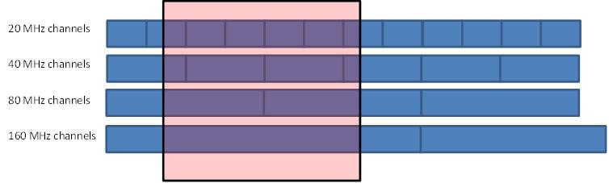

On this basis, for the so-called “Sim city” (with 5.25 M inhabitants), the calculation of the number of RLAN overlapping the EESS (active) bandwidth and the bandwidth factor is made as follows (for RLAN density option D1):



These calculation leads to the following basic assumptions that were used for sharing studies with SAR sensor:

– Number of RLAN overlapping the EESS (bandwidth) = **11279**

– Corresponding RLAN density per inhabitant = **0.0021**

– Average bandwidth factor per overlapping RLAN = -**1.94 dB**

Similarly, for RLAN density options D2-low and D2-high, the calculation of the number of RLAN overlapping the EESS (active) bandwidth is made as follows (noting that the bandwidth factor remains similar):



These calculation leads to the following basic assumptions that were used for sharing studies with SAR sensor:

– Number of RLAN overlapping the EESS (bandwidth) = **21000 (D2-low)** and **210000 (D2‑high)**

– Corresponding RLAN density per inhabitant = **0.004 (D2-low)** and **0.04 (D2-high)**

Summary for SAR sensor:

|  |  |  |  |
| --- | --- | --- | --- |
| RLAN density option | Nb of RLAN overlapping the 100 MHz EESS bandwidth | Nb of RLAN per inhabitant (density) overlapping the 100 MHz EESS bandwidth | Average bandwidth factor |
| **D1** | 11279 | 0.0021 | -1.94 dB |
| **D2-low** | 21000 | 0.004 | -1.94 dB |
| **D2-high** | 210000 | 0.04 | -1.94 dB |

#### 4.2.1.2 Altimeter sensor with 320 MHz bandwidth

The overlapping of the EESS (active) altimeter bandwidth on the RLAN channel plan is described below:

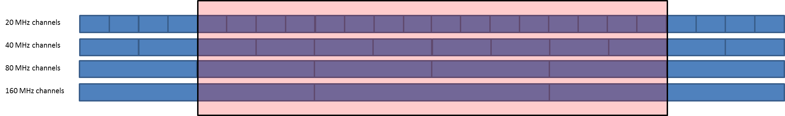

On this basis, for the so-called “Sim city” (with 5.25 M inhabitants), the calculation of the number of RLAN overlapping the EESS (active) bandwidth and the bandwidth factor is made as follows (for RLAN density option D1):



These calculation leads to the following basic assumptions for sharing studies:

– Number of RLAN overlapping the EESS (bandwidth) = **25297**

– Corresponding RLAN density per inhabitant = **0.0048**

– Average bandwidth factor per overlapping RLAN = -**0.4 dB**

Similarly, for RLAN density option options D2-low and D2-high, the calculation of the number of RLAN overlapping the EESS (active) bandwidth is made as follows (noting that the bandwidth factor remains similar):





These calculation leads to the following basic assumptions for sharing studies:

– Number of RLAN overlapping the EESS (bandwidth) = **47103 (D2-low)** and **471021 (D2‑high)**

– Corresponding RLAN density per inhabitant = **0.00897 (D2-low)** and **0.0897 (D2-high)**

Summary for Altimeter sensor:

|  |  |  |  |
| --- | --- | --- | --- |
| RLAN density option | Nb of RLAN overlapping the 320 MHz EESS bandwidth | Nb of RLAN per inhabitant (density) overlapping the 320 MHz EESS bandwidth | Average bandwidth factor |
| **D1** | 25297 | 0.0048 | -0.4 dB |
| **D2-low** | 47103 | 0.00897 | -0.4 dB |
| **D2-high** | 471021 | 0.0897 | -0.4 dB |

#### 4.2.1.3 Scatterometer sensor with 2 MHz bandwidth

The overlapping of the EESS (active) scatterometer bandwidth on the RLAN channel plan is described below:

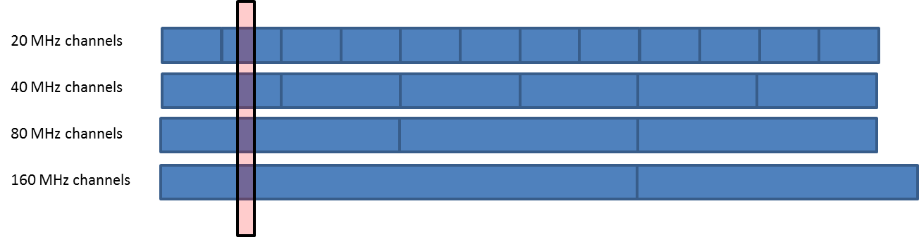

On this basis, for the so-called “Sim city” (with 5.25 M inhabitants), the calculation of the number of RLAN overlapping the EESS (active) bandwidth and the bandwidth factor is made as follows (for RLAN density option D1):



These calculation leads to the following basic assumptions for sharing studies:

– Number of RLAN overlapping the EESS (bandwidth) = 5 786

– Corresponding RLAN density per inhabitant = 0.0011

– Average bandwidth factor per overlapping RLAN = -16.03 dB

Similarly, for RLAN density option options D2-low and D2-high, the calculation of the number of RLAN overlapping the EESS (active) bandwidth is made as follows (noting that the bandwidth factor remains similar):





These calculation leads to the following basic assumptions for sharing studies:

– Number of RLAN overlapping the EESS (bandwidth) = 10 773 (D2-low) and 107 722 (D2-high).

– Corresponding RLAN density per inhabitant = 0.0021 (D2-low) and 0.021 (D2-high).

Summary for SCA sensor:

|  |  |  |  |
| --- | --- | --- | --- |
| RLAN density option | Nb of RLAN overlapping the 2 MHz EESS bandwidth | Nb of RLAN per inhabitant (density) overlapping the 2 MHz EESS bandwidth | Average bandwidth factor |
| **D1** | 5 786 | 0.0011 | -16.03 dB |
| **D2-low** | 10 773 | 0.0021 | -16.03 dB |
| **D2-high** | 107 722 | 0.021 | -16.03 dB |

### 4.2.2 Sharing and compatibility studies with EESS (active) in the 5 350-5 470 MHz band

#### 4.2.2.1 Status of sharing studies

Sharing and coexistence between RLAN and EESS (active) in the 5 350-5 470 MHz band were studied during the previous study period (in JTG 4-5-6-7) and led to the following conclusion (see CPM Report to the 2015 World Radiocommunication Conference (Document N° 3 of WRC‑15)):

*“Results of sharing studies show that with the RLAN parameters described above, sharing between RLAN and the EESS (active) systems in the 5 350-5 470 MHz frequency band would not be feasible. Sharing may only be feasible if additional RLAN mitigation measures are implemented.”*

One should also highlight the fact that these findings are duly reproduced in Recognising a) of Resolution **239 (WRC-15)**.

These conclusions were developed after intensive studies on sharing and coexistence between RLAN in the 5 350-5 470 MHz band and EESS (active) mainly with EESS (active) SAR systems. These conclusions are summarised in the preliminary draft new Report ITU-R RS.[EESS RLAN 5 GHz] on *“Sharing studies between RLAN and EESS (active) systems in the frequency range 5 350-5 470 MHz”* (see Annex 35 to Document [4-5-6-7/715](http://www.itu.int/md/R12-JTG4567-C-0715/en) (Chairman’s Report)). Taking into account the whole ranges of RLAN parameters (e.g. antenna gain discrimination, devices densities, outdoor ratio, building attenuation) under all scenarios, these studies shows that RLAN deployment in the frequency band 5 350-5 470 MHz would create large interference in the CSAR sensor on board the Sentinel-1 satellite (up to 30.4 dB).

Additional studies have been performed using static and dynamic analysis with altimeter (Sentinel-3 Altimeter sensor (SRAL)) and scatterometer (EPS-SG sensor (SCA)) and are given in Annexes 3 and 4, repsectively. These studies take into account similar assumptions and ranges of RLAN parameters (e.g. antenna gain discrimination, devices densities, outdoor ratio, building attenuation) than those considered for analysis made for SAR sensors during previous study period.

These studies confirms that, under all scenarios, RLAN deployment in the 5 350-5 470 MHz band would create large interference to altimeters (up to 26.6 dB) and scatterometers (up to 20.9 dB), hence in the same order of magnitude than for SAR sensors.

All together, these studies confirm the findings of JTG 4-5-6-7 and CPM-15-2 that sharing between RLAN and EESS (active) in the 5 350-5 470 MHz band may only be feasible if additional RLAN mitigation measures are implemented.

Consistently with Resolution **239 (WRC-15)**, the work in this frequency band should hence concentrate on studying whether any additional mitigation techniques beyond those analysed in the previous studies would provide coexistence between WAS/RLAN systems and EESS (active) in the in the 5 350-5 470 MHz band.

#### 4.2.2.2 Consideration of potential RLAN mitigation techniques

No mitigation techniques have been identified for sharing and compatibility studies with EESS (active) in the 5 350-5 470 MHz band.

## 4.3 Sharing and compatibility of Radiolocation with WAS/RLAN in the 5 350‑5 470 MHz

### 4.3.1 Sharing and compatibility studies for 5 350-5 470 MHz without RLAN mitigation techniques

#### 4.3.1.1 Compatibility of WAS/RLAN with airborne radars of the radiolocation service in the frequency band 5 350-5 470 MHz

TABLE 4.x

Technical characteristics and protection criteria of ground based radars in the radiolocation service   
 operating in separate frequency bands 5 350-5 470 MHz MHz

|  |  |  |  |  |  |  |
| --- | --- | --- | --- | --- | --- | --- |
| Radar | Radar 2 | Radar 3 | Radar 4 | Radar 5 | Radar 7 | Radar 9 |
| Location | Ground | Ground | Ground | Ground | Ground, shipborne | Airborne | |
| Тn, К | 627 | 627 | 3361 | 627 | 2610 | 359 | |
| Рnoise, add, dBW | -147 | -141 | -130 | -132 | -134 | -143 | |
| Iadd, dBW | -153 | -147 | -136 | -138 | -140 | -153 | |
| Radar | Radar 12 | Radar 13 | Radar 15 | Radar 17 | Radar 19 | Radar 20 |
| Location | Ground, shipborne | Ground | Ground | Airborne | Ground | shipborne |
| Тn, К | 438 | 289 | 202 | 865 | 289 | 170 |
| Рnoise, add, dBW | -134 | -140 | -133 | -141 | -145 | -149 |
| Iadd, dBW | -140 | -146 | -139 | -151 | -151 | -155 |
| Radar | Radar 21 | Radar 22 | Radar 23 |  |  |  |
| Location | Ground | Ground | Ground |  |  |  |
| Тn, К | 289 | 627 | 5496 |  |  |  |
| Рnoise, add, dBW | -145 | -135 | -124 |  |  |  |
| Iadd, dBW | -151 | -141 | -130 |  |  |  |

Interference from RLAN transmitters to operation of air-borne radiolocation stations was estimated using the scenario presented in Figure 4.2 addressing air-borne radars of type 9 and 17 (Recommendation ITU-R [М.1638-1](http://www.itu.int/rec/R-REC-M.1638/en)).

FIGuRE 4.2

Interference scenario for air-borne receivers



Analysis of data given in Table 3.5.1-1 and Table 4.x shows that airborne Radar 9 and Radar 17 operate in the frequency band 5 350-5 470 MHz. Interference impact assessment from RLAN to these radars was performed subject to the interference scenario given above. Table 4.3 contains the calculation results of the required separation distance for airborne Radars from single outdoor and indoor RLAN transmitters, obtained by using the propagation model given in Recommendation ITU-R P.525-3.

TABLE 4.3

Worst case separation distances (km) between air-borne radars   
from indoor and outdoor deployed RLANs without mitigation techniques

|  |  |  |  |  |
| --- | --- | --- | --- | --- |
|  | EIRPeff=-7 dBW, σ=0 dB | | EIRPeff=-7 dBW, σ=20 dB | |
| ΔFRLAN, MHz | 20 | 160 | 20 | 160 |
| Radar 9 | >RLOS | >RLOS | 200 | 71 |
| Radar 17 | >RLOS | 342 | 97 | 34 |

In addition the required separation distances for Radars 9 and 17 were estimated based on the propagation model given in Recommendation ITU-R P. The estimation results are presented in Table 4.3A.

table 4.3A

Worst case separation distances (km) required for protecting air-borne   
radars from indoor and outdoor deployed RLANs

|  |  |  |  |  |
| --- | --- | --- | --- | --- |
|  | EIRPeff=-7 dBW, σ=0 dB | | EIRPeff=-7 dBW, σ=20 dB | |
| ΔFRLAN, MHz | 20 | 160 | 20 | 160 |
| Radar 9 | >RLOS | >RLOS | 370 | 140 |
| Radar 17 | >RLOS | >RLOS | 185 | 70 |

Analysis of the results reflected in Table 4.3 and Table 4.3A shows that under the assumptions in the study even in case of a single-source interference caused by outdoor RLAN transmitter the separation distance could far exceed line-of-sight distance between an air-borne radar receiver and a RLAN transmitter. In case of deployment of a RLAN indoor transmitter the separation distance could range from 90 km to 370 km depending on the RLAN bandwidth.

Estimation of the required separation distances was also conducted assuming multisource interference caused by three simultaneously operating indoor and outdoor RLAN transmitters deployed in a single building. The estimation results for the propagation model given in Recommendation ITU-R P.525-3 are shown in Table 4.4. The estimation results for the propagation model described in Recommendation ITU-R P.528-3 are shown in Table 4.4A.

TABLE 4.4

Separation distances (km) between air-borne radars  
 from three indoor and outdoor deployed RLANs without mitigation techniques

|  |  |  |  |  |
| --- | --- | --- | --- | --- |
|  | EIRPeff=-7 dBW, σ=0 dB | | EIRPeff=-7 dBW, σ=20 dB | |
| ΔFRLAN, MHz | 20 | 160 | 20 | 160 |
| Radar 9 | >RLOS | >RLOS | 344 | 122 |
| Radar 17 | >RLOS | >RLOS | 166 | 59 |

TABLE 4.4A

Separation distances (km) required for protecting air-borne radars  
from three indoor and outdoor deployed RLANs

|  |  |  |  |  |
| --- | --- | --- | --- | --- |
|  | EIRPeff=-7 dBW, σ=0 dB | | EIRPeff=-7 dBW, σ=20 dB | |
| ΔFRLAN, MHz | 20 | 160 | 20 | 160 |
| Radar 9 | >RLOS | >RLOS | >RLOS | 265 |
| Radar 17 | >RLOS | >RLOS | 310 | 115 |

Analysis of estimation results described in Table 4.4 and Table 4.4A shows that based on the assumptions in the study a partial consideration of multisource interference caused by RLANs transmitters would result in significant increase of separation distances for operation of air-borne radar without interference.

Further clarification of effect caused by multisource interference, e.g. when, say, 100 outdoor RLANs transmitters operate in buildings of one urban quarter, would result in a separation distance which would significantly exceed line-of-sight distance for airborne radars at the altitude of 10 km.

Consideration of interference caused by deployed in one urban quarter indoor RLANs transmitters with 20 MHz signal bandwidth shows that the separation distance would exceed the line‑of-sight distance for Radars 9 and 17. Consideration of RLANs transmitters with 160 MHz signal bandwidth would result in the separation distance exceeding the line-of-sight distance for Radar 9. The separation distance would be 342 km for Radar 17. Based on the assumptions used in this study compatibility between RLANs and air-borne radars is difficult in the 5 350 – 5 470 MHz frequency band.

#### 4.3.1.2 Compatibility of WAS/RLAN with ground radars of the radiolocation service in the frequency bands 5 350-5 470 MHz

TABLE 4.x

Technical characteristics and protection criteria of ground based meteorological radars

|  |  |  |  |  |  |  |
| --- | --- | --- | --- | --- | --- | --- |
| Radar | Radar 1 | Radar 4 | Radar 8 | Radar 12 | Radar 13 | Radar 14 |
| Location | Ground | | | | | |
| Тn, К | 1 163 | 289 | 289 | 159 | 75 | 149 |
| Рnoise, add, dBW | -141 | -146 | -134 | -151 | -150 | -144 |
| Iadd, dBW | -151 | -156 | -144 | -161 | -160 | -154 |

Compatibility evaluation of WAS/RLAN with ground-based radars operating in the considered frequency bands was performed in line with the interference scenario given below.

FIGURE 4.3

Interference scenario for RLS ground-based radar receiver



Interference was estimated using a propagation model described in Recommendation ITU-R [Р.452](http://www.itu.int/rec/R-REC-P.452/en). The assumed height of RLANs transmitters was 14 m, 20 m and 26 m. Instead of using Rec. ITU-R [P.2108](https://www.itu.int/rec/R-REC-P.2108/en), propagation loss in walls was considered using the following equation:

, dBW (6)

where:

σ – additional fading, dB.

Fading in walls was assumed as 20 dB. The assumed radar antenna height above the ground level was 20 m. Multi-source interference was taken into account using equation (5).

Table 4.5 presents minimum estimated separation distances between ground-based radiodetermination radars and a single-source interference caused by outdoor RLAN transmitters in the frequency bands 5 350-5 470 MHz. Estimations were conducted for two operation modes of RLAN with bandwidth of 20 MHz and 160 MHz. Estimation was also conducted assuming multisource interference caused by three simultaneously operating indoor RLAN transmitters deployed in a single building at the same heights of RLAN.

TABLE 4.5

Separation distances (km) between ground-based radiolocation radars and outdoor deployed RLANs in the frequency band 5 350-5 470 MHz without mitigation techniques

| RLAN bandwidth | 20 MHz | | | | 160 MHz | | | |
| --- | --- | --- | --- | --- | --- | --- | --- | --- |
| RLAN transmitter height, m | 14 | 20 | 26 | Σ | 14 | 20 | 26 | Σ |
| Radar 2 | 63 | 65 | 68 | 71 | 48 | 54 | 57 | 60 |
| Radar 3 | 54 | 57 | 59 | 62 | 44 | 47 | 50 | 53 |
| Radar 4 | 44 | 48 | 50 | 52 | 36 | 39 | 42 | 44 |
| Radar 5 | 49 | 51 | 54 | 58 | 40 | 43 | 46 | 48 |
| Radar 7 | 32 | 34 | 38 | 39 | 25 | 28 | 32 | 33 |
| Radar 12 | 34 | 38 | 40 | 42 | 27 | 31 | 33 | 35 |
| Radar 13 | 54 | 56 | 58 | 61 | 44 | 47 | 50 | 52 |
| Radar 15 | 54 | 57 | 59 | 62 | 45 | 48 | 50 | 53 |
| Radar 19 | 54 | 57 | 59 | 62 | 45 | 48 | 51 | 53 |
| Radar 20 | 52 | 54 | 57 | 60 | 43 | 46 | 48 | 51 |
| Radar 21 | 54 | 57 | 60 | 63 | 45 | 48 | 51 | 53 |
| Radar 22 | 42 | 44 | 47 | 49 | 33 | 37 | 40 | 42 |
| Radar 23 | 31 | 34 | 37 | 38 | 24 | 28 | 31 | 38 |

Analysis of the estimation results described in Tables 4.5 shows that the separation distances between ground radars and RLANs based on the assumptions in this study would be of several dozen km even for RLANs using data transfer channel of 160 MHz. For example, in the frequency band 5 350-5 470 MHz for Radar 2 suffering interference from RLAN transmitter using a data channel of 160 MHz bandwidth and deployed at a height of 26 m the estimated separation distance is 57 km. Based on the above the conclusions may be drawn that enlarging RLANs bandwidth to reduce spectral density of interference caused for radars may not be considered as one of the interference mitigation techniques in relation to ground-based radiodetermination radars.

Minimum separation distances between required for protection of ground radars and a single-source interference caused by indoor RLAN transmitters in the frequency bands 5 350-5 470 MHz are presented in Tables 4.6. Estimations were conducted for two operation modes of RLAN. Estimation was also conducted assuming multisource interference caused by three simultaneously operating indoor RLAN transmitters deployed in a single building at height of 14 m, 20 m. and 26 m.

TABLE 4.6

Separation distances (km) between ground-based radiolocation radars and indoor deployed RLANs in the frequency band 5 350-5 470 MHz without mitigation techniques

| RLAN bandwidth | 20 MHz | | | | 160 MHz | | | |
| --- | --- | --- | --- | --- | --- | --- | --- | --- |
| RLAN transmitter height, m | 14 | 20 | 26 | Σ | 14 | 20 | 26 | Σ |
| Radar 2 | 41 | 44 | 47 | 49 | 33 | 36 | 39 | 41 |
| Radar 3 | 35 | 38 | 41 | 43 | 28 | 31 | 34 | 36 |
| Radar 4 | 28 | 31 | 34 | 36 | 22 | 26 | 26 | 29 |
| Radar 5 | 31 | 34 | 37 | 39 | 24 | 28 | 31 | 32 |
| Radar 7 | 17 | 18 | 18 | 24 | 6 | 6 | 6 | 10 |
| Radar 12 | 21 | 23 | 24 | 27 | 8 | 8 | 8 | 15 |
| Radar 13 | 34 | 37 | 40 | 41 | 28 | 31 | 33 | 35 |
| Radar 15 | 35 | 38 | 41 | 43 | 28 | 31 | 34 | 36 |
| Radar 19 | 35 | 38 | 41 | 43 | 28 | 31 | 34 | 36 |
| Radar 20 | 33 | 37 | 39 | 41 | 27 | 30 | 32 | 34 |
| Radar 21 | 35 | 38 | 41 | 43 | 28 | 32 | 34 | 36 |
| Radar 22 | 26 | 29 | 32 | 33 | 21 | 23 | 24 | 26 |
| Radar 23 | 15 | 15 | 15 | 21 | 5 | 5 | 5 | 8 |

Analysis of the estimation results described in Tables 4.6 shows that in spite of reducing the level of interference due to fading in the walls separation distances of several tens km are needed under the assumptions in this study. The results shown in these Tables were gained for the walls with propagation loss of 20 dB. However it is to note that the level of signal fading in walls is overestimated for a significant number of buildings, office ones specifically. Therefore, the separation distances would exceed those shown in Table 4.6.

#### 4.3.1.3 Compatibility of WAS/RLAN with ground meteorological radars in the frequency bands 5 350-5 470 MHz MHz

Separationdistances for the ground-based meteorological radars operating in the frequency bands considered were also estimated in line with the interference scenario depicted in Figure 4.3 and assumptions in the study. Interference was estimated using a free space propagation model described in Recommendation ITU-R [Р.452](http://www.itu.int/rec/R-REC-P.452/en). The assumed height of RLANs transmitters was 14 m, 20 m and 26 m. Estimation was also conducted assuming multisource interference caused by three simultaneously operating RLAN transmitters deployed in a single building at height of 14 m, 20 m and 26 m. Propagation loss in walls were considered using expression (6). Fading in walls was assumed as 20 dB. The assumed radar antenna height above the ground level was 20 m. Multi-source interference was taken into account using equation (5).

Table 4.7 present minimum estimated separation distances between ground-based meteorological radars and outdoor RLAN transmitters. Estimations were conducted for two modes of RLAN operation.

TABLE 4.7

Separation distances (km) between ground-based meteorological radars and outdoor deployed RLANs in the frequency band 5 350-5 470 MHz without mitigation techniques

|  |  |  |  |  |  |  |  |  |  |
| --- | --- | --- | --- | --- | --- | --- | --- | --- | --- |
| RLAN bandwidth | 20 MHz | | | | 160 MHz | | | | |
| RLAN transmitter height, m | 14 | 20 | 26 | Σ | 14 | 20 | 26 | Σ |
| Radar 1 | 46 | 49 | 51 | 54 | 38 | 41 | 44 | 49 |
| Radar 4 | 54 | 56 | 59 | 62 | 44 | 47 | 50 | 52 |
| Radar 8 | 60 | 62 | 65 | 68 | 50 | 53 | 55 | 59 |
| Radar 12 | 63 | 66 | 69 | 72 | 53 | 55 | 58 | 61 |
| Radar 13 | 75 | 77 | 79 | 83 | 62 | 65 | 68 | 71 |
| Radar 14 | 64 | 66 | 68 | 70 | 53 | 55 | 58 | 61 |

Analysis of the estimation results described in Table 4.7 shows that for example, in the Radar frequency band 5 350‑5 470 MHz the separation distance would be up to 79 km for Radar 13 assuming a single RLAN transmitter using a data channel of 20 MHz bandwidth deployed at height of 26 m. In case of a RLAN transmitter using a 160 MHz channel bandwidth the separation distance would reduce to 68 km and still would be of several tens km even for the other considered Radar types.Based on the above the conclusions may be drawn that enlarging RLANs bandwidth to reduce spectral density of interference caused for radars may not be sufficient.

Table 4.8 presents minimum estimated separation distances between meteorological radars andindoor RLAN transmitters based on the assumptions used in this study.

TABLE 4.8

Separation distances (km) between ground-based meteorological radars and indoor deployed RLANs in the frequency band 5 350-5 470 MHz without mitigation techniques

|  |  |  |  |  |  |  |  |  |
| --- | --- | --- | --- | --- | --- | --- | --- | --- |
| RLAN bandwidth | 20 MHz | | | | 160 MHz | | | |
| RLAN transmitter height, m | 14 | 20 | 26 | Σ | 14 | 20 | 26 | Σ |
| Radar 1 | 29 | 33 | 36 | 37 | 24 | 27 | 29 | 31 |
| Radar 4 | 34 | 38 | 41 | 43 | 28 | 31 | 34 | 36 |
| Radar 8 | 39 | 42 | 45 | 48 | 32 | 35 | 37 | 39 |
| Radar 12 | 41 | 44 | 47 | 49 | 33 | 36 | 39 | 41 |
| Radar 13 | 47 | 50 | 53 | 56 | 39 | 42 | 44 | 46 |
| Radar 14 | 44 | 47 | 49 | 51 | 36 | 38 | 41 | 43 |

Analysis of the estimation results described in Tables 4.8 shows that in spite of reducing the level of interference to operation of the ground-based meteorological radar receivers the majority of them would require separation distances of several tens km. The results shown in Table 4.8 were gained for the walls with propagation loss of 20 dB instead of Rec. ITU-R P.2108.

### 4.3.2 Sharing and compatibility studies with RLAN mitigation techniques

For sharing between RLAN and meteorological radar the application of a mitigation technique, like DFS is required. Table 4.3.2-1 provides a summary of the DFS requirements for the frequency band 5 350-5 470 MHz. These parameters proved to allow WAS to avoid interfering with the radio determination service in the band 5 600-5 650 MHz.

Table 4.3.2-1

| Parameter | Values for the frequency band 5 350-5 470 MHz |
| --- | --- |
| Minimum pulse width (see detailed test signals in Report ITU-R M.2115) | 0.5 μs |
| PRF (see detailed test signals in Report ITU-R M.2115) | Fixed, Staggered and Interleaved |
| Channel Availability Check (CAC) time | 10 minutes |
| Off-Channel CAC (Note 1) | Yes |
| CAC and Off-Channel CAC detection probability (Note 2) | 99.99% |
| In-service monitoring detection probability | 60% |
| CAC for slave devices with power above 200 mW (after initial detection by In-service) | Yes |
| Detection Threshold | -62 +10 -EIRP Spectral Density (dBm/MHz) + G (dBi), however the DFS threshold level shall not be lower than -64 dBm assuming a 0 dBi receive antenna gain |
| Channel Move time | 10s |
| Channel closing time | 1s |
| Non-occupancy period | 30 minutes |
| Possibility to exclude 5 600‑5 650 MHz band from the channel plan or to exclude these channels from the list of usable channels | Yes |
| Requirement that none of the DFS related settings are accessible to the end‑user | Yes |

## 4.4 Sharing and compatibility of Radionavigation versus WAS/RLAN in the 5 460‑5 470 MHz

### 4.4.1 Sharing and compatibility studies without RLAN mitigation techniques

TABLE 4.x

Technical characteristics and protection criteria of radars in the radionavigation service   
operating in the frequency bands 5 460-5 470 MHZ

|  |  |  |
| --- | --- | --- |
| Radar | Radar 10 | Radar 10A |
| Тn, К | 289 | 289 |
| Рnoise, add, dBW | -134 | -134 |
| Iadd, dBW | -144 | -144 |

In accordance with Recommendation ITU-R M.1638-1 two types of ground-based navigation radars: Radar 10 and Radar 10A operate in this frequency band. The technical characteristics and protection criteria are given in Table 3.3 and Table 4.x. For the specified Radars the separation distances were estimated in line with interference scenario shown in Figure 4.3. With this a propagation model, presented in Recommendation ITU-R Р.452 was used for estimation. The estimation assumed the height of RLAN transmitters to be 14 m, 20 m and 26 m. Estimation was also conducted assuming multisource interference caused by three simultaneously operating RLAN transmitters deployed in a single building at height of 14 m, 20 m and 26 m. Propagation loss in walls were considered using expression (6). Fading in walls was assumed as 20 dB. The assumed radar antenna height above the ground level was 20 m. Multi-source interference was taken into account using equation (5).

Table 4.10 presents minimum estimated separation distances between ground-based radionavigation radars and a single-source interference caused by outdoor RLAN transmitters. Table 4.10 also contains estimation results for a case of multiple interference caused by three simultaneously operating outdoor RLAN transmitters deployed out of a single building. Estimations were conducted for two modes of RLAN operation.

TABLE 4.10

Separation distances (km) between ground-based Radionavigation radars   
and outdoor deployed RLANs in the frequency band 5 460-5 470 MHz without interference mitigation techniques

|  |  |  |  |  |  |  |  |  |  |
| --- | --- | --- | --- | --- | --- | --- | --- | --- | --- |
| RLAN bandwidth | 20 MHz | | | | 160 MHz | | | | |
| RLAN transmitter height, m | 14 | 20 | 26 | Σ | 14 | 20 | 26 | Σ |
| Radar 10 | 47 | 50 | 53 | 55 | 38 | 41 | 44 | 46 |
| Radar 10а | 47 | 50 | 53 | 55 | 38 | 41 | 44 | 46 |

Analysis of the estimation results shows that the separation distances for radionavigation Radars and RLAN with bandwidth of 20 MHz would be of several dozen km. In case of a RLAN transmitter using a 160 MHz channel bandwidth the separation distance would be reduced and still the reduction will not exceed 20% from the separation distance for RLANs using data transfer channel of 20 MHz. Table 4.11 presents estimated separation distances between radionavigation radars and indoor RLAN transmitters.

TABLE 4.11

Separation distances (km) between ground-based radionavigation radars   
and indoor deployed RLANs in the frequency band 5 460-5 470 MHz without mitigation techniques

|  |  |  |  |  |  |  |  |  |  |
| --- | --- | --- | --- | --- | --- | --- | --- | --- | --- |
| RLAN bandwidth | 20 MHz | | | | 160 MHz | | | | |
| RLAN transmitter height, m | 14 | 20 | 26 | Σ | 14 | 20 | 26 | Σ |
| Radar 10 | 30 | 33 | 36 | 37 | 23 | 27 | 30 | 31 |
| Radar 10а | 30 | 33 | 36 | 37 | 23 | 27 | 30 | 31 |

Analysis of the estimation results shows that in spite of significant reduction of the interference level caused by RLAN transmitters separation distances of several tens km are needed.

### 4.4.2 Sharing and compatibility studies with RLAN mitigation techniques

No additional mitigation techniques have been identified for sharing and compatibility of Radionavigation versus WAS/RLAN in the 5 460‑5 470 MHz.

# 5 Summay of sharing and compatibility studies per service

## 5.1 General considerations

This report studies the sharing and compatibilities of WAS/RLAN with the aeronautical radionavigation, radiolocation, EESS (active) and radionavigation services in the 5 350-5 470 MHz frequency range, as well as the new mitigation techniques which could provide compatibility between WAS/RLAN systems and incumbent services.

## 5.2 Sharing and compatibility results for aeronautical radionavigation and radiolocation in the band 5 350-5 470 MHz without mitigation techniques

The compatibility study results of outdoor RLAN in the 5 350-5 470 MHz frequency band based on the assumptions in the study with airborne Radars of the aeronautical radionavigation and radiolocation services show that the separationdistances from several hundreds km up to line-of-sight distance. Consideration of potential multi-source interference from RLAN transmitters show that for protection of airborne Radar receivers based on the assumptions in this study the separation distance is equal to the line-of-sight distance in spite of RLAN transmitter bandwidth.

Based upon the assumptions used in the study, the separation distances between airborne radars and a single RLAN in the 5 350-5 470 MHz band range from several tens km to several hundreds km depending on RLAN transmitter bandwidth while consideration of multi-source interference shows that the separation distances equal to line-of-sight.

Based upon the assumptions used in the study for ground-based radiolocation Radars the separation distances from single-source interference range from several tens km for outdoor RLAN and indoor RLAN in 5 350-5 470 MHz as well while multi-source interference results in additional increase of separation distance subject to the RLAN transmitters’ density and the considered Radar operational characteristics.

Analysis of the estimated results show that compatibility in the 5 350-5 470 MHz frequency band of RLAN with aeronautical radionavigation and radiolocation Radars operating in this frequency band will be difficult.

No mitigation techniques have been proposed for sharing and compatibility of aeronautical radionavigation and radiolocation services versus WAS/RLAN in the 5 350‑5 470 MHz.

## 5.3 Sharing and compatibility results for EESS (active) in the band 5 350-5 470 MHz

Additional studies performed between WAS/RLAN and EESS (active) confirms that, under all scenarios studied, RLAN deployment in the 5 350-5 470 MHz frequency band would create large interference to altimeters (up to 26.6 dB) and scatterometers (up to 20.9 dB), hence in the same order of magnitude than for the CSAR sensor (up to 30.4 dB), considered during previous study period.

All together, these studies confirm the previous findings that sharing between RLAN and EESS (active) in the 5350-5470 MHz band may only be feasible if additional RLAN mitigation measures are implemented (see also *Recognising a)* of Resolution **239 (WRC-15)**).

Consistently with Resolution **239 (WRC-15)**, the work in this frequency band should hence concentrate on studying whether any additional mitigation techniques beyond those analysed in the previous studies would provide coexistence between WAS/RLAN systems and EESS (active) in the in the 5 350-5 470 MHz band.

Based on the results of the studies presented in this report, it can be concluded that no additional mitigation techniques have been proposed which could provide compatibility between WAS/RLAN systems and EESS (active) systems in the 5 350-5 470 MHz band.

## 5.4 Sharing and compatibility results for radionavigation in the band 5 460-5 470 MHz

Analysis of the estimation results shows that the separation distances for radionavigation Radars and RLAN would be of several tens km.

No mitigation techniques have been proposed for sharing and compatibility of radionavigation versus WAS/RLAN in the 5 460‑5 470 MHz.

ANNEX 1

List of current and planned EESS (active) systems in the 5 GHz range (non-exhaustive)

***Note****: This table has been derived to the best knowledge of the delegates attending the Space Frequency Coordination Group (SFCG) and WP 7C and should hence only be used as informative document since no guarantee can be offered that it fully covers all the existing and planned missions with sensors operating in the 5 GHz range.*

| Administration | Satellite | Sensor type | # Sats | Apogee/ Perigee (km/km) | Inclination (°) | Sat. Nb | Date of launch (Month and year) | Mission Duration | RAAN (°) | Argument of perigee (°) | True Anomaly (°) | EPOCH |
| --- | --- | --- | --- | --- | --- | --- | --- | --- | --- | --- | --- | --- |
| Canada | RADARSAT-2C | SAR | 1 | 789 | 98.6 | 1 | 12/2007 | 7 years  (design life)  Still operational | 173.5 | 90.0 | 38.8 | 15166.23953944 |
| RADARSAT-3B | SAR | 6 | 617/586 | 97.7 | 1 | 07/2018 | 7 years  (design life) Operational system, will be renewed | 250.8 | 90.0 | 120° separation | Not launched |
| 2 | 07/2018 | 7 years  (design life)  Operational system, will be renewed | 250.8 | 90.0 | Not launched |
| 3 | 07/2018 | 7 years  (design life)  Operational system, will be renewed | 250.8 | 90.0 | Not launched |
| 4 | Planned  2022 | 7 years  (design life) Operational system, will be renewed | 250.8 | 90.0 | TBD | Not launched |
| 5 | Planned  2022 | 7 years  (design life)  Operational system, will be renewed | 250.8 | 90.0 | TBD | Not launched |
| 6 | Planned  2022 | 7 years  (design life)  Operational system, will be renewed | 250.8 | 90.0 | TBD | Not launched |
| China | HY-2 | Altimeter and scatterometer | 1 | 963 | 99.34 | 1 | 08/2011 | 3 years  (design life)  Still operational | 253.7 | 54.1 | 306 | 17043.685370 |
| FY-3-A | Scatterometer | 1 | 854/818 | 98.75 |  |  | | | | | |
| 1 | Planned  11/2018 | no limit in time | 314.17 | 0 | 0 | Not launched |
|  |  | | | | | |
|  |  | | | | | |
| GC-3 | SAR | 1 | 755 | 98.4 | 1 | 08/2016 | 8 years  (design life)  Operational system, will be renewed | 128.11 | 0 | 202.12 | 30-04-2016  07:14:26.77 UTC |
| France  USA | SWOT | Altimeter | 1 | 890.582  **(Note 1)** | 78 | 1 | Planned  10/2020 | 3 years (design lifetime) | 22.36 | 90.0 | 270.12 (LAN) | Not launched |
| France  EUMETSAT  USA | JASON2/OSTM  /USOCEAN  **(Note 2)** | Altimeter | 1 | 1336 | 66 | 1 | 06/2008 | 6-10 years | 306.05 | 266.33 | 156.34 | 2016  272.15638603 |
| JASON3/OSTM  /USOCEAN | Altimeter | 1 | 1336 | 66 | 1 | 01/2016 | 6-10 years | 305.6 | 265.85 | 94.16 | 2016  272.53411538 |
| ESA | SENTINEL-1 | SAR | 4 | 701.2/684.5 | 98.183 | 1 | 04/2014 | Up to 12 years | 263.78 | 80.27 | 279.86 | 14/09/2016  04 :33 :48 |
| 2 | 04/2016 | Up to 12 years | 263.30 | 80.37 | 279.77 | 13/09/2016  21 :08 :45 |
| 3 | Planned  2021 | Up to 12 years | 263.XX | 80.XX | TBD | Not launched |
| 4 | Planned  2022 | Up to 12 years | 263.XX | 80.XX | TBD | Not launched |
| SENTINEL-3 | Altimeter | 4 | 808.1/791.5 | 98.6 | 1 | 02/2016 | Up to 12 years | 323.58 | 105.7 | 254.43 | 14/09/2016  04 :45 :07 |
| 2 | Planned  2017 | Up to 12 years | 323.XX | 105.XX | Expected 120° from Satellite #1 | Not launched |
| 3 | Planned  2023 | Up to 12 years | 323.XX | 105.XX | TBD | Not launched |
| 4 | Planned  2024 | Up to 12 years | 323.XX | 105.XX | TBD | Not launched |
| EUMETSAT | SENTINEL-6  (Jason-CS) | Altimeter | 2 | 1336 | 66 | 1 | Planned  2020 | 6-10 years | 306 | 90 | 180° separation | Not launched |
| 2 | Planned  2025 | 6-10 years | 306 | 90 | Not launched |
| ASCAT | Scatterometer | 3 | 832 | 98.7 | 1 | 10/2006 | 10-14 years | 330.19 | 157.1 | 203.07 (mean anomaly) | 2016  272.71848113 |
| 2 | 09/2012 | 10-14 years | 330.65 | 157.03 | 320.85 (mean anomaly) | 2016  272.63852887 |
| 3 | Planned  2018 | 10-14 years | 330.XX | 157.XX | TBD | Not launched |
| SCA | Scatterometer | 3 | 832 | 98.7 | 1 | Planned  2021 | 10-14 years | 62.4731+0.98564735 x (Nb Julian days from 1/1/2000) | 90 | 120° separation | Not launched |
| 2 | Planned  2023 | 10-14 years | 90 | Not launched |
| 3 | Planned  2029 | 10-14 years | 90 | Not launched |
| India | RISAT | SAR | 1 | 536.38 | 97.6 | 1 | TBD | TBD | TBD | TBD | TBD | TBD |
| Russia |  |  |  |  |  |  |  | | | | | |
| MINI-RSA  (on-board ISS) | SAR | 1 | 400.6/409.6 | 51.64 | 1 | Planned  4Q 2017 | Up to 7 years | 258.95 | 17.78 | 124.40 | 29.09.16 07:56:33 GMT+2 |
| GEO-IK-2  **(Note 3)** | Altimeter | 3 | 1000 | 99.4 | 1 | 06/2016 | no limit in time | TBD | TBD | TBD | TBD |
| 2 | Planned  2017 | no limit in time | TBD | TBD | TBD | TBD |
| 3 | TBD | no limit in time | TBD | TBD | TBD | TBD |

|  |  |  |
| --- | --- | --- |
| TOTAL | Altimeters | 13 |
| Scatterometers | 8 |
| SAR | 14 |
| TOTAL | 35 |

**Note 1**: Only 21-day repeat science orbit (890.6 km altitude) is shown; the 1-day repeat “fast-sampling orbit” has a 857.2 km altitude orbit.

**Note 2**: Starting the week of 3 October 2016 Jason-2 will be moved to an 'interleaved' orbit, ~160° different from Jason-3, to split the ground track and separate them by about 1/2 of the repeat cycle (5 of the ~10 days). The inclination and altitude will be the same, but not the phase.

**Note 3:** Satellites of the constellation use different orbital planes, which are separated by 120°.

ANNEX 2

Detailed characteristics of EESS (active) systems

Several types of synthetic aperture radars (SAR), altimeters, and scatterometers are identified as EESS (active) missions in the frequency bands between 5 150 MHz and 5 925 MHz to be studied under agenda item 1.16. Typical characteristics for EESS (active) sensors are shown in Table 2 for frequency overlaps that should be considered in sharing studies within these bands. The actual mission names as well the generic names which will be used in the final recommendation are provided in the table. It should be noted that the service area for most of these active sensors is global.

Table 1

Typical parameters of EESS (active) sensors in the 5 250-5 570 MHz band

| Mission/Sensor | SAR-D1  (Sentinel- 1 (CSAR)) | SAR-D2 (ASAR) | SAR-D3 (RISAT-1) | SAR-D4 (Radarsat-2) | SAR-D5 (Radarsat-3 (RCM)) | SAR-D6 (Radarsat Next Generation (RNG)) | SAR-D7 (GC-3) |
| --- | --- | --- | --- | --- | --- | --- | --- |
| Sensor type | SAR | SAR | SAR | SAR | SAR | SAR | SAR |
| Type of orbit | Circular SSO | SSO, circular | SSO | Near circular | Near circular | Near circular | Near circular |
| Altitude, km | 693 | 764 | 536 | 792-813 | 586.9-615.2 | 586.9-615.2 | 755 |
| Inclination, deg | 98.18 | 98.6 | 97 | 98.6 | 97.74 | 97.74 | 98.4 |
| Ascending Node LST | 18:00/6:00[1] | 10:30 | 6:00 | 6:00 | 6:00 | 6:00 | 18:00 |
| Repeat period, days | 12 | 35 | 13 | 24 | 12 | 12 | 29 |
| Antenna type | Phase array | Phase array | Planar Phased Array | Planar Phased Array | Planar Phased Array | Planar Phased Array | Planar Phased Array |
| Number of beams | 1 | 1 | 1 | 1 | 1 | 1 | 1 |
| Antenna Size/diameter | 12.3 m × 0.8 m | 10 m × 1.3 m | 10 m × 3 m | 15 m × 1.5 m | 6.88 m × .37 m | 6.88 m × 1.37 m | 15 m× 1.232 m |
| Antenna Pk Xmt Gain, dBi | 43.5 to 45.3 | 40 to 45 | 35 | 49[2] | 453 | 453 | 48 |
| Antenna Pk Rcv Gain, dBi | 43.5 to 44.8 | 40 to 45 | 35 | 493 | 453 | 453 | 48 |
| Polarization | V, H | H, V | Linear H,V | HH, HV, VH, VV | HH, VV, HV, VH, CH, CV | HH, VV, HV, VH, CH, CV | HH, HV, VH, VV |
| Antenna beam look angle, deg | 20-47[3] | 15-45 | 10-45 | 9-50 | 16-51 | 16-53 | 10-60 |
| Antenna beam azimuth angle, deg | 90 | 90 | 90 | 0 | 0 | 0 | 0 |
| Antenna elev. beamwidth, deg | 6 to 8 | 2.5 | 4.6 | 1.88 (for focused beam) | 2.05 (for focused beam) | 2.05 (for focused beam) | 2.288 |
| Antenna az. beamwidth, deg | 0.3 | 0.3 | 1.4 | 0.19 | 0.42(for focused beam) | 0.42(for focused beam) | 0.188 |
| Swath width (km) | 20-410 | 10-405 | 10-225 | 18-500 | 20-500 | 20-500 | 10~650 |
| RF center frequency, MHz | 5 405 | 5 331 | 5 350 | 5 405 | 5 405 | 5 405 | 5 400 |
| RF bandwidth, MHz | 100 | 16 | 18.75-75 | 11.6, 17.3, 30, 50, 100 | 14-100 | 14-300 | 2-240 |
| Transmit Pk pwr, W | 4 140 | 2 500 | 4 000 | 2 400 or  3 700 | 1 490 | 1 990 | 15 360 |
| Transmit Ave. pwr, W | 370 | 200 | 260 | 300 | 180 | 240 | 1 900 |
| Pulsewidth, μsec | 5 to 53 | 16 to 41 | 2 0 | 21,42 | 10 to 50 | 10 to 50 | 15 to 50 |
| Pulse Repetition Frequency (PRF) Hz | 1 450-2 000 | 1 600‑2 100 | 3 250 | 1 000-2 800 | 2 000-7 000 | 2 000-7 000 | 1 100-4 500 |
| Chirp rate, MHz/μsec | 0.34-3.75 | 0.39 | 0.937-3.75 | 0.27 to 2.38 | 0.14 to 10 | 0.14 to 10 | 0.13 to 6.85 |
| Transmit duty cycle, % | 0.5-9.0 depending on ops mode | 8.61 | 6.5 | Variable, max 8% | Variable, max 12% | Variable, max 12% | Variable, max 20% |
| e.i.r.p. ave, dBW | 70 (for 9% duty cycle) | 68.0 | 68 | Approx. 73[4] | 67.67 | 69.0 | Approx. 80.7 |
| e.i.r.p. peak, dBW | 80 | 78.0 | 71.0 | 83.5[5] | 76.7 | 78.0 | 89.8 |
| System Noise figure, dB | 3.2 | 4.5 | 5.8 | 6 | 6 | 6 | 4 |

| Mission/Sensor | ALT-D1 (JASON-2/3 SSALT, POSEIDON-3/3B) (Note 3) | ALT-D2  (Sentinel 3 SRAL) (Note 1 & 3) | ALT-D3 (HY-2A)  (Note 3) | ALT-D4 (Sentinel-6 POSEIDON-4)  (Notes 1, 2  & 3) | ALT-D5  (SWOT)  (Note 3) |
| --- | --- | --- | --- | --- | --- |
| Sensor type | Altimeter | Altimeter | Altimeter | Altimeter | Altimeter |
| Type of orbit | NSS | Circular, SSO | SSO | NSS | NSS |
| Altitude, km | 1 336 | 814 | 963 | 1 336 | 890 |
| Inclination, deg | 66 | 98.65 | 99.3 | 66 | 78 |
| Ascending Node LST | NSS | 22:00 | 06:00 | NSS | NSS |
| Repeat period, days | 10 | 27 | 14 | 10 | 21 |
| Antenna type | Parabolic reflector | Parabolic reflector | Parabolic reflector | Parabolic reflector | Parabolic reflector |
| Number of beams | 1 | 1 | 1 | 1 | 1 |
| Antenna Size/diameter | 1.2 m | 1.2 m | 1.4 m | 1.2 m | 1.2 m |
| Antenna Pk Xmt Gain, dBi | 32 | 34.5 | 35; 43 | 33.5 | 32 |
| Antenna Pk Rcv Gain, dBi | 32 | 34.5 | 35; 43 | 33.5 | 32 |
| Polarization | linear | linear | linear VV | linear | linear |
| Azimuth scan rate, rpm | 0 | 0 | 0 | 0 | 0 |
| Antenna beam look angle, deg | 0 | 0 | 0 | 0 | 0 |
| Antenna beam azimuth angle, deg | 0 | 0 | 0 | 0 | 0 |
| Antenna elev. beamwidth, deg | 3.4 | 3.4 | 2.3 | 3.4 | 3.4 |
| Antenna az. beamwidth, deg | 3.4 | 3.4 | 2.3 | 3.4 | 3.4 |
| Swath width (km) | 79.4 | 48.4 | 38.7 | 97 | 52.9 |
| RF center frequency, MHz | 5 300 | 5 410 | 5 250 | 5 410 | 5 300 |
| RF bandwidth, MHz | 100, 320 | 320 | 160 | 320 | 100, 320 |
| Transmit Pk pwr, W | 17 | 32 | 20 | 25 | 17 |
| Transmit Ave. pwr, W | 0.51 | 0.4 (LRM), 0.25 (SAR) | 8.2 | <2 | 0.51 |
| Pulsewidth, μsec | 106.0 | 49 | 102.4 | 32 | 106.0 |
| Pulse Repetition Frequency (PRF) Hz | 300 | 275 (LRM), 157 (SAR) | 670 | 2 060-9 280 | 300 |
| Chirp rate, MHz/μsec | 0.9, 3.0 | 6.5 | 1.56 | 9.69 | 0.9, 3.0 |
| Transmit duty cycle, % | 3.1 | 1.5 (LRM),  0.7 (SAR) | 40.96 | 30 | 3.1 |
| e.i.r.p. ave, dBW | 29.5 | 30.8 (LRM), 28.4 (SAR) | 44.1 | 36.51 | 29.5 |
| e.i.r.p. peak, dBW | 44.8 | 49.5 | 48 | 47.47 | 44.8 |
| System Noise figure, dB | 4.45 | 3.8 | 3.5 | 3.5 | 4.45 |

Note 1 − Dual frequency radar altimeter (C/Ku Band) which performs measurements either in low resolution mode (LRM) or synthetic aperture radar mode (Nadir-SAR). LRM mode is the conventional altimeter pulse limited mode with interleaved C/Ku Band pulses, while Nadir-SAR mode is the high along track resolution mode based on SAR processing. The system is a two-satellite constellation.

Note 2 – The Poseidon-4 altimeter of Sentinel-6 is an evolution of the Poseidon-3/3B, SIRAL and SRAL altimeters of the Jason-3, CryoSat-2 and Sentinel-3 satellites, respectively.

Note 3 – It should be noted that EESS (active) altimeters may experience the influence from land backscatter (main lobe or side lobes), oceanic surface having anomalous profiles or other unwanted reflections (mispointing errors for example). It is therefore usually agreed to use the value of 2 times the 3 dB beamwidth as a typical value for the reflected area.

Table 2 (*continued*)

| Mission/Sensor | SCAT-D2 (Metop-SG SCA) |
| --- | --- |
| Sensor type | Scatterometer |
| Type of orbit | SSO |
| Altitude, km | 832 |
| Inclination, deg | 98.7 |
| Ascending Node LST | 21:30 |
| Repeat period, days | 29 |
| Antenna type | Six fan beam‑antennas  (slotted WG arrays) |
| Number of beams | 6 |
| Antenna Size/diameter | 2.757 m x 0.315 m (mid), 3.02 m x 0.315 m (side) |
| Antenna Pk Xmt Gain, dBi | 23-31[6] |
| Antenna Pk Rcv Gain, dBi | 23-31 |
| Polarization | linear VV for all 6 beams + VH/HV and linear HH for the 2 mid‑beams |
| Azimuth scan rate, rpm | 0 |
| Antenna beam look angle, deg | 17.5-45.5 (mid beams)  24-54 (side beams) |
| Antenna beam azimuth angle, deg | 45, 90, 135, 225, 270, 315 |
| Antenna elev. beamwidth, deg | 28 (mid beams)  30 (side beams) |
| Antenna az. beamwidth, deg | 1.3 |
| Swath width (km) | 665 on each side of the orbit plane |
| RF center frequency, MHz | 5 355 |
| RF bandwidth, MHz | 2 |
| Transmit Pk pwr, W | 2 512 |
| Transmit Ave. pwr, W | 92 |
| Pulsewidth, μsec | 1 000 |
| Pulse Repetition Frequency (PRF) Hz | 32 |
| Chirp rate, MHz/μsec | 0.00002 |
| Transmit duty cycle, % | 3.68 |
| e.i.r.p. ave, dBW | 42-50 |
| e.i.r.p. peak, dBW | 57-65 |
| System Noise figure, dB | 3.5 |

ANNEX 3

Sharing studies between RLANs and EESS (active) Altimeter sensor  
(Sentinel-3 SRAL sensor)

# 1 Introduction/Background

The present Annex addresses sharing between WAS/RLAN and EESS (active) altimeters sensors, based on the ESA Sentinel-3 SRAL sensor.

It provides static and dynamic analysis taking into account similar assumptions and ranges of RLAN parameters (e.g. antenna gain discrimination, devices densities, outdoor ratio, building attenuation) than those considered for analysis made for SAR sensors and given in Document [4-5-6-7/664](http://www.itu.int/md/R12-JTG4567-C-0664/en) (ESA).

# 2 Technical characteristics

## 2.1 EESS (active)

### 2.1.1 Parameters

The EESS (active) parameters and interference criteria used in the present studies are those provided by WP 7C to WP 5A in their liaison statement in Document [5A/38](http://www.itu.int/md/R15-WP5A-C-0038/en).

Table 1 gives the technical parameters for the SRAL sensor on board Sentinel-3 satellites being developed by ESA for the Copernicus program of the European Commission.

Table 1

|  |  |
| --- | --- |
| Parameter | Sentinel-3 SRAL |
| Sensor type | ALTIMETER |
| Orbital altitude (km) | 800 |
| Orbital inclination (degrees) | 98.65 |
| RF centre frequency (MHz) | 5 410 |
| Peak radiated power (W) | 32 (at ant input) |
| Polarisation | Linear |
| Antenna type | Parabolic reflector 1.2 m |
| Antenna gain (dBi) | 34.5 |
| Antenna pattern steering capability | No |
| Antenna pattern | Based on F.699 |
| Antenna orientation (degrees from nadir) | Nadir (altimeter) |
| Receiver noise figure (dB) | 3.8 |
| Pulse/Receiver bandwidth (MHz) | 320 |
| Noise power (dBW) | –115 |
| Service area | Global |
| Footprint (km2) | 1 840 |

Concerning the polarisation, it is to be noted that Sentinel-3 SRAL makes use of a dual linearly polarised antenna. **Therefore no polarisation discrimination advantage can be taken into account.**

The antenna pattern used for SRAL is based on Recommendation ITU-R [F.699](http://www.itu.int/rec/R-REC-F.699/en).

### 2.1.2 Protection criteria

The relevant protection criteria is given in Table 2, taken from Recommendation ITU-R [RS.1166-4](http://www.itu.int/rec/R-REC-RS.1166/en). Even if RLANs are nomadic/mobile by nature, this study assumes that RLAN interference will be systematic due to their high density deployment. Based on this assumption, the relevant percentage of data availability, corresponding to the percentage of time, is therefore 99% (see Document [5A/38](http://www.itu.int/md/R15-WP5A-C-0038/en))

Table 2

|  |  |  |  |  |
| --- | --- | --- | --- | --- |
| Sensor type | Interference criteria | | Data availability criteria (%) | |
| Performance degradation | *I*/*N* (dB) | Systematic | Random |
| Altimeter | 4% degradation in height noise | –3 | 99 | 95 |

For the SRAL instrument, the protection criteria calculated over a 320 MHz bandwidth is   
–118.1 dBW (-88.1 dBm) not to be exceeded more than 1% of the time.

This criteria is applied over data acquisition periods of time when the sensor is operating over the measurement area of interest (as per Recommendation ITU-R RS.1166-4).

## 2.2 Mobile service (WAS/RLAN)

RLAN parameters used in the present studies are those agreed in the previous study period and given in the preliminary draft new Report ITU-R RS.[EESS RLAN 5 GHz] (see Annex 35 to Document [4-5-6-7/715](http://www.itu.int/md/R12-JTG4567-C-0715/en) (Chairman’s Report)):

– e.i.r.p. distribution:

|  |  |  |  |  |
| --- | --- | --- | --- | --- |
| RLAN e.i.r.p. Level | 200 mW (Omni-Directional) | 80 mW (Omni-Directional) | 50 mW (Omni-Directional) | 25 mW (Omni-Directional) |
| RLAN Device Percentage | 19% | 27% | 15% | 39% |

Note: Such distribution corresponds to a 19 dBm average e.i.r.p.

– Indoor/outdoor:

Outdoor ratio: 5% (RLAN devices are assumed to be indoors only, based on the requirement to help facilitate coexistence. For the purposes of sharing studies, 5% of the devices should be modelled without building attenuation)

– Channel Bandwidth distribution:

|  |  |  |  |  |
| --- | --- | --- | --- | --- |
| Channel bandwidth | 20 MHz | 40 MHz | 80 MHz | 160 MHz |
| RLAN Device Percentage | 10% | 25% | 50% | 15% |

– Bandwidth factor:

The bandwidth factor (BWF) used in this document is derived taking into account the positioning of an EESS (active) 100 MHz bandwidth over the RLAN raster/channel plan, as shown below.

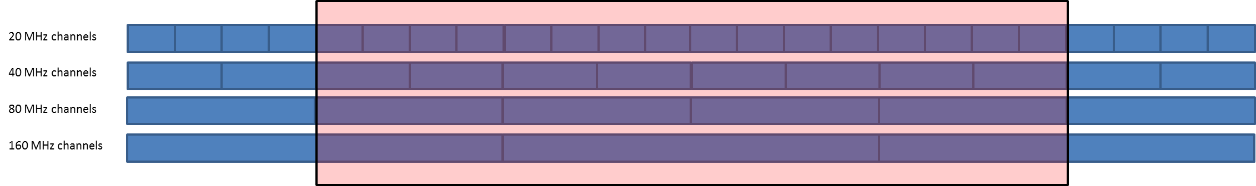

On this basis, the following bandwidth factors are considered (see details in Annex 2):

• 160 MHz (15% of RLANs): 1 channel overlaps fully overlaps the EESS bandwidth and 2 overlap by 80 MHz.

– BWF = 0 dB for 1/3 of cases

– BWF = 10 *log(80/160) = - 3 dB for 2/3 of cases

This represent an average BWF = -1.76 dB

• 80 MHz (50% of RLANS): 4 channels fully overlaps the EESS bandwidth. No bandwidth factor is applied.

• 40 MHz (25% of RLANS): 8 channels fully overlaps the EESS bandwidth. No bandwidth factor is applied.

• 20 MHz (10% of RLANS): 16 channels fully overlaps the EESS bandwidth. No bandwidth factor is applied.

Overall, considering all bandwidth, this represent an average BWF = - 0.4 dB

– Propagation conditions:

• building attenuation with a Gaussian distribution (17 dB + 7 dB) truncated at 1 dB, as described in the figure below:

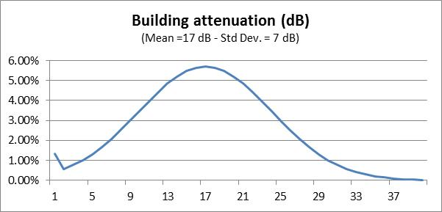

Note: when used to calculate aggregate interference from multiple sources (as in the present case), the impact of this distribution is similar to the one leading from a 12 dB average attenuation.

• Angular clutter loss model from Recommendation ITU-R [P.452](http://www.itu.int/rec/R-REC-P.452/en) associated with RLAN heights distributions and specific parameters for Urban, Suburban and Rural environments. The antenna heights are randomly selected using a uniform probability distribution from the set of floor heights at 3 meter steps. It should be noted that due to the EESS (active) geometry (Nadir) this model leads to no attenuation.



Antenna height

|  |  |
| --- | --- |
| RLAN deployment region | Antenna height (metres) |
| Urban | 1.5 to 28.5 |
| Suburban | 1.5, 4.5 |
| Rural | 1.5, 4.5 |

– Antenna gain/discrimination (Omnidirectional in azimuth for all scenarios)

• Option A1: Omnidirectional in elevation with 0 dBi gain.

• Option A3: An average 4 dB antenna discrimination is applied to the e.i.r.p. level distribution above in the direction of the satellite Omnidirectional in elevation with 0 dBi gain.

Note: since Option A3 is proposing a fixed discrimination of 4 dB, corresponding results can therefore be extrapolated by shifting by 4 dB the results obtained with Option A1 (0 dBi).

– Number of active RLAN:

• Option D1: 11 279 active devices per 100 MHz channel per 5.25 million inhabitants (so-called “Sim City” with 5.25 M inhabitants).

• Option D2: from 0.004 (D2-low) to 0.04 (D2-high) per 100 MHz channel per inhabitant.

Extrapolation of these numbers from a 100 MHz bandwidth to a 320 MHz bandwidth is detailed in Annex 2 and leads to the following figures:

• Option D1: 25297 active devices per 320 MHz channel per 5.25 million inhabitants (Sim City), i.e. a density of 0.0048 RLAN per inhabitant.

• Option D2-Low: 47103 active devices per 320 MHz channel per 5.25 million inhabitants (Sim City), i.e. a density of 0.00897 RLAN per inhabitant.

• Option D2-High: 471021 active devices per 320 MHz channel per 5.25 million inhabitants (Sim City), i.e. a density of 0.0897 RLAN per inhabitant.

These factors lead to the following number of active RLAN to be considered over the French territory (with a population of 66 M inh.), Dutch territory (with a population of 16.8 M inh.) and the UK territory (with a population of 63.3 M inh.):

|  |  |  |  |  |
| --- | --- | --- | --- | --- |
|  | Nb of active RLAN per inhabitant | Nb of active RLAN over France  (in 320 MHz) | Nb of active RLAN over NL  (in 320 MHz) | Nb of active RLAN over UK  (in 320 MHz) |
| Option D1 | 0.0048 per inh. | 318 019 | 80 950 | 305 009 |
| Option D2 | Low (0.00897 per inh.) | 592 142 | 150 727 | 567 918 |
| High (0.0897 per inh.) | 5 921 422 | 1 507 271 | 5 679 182 |

Detailed deployment assumptions are described in the analysis sections.

# 3 Analysis

Analyses based on static and dynamic methodologies have been used to address the compatibility between WAS/RLAN and EESS (active) altimeter in the 5 350-5 470 MHz frequency band:

– Section 3.1: static analyses.

– Section 3.2: dynamic analyses based on existing population densities.

– Section 3.3: consideration of some additional parameters proposed in PDN Report ITU‑R RS.[EESS RLAN 5 GHz].

## 3.1 Static analyses

### 3.1.1 Single entry static analysis

The following Table 4 provides calculation of the impact of 1 single outdoor RLAN on EESS (active) sensors described in Table 1 above.

Table 4

|  |  |
| --- | --- |
| Parameter | Sentinel-3 SRAL |
| Frequency (MHz) | 5 410 |
| Orbital altitude (km) | 800 |
| Off Nadir Angle (°) | 0 |
| Slant path distance (km) | 800 |
| Free Space losses (dB) | 165.2 |
| EESS antenna gain (dBi) | 34.5 |
| **EESS protection criteria (dBm/320 MHz)** | **–88.1** |
| RLAN EIRP (dBm) | 23 |
| **Interference from 1 outdoor RLAN (dBm)** | **–107.7** |
| Margin for 1 outdoor RLAN (dB) | 19.6 |
| **Nb of outdoor RLAN in the EESS footprint to reach the protection criteria** | **91** |

This calculation shows that 91 outdoor RLANs within the 1 840 km² EESS (active) footprint transmitting with the full e.i.r.p. of 200 mW are sufficient to interfere with an EESS (active) system.

**This represents a maximum density of less than 0.05 RLAN / km².**

### 3.1.2 Static analysis based on EESS (active) footprint shape

The following analysis provides calculation of the aggregate RLAN impact on EESS (active) considering the so-called ‘Sim City” (circular based) with the footprint shape of the EESS (active) system (with a radius of 24.2 km), as shown on the Figure 1 below.

Figure 1

RLAN deployment and EESS (active) footprint

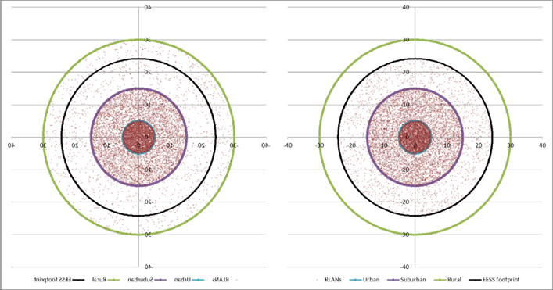

In this case, the percentage of RLAN within the EESS (active) footprint (as on the right figure) can be calculated as in Table 5 below.

Table 5

|  |  |  |  |  |
| --- | --- | --- | --- | --- |
|  | Distance (km) | Area (km²) | Area enclosed in EESS footprint (km²) | Ratio of RLAN within the EESS footprint |
| Urban | 5 | 79 | 79 | 100% |
| Suburban | 15 | 628 | 628 | 100% |
| Rural | 30 | 2 121 | 1133 | 53% |

To consider potential interference from RLAN deployment on EESS (active) sensor, one can therefore use these percentages to determine the total number of RLAN in the EESS (active) footprint, for both density Option D1 (total of 25297 RLAN within the overall city for 5.25 M inhabitants), the low edge of Density Option D2 (47102 RLAN) and the upper edge of Density Option D2 (471022 RLAN) as given in Table 6 below.

Table 6

|  |  |  |  |  |  |
| --- | --- | --- | --- | --- | --- |
|  | Ratio of RLAN within the EESS footprint | Ratio of RLAN in each city area (based on model agreed in JTG) | Nb of active RLAN in EESS footprint (Option D1) | Nb of active RLAN in EESS footprint (Option D2-low) | Nb of active RLAN in EESS footprint (D2-high) |
| Total Nb of RLAN in city |  | **100%** | 25297 | 47102 | 471022 |
| Urban | 100% | 35.5% | 8978 | 16718 | 167176 |
| Suburban | 100% | 53.3% | 13488 | 25115 | 251148 |
| Rural | 53% | 11.2% | 1512 | 2816 | 28159 |
| **Total Nb of RLAN in EESS footprint** |  |  | **23979** | **44648** | **446482** |

On this basis, the following Table 7 provides calculation of interference for the “EESS (active) footprint shape scenario” for the Sentinel-3 SRAL.

Table 7

|  |  |  |  |
| --- | --- | --- | --- |
| Parameter | Sentinel-3 SRAL with RLAN Density Option D1 | Sentinel-3 SRAL with RLAN Density Option D2-low | Sentinel-3 SRAL with RLAN Density Option D2-high |
| Frequency (MHz) | 5 410 | 5 410 | 5 410 |
| Orbital altitude (km) | 800 | 800 | 800 |
| Off Nadir Angle (°) | 0 | 0 | 0 |
| Slant path distance (km) | 800 | 800 | 800 |
| Free Space losses (dB) | 165.2 | 165.2 | 165.2 |
| EESS antenna gain (dBi) | 34.5 | 34.5 | 34.5 |
| Average RLAN EIRP (dBm) (including average BWF) | 18.6 | 18.6 | 18.6 |
| **Interference from 1 RLAN (dBm)** | **-112.1** | **-112.1** | **-112.1** |
| Nb of RLAN (see table 6 above) | **23979** | **44648** | **446482** |
| Nb of outdoor RLAN (5%) | **1199 (=30.8 dB)** | **2232 (=33.5 dB)** | **22324 (=43.5 dB)** |
| Nb of indoor RLAN | **22780 (=43.6 dB)** | **42416 (=46.3 dB)** | **424158 (=56.3 dB)** |
| Average indoor/outdoor attenuation (dB) | 12 | 12 | 12 |
| Interference from outdoor RLAN (dBm/320 MHz) | -81.3 | -78.6 | -68.6 |
| Interference from indoor RLAN (dBm/320 MHz) | -80.5 | -77.8 | -67.8 |
| **TOTAL INTERFERENCE (dBm/320 MHz)** | **-77.9** | **-75.2** | **-65.2** |
| EESS protection criteria (dBm/320 MHz) | -88.1 | -88.1 | -88.1 |
| **Exceeding = Negative Margin (dB) with antenna Option A1** | **10.2** | **12.9** | **22.9** |

This Table shows that, when considering the “footprint shape” scenario, (with RLAN antenna Option A1), the RLAN deployment exceeds the EESS (active) protection criteria from 10.2 dB (with Density Option D1) to 22.9 dB (with Density Option D2-high).

As a summary, the following Table 8 provides the level of interference in excess considering all different RLAN density scenarios and antenna options.

Table 8

Level of interference in excess (static analysis)

|  |  |  |
| --- | --- | --- |
| Scenario | Sentinel-3 SRAL | |
| RLAN Antenna | Antenna Option A1 | Antenna Option A3 (= A1 –4 dB) |
| **JTG Option D1** | 10.2 dB | 6.2 dB |
| **JTG Option D2-low** | 12.9 dB | 8.9 dB |
| **JTG Option D2-high** | 22.9 dB | 18.9 dB |

These calculations therefore show that when considering the “footprint shape” scenario, the RLAN deployment **largely exceeds the EESS (active) protection up to 22.9 dB** and allow to show there is no compatibility between RLAN and EESS (active) altimeters sensors in the 5 350-5 470 MHz frequency band.

## 3.2 Dynamic analyses

### 3.2.1 RLAN deployment

The dynamic analysis have been considered over France (550 000 km² and 66 M inhabitants) on the one hand and over a more restricted area covering the Paris metropolitan area (a square of 10 000 km² and approximately 10.2 M inhabitants) on the other hand.

Some calculations have also been made considering the Netherlands (41 530 km² and 16.8 M inhabitants).

Other simulations have been considered over the UK (244 000 km² and 63.3 M inhabitants) on the one hand and over a more restricted area covering the London metropolitan area (a square of 10 000 km² and approximately 12.9 M inhabitants) on the other hand.

These simulations are properly reflecting the real scenarios, with real population distributions.

Over these areas, different scenarios related to the number of active RLAN were considered as in Table 9 below:

Table 9

Scenarios considered for the dynamic analysis

|  |  |  |  |  |  |  |
| --- | --- | --- | --- | --- | --- | --- |
|  | Nb of active RLAN per inhabitant | Nb of active RLAN over France  (in 320 MHz) | Nb of active RLAN over Paris Metro (in 320 MHz) | Nb of active RLAN over NL  (in 320 MHz) | Nb of active RLAN over UK  (in 320 MHz) | Nb of active RLAN over London Metro (in 320 MHz) |
| Option D1 | 0.0048 per inh. | 318 019 | 49 148 | 80 950 | 305 009 | 62 158 |
| Option D2 | Low (0.00897 per inh.) | 592 142 | 91 513 | 150 727 | 567 918 | 115 737 |
| High (0.0897 per inh.) | 5 921 422 | 915 129 | 1 507 271 | 5 679 182 | 1 157 369 |

These active RLAN have been deployed following the population densities, as depicted in Figure 2 below.

An EESS (active) measurement area has been defined around France, with an area of about 1 000 000 km² (blue square on Figure 2A), around Paris with an area of 10 000 km² (blue square on Figure 2B), around the Netherlands with an area of about 120 000 km² (blue square on Figure 2C), around the UK, with an area of about 700 000 km² (blue square on Figure 2D) and around London with an area of 10 000 km².

Figure 2a

RLAN deployment and measurement area over France (592 142 RLANs for D2-low)

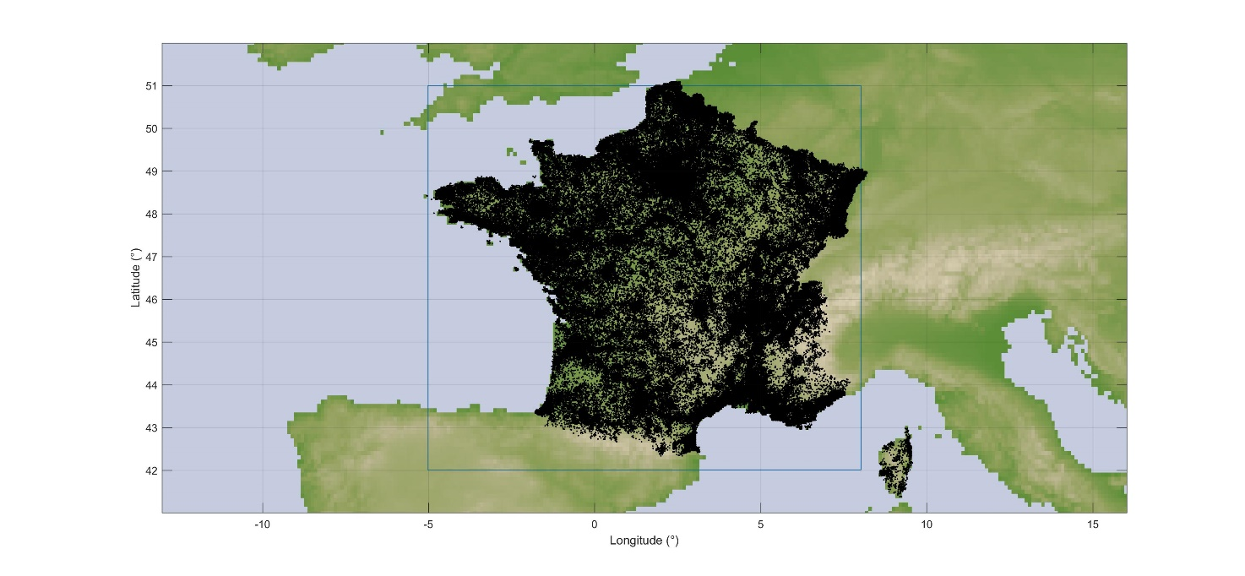

Figure 2B

RLAN deployment and measurements area over Paris metropolitan (91 513 RLANs for D2-low)

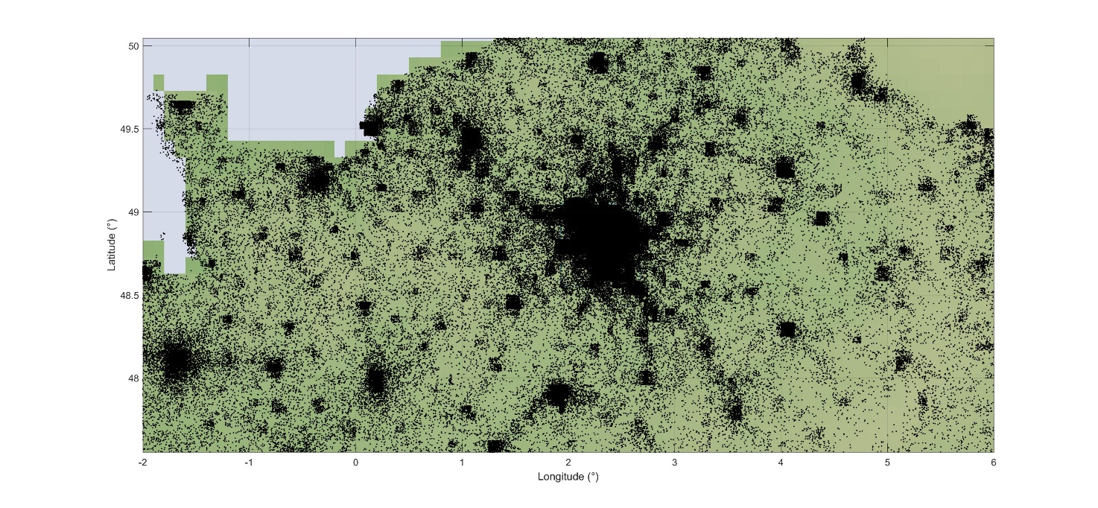

Figure 2C

RLAN deployment and measurements area over the Netherlands (150 727 RLANs for D2-low)

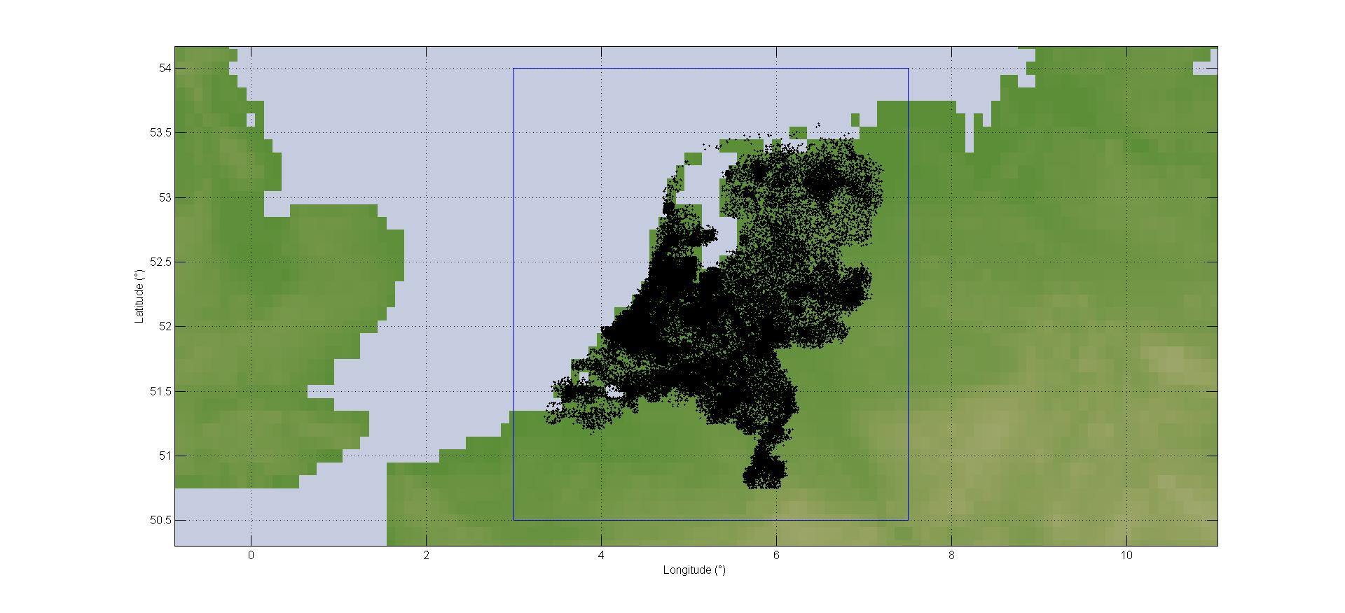

Figure 2D

RLAN deployment and measurements area over the UK (567 918 RLANs for D2-low)

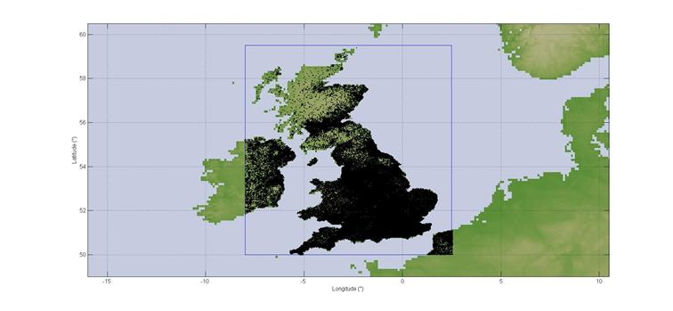

### 3.2.2 Dynamic analyses conditions

Simulations have been run for the SRAL sensor on board Sentinel-3 with a **time step of 1 second and for a period of 30 days**.

At each step of the simulation (i.e. corresponding to 1 s dynamic of the EESS satellite), the interference to the EESS (active) sensor from each RLAN in visibility is calculated (taking into account the EESS antenna pattern to determine the relative gain), hence leading to an aggregate interference.

The percentage of time of interference is calculated with reference to the measurement area, which means that only the time steps when the sensor antenna boresight is within the blue area are retained for the calculation of the percentage of time of interference.

Then, compiling the aggregate interference over the whole steps of the simulations allows to deriving the interference distribution that will be compared to the EESS (active) protection criteria.

The SRAL sensor has been considered with an antenna pointing at nadir with a payload active 100% of the time.

### 3.2.3 Dynamic analyses results over France

On this basis, Figure 3 gives the cumulative distribution function of interference for deployment of 592 142 RLANs over France (Option D2-low) and antenna Option A1.

Figure 3

Interference for Sentinel-3 (Over France – options A1 and D2-low)

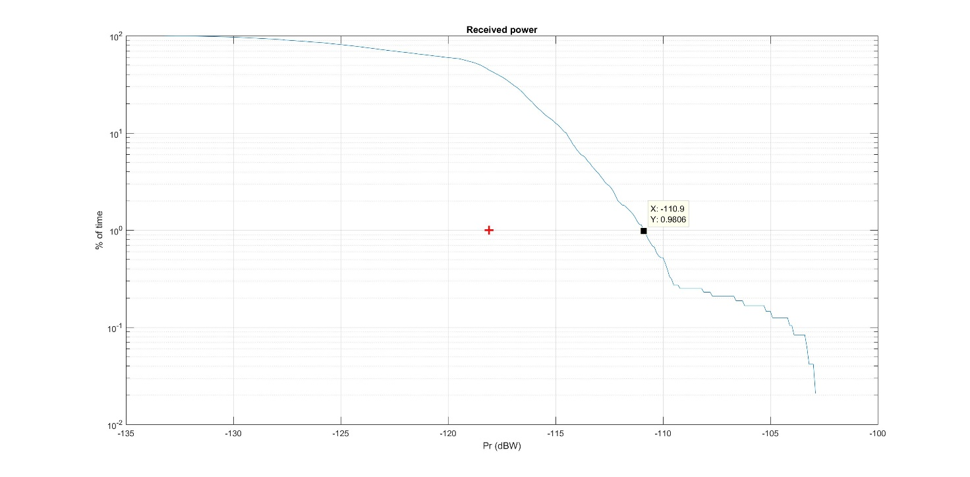

It can be seen that the EESS (active) protection criterion **is exceeded by 7.1 dB (–110.9 dBW)**.

It can also be seen that the interference level corresponding to the protection criteria is exceeded for more than 30% of the time. The situation is also depicted on Figure 4 below showing in red the interfered portion of images (vs the non-interfered in white). It should be noted that, for the evaluation of the results it doesn’t matter if the random or systemic data availability protection criteria have been assumed since both criteria are exceeded by a wide margin.

Figure 4

Interfered portion of images (in red) vs non-interfered (in white) (Over France – options A1 and D2-low)

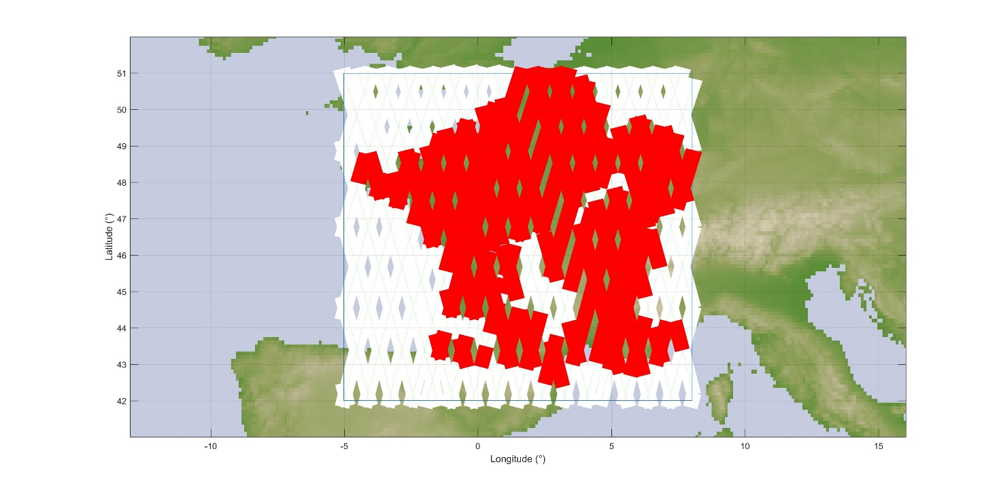

In addition, Figure 5 gives the cumulative distribution function of interference for deployment of 318 019 RLANs over France (Option D1) and antenna Option A1.

Figure 5

Interference for Sentinel-3 (Over France – options A1 and D1)

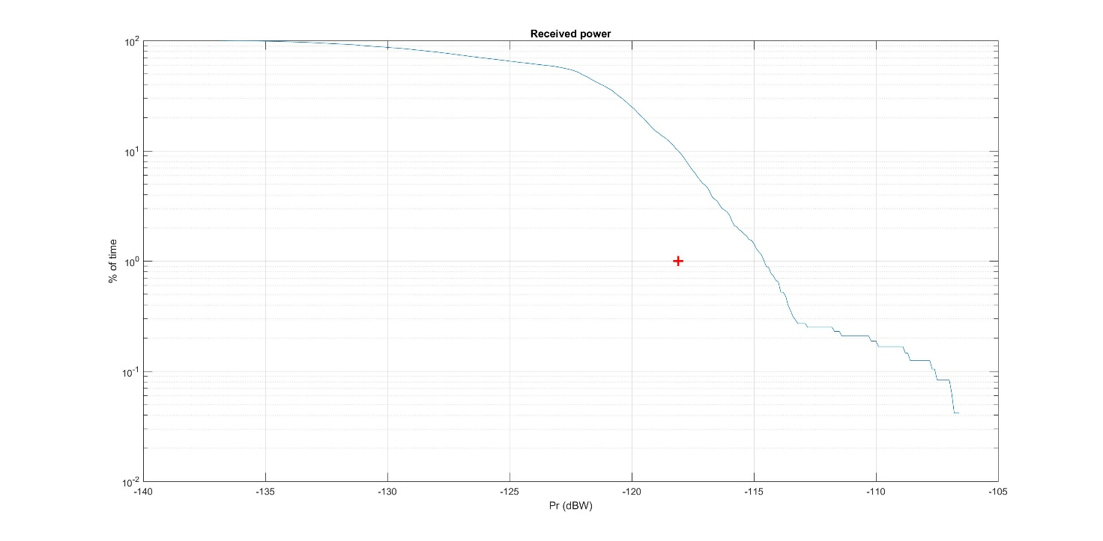

It can be seen that the EESS (active) protection criterion **is exceeded by 3.4 dB (–114.6 dBW)**.

It can also be seen that the interference level corresponding to the protection criteria is exceeded for more than 10% of the time. The situation is also depicted on Figure 6 below showing in red the interfered portion of images (vs the non-interfered in white).

Figure 6

Interfered portion of images (in red) vs non-interfered (in white) (Over France – options A1 and D1)

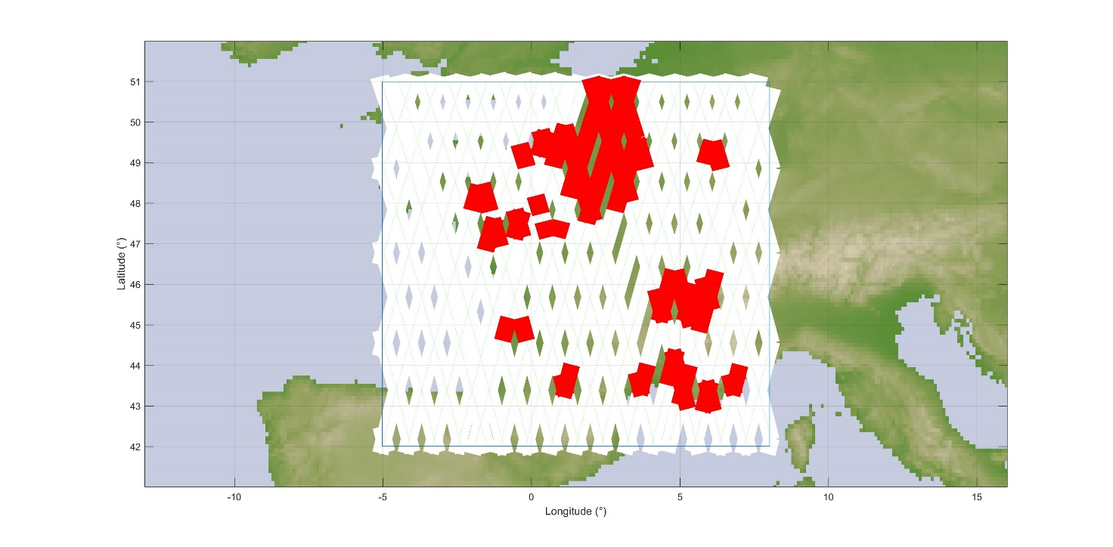

It appears obvious that in these situations, the Sentinel-3 sensor will be totally ineffective over most land and coastal areas, in particular all urban and suburban areas.

Finally, Table 10 provides the levels of interference in excess for the 3 RLAN density options (D1, D2-low and D2-High) and antenna Options A1 and A3.

Table 10

Interference in excess (over France)

|  |  |  |  |  |
| --- | --- | --- | --- | --- |
| Scenario | Active RLAN density (Nb per inhabitant per 320 MHz) | Nb of active RLAN over France  (in 320 MHz) | Interference in excess for antenna  Option A1 | Extrapolated for antenna Option A3  (A1 – 4 dB) |
| JTG Option D1 | 0.0048 | 318 019 | **3.4 dB** | **-0.6 dB** |
| JTG Option D2-low | 0.00897 | 592 142 | **7.1 dB** | **3.1 dB** |
| JTG Option D2-high  (D2-Low +10 dB) | 0.0897 | 5 921 422 | **17.1 dB** | **13.1 dB** |

### 3.2.4 Dynamic analyses results over Paris metropolitan

Under the same principle, the following Figure 7 gives the cumulative distribution functions of interference corresponding to a deployment of 592 142 RLANs over France, including 91 513 RLANs over Paris metropolitan area (Option D2-low) and antenna Option A1.

Figure 7

Interference for Sentinel-3 (Over Paris Metro – options A1 and D2-low)

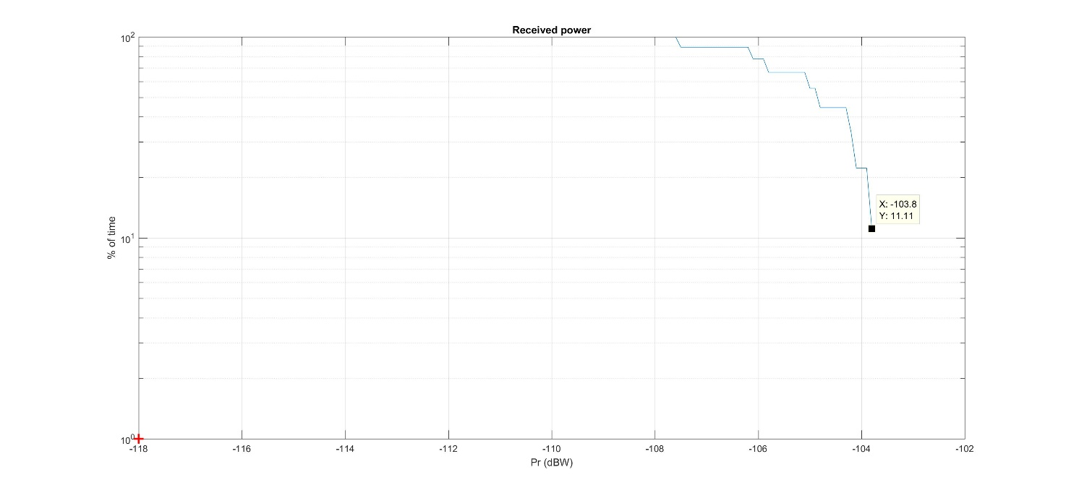

It can be seen that the EESS (active) protection criterion **is largely exceeded by 14.2 dB   
(–103.8 dBW)**. The interference level corresponding to the protection criteria **is exceeded for 100 % of the time.** It should be noted that, for the evaluation of the results it doesn’t matter if the random or systemic data availability protection criteria have been assumed since both criteria are exceeded by a wide margin.

Similarly, the following Figure 8 gives the cumulative distribution functions of interference corresponding to a deployment of 318 019 RLANs over France, including 49 148 RLANs over Paris metropolitan area (Option D1) and antenna Option A1.

Figure 8

Interference for Sentinel-3 (Over Paris Metro – options A1 and D1)

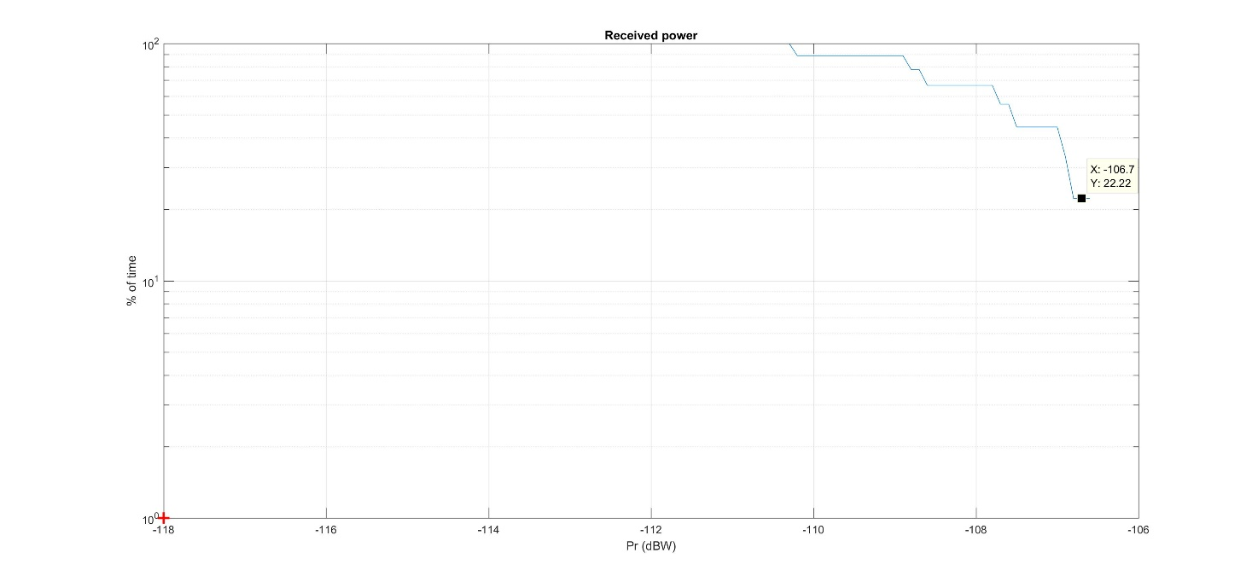

It can be seen that the EESS (active) protection criterion **is largely exceeded by 11.3 dB   
(–106.7 dBW)**. The interference level corresponding to the protection criteria **is exceeded 100 % of the time.** It should be noted that, for the evaluation of the results it doesn’t matter if the random or systemic data availability protection criteria have been assumed since both criteria are exceeded by a wide margin.

Finally, Table 11 provides the levels of interference in excess for the 3 RLAN density options (D1, D2-low and D2-High) and antenna Options A1 and A3.

Table 11

Interference in excess (over Paris metropolitan)

|  |  |  |  |  |
| --- | --- | --- | --- | --- |
| Scenario | Active RLAN density (Nb per inhabitant per 320 MHz) | Nb of active RLAN over Paris Metro (in 320 MHz) | Interference in excess for antenna  Option A1 | Extrapolated for antenna Option A3  (A1 – 4 dB) |
| JTG Option D1 | 0.0048 | 49 148 | **11.3 dB** | **7.3 dB** |
| JTG Option D2-low | 0.00897 | 91 513 | **14.2 dB** | **10.2 dB** |
| JTG Option D2-high  (D2-Low +10 dB) | 0.0897 | 915 129 | **24.2 dB** | **20.2 dB** |

### 3.2.5 Dynamic analyses results over the Netherlands

Under the same principle, the following Figure 9 gives the cumulative distribution functions of interference corresponding to a deployment of 150 727 RLANs over the Netherlands (Option D2‑low) and antenna Option A1.

Figure 9

Interference for Sentinel-3 (Over the Netherlands – options A1 and D2-low)

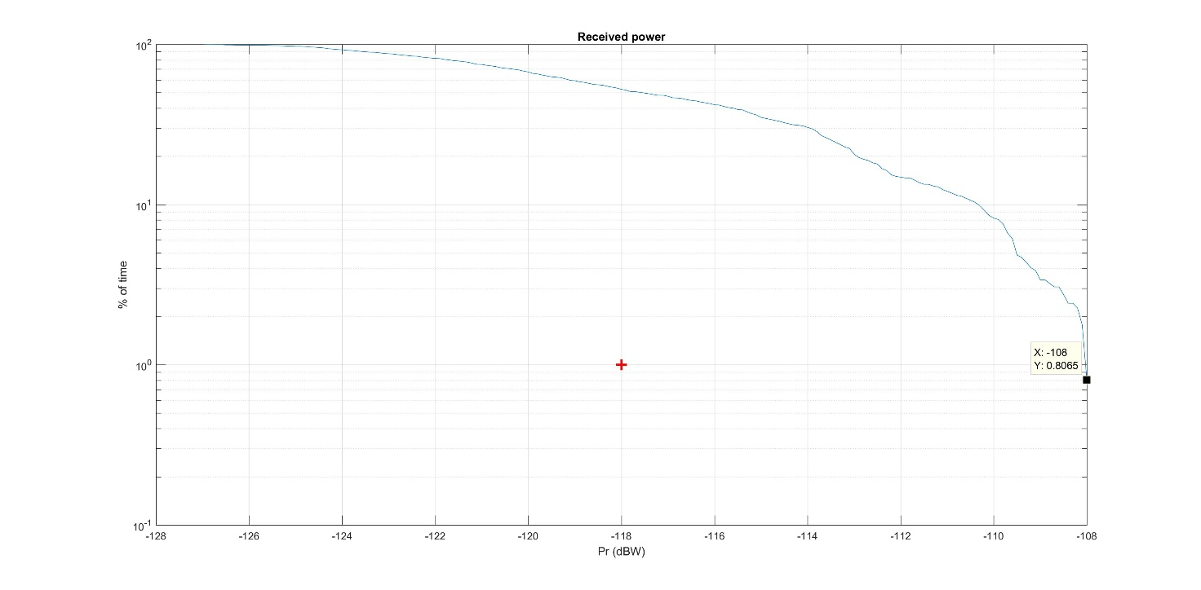

It can be seen that the EESS (active) protection criterion **is largely exceeded by 10 dB   
(–-108 dBW)**.

It can also be seen that the interference level corresponding to the protection criteria is exceeded for more than 50% of the time. The situation is also depicted on Figure 10 below showing in red the interfered portion of images (vs the non-interfered in white). It should be noted that, for the evaluation of the results it doesn’t matter if the random or systemic data availability protection criteria have been assumed since both criteria are exceeded by a wide margin.

Figure 10

Interfered portion of images (in red) vs non-interfered (in white)   
(Over the Netherlands – options A1 and D2-low)

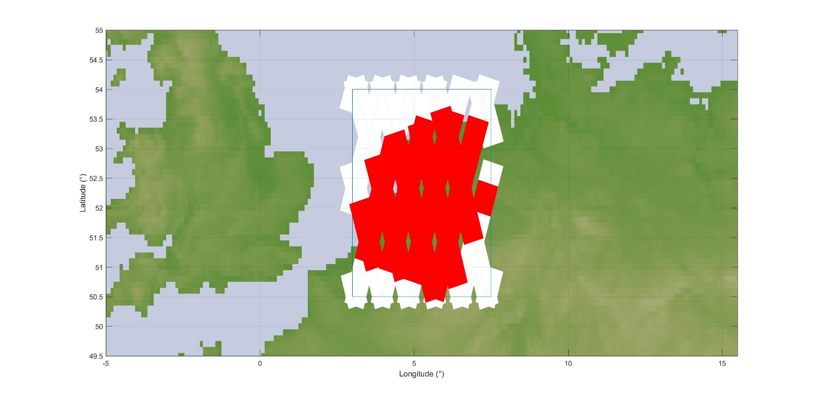

It appears obvious that in this situation (150 727 active RLAN corresponding to 0.00897 active RLAN per inh.), the Sentinel-3 sensor will be totally ineffective over the Netherlands.

Finally, Table 12 provides the levels of interference in excess for the 3 RLAN density options (D1, D2-low and D2-High) and antenna Options A1 and A3.

Table 12

Interference in excess (over the Netherlands)

|  |  |  |  |  |
| --- | --- | --- | --- | --- |
| Scenario | Active RLAN density (Nb per inhabitant per 320 MHz) | Nb of active RLAN over the Netherlands (in 320 MHz) | Interference in excess for antenna  Option A1 | Extrapolated for antenna Option A3  (A1 – 4 dB) |
| JTG Option D1 (D2-Low –3 dB) | 0.0048 | 80 950 | **7 dB** | **3 dB** |
| JTG Option D2-low | 0.00897 | 150 727 | **10 dB** | **6 dB** |
| JTG Option D2-high  (D2-Low +10 dB) | 0.0897 | 1 507 270 | **20 dB** | **16 dB** |

### 3.2.6 Dynamic analyses results over the UK

Figure 11 gives the cumulative distribution function of interference for deployment of 567 918 RLANs over the United Kingdom (Option D2-low) and antenna Option A1.

Figure 11

Interference for Sentinel-3 (Over the UK – options A1 and D2-low)

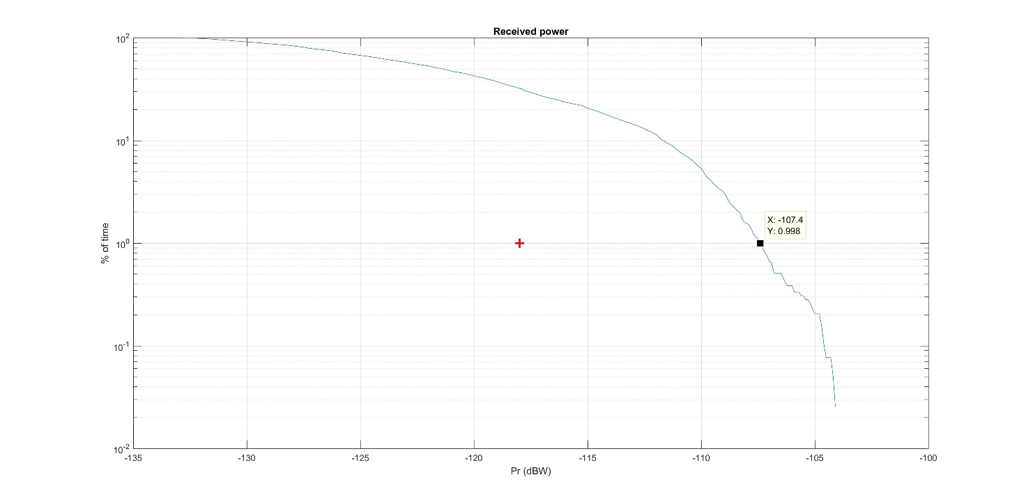

It can be seen that the EESS (active) protection criterion **is exceeded by 10.6 dB (–-107.4 dBW)**. It should be noted that, for the evaluation of the results it doesn’t matter if the random or systemic data availability protection criteria have been assumed since both criteria are exceeded by a wide margin.

It can also be seen that the interference level corresponding to the protection criteria is exceeded for more than 30% of the time. The situation is also depicted on Figure 12 below showing in red the interfered portion of images (vs the non-interfered in white).

Figure 12

Interfered portion of images (in red) vs non-interfered (in white)   
(Over the UK – options A1 and D2-low)

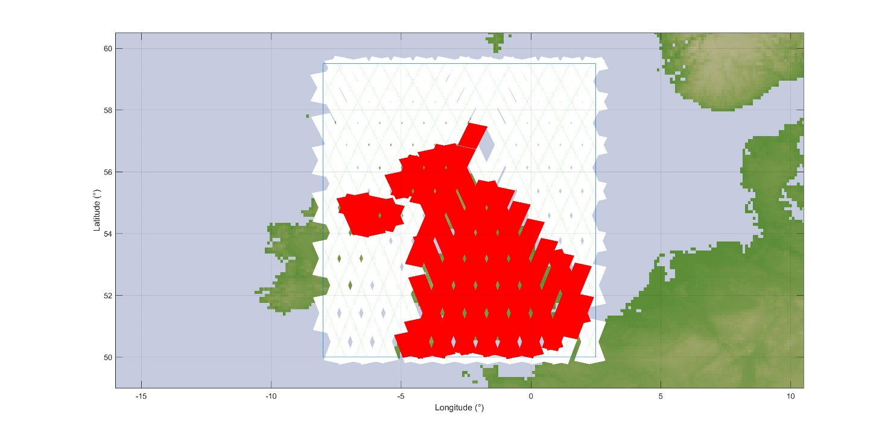

In addition, Figure 13 gives the cumulative distribution function of interference for deployment of 305 009 RLANs over the UK (Option D1) and antenna Option A1.

Figure 13

Interference for Sentinel-3 (Over the UK – options A1 and D1)

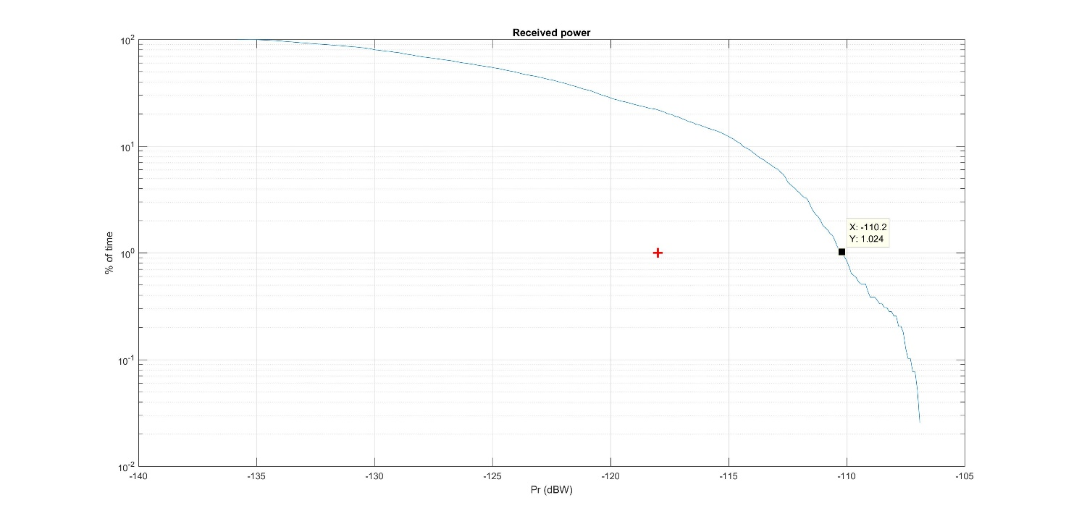

It can be seen that the EESS (active) protection criterion **is largely exceeded by 7.8 dB   
(–110.2 dBW)**.

It can also be seen that the interference level corresponding to the protection criteria is exceeded for more than 20% of the time. The situation is also depicted on Figure 14 below showing in red the interfered portion of images (vs the non-interfered in white). It should be noted that, for the evaluation of the results it doesn’t matter if the random or systemic data availability protection criteria have been assumed since both criteria are exceeded by a wide margin.

Figure 14

Interfered portion of images (in red) vs non-interfered (in white)   
(Over the UK – JTG options A1 and D1)

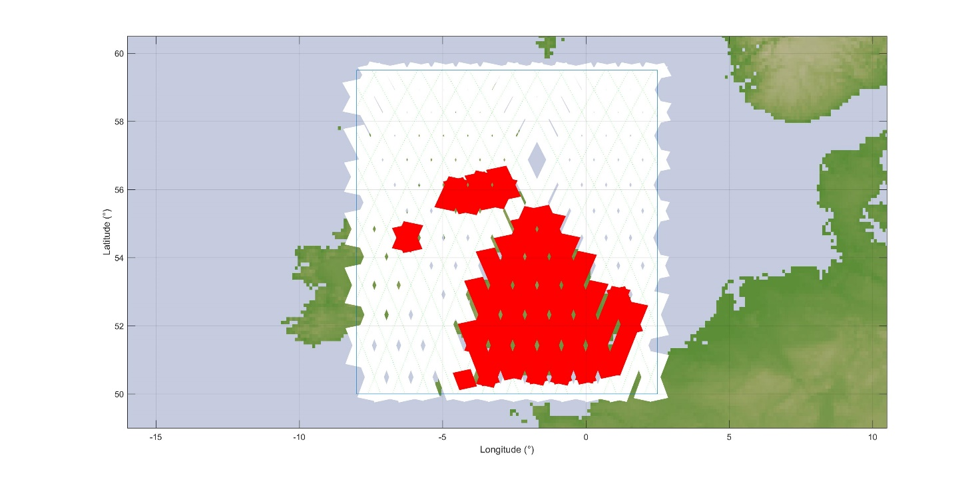

It appears obvious that in these situations, the Sentinel-3 sensor will be totally ineffective over most land and coastal areas, in particular all urban and suburban areas.

Finally, Table 13 provides the levels of interference in excess for the 3 RLAN density options (D1, D2-low and D2-High) and antenna Options A1 and A3.

Table 13

Interference in excess (over the UK)

|  |  |  |  |  |
| --- | --- | --- | --- | --- |
| Scenario | Active RLAN density (Nb per inhabitant per 320 MHz) | Nb of active RLAN over the UK (in 320 MHz) | Interference in excess for antenna  Option A1 | Extrapolated for antenna Option A3 (A1 – 4 dB) |
| JTG Option D1 | 0.0048 | 305 009 | **7.8 dB** | **3.8 dB** |
| JTG Option D2-low | 0.00897 | 567 918 | **10.6 dB** | **6.6 dB** |
| JTG Option D2-high (D2-Low +10 dB) | 0.0897 | 5 679 180 | **20.6 dB** | **16.6 dB** |

### 3.2.7 Dynamic analyses results over London metropolitan

Figure 15 gives the cumulative distribution functions of interference corresponding to a deployment of 567 918 RLANs over the UK, including 115 737 RLANs over London metropolitan area (Option D2-low) and antenna Option A1.

Figure 15

Interference for Sentinel-3 (Over London Metro – options A1 and D2-low)

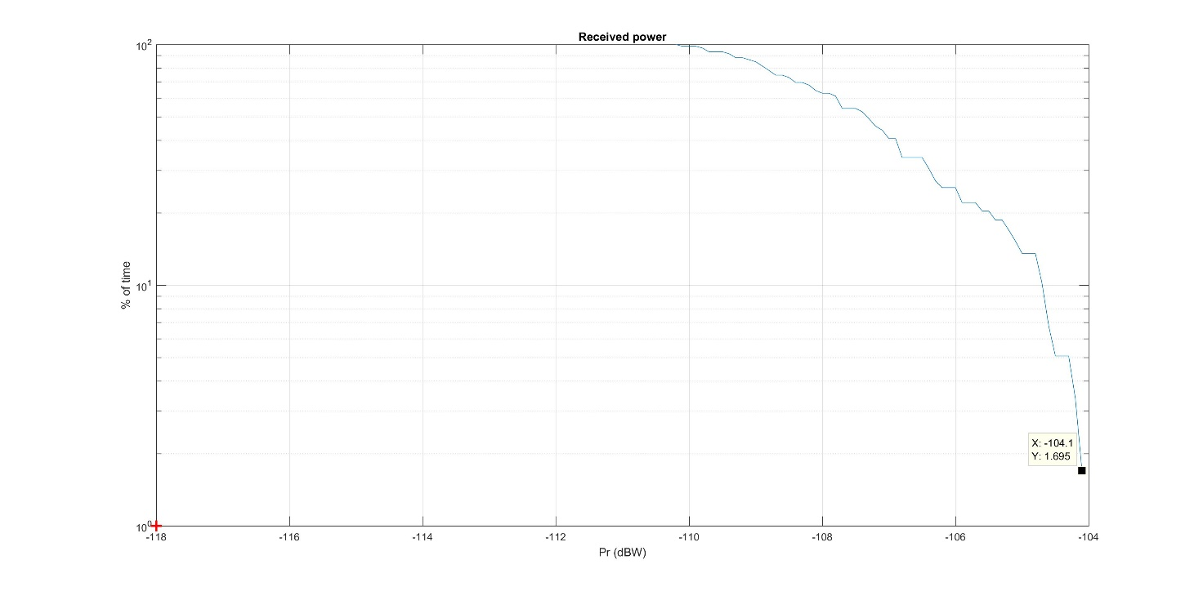

It can be seen that the EESS (active) protection criterion **is largely exceeded by 16.6 dB   
(–104.1 dBW)**.

It can also be seen that the interference level corresponding to **the protection criteria is exceeded for 100% of the time**. It should be noted that, for the evaluation of the results it doesn’t matter if the random or systemic data availability protection criteria have been assumed since both criteria are exceeded by a wide margin.

Finally, Table 14 provides the levels of interference in excess for the 3 RLAN density options (D1, D2-low and D2-High) and antenna Options A1 and A3.

Table 14

Interference in excess (over London metropolitan)

|  |  |  |  |  |
| --- | --- | --- | --- | --- |
| Scenario | Active RLAN density (Nb per inhabitant per 320 MHz) | Nb of active RLAN over London Metro (in 320 MHz) | Interference in excess for antenna Option A1 | Extrapolated for antenna Option A3 (A1 –4 dB) |
| JTG Option D1 (D2-Low –3 dB) | 0.0048 | 62 158 | **13.6 dB** | **9.6 dB** |
| JTG Option D2-low | 0.00897 | 115 737 | **16.6 dB** | **12.6 dB** |
| JTG Option D2-high (D2-Low +10 dB) | 0.0897 | 1 157 369 | **26.6 dB** | **22.6 dB** |

### 3.2.8 Dynamic analyses – Summary of results

The results of the dynamic analysis over France are given below (see Table 10 above):

|  |  |  |  |  |
| --- | --- | --- | --- | --- |
| Scenario | Active RLAN density (Nb per inhabitant per 320 MHz) | Nb of active RLAN over France (in 320 MHz) | Interference in excess for antenna  Option A1 | Extrapolated for antenna Option A3  (A1 – 4 dB) |
| JTG Option D1 | 0.0048 | 318 019 | **3.4 dB** | **-0.6 dB** |
| JTG Option D2-low | 0.00897 | 592 142 | **7.1 dB** | **3.1 dB** |
| JTG Option D2-high  (D2-Low +10 dB) | 0.0897 | 5 921 422 | **17.1 dB** | **13.1 dB** |

The results of the dynamic analysis over Paris Metropolitan are given below (see Table 11 above):

|  |  |  |  |  |
| --- | --- | --- | --- | --- |
| Scenario | Active RLAN density (Nb per inhabitant per 320 MHz) | Nb of active RLAN over Paris Metro (in 320 MHz) | Interference in excess for antenna  Option A1 | Extrapolated for antenna Option A3  (A1 – 4 dB) |
| JTG Option D1 | 0.0048 | 49 148 | **11.3 dB** | **7.3 dB** |
| JTG Option D2-low | 0.00897 | 91 513 | **14.2 dB** | **10.2 dB** |
| JTG Option D2-high  (D2-Low +10 dB) | 0.0897 | 915 129 | **24.2 dB** | **20.2 dB** |

The results of the dynamic analysis over the Netherlands are given below (see Table 12 above):

|  |  |  |  |  |
| --- | --- | --- | --- | --- |
| Scenario | Active RLAN density (Nb per inhabitant per 320 MHz) | Nb of active RLAN over the Netherlands (in 320 MHz) | Interference in excess for antenna  Option A1 | Extrapolated for antenna Option A3  (A1 – 4 dB) |
| JTG Option D1 (D2-Low –3 dB) | 0.0048 | 80 950 | **7 dB** | **3 dB** |
| JTG Option D2-low | 0.00897 | 150 727 | **10 dB** | **6 dB** |
| JTG Option D2-high  (D2-Low +10 dB) | 0.0897 | 1 507 270 | **20 dB** | **16 dB** |

The results of the dynamic analysis over the UK are given below (see Table 13 above):

|  |  |  |  |  |
| --- | --- | --- | --- | --- |
| Scenario | Active RLAN density (Nb per inhabitant per 320 MHz) | Nb of active RLAN over the UK (in 320 MHz) | Interference in excess for antenna  Option A1 | Extrapolated for antenna Option A3 (A1 – 4 dB) |
| JTG Option D1 | 0.0048 | 305 009 | **7.8 dB** | **3.8 dB** |
| JTG Option D2-low | 0.00897 | 567 918 | **10.6 dB** | **6.6 dB** |
| JTG Option D2-high (D2-Low +10 dB) | 0.0897 | 5 679 180 | **20.6 dB** | **16.6 dB** |

The results of the dynamic analysis over London Metropolitan are given below (see Table 14 above):

|  |  |  |  |  |
| --- | --- | --- | --- | --- |
| Scenario | Active RLAN density (Nb per inhabitant per 320 MHz) | Nb of active RLAN over London Metro (in 320 MHz) | Interference in excess for antenna Option A1 | Extrapolated for antenna Option A3 (A1 –4 dB) |
| JTG Option D1 (D2-Low –3 dB) | 0.0048 | 62 158 | **13.6 dB** | **9.6 dB** |
| JTG Option D2-low | 0.00897 | 115 737 | **16.6 dB** | **12.6 dB** |
| JTG Option D2-high (D2-Low +10 dB) | 0.0897 | 1 157 369 | **26.6 dB** | **22.6 dB** |

Overall, in all cases, the above dynamic analyses confirm the result of static analyses, presenting interference largely exceeding EESS (active) protection criteria and allow to show that **there is no compatibility between RLAN and EESS (active) in the 5 350-5 470 MHz frequency band.**

## 3.3 consideration of some additional parameters

In addition to the RLAN parameters given in section 2 above, PDN Report ITU-R RS.[EESS RLAN 5 GHz] mentions different parametric assumptions as follows:

– Outdoor ratio: consider 2% and 10% in addition to the agreed 5%.

– Indoor/outdoor attenuation: consider a fixed 17 dB in additional to the agreed “Gaussian 17 dB +-7 dB standard deviation”.

As expressed in Document [4-5-6-7/664](http://www.itu.int/md/R12-JTG4567-C-0664/en), and validated by dynamic simulations, the impact of these parametric parameters can be calculated as follows:

Aresult = 10 log(Or + (1-Or)10(-IOa/10)

where:

Aresult = resulting attenuation;

Or = Outdoor ratio;

IOa = Indoor/outdoor attenuation.

On this basis, the following Table 21 provides the corresponding results:

Table 21

Calculated attenuations due to the parametric parameters

|  |  |  |  |
| --- | --- | --- | --- |
|  | Outdoor ratio | | |
| Indoor/outdoor attenuation | 2% | 5% | 10% |
| Gaussian 17 dB + -7 dB (resulting in 12 dB) | 10.9  (-1.3) | 9.6  (0) | 8.0  (+1.6) |
| Fixed 17dB | 14.0  (-4.4) | 11.6  (-2) | 9.3  (+0.3) |

Note: The figures in brackets ( x) represent the difference compared to the JTG  
agreed scenario (in Red: 5% Outdoor ratio and “Gaussian 17 dB + -7 dB”)

It can therefore be seen that the potential impact of the parametric assumptions mentioned in JTG ranges from a potential decrease of the interference of 4.4 dB up to an increase by 1.5 dB and will therefore not change the overall negative conclusions in previous sections.

# 4 Summary

Under all scenarios and simulation methodologies (static and dynamic), the analyses show that RLAN deployment in 5 350-5 470 MHz would create large interference in the SRAL sensor on board the Sentinel-3 satellite.

The static analyses presented above indicate that:

– the maximum density of outdoor RLANs (transmitting with the full e.i.r.p. of 200 mW) within the 1 840 km² EESS (active) is less than 0.05 RLAN / km² (see section 3.1.1)

– Depending on the scenario (different number of active RLAN (D1 and D2) and RLAN antenna A1 and A3), the interference to the EESS (active) sensor will be **in excess of the relevant protection criteria by 6.2 to 22.9 dB** (see section 3.1.2)

The dynamic analyses presented above indicate that, depending on the scenario (different number of active RLAN (D1 and D2) and RLAN antenna A1 and A3), the interference to the EESS (active) sensor will be **in excess of the relevant protection criteria by** (for 0.0048 to 0.0897 active RLAN per inhabitant, respectively):

– **-0.6 to 17.1 dB** (case over France) *(see section 3.2.3)*

– **7.3. to 24.2 dB** (case over Paris metropolitan) *(see section 3.2.4)*

– **3 to 20 dB** (case over the Netherlands) *(see section 3.2.5)*

– **3.8 to 20.6 dB** (case over the UK) *(see section 3.2.6)*

– **9.6 to 26.6 dB** (case over London metropolitan) *(see section 3.2.7)*.

It has to be highlighted that these analyses were not considering a number of assumptions that would further increase these negative margins, such as an additional **apportionment factor of the protection criteria** (since the band is already shared with terrestrial radars). ESA stresses that this apportionment factor has not been introduced in the analysis given the already large negative results obtained under the assumption that no other services could generate interference to EESS (active).

Further, some assumptions related to RLAN remains unclear or unresolved and could also increase the potential interference to EESS (active). This covers in particular the possibilities given to a single RLAN to make use of multiple channels transmission (by means of either orthogonal transmissions or MIMO technique) or to concatenate multiple small channels to provide wider bandwidth with higher power. Such questioning also relates to other applications than RLAN since opening a band to RLAN, low power and unlicensed by nature, will drive the use of different applications such as SRDs, M2M, … (similarly to the current situation in the 2.4 GHz band) or LAA-LTE. Consideration of these additional applications would need to be taken into account.

**Overall, this document demonstrates and confirms that RLANs cannot share with EESS (active) in 5 350-5 470 MHz** frequency band**, confirming that sharing between RLAN** deployments in the 5 350-5 470 MHz frequency band **and EESS (active) may only be feasible if additional RLAN mitigation measures are implemented.**

ANNEX 4

Sharing studies between RLANs and EESS (active) scatterometer sensor  
(SCA sensor)

# 1 Introduction/Background

The present Annex addresses sharing between WAS/RLAN and EESS (active) scatterometers sensors, based on the EUMETSAT SCA sensor.

It provides static and dynamic analysis taking into account similar assumptions and ranges of RLAN parameters (e.g. antenna gain discrimination, devices densities, outdoor ratio, building attenuation) than those considered for analysis made for SAR sensors and given in Document [4-5-6-7/664](http://www.itu.int/md/R12-JTG4567-C-0664/en) (ESA).

# 2 Technical characteristics

## 2.1 EESS (active)

### 2.1.1 Parameters

The EESS (active) parameters and interference criteria used in the present studies are those provided by WP 7C to WP 5A in their liaison statement in Document [5A/38](http://www.itu.int/md/R15-WP5A-C-0038/en).

Table 1 gives the technical parameters for the SCA sensor on board EPS-SG satellites being developed by EUMETSAT.

Table 1

| Parameter | EPS-SG SCA |
| --- | --- |
| Sensor type | SCATTEROMETER |
| Orbital altitude (km) | 832 |
| Orbital inclination (degrees) | 98.7 |
| RF centre frequency (MHz) | 5 355 |
| Peak radiated power (W) | 2512 peak (92 average) |
| Polarisation | VV+VH |
| Antenna type | 6 x fan beam antennas (2 mid-beams at +- 90° azimuths and 4 side-beams at +-45° azimuth and +-135° azimuth) |
| Antenna gain (dBi) | 27-30 for mid-beams  23-31 for side-beams |
| Antenna pattern steering capability | No |
| Antenna pattern | See Below |
| Antenna orientation (degrees from nadir) | 17.5-45.5 (mid beams)  24-54 (side beams) |
| Receiver noise figure (dB) | 3.5 |
| Pulse/Receiver bandwidth (MHz) | 2 |
| Noise power (dBW) | –138 |
| Service area | Global |
| Footprint (km2) | 12 400 km² for mid-beams  21 000 km² for side-beams |

Concerning the polarisation, it is to be noted that EPS-SG SCA makes use of a dual linearly polarised antenna. Thus, no polarisation discrimination advantage can be taken into account.

### 2.1.2 Antenna pattern

The SCA antenna system is composed of 6 fan-beam antennas (with 1° aperture).

– 4 x SIDE-beams at 45°, 135°, 225° and 315° (with an antenna beam look angle from nadir ranging 24° to 54°).

– 2 x MID-beams at 90° and 270° (with an antenna beam look angle from nadir ranging 17.5° to 45.5°).

Corresponding footprints are synthetised on Figure 1 below.

Figure 1

SCA footprints

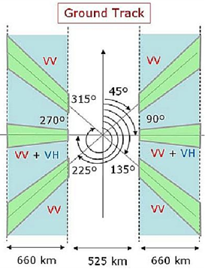

The antenna pattern model for sharing analysis is given as follows.

*G = max(Gmin ; Gver+Ghor)*

with:

*Ghor*= 10 x log (sinc(coefH.sin(Az))²);

*coefH* = 40;

*Az* = Azimuth angle taken from the pointing angle of the antenna (in radians);

*Gver* = linear extrapolation from Table 2 (for MID and SIDE beam) with Elevation angle in degrees;

Gmin = –10.

Note: The *cardinal* sinc function is here used in its form: $sinc\left(x\right)=\frac{sin⁡(πx)}{πx}$

Table 2

Specific antenna gain for linear extrapolation

Note: The elevation angles are given with reference (0°) at satellite Nadir



The antenna pattern representation for each beam type (MID and SIDE) are given on Figures 1A, 1B, 2A and 2B for both vertical (at 0° azimuth) and horizontal (at elevation corresponding to the maximum gain, i.e. 45° (MID) and 55° (SIDE).

Figure 1A

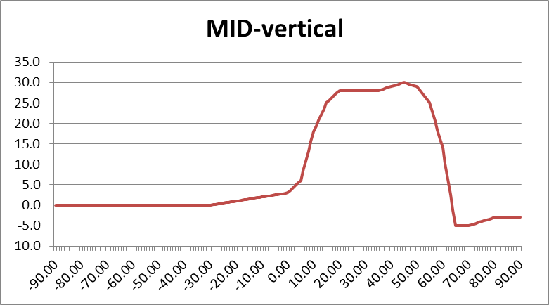

Figure 1B

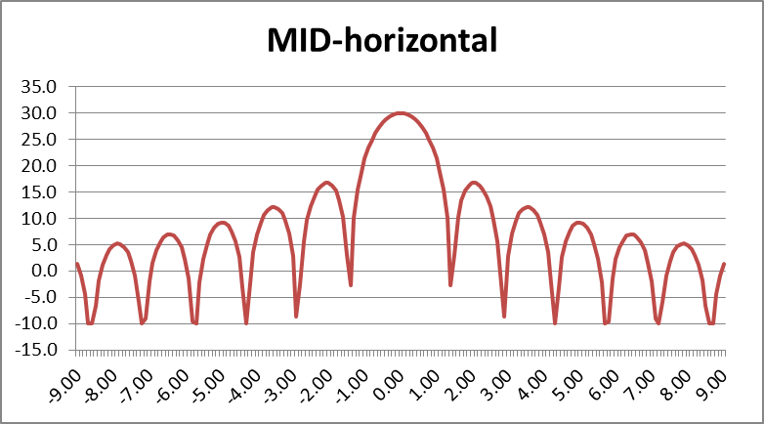

Figure 2A

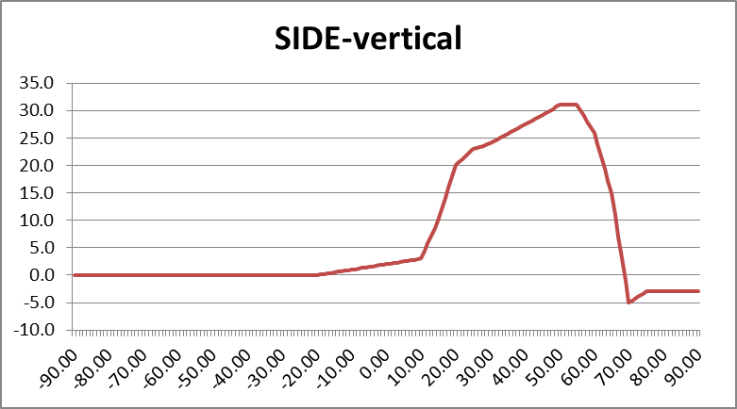

Figure 2B

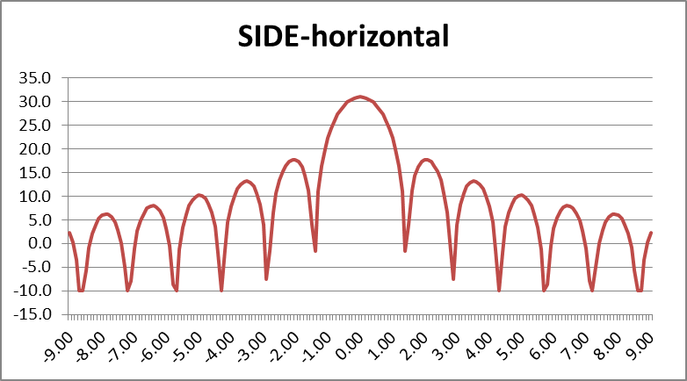

### 2.1.3 Protection criteria

The relevant protection criteria is given in Table 3, taken from Recommendation ITU-R [RS.1166-4](http://www.itu.int/rec/R-REC-RS.1166/en). Even if RLANs are nomadic/mobile by nature, this study assumes that the interference will be systematic due to the high density RLAN deployment. Based on this assumption, the relevant percentage of data availability, corresponding to the percentage of time, is therefore 99% (see Document [5A/38](http://www.itu.int/md/R15-WP5A-C-0038/en))

Table 3

|  |  |  |  |  |
| --- | --- | --- | --- | --- |
| Sensor type | Interference criteria | | Data availability criteria (%) | |
| Performance degradation | *I*/*N* (dB) | Systematic | Random |
| Scatterometer | 8% degradation in measurement of normalized radar backscatter to deduce wind speeds | –5 | 99 | 95 |

For the SCA instrument, the protection criteria calculated over a 2 MHz bandwidth is –143 dBW  
(-113 dBm) not to be exceeded more than 1% of the time.

This criteria is applied over data acquisition periods of time when the sensor is operating over the measurement area of interest (as per Recommendation ITU-R RS.1166-4).

## 2.2 Mobile service (WAS/RLAN)

RLAN parameters used in the present studies are those agreed in the previous study period and given in the preliminary draft new Report ITU-R RS.[EESS RLAN 5 GHz] (see Annex 35 to Document 4-5-6-7/715 (Chairman’s Report)):

– e.i.r.p. distribution:

|  |  |  |  |  |
| --- | --- | --- | --- | --- |
| RLAN e.i.r.p. Level | 200 mW (Omni-Directional) | 80 mW (Omni-Directional) | 50 mW (Omni-Directional) | 25 mW (Omni-Directional) |
| RLAN Device Percentage | 19% | 27% | 15% | 39% |

Note: Such distribution corresponds to a 19 dBm average e.i.r.p.

– Indoor/outdoor:

Outdoor ratio: 5% (RLAN devices are assumed to be indoors only, based on the requirement to help facilitate coexistence. For the purposes of sharing studies, 5% of the devices should be modelled without building attenuation)

– Channel Bandwidth distribution:

|  |  |  |  |  |
| --- | --- | --- | --- | --- |
| Channel bandwidth | 20 MHz | 40 MHz | 80 MHz | 160 MHz |
| RLAN Device Percentage | 10% | 25% | 50% | 15% |

– Bandwidth factor:

The bandwidth factor (BWF) used in this document is derived taking into account the positioning of an EESS (active) 2 MHz bandwidth over the RLAN raster/channel plan, as shown below.



On this basis, the following bandwidth factors are considered (see details in Annex 2):

• 160 MHz (15% of RLANs): 1 channel overlaps by 2 MHz.

– BWF = 10 *log(2/160) = -19 dB

• 80 MHz (50% of RLANS): 1 channel overlaps by 2 MHz.

– BWF = 10 *log(2/80) = -16 dB

• 40 MHz (25% of RLANS): 1 channel overlaps by 2 MHz.

– BWF = 10 *log(2/40) = -13 dB

• 20 MHz (10% of RLANS): 1 channel overlaps by 2 MHz.

– BWF = 10 *log(2/20) = -10 dB

Overall, considering all bandwidth, this represent an average BWF = -16 dB

– Propagation conditions:

• building attenuation with a Gaussian distribution (17 dB + 7 dB) truncated at 1 dB, as described in the figure below:



Note: when used to calculate aggregate interference from multiple sources (as in the present case), the impact of this distribution is similar to the one leading from a 12 dB average attenuation.

• Angular clutter loss model from Recommendation ITU-R [P.452](http://www.itu.int/rec/R-REC-P.452/en) associated with RLAN heights distributions and specific parameters for Urban, Suburban and Rural environments. The antenna heights are randomly selected using a uniform probability distribution from the set of floor heights at 3 meter steps. It should be noted that due to the EESS (active) geometry this model leads to no attenuation.



Antenna height

|  |  |
| --- | --- |
| RLAN deployment region | Antenna height (metres) |
| Urban | 1.5 to 28.5 |
| Suburban | 1.5, 4.5 |
| Rural | 1.5, 4.5 |

– Antenna gain/discrimination (Omnidirectional in azimuth for all scenarios)

• Option A1: Omnidirectional in elevation with 0 dBi gain

• Option A3: An average 4 dB antenna discrimination is applied to the e.i.r.p. level distribution above in the direction of the satellite Omnidirectional in elevation with 0 dBi gain

Note: since Option A3 is proposing a fixed discrimination of 4 dB, corresponding results can therefore be extrapolated by shifting by 4 dB the results obtained with Option A1 (0 dBi).

– Number of active RLAN:

• Option D1: 11 279 active devices per 100 MHz channel per 5.25 million inhabitants (so-called “Sim City” with 5.25 M inhabitants).

• Option D2: from 0.004 (D2-low) to 0.04 (D2-high) per 100 MHz channel per inhabitant.

Extrapolation of these numbers from a 100 MHz bandwidth to a 2 MHz bandwidth is detailed in Annex 2 and leads to the following figures:

• Option D1: 5786 active devices per 2 MHz channel per 5.25 million inhabitants (Sim City), i.e. a density of 0.0011 RLAN per inhabitant.

• Option D2-Low: 10773 active devices per 2 MHz channel per 5.25 million inhabitants (Sim City), i.e. a density of 0.0021 RLAN per inhabitant.

• Option D2-High: 107722 active devices per 2 MHz channel per 5.25 million inhabitants (Sim City), i.e. a density of 0.021 RLAN per inhabitant.

These factors lead to the following number of active RLAN to be considered over the French territory (with a population of 66 M inh.) and the UK territory (with a population of 63.3 M inh.):

|  |  |  |  |
| --- | --- | --- | --- |
|  | Nb of active RLAN per inhabitant | Nb of active RLAN over France  (in 2 MHz) | Nb of active RLAN over UK  (in 2 MHz) |
| Option D1 | 0.0011 per inh. | 72 738 | 69 763 |
| Option D2 | Low (0.0021 per inh.) | 135 432 | 129 892 |
| High (0.021 per inh.) | 1 354 319 | 1 298 916 |

Detailed deployment assumptions are described in the analysis sections.

# 3 Analysis

Analyses based on static and dynamic methodologies have been used to address the compatibility between WAS/RLAN and EESS (active) altimeter in the 5 350-5 470 MHz frequency band:

– Section 3.1: static analyses.

– Section 3.2: dynamic analyses based on existing population densities.

## 3.1 Static analyses

### 3.1.1 Single entry static analysis

The following Table 4 provides calculation of the impact of 1 single outdoor RLAN on EESS (active) SCA sensor, for both MID and SIDE beams described in Table 1 above.

Table 4

| Parameter | SCA  SIDE beam | SCA  MID beam |
| --- | --- | --- |
| Frequency (MHz) | 5355 | 5355 |
| Orbital altitude (km) | 832 | 832 |
| Off Nadir Angle (°) (at center beam) | 39 | 31.5 |
| Slant path distance (km) | 1121 | 1001 |
| Free Space losses (dB) | 168.0 | 167.0 |
| EESS antenna gain (dBi)(average over footprint) | 27.1 | 27.5 |
| **EESS protection criteria (dBm/2 MHz)** | **–113** | **–113** |
| RLAN EIRP (dBm) | 23 | 23 |
| Bandwidth factor for 20 MHz RLAN (dB) | 10 | 10 |
| **Interference from 1 outdoor RLAN (dBm)** | **-127.9** | **-126.5** |
| Margin for 1 outdoor RLAN (dB) | 14.9 | 13.5 |
| **Nb of outdoor RLAN in the EESS footprint to reach the protection criteria** | **31** | **23** |

These calculations shows that, for the a SIDE beam, 31 outdoor RLANs transmitting with the full e.i.r.p. of 200 mW within the 21 000 km² footprint are sufficient to interfere with the SCA sensor.

Similarly, for the a MID beam, 23 outdoor RLANs transmitting with the full e.i.r.p. of 200 mW within the 12 400 km² footprint are sufficient to interfere with the SCA sensor.

This represents a maximum density of 0.0015 and 0.0018 RLAN / km², respectively.

### 3.1.2 Static analysis based on EESS (active) footprint shape

The following analysis provides calculation of the aggregate RLAN impact on EESS (active) considering the so-called ‘Sim City” (circular based) with the footprint shape of the EESS (active) system, as shown on the Figure 3 below.

Figure 3

RLAN deployment and EESS (active) footprint

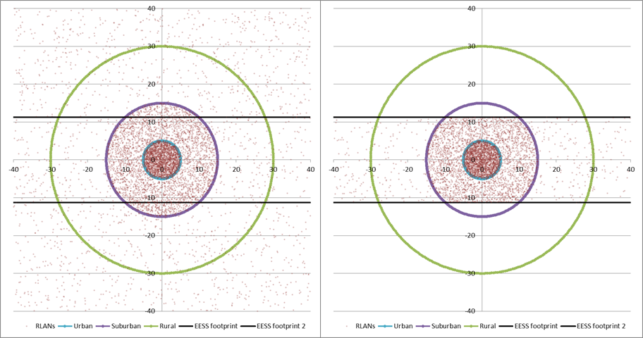

Considering the size of the EESS (active) scatterometer footprints (with lengths of 660 km (MID beam) and 930 km (SIDE beam)), they largely extend out of the circular based RLAN deployment and limiting calculation to this deployment only would artificially limit the interference. To avoid this, the portion of the EESS (active) scatterometer footprints outside of the circular based “Sim city” have been considered covering rural areas.

In this case, the percentage of RLAN within the EESS (active) footprint (as on the right figure) can be calculated as in Tables 5A and 5B below (considering footprint widths at center footprint of 18.9 km (MID beam) and 22.6 km (SIDE beam)).

Table 5A

|  |  |  |  |  |
| --- | --- | --- | --- | --- |
| SIDE  beam | Distance (km) | Area (km²) | Area enclosed in EESS footprint (km²) | Ratio of RLAN within the EESS footprint |
| Urban | 5 | 79 | 79 | 100% |
| Suburban | 15 | 628 | 527 | 84% |
| Rural | 30 | 2 121 | 715 | 34% |
| Rural (outside the city) |  |  | 19 680 |  |

Table 5B

|  |  |  |  |  |
| --- | --- | --- | --- | --- |
| MID  beam | Distance (km) | Area (km²) | Area enclosed in EESS footprint (km²) | Ratio of RLAN within the EESS footprint |
| Urban | 5 | 79 | 79 | 100% |
| Suburban | 15 | 628 | 447 | 71% |
| Rural | 30 | 2 121 | 586 | 28% |
| Rural (outside the city) |  |  | 11 288 |  |

To consider potential interference from RLAN deployment on EESS (active) sensor, one can therefore use these percentages to determine the total number of RLAN in the EESS (active) footprint, for both density Option D1 (total of 25297 RLAN within the overall city for 5.25 M inhabitants), the low edge of Density Option D2 (47102 RLAN) and the upper edge of Density Option D2 (471022 RLAN) as given in Tables 6A and 6B below.

Table 6A

|  |  |  |  |  |  |
| --- | --- | --- | --- | --- | --- |
| SIDE  beam | Ratio of RLAN within the EESS footprint | Ratio of RLAN in each city area (based on model agreed in JTG) | Nb of active RLAN in EESS footprint (Option D1) | Nb of active RLAN in EESS footprint (Option D2-low) | Nb of active RLAN in EESS footprint (D2-high) |
| Total Nb of RLAN in city |  | **100%** | 5 785 | 10 773 | 107722 |
| Urban | 100% | 35.5% | 2 053 | 3 824 | 38 233 |
| Suburban | 84% | 53.3% | 2 589 | 4 821 | 48 204 |
| Rural | 34% | 11.2% | 218 | 406 | 4 061 |
| Rural (outside the city)* |  |  | 6 006 | 11 185 | 111 851 |
| **Total Nb of RLAN in EESS footprint** |  |  | **10 866** | **20 236** | **202 349** |

* RLAN density of 0.31/km² (D1), 0.57/km² (D2-low) and 5.68/km² (D2-high)

Table 6B

|  |  |  |  |  |  |
| --- | --- | --- | --- | --- | --- |
| MID | Ratio of RLAN within the EESS footprint | Ratio of RLAN in each city area (based on model agreed in JTG) | Nb of active RLAN in EESS footprint (Option D1) | Nb of active RLAN in EESS footprint (Option D2-low) | Nb of active RLAN in EESS footprint (D2-high) |
| Total Nb of RLAN in city |  | **100%** | 5 785 | 10 773 | 107 722 |
| Urban | 100% | 35.5% | 2 053 | 3 824 | 38 233 |
| Suburban | 71% | 53.3% | 2 195 | 4 088 | 40 877 |
| Rural | 28% | 11.2% | 179 | 333 | 3 333 |
| Rural (outside the city)* |  |  | 3 445 | 6 416 | 64 156 |
| **Total Nb of RLAN in EESS footprint** |  |  | **7 873** | **14 660** | **146 598** |

* RLAN density of 0.31/km² (D1), 0.57/km² (D2-low) and 5.68/km² (D2-high)

On this basis, the following Tables 7A and 7B provides calculation of interference for the “EESS (active) footprint shape scenario” for the EPS-SG SCA instrument for both SIDE and MID beams.

Table 7A (SIDE BEAM)

|  |  |  |  |
| --- | --- | --- | --- |
| Parameter | EPS-SG SCA (SIDE beam) with RLAN Density Option D1 | EPS-SG SCA (SIDE beam) with RLAN Density Option D2-low | EPS-SG SCA (SIDE beam) with RLAN Density Option D2-high |
| Frequency (MHz) | 5 355 | 5 355 | 5 355 |
| Orbital altitude (km) | 832 | 832 | 832 |
| Off Nadir Angle (°) (at center beam) | 39 | 39 | 39 |
| Slant path distance (km) (at center beam) | 1 121 | 1 121 | 1 121 |
| Free Space losses (dB) (at center beam) | 168.0 | 168.0 | 168.0 |
| EESS antenna gain (dBi) (average over footprint) | 27.1 | 27.1 | 27.1 |
| Average RLAN EIRP (dBm) (including average BWF) | 3 | 3 | 3 |
| **Interference from 1 RLAN (dBm)** | **-137.9** | **-137.9** | **-137.9** |
| Nb of RLAN (see table 6A above) | **10 866** | **20 236** | **202 349** |
| Nb of outdoor RLAN (5%) | **543 (=27.2 dB)** | **1 012 (=30.1 dB)** | **10 117 (=40.1 dB)** |
| Nb of indoor RLAN | **10 323 (=40.1 dB)** | **19 224 (=42.8 dB)** | **192 231 (=52.8 dB)** |
| Average indoor/outdoor attenuation (dB) | 12 | 12 | 12 |
| Interference from outdoor RLAN (dBm/2 MHz) | -110.6 | -107.9 | -97.9 |
| Interference from indoor RLAN (dBm/2 MHz) | -109.8 | -107.1 | -97.1 |
| **TOTAL INTERFERENCE (dBm/2 MHz)** | **-107.1** | **-104.4** | **-94.4** |
| EESS protection criteria (dBm/2 MHz) | -113.0 | -113.0 | -113.0 |
| **Exceeding = Negative Margin (dB) with antenna Option A1** | **5.9** | **8.6** | **18.6** |

Table 7B (MID BEAM)

| Parameter | EPS-SG SCA (MID beam) with RLAN Density Option D1 | EPS-SG SCA (MID beam) with RLAN Density Option D2-low | EPS-SG SCA (MID beam) with RLAN Density Option D2-high |
| --- | --- | --- | --- |
| Frequency (MHz) | 5 355 | 5 355 | 5 355 |
| Orbital altitude (km) | 832 | 832 | 832 |
| Off Nadir Angle (°) (at center beam) | 31.5 | 31.5 | 31.5 |
| Slant path distance (km) (at center beam) | 1 001 | 1 001 | 1 001 |
| Free Space losses (dB) (at center beam) | 167.0 | 167.0 | 167.0 |
| EESS antenna gain (dBi) (average over footprint) | 27.5 | 27.5 | 27.5 |
| Average RLAN EIRP (dBm) (including average BWF) | 3 | 3 | 3 |
| **Interference from 1 RLAN (dBm)** | **-136.5** | **-136.5** | **-136.5** |
| Nb of RLAN (see table 6B above) | 7 873 | 14 660 | 146 598 |
| Nb of outdoor RLAN (5%) | **394 (=26 dB)** | **733 (=28.7 dB)** | **7 330 (=38.7 dB)** |
| Nb of indoor RLAN | **7 479 (=38.7 dB)** | **13 927 (=41.4 dB)** | **139 268 (=51.4 dB)** |
| Average indoor/outdoor attenuation (dB) | 12 | 12 | 12 |
| Interference from outdoor RLAN (dBm/2 MHz) | -110.6 | -107.9 | -97.9 |
| Interference from indoor RLAN (dBm/2 MHz) | -109.8 | -107.1 | -97.1 |
| **TOTAL INTERFERENCE (dBm/2 MHz)** | **-107.2** | **-104.5** | **-94.5** |
| EESS protection criteria (dBm/2 MHz) | -113.0 | -113.0 | -113.0 |
| **Exceeding = Negative Margin (dB) with antenna Option A1** | **5.8** | **8.5** | **18.5** |

These Tables show that, when considering the “footprint shape” scenario, (with RLAN antenna Option A1), the RLAN deployment exceeds the EESS (active) protection criteria from 5.8 dB (with Density Option D1) to 18.6 dB (with Density Option D2-high).

As a summary, the following Table 8 provides the level of interference in excess considering all different RLAN density scenarios and antenna options.

Table 8

Level of interference in excess (static analysis)

|  |  |  |  |  |
| --- | --- | --- | --- | --- |
| Scenario | EPS-SG SCA (SIDE beam) | | EPS-SG SCA (MID beam) | |
| RLAN Antenna | Antenna Option A1 | Antenna Option A3 (= A1 –4 dB) | Antenna Option A1 | Antenna Option A3 (= A1 –4 dB) |
| **JTG Option D1** | 5.9 dB | 1.9 dB | 5.8 dB | 1.8 dB |
| **JTG Option D2-low** | 8.6 dB | 4.6 dB | 8.5 dB | 4.5 dB |
| **JTG Option D2-high** | 18.6 dB | 14.6 dB | 18.5 dB | 14.5 dB |

These calculations therefore show that when considering the “footprint shape” scenario, the RLAN deployment largely exceeds the EESS (active) protection up to 18.6 dB and show that compatibility is not feasible between RLAN and EESS (active) scatterometer sensors in the 5 350-5 470 MHz frequency band.

## 3.2 Dynamic analyses

### 3.2.1 RLAN deployment

The dynamic analysis have been considered over France (550 000 km² and 66 M inhabitants) on the one hand and over a more restricted area covering the Paris metropolitan area (a square of 10 000 km² and approximately 10.2 M inhabitants) on the other hand.

Other simulations have been considered over the UK (244 000 km² and 63.3 M inhabitants) on the one hand and over a more restricted area covering the London metropolitan area (a square of 10 000 km² and approximately 12.9 M inhabitants) on the other hand.

These simulations are properly reflecting the real scenarios, with real population distributions.

Over these areas, different scenarios related to the number of active RLAN were considered as outlined in Table 9 below:

Table 9

Scenarios considered for the dynamic analysis

|  |  |  |  |  |  |
| --- | --- | --- | --- | --- | --- |
|  | Nb of active RLAN per inhabitant | Nb of active RLAN over France  (in 2 MHz) | Nb of active RLAN over Paris Metro (in 2 MHz) | Nb of active RLAN over UK  (in 2 MHz) | Nb of active RLAN over London Metro (in 2 MHz) |
| Option D1 | 0.0011 per inh. | 72 738 | 11 241 | 69 763 | 14 217 |
| Option D2 | Low (0.0021 per inh.) | 135 432 | 20 930 | 129 892 | 26 471 |
| High (0.021 per inh.) | 1 354 319 | 209 304 | 1 298 916 | 264 708 |

These active RLAN have been deployed following the population densities, as depicted in Figure 2 below.

An EESS (active) measurement area has been defined around France, with an area of about 1 000 000 km² (blue square on Figure 4A), around Paris with an area of 10 000 km² (blue square on Figure 4B), around the Netherlands with an area of about 120 000 km² (blue square on Figure 4C), around the UK, with an area of about 700 000 km² (blue square on Figure 4D) and around London with an area of 10 000 km².

Figure 4a

RLAN deployment and measurement area over France (135 432 RLANs for D2-low)



Figure 4B

RLAN deployment and measurements area over Paris metropolitan (20 930 RLANs for D2-low)



Figure 4C

RLAN deployment and measurements area over the Netherlands (34 474 RLANs for D2-low)



Figure 4D

RLAN deployment and measurements area over the UK (129 892 RLANs for D2-low)



### 3.2.2 Dynamic analyses conditions

Simulations have been run for the EPS-SG SCA sensor (MID beam) with a time step of 1 second and for a period of 30 days.

At each step of the simulation (i.e. corresponding to 1 s dynamic of the EESS satellite), the interference to the EESS (active) sensor from each RLAN in visibility is calculated (taking into account the EESS antenna pattern to determine the relative gain), hence leading to an aggregate interference.

The percentage of time of interference is calculated with reference to the measurement area, which means that only the time steps when the sensor antenna boresight is within the blue area are retained for the calculation of the percentage of time of interference.

Then, compiling the aggregate interference over the whole steps of the simulations allows to deriving the interference distribution that will be compared to the EESS (active) protection criteria.

The SCA sensor has been considered with a payload active 100% of the time.

### 3.2.3 Dynamic analyses results over France

On this basis, Figure 5 gives the cumulative distribution function of interference for deployment of 135 432 RLANs over France (Option D2-low) and antenna Option A1.

Figure 5

Interference for SCA (MID beam) (Over France – options A1 and D2-low)

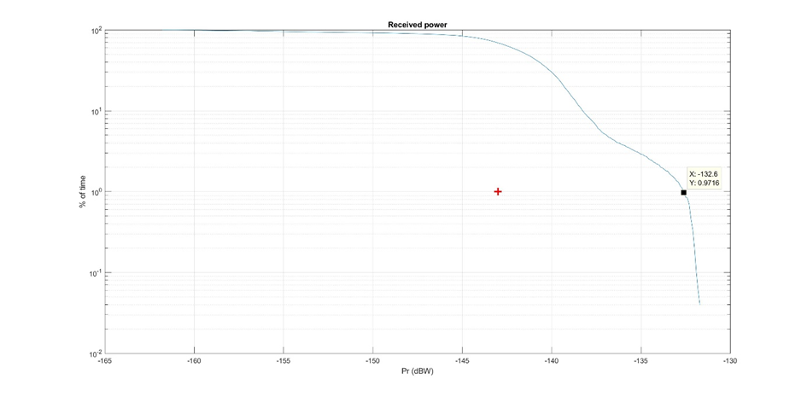

It can be seen that the EESS (active) protection criterion is exceeded by 10.2 dB (–132.8 dBW).

It can also be seen that the interference level corresponding to the protection criteria is exceeded for more than 70% of the time. The situation is also depicted on Figure 6 below showing in red the interfered portion of images (vs the non-interfered in white). It should be noted that, for the evaluation of the results it doesn’t matter if the random or systemic data availability protection criteria have been assumed since both criteria are exceeded by a wide margin.

Figure 6

Interfered portion of images (in red) vs non-interfered (in white) (Over France – options A1 and D2-low)

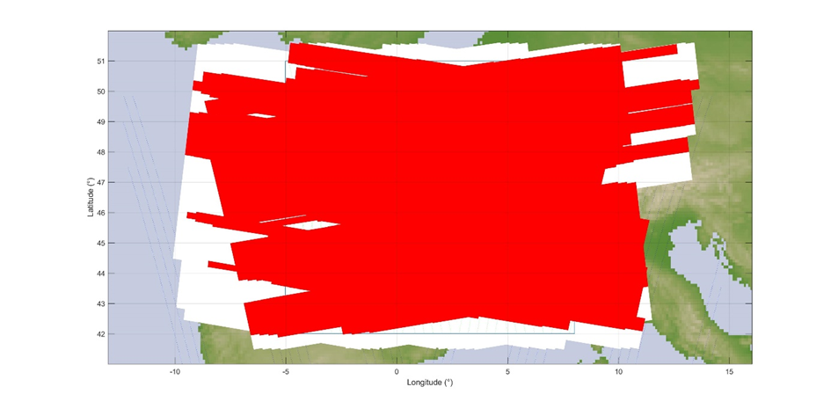

In addition, Figure 7 gives the cumulative distribution function of interference for deployment of 72 738 RLANs over France (Option D1) and antenna Option A1.

Figure 7

Interference for SCA (MID beam) (Over France – options A1 and D1)

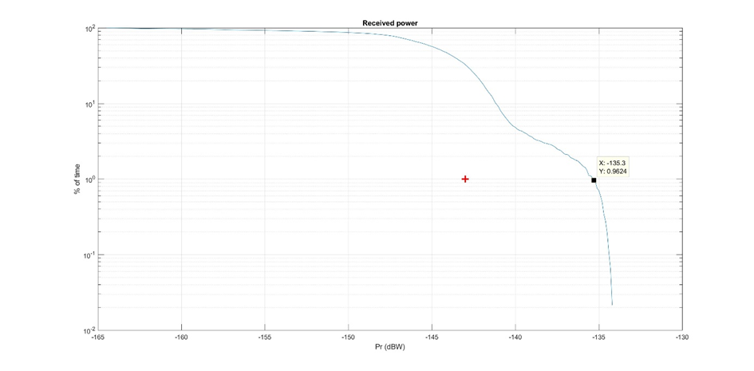

It can be seen that the EESS (active) protection criterion is exceeded by 7.7 dB (–135.3 dBW).

It can also be seen that the interference level corresponding to the protection criteria is exceeded for more than 40% of the time. The situation is also depicted on Figure 8 below showing in red the interfered portion of images (vs the non-interfered in white). It should be noted that, for the evaluation of the results it doesn’t matter if the random or systemic data availability protection criteria have been assumed since both criteria are exceeded by a wide margin.

Figure 8

Interfered portion of images (in red) vs non-interfered (in white) (Over France – options A1 and D1)



It appears obvious that in these situations, the SCA sensor will be totally ineffective over most land and coastal areas, in particular all urban and suburban areas.

Finally, Table 10 provides the levels of interference in excess for the 3 RLAN density options (D1, D2-low and D2-High) and antenna Options A1 and A3.

Table 10

Interference in excess (over France)

|  |  |  |  |  |
| --- | --- | --- | --- | --- |
| Scenario | Active RLAN density (Nb per inhabitant per 2 MHz) | Nb of active RLAN over France (in 2 MHz) | Interference in excess for antenna Option A1 | Extrapolated for antenna Option A3  (A1 – 4 dB) |
| JTG Option D1 | 0.0011 | 72 738 | **7.7 dB** | **3.7 dB** |
| JTG Option D2-low | 0.0021 | 135 432 | **10.2 dB** | **6.2 dB** |
| JTG Option D2-high  (D2-Low +10 dB) | 0.021 | 1 354 319 | **20.2 dB** | **16.2 dB** |

### 3.2.4 Dynamic analyses results over Paris metropolitan

Under the same principle, the following Figure 9 gives the cumulative distribution functions of interference corresponding to a deployment of 135 432 RLANs over France, including 20 930 RLANs over Paris metropolitan area (Option D2-low) and antenna Option A1.

Figure 9

Interference for SCA (MID beam) (Over Paris Metro – options A1 and D2-low)

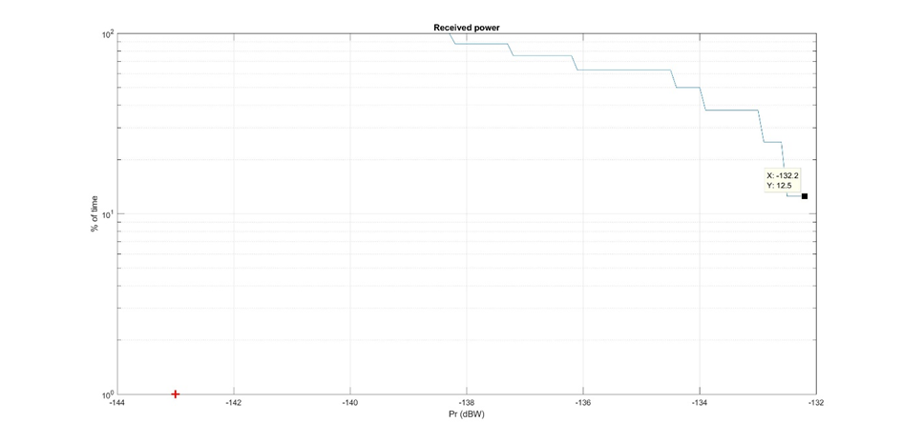

It can be seen that the EESS (active) protection criterion is largely exceeded by 10.8 dB   
(–132.2 dBW). The interference level corresponding to the protection criteria is exceeded for 100 % of the time. It should be noted that, for the evaluation of the results it doesn’t matter if the random or systemic data availability protection criteria have been assumed since both criteria are exceeded by a wide margin.

Similarly, the following Figure 10 gives the cumulative distribution functions of interference corresponding to a deployment of 72 738 RLANs over France, including 11 241 RLANs over Paris metropolitan area (Option D1) and antenna Option A1.

Figure 10

Interference for SCA (MID beam) (Over Paris Metro – options A1 and D1)

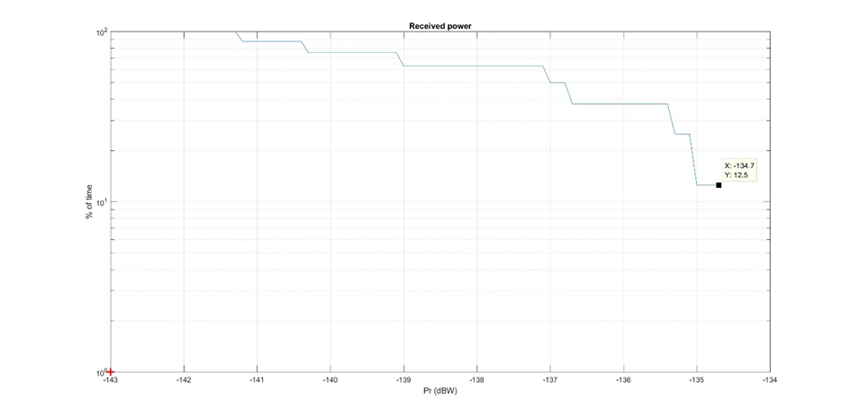

It can be seen that the EESS (active) protection criterion is largely exceeded by 8.3 dB   
(–134.7 dBW). The interference level corresponding to the protection criteria is exceeded 100 % of the time. It should be noted that, for the evaluation of the results it doesn’t matter if the random or systemic data availability protection criteria have been assumed since both criteria are exceeded by a wide margin.

Finally, Table 11 provides the levels of interference in excess for the 3 RLAN density options   
(D1, D2-low and D2-High) and antenna Options A1 and A3.

Table 11

Interference in excess (over Paris metropolitan)

|  |  |  |  |  |
| --- | --- | --- | --- | --- |
| Scenario | Active RLAN density (Nb per inhabitant per 2 MHz) | Nb of active RLAN over Paris Metro  (in 2 MHz) | Interference in excess for antenna Option A1 | Extrapolated for antenna Option A3 (A1 – 4 dB) |
| JTG Option D1 | 0.0011 | 11 241 | **8.3 dB** | **4.3 dB** |
| JTG Option D2-low | 0.0021 | 20 930 | **10.8 dB** | **6.8 dB** |
| JTG Option D2-high  (D2-Low +10 dB) | 0.021 | 209 304 | **20.8 dB** | **16.8 dB** |

### 3.2.5 Dynamic analyses results over the UK

Figure 11 gives the cumulative distribution function of interference for deployment of 129 892 RLANs over the United Kingdom (Option D2-low) and antenna Option A1.

Figure 11

Interference for SCA (MID beam) (Over the UK – options A1 and D2-low)

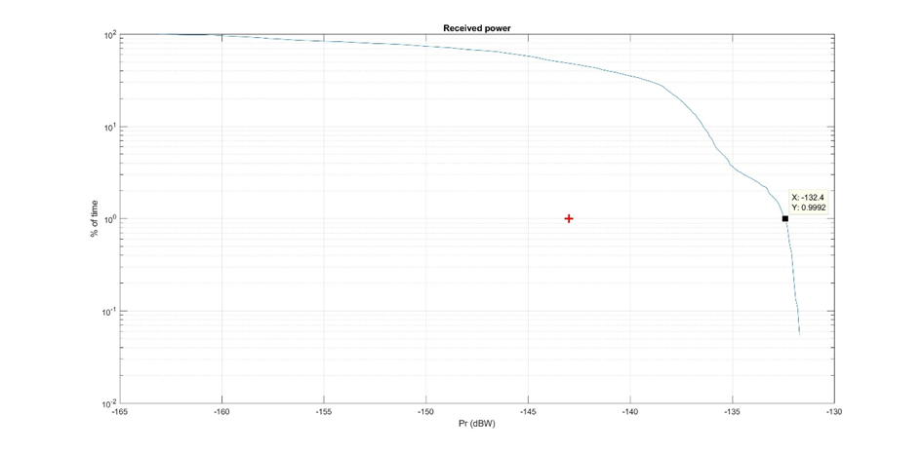

It can be seen that the EESS (active) protection criterion **is exceeded by 10.6 dB (–-132.4 dBW)**.

It can also be seen that the interference level corresponding to the protection criteria is exceeded for more than 40% of the time. The situation is also depicted on Figure 12 below showing in red the interfered portion of images (vs the non-interfered in white). It should be noted that, for the evaluation of the results it doesn’t matter if the random or systemic data availability protection criteria have been assumed since both criteria are exceeded by a wide margin.

Figure 12

Interfered portion of images (in red) vs non-interfered (in white) (Over the UK – options A1 and D2-low)



In addition, Figure 13 gives the cumulative distribution function of interference for deployment of 69 763 RLANs over the UK (Option D1) and antenna Option A1.

Figure 13

Interference for SCA (MID beam) (Over the UK – options A1 and D1)

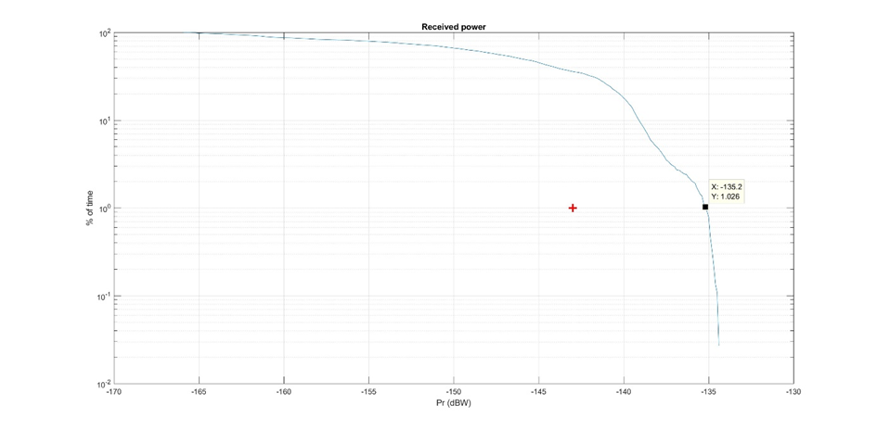

It can be seen that the EESS (active) protection criterion is largely exceeded by 7.8 dB   
(–135.2 dBW).

It can also be seen that the interference level corresponding to the protection criteria is exceeded for more than 30% of the time. The situation is also depicted on Figure 14 below showing in red the interfered portion of images (vs the non-interfered in white). It should be noted that, for the evaluation of the results it doesn’t matter if the random or systemic data availability protection criteria have been assumed since both criteria are exceeded by a wide margin.

Figure 14

Interfered portion of images (in red) vs non-interfered (in white) (Over the UK – JTG options A1 and D1)

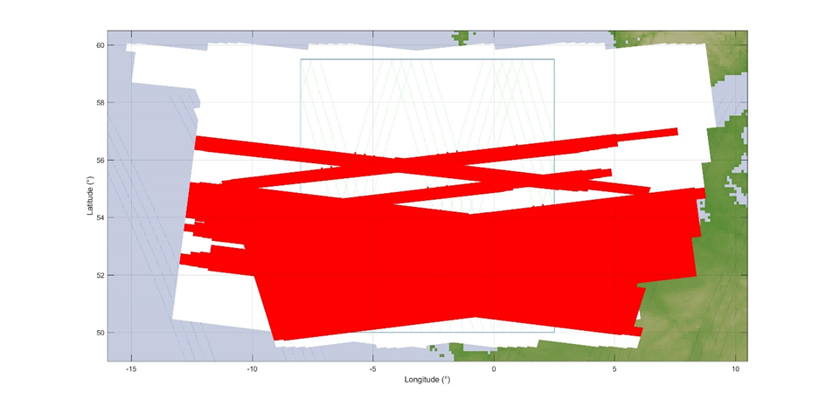

It appears obvious that in these situations, the SCA (MID beam) sensor will be totally ineffective over most land and coastal areas, in particular all urban and suburban areas.

Finally, Table 12 provides the levels of interference in excess for the 3 RLAN density options (D1, D2-low and D2-High) and antenna Options A1 and A3.

Table 12

Interference in excess (over the UK)

|  |  |  |  |  |
| --- | --- | --- | --- | --- |
| Scenario | Active RLAN density (Nb per inhabitant per 2 MHz) | Nb of active RLAN over the UK (in 2 MHz) | Interference in excess for antenna  Option A1 | Extrapolated for antenna Option A3 (A1 – 4 dB) |
| JTG Option D1 | 0.0011 | 69 763 | **7.8 dB** | **3.8 dB** |
| JTG Option D2-low | 0.0021 | 129 892 | **10.6 dB** | **6.6 dB** |
| JTG Option D2-high (D2-Low +10 dB) | 0.021 | 1 298 916 | **20.6 dB** | **16.6 dB** |

### 3.2.6 Dynamic analyses results over London metropolitan

Figure 15 gives the cumulative distribution functions of interference corresponding to a deployment of 129 892 RLANs over the UK, including 26 471 RLANs over London metropolitan area (Option D2-low) and antenna Option A1.

Figure 15

Interference for SCA (MID beam) (Over London Metro – options A1 and D2-low)

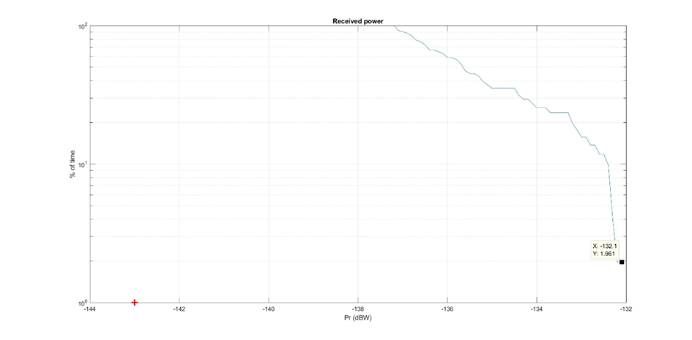

It can be seen that the EESS (active) protection criterion **is largely exceeded by 10.9 dB   
(–132.1 dBW)**.

It can also be seen that the interference level corresponding to **the protection criteria is exceeded for 100% of the time**. It should be noted that, for the evaluation of the results it doesn’t matter if the random or systemic data availability protection criteria have been assumed since both criteria are exceeded by a wide margin.

Finally, Table 13 provides the levels of interference in excess for the 3 RLAN density options (D1, D2-low and D2-High) and antenna Options A1 and A3.

Table 13

Interference in excess (over London metropolitan)

|  |  |  |  |  |
| --- | --- | --- | --- | --- |
| Scenario | Active RLAN density (Nb per inhabitant per  2 MHz) | Nb of active RLAN over London Metro (in 2 MHz) | Interference in excess for antenna Option A1 | Extrapolated for antenna Option A3 (A1 –4 dB) |
| JTG Option D1 (D2-Low –3 dB) | 0.0011 | 14 217 | **7.9 dB** | **3.9 dB** |
| JTG Option D2-low | 0.0021 | 26 471 | **10.9 dB** | **6.9 dB** |
| JTG Option D2-high (D2-Low +10 dB) | 0.021 | 264 708 | **20.9 dB** | **16.9 dB** |

### 3.2.7 Dynamic analyses – Summary of results

The results of the dynamic analysis over France are given below (see Table 10 above):

|  |  |  |  |  |
| --- | --- | --- | --- | --- |
| Scenario | Active RLAN density (Nb per inhabitant per  2 MHz) | Nb of active RLAN over France (in 2 MHz) | Interference in excess for antenna  Option A1 | Extrapolated for antenna Option A3  (A1 – 4 dB) |
| JTG Option D1 | 0.0011 | 72 738 | **7.7 dB** | **3.7 dB** |
| JTG Option D2-low | 0.0021 | 135 432 | **10.2 dB** | **6.2 dB** |
| JTG Option D2-high  (D2-Low +10 dB) | 0.021 | 1 354 319 | **20.2 dB** | **16.2 dB** |

The results of the dynamic analysis over Paris Metropolitan are given below (see Table 11 above):

|  |  |  |  |  |
| --- | --- | --- | --- | --- |
| Scenario | Active RLAN density (Nb per inhabitant per 2 MHz) | Nb of active RLAN over Paris Metro (in 2 MHz) | Interference in excess for antenna  Option A1 | Extrapolated for antenna Option A3  (A1 – 4 dB) |
| JTG Option D1 | 0.0011 | 11 241 | **8.3 dB** | **4.3 dB** |
| JTG Option D2-low | 0.0021 | 20 930 | **10.8 dB** | **6.8 dB** |
| JTG Option D2-high  (D2-Low +10 dB) | 0.021 | 209 304 | **20.8 dB** | **16.8 dB** |

The results of the dynamic analysis over the UK are given below (see Table 12 above):

|  |  |  |  |  |
| --- | --- | --- | --- | --- |
| Scenario | Active RLAN density (Nb per inhabitant per  2 MHz) | Nb of active RLAN over the UK (in 2 MHz) | Interference in excess for antenna  Option A1 | Extrapolated for antenna Option A3 (A1 – 4 dB) |
| JTG Option D1 | 0.0011 | 69 763 | **7.8 dB** | **3.8 dB** |
| JTG Option D2-low | 0.0021 | 129 892 | **10.6 dB** | **6.6 dB** |
| JTG Option D2-high (D2-Low +10 dB) | 0.021 | 1 298 916 | **20.6 dB** | **16.6 dB** |

The results of the dynamic analysis over London Metropolitan are given below (see Table 13 above):

|  |  |  |  |  |
| --- | --- | --- | --- | --- |
| Scenario | Active RLAN density (Nb per inhabitant per  2 MHz) | Nb of active RLAN over London Metro (in 2 MHz) | Interference in excess for antenna Option A1 | Extrapolated for antenna Option A3 (A1 –4 dB) |
| JTG Option D1 (D2-Low –3 dB) | 0.0011 | 14 217 | **7.9 dB** | **3.9 dB** |
| JTG Option D2-low | 0.0021 | 26 471 | **10.9 dB** | **6.9 dB** |
| JTG Option D2-high (D2-Low +10 dB) | 0.021 | 264 708 | **20.9 dB** | **16.9 dB** |

Overall, in all cases, the above dynamic analyses confirm the result of static analyses, presenting interference largely exceeding EESS (active) protection criteria and show that compatibility is not feasible between RLAN and EESS (active) in the 5350-5470 MHz frequency band.

# 4 Summary

Under all scenarios and simulation methodologies (static and dynamic), the analyses show that RLAN deployment in 5 350-5 470 MHz would create large interference in the SCA sensor on board the EPS-SG satellites.

The static analyses presented above indicate that:

– the maximum allowed density of outdoor RLANs (transmitting with the full e.i.r.p. of 200 mW) within the 12 400 km² (MID beam) and 21000 km² (SIDE beam) EESS (active) is 0.0015 and 0.0018 RLAN / km², respectively (see section 3.1.1)

– Depending on the scenario (different number of active RLAN (D1 and D2) and RLAN antenna A1 and A3), the interference to the EESS (active) sensor will be in excess of the relevant protection criteria by 1.8 to 18.6 dB (see section 3.1.2)

The dynamic analyses presented above indicate that, depending on the scenario (different number of active RLAN (D1 and D2) and RLAN antenna A1 and A3), the interference to the EESS (active) sensor will be in excess of the relevant protection criteria by (for 0.0011 to 0.021 active RLAN per inhabitant, respectively)**:**

– 3.7 to 20.2 dB (case over France) *(see section 3.3.3)*

– 4.3 to 20.8 dB (case over Paris metropolitan) *(see section 3.3.4)*

– 3.8 to 20.6 dB (case over the UK) *(see section 3.3.5)*

– 3.9 to 20.9 dB (case over London metropolitan) *(see section 3.3.6)*.

It has to be highlighted that these analyses were not considering a number of assumptions that would further increase these negative margins, such as an additional apportionment factor of the protection criteria (since the band is already shared with terrestrial radars). EUMETSAT stresses that this apportionment factor has not been introduced in the analysis given the already large negative results obtained under the assumption that no other services could generate additional interference to EESS (active).

Further, some assumptions related to RLAN remains unclear or unresolved and could also increase the potential interference to EESS (active). This covers in particular the possibilities given to a single RLAN to make use of multiple channels transmission (by means of either orthogonal transmissions or MIMO technique) or to concatenate multiple small channels to provide wider bandwidth with higher power. Such questioning also relates to other applications than RLAN since opening a band to RLAN, low power and unlicensed by nature, will drive the use of different applications such as SRDs, M2M, … (similarly to the current situation in the 2.4 GHz band) or LAA-LTE. Thus, consideration of these additional applications would need to be taken into account.

Overall, this document demonstrates and confirms again that RLANs operating in the 5 350-5 470 MHz frequency range cannot share with EESS (active) confirming that sharing between RLAN deployments in the 5 350-5 470 MHz frequency range and EESS (active) may only be feasible if additional RLAN mitigation measures are implemented.

List of References

[1] EC Mandate to CEPT to study and identify harmonised compatibility and sharing conditions for Wireless Access Systems including Radio Local Area Networks in the bands 5 350-5 470 MHz and 5 725-5 925 MHz ('WAS/RLAN extension bands') for the provision of wireless broadband services, September 2013

[2] ECC Decision (04)08: "Harmonised use of 5 GHz for the implementation of WAS/RLANs"

[3] WRC Resolution **229 (WRC-03)**: "Use of the bands 5 150-5 250, 5 250-5 350 MHz and 5 470-5 725 MHz by the mobile service for the implementation of Wireless Access Systems including Radio Local Area Networks"

[4] ERC Report 67: "Study of the Frequency sharing between HIPERLANs and MSS feeder links in the 5 GHz band"

[5] ERC Report 72: "Compatibility studies related to the possible extension band for HIPERLAN at 5 GHz"

[6] ETSI EN 301 893: "Broadband Radio Access Networks (BRAN); 5 GHz high performance RLAN; Harmonized EN covering the essential requirements of Article 3.2 of the R&TTE Directive"

[7] EC Decision 2005/513/EC complemented by EC Decision 2007/90/EC

[8] Recommendation ITU-R M.1739: "Protection criteria for wireless access systems, including radio local area networks, operating in the mobile service in accordance with Resolution 229 (WRC-03) in the bands 5 150-5 250 MHz, 5 250-5 350 MHz and 5 470‑5 725 MHz"

[9] ERC Report 25: "The European table of frequency allocations and applications in the frequency range 8.3 kHz to 3000 GHz"

[10] EC Decision 2008/671/EC: "Commission Decision of 5 August 2008 on the harmonised use of radio spectrum in the 5 875-5 905 MHz frequency band for safety related applications of Intelligent Transport Systems (ITS)"

[11] ECC Decision (08)01: "ECC Decision of 14 March 2008 on the harmonised use of the 5 875-5 925 MHz frequency band for Intelligent Transport Systems (ITS)"

[12] ECC Recommendation (08)01: "Use of the band 5 855-5 875 MHz for Intelligent Transport Systems"

[13] ECC Report 101: "Compatibility studies in the band 5 855-5 925 MHz between Intelligent Transport Systems (ITS) and other systems"

[14] ECC Decision (12)04: "ECC Decision of 2 November 2012 on the withdrawal of ECC Decision (02)01. For national implementation issues related to the withdrawn Decision, check EFIS"

[15] ERC Recommendation 70-03: "Relating to the use of Short Range Devices (SRD)"

[16] ETSI EN 300 674: "Electromagnetic compatibility and Radio spectrum Matters (ERM); Road Transport and Traffic Telematics (RTTT); Dedicated Short Range Communication (DSRC) transmission equipment (500 kbit/s / 250 kbit/s) operating in the 5.8 GHz Industrial, Scientific and Medical (ISM) band; Part 1: General characteristics and test methods for Road Side Units (RSU) and On-Board Units (OBU)"

[17] CENELEC EN 12253: "Road transport and traffic telematics - Dedicated short-range communication - Physical layer using microwave at 5.8 GHz"

[18] ECC Report 68: "Compatibility studies in the band 5 725-5 875 MHz between Fixed Wireless Access (FWA) systems and other systems"

[19] Recommendation ITU-R P.452: "Prediction procedure for the evaluation of interference between stations on the surface of the Earth at frequencies above about 0.1 GHz"

[20] EC Decision 2006/771/EC: "Commission Decision of 9 November 2006 on the harmonisation of the radio spectrum for use by short-range devices"

[21] IARU Region-1 VHF Managers Handbook

[22] Recommendation ITU-R M.1732-1: "Characteristics of systems operating in the amateur and amateur-satellite services for use in sharing studies"

[23] ECC Report 210: "Compatibility/sharing studies related to Broadband Direct-Air-to-Ground Communications (DA2GC) in the frequency bands 5 855-5 875 MHz, 2 400‑2 483.5 MHz and 3 400-3 600 MHz"

[24] ETSI TR 101 599: "Electromagnetic compatibility and Radio spectrum matters (ERM) System Reference Document (SRDoc); Broadband Direct-Air-to-Ground Communications System employing beamforming antennas, operating in the 2.4 GHz and 5.8 GHz bands"

[25] ETSI TR 103 108: "Electromagnetic compatibility and Radio spectrum Matters (ERM); System Reference document (SRdoc); Broadband Direct-Air-to-Ground Communications System operating in the 5.855 GHz to 5.875 GHz band using 3G technology"

[26] ECC Report 206: "Compatibility studies in the band 5 725-5 875 MHz between SRD equipment for wireless industrial applications and other systems"

[27] IEEE 802.11-2012: "Wireless LAN Medium Access Control (MAC) and Physical Layer (PHY) Specifications"

[28] ETSI EN 302 571 V1.2.2 (2011-10): "Intelligent Transport Systems (ITS); Radiocommunications equipment operating in the 5 855 MHz to 5 925 MHz frequency band; Harmonized EN covering the essential requirements of article 3.2 of the R&TTE Directive"

[29] Recommendation ITU-R SM.329: "Unwanted emissions in the spurious domain"

[30] ERC Recommendation 74-01: "Unwanted Emissions in the Spurious Domain"

[31] Recommendation ITU-R F.1336-3: "Reference radiation patterns of omnidirectional, sectoral and other antennas for the fixed and mobile service for use in sharing studies in the frequency range from 400 MHz to about 70 GHz"

[32] ETSI ES 200 674-1 V2.4.1 (2013-05): “Technical characteristics and test methods for High Data Rate (HDR) data transmission equipment operating in the 5,8 GHz Industrial, Scientific and Medical (ISM) band”

[33] NTIA 5 GHz report, January 2013, “Evaluation of the 5 350-5 470 MHz and 5 850‑5 925 MHz bands pursuant to section 6406(b) of the middle class tax relief and job creation act of 2012

[34] ETSI TR 102 960: "Intelligent Transport Systems (ITS); Mitigation techniques to avoid interference between European CEN Dedicated Short Range Communication (RTTT DSRC) equipment and Intelligent Transport Systems (ITS) operating in the 5 GHz frequency range; Evaluation of mitigation methods and techniques"

[35] ETSI TS 102 792: "Intelligent Transport Systems (ITS); Mitigation techniques to avoid interference between European CEN Dedicated Short Range Communication (CEN DSRC) equipment and Intelligent Transport Systems (ITS) operating in the 5 GHz frequency range"

[36] <http://www.statistiques-mondiales.com/union_europeenne.htm>

[37] <http://appsso.eurostat.ec.europa.eu/nui/show.do?dataset=lfst_hhnhtych&lang=en>

[38] <https://www.ssb.no/en/befolkning/statistikker/familie/aar/2014-12-12>

[39] <http://www.bfs.admin.ch/>

[40] <http://appsso.eurostat.ec.europa.eu/nui/show.do?dataset=bd_9ac_l_form_r2&lang=en>

[41] 3GPP TR 36.889: Feasibility Study on Licensed-Assisted Access to Unlicensed Spectrum, <http://www.3gpp.org/DynaReport/36889.htm>

[42] CEPT Report 57: "Compatibility and sharing conditions for WAS/RLAN in the bands 5 350-5 470 MHz and 5 725-5 925 MHz"

[43] ECC Report 181 on improving spectrum efficiency in SRD bands

[44] JRC study on RLAN deployment and device densities: <http://www.cept.org/Documents/se-24/25709/SE24(15)070R0_WI52_number-of-RLAN-JRC>

[45] JRC study on in-home RLAN coverage and number of RLAN APs per household: <http://www.cept.org/Documents/se-24/25805/SE24(15)089R0_WI52_Further-considerations-on-WLAN-indoor-coverage>

[46] JRC measurements of 802.11ac RLAN APs operating in the 5 GHz band: <http://www.cept.org/Documents/se-24/24051/SE24(15)042R0_WI52_JRC_5GHZ_RLAN-_measurements>

[47] ECC Report 244 “Compatibility studies related to RLANs in the 5 725-5 925 MHz band”.

1. This system is a two-satellites constellation.
2. Lower gain can be used for the wider beams.
3. Antenna beam “incident angles”.
4. Average e.i.r.p. over a pulse repetition interval.
5. Max e.i.r.p. during pulse transmission.
6. Antenna gain varies depending on antenna location (mid or side), and incident angle.