|  |  |
| --- | --- |
| **Radiocommunication Study Groups** |  |
|  |  |
|  |  |
| Received: 23 May 2019 | **Document 5D/1197-E** |
| **24 May 2019** |
| **English only** |
|  | **TECHNOLOGY ASPECTS** |
| Alliance for Telecommunications Industry Solutions1 | |
| Liaison Statement from 3GPP Proponent regarding IMT-2020 Transposition Timings in Step 8 of IMT-2020 Process | |
|  | |

Background

3GPP thanks ITU-R Working Party (WP) 5D for their work in IMT-2020 and recognizes the importance of the 3GPP 5G technology being included as a technology in IMT-2020. The 3GPP Proponent[1] will finalize their technology submissions of the NR RIT (Releases 15 & 16) and the LTE/NR SRIT (Releases 15 & 16) and provide them to the WP 5D meeting #32 in July 2019 by the specified contribution deadline on 2 July 2019.

In reviewing the 3GPP 5G work, 3GPP notes to WP 5D its amended development program for Release 16. 3GPP asks WP 5D in this liaison if WP 5D could review its year-end 2020 schedule for IMT-2020 to provide some additional time for the provision of the transposed standards URL references to ITU-R for finalization of the new Recommendation ITU-R M.[IMT-2020.SPECS].

Adjustment to the 3GPP Release 16 Schedule

In RAN Plenary #82, 3GPP amended the development schedule for 5G Release 16 to better reflect the complexities of the technology specifications development work. This was done in order to properly facilitate the sequencing of work between 3GPP RAN working groups for overall specification stability. Annex 1 shows this amended Release 16 schedule.

Global Core Specification (GCS) for IMT-2020 process Step 8

3GPP plans to use the June 2020 specification output from the 3GPP Plenaries. In particular, the output of RAN #88 (15-18 June 2020), when Release 16 ASN.1 freeze milestone is concluded, will be the primary basis of the IMT-2020 separate GCSs that correspond to the [3GPP submissions](https://www.3gpp.org/release-16) of the NR RIT (Releases 15 & 16)[2] and the LTE/NR SRIT (Releases 15 & 16)2. These specifications will establish the primary basis of the Global Core Specification (GCS) that the 3GPP GCS Proponent will provide to ITU-R WP 5D in time for the WP 5D Meeting #35 (24 June -1 July 2020). *This is in anticipation of the detailed ITU-R schedule for IMT-2020 Step 8.*

The approved June 2020 version of the 3GPP specifications will be used by the 3GPP Transposing Organizations (TOs) for their individual standards transpositions, and for the creation of the relevant URL references to be provided to ITU-R for inclusion in the draft new Recommendation under Step 8 of the IMT-2020 process*. It is expected that the published versions of the specifications from the June 2020 Plenary will be available to the Organizational Partners (OPs) by 6 July 2020 to initiate their transposition work.*

Anticipation of Schedules

While the normal detailed sequencing schedule used in IMT technology Recommendations for IMT-2020 Step 8 has not yet been communicated officially (via liaison) to the External Organizations by WP 5D, the 3GPP TOs have considered the usual milestones of the IMT process in their work planning analysis, assisted by consultations with the ITU-R WP 5D Chairman and the Chair of the WP 5D Work Plan Ad Hoc group.

Based on a typical schedule for the URL references for ITU-R IMT technology Recommendations, the URL references for IMT-2020 need to be supplied by the TOs to ITU-R approximately 30 days ahead of the planned WP 5D Meeting #36 (7-14 October 2020). This lead time is needed in order for the Radiocommunication Bureau to compile all the TOs’ references and tables into the final draft version for all technologies included in Step 8 in time for WP 5D Meeting #36. *The deadline for these URL references and related information to be sent to the Radiocommunication Bureau by the TOs would thusly be expected to be planned for 7 September 2020 by the ITU-R.*

WP 5D will conclude the draft Recommendation ITU-R M.[IMT-2020.SPECS] in its Meeting #36 and forward it to ITU-R Study Group 5 for initiating final ITU-R approval.

Analysis of Schedules

In conjunction with the internal 3GPP Release 16 schedule extension, 3GPP has surveyed the OPs to inquire if the anticipated ITU-R 7 September 2020 date could be met for the standards transpositions and the provision of the URL references to ITU-R. *The 7 September date would allow the 3GPP TOs 8 weeks to complete their tasks.*

*The 3GPP TOs have indicated that their internal processes and approval would require at least 12 weeks under an expedited schedule of their work.*

3GPP Request

3GPP would like to inform WP 5D of this schedule analysis within 3GPP. 3GPP kindly requests that WP 5D take this situation into account. When WP 5D is defining the detailed schedule to be provided to External Organizations for the work of Step 8 under the IMT-2020 process, *3GPP would like to inquire if WP 5D may be able to offer any solutions from the ITU-R perspective of the year-end 2020 work timings for IMT-2020 that could permit the 3GPP TOs to have the identified 12 weeks of time.*

3GPP notes that with the complexities of 5G as a new generation of technology and the importance of the new Recommendation ITU-R M.[IMT-2020.SPECS] globally for all stakeholders (including support for the results of WRC-19), any additional time afforded to the External Organizations in Step 8 for provision of the URL references would be of great benefit to *all* the radio interface technology proponents, not just 3GPP.

3GPP welcomes any accommodation WP 5D might make concerning the scheduling of the work to conclude the first release of Recommendation ITU-R M.[IMT-2020.SPECS] and kindly asks for feedback to 3GPP from that discussion.

Annex 1

New 3GPP Release 16 Schedule

December 2018

*(Source: 3GPP TSG RAN Chairman)*

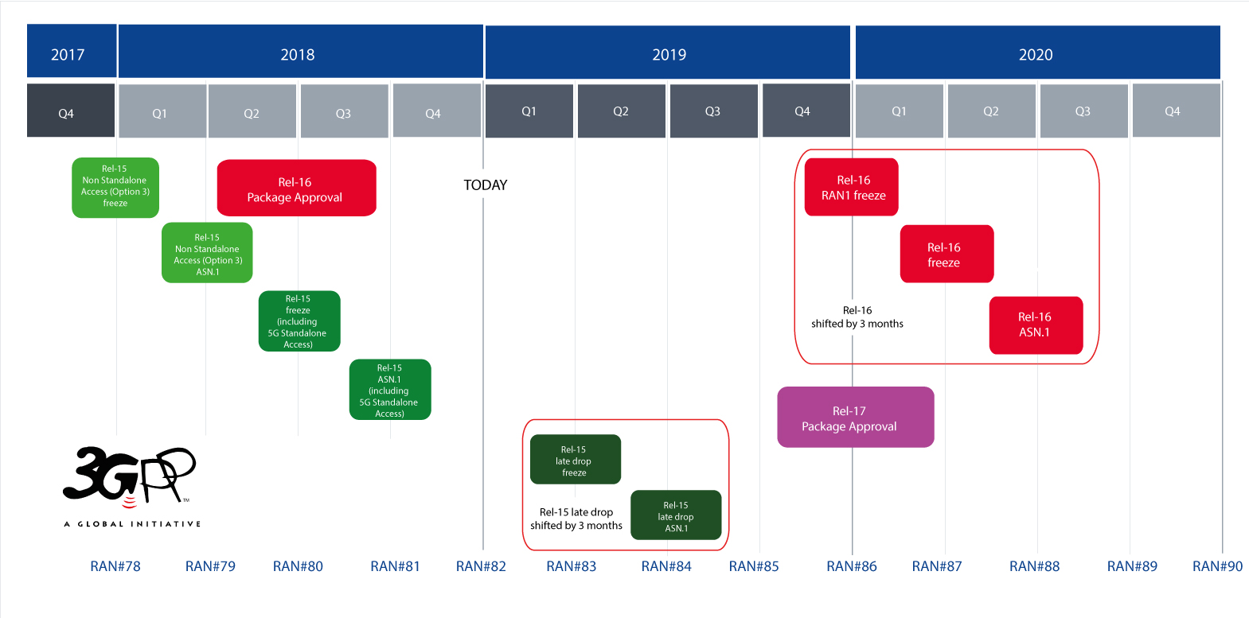

*See also* [*Document SP-181241*](http://www.3gpp.org/ftp/tsg_ran/TSG_RAN/TSGR_82/Report/SA_input/) *RAN Plenary #82 Report to SA Plenary*

|  |  |
| --- | --- |
| 3GPP has agreed revised completion dates for Release 16 – schedule shifted out by 3 months | |
| Release 16 RAN-1 Freeze | *RAN # 86 December 2019* |
| Release 16 RAN Stage 3 Freeze | *RAN # 87 March 2020* |
| Release 16 ASN.1 Freeze | *RAN # 88 June 2020* |
| Release 16 RAN-4 Freeze | *RAN # 89 September 2020* |

______________

1. Submitted on behalf of the 3GPP Proponent of the 3GPP submission, which is collectively the 3GPP Organizational Partners (OPs). The 3GPP OPs are ARIB, ATIS, CCSA, ETSI, TSDSI, TTA and TTC (<http://www.3gpp.org/partners>).
2. Also see: <ftp://ftp.3gpp.org/Inbox/Marcoms/graphie4/2019_brochure_5G_world/version05_04.pdf>.