World Radiocommunication Conference (WRC-15)  Geneva, 2–27 November 2015 | 
INTERNATIONAL TELECOMMUNICATION UNION
PLENARY MEETING | Revision 2 to Document 9-E
 | 15 November 2015
 | Original: English
European Common Proposals (CEPT)
Proposals for the work of the conference
This contribution presents the European common proposals for WRC-15. These have been developed by the European Conference of Postal and Telecommunications Administrations (CEPT) Conference Preparatory Group (CPG). As in past conferences, the intent of these proposals is to provide a timely and effective response to emerging radiocommunication needs while maximizing efficient use of the spectrum, protecting current services and their expected development, and enabling equitable access to frequencies by all countries and systems.
The European administrations welcome the opportunity offered by WRC-15 for in-depth discussions with the other ITU administrations on the issues included in the Conference agenda. To this effect, coordinators have been designated for each agenda item to act as point of contact with the other administrations to contribute to the efforts of the Conference in arriving at decisions that can be supported by all ITU countries.
The detailed proposals are provided in 26 addenda to this contribution, one per agenda item of the Conference. The table of contents for these addenda is provided in Annex 1.
Annex 2 to this contribution provides the list of European coordinators for each of the WRC-15 agenda items.
The table of co-signatures by European administrations is provided in Annex 3.

Annexes: 3
Annex 1
Structure of the European common proposals to WRC-15 and
correspondence with WRC-15 Agenda items
Document | Title | CPI
Main document | European common proposals for the work of the Conference
Addendum 1 | European common proposals Part 1 Agenda item 1.1 | yes
Add. 1 to Addendum 1 | European common proposals Part 1 Subpart 1 – Band 1427-1518 MHz | yes
Add. 2 to Addendum 1 | European common proposals Part 1 Subpart 2 – Band 3400-3800 MHz | yes
Add. 3 to Addendum 1 | European common proposals Part 1 Subpart 3 – Band 470-694 MHz | yes
Add. 4 to Addendum 1 | European common proposals Part 1 Subpart 4 – NOC bands | yes
Add. 5 to Addendum 1 | European common proposals Part 1 Subpart 5 – Band 3800-4200 MHz | yes
Add. 6 to Addendum 1 | European common proposals Part 1 Subpart 6 – Bands 4400-4500; 4800-5000; 5925-6425 MHz | yes
Add. 7 to Addendum 1 | European common proposals Part 1 Subpart 7 – Band 2700-2900 MHz | yes
Addendum 2 | European common proposals Part 2 Agenda item 1.2
Add. 1 to Addendum 2 | European common proposals Part 2 Subpart 1 Agenda item 1.2 – Issues A and D | yes
Add. 2 to Addendum 2 | European common proposals Part 2 Subpart 2 Agenda item 1.2 – Issue B | yes
Add. 3 to Addendum 2 | European common proposals Part 2 Subpart 2 Agenda item 1.2 – Issue C | yes
Addendum 3 | European common proposals Part 3 Agenda item 1.3 | yes
Addendum 4 | European common proposals Part 4 Agenda item 1.4 | yes
Addendum 5 | not used
Addendum 6 | European common proposals Part 6 Agenda item 1.6
Add. 1 to Addendum 6 | European common proposals Part 6 Subpart 1 - Agenda item 1.6.1 | yes
Add. 2 to Addendum 6 | not used
Addendum 7 | European common proposals Part 7 Agenda item 1.7 | yes
Addendum 8 | European common proposals Part 8 Agenda item 1.8 | yes
Addendum 9 | European common proposals Part 9 Agenda item 1.9 | yes
Add. 1 to Addendum 9 | European common proposals Part 9 Subpart 1 Agenda item 1.9.1 | yes
Add. 2 to Addendum 9 | European common proposals Part 9 Subpart 2 Agenda item 1.9.2 | yes
Addendum 10 | European common proposals Part 10 Agenda item 1.10 | yes
Addendum 11 | European common proposals Part 11 Agenda item 1.11 | yes
Addendum 12 | European common proposals Part 12 Agenda item 1.12 | yes
Addendum 13 | European common proposals Part 13 Agenda item 1.13 | yes
Addendum 14 | not used
Addendum 15 | European common proposals Part 15 Agenda item 1.15 | yes
Addendum 16 | European common proposals Part 16 Agenda item 1.16 | yes
Add. 1 to Addendum 16 | European common proposals Part 16 Subpart 1 - Agenda item 1.16 Issue A | yes
Add. 2 to Addendum 16 | European common proposals Part 16 Subpart 2 - Agenda item 1.16 Issue B | yes
Add. 2 to Addendum 16 | European common proposals Part 16 Subpart 3 - Agenda item 1.16 Issue C | yes
Addendum 17 | European common proposals Part 17 Agenda item 1.17 | yes
Addendum 18 | European common proposals Part 18 Agenda item 1.18 | yes
Addendum 19 | European common proposals Part 19 Agenda item 2 | yes
Addendum 20 | European common proposals Part 20 Agenda item 4 | yes
Addendum 21 | European common proposals Part 21 Agenda item 7 | yes
Add. 1 to Addendum 21 | European common proposals Part 21 Subpart A - Agenda item 7 Issue A | yes
Add. 2 to Addendum 21 | European common proposals Part 21 Subpart B - Agenda item 7 Issue B | yes
Add. 3 to Addendum 21 | European common proposals Part 21 Subpart C - Agenda item 7 Issue C | yes
Add. 4 to Addendum 21 | European common proposals Part 21 Subpart D - Agenda item 7 Issue D | yes
Add. 5 to Addendum 21 | European common proposals Part 21 Subpart E - Agenda item 7 Issue E | yes
Add. 6 to Addendum 21 | European common proposals Part 21 Subpart F - Agenda item 7 Issue F | yes
Add. 7 to Addendum 21 | European common proposals Part 21 Subpart G - Agenda item 7 Issue G | yes
Add. 8 to Addendum 21 | not used
Add. 9 to Addendum 21 | European common proposals Part 21 Subpart I - Agenda item 7 Issue I | yes
Add. 10 to Addendum 21 | European common proposals Part 21 Subpart J - Agenda item 7 Issue J | yes
Add. 11 to Addendum 21 | European common proposals Part 21 Subpart K - Agenda item 7 Issue K | yes
Add.12 to Addendum 21 | European common proposals Part 21 Subpart L - Agenda item 7 Issue L | yes
Add.13 to Addendum 21 | European common proposals Part 21 Subpart np - Agenda item 7 Issue NP | yes
Addendum 22 | European common proposals Part 22 Agenda item 9.1
Add. 1 to Addendum 22 | European common proposals Part 22 Subpart A - Agenda item 9.1 Issue 9.1.1 | yes
Add. 2 to Addendum 22 | European common proposals Part 22 Subpart B - Agenda item 9.1 Issue 9.1.2 | yes
Add. 3 to Addendum 22 | European common proposals Part 22 Subpart C - Agenda item 9.1 Issue 9.1.3 | yes
Add. 4 to Addendum 22 | European common proposals Part 22 Subpart D - Agenda item 9.1 Issue 9.1.4 | yes
Add. 5 to Addendum 22 | not used
Add. 6 to Addendum 22 | European common proposals Part 22 Subpart E - Agenda item 9.1 Issue 9.1.6 | yes
Add. 7 to Addendum 22 | European common proposals Part 22 Subpart F - Agenda item 9.1 Issue 9.1.7 | yes
Add. 8 to Addendum 22 | European common proposals Part 22 Subpart G - Agenda item 9.1 Issue 9.1.8 | yes
Addendum 23 | European common proposals Part 23 Agenda item 9.2 | yes
Addendum 24 | not used
Addendum 25 | European common proposals Part 25 Agenda item 10 | yes
Addendum 26 | European common proposals Part 26 on Resolution 185 (PP-14) | yes

Annex 2
List of European coordinators for WRC-15
AI | WRC-15 Agenda Item | CEPT Coordinator | Photo
 | overall coordination in preparation of WRC-15; | Mr Alexander Kühn  Germany  alexander.kuehn@bnetza.de | 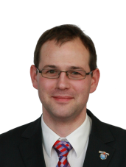
1.1 | to consider additional spectrum allocations to the mobile service on a primary basis and identification of additional frequency bands for International Mobile Telecommunications (IMT) and related regulatory provisions, to facilitate the development of terrestrial mobile broadband applications, in accordance with Resolution 233 (WRC-12); | Mr Pasi Toivonen  Finland  pasi.toivonen@ficora.fi | 
1.2 | to examine the results of ITU-R studies, in accordance with Resolution 232 (WRC-12), on the use of the frequency band 694-790 MHz by the mobile, except aeronautical mobile, service in Region 1 and take the appropriate measures; | Mr Steve Green  UK  steve.green@ofcom.org.uk | 
1.3 | to review and revise Resolution 646 (Rev.WRC-12) for broadband public protection and disaster relief (PPDR), in accordance with Resolution 648 (WRC-12); | Mr Andrew Gowans  UK  andrew.gowans@ofcom.org.uk | 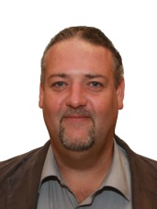
1.4 | to consider possible new allocation to the amateur service on a secondary basis within the band 5 250-5 4 50/5 250-5 450 kHz in accordance with Resolution 649 (WRC-12); | Mr Hans Blondeel Timmerman  The Netherlands  pb2t@me.com | 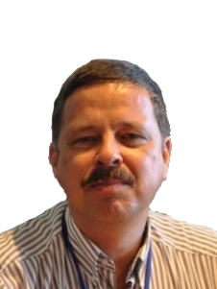
1.5 | to consider the use of frequency bands allocated to the fixed-satellite service not subject to Appendices 30, 30A and 30B for the control and non-payload communications of unmanned aircraft systems (UAS) in non-segregated airspaces, in accordance with Resolution 153 (WRC-12); | Mr Hans-Jürgen Tscheulin  Germany  hansjuergen.tscheulin@audens.de | 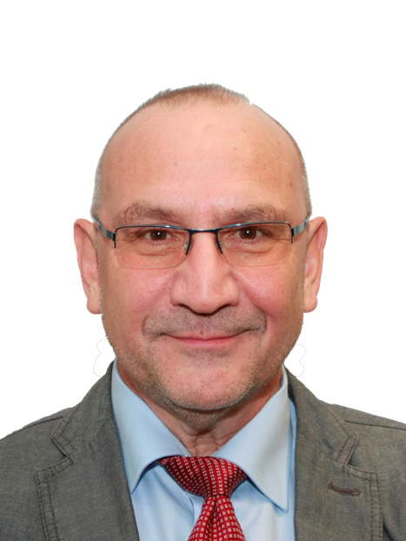
1.6 | to consider possible additional primary allocations: | Mr Mikhail Simonov  Russian Federation  mms@niir.ru | 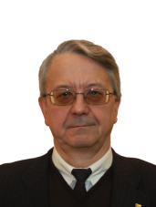
1.6.1 | to the fixed-satellite service (Earth-to-space and space-to-Earth) of 250 MHz in the range between 10 GHz and 17 GHz in Region 1;
1.6.2 | to the fixed-satellite service (Earth-to-space) of 250 MHz in Region 2 and 300 MHz in Region 3 within the range 13-17 GHz; and review the regulatory provisions on the current allocations to the fixed-satellite service within each range, taking into account the results of ITU R studies, in accordance with Resolutions 151 (WRC-12) and 152 (WRC-12), respectively;
1.7 | to review the use of the band 5 091-5 150 MHz by the fixed-satellite service (Earth-to-space) (limited to feeder links of the non-geostationary mobile-satellite systems in the mobile-satellite service) in accordance with Resolution 114 (Rev.WRC-12); | acting CEPT Coordinator  Mr Victor Glushko  Russian Federation  glushko@geyser-telecom.ru | 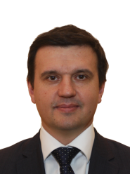
1.8 | to review the provisions relating to earth stations located on board vessels (ESVs), based on studies conducted in accordance with Resolution 909 (WRC-12); | Mr Bernard Lagarde  France  bernard.lagarde@anfr.fr | 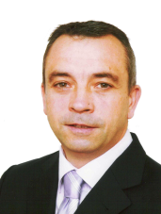
1.9 | to consider, in accordance with Resolution 758 (WRC-12); | Ms Soraya Contreras  France  soraya.contreras@anfr.fr | 
1.9.1 | possible new allocations to the fixed-satellite service in the frequency bands 7 150-7 250 MHz (space-to-Earth) and 8 400-8 500 MHz (Earth-to-space), subject to appropriate sharing conditions;
1.9.2 | the possibility of allocating the bands 7 375-7 750 MHz and 8 025-8 400 MHz to the maritime-mobile satellite service and additional regulatory measures, depending on the results of appropriate studies;
1.10 | to consider spectrum requirements and possible additional spectrum allocations for the mobile-satellite service in the Earth-to-space and space-to-Earth directions, including the satellite component for broadband applications, including International Mobile Telecommunications (IMT), within the frequency range from 22 GHz to 26 GHz, in accordance with Resolution 234 (WRC-12); | Mr Juergen Nitschke  Germany  juergen.nitschke@BNetzA.de | 
1.11 | to consider a primary allocation for the Earth exploration-satellite service (Earth-to-space) in the 7-8 GHz range, in accordance with Resolution 650 (WRC-12); | Mrs.Elena Daganzo-Eusebio  The Netherlands  elena.daganzo-eusebio@esa.int | 
1.12 | to consider an extension of the current worldwide allocation to the Earth exploration-satellite (active) service in the frequency band 9 300-9 900 MHz by up to 600 MHz within the frequency bands 8 700-9 300 MHz and/or 9 900-10 500 MHz, in accordance with Resolution 651 (WRC-12); | Hanspeter Kuhlen  Germany  hanspeter.kuhlen@airbus.com | 
1.13 | to review No. 5.268 with a view to examining the possibility for increasing the 5 km distance limitation and allowing space research service (space-to-space) use for proximity operations by space vehicles communicating with an orbiting manned space vehicle, in accordance with Resolution 652 (WRC-12); | Mr Thibaut Caillet  France  thibaut.caillet@anfr.fr | 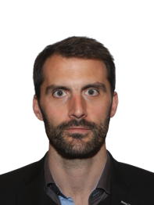
1.14 | to consider the feasibility of achieving a continuous reference time-scale, whether by the modification of coordinated universal time (UTC) or some other method, and take appropriate action, in accordance with Resolution 653 (WRC-12); | Mr Bharat Dudhia  United Kingdom  bharat.dudhia@ofcom.org.uk | 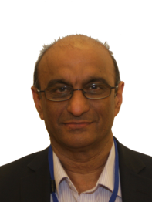
1.15 | to consider spectrum demands for on-board communication stations in the maritime mobile service in accordance with Resolution 358 (WRC-12); | Mr Jaap Steenge  The Netherlands  jaap.steenge@agentschaptelecom.nl | 
1.16 | to consider regulatory provisions and spectrum allocations to enable possible new Automatic Identification System (AIS) technology applications and possible new applications to improve maritime radiocommunication in accordance with Resolution 360 (WRC-12); | Mr Hans-Karl von Arnim  Germany  hans-karl.arnim@bsh.de | 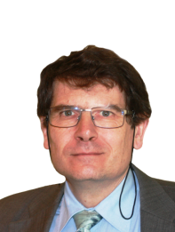
1.17 | to consider possible spectrum requirements and regulatory actions, including appropriate aeronautical allocations, to support wireless avionics intra-communications (WAIC), in accordance with Resolution 423 (WRC-12); | Mr Uwe Schwark  Germany  uwe.schwark@airbus.com | 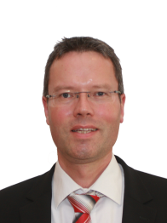
1.18 | to consider a primary allocation to the radiolocation service for automotive applications in the 77.5-78.0 GHz frequency band in accordance with Resolution 654 (WRC-12); | Mr Marco Marcovina  France  marco.marcovina@anfr.fr | 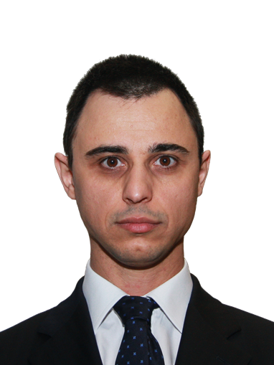
2 | to examine the revised ITU R Recommendations incorporated by reference in the Radio Regulations communicated by the Radiocommunication Assembly, in accordance with Resolution 28 (Rev.WRC 03), and to decide whether or not to update the corresponding references in the Radio Regulations, in accordance with the principles contained in Annex 1 to Resolution 27 (Rev.WRC-12); | Mr Karel Antousek  Czech Republic  antousekk@ctu.cz | 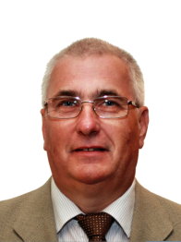
4 | in accordance with Resolution 95 (Rev.WRC-07), to review the resolutions and recommendations of previous conferences with a view to their possible revision, replacement or abrogation; | Mr Karel Antousek  Czech Republic  antousekk@ctu.cz
7 | to consider possible changes, and other options, in response to Resolution 86 (Rev. Marrakesh, 2002) of the Plenipotentiary Conference, an advance publication, coordination, notification and recording procedures for frequency assignments pertaining to satellite networks, in accordance with Resolution 86 (Rev.WRC-07) to facilitate rational, efficient, and economical use of radio frequencies and any associated orbits, including the geostationary satellite orbit; | Ms Anna Marklund  Sweden  anna.marklund@ses.com | 
8 | to consider and take appropriate action on requests from administrations to delete their country footnotes or to have their country name deleted from footnotes, if no longer required, taking into account Resolution 26 (Rev.WRC-07); | Mr Dmytro Protsenko  Ukraine  protsenko@ucrf.gov.ua | 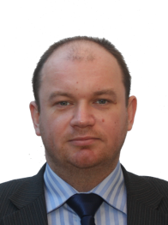
9 | to consider and approve the Report of the Director of the Radiocommunication Bureau, in accordance with Article 7 of the Convention:
9.1.1 | Resolution 205 (Rev.WRC-12)  Protection of the systems operating in the mobile-satellite service in the band 406-406.1 MHz | Mr Jean Pla  France  jean.pla@cnes.fr | 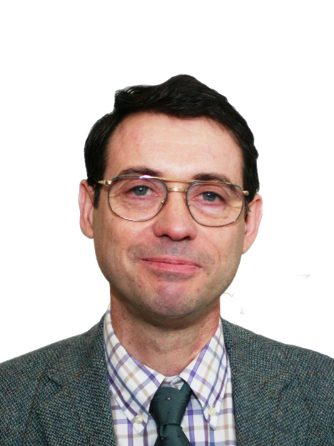
9.1.2 | Resolution 756 (WRC-12) Studies on possible reduction of the coordination arc and technical criteria used in application of No. 9.41 in respect of coordination under No. 9.7 | Mr Mario Neri  United Kingdom  mario.neri@ofcom.org.uk | 
9.1.3 | Resolution 11 (WRC-12) Use of satellite orbital positions and associated frequency spectrum to deliver international public telecommunication services in developing countries | Mr Mario Neri  United Kingdom  mario.neri@ofcom.org.uk
9.1.4 | Resolution 67 (WRC-12) Updating and rearrangement of the Radio Regulations | acting CEPT Coordinator  Martin Fenton  United Kingdom  Martin.Fenton@ofcom.org.uk | 
9.1.5 | Resolution 154 (WRC-12).  Consideration of technical and regulatory actions in order to support existing and future operation of fixed-satellite service earth stations within the band 3 400-4 200 MHz, as an aid to the safe operation of aircraft and reliable distribution of meteorological information in some countries in Region 1 | Mr Mindaugas Sruogius  Litauen  mindaugas.sruogius@rrt.lt | 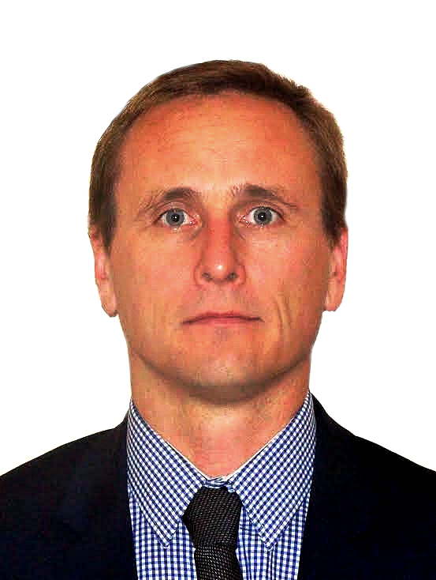
9.1.6 | Resolution 957 (WRC-12)  Studies towards review of the definitions of fixed service, fixed station and mobile station | Anders Jonsson  Sweden  anders.jonsson@pts.se | 
9.1.7 | Resolution 647 (Rev. WRC-12)  Spectrum management guidelines for emergency and disaster relief radiocommunication | Mr Andrew Gowans  United Kingdom  andrew.gowans@ofcom.org.uk | 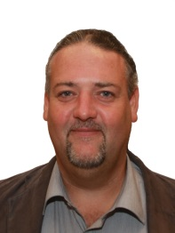
9.1.8 | Resolution 757 (WRC-12) Regulatory aspects for nano- and picosatellites | Mr Wouter Jan Ubbels  The Netherlands  w.j.ubbels@isispace.nl | 
9.2 | on any difficulties or inconsistencies encountered in the application of the Radio Regulations (satellite part) | Mr Jonas Eneberg  United Kingdom  jonas.eneberg@inmarsat.com | 
9.3 | Resolution 80 (Rev.WRC-07): Due diligence in applying the principles embodied in the Convention. | acting CEPT Coordinator  Alexandre Vallet  France  alexandre.vallet@anfr.fr | 
10 | to recommend to the Council items for inclusion in the agenda for the next WRC, and to give its views on the preliminary agenda for the subsequent conference and on possible agenda items for future conferences, in accordance with Article 7 of the Convention | Wesley Milton  United Kingdom  wesley.milton@ofcom.org.uk | 
GFT | Resolution 185 (Busan, 2014) - Global flight tracking for civil aviation - The Plenipotentiary Conference of the International Telecommunication Union (Busan, 2014), resolves to instruct WRC-15, pursuant to No. 119 of the ITU Convention, to include in its agenda, as a matter of urgency, the consideration of global flight tracking, including, if appropriate, and consistent with ITU practices, various aspects of the matter, taking into account ITU-R studies. | acting CEPT Coordinator  Gerlof Osinga  The Netherlands  gerlof.osinga@agentschaptelecom.nl | 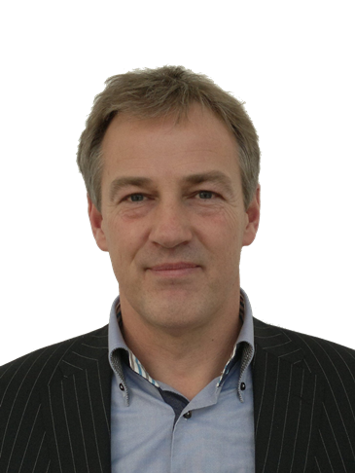

Annex 3
List of co-signatures of the European Common Proposals (ECPs)
Addendum | 1A1 | 1A2 | 1A3 | 1A4 | 1A5 | 1A6 | 1A7 | 2A1 | 2A2 | 2A3 | 3 | 4 | 5 | 6A1
Agenda item | 1.1 | 1.1 | 1.1 | 1.1 | 1.1 | 1.1 | 1.1 | 1.2 | 1.2 | 1.2 | 1.3 | 1.4 | not used | 1.6.1
Sub-part | 1 | 2 | 3 | 4 | 5 | 6 | 7 | 1 | 2 | 3 |  |  |  | 1
ALB
AND |  |  | 1 | 1 | 1 | 1 |  | 1 | 1
AUT | 1 | 1 | 1 | 1 | 1 | 1 | 1 | 1 | 1 | 1 | 1 |  |  | 1
AZE |  | 1 | 1 |  | 1 | 1 | 1 | 1 |  |  | 1 |  |  | 1
BEL | 1 | 1 | 1 | 1 | 1 | 1 | 1 | 1 | 1 |  | 1 |  |  | 1
BIH
BLR
BUL | 1 |  | 1 | 1 | 1 | 1 | 1 |  | 1 | 1 | 1 | 1 |  | 1
CVA | 1 | 1 | 1 | 1 | 1 | 1 | 1 | 1 | 1 |  | 1 | 1
CYP | 1 | 1 | 1 | 1 | 1 | 1 | 1 | 1 | 1 |  | 1 | 1 |  | 1
CZE | 1 | 1 | 1 | 1 | 1 | 1 | 1 | 1 | 1 | 1 | 1 | 1 |  | 1
D |  | 1 | 1 | 1 | 1 | 1 | 1 | 1 | 1 | 1 | 1 |  |  | 1
DNK | 1 | 1 | 1 | 1 | 1 | 1 | 1 | 1 | 1 | 1 | 1 | 1 |  | 1
E | 1 | 1 | 1 | 1 | 1 | 1 | 1 | 1 | 1 | 1 | 1 | 1
EST | 1 | 1 | 1 | 1 | 1 | 1 | 1 | 1 | 1 | 1 | 1 | 1 |  | 1
F | 1 | 1 | 1 | 1 | 1 | 1 | 1 | 1 | 1 | 1 | 1 |  |  | 1
FIN | 1 | 1 |  | 1 | 1 | 1 |  | 1 | 1 | 1 | 1 | 1 |  | 1
G | 1 | 1 | 1 | 1 | 1 | 1 |  | 1 | 1 | 1 | 1 | 1 |  | 1
GEO | 1 | 1 | 1 | 1 | 1 | 1 | 1 | 1 | 1 | 1 | 1 | 1 |  | 1
GRC |  |  | 1 | 1 | 1 | 1 | 1 |  |  |  | 1 |  |  | 1
HNG | 1 | 1 | 1 | 1 | 1 | 1 | 1 | 1 | 1 |  | 1 | 1 |  | 1
HOL | 1 | 1 | 1 | 1 | 1 | 1 | 1 | 1 | 1 | 1 | 1 | 1 |  | 1
HRV | 1 | 1 | 1 | 1 | 1 | 1 | 1 | 1 | 1 | 1 | 1 | 1 |  | 1
I | 1 | 1 | 1 | 1 | 1 | 1 | 1 | 1 | 1 | 1 | 1 | 1
IRL | 1 | 1 | 1 | 1 | 1 | 1 | 1 | 1 | 1 |  | 1 |  |  | 1
ISL | 1 | 1 | 1 | 1 | 1 | 1 | 1 | 1 | 1 | 1 | 1 | 1 |  | 1
LIE | 1 | 1 |  | 1 | 1 | 1 | 1 | 1 | 1 |  | 1 | 1 |  | 1
LTU | 1 | 1 | 1 | 1 | 1 |  |  |  |  | 1
LUX | 1 |  | 1 | 1 | 1 | 1 | 1 | 1 | 1 | 1 | 1 | 1 |  | 1
LVA | 1 | 1 | 1 | 1 | 1 | 1 |  |  |  | 1
MCO | 1 | 1 | 1 | 1 | 1 | 1 | 1 | 1 | 1 |  | 1 | 1 |  | 1
MDA | 1 | 1 | 1 | 1 | 1 | 1 | 1 | 1 | 1 |  | 1 |  |  | 1
MKD
MLT | 1 | 1 | 1 | 1 | 1 | 1 | 1 | 1 | 1 | 1 | 1 | 1 |  | 1
MNE | 1 | 1 | 1 | 1 | 1 | 1 | 1 | 1 | 1 |  | 1 | 1 |  | 1
NOR | 1 | 1 | 1 | 1 | 1 | 1 |  | 1 | 1 | 1 | 1 | 1 |  | 1
POL | 1 | 1 | 1 | 1 |  | 1 | 1 | 1 | 1 |  | 1 |  |  | 1
POR |  | 1 | 1 | 1 | 1 | 1 | 1 | 1 | 1 |  | 1 | 1 |  | 1
ROU |  | 1 | 1 | 1 | 1 | 1 | 1 |  |  | 1
RUS |  |  | 1 | 1 | 1 |  | 1 | 1 |  | 1 |  |  |  | 1
S | 1 | 1 | 1 | 1 |  | 1 |  | 1 | 1 | 1 | 1 | 1 |  | 1
SMR | 1 | 1 | 1 | 1 | 1 | 1 | 1 | 1 | 1 | 1 | 1 | 1 |  | 1
SRB
SUI | 1 | 1 |  | 1 | 1 | 1 | 1 | 1 | 1 |  | 1 | 1
SVK | 1 | 1 | 1 | 1 | 1 | 1 | 1 |  |  | 1 | 1 | 1 |  | 1
SVN | 1 | 1 |  | 1 |  | 1 | 1 | 1 | 1 | 1 | 1 | 1 |  | 1
TUR | 1 |  | 1 | 1 | 1 | 1 | 1 | 1 | 1 |  | 1 | 1 |  | 1
UKR | 1 | 1 |  |  |  |  | 1 | 1 | 1 | 1 | 1 | 1 |  | 1
Sub-part | 1 | 2 | 3 | 4 | 5 | 6 | 7 | 1 | 2 | 3 |  |  | not used | 1
Agenda item | 1.1 | 1.1 | 1.1 | 1.1 | 1.1 | 1.1 | 1.1 | 1.2 | 1.2 | 1.2 | 1.3 | 1.4 |  | 1.6.1
Addendum | 1A1 | 1A2 | 1A3 | 1A4 | 1A5 | 1A6 | 1A7 | 2A1 | 2A2 | 2A3 | 3 | 4 | 5 | 6A1
co-signatures | 36 | 37 | 38 | 41 | 39 | 40 | 36 | 37 | 36 | 27 | 38 | 29 |  | 35
Addendum | 6A2 | 7 | 8 | 9A1 | 9A2 | 10 | 11 | 12 | 13 | 14 | 15 | 16A1 | 16A2 | 16A3
Agenda item | not used | 1.7 | 1.8 | 1.9.1 | 1.9.2 | 1.10 | 1.11 | 1.12 | 1.13 | not used | 1.15 | 1.16 | 1.16 | 1.16
Sub-part |  |  |  | 1 | 2 |  |  |  |  |  |  | A | B | C
ALB
AND
AUT |  | 1 | 1 | 1 | 1 | 1 | 1 | 1 | 1 |  | 1 | 1 | 1 | 1
AZE |  |  |  | 1 |  | 1 |  |  | 1 |  | 1
BEL |  | 1 | 1 | 1 | 1 | 1 | 1 | 1 | 1 |  | 1 | 1 | 1 | 1
BIH
BLR
BUL |  | 1 | 1 | 1 | 1 | 1 | 1 | 1 | 1 |  | 1 | 1
CVA |  | 1 |  | 1 | 1 | 1 | 1 | 1 | 1 |  | 1 | 1 | 1 | 1
CYP |  | 1 | 1 | 1 | 1 | 1 | 1 | 1 | 1 |  | 1 | 1 | 1 | 1
CZE |  | 1 | 1 | 1 | 1 | 1 | 1 | 1 | 1 |  | 1 | 1 | 1 | 1
D |  | 1 | 1 |  | 1 | 1 | 1 | 1 | 1 |  | 1 | 1 | 1 | 1
DNK |  | 1 | 1 | 1 | 1 | 1 | 1 | 1 | 1 |  | 1 | 1 | 1 | 1
E |  | 1 |  |  | 1 | 1 | 1 | 1 | 1 |  | 1 | 1 | 1 | 1
EST |  | 1 | 1 | 1 | 1 | 1 | 1 | 1 | 1 |  | 1
F |  | 1 | 1 | 1 | 1 | 1 |  | 1 | 1 |  | 1 | 1 | 1 | 1
FIN |  | 1 | 1 | 1 | 1 | 1 | 1 | 1 | 1 |  | 1 | 1 | 1 | 1
G |  | 1 |  | 1 |  | 1 | 1 | 1 | 1 |  | 1 | 1 | 1 | 1
GEO |  | 1 | 1 | 1 | 1 | 1 | 1 | 1 | 1 |  | 1 | 1 | 1 | 1
GRC |  |  |  | 1 |  |  | 1 | 1 | 1 |  | 1
HNG |  | 1 | 1 | 1 | 1 | 1 | 1 | 1 | 1 |  | 1 | 1 | 1 | 1
HOL |  | 1 |  | 1 | 1 | 1 | 1 | 1 | 1 |  | 1 | 1 | 1 | 1
HRV |  | 1 | 1 | 1 | 1 | 1 | 1 | 1 | 1 |  | 1 | 1 | 1 | 1
I |  | 1 |  | 1 | 1 | 1 | 1 | 1 | 1 |  | 1 | 1 | 1 | 1
IRL |  |  | 1 |  | 1 | 1 | 1 | 1 | 1 |  | 1 | 1 | 1 | 1
ISL |  | 1 | 1 | 1 | 1 | 1 | 1 | 1 | 1 |  | 1 | 1 | 1 | 1
LIE |  | 1 | 1 |  | 1 | 1 | 1 | 1 | 1 |  | 1 | 1 | 1 | 1
LTU |  | 1 |  | 1 | 1 | 1 | 1 | 1 | 1 |  | 1 | 1 | 1 | 1
LUX |  | 1 | 1 | 1 | 1 | 1 | 1 | 1 | 1 |  | 1 | 1 | 1 | 1
LVA |  | 1 |  | 1 | 1 | 1 | 1 | 1 | 1 |  | 1 | 1 | 1 | 1
MCO |  |  | 1 |  |  | 1 |  |  |  |  | 1
MDA |  | 1 | 1 | 1 | 1 | 1 | 1 | 1 | 1 |  | 1 | 1 | 1 | 1
MKD
MLT |  | 1 | 1 |  | 1 | 1 | 1 | 1 | 1 |  | 1 | 1 | 1 | 1
MNE |  | 1 | 1 | 1 | 1 | 1 | 1 | 1 | 1 |  | 1 | 1 | 1 | 1
NOR |  | 1 |  | 1 | 1 | 1 | 1 | 1 | 1 |  | 1 | 1 | 1 | 1
POL |  | 1 | 1 | 1 | 1 | 1 | 1 | 1 | 1 |  | 1 | 1 | 1 | 1
POR |  | 1 | 1 | 1 | 1 | 1 | 1 | 1 | 1 |  | 1 | 1 | 1 | 1
ROU |  | 1 | 1 | 1 | 1 | 1 | 1 | 1 | 1 |  | 1 | 1 | 1 | 1
RUS |  | 1 | 1 |  | 1 |  |  |  | 1 |  | 1 |  | 1
S |  | 1 | 1 | 1 | 1 | 1 | 1 |  | 1 |  | 1 | 1 | 1 | 1
SMR |  | 1 | 1 | 1 | 1 | 1 | 1 | 1 | 1 |  | 1 | 1 | 1 | 1
SRB
SUI |  | 1 | 1 |  | 1 | 1 | 1 | 1 | 1 |  | 1 | 1 | 1 | 1
SVK |  | 1 | 1 | 1 | 1 | 1 | 1 | 1 | 1 |  | 1 | 1 | 1 | 1
SVN |  | 1 | 1 | 1 | 1 | 1 | 1 | 1 | 1 |  | 1 | 1 | 1 | 1
TUR |  | 1 | 1 | 1 | 1 | 1 | 1 | 1 | 1 |  | 1 | 1 | 1 | 1
UKR |  | 1 | 1 | 1 | 1 | 1 | 1 | 1 | 1 |  | 1 | 1 | 1 | 1
Sub-part | not used |  |  | 1 | 2 |  |  |  |  | not used |  | A | B | C
Addendum |  | 7 | 8 | 9A1 | 9A2 | 10 | 11 | 12 | 13 |  | 15 | 16A1 | 16A2 | 16A3
Agenda item | 1.6.2 | 1.7 | 1.8 | 1.9.1 | 1.9.2 | 1.10 | 1.11 | 1.12 | 1.13 | 1.14 | 1.15 | 1.16 | 1.16 | 1.16
co-signatures |  | 37 | 28 | 33 | 36 | 37 | 36 | 36 | 39 |  | 40 | 35 | 35 | 34
Addendum | 17 | 18 | 19 | 20 | 21A1 | 21A2 | 21A3 | 21A4 | 21A5 | 21A6 | 21A7 | 21A8 | 21A9 | 21A10
Agenda item | 1.17 | 1.18 | 2 | 4 | 7 | 7 | 7 | 7 | 7 | 7 | 7 | not used | 7 | 7
Sub-part |  |  |  |  | A | B | C | D | E | F | G |  | I | J
ALB
AND
AUT | 1 | 1 |  | 1 | 1 | 1 | 1 | 1 | 1 | 1 | 1 |  | 1 | 1
AZE | 1 |  | 1 |  |  |  | 1 | 1 |  | 1 | 1 |  |  | 1
BEL | 1 | 1 | 1 | 1 | 1 | 1 | 1 | 1 | 1 | 1 | 1 |  | 1 | 1
BIH
BLR
BUL | 1 | 1 | 1 | 1 |  |  | 1 | 1 | 1 | 1 | 1 |  | 1 | 1
CVA | 1 |  | 1 | 1 | 1 | 1 | 1 | 1 | 1 | 1 | 1 |  | 1 | 1
CYP | 1 | 1 | 1 | 1 | 1 | 1 |  | 1 | 1 | 1 | 1 |  | 1 | 1
CZE | 1 | 1 | 1 | 1 | 1 | 1 | 1 | 1 | 1 | 1 | 1 |  | 1 | 1
D | 1 | 1 | 1 | 1 | 1 | 1 | 1 | 1 | 1 | 1 | 1 |  | 1 | 1
DNK | 1 | 1 | 1 | 1 | 1 | 1 | 1 | 1 | 1 | 1 | 1 |  | 1 | 1
E | 1 |  | 1 | 1 | 1 | 1 | 1 | 1 | 1 | 1 | 1 |  | 1 | 1
EST | 1 | 1 | 1 | 1 | 1 | 1 | 1 | 1 | 1 | 1 | 1 |  | 1 | 1
F | 1 | 1 | 1 | 1 | 1 | 1 | 1 | 1 | 1 | 1 | 1 |  | 1 | 1
FIN | 1 | 1 | 1 | 1 | 1 | 1 | 1 | 1 | 1 | 1 | 1 |  | 1 | 1
G | 1 | 1 | 1 | 1 | 1 | 1 | 1 | 1 | 1 | 1 | 1 |  | 1 | 1
GEO | 1 | 1 | 1 | 1 | 1 | 1 | 1 | 1 | 1 | 1 | 1 |  | 1 | 1
GRC | 1 | 1 | 1 |  | 1 | 1 |  | 1 | 1 | 1 | 1 |  | 1 | 1
HNG | 1 | 1 | 1 | 1 | 1 | 1 | 1 | 1 | 1 | 1 | 1 |  | 1 | 1
HOL | 1 | 1 | 1 | 1 | 1 | 1 | 1 | 1 | 1 | 1 | 1 |  | 1 | 1
HRV | 1 | 1 | 1 | 1 | 1 | 1 | 1 | 1 | 1 | 1 | 1 |  | 1 | 1
I | 1 |  | 1 | 1 | 1 | 1 | 1 | 1 | 1 | 1 | 1 |  | 1 | 1
IRL | 1 | 1 | 1 | 1 |  |  |  | 1
ISL | 1 | 1 | 1 | 1 | 1 | 1 | 1 | 1 | 1 | 1 | 1 |  | 1 | 1
LIE | 1 | 1 | 1 | 1 | 1 | 1 | 1 | 1 | 1 | 1 | 1 |  | 1 | 1
LTU | 1 |  | 1 |  | 1 | 1 | 1 | 1 | 1 | 1 | 1
LUX | 1 | 1 | 1 | 1 | 1 | 1 | 1 | 1 | 1 | 1 | 1 |  | 1 | 1
LVA | 1 |  | 1 |  | 1 | 1 | 1 | 1 | 1 | 1 | 1
MCO |  | 1 |  | 1 | 1 | 1 | 1 | 1 | 1 | 1 | 1 |  | 1 | 1
MDA | 1 | 1 | 1 | 1 | 1 | 1 | 1 | 1 | 1 | 1 | 1 |  | 1 | 1
MKD
MLT | 1 | 1 | 1 | 1 | 1 | 1 | 1 | 1 | 1 | 1 | 1 |  | 1 | 1
MNE | 1 | 1 | 1 | 1 | 1 | 1 | 1 | 1 | 1 | 1 | 1 |  | 1 | 1
NOR | 1 | 1 | 1 | 1 | 1 | 1 | 1 | 1 | 1 | 1 | 1 |  | 1 | 1
POL | 1 | 1 | 1 | 1 | 1 | 1 | 1 | 1 | 1 | 1 | 1 |  | 1 | 1
POR | 1 | 1 | 1 | 1 | 1 | 1 | 1 | 1 | 1 | 1 | 1 |  | 1 | 1
ROU | 1 | 1 | 1 | 1 | 1 | 1 | 1 | 1 | 1 | 1 | 1 |  | 1 | 1
RUS | 1 | 1 | 1 |  | 1 | 1 | 1 | 1 |  | 1 | 1 |  | 1 | 1
S | 1 | 1 | 1 | 1 | 1 | 1 | 1 | 1 | 1 | 1 | 1 |  | 1 | 1
SMR | 1 | 1 |  | 1 | 1 | 1 | 1 | 1 | 1 | 1 | 1 |  | 1 | 1
SRB
SUI | 1 | 1 | 1 | 1 | 1 | 1 | 1 | 1 | 1 | 1 | 1 |  | 1 | 1
SVK | 1 | 1 | 1 | 1 | 1 | 1 | 1 | 1 | 1 | 1 | 1 |  | 1 | 1
SVN | 1 | 1 | 1 | 1 | 1 | 1 | 1 | 1 | 1 | 1 | 1 |  | 1 | 1
TUR | 1 | 1 | 1 | 1 | 1 | 1 | 1 | 1 | 1 | 1 | 1 |  | 1 | 1
UKR | 1 | 1 | 1 | 1 | 1 | 1 | 1 | 1 | 1 | 1 | 1 |  | 1 | 1
Sub-part |  |  |  |  | A | B | C | D | E | F | G | not used | I | J
Agenda item | 1.17 | 1.18 | 2 | 4 | 7 | 7 | 7 | 7 | 7 | 7 | 7 |  | 7 | 7
Addendum | 17 | 18 | 19 | 20 | 21A1 | 21A2 | 21A3 | 21A4 | 21A5 | 21A6 | 21A7 | 21A8 | 21A9 | 21A10
co-signatures | 41 | 36 | 39 | 37 | 39 | 39 | 39 | 42 | 39 | 41 | 41 |  | 38 | 39
Addendum | 21A11 | 21A12 | 21A13 | 22A1 | 22A2 | 22A3 | 22A4 | 22A6 | 22A7 | 22A8 | 23 | 24 | 25 | 26
Agenda item | 7 | 7 | 7 | 9.1 | 9.1 | 9.1 | 9.1 | 9.1 | 9.1 | 9.1 | 9.2 | not used | 10 | GFT
Sub-part | K | L | NP | 9.1.1 | 9.1.2 | 9.1.3 | 9.1.4 | 9.1.6 | 9.1.7 | 9.1.8
ALB
AND |  |  |  |  |  |  |  | 1
AUT | 1 | 1 | 1 | 1 | 1 | 1 | 1 | 1 | 1 | 1 | 1 |  | 1 | 1
AZE | 1 | 1 |  | 1 |  |  |  | 1 |  |  |  |  |  | 1
BEL | 1 | 1 | 1 | 1 | 1 | 1 | 1 | 1 | 1 | 1 | 1 |  | 1 | 1
BIH
BLR
BUL | 1 | 1 |  | 1 | 1 | 1 | 1 | 1 | 1 | 1 | 1 |  | 1 | 1
CVA | 1 | 1 | 1 | 1 | 1 | 1 | 1 | 1 | 1 | 1 | 1 |  | 1 | 1
CYP | 1 | 1 |  | 1 |  | 1 | 1 | 1 | 1 | 1 | 1 |  | 1 | 1
CZE | 1 | 1 | 1 | 1 | 1 | 1 | 1 | 1 | 1 | 1 | 1 |  | 1 | 1
D | 1 | 1 | 1 | 1 | 1 | 1 | 1 | 1 | 1 | 1 | 1 |  | 1 | 1
DNK | 1 | 1 | 1 | 1 | 1 | 1 | 1 | 1 | 1 | 1 | 1 |  | 1 | 1
E | 1 | 1 | 1 | 1 |  | 1 | 1 | 1 | 1 | 1 | 1 |  | 1 | 1
EST | 1 | 1 | 1 | 1 | 1 | 1 | 1 | 1 | 1 | 1 | 1 |  | 1 | 1
F |  | 1 | 1 | 1 | 1 |  | 1 | 1 | 1 | 1 | 1 |  | 1 | 1
FIN | 1 | 1 | 1 | 1 | 1 | 1 | 1 | 1 | 1 | 1 | 1 |  | 1 | 1
G | 1 | 1 | 1 | 1 | 1 | 1 | 1 | 1 | 1 | 1 | 1 |  | 1 | 1
GEO | 1 | 1 | 1 | 1 | 1 | 1 | 1 | 1 | 1 | 1 | 1 |  | 1 | 1
GRC | 1 | 1 |  | 1 |  | 1 | 1 | 1 | 1 | 1 | 1 |  |  | 1
HNG | 1 | 1 | 1 | 1 | 1 | 1 | 1 | 1 | 1 | 1 | 1 |  | 1 | 1
HOL | 1 | 1 | 1 | 1 | 1 | 1 | 1 | 1 | 1 | 1 | 1 |  | 1 | 1
HRV | 1 | 1 | 1 | 1 | 1 | 1 | 1 | 1 | 1 | 1 | 1 |  | 1 | 1
I | 1 | 1 | 1 | 1 | 1 | 1 | 1 | 1 | 1 | 1 | 1 |  | 1 | 1
IRL |  |  |  | 1 |  |  | 1 | 1 |  |  |  |  | 1 | 1
ISL | 1 | 1 | 1 | 1 | 1 | 1 | 1 | 1 | 1 | 1 | 1 |  | 1 | 1
LIE | 1 | 1 | 1 | 1 | 1 | 1 | 1 | 1 | 1 | 1 | 1 |  | 1 | 1
LTU |  |  |  | 1 |  |  | 1 | 1 | 1 | 1 | 1
LUX | 1 | 1 | 1 | 1 | 1 | 1 | 1 | 1 | 1 | 1 | 1 |  | 1 | 1
LVA |  |  |  | 1 |  |  | 1 | 1 | 1 | 1 | 1
MCO |  | 1 | 1 | 1 | 1 | 1 | 1 | 1 | 1 | 1 | 1 |  | 1
MDA | 1 | 1 | 1 | 1 | 1 | 1 | 1 | 1 | 1 | 1 | 1 |  | 1 | 1
MKD
MLT | 1 | 1 | 1 | 1 | 1 | 1 | 1 | 1 | 1 | 1 | 1 |  | 1 | 1
MNE | 1 | 1 | 1 | 1 | 1 | 1 | 1 | 1 | 1 | 1 | 1 |  | 1 | 1
NOR | 1 | 1 | 1 | 1 | 1 | 1 | 1 | 1 | 1 | 1 | 1 |  | 1 | 1
POL | 1 | 1 | 1 | 1 | 1 | 1 | 1 | 1 | 1 | 1 | 1 |  | 1 | 1
POR | 1 | 1 | 1 | 1 | 1 | 1 | 1 | 1 | 1 | 1 | 1 |  | 1 | 1
ROU | 1 | 1 | 1 | 1 | 1 | 1 | 1 | 1 | 1 | 1 | 1 |  | 1 | 1
RUS |  | 1 |  | 1 |  |  |  | 1 | 1 | 1 | 1 |  |  | 1
S | 1 | 1 | 1 | 1 | 1 | 1 | 1 | 1 | 1 | 1 | 1 |  |  | 1
SMR | 1 | 1 | 1 | 1 | 1 | 1 | 1 | 1 | 1 | 1 | 1 |  | 1 | 1
SRB
SUI | 1 | 1 | 1 | 1 | 1 | 1 | 1 | 1 | 1 | 1 | 1 |  | 1 | 1
SVK | 1 | 1 | 1 | 1 | 1 | 1 | 1 | 1 | 1 | 1 | 1 |  | 1 | 1
SVN | 1 | 1 | 1 | 1 | 1 | 1 | 1 | 1 | 1 | 1 | 1 |  | 1 | 1
TUR | 1 | 1 | 1 | 1 | 1 | 1 | 1 | 1 | 1 | 1 | 1 |  | 1 | 1
UKR | 1 | 1 | 1 | 1 | 1 | 1 | 1 | 1 | 1 | 1 | 1 |  | 1 | 1
Sub-part | K | L | NP | 9.1.1 | 9.1.2 | 9.1.3 | 9.1.4 | 9.1.6 | 9.1.7 | 9.1.8 |  | not used
Agenda item | 7 | 7 | 7 | 9.1 | 9.1 | 9.1 | 9.1 | 9.1 | 9.1 | 9.1 | 9.2 |  | 10 | GFT
Addendum | 21A11 | 21A12 | 21A13 | 22A1 | 22A2 | 22A3 | 22A4 | 22A6 | 22A7 | 22A8 | 23 | 24 | 27 | 28
co-signatures | 36 | 39 | 34 | 42 | 34 | 36 | 40 | 43 | 40 | 40 | 40 |  | 36 | 39
_____________

Members of CEPT (Europe) are: Albania (Republic of), Germany (Federal Republic of), Andorra (Principality of), Austria, Azerbaijani Republic, Belarus (Republic of), Belgium, Bosnia and Herzegovina, Bulgaria (Republic of), Cyprus (Republic of), Vatican City State, Croatia (Republic of), Denmark, Spain, Estonia (Republic of), Russian Federation, Finland, France, Georgia, Greece, Hungary, Ireland, Iceland, Italy, Latvia (Republic of), The Former Yugoslav Republic of Macedonia, Liechtenstein (Principality of), Lithuania (Republic of), Luxembourg, Malta, Moldova (Republic of), Monaco (Principality of), Montenegro, Norway, Netherlands (Kingdom of the), Poland (Republic of), Portugal, Slovak Republic, Czech Republic, Romania, United Kingdom of Great Britain and Northern Ireland, San Marino (Republic of), Serbia (Republic of ), Slovenia (Republic of), Sweden, Switzerland (Confederation of), Turkey, Ukraine.

