|  |  |
| --- | --- |
| **世界无线电通信大会（WRC-15） 2015年11月2-27日，日内瓦** |  |
| **国 际 电 信 联 盟** |  |
|  |  |
| **全体会议** | **文件 73-C** |
|  | **2015年10月16日** |
|  | **原文：英文** |
|  | |
| 法国、卢森堡、挪威、荷兰（王国） | |
| 7 150-7 250 MHz（空对地）和8 400-8 500 MHz频段内 FSS和FS之间的共用（地对空） | |
|  | |
| 议项1.9.1 | |

1.9 根据第**758**号决议**（WRC-12）**考虑：

1.9.1 在遵守适当共用条件的前提下，在7 150-7 250 MHz频段（空对地）和8 400-8 500 MHz频段（地对空）为卫星固定业务做出可能的新划分；

背景

2015年6月ITU-R 4A工作组会议未能就卫星固定业务（FSS）（空对地）与空间研究业务（SRS）（深空和近地）之间的共用问题达成共识。因此，汇集有关WRC-15议项1.9.1所有研究的新报告初稿既没在2014年6月会议4A工作组主席报告所含的前一版本的基础上进行更新，也没有进行修改。因此，新报告初稿仍附在4A工作组主席报告的附件。

与FSS（空对地）和SRS之间共用没有达成共识形成对照，新报告初稿中有关FSS和地面业务共用问题的章节业已完成并在4A工作组中达成一致。特别是有关FSS和固定业务（FS）在7 150-7 250 MHz（FSS空对地）和8 400-8 500 MHz（FSS地对空）的共用的章节自2014年以来已经稳定下来，而且，ITU-R 5C工作组也有机会对就这一问题开展的各项研究进行评述。另外，5C工作组同意4A工作组采取的利用《无线电规则》第21条中的pfd值对7 150-7 250 MHz频段内的固定业务进行保护的方法（见本文件附件1所附的4A/598号文件）。在该文件中，5C工作组赞成通过为8 400-8 500 MHz频段内操作的任何可能新建的FSS地球站规定最小天线直径，对整个共用环境进行管理。

提案

本文提供4A工作组所作的共用研究，评估WRC-15议项1.9.1框架下FS与FSS间的兼容性。此共用研究载于ITU-R S.[FSS 7/8 GHz 兼容]新报告初稿中（见4A/669号文件附件2），并附于本文稿附件2中。如上所述，附件1是ITU-R FS专家组，5C工作组提供的内容，其中指出4A工作组对7 150-7 250 MHz和8 400-8 500 MHz频段内FS采取的保护方法已取得一致。

**后附资料：**2

attachment 1

(English only)

Source: Document 4A/598

Working Party 5C (WP 5C) thanks Working Party 4A for their liaison statement contained in Document [5C/324](http://www.itu.int/md/R12-WP5C-C-0324/en) replying to a previous liaison statement from WP 5C (Document [4A/485](http://www.itu.int/md/R12-WP4A-C-0485/en)).

Working Party 5C notes its suggestions to use RR Article **21** pfd limit rather than an e.i.r.p. spectral density mask for FSS to protect the fixed service in the band 7 150-7 250 MHz, has been agreed by WP 4A. Furthermore, a minimum antenna diameter of 3.5 meters for any potential new FSS earth stations operating in the band 8 400-8 500 MHz has been identified by WP 4A to manage the sharing environment with the fixed service in the same band. WP 5C agrees with this approach and that the introduction of a minimum earth station antenna diameter is a way of managing the overall sharing environment.

Taking into account the above, WP 5C at this stage has no further comments on the preliminary draft new Report ITU-R S.[FSS 7/8 GHz COMPATIBILITY] contained in Annex 17 to   
Document [4A/591](http://www.itu.int/md/R12-WP4A-C-0591/en) and looks forward to being kept informed of any further developments under this agenda item.

|  |  |
| --- | --- |
| **Status:** For information |  |
| **Contact:** Mr Charles Glass | **E-mail**:[cglass@ntia.doc.gov](mailto:cglass@ntia.doc.gov) |

Attachment 2

(English only)

FS and FSS sharing in the frequency bands 7 150-7 250 MHz   
and 8 400-8 500 MHz

# 

# Introduction

The frequency bands 7 250-7 750 MHz (space-to-Earth) and 7 900-8 400 MHz (Earth-to-space) are currently allocated worldwide to the fixed-satellite service (FSS) on a primary basis. In this current allocation, the FSS successfully coexists with terrestrial services, in particular with the Fixed Service (FS) and with the Mobile Service (MS), which also have primary allocations in the mentioned frequency bands.

The shortfall of spectrum available for current and future applications of the FSS in the currently allocated bands (7 250-7 750 MHz and 7 900-8 400 MHz) can be addressed with an additional spectrum allocation of 100 MHz for each sense of the transmission. Therefore, Resolution **758 (WRC-12)** considers possible new allocations to the fixed-satellite service in the frequency bands 7 150-7 250 MHz (space-to-Earth) and 8 400-8 500 MHz (Earth-to-space), adjacent to the current FSS allocation and subject to appropriate sharing conditions.

# 2 FSS system characteristics

## 2.1 FSS earth station characteristics

Several types of FSS earth stations are foreseen with technical characteristics as shown   
in Table 2.1-1.

Table 2.1-1

FSS earth station characteristics

|  |  | Earth station types | | | | |
| --- | --- | --- | --- | --- | --- | --- |
| Characteristics of earth station | Units | Type 1 | Type 2 | Type 3 | Type 4 | Type 5 |
| Transmitter center frequency | GHz | 8.45 | 8.45 | 8.45 | 8.45 | 8.45 |
| Maximum transmit output power | Watts | 2 000 | 2 000 | 600 | 2 000 | 1 000 |
| Transmit antenna diameter | m | 18 | 11 | 5 | 2.5 | 1.5 |
| Transmit antenna peak gain | dBi | 62 | 58 | 51 | 45 | 40 |
| Transmit antenna –3 dB beamwidth | deg | 0.14 | 0.22 | 0.49 | 0.99 | 1.65 |
| Transmit antenna pattern type (ITU Recommendation, data (angle versus gain) or plot) |  | Rec. ITU-R S.580-6 | | | | |
| Transmit antenna minimum elevation angle towards the satellite | deg | 10 | 10 | 10 | 10 | 10 |
| Transmit antenna polarization (RHC, LHC, VL, HL or offset linear) |  | RHC | RHC | RHC | RHC | RHC |
| Uplink possible occupied bandwidth per carrier | MHz | 0.004 to 100 | | | 0.004 to 4 | |
| Transmit losses | dB | 2 | 2 | 2 | 2 | 2 |
| Transmit effective isotropic radiated power e.i.r.p. | dBW | 93 | 89 | 76 | 76 | 68 |
| Maximum transmit e.i.r.p. spectral density | dBW/Hz | 10 | 10 | 10 | 10 | 10 |
| Maximum transmit e.i.r.p. spectral density in a 10 MHz bandwidth [1]* | dBW/ 10 MHz | 80 | 80 | 76 | 76 | 68 |
| Receiver center frequency | GHz | 7.2 | 7.2 | 7.2 | 7.2 | 7.2 |
| Receive antenna diameter (if different from transmit) | m | - | - | - | - | - |
| Receive antenna peak gain (if different from transmit) | dBi | 60 | 56 | 49 | 43 | 39 |
| Transmit antenna –3 dB beamwidth | deg | 0.16 | 0.26 | 0.58 | 1.16 | 1.93 |
| Receive antenna pattern type (ITU Recommendation, data (angle versus gain) or plot) (if different from transmit) |  | Rec. ITU-R S.580-6 | | | | |
| Receive antenna minimum elevation angle towards the satellite | deg | 10 | 10 | 10 | 10 | 10 |
| Receive antenna polarization (RHC, LHC, VL, HL or offset linear) |  | LHC | LHC | LHC | LHC | LHC |
| Receiver noise temperature | K | 200 | 125 | 126 | 159 | 200 |
| Downlink occupied bandwidth per carrier | MHz | 0.004 to 100 | | | | |
| Receiver losses | dB | 0 | 0 | 0 | 0 | 0 |
| Earth station G/T | dB/K | 37 | 37 | 28 | 21 | 16 |

Note that, for the FSS earth stations of Type 5, the transmitter power spectral density is −30 dBW/Hz. The resulting e.i.r.p. spectral density towards the 0-deg horizon is about −26 dBW/Hz (= –30 dBW/Hz transmitter power spectral density +4 dB gain at 10 deg off-axis), which is much smaller than maximum allowed value of 4 dBW/Hz specified by the Radio Regulations No. **21.8**.

### 2.1.1 FSS earth station antenna sizes and weights

This section provides a rationale to fulfill the following objectives:

– to limit the total number of FSS earth stations, and

– to avoid transportable earth stations that may be deployed at unknown locations.

The general idea is based on the fact that there are no direct radio parameters really appropriate to fulfill these objectives. Technical studies performed under WRC-15 agenda item 1.9.1 to protect other existing services were conducted on the basis of earth stations at fixed known positions. To ensure that, when earth stations are actually deployed, they can be coordinated on a case-by-case basis, a possible approach relies on the imposition of a large enough minimum antenna size together with a clear provision that each earth station shall be coordinated.

Table 2.1-1 above lists the FSS Earth station characteristics that are the basis for the technical studies conducted on WRC-15 agenda item 1.9.1, which contains five types of FSS Earth stations and their antenna diameters are 1.5 m, 2.5 m, 5 m, 11 m and 18 m. It is obvious that earth stations having 11-meter or 18-meter antennas cannot be considered as transportable earth stations and can only be deployed at fixed known locations. Besides, experience shows that earth station with 1.5‑meter antennas are indeed already used as VSAT-like earth stations in 7/8-GHz bands or even higher frequency bands. Concerning 2.5-meter and 5-meter antennas, it is more difficult to reach an immediate conclusion and therefore the weight of earth stations having such antennas are investigated with the finding that earth stations employing 2.5-meter and 5-meter antennas and operated in the adjacent FSS 7/8 GHz bands were assessed to weigh around 3.5 tons and 12 tons respectively. These weights do not necessarily imply that these earth stations cannot be transported at all but it means that such earth stations are transported only following a long planning exercise (often several months) and deployed at the same fixed location for months or even years. Both the a-priori planning and the long deployment time allow operators of such earth stations to coordinate them individually in advance.

## 2.2 FSS satellite characteristics

The initial assumptions on the required parameters to carry out compatibility studies, are shown in the table below for geostationary satellite systems.

Table 2.2-1

GSO satellite system design characteristics (partially derived from Recommendation ITU-R S.1328)

| GSO | Units | Value | Value | Value | Value |
| --- | --- | --- | --- | --- | --- |
| Carrier parameters |  |  |  |  |  |
| Type |  | Minimum | Maximum | Minimum | Maximum |
| Centre frequency of uplink band | GHz | 8.45 | 8.45 | 8.45 | 8.45 |
| Uplink polarization (RHC, LHC, VL, HL or offset linear) |  | RHC | RHC | RHC | RHC |
| Centre frequency of downlink band | GHz | 7.2 | 7.2 | 7.2 | 7.2 |
| Downlink polarization (RHC, LHC, VL, HL or offset linear) |  | LHC | LHC | LHC | LHC |
| Modulation type (e.g. FM, BPSK, QPSK etc.) |  | BPSK, QPSK, 8-PSK | | | |
| Downlink occupied bandwidth per carrier | MHz | 0.004 | 100 | 0.004 | 100 |
| Space station parameters |  |  |  |  |  |
| Maximum satellite power | W | 100 | 100 | 100 | 100 |
| Peak transmit antenna gain | dBi | 20 | 20 | 33 | 33 |
| Minimum transmit antenna gain for passive antenna : | dBi | 16 | 16 | 29 | 29 |
| Transmit antenna gain pattern (e.g. Rec. ITU-R S.672, CR/58 data file, etc.) |  | Rec. ITU-R S.672 | Rec. ITU-R S.672 | Rec. ITU-R S.672 | Rec. ITU-R S.672 |
| Maximum transmit e.i.r.p. spectral density | dBW/Hz | –26 | –26 | –26 | –26 |

The FSS satellite antenna pattern is assumed to follow Recommendation ITU-R S.672-4, shown in Figure 2.1-1

FIGURE 2.1-1

FSS satellite antenna gain (Rec. ITU-R S.672-4)



Power flux‑density (p.f.d.) limits in Table **21-4** of Article **21** of the Radio Regulations for the FSS applied to adjacent bands 7 250-7 850 MHz can be considered to be applicable to the new proposed FSS (space-to-Earth) allocation in 7 150-7 250 MHz band. The p.f.d. at the Earth’s surface produced by emissions from a space station in the FSS in this band shall not exceed the limits in the following table.

|  |  |  |  |  |  |
| --- | --- | --- | --- | --- | --- |
| Frequency band | Service | Limit in dB(W/m2) for angles of arrival () above the horizontal plane | | | Reference  bandwidth |
| 0-5 | 5-25 | 25-90 |
| 7 250-7 750 MHz | Fixed-satellite (space-to-Earth) | –152 | –152  0.5( – 5) | –142 | 4 kHz |

Note that all of the proposed FSS systems have the same e.i.r.p. spectral density of −26 dBW/Hz. In order to determine the maximum allowed e.i.r.p. spectral density for the FSS satellites, the power flux density levels allowed on the Earth's surface need to be specified for the proposed new frequency allocation for FSS. The p.f.d. limits shown above can be extended to apply for the proposed new band 7 150-7 250 MHz. Figure 2.2-1 below shows the maximum allowed p.f.d. limits in the 7 GHz band and the maximum e.i.r.p. spectral density for the GSO satellites versus the GSO satellite elevation angle on the Earth’s surface derived using the RR Article **21** (Table **21-4)** p.f.d. limits. It also shows the maximum e.i.r.p. spectral density proposed by FSS.

Figure 2.1-2

RR allowed p.f.d. for FSS GSO satellite vs. GSO satellite elevation angle with respect to Earth’s surface

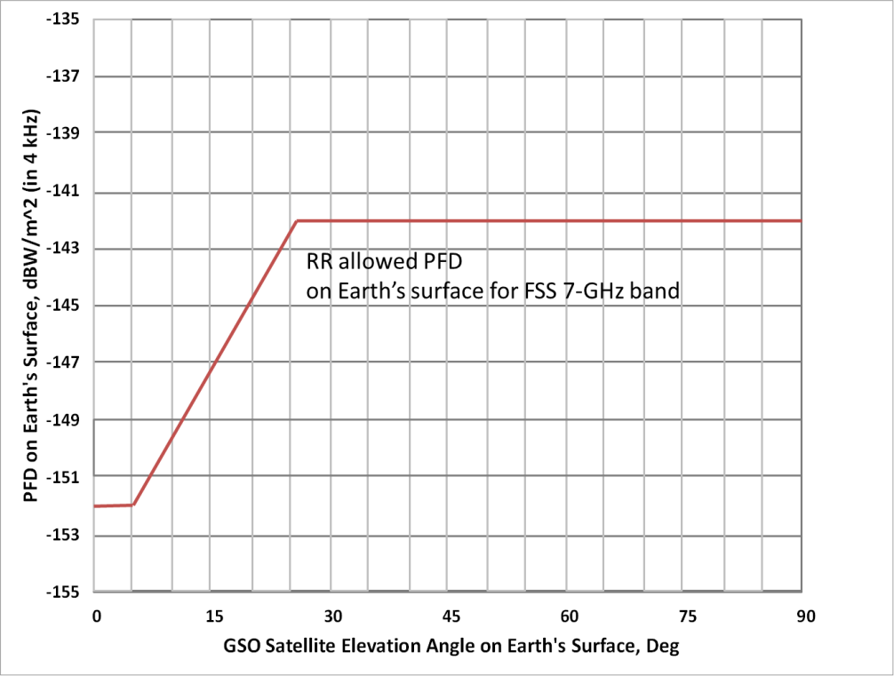

Figure 2.1-3

RR allowed e.i.r.p. spectral density for FSS GSO satellite vs. GSO satellite elevation angle on Earth’s surface

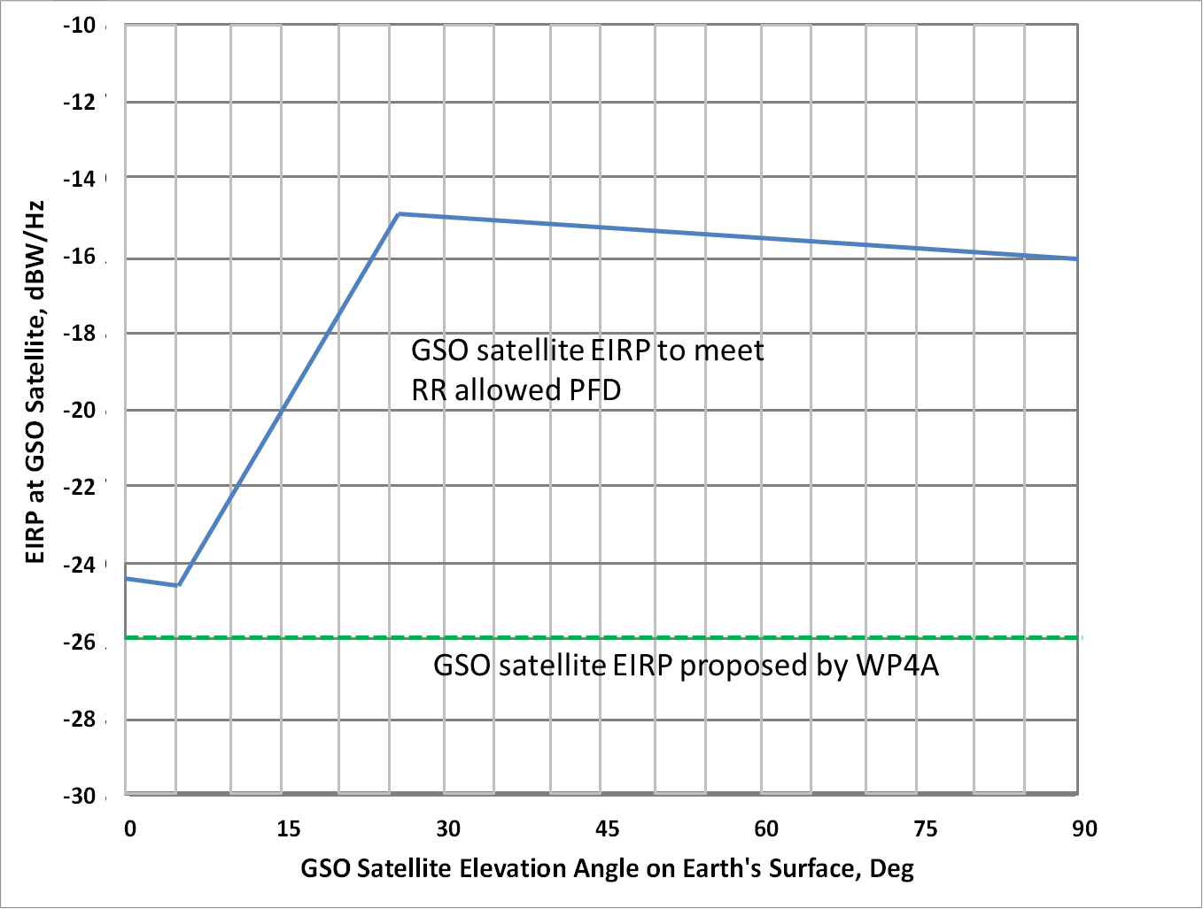

The p.f.d. limits on the Earth's surface vary from −152 dBW/m2 (in 4 kHz) for low elevation angles to −142 dBW/m2 (in 4 kHz) for elevation angles greater than 25 deg. The allowed e.i.r.p. spectral density is calculated using the p.f.d. limits and the distance between the GSO satellite and a point on the Earth’s surface as a function of satellite elevation angle. Note that the maximum allowed e.i.r.p. spectral density is –15 dBW/Hz corresponding to 25 deg satellite elevation angle. At 90 deg elevation angle, the maximum allowed e.i.r.p. spectral density is −16 dBW/Hz. The e.i.r.p. spectral density proposed by FSS is −26 dBW/Hz for all elevation angles, which is 10 to 11 dB below the maximum allowed e.i.r.p. spectral density at elevation angles greater than 25 deg.

In the following sharing studies for the 7-GHz band, the FSS satellite e.i.r.p. spectral density is considered to be −26 dBW/Hz.

For worst case initial aggregate interference studies, the FSS satellite system has been considered to be a constellation of geostationary space stations simultaneously providing a co-frequency and co-polarisation global coverage., equally spaced on the geostationary orbit. Studies consider 2 deg, 3 deg, and 4 deg spacing of the FSS GSO satellites for a total of 180, 120, and 90 satellites.An analysis of MIFR shows that currently more than 100 satellite networks are notified in the band 7 250-7 750 MHz, over 84 orbital locations. Twelve of these networks contain only 1 MHz in the band 7 250-7 750 MHz. Some of these orbital locations are separated by less than 2 deg. For such small orbital separation case, assuming a global coverage, co-frequency co-coverage operations is not realistic from the operational point of view of FSS networks.

# 3 Results of sharing studies between FSS (space-to-Earth) and Fixed Service in the frequency band 7 150-7 250 MHz

Based on the FS characteristics and using a protection criterion of I/N = –10 dB specified in Recommendation ITU-R F.758-5, the interference assessment for the FS is derived and shown in Figure 3-1. This calculation assumes 1 dB feeder/multiplexer loss, 3 dB polarization loss, 2.5 dB receiver noise figure, and FS antenna gain (at a carrier frequency of 7 200 MHz) for off-axis arrival angles from 0 deg to 90 deg. From the figure, the derived interference protection levels in p.f.d. for the FS agree with RR Article **21** p.f.d. limits.

Figure 3-1

Masks of the allowable aggregate p.f.d. for the proposed FSS spacecraft emissions

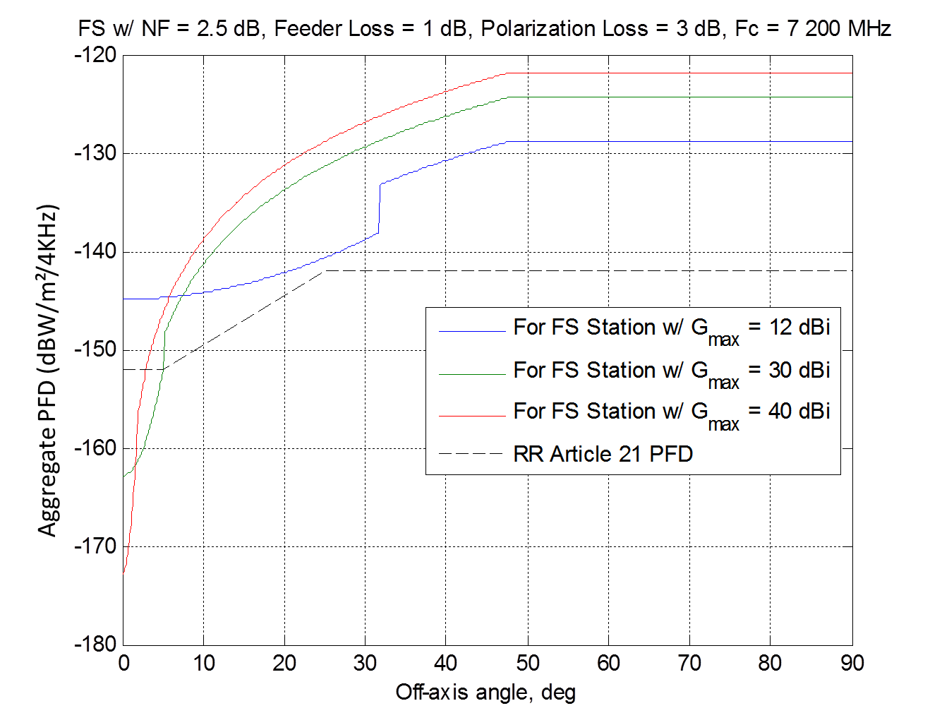

To ensure protection of the FS stations from the FSS spacecraft planned for operation in the frequency band 7 150-7 250 MHz for a certain angle of arrival, the aggregate p.f.d. should not exceed the levels given in figure above. To determine the allowable p.f.d. from one FSS spacecraft, it is required to determine characteristics of the FSS system planned for operation in the indicated frequency band. In order to protect the FS, the provisions of No. **21.16** shall be applied to a space station in the FSS in this band. Since the interference characteristics from a space station in the FSS into a station in the FS in the band 7 250-7 750 MHz is not much different from those in the band 7 150-7 250 MHz, any additional sharing condition is not required provided that the p.f.d. limit above apply to FSS space stations in the band 7 150-7 250 MHz.

From the results of the simulation, the allowable aggregate p.f.d. masks defined are very similar to the p.f.d. limit stated in the Article 21 of the Radio Regulations. Figure 3-2 plots FS station off-axis angle as a function of FSS GSO space station off-zenith angle for three different FS station elevation angles of 0, 5, and 10 degrees.

FIGURE 3-2

FS off-axis angle as a function of FSS GSO off-zenith angle for 3 FS elevation angles



Figure 3-3 plots the FSS GSO p.f.d. (dBW/m2/4 kHz) as a function of FSS space station off-zenith angle and as a function of FS off-axis angle for FSS GSO with maximum transmit e.i.r.p. spectral density of –26 dBW/Hz and peak transmit antenna gains of 20 dBi and 33 dBi, as seen by a FS with a 0 deg. elevation angle. The FSS satellite antenna patterns are assumed to follow Recommendation ITU-R S.672-4, shown in Figure 2.1-1. As shown in Figure 3-3, the derived FSS GSO p.f.d. are below the RR Article **21** p.f.d. limits (particularly, –152.0 dBW/m2/4 kHz at 5 deg off-axis angle).

FIGURE 3-3

p.f.d. limits for FSS GSO space stations when FS are at 0-deg elevation angle

 

The conducted studies showed that the probability of GSO intersection by a receiving FS station main beam with elevation angle exceeding 5 deg. would be *p*=0.02619% in the frequency band 7 150-7 250 MHz. It implies that even if the FS station antenna elevation angle exceeds 5 deg., the probability of its main beam to point towards the GSO would be very low.

The deterministic assessment with sequential estimation of GSO avoidance for each FS station recorded in IFIC with receiving antenna elevation angle exceeding 5 deg showed that no such station antenna main beam direction would intersect GSO. The off-set angle with respect to the GSO arc would be from 5 deg. to 50 deg., depending on the location of the FS station.

Based on the obtained results, it is reasonable to extend the RR Article **21** p.f.d. limits for FSS existing allocation (7 250-7 750 MHz) to the band 7 150-7 250 MHz and to conclude that they would provide protection for FS receiving stations. It would be appropriate to establish GSO avoidance requirement for newly notified FS stations.

With the extension of the RR Article 21 p.f.d. limits for FSS existing allocation (7 250-7 750 MHz) to the band 7 150-7 250 MHz, sharing between the FSS and FS is feasible.

# 4 Results of sharing studies between FSS (Earth-to-space) and Fixed Service in the frequency band 8 400-8 500 MHz

Figure 4-1 shows the FS antenna patterns (Recommendation ITU-R F.1245-2) at a carrier frequency of 8 400 MHz to be used in sharing studies between FS and proposed FSS Earth stations, for FS antenna gains of 46 dBi, 30 dBi, and 12 dBi.

Figure 4-1

FS antenna patterns (Rec. ITU-R F.1245) at 8 400 MHz



Based on the FS characteristics and using a protection criterion of I/N = –10 dB specified in Recommendation ITU-R F.758-5, the interference assessment for the FS is shown in Figure 4-2. This calculation assumes feeder/multiplexer loss of 1 dB, 3 dB polarization loss, and the FS antenna gain (at a carrier frequency of 8 400 MHz) for off‑axis arrival angles from 0 deg to 90 deg.

Figure 4-2

FS interference protection threshold – Power spectral-density (dBW/MHz)



The studies show that separation distances assuming flat terrain between FS systems and FSS earth stations are around 100 km (83.5 to 120 km) to meet long-term protection criterion and between 211.5 and 426 km to meet short-term protection criterion. These distances could be reduced when actual terrain elevation is taken into account. Sharing between FSS (Earth-to-space) and FS is feasible and can be achieved through coordination process under RR **9.17** applying the methods of RR Appendix **7**.

#### 4.3.1.1 FSS (Earth-to-space) and fixed wireless systems in the fixed service

It can be considered that FSS earth station of Types 1 and 2 as in Section 2 may be compatible with fixed wireless systems FWS at the distances around 100 km, i.e., 83.5 km to 105.4 km. For other types of FSS earth stations, distances from 120 km up to 310 km are required to meet the long-term interference level at the FWS.

In order to meet short-term interference level at FWS, distances of 211.5 km to 426 km, are required.

The results show that the required separation varies up to a few hundred kilometres if all types of FSS earth stations are deployed. The required separation distances for short-term analysis are greater than those for long-term analysis, which leads to the conclusion that if the short-term criterion is satisfied, then the associated long-term criteria will be also satisfied.

If actual path profile is applied for the calculation, the required distance could be reduced due to natural and artificial obstacles. Thus in actual case, the distance between FSS earth station and FWS will be less than the results given above.

Annex 1 to attatchment 2

FSS-Fixed service compatibility studies in the bands   
7 150-7 250 MHz and 8 400-8 500 MHz

# A1-1 FSS (space-to-Earth) - Fixed service compatibility studies for the band 7 150-7 250 MHz

## A1-1.1 Fixed station characteristics

FS station characteristics in the considered frequency band are given in Recommendation ITU‑R F.758-5 “System parameters and considerations in the development of criteria for sharing or compatibility between digital fixed wireless systems in the fixed service and systems in other services and other sources of interference” and are presented in Table 1.1-1 below.

Table 1.1-1

|  |  |  |  |  |
| --- | --- | --- | --- | --- |
| Frequency range (GHz) | 7.110-7.900 | | 7.725-8.500 | |
| Reference ITU‑R Recommendation | F.385 | | F.386 | |
| Modulation | 16-QAM | 128-QAM | 16-QAM | 128-QAM |
| Channel spacing and receiver noise bandwidth (MHz) | 3.5, 5, 7, **10**, 14, **20**, **28**, **30**, **40**, **60**, **80** | 3.5, 5, 7, **10**, 14, **20**, **28**, **30**, **40**, **60**, **80** | 1.25, 2.5, 5, 7, **10**, 11.662, 14, **20**, **28**, 29.65, **30**, **40**, **60**, **80** | 1.25, 2.5, 5, 7, **10**, 11.662, 14, **20**, **28**, 29.65, **30**, **40**, **60**, **80** |
| Tx output power range (dBW) | −6.5…20.0 | −6.5…20.0 | −6.5…20.0 | −6.5…20.0 |
| Tx output power spectral density range (dBW/MHz) | −25.5…10.0 | −25.5…10.0 | −25.5…10.0 | −25.5…10.0 |
| Feeder/multiplexer loss range (dB) | 0…3.0 | 0…3.0 | 0…3.0 | 0…3.0 |
| Antenna gain range (dBi) | 12…48.6 | 12…48.6 | 12…48.6 | 12…48.6 |
| e.i.r.p. range (dBW) | 5.5…65.5 | 5.5…65.5 | 5.5…65.5 | 5.5…65.5 |
| e.i.r.p. spectral density range (dBW/MHz) | −13.5…55.5 | −13.5…55.5 | −13.5…55.5 | −13.5…55.5 |
| Receiver noise figure typical (dB) | 2.5…6 | 2.5…6 | 2.5…6 | 2.5…8 |
| Receiver noise power spectral density typical (=*NRX*) (dBW/MHz) | −141.5… −138.0 | −141.5… −138.0 | −141.5…−138.0 | −141.5…−136 |
| Normalized Rx input level for 1 × 10−6 BER (dBW/MHz) | −121.0… −117.5 | −112.5… −115.0 | −121.0…−117.5 | −111.3…−106.5 |
| Nominal long-term interference power spectral density (dBW/MHz) | −141.5… −138.0 + *I/N* | −141.5… −138.0 + *I/N* | −141.5… −138.0 + *I/N* | −141.5… −136+ *I/N* |

The indicated characteristics were recommended for use in the sharing studies of the FS with FSS in the frequency bands 7 150-7 250 MHz (space-to-Earth) and 8 400-8 500 MHz (Earth-to-space).   
It is also proposed to use the criterion I/N = –10 dB (for aggregate interference) as the protection criterion for FS stations in accordance with Recommendation ITU-R F.758-5 for “co-primary” services. It is proposed to take the FS antenna parameters from Recommendation ITU-R F.1245.

Taking into account the worst case (power spectral density of the receiver noise, *NRX* = –141.5dB(W/MHz)) and the provided criterion *I/N =* –10 dB, the maximum allowable power spectral density of the long-term aggregate interference at the FS station input is –151.5 dB(W/MHz).

The study considers three FS antenna types: with antenna gain of 46 dBi, 30 dBi and 12 dBi. The antenna patterns for these antennas, calculated in accordance with Recommendation ITU‑R F.1245, are given in Figure A1.1-1, respectively.

Figure A1.1-1

Antenna pattern with narrow and wide beam



## A1-1.2 Interference impact scenario and model

Interference from GSO satellites is constant and long-term. In most cases, interference from GSO satellites comes through the side lobes and back lobes of FS station antenna pattern.

The equivalent power spectral density of interference at the FS station input is defined as the sum of the power densities produced at the FS receive station on the Earth’s surface by all the transmit stations within a geostationary-satellite system, operating co-frequency, taking into account the off‑axis discrimination of a reference FS receiving antenna. The equivalent power spectral density is calculated using the following formula (see RR Article **22**, No. **22.5C.1**):

(1)

where:

*N –* number of transmit stations in the GSO system that are visible from the FS receive station on the Earth's surface;

*i* – index of the transmit station considered in the GSO satellite system;

*Pi* – RF power at the input of the antenna of the transmit station, considered in the GSO satellite system (dBW) in the reference bandwidth of 1 MHz, dBW/MHz;

*φi* – off-axis angle between the bore-sight of the transmit station considered in the GSO satellite system and the direction of the FS receive station;

*gt(φi)* – transmit antenna gain of the station considered in the GSO satellite system in the direction of the FS receive station;

*θi* – off-axis angle between the bore-sight of the antenna of the FS receive station and the direction of the *i*-th transmit station considered in the GSO system;

*grx(θi)* – receive antenna gain of the FS receive station in the direction of the *i*-th transmit station considered in the GSO satellite system;

*li* – free space losses of the *i*-th interfering signal;

*IΣ* – equivalent power spectral density of the aggregate interference.

In the case where interference is caused by a single source, Equation (1) becomes the following:

$I=10∙\log_{10}\left[{10}^{\frac{P_{t}}{10}}∙\frac{g_{t}(φ)∙g_{rx}(θ)}{l}\right]$ (2)

or coming from absolute to relative values:

${I=P}_{t}+G_{t}\left(φ\right)+G_{RX}\left(θ\right)-L$ (3)

where:

*Pt* – maximum power spectral density at the antenna input of the considered transmit station in GSO in the referenced bandwidth 1 MHz, dB (W/MHz);

*Gt(φ) –* transmit antenna gain of the station considered in the GSO satellite system in the direction of the FS receive station, dBi;

*GRX(θ) –* receive antenna gain of the FS station in the direction of the transmit station considered in the GSO satellite system, dBi;

*L* – free space loss in the interfering signal distribution.

This study considered scenarios where the main lobe of the GSO FSS satellite antenna is coupled into the main lobe (M-M), side lobes (M-S) and back lobes (M-B) of the FS station antenna, which are calculated in accordance with Recommendation ITU-R F.1245. The e.i.r.p. spectral density of a single FSS spacecraft is assumed to be 30 dB (W/MHz).

Figure 1.1-1

Interference impact scenarios from FSS spacecraft to FS station

Main beam

Side lobe

## A1-1.3 FSS-Fixed service sharing

This section examines the impact of such FSS (space-to-Earth) space station into the fixed service and proposes a p.f.d. mask which ensures the protection of the FS.

### A1-1.3.1 Methodology

The equivalent power spectral density of interference at the FS station input is defined as the sum of the power densities produced at the FS receive station on the Earth’s surface by all the transmit stations within a geostationary-satellite system, operating co-frequency taking into account the   
off-axis discrimination of a reference FS receiving antenna. The equivalent power spectral density is calculated using the following formula (see RR Article **22**, No. **22.5C.1**):

(1)

where:

*N –* number of transmit stations in the GSO system that are visible from the FS receive station on the Earth's surface;

*i* – index of the transmit station considered in the GSO satellite system;

*Pi* – RF power at the input of the antenna of the transmit station, considered in the GSO satellite system (dBW) in the reference bandwidth of 1 MHz, dBW/MHz;

*φi* – off-axis angle between the bore-sight of the transmit station considered in the GSO satellite system and the direction of the FS receive station;

*gt(φi)* – transmit antenna gain of the station considered in the GSO satellite system in the direction of the FS receive station;

*θi* – off-axis angle between the bore-sight of the antenna of the FS receive station and the direction of the *i*-th transmit station considered in the GSO system;

*grx(θi)* – receive antenna gain of the FS receive station in the direction of the *i*-th transmit station considered in the GSO satellite system;

*li* – free space losses of the *i*-th interfering signal;

*IΣ* – equivalent power spectral density of the aggregate interference.

In case when interference is caused by single source the Equation (1) is the following:

$I=10∙\log_{10}\left[{10}^{\frac{P_{t}}{10}}∙\frac{g_{t}(φ)∙g_{rx}(θ)}{l}\right]$ (2)

or coming from absolute to relative values:

${I=P}_{t}+G_{t}\left(φ\right)+G_{RX}\left(θ\right)-L$ (3)

where:

*Pt* – maximum power spectral density at the antenna input of the considered transmit station in GSO in the referenced bandwidth 1 MHz, dB (W/MHz);

*Gt(φ) –* transmit antenna gain of the station considered in the GSO satellite system in the direction of the FS receive station, dBi;

*GRX(θ) –* receive antenna gain of the FS station in the direction of the transmit station considered in the GSO satellite system, dBi;

*L* – free space losses in the interfering signal distribution.

The study determines a p.f.d. mask which respect the p.f.d. limits defined in the RR Article **21** (Table 21-4).

The losses of the interfering signal were calculated in accordance with Recommendation   
ITU-R P.525. The antenna-feeder path losses, polarization losses and also fading of interfering signal in the atmosphere and hydrometeors were not taken into account.

FS station characteristics in the considered frequency band are given in Recommendation ITU‑R F.758-5 and reminded in section A1-1.1.

The value of the maximum allowable power spectral density of the long-term interference at the FS station input is *(−141.5…−138.0)+I/N dB(W/MHz)*. Taking into account the worst case (power spectral density of the receiver noise, *NRX* = –141.5dB(W/MHz)) and the set criterion  
*I/N =* –10 dB, the maximum allowable power spectral density of the long-term aggregate interference at the FS station input is –151.5 dB(W/MHz).

### A1-1.3.2 Results

The figure below shows the p.f.d. masks which ensure a protection for a FS with elevation angles equal to 0° and 5°.

Figure 1.3.2-1

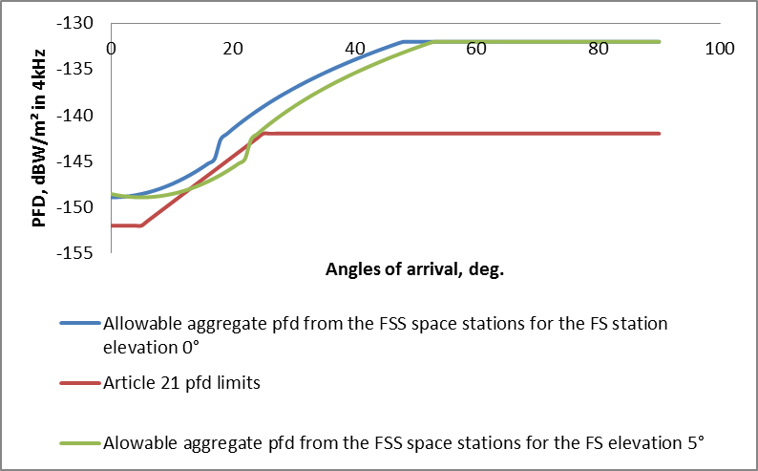

## A1-1.4 FS interference to FSS earth station receivers in the 7 150-7 250 MHz band

This section assesses the potential interference from the FS into the FSS receiving earth stations in the 7 150-7 250 MHz band and satellite receivers in the 8 400-8 500 MHz band.

### A1-1.4.1 Introduction

The interference impact from FS stations to FSS satellite receivers located in GSO is defined by the probability of the FS station antenna main beam pointing towards the GSO direction. In general, this probability is low and depends on the number of stations with elevation angles higher than 0° .The compatibility between FS and FSS (Earth-to-space) is ensured for such scenarios by the application of separation angles between the FS stations pointing direction and the GSO.

In addition, under RR No. **21.2** and Table 21-1 the sites for stations in the fixed service employing maximum values of equivalent isotropically radiated power (e.i.r.p.) exceeding +35 dBW in the frequency range 8 GHz, should be selected so that the direction of maximum radiation of any antenna will be separated from the geostationary-satellite orbit by 2 degrees. In the cases when the conditions of RR No. **21.2** cannot be met for the frequency range of 8 GHz, the maximum e.i.r.p. value of FS station shall not exceed the values given in RR No. **21.4**. Thus for the case of influence caused by FS terrestrial stations to FSS receivers on GSO, RR provisions stipulate e.i.r.p. limits of FS stations in the direction of GSO in the frequency range 1‑10 GHz.

More relevant for the operation of the FSS is a potential interference impact from the transmitting terrestrial FS stations to receiving FSS earth station in the frequency range 7 GHz.

Taking into account the mentioned above, this section provides the compatibility studies of the FS with FSS (space-to-Earth) in the frequency range 7 150-7 250 MHz.

### A1-1.4.2 Interference scenario

The considered interference scenario is shown on Figure 1.4.2-1.

Figure 1.4.2-1

Interference impact scenario FS-FSS (space-to-Earth)



### A1-1.4.3 Initial data and protection criteria

The basic characteristics of the receiving earth stations of FSS are given in Table 2.1-1 in Section 2 of the main body of this Report.

The basic characteristics of the transmitting FS stations in the frequency range 7 GHz are given in Recommendation ITU-R F.758-5 and shown in Table 1.1-1 in this Annex.

The maximum permissible aggregate interference from Recommendation ITU-R S.1432-1 interference-to-noise ratio I/N= –12.2 dB (6%), where N– is the thermal noise level of FSS earth station is used as a protection criterion for FSS earth station.

Taking into account this criterion and the thermal noise value of FSS earth station receiver for each type of FSS station, the permissible interference power spectral density at the FSS earth station receiver front end is defined in Table 1.4.3-1.

Table 1.4.3-1

Allowable interference power spectral density at the input of the earth station FSS receiver

|  |  |  |  |  |
| --- | --- | --- | --- | --- |
| **FSS ES type** | **Receiver noise temperature, К** | **Noise power spectral density, dBW/MHz** | **Protection criterion I/N, dB** | **Permissible interference power spectral density, dBW/MHz** |
| 1 | 200 | –145.6 | –12.2 | –157.8 |
| 2 | 125 | –147.6 | –159.8 |
| 3 | 126 | –147.5 | –159.7 |
| 4 | 159 | –146.6 | –158.8 |
| 5 | 200 | –145.6 | –157.8 |

### A1-1.4.4 Calculation methodology

The minimum required value of basic losses for protection of FSS stations can be estimated by the following equation:

Lb( p%)  Pt  Gt (t) – (Pi – Gr (r))

where:

*Pt* : FS station transmitter power, dBW;

*Gt* (*t*) : FS station antenna gain in the direction of FSS earth station (dBi);

*Gr* (*r*): FSS earth station antenna gain in the direction of FS station (dBi);

*Pi* : maximum permissible value of long-term interference at FSS earth station front end (dBW);

*t* : angle between the direction of main emission and direction to the victim receiver (degrees);

*r* : angle between the main beam of FSS earth station receiving antenna and interference source (degrees);

Lb( p%): minimum required value of basic losses not exceeded during p% of time, dB.

Based on the basic propagation losses described in the methodology and using the Recommendation ITU-R P.452-15, the protection distance is defined.

### A1-1.4.5 Estimation results

The estimation of the minimum required values of basic losses and the required protection distances was carried out under the following assumptions: FSS earth station of types 1-5 (see Table 2.1-1 in Section 2.1 of the main body of the Report) are considered. FSS earth station antenna pattern described in Recommendation ITU R S.580-6 is considered for stations of 1-4 types and antenna pattern described in Recommendation ITU R S. 465-6 is considered for stations of 5th type; the minimum elevation angle of FSS earth station receiving antenna is 10 degrees.

The parameters of FS stations are given in Recommendation ITU-R F.758-5 (Table 1.1-1), FS station antenna pattern is described in Recommendation ITU-R F.1245 and 4 scenarios were considered:

– FS station impact with the minimum power spectral density with antenna gain of 12 dBi;

– FS station impact with the maximum power spectral density with antenna gain of 12 dBi;

– FS station impact with the minimum power spectral density with antenna gain of 48.6 dBi;

– FS station impact with the maximum power spectral density with antenna gain of 48.6 dBi.

For each of scenarios, three options on interference impact were considered: by the main, side, and back lobes of antenna pattern.

It should be noted that the main lobe impact of FS station (for high antenna gain) is possible only when FSS earth station are located directly between two FS stations of P-P link therefore to estimate protection distances it is required to use the assessments based on the scenarios with side and back lobes impact.

The protection criterion of I/N ≤ –12.2 dB given in Recommendation ITU-R S.1432 is used. This criterion is valid for the aggregate interference from all FS stations operating co-frequency and in the area of the affected FSS earth station location. Therefore, the permissible interference criterion for one interfering FS station will be more stringent. The time percent for long-term interference is 20% (p=20%) of any month.

While defining the protection distances subject to the required basic propagation losses estimated by the methodology given in Recommendation ITU-R P.452-15, the following assumptions were taken: the average vertical gradient of radiowave refraction index of the lower atmosphere ΔN=50, surface refractivity N0=329, average frequency equal to 7.2 GHz, wavelength λ=4.2 cm, the propagation model in A2 zone (all land, other than coastal and shore areas) is used, transmitting antenna center height of FSS earth station of type 1 above the ground level hES1=10 m, antenna height of other earth station hES = 5 m, transmitting antenna center height of FS station hFS=15 m. The estimations were carried out for smooth surface excluding terrain.

The required losses and the protection distances for earth station type 1-5 were estimated under FS station impact with the minimum power spectral density and antenna gain of 12 dBi.

Table 1.4.5-1

|  |  |  |  |  |  |  |  |  |
| --- | --- | --- | --- | --- | --- | --- | --- | --- |
| Option | FS station power spectral density, dBW/МHz | FS station antenna gain towards FSS ES, dBi | FS station e.i.r.p. towards FSS ES, dBW/МHz | FSS ES type | FSS ES antenna gain towards FS station, dBi | Permissible interference at front end of FSS ES receiver, dBW/МHz | Required propagation losses, dB | Req. protection distance, km |
| M-M | –25.5 | 12 | –13.5 | 1-4 | 4 | –159.8 | 150.3 | **24.3** |
| 5 | 7 | –157.8 | 151.3 | **24.9** |
| S-M | 5.5 | –20 | 1-4 | 4 | –159.8 | 143.8 | **20.5** |
| 5 | 7 | –157.8 | 144.8 | **21.1** |
| B-M | –4 | –29.5 | 1-4 | 4 | –159.8 | 134.3 | **15.3** |
| 5 | 7 | –157.8 | 135.3 | **15.9** |

The required losses and the protection distances for earth station type 1-5 were estimated under FS station impact with the maximum power spectral density and antenna gain of 12 dBi.

Table 1.4.5-2

|  |  |  |  |  |  |  |  |  |
| --- | --- | --- | --- | --- | --- | --- | --- | --- |
| Option | FS station power spectral density, dBW/МHz | FS station antenna gain towards FSS ES, dBi | FS station e.i.r.p. towards FSS ES, dBW/МHz | FSS ES type | FSS ES antenna gain towards FS station, dBi | Permissible interference at front end of FSS ES receiver, dBW/МHz | Required propagation losses, dB | Req. protection distance, km |
| M-M | 10 | 12 | 22 | 1-4 | 4 | –159.8 | 185.8 | **53.0** |
| 5 | 7 | –157.8 | 186.8 | **54.1** |
| S-M | 5.5 | 15.5 | 1-4 | 4 | –159.8 | 179.3 | **46.5** |
| 5 | 7 | –157.8 | 180.3 | **47.4** |
| B-M | –4 | 6 | 1-4 | 4 | –159.8 | 169.8 | **38.1** |
| 5 | 7 | –157.8 | 170.8 | **38.8** |

The required path losses and the protection distances for earth station type 1-5 were estimated under FS station impact with the minimum power spectral density, antenna gain of 48.6 dBi, and feeder losses of 3 dB.

Table 1.4.5-3

|  |  |  |  |  |  |  |  |  |
| --- | --- | --- | --- | --- | --- | --- | --- | --- |
| Option | FS station power spectral density, dBW/МHz | FS station antenna gain towards FSS ES, dBi | FS station e.i.r.p. towards FSS ES (with Lfeed=3dB) , dBW/МHz | FSS ES type | FSS ES antenna gain towards FS station, dBi | Permissible interference at front end of FSS ES receiver, dBW/МHz | Required propagation losses, dB | Req. protection distance, km |
| M-M | –25.5 | 48.6 | 20.1 | 1-4 | 4 | –159.8 | 183.9 | **51.0** |
| 5 | 7 | –157.8 | 184.9 | **51.9** |
| S-M | 11.5 | –17 | 1-4 | 4 | –159.8 | 146.8 | **22.2** |
| 5 | 7 | –157.8 | 147.8 | **22.8** |
| B-M | –13 | –41.5 | 1-4 | 4 | –159.8 | 122.3 | **4.4** |
| 5 | 7 | –157.8 | 123.3 | **5.0** |

The required path losses and the protection distances for earth station type 1-5 were estimated under FS station impact with the maximum power spectral density, antenna gain of 48.6 dBi and feeder losses of 3 dB.

Table 1.4.5-4

|  |  |  |  |  |  |  |  |  |
| --- | --- | --- | --- | --- | --- | --- | --- | --- |
| Option | FS station power spectral density, dBW/МHz | FS station antenna gain towards FSS ES, dBi | FS station e.i.r.p. towards FSS ES (with Lfeed=3dB) , dBW/МHz | FSS ES type | FSS ES antenna gain towards FS station, dBi | Permissible interference at front end of FSS ES receiver, dBW/МHz | Required propagation losses, dB | Req. protection distance, km |
| M-M | 10 | 48.6 | 55.6 | 1-4 | 4 | –159.8 | 219.4 | **210.7** |
| 5 | 7 | –157.8 | 220.4 | **219.7** |
| S-M | 11.5 | 18.5 | 1-4 | 4 | –159.8 | 182.3 | **49.4** |
| 5 | 7 | –157.8 | 183.3 | **50.4** |
| B-M | –13 | -6 | 1-4 | 4 | –159.8 | 157.8 | **29.1** |
| 5 | 7 | –157.8 | 158.8 | **29.8** |

### A1-1.4.6 Conclusions

The static analysis results showed that FSS earth stations of all types are compatible with FS stations with protection distances ranging from 5 to 54 km. In the scenario “main-to-main” when FS station with antenna gain of 48.6 dBi interfere the FSS earth station, the protection distances are about 220 km. The antenna pattern width at 3 dB is 0.6 degrees and it considerably reduces the probability of such interference scenario.

Therefore taking into account the frequency and distance separations, the compatibility between FS stations and potential FSS allocation in the frequency range 7 GHz is considered to be feasible.

## A1-1.5 FSS downlink interference to the FS stations in the 7  150-7  250 MHz band

### A1-1.5.1 Introduction

Based on conducted study results described in this Report, the current approach to provide protection for fixed service (FS) stations from envisioned allocation to the fixed-satellite service (FSS) (space-to-Earth) in the frequency band 7 150-7 250 MHz assumes application of power flux density (p.f.d.) limitations specified in Radio Regulations (RR) Article **21** for adjacent frequency bands. It is noted in particular that FS stations with antenna elevation angles exceeding 5 degrees should be taken into consideration when conducting the sharing studies. There were concerns about the fact that designing the FS stations for operating in the given frequency band omitted examination of the problem related to geostationary orbit (GSO) avoidance when pointing a FS station antenna beam. Therefore, the following situations were considered:

a) extending the current RR Article **21** power flux density limits in the adjacent bands to protect the FS in the frequency band 7 150-7 250 MHz, including the cases where the FS antenna exceeds 5 deg elevation angle;

b) the protection of existing FS systems without geostationary orbit avoidance in the 7 150-7 250 MHz band.

Taking the above into consideration, this section estimates the probability of pointing towards the GSO arc from a FS station antenna main lobe with elevation angle exceeding 5 deg. It also contains relevant deterministic estimations related to incumbent FS stations for which information is presented in the ITU Radiocommunication Bureau (BR) data base (DB) for terrestrial services.

### A1-1.5.2 Interference scenario

The assumed interference scenario is shown in Figure 1.5.2-1.

Figure 1.5.2-1

Interference scenario considered



Preliminary study results suggested that the proposed p.f.d. limits for elevation angles above 5 deg could be insufficient if FSS space station main beam emission fell into a the main beam of a type of FS station receiving antenna («main lobe-to-main lobe» scenario for FS stations with gain around 48.6 dBi). Taking into account that an average value for such antenna pattern main beam width is around 1 – 2 deg, the above scenario could be posible when FS station receiving antenna main beam is pointed at GSO arc. Hence estimation of the probability of occurrence of a «main lobe-to-main lobe» scenario is required to define the compatibility conditions.

### A1-1.5.3 Determination of the initial data for estimation

Assumptions for the estimations were defined by analyzing the relevant data base (DB) for terrestrial services via sampling the data for FS stations operating in the frequency band   
7 150-7 250 MHz with their information recorded in the International Frequency Information Circular (IFIC) for terrestrial services (BR IFIC 2757 of November 12, 2013).

The Terrestrial Services data base (BR IFIC TS) contains data reflecting the **transmitting** station parameters (azimuth and elevation angle of maximum emission level; antenna pattern width; operation frequencies; emission powers, etc.) whereas the objective of the studies refers to the estimation of the interference impact on **receiving** FS stations (the appropriate data for associated stations are unavailable in some cases and the content covers only identification of the site location and geographical coordinates). Taking the operational features of point-to-point (P-P) FS stations into consideration, the required parameters (azimuth, elevation angle) of P-P receiving station is derived on the basis of relevant transmitting station parameters. It is obvious that if a FS transmitting station elevation angle is δ, then the associated FS receiving station elevation angle would also be of δ but with an opposite sign. Therefore, FS receiving stations having elevation angle above 5 deg would correspond to transmitting FS stations in the DB with antenna elevation angle below 5 deg such as δRx = –δTx (see Figure 1.5.2-1).

A FS receiving station azimuth may be derived on the basis of azimuth data for FS P-P transmitting station radio link (see Figure 1.5.3-1):

AzRx = AzTx + π for 0 ≤ AzTx ≤ π

AzRx = AzTx – π for π ≤ AzTx ≤ 2π

Figure 1.5.3-1

Indication of the azimuth for the FS victim station receiver



### A1-1.5.4 Estimation methodology

#### A1-1.5.4.1 Probabilistic approach

Antenna beam axis of any FS station deployed in any site on the Earth surface (between 81ºN and 81ºS) with elevation angles not exceeding specified limits would intersect GSO arc for two azimuth values. Then, assuming an even distribution of the FS stations, probability of intersecting a GSO arc (*PI*) by a receiving antenna main beam of any FS station may be shown as:

$P_{1}=\frac{2⋅Θ}{360}⋅100\%$ (1)

where θ is a FS receiving station antenna pattern main beam width.

The above equation describes probability of intersecting the GSO arc by the main beam of **any** FS station antenna. However, the majority of FS stations are known to operate at elevation angles between 0 deg and 5 deg; therefore, it seems appropriate to incorporate a weight factor to support estimating the probability of events referred to a GSO arc intersection by an FS station main beam with elevation angle exceeding 5 deg. The weight factor would be:

$ξ=\frac{n}{N}$ (2)

where:

*N* – is a total number of sampled FS stations;

*n* – is a number of sampled FS stations with antenna elevation angles above 5 deg.

Then, the probability of the GSO arc intersection by an FS station main beam with elevation angle exceeding 5 deg would be:

$P\left(\%\right)=P_{1}⋅ξ$ (3)

#### A1-1.5.4.2 Deterministic approach

If geographical coordinates of a given FS receiving station site location *N* (φN, λN) are known, its main beam axis azimuth (*A*) and elevation angle (γ) towards the GSO may be defined   
(see Figure 1.5.4.2-1). In that case Earth surface imperfections at location *N* height above   
the Earth surface should be taken into account.

Figure 1.5.4.2-1

Indication of antenna beam azimuth and elevation angle in geocentric and telocentric reference systems

X

Y

Z

Greenwich meridian

Earth center

0

Equator

N

A

Earth North pole

λ

N

φ

N

η

B

C

D

ξ

ζ

γ

Spacecraft

Station

location site

Assuming the Earth to be an ideal sphere with a FS station zero height above the sea level then FS station antenna main beam azimuth and elevation angle towards the GSO could be derived using   
the following expressions:

$A=arctg\frac{sin⁡(λ_{C}-λ_{N})}{-sinφ_{N}cos(λ_{C}-λ_{N})}+kπ$ (4)

$γ≈arcsin\frac{H⋅cosφ_{N}⋅\cos\left(λ_{C}-λ_{N}\right)-R}{\sqrt{H^{2}+R^{2}-2HRcosφ_{N}\cos\left(λ_{C}-λ_{N}\right)}}$ (5)

where:

*λС* is longitude of subsatellite point on a GSO arc in a relative geocentric reference system;

*H* ≈ 42 170 km is GSO height above the Earth center;

*R* ≈ 6 371 km is the Earth radius;

*k* = 0 for *φN* < 0, *λС* > *λN*; *k* = 2 for *φN* < 0, *λС* < *λN*; *k* = 1 for *φN* > 0.

Elevation angle towards the GSO (*γ*) is estimated for each FS station for which information (φN, λN, *AzRx*) is available in BR DB for terrestrial services and which operates in the frequency band 7 150‑7 250 MHz with receiving antenna elevation angle above 5 deg. The elevation angle *γ* is obtained by solving Equations (4) and (5) with two unknowns (λС and γ) and assuming *A = AzRx.*

Only FS stations with azimuth AzRx within the range from 90 deg to 270 deg potentially intersecting GSO are taken into account in the Northern Hemisphere.

The value of the elevation angle towards the GSO derived from Equations (4) and (5) is compared with the FS receiving station operational elevation angle. The difference between those values represents the off-set of the receiving FS station antenna main beam with respect to the direction that points towards the GSO arc. Such offset is given by:

$Δ=γ-δ_{Rx}$ (6)

### A1-1.5.5 Estimation results

The analysis results of the BR DB for Terrestrial Services relating to FS stations operating in   
the frequency band 7 150-7 250 MHz are presented in Appendix A of this Annex. The results show that 2 120 FS frequency assignments are currently notified in the frequency band 7 150-7 250 MHz with only   
1 230 such assignments include data for their azimuth and elevation angle. Then, based on the assumed methodology a number of FS stations with elevation angle above 5 deg (*n* = 29) was determined from a total set of *N* = 1230 stations. The average width of FS station antenna main beam was assumed to be 2 deg.

Then probability of intersecting the GSO arc by FS station antenna main beam with elevation angle δ > 5 deg would be:

P=P1∙ξ=2θ/360∙n/N∙100%=0.02619%

The derived value shows that probability of GSO intersection by a FS station receiving station main beam would be rather low even if elevation angle of that beam exceeds 5 deg.

To verify the validity of the obtained results (estimation of probability *P*) GSO avoidance (difference between pointing at GSO and antenna operational elevation angle) was estimated for each FS receiving station with its antenna elevation angle above 5 deg using data for actual FS stations registered in the frequency band 7 150-7 250 MHz. The estimation results are shown in Appendix B of this Annex. It is obvious from the obtained results that no sampled FS station with receiving antenna elevation angle above 5 deg would intersect the GSO with an off-set angle from 5º to 50º.

It is understood that the IFIC Terrestrial Services does not contain information for each FS stations operating in the 7 GHz band. The stations deployed inside the territory of any administration and requiring no border coordination may not be notified. Nevertheless, the estimation results of the deterministic approach with sequential estimation of direction towards the GSO for each FS station confirm the results of the probabilistic estimation.

### A1-1.5.6 Conclusions

The conducted studies showed that probability of GSO intersection by a receiving FS station main beam with elevation angle exceeding 5 deg would be *P*=0.02619% in the frequency band 7 150-7 250 MHz. It implies that even if the elevation angle of the FS station antenna exceeds 5 deg, the probability of its main beam to point towards the GSO is very low.

The deterministic assessment with sequential estimation of GSO avoidance for each FS station recorded in IFIC with receiving antenna elevation angle exceeding 5 deg showed that no such station antenna main beam direction would intersect GSO. The off-set angle from GSO would be from 5 deg to 50 deg depending on the FS station.

Based on the obtained results it is reasonable to apply RR Article **21** p.f.d. limitations in adjacent frequency band and to conclude that they will provide protection for FS receiving stations in the frequency band 7 150-7 250 MHz.

A1-1.5 / APPENDIX A

Results of Terrestrial Service data base analysis for notified elevation angles of FS stations in   
the frequency band 7 150-7 250 MHz are shown in Table 1 and Figure 1.

Table 1

|  |  |
| --- | --- |
| FS RS antenna  elevation angle (deg.) | Number of FS  terrestrial stations |
| 88.8 | 2 |
| 5 … 30 | 27 |
| 1 … +5 | 98 |
| –1 … +1 | 957 |
| –1 …–5 | 98 |
| –33 … –5 | 48 |
| unavailable | 890 |

Figure 1

Distribution of FS stations in 7 GHz band by elevation angles of receiving antennas



Results of Terrestrial Service data base analysis for notified antenna pattern width of FS stations in the frequency band 7 150-7 250 MHz are shown in Table 2 and Figure 2.

Table 2

|  |  |
| --- | --- |
| FS antenna  beamwidth (deg.) | Number of FS  terrestrial stations |
| <1 | 115 |
| 1 … 2 | 924 |
| 2 … 3 | 360 |
| 3 … 4 | 64 |
| 4 …5 | 41 |
| >5 | 10 |
| unavailable | 606 |

Figure 2

Distribution of FS stations in 7 GHz band by antenna pattern width



A1-1.5 / APPENDIX B

Table 1 below describes characteristics of P-P radio links for which information is published in International Frequency Information Circular (Terrestrial Services) BR IFIC 2757. The receiving station antenna elevation angle for those radio links exceeds 5 deg. FS receiving station antenna azimuth and elevation angle were estimated using the methodology described herein.

Table 1

| adm | freq_ assgn | bdwdth_ cde | stn_ type | fxm_geo.geo_ type | fxm_geo.site_name | long_dec | lat_dec | site_ alt | azm_ max_e | bmwdth | elev | fxm_geo_1.site_ name | AzRx | δRx |
| --- | --- | --- | --- | --- | --- | --- | --- | --- | --- | --- | --- | --- | --- | --- |
| SUI | 7 201.133 | 3M89 | TX | POINT | AIROLO | 8.59833 | 46.54139 | 2 067 | 179.9 | 1.62 | –30.2 | GIANON ATEL | 359.9 | 30.2 |
| SUI | 7 201.133 | 3M89 | TX | POINT | AIROLO | 8.59833 | 46.54139 | 2 067 | 179.9 | 1.62 | –30.2 | AIROLO ATEL | 359.9 | 30.2 |
| OMA | 7 215.5 | 14M0 | TX | POINT | Al Jirri PR | 56.18722 | 26.22222 | 234 | 194.6 | 1.9 | –14 | Al Jirri | 14.6 | 14 |
| AUT | 7 228 | 108K | TX | POINT | ALBERSCHWENDE GA P | 9.82639 | 47.47222 | 783 | 85 | 2.6 | –5.6 | ALBERSCHWENDE WEITL | 265 | 5.6 |
| YEM | 7 135 | 28M0 | TX | POINT | ALGIFF | 46.06528 | 13.90222 |  | 26.7 | 2.45 | –88.8 | MUDIYA | 206.7 | 88.8 |
| YEM | 7 184 | 28M0 | TX | POINT | ALGIFF | 46.06528 | 13.90222 |  | 26.7 | 2.44 | –88.8 | MUDIYA | 206.7 | 88.8 |
| SUI | 7 205.52 | 500K | TX | POINT | ARBEA ALP EGL | 9.20444 | 46.41833 | 1 912 | 342.3 | 1.62 | –5.2 | S BERNARDINO EGL | 162.3 | 5.2 |
| SUI | 7 193.358 | 23M3 | TX | POINT | BAERSILICHOPF | 8.00583 | 46.86611 | 1 406 | 26.7 | 1.57 | –14.9 | FLUEHLI LAENGBRUEGG | 206.7 | 14.9 |
| E | 7 240 | 12M0 | TX | POINT | BALADRIAS RP | –0.33528 | 42.77778 | 1 541 | 149 | 0.8 | –15.4 | SALLENT GALLEGO | 329 | 15.4 |
| SUI | 7 207.52 | 500K | TX | POINT | BRUNET PR CABANE | 7.27556 | 46.03361 | 2 063 | 93.1 | 1 | –10.2 | FIONNAY | 273.1 | 10.2 |
| SUI | 7 197.245 | 1M30 | TX | POINT | CAMUSIO PR | 8.89417 | 46.10000 | 1 661 | 39.1 | 1.22 | –6 | TORRETTA | 219.1 | 6 |
| SUI | 7 204.52 | 500K | TX | POINT | COSTA D ARZO EW | 8.50750 | 46.45278 | 2 385 | 164.3 | 1 | –14.7 | ROBIEI 1 | 344.3 | 14.7 |
| OMA | 7 243.5 | 14M0 | TX | POINT | Fine Peak MUS064 | 56.17528 | 26.09944 | 1 352 | 28.2 | 1.9 | –6 | Quida PR | 208.2 | 6 |
| SUI | 7 170.034 | 11M7 | TX | POINT | FOPPIANA ALPA | 8.88333 | 46.20583 | 1 492 | 240 | 1.16 | –10.2 | MURALTO CT | 60 | 10.2 |
| SUI | 7 158.372 | 23M3 | TX | POINT | GEBIDEM | 7.93694 | 46.27167 | 2 302 | 291.4 | 1.5 | –5.5 | HOHTENN | 111.4 | 5.5 |
| SUI | 7 201.133 | 3M89 | TX | POINT | GIANON ATEL | 8.84944 | 46.45556 | 1 385 | 198 | 1.62 | –22.6 | LAVORGO ATEL | 18 | 22.6 |
| E | 7 184 | 17M2 | TX | POINT | HERRERA DUQUE RP | –5.04750 | 39.14861 | 7 60 | 260 | 1.3 | –8.2 | HERRERA DEL DUQUE | 80 | 8.2 |
| E | 7 226 | 12M0 | TX | POINT | HERRERA DUQUE RP | –5.04750 | 39.14861 | 753 | 260 | 1 | –8.2 | HERRERA DEL DUQUE | 80 | 8.2 |
| AUT | 7 152 | 500K | TX | POINT | LIENZ | 12.70278 | 46.83611 | 2 044 | 83 | 4 | –15 | LIENZ | 263 | 15 |
| SUI | 7 158.372 | 11M7 | TX | POINT | MT GENEROSO | 9.01611 | 45.92750 | 1 614 | 268.6 | 1.04 | –9 | VICO MORCOTE | 88.6 | 9 |
| SUI | 7 181.696 | 23M3 | TX | POINT | MULTA | 10.41333 | 46.59806 | 1 463 | 311 | 2.32 | –5.3 | VALCHAVA | 131 | 5.3 |
| AUT | 7 192.5 | 1M60 | TX | POINT | OBERHOFEN | 11.12361 | 47.30722 | 633 | 147 | 8.2 | –7.8 | RANGGER KOEPFL | 327 | 7.8 |
| SUI | 7 204.02 | 500K | TX | POINT | OLTEN | 7.94556 | 47.33694 | 782 | 300.1 | 1.64 | –5.8 | OLTEN EW | 120.1 | 5.8 |
| SUI | 7 189.471 | 3M89 | TX | POINT | PR AUBRUGG EWZ | 8.57444 | 47.41333 | 526 | 283.4 | 1.1 | –22.9 | ZUERICH AUWIESE | 103.4 | 22.9 |
| OMA | 7 243.5 | 14M0 | TX | POINT | Quida PR | 56.22722 | 26.18667 | 188 | 262.5 | 1.9 | –17 | Quida MUS00074 | 82.5 | 17 |
| SUI | 7 205.02 | 3M89 | TX | POINT | TITLIS | 8.42694 | 46.77167 | 3 084 | 242.3 | 2.4 | –7.9 | HEITEREN | 62.3 | 7.9 |
| SUI | 7 158.372 | 11M7 | TX | POINT | VICO MORCOTE | 8.91889 | 45.92722 | 423 | 152.4 | 1.04 | –27.7 | MORCOTE TZ | 332.4 | 27.7 |
| AUT | 7 188.5 | 500K | TX | POINT | ZELL AM ZILLER | 11.90000 | 47.23333 | 586 | 330 | 2.4 | –18 | LARCHKOPF | 150 | 18 |
| SUI | 7 205.02 | 23M3 | TX | POINT | ZERNEZ 2 MUNT PR | 10.06306 | 46.70139 | 2 493 | 89.2 | 1.04 | –16.6 | ZERNEZ | 269.2 | 16.6 |

Azimuth values for which GSO impact is impossible are shown in color.

Results of GSO avoidance (difference between pointing at GSO and antenna operational elevation angle) estimations for each FS receiving station with its antenna elevation angle above 5 deg are shown in Table 2.

Table 2

|  |  |  |  |  |  |  |  |  |  |
| --- | --- | --- | --- | --- | --- | --- | --- | --- | --- |
| ADM | FS Rx site name | FS Receiver azimuth, AzRx, deg. | FS Receiver elevation angle, δRx, deg. | FS Receiver long., λN, deg. | FS Receiver lat., φN, deg. | Azimuth to GSO, A, deg. | Elevation angle to GSO, γ, deg. | Point of intersection with the GSO, λc, deg. | Differ. between δRx and the direction to GSO, Δ, deg. |
| YEM | MUDIYA | 206.7 | 88.8 | 46.08056 | 13.93194 | 206.7 | 71.8 | 39.17 | 17.0 |
| YEM | MUDIYA | 206.7 | 88.8 | 46.08056 | 13.93194 | 206.7 | 71.8 | 39.17 | 17.0 |
| SUI | S BERNARDINO EGL | 162.3 | 5.2 | 9.1925 | 46.44639 | 162.3 | 35.1 | 22.2 | 29.9 |
| SUI | FLUEHLI LAENGBRUEGG | 206.7 | 14.9 | 8.01722 | 46.88139 | 206.7 | 32.6 | –12.15 | 17.7 |
| SUI | TORRETTA | 219.1 | 6 | 9.0075 | 46.19306 | 219.1 | 29.1 | –21.4 | 23.1 |
| OMA | Quida PR | 208.2 | 6 | 56.22722 | 26.18667 | 208.2 | 56.0 | 42.9 | 50.0 |
| SUI | HOHTENN | 111.4 | 5.5 | 7.75639 | 46.32139 | 111.4 | 10.7 | 69.3 | 5.2 |
| SUI | VALCHAVA | 131 | 5.3 | 10.40861 | 46.60111 | 131.0 | 23.9 | 50.3 | 18.6 |
| SUI | OLTEN EW | 120.1 | 5.8 | 7.90528 | 47.35306 | 120.1 | 16.5 | 59.65 | 10.7 |
| SUI | ZUERICH AUWIESE | 103.4 | 22.9 | 8.57167 | 47.41389 | 103.4 | 3.3 | 80.65 | 19.6 |
| AUT | LARCHKOPF | 150 | 18 | 11.92639 | 47.20139 | 150.0 | 31.3 | 34.85 | 13.3 |

# A1-2 FSS (Earth-to-space) – Fixed service compatibility studies for the band 8 400-8 500 MHz

## A1-2.1 FSS (Earth-to-space) and fixed service

### A1-2.1.1 Methodology and interference scenario

The minimum required value of the main losses for protection of FS systems can be calculated by the following formula:

Lb( p%)  Pt  Gt (t) – (Pi – Gr (r))

where:

Pt : FSS earth station transmitter power, dBW;

*Gt* (*t*) : FSS earth station antenna gain towards FS system (dBi);

*Gr* (*r*): FS system antenna gain towards FSS earth station (dBi);

*Pi* : maximum permissible power spectral density of long-term interference at the FS system receiver input (dBW);

*t* : angle between the main emission and interference reception (deg.);

*r* : angle between the main beam of FS system receive antenna and interference source (deg.);

Lb ( p%): minimum permissible loss level not exceeded for p% time, dB.

The protection distance is determined based on the propagation losses calculated as indicated in the in Recommendation ITU-R P.452-14.

The considered interference scenario is given in Figure 2.1.1-1.

Figure 2.1.1-1

The considered interference scenario

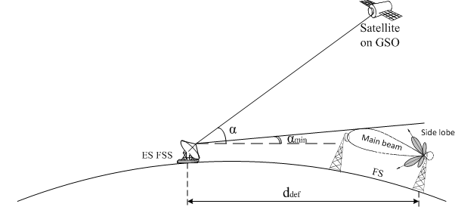

### A1-2.1.2 Methodology

FS station characteristics and protection criteria are presented in Recommendation ITU-R F.758-5, Table 4.

Calculation of the minimum required values of main losses and evaluation of the required protection distances was carried out under the following assumptions. Earth station of the 1st, 2nd, 3rd and 4-th types (Section 2) are used and the maximum e.i.r.p. spectral density of FSS earth station is 10 dB(W/Hz) or 70 dB(W/MHz), FSS earth station antenna gain is indicated in Recommendation ITU-R S.580‑6 and ITU-R S.465, as appropriate the minimum antenna elevation angle of FSS earth station is 10 degrees. The FS station parameters are determined in Recommendation ITU-R F.758-5 (Table 4), FS station antenna pattern is specified in Recommendation ITU-R F.1245 and the study considers 2 types of FS antenna: FS of 1st type and FS of 2nd type. FS station of 2nd type has a very narrow antenna pattern: about 0.6 deg at the level of 3 dB; therefore, the probability of interfering into the main lobe is very low and the calculations take into account interference falling into the side lobes of FS station 2nd type antenna pattern, in particular in the first side lobe as a worst case (in accordance with Recommendation ITU-R F.1245 *G1=2+15log(D/λ)=32.6* dBi). The protection criterion I/N ≤ –10 dB is used as specified in Recommendation ITU-R F.758-5 for determining compatibility between primary services. It should be noted that this criterion is valid for the aggregate interference caused by all FSS earth station operating co-frequency and in the areas of the affected FS stations. Therefore, the permissible interference criterion for one interfering FSS station can be more stringent.

The additional FSS system characteristic planned for operation in the considered frequency band are required for defining the permissible interference and protection distances in the two-way interference scenario. The time percentage for long-term interference is *p*=20%.

For defining the protection distances, depending on the required propagation losses evaluated by the methodology of Recommendation ITU-R P.452-14, the following assumptions were taken. The average radio-refractive index lapse-rate through the lowest of the atmosphere ΔN=50,   
the sea-level surface refractivity N0=329, frequency 8.45 GHz, FSS earth station 1st type antenna center height above the terrain hES1=10 m, antenna height of other earth station types hES=5 m, antenna center height of FS receive station hFS=15 m. The calculations were carried out for plain surface not taking into account the path profile of the interfering signal.

The calculation of the required path losses and evaluation of the required protection distance for earth station 1st type (antenna diameter=18 m) are given in the following table:

|  |  |  |  |  |  |
| --- | --- | --- | --- | --- | --- |
| α,  deg. | e.i.r.p. spectral density (α),  dB (W/MHz) | Gr,  dBi | Pi,  dB (W/MHz) | Lb(20%),  dB | d(20%),  km |
| 10 | 12 | 12 | –151.5 | 175.5 | **45.5** |
| 20 | 4.5 | 168 | **39.5** |
| 30 | 3 | 166.5 | **38.4** |
| 40 | 0 | 163.5 | **36.6** |
| 50 | –2 | 161.5 | **35.4** |
| 10 | 12 | 32.6 | 196.1 | **68.2** |
| 20 | 4.5 | 188.6 | **57.6** |
| 30 | 3 | 187.1 | **56.3** |
| 40 | 0 | 184.1 | **53.2** |
| 50 | -2 | 182.1 | **51.3** |

The calculation of the required path losses and evaluation of the required protection distance for earth station 2nd type (Dant antenna diameter =11 m).

|  |  |  |  |  |  |
| --- | --- | --- | --- | --- | --- |
| α,  deg. | e.i.r.p. spectral density (α), dB (W/MHz) | Gr,  dBi | Pi,  dB (W/MHz) | Lb(20%),  dB | d(20%),  km |
| 10 | 16 | 12 | –151.5 | 179.5 | **46** |
| 20 | 8.5 | 172 | **39.6** |
| 30 | 7 | 170.5 | **38.4** |
| 40 | 4 | 167.5 | **36.2** |
| 50 | 2 | 165.5 | **34.7** |
| 10 | 16 | 32.6 | 200.1 | **82.5** |
| 20 | 8.5 | 192.6 | **59.8** |
| 30 | 7 | 191.1 | **58** |
| 40 | 4 | 188.1 | **54.5** |
| 50 | 2 | 186.1 | **52.3** |

The calculation of the required path losses and evaluation of the required protection distance for earth station 2nd type (Dant=5 m).

|  |  |  |  |  |  |
| --- | --- | --- | --- | --- | --- |
| α, deg. | e.i.r.p. spectral density (α), dB (W/MHz) | Gr, dBi | Pi, dB (W/MHz) | Lb(20%), dB | d(20%), km |
| 10 | 23 | 12 | –151.5 | 186.5 | **52.7** |
| 20 | 15.5 | 179 | **45.6** |
| 30 | 14 | 177.5 | **44.3** |
| 40 | 11 | 174.5 | **41.6** |
| 50 | 9 | 172.5 | **40** |
| 10 | 23 | 32.6 | 207.1 | **127.5** |
| 20 | 15.5 | 199.6 | **79.5** |
| 30 | 14 | 198.1 | **72.5** |
| 40 | 11 | 195.1 | **64** |
| 50 | 9 | 193.1 | **60.5** |

The calculation of the required path losses and evaluation of the required protection distance for earth station 3rd type (Dant=2.5 m).

|  |  |  |  |  |  |
| --- | --- | --- | --- | --- | --- |
| α,  deg. | e.i.r.p. spectral density (α),  dB (W/MHz) | Gr,  dBi | Pi,  dB (W/MHz) | Lb(20%),  dB | d(20%),  km |
| 10 | 29 | 12 | –151.5 | 192.5 | **59.7** |
| 20 | 21.5 | 185 | **51.8** |
| 30 | 20 | 183.5 | **49.75** |
| 40 | 17 | 180.5 | **46.9** |
| 50 | 15 | 178.5 | **45.1** |
| 10 | 29 | 32.6 | 213.1 | **174** |
| 20 | 21.5 | 205.6 | **117** |
| 30 | 20 | 204.1 | **107** |
| 40 | 17 | 201.1 | **88** |
| 50 | 15 | 199.1 | **77** |

The calculation of the required path losses and evaluation of the required protection distance for earth station 4-th type (Dant=1.5 m).

|  |  |  |  |  |  |
| --- | --- | --- | --- | --- | --- |
| α,  deg. | e.i.r.p. spectral density (α),  dB (W/MHz) | Gr,  dBi | Pi,  dB (W/MHz) | Lb(20%),  dB | d(20%),  km |
| 10 | 37 | 12 | –151.5 | 200.5 | **84.5** |
| 20 | 29.5 | 193 | **60.4** |
| 30 | 25 | 188.5 | **55** |
| 40 | 22 | 185.5 | **51.8** |
| 50 | 20 | 183.5 | **49.75** |
| 10 | 37 | 32.6 | 221.1 | **245.5** |
| 20 | 29.5 | 213.6 | **178.5** |
| 30 | 25 | 209.1 | **142.5** |
| 40 | 22 | 206.1 | **120.5** |
| 50 | 20 | 204.1 | **107** |

# A1-3 FSS (Earth-to-space) and fixed wireless systems

The received interference power spectral density at the receiver of fixed wireless system (FWS) from the emission of the FSS earth station is calculated using the following formula.

*Pr = Pt + Gt (θt) – Lb(p%) + Gr(θr)*

where:

Pt : Transmitter power spectral density of FSS earth station (dBW/MHz);

Gt (θt) : Antenna gain of FSS earth station towards FWS (dBi);

θt : Angle between the main emission of FSS earth station and interference reception (degrees);

Gr (θr): Antenna gain of FWS towards FSS earth station (dBi);

θr : Angle between the main beam of FWS receiving antenna and interference source (degrees);

Lb ( p%): Path loss level not exceeded for p% time (dB).

In order to evaluate if the received interference power spectral density at the receiver of the FWS from the emission of FSS earth station can meet the protection criterion of the FWS, *Lb* (*p*%) is calculated to get the required protection distance between interfering FSS earth station and FWS receiver. The required protection distance is determined based on the path loss indicated in the methodology given in Recommendation ITU-R P.452-14 with flat terrain.

The effect of interference on terrestrial and space systems often needs to be assessed by considering long- and short-term interference criteria. These criteria are generally represented by   
a permissible interference power not to be exceeded for more than a specified percentage of time. Generally, when *p* is a small percentage of the time, in the range 0.001% to 1.0%, the interference is referred to as “short-term” and if *p* ≥ 20%, it is referred to as “long-term.”

## A1-3.1 Long-term analysis

The long-term interference criterion (typically associated with percentages of time ≥ 20%) allows the error performance objective (for digital systems) or noise performance objective (for analogue systems) to be met. This criterion will generally represent a low level of interference and hence require a high degree of isolation between the coordinating earth station and terrestrial stations, or other receiving earth stations operating in bidirectionally allocated bands.

If FSS in the Earth-to-space direction is to be introduced into bands already heavily used, aggregate interference impacts on the existing services in the bands should be considered as appropriate. I/N values for long-term interference of –6 dB or –10 dB, as appropriate, may be applicable where the risk of simultaneous interference from the stations of the other co-primary allocations is negligible and in other cases, a more stringent criterion may be required to account for aggregate interference from all interfering co-primary services.

Based on Recommendation ITU-R F.1094-2, it is possible to apportion allowable interference in digital FWS to the FS, to other co-primary services, and to other emissions respectively as   
X = 89 %, Y = 10 % and Z = 1 % of the total interference allowance. Allowing 20 % degradation due to total interference, this means that the allowance for other co‑primary services is 2 % of the error performance objectives. If only FSS is considered as co‑primary service in the band, the FSS portion would then be 2 % of the error performance objective, leading to an allowable I/N of −17 dB. If another or two other co-primary service(s), i.e. MS or/and SRS (space-to-Earth) is/are considered as co-primary service(s) in the band, the FSS portion would be 1 % or 0.67 %, leading to an allowable I/N of –20 dB or –21.7 dB.

For long-term analysis, *Lb* (20%) is calculated to find the required separation distance to meet   
the long-term interference criteria. The calculation results are summarized in the following table. In the calculation, the maximum transmitting e.i.r.p. spectral density of earth station is limited to 70 dBW/MHz.

TABLE 3.1-1

**Results of long-term analysis**

|  |  |  |  |  |  |  |  |  |  |  |  |  |  |  |  |  |
| --- | --- | --- | --- | --- | --- | --- | --- | --- | --- | --- | --- | --- | --- | --- | --- | --- |
| Calculation item | Unit | Earth station Type 1 | | | Earth station Type 2 | | | Earth station Type 3 | | | Earth station Type 4 | | | Earth station Type 5 | | |
| Calculated interference power spectral density | dBW/ MHz | 41.6 | | | 45.6 | | | 52.6 | | | 58.6 | | | 70.3 | | |
| Allowable I/N | dB | –17 | –20 | –21.7 | –17 | –20 | –21.7 | –17 | –20 | –21.7 | –17 | –20 | –21.7 | –17 | –20 | –21.7 |
| FWS  long-term interference criteria | dBW/ MHz | -158.5 | -161.5 | -163.2 | -158.5 | -161.5 | -163.2 | -158.5 | -161.5 | -163.2 | -158.5 | -161.5 | -163.2 | -158.5 | -161.5 | -163.2 |
| Required attenuation | dB | 200.1 | 203.1 | 204.8 | 204.1 | 207.1 | 208.8 | 211.1 | 214.1 | 215.8 | 217.1 | 220.1 | 221.8 | 228.8 | 231.8 | 233.5 |
| Required distance | km | 83.5 | 87.5 | 90.4 | 89.0 | 96.6 | 105.4 | 120.0 | 141.2 | 153.9 | 164.1 | 188.4 | 202.8 | 264.3 | 293.0 | 309.6 |

## A1-3.2 Short-term analysis

The short-term criterion is a higher level of interference, typically associated with time percentages in the range 0.001% to 1% of time, which will either make the interfered-with system unavailable, or cause its specified short-term interference objectives (error rate or noise) to be exceeded.

Appendix **7** to the Radio Regulations addresses the protection provided by the short-term criterion. Since currently there is no criterion of permissible interference power at the terrestrial station in the band 8.4-8.5 GHz, it is assumed that the same criterion applied to the adjacent band 7.9-8.4 GHz which is –149 dBW/MHz at the input of FWS receiving antenna where antenna gain is 46 dBi and no cable loss is included.

For short-term analysis, *Lb* (0.0025%) is calculated to find the required separation distance to meet the protection criterion. The calculation results are summarized in the following table. As in the calculation for long-term analysis, the maximum transmitting e.i.r.p. spectral density of earth station is limited to 70 dBW/MHz.

TABLE 3.2-1

**Results of short-term analysis**

|  |  |  |  |  |  |  |
| --- | --- | --- | --- | --- | --- | --- |
| **Calculation item** | **Unit** | **Type 1** | **Type 2** | **Type 3** | **Type 4** | **Type 5** |
| Calculated interference power spectral density | dBW/MHz | 12.0 | 16.0 | 23.0 | 29.0 | 40.7 |
| FWS  short-term interference level | dBW/MHz | –149.0 | –149.0 | –149.0 | –149.0 | –149.0 |
| Required attenuation | dB | 161.0 | 165.0 | 172.0 | 178.0 | 189.7 |
| Required distance | km | 211.5 | 246.9 | 310.5 | 353.8 | 426 |

**A1-3.3 Conclusions**

It can be considered that FSS earth station of Types 1 and 2 may be compatible with FWS at the distances around 100 km, i.e., 83.5 km to 105.4 km. For other types of FSS earth station, greater distances over 120 km are required to meet the long-term interference level at the FWS.

In order to meet short-term interference level at FWS, distances of 211.5 km to 426 km are required, which are greater than those for long-term analysis.

The results show that the required separation varies up to a few hundreds kilometers if all types of FSS earth station will be deployed. The required separation distance for short-term analysis is greater than that for long-term analysis, which leads to the conclusion that if the short-term criterion is satisfied, then any associated long-term criteria may also be satisfied.

If actual path profile is applied for the calculation, the required distance could be reduced due to natural and artificial obstacles. Thus in actual case, the distance between FSS earth station and FWS will be less than the calculated results.

______________

1. * Transmit e.i.r.p. spectral density limit in a 10 MHz bandwidth = minimum between (Transmit effective isotropic radiated power e.i.r.p.) and (Transmit e.i.r.p. spectral density limit per Hz +10 log (10 MHz)).