|  |  |
| --- | --- |
| **World Radiocommunication Conference (WRC-15) Geneva, 2–27 November 2015** |  |
| **INTERNATIONAL TELECOMMUNICATION UNION** |  |
|  |  |
| PLENARY MEETING | **Addendum 5 to Document 130-E** |
|  | **16 October 2015** |
|  | **Original: English** |
|  | |
| Angola (Republic of)/Botswana (Republic of)/Lesotho (Kingdom of)/ Madagascar (Republic of)/Malawi/Mauritius (Republic of)/ Mozambique (Republic of)/Namibia (Republic of)/Democratic Republic  of the Congo/Seychelles (Republic of)/South Africa (Republic of)/ Swaziland (Kingdom of)/Tanzania (United Republic of)/ Zambia (Republic of)/Zimbabwe (Republic of) | |
| Proposals for the work of the conference | |
|  | |
| Agenda item 1.5 | |

1.5 to consider the use of frequency bands allocated to the fixed-satellite service not subject to Appendices **30**, **30A** and **30B** for the control and non-payload communications of unmanned aircraft systems (UAS) in non-segregated airspaces, in accordance with Resolution **153 (WRC‑12)**;

Introduction

An unmanned aircraft system (UAS) consist of a geostationary satellite operated in FSS frequency bands, an UA with an earth station on board to interconnect the communication link between this UA and associated remote earth station, called “unmanned aircraft control station” (UACS). UA are aircraft that do not carry a human pilot but that are piloted remotely, i.e. through a reliable communication link from outside the aircraft. UAS operations up to now have been limited to segregated airspace using FSS links under RR No. 4.4. However, it is planned to expand UAS deployment outside of segregated airspace.

Report ITU-R M.2171 identified the spectrum requirements for unmanned aircraft (UA) command and non-payload communication (CNPC) that would be needed to support flight through nonsegregated airspace. Those requirements identified the need for both line of sight (LOS) and beyond line of sight (BLOS) spectrum. While the LOS requirements were addressed at the last World Radiocommunication Conference held in 2012 the BLOS requirements were only partially addressed.

Agenda item 1.5 was therefore established to investigate whether fixed-satellite service (FSS) networks, not subject to Appendix 30, 30A and 30B could be used to provide additional capacity for UA CNPC links.

Proposal

The SADC member states support Method A option 1 Resolution of the CPM Report, which proposes to enable the use of Fixed Satellite Service spectrum for control and non-payload communications by unmanned aircraft systems in accordance with ICAO standards and procedures.

**Reasons:** Results contained in the DRAFT NEW REPORT ITU-R M.[UAS-FSS] indicate that studies on compatibility and sharing betwwen UAs and incumbent systems in the FSS band are complete and that the systems are compatible. The UAs can therefore use FSS bands that are not subject to Appendices 30, 30A and 30B which show favourable sharing and compatibility results. Futhermore the Iternational Civial Authority Organisation , ICAO also support the same method. This method will allow ICAO to continue with work on Standards and Recommended Procedures, SARPs, for intergation of UAs into un-segregated airspaces while the ITU will satisfy the technical and regulatory requirement set by ICAO.

ARTICLE 5

Frequency allocations

Section IV – Table of Frequency Allocations  
(See No. 2.1)

MOD AGL/BOT/LSO/MDG/MWI/MAU/MOZ/NMB/COD/SEY/AFS/SWZ/TZA/ZMB/  
ZWE/130A5/1

14-15.4 GHz

|  |  |  |
| --- | --- | --- |
| Allocation to services | | |
| Region 1 | Region 2 | Region 3 |
| 14-14.25 FIXED-SATELLITE (Earth-to-space) 5.457A 5.457B 5.484A     5.506 5.506B ADD 5.A15  RADIONAVIGATION 5.504  Mobile-satellite (Earth-to-space) 5.504B 5.504C 5.506A  Space research  5.504A 5.505 | | |

NOTE: The footnote in the example above could be applied to those frequency bands allocated to the FSS and not subject to RR Appendix **30**, **30A**, or **30B** for which studies have been conducted in the frequency ranges 10.95-14.5 GHz, 17.8-20.2 GHz and 27.5-30 GHz.

ADD AGL/BOT/LSO/MDG/MWI/MAU/MOZ/NMB/COD/SEY/AFS/SWZ/TZA/ZMB/  
ZWE/130A5/2

5.A15 Resolution **[130A5-A15-FSS-UA-CNPC] (WRC-15)** shall apply.     (WRC-15)

ADD AGL/BOT/LSO/MDG/MWI/MAU/MOZ/NMB/COD/SEY/AFS/SWZ/TZA/ZMB/  
ZWE/130A5/3

Draft New Resolution [130A5-A15-FSS-UA-CNPC] (wrc-15)

Provision related to earth stations on board unmanned aircraft which operate with geostationary satellites in the fixed-satellite service for the control and  
non-payload communications of unmanned aircraft systems  
in non-segregated airspaces

The World Radiocommunication Conference (Geneva, 2015),

considering

*a)* that worldwide use of unmanned aircraft systems (UAS) is expected to increase significantly in the near future;

*b)* that unmanned aircraft (UA) need to operate seamlessly with piloted aircraft in non-segregated airspace;

*c)* that the operation of UAS in non-segregated airspace requires reliable communication links, in particular to relay the air traffic control communications and for the remote pilot to control the flight;

*d)* that there is a demand for the control of unmanned aircraft systems (UAS) via satellite communication networks to relay control and non-payload communications (CNPC) beyond the horizon while operating in non-segregated airspace as shown in Annex 2;

*e)* that there is a need to provide internationally harmonized use of spectrum for UA CNPC application;

*f)* that the use of fixed-satellite service (FSS) frequency assignments by UAS CNPC links should take into account their Article **11** notification status,

considering further

*a)* that there is a need to limit the number of communication equipment on board a UA;

*b)* that, as a dedicated satellite system for UAS is not likely to be implemented, it is necessary to take into account the existing and future satellite systems to accommodate the growth of the use of UAS;

*c)* that there are various technical methods that may be used to increase the reliability of digital communication links, e.g. modulation, coding, redundancy, etc., that can be used to ensure safe operations of UAS in non-segregated airspace;

*d)* that for UAS communications used for the control of UA, relay of air traffic control (ATC) voice communications, and sense and avoid, relate to the safe operation of UAS and have certain technical, operational, and regulatory requirements;

*e)* that the requirements in *considering further d)* can be specified for UAS use of FSS networks,

noting

*a)* that Report ITU‑R M.2171 provides information on the vast number of applications for unmanned aircraft which need the access to non-segregated airspaces;

*b)* that Recommendation **724 (WRC‑07)** notes that FSS is not, intrinsically, a safety service,

recognizing

*a)* that appropriate technical, operational and regulatory provisions can be taken in the ITU‑R such that UAS CNPC links operate safely;

*b)* that the UAS CNPC links shall be operated in accordance with procedures established by the International Civil Aviation Organization (ICAO),

resolves

1 that UA control and non-payload communication shall operate under the regulatory and operational provisions contained in Annex 1;

2 that earth stations on unmanned aircraft can communicate with a space station operating in the fixed-satellite service;

3 that the operation of an earth station on an unmanned aircraft when communicating with stations of the fixed-satellite service meet the sharing environment and regulatory provisions applicable to FSS, thus not creating more interference than the notified FSS assignments under the UAS CNPC links would operate, and not requesting more protection from interference than the associated notified FSS assignment;

4 that the FSS stations operating in frequency bands supporting these CNPC links shall conform to the applicable technical provisions of the Radio Regulations,

encourages concerned administrations

to cooperate with administrations which license UA CNPC while seeking agreement under the above-mentioned provisions,

instructs the Secretary-General

to bring this Resolution to the attention of the ICAO.

Annex 1 to Resolution [130A5-A15-FSS-UA-CNPC] (WRC-15)

Regulatory and operational provisions for UA CNPC links operating  
through satellite systems operated in the FSS frequency bands

1 It is anticipated that ICAO will develop associated standards and recommended practices (SARPs), taking into account the above.

2 Conformity with the Radio Regulations is ensured by application of Articles **9** and **11**. In the course of this action, the BR always checks the consistency of any frequency assignment with the relevant technical and regulatory provisions contained in the RR, thus any UAS CNPC link will operate under the protection provided by the registered FSS frequency assignments.

3 FSS frequencies used for UAS will use frequency assignments that are “successfully coordinated”. Satellite operators and administrations are required to carry out coordination of their FSS frequency assignments in accordance with the provisions contained in Article **9** of the Radio Regulations. The application of such provisions ensures that FSS frequency assignments can operate free from harmful interference caused by and to other systems. The efficiency of those rules is proven by the fact that FSS frequency assignments have been successfully operated for many years.

4 When the coordination process is completed, the BR will be notified (according to the provisions of Article **11**) by the administration proposing the new system and the frequency assignments will be recorded in the MIFR. If a frequency assignment is recorded in the MIFR under No. **11.41**, such an assignment is still entitled to protect and be protected against frequency assignments of other networks with which coordination has been successfully completed. The FSS operator then has to make sure that the outstanding coordination issues are examined to determine if UAS CNPC operations can take place within the ICAO SARPs requirements. This would be done for example by determining whether the affected network with which coordination has not been achieved is actually in operation and if so what the operational parameters are (e.g. orbital location and filed power levels) to ensure that any resultant impact would be acceptable.

5 Predicting interference risks, planning solutions for potential interference scenarios, adopting measures to solve the interference issues and reporting on the interference cases, are elements which are well known to FSS operators and which should be included in the specific agreements between FSS operators and UAS operators with guidance from Aviation Authorities (some of which could be included in SARPs).

6 Innovative ways to detect and prosecute the interference cases are being developed nowadays at international level, in order to gain further experience and contribute to harmonized and transparent reporting mechanisms of interference cases.

7 ITU and ICAO will carry out their mutual responsibilities in a cooperative manner. It is important that the respective roles of ICAO and ITU be fully understood to ensure appropriate separation of regulatory needs to be addressed in the Radio Regulations and operational issues to be addressed by ICAO processes. In this context, ITU will develop the typical conditions for operation of CNPC links, and then, ICAO will develop further operational conditions to ensure safe operation.

FIGURE 1

Typical BLoS CNPC links in an unmanned aircraft system

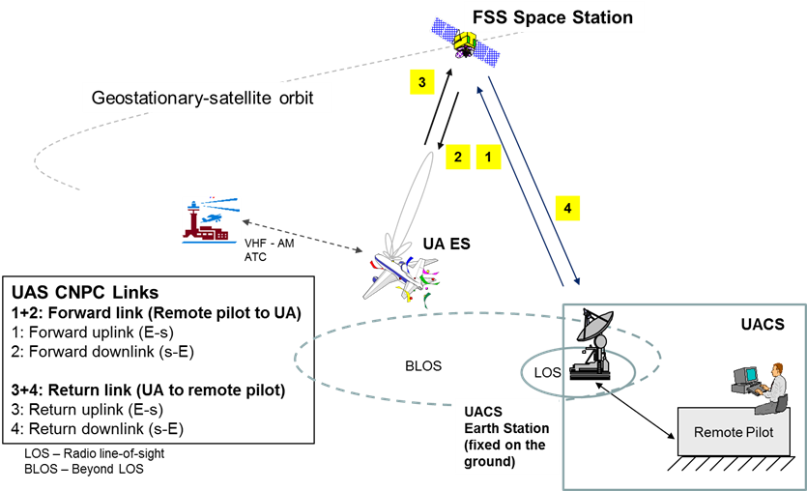

The forward and return (UAS) links via an FSS network

______________