|  |  |
| --- | --- |
| **World Radiocommunication Conference (WRC-19) Sharm el-Sheikh, Egypt, 28 October – 22 November 2019** |  |
|  |  |
|  |  |
| PLENARY MEETING | **Addendum 6 to Document 14-E** |
|  | **4 October 2019** |
|  | **Original: English** |
|  | |
| Canada | |
| Proposals for the work of the conference | |
|  | |
| Agenda item 1.6 | |

1.6 to consider the development of a regulatory framework for non-GSO FSS satellite systems that may operate in the frequency bands 37.5-39.5 GHz (space-to-Earth), 39.5-42.5 GHz (space-to-Earth), 47.2-50.2 GHz (Earth-to-space) and 50.4-51.4 GHz (Earth-to-space), in accordance with Resolution **159 (WRC-15)**;

Introduction

Canada supports the Inter-American Proposal for agenda item 1.6 submitted by the Inter-American Telecommunication Commission (CITEL), that proposes the development of a regulatory framework for non-GSO FSS satellite systems that may operate in the frequency bands 37.5‑39.5 GHz (space-to-Earth), 39.5‑42.5 GHz (space-to-Earth), 47.2-50.2 GHz (Earth-to-space) and 50.4‑51.4 GHz (Earth-to-space).

However, in order to facilitate compatibility between non-GSO FSS in the frequency bands 49.7‑50.2 GHz and 50.4-50.9 GHz and EESS (passive) in the frequency band 50.2‑50.4 GHz, Canada has carried out additional studies to consider the use of mitigation techniques by FSS systems. Based on these studies, mitigation techniques may be employed, which could allow the use of power levels in the frequency band 50.2-50.4 GHz higher than the proposed revised limits in Resolution **750**, while simultaneously providing the level of protection for EESS (passive) as defined in Recommendation ITU‑R RS.2017. As such, Canada proposes a new draft Resolution with an Annex on mitigation measures to supplement to the limits in Resolution **750**.

With respect to the proposed limits contained in the Inter-American Proposal for agenda item 1.6, Canada has further considered the issue of whether additional limits to address the effect of aggregate interference from ubiquitously deployed non‑GSO user terminals are required. Canada proposes that the Resolution **750** limits given in the Inter-American Proposal for the bands 49.7-50.2 GHz and 50.4-50.9 GHz be tightened by 5 dB for user terminals to account for this effect.

The following proposals complement the proposals in Addendum 6 to Document 11. Canada’s proposed changes to Resolution **750** are highlighted in yellow. Supporting material is also included as an attachment to this document for information.

MOD CAN/14A6/1

RESOLUTION 750 (Rev.WRC‑19)

Compatibility between the Earth exploration-satellite service (passive) and relevant active services

The World Radiocommunication Conference (Sharm el-Sheikh, 2019),

...

TABLE 1-1

|  |  |  |  |
| --- | --- | --- | --- |
| EESS (passive) band | Active service band | Active service | Limits of unwanted emission power from active service stations in a specified bandwidth within the EESS (passive) band1 |
| 1 400- 1 427 MHz | 1 427- 1 452 MHz | Mobile | −72 dBW in the 27 MHz of the EESS (passive) band for IMT base stations  −62 dBW in the 27 MHz of the EESS (passive) band for IMT mobile stations2, 3 |
| 23.6-24.0 GHz | 22.55-23.55 GHz | Inter-satellite | −36 dBW in any 200 MHz of the EESS (passive) band for non-geostationary (non-GSO) inter-satellite service (ISS) systems for which complete advance publication information is received by the Bureau before 1 January 2020, and −46 dBW in any 200 MHz of the EESS (passive) band for non-GSO ISS systems for which complete advance publication information is received by the Bureau on or after 1 January 2020 |
| 31.3-31.5 GHz | 31-31.3 GHz | Fixed (excluding HAPS) | For stations brought into use after 1 January 2012: −38 dBW in any 100 MHz of the EESS (passive) band. This limit does not apply to stations that have been authorized prior to 1 January 2012 |

|  |  |  |  |
| --- | --- | --- | --- |
| 50.2-50.4 GHz | 49.7-50.2 GHz | Fixed-satellite GSO (E‑to‑s)4 | For GSO stations brought into use after the date of entry into force of the Final Acts of WRC‑07 and brought into use prior to 1 January 2024:  −10 dBW into the 200 MHz of the EESS (passive) band for earth stations having an antenna gain greater than or equal to 57 dBi  −20 dBW into the 200 MHz of the EESS (passive) band for earth stations having an antenna gain less than 57 dBi  For GSO stations brought into use on or after 1 January 2024:  -25 dBW into the 200 MHz of the EESS (passive) band for stations with elevations angles less than 80°  -45 dBW into the 200 MHz of the EESS (passive) band for stations with elevations angles greater than or equal to 80° |
| 50.2-50.4 GHz | 49.7-50.2 GHz | Fixed-satellite non-GSO (E‑to‑s)4 | For non-GSO stations brought into use after the date of entry into force of the Final Acts of WRC‑07 and brought into use before the date of entry into force of the Final Acts of WRC‑19:  −10 dBW into the 200 MHz of the EESS (passive) band for earth stations having an antenna gain greater than or equal to 57 dBi  −20 dBW into the 200 MHz of the EESS (passive) band for earth stations having an antenna gain less than 57 dBi  For non-GSO stations brought into use on or after the date of entry into force of the Final Acts of WRC‑19:  -35 dBW into the 200 MHz of the EESS (passive) band for stations having an antenna gain greater than 57 dBi.  -40 dBW into the 200 MHz of the EESS (passive) band for stations having an antenna gain less than 57 dBi.  Resolution [AI 1.6 EESS] (WRC-19) applies. |

|  |  |  |  |
| --- | --- | --- | --- |
| 50.2-50.4 GHz | 50.4-50.9 GHz | Fixed-satellite GSO (E‑to‑s)4 | For GSO stations brought into use after the date of entry into force of the Final Acts of WRC‑07 and brought into use prior to 1 January 2024:  −10 dBW into the 200 MHz of the EESS (passive) band for earth stations having an antenna gain greater than or equal to 57 dBi  −20 dBW into the 200 MHz of the EESS (passive) band for earth stations having an antenna gain less than 57 dBi  For GSO stations brought into use on or after 1 January 2024:-25 dBW into the 200 MHz of the EESS (passive) band for stations with elevations angles less than 80°  -45 dBW into the 200 MHz of the EESS (passive) band for stations with elevations angles greater than or equal to 80° |
| 50.2-50.4 GHz | 50.4-50.9 GHz | Fixed-satellite non-GSO (E‑to‑s)4 | For non-GSO stations brought into use after the date of entry into force of the Final Acts of WRC‑07 and brought into use before the date of entry into force of the Final Acts of WRC‑19:  −10 dBW into the 200 MHz of the EESS (passive) band for earth stations having an antenna gain greater than or equal to 57 dBi  −20 dBW into the 200 MHz of the EESS (passive) band for earth stations having an antenna gain less than 57 dBi  For non-GSO stations brought into use on or after the date of entry into force of the Final Acts of WRC‑19:  -35 dBW into the 200 MHz of the EESS (passive) band for stations having an antenna gain greater than 57 dBi.  -40 dBW into the 200 MHz of the EESS (passive) band for stations having an antenna gain less than 57 dBi.  Resolution [AI 1.6 EESS] (WRC-19) applies. |
| 52.6-54.25 GHz | 51.4-52.6 GHz | Fixed | For stations brought into use after the date of entry into force of the Final Acts of WRC‑07:  −33 dBW in any 100 MHz of the EESS (passive) band |
| 1 The unwanted emission power level is to be understood here as the level measured at the antenna port.  2 This limit does not apply to mobile stations in the IMT systems for which the notification information has been received by the Radiocommunication Bureau by 28 November 2015. For those systems, −60 dBW/27 MHz applies as the recommended value.  3 The unwanted emission power level is to be understood here as the level measured with the mobile station transmitting at an average output power of 15 dBm.  4 The limits apply under clear-sky conditions. During fading conditions, the limits may be exceeded by earth stations when using uplink power control. | | | |

TABLE 1-2

**Reasons:** Studies have shown that GSO FSS systems alone cause exceedance the EESS (passive) protection criteria and that in order to allow the aggregate interference from both GSO and non-GSO FSS stations emission to meet this criteria modifications to the unwanted emission limits for both GSO and non-GSO FSS systems are needed. Since it will be impractical to apply changes to GSO FSS networks that are operational, planned for near term operation or filed, the proposed changes would not apply to any GSO systems brought into use before January 1, 2024.

ADD CAN/14A6/2

Draft New Resolution [CAN/A16 EESS]

Compatibility between the Earth exploration-satellite service in the 50.2 – 50.4 GHz band and non-geostationary satellite systems in the fixed-satellite service in adjacent frequency bands

The World Radiocommunication Conference (Sharm el-Sheikh, 2019),

considering

*a)* that WRC-19 has included in Resolution **750** **(Rev.WRC-19)** some unwanted emission limits for earth stations operating with non-GSO systems to protect earth exploration-satellite service (EESS) (passive) in the 50.2‑50.4 GHz frequency band;

*b)* that mitigation techniques may be envisaged based on the dynamic of the interference, where the unwanted emission limits specified at the antenna input could be relaxed in the interest of both the FSS and the EESS (passive);

*c)* that any viable mitigation technique would require proper implementation to ensure effective protection of EESS (passive);

*d)* that some mitigation techniques require the knowledge of real-time ephemeral data,

recognizing

that for certain EESS satellites, an administration may be unable to provide real-time ephemeral data necessary to allow determination of positioning,

noting

*a)* that Recommendation ITU-R RS.1861 contains typical parameters of sensors operating in the EESS in the 50.2-50.4 GHz frequency band;

*b)* that Recommendation ITU‑R RS.2017 provides the interference criteria for passive sensors operating in the EESS;

*c)* that a mitigation technique is implementable only as long as the integrity of the FSS link can be maintained and the needed end-to-end connectivity can be achieved,

resolves

1 that an administration takes all steps to ensure that earth stations being designed and constructed to operate with a non-geostationary satellite system in the fixed-satellite service (FSS) in the frequency bands 49.7-50.2 GHz and/or 50.4-50.9 GHz meet the interference criteria as stated in Recommendation ITU-R RS.2017 at any space station of the EESS station operating in the frequency band 50.2-50.4 GHz;

2 that in the frequency bands 49.7‑50.2 GHz and 50.4‑50.9 GHz, the limits in Table 1‑1 of Resolution **750 (Rev.WRC-19)** that apply to earth stations of non-GSO systems in the FSS may be exceeded if any viable mitigation measures such as those referred to in the Annex are implemented. In such a case, the notifying administration of the FSS system shall contact the administration operating the EESS (passive) space station to enter into a consultation process on mitigation measures to be used, in order to achieve a mutually acceptable solution;

3 that if no mutually acceptable solution is achieved between the notifying administration of the FSS and the administration operating the EESS (passive), the unwanted emission power limits defined in Resolution **750 (Rev.WRC-19)**  shall apply;

4 that an administration may exercise some flexibility in adopting other mitigation techniques, provided that they develop national regulatory procedures to meet their obligations to achieve the required level of protection to the EESS (passive),

invites administrations

to employ as many interference mitigation techniques, such as those referred to in the Annex, as appropriate for non-geostationary systems in the FSS.

Reasons: To allow for less restrictive power limits to non-geostationary FSS earth stations if mitigation techniques are implemented to adequately protect the EESS (passive).

ANNEX TO RESOLUTION [CAN/A16 EESS] (WRC-19)

Interference mitigation techniques

This Annex lists several possible interference mitigation techniques that may be used, either in combination or independently, depending on the resources of administrations. The use of any or all of these techniques is not mandatory. If no mitigation measures are implemented, the unwanted emission power limits defined in Resolution **750 (Rev.WRC-19)** apply.

# 1 Angle avoidance

Angle avoidance consists in the FSS earth station avoiding normal transmission to an FSS satellite that is within a pre-determined angle with the EESS (passive) spacecraft, as measured at the FSS earth station. During times when orbital geometry results in such inline events, the FSS earth station could either significantly reduce its transmit power to the relevant beam, switch frequencies, or switch to another visible satellite. The ephemeral data of the EESS (passive) spacecraft is required to implement this mitigation technique.

# 2 Power control

Power control consists in reducing the transmit power of the FSS earth station as the associated FSS satellite approaches towards the earth station, to account for the reduction in path loss due to the reduction in distance and the increase of the earth station elevation angle. The reductions of the FSS transmit power of the earth station can ensure a constant power at the satellite receiver while reducing the interference level to other services. This technique does not require the ephemeral data of the EESS (passive) satellites.

# 3 Time window power reduction

This mitigation technique consists in reducing the power at the input to an FSS earth station during time windows when the EESS (passive) sensor is determined to be measuring the area where the FSS earth station is located. An area on the Earth’s surface that circumscribes the footprint of the ESSS (passive) could be implemented to determine when the earth station is required to reduce its power. The ephemeral data of the EESS (passive) spacecraft is required to implement this mitigation technique, and is most effective for EESS (passive) sensors for which the observation area is predictable, such as a push-broom type of sensor.

**Attachment**

Numerous compatibility studies aiming to address WRC-19 AI 1.6 have determined that the current limits on FSS out of band emissions in the 50.2-50.4 GHz band in Resolution **750** **(Rev.WRC-15)** may not be sufficient to satisfy remote sensing performance criteria as per Recommendation ITU-R RS.2017. CPM19-2 notes that “techniques for non-GSO systems aside from an input power limit could also be considered to protect passive sensing while ensuring efficient use of the spectrum.” Accordingly, two examples of studies are presented below for information, which consider additional mitigation techniques designed to reduce adjacent band interference from non-GSO FSS systems into the EESS (passive) in the band 50.2 50.4 GHz. It is noted that different assumptions could also be made, which could alter the results of studies.

Study #1: Assessment of interference in the EESS (passive) band 50.2-50.4 GHz produced by non-GSO FSS networks in the adjacent bands

# 1 Background

This study focuses on the simulation of pushbroom sensors and the modelling of example FSS earth station operations, which entail elevation angle power control. It explores the efficacy of two mitigation techniques that reduce the amount of filtering that could otherwise be required at the input of FSS earth stations:

1) Angular avoidance of the EESS (passive) spacecraft by FSS earth stations, which necessitates the sharing of ephemeral data

2) Reduction of FSS earth station power based on specified time windows, which does not necessitate the sharing of ephemeral data.

## 1.1 Pushbroom Sensor Modelling

The pushbroom sensor has 90 effective sensor beams that are linearly arranged, perpendicular to the ground path of the EESS satellite. The beam pattern of the passive sensor modelled in the study was that of the average antenna pattern of *recommends 1* of Rec. ITU-R RS.1813.

Each beam has an independent gain pattern, which allows 90 independent measurements to be taken simultaneously and this is the primary advantage of a pushbroom sensor. To clarify, the sensor does not behave as though it comprises a single, cross-track receive beam with 90 times the width of a single beam, as this would defeat the purpose of the pushbroom. Instead, a signal radiating directly into beam #0 (traced in red) of Figure 1 would experience 0 dB of rejection when measured by that beam of the EESS sensor, while the same signal would have 12 dB of rejection into beam #1, and 30 dB of rejection into beam #2.

Similarly, an interference source radiating into one beam of the pushbroom will result in differing levels of power into other beams, which will be proportional to the respective amounts of rejection offered by each beam’s angular offset. This is further illustrated in Figure 1 below, wherein an example inline event with an FSS ES in the centre of the circular measurement area (large orange circle) causes high interference power into a single beam of the pushbroom sensor array (this beam is shown as red) and lower power into adjacent beams (12 dB lower is shown as orange and 30 dB is lower shown as yellow). The remaining beams, shown as green, make measurements within the measurement area while being subject to very low levels of interference. The beams outlined in white are taking measurements outside of the measurement area, and as such would not be relevant to the statistical calculations.

Figure 1

Interference event into pushbroom passive sensor, shown as a footprint of 90 beams on Earth’s surface

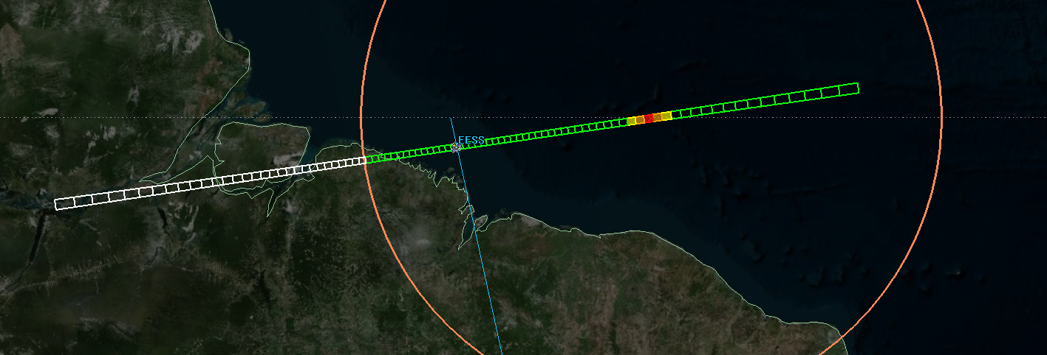

At this particular instant, 60 data points are being taken within the measurement area, 30 data points are being taken outside the measurement area, and one data point in the measurement area is invalidated due to the interference level exceeding the -166 dBW / 200 MHz threshold.

In the context of Recommendation ITU-R RS.2017, it can be stated that of the 60 data points collected within the measurement area, 59 of them, or 98.33%, are accurate (i.e. subject to interference levels below -166 dBW/ 200 MHz). If the simulation comprised this single instant, it would fail the 99.99% performance criteria.

# 2 Non-GSO Dynamic Simulations

It is assumed that non-GSO FSS operations in the bands adjacent to the 50.2-50.4 GHz (passive) band would be very difficult to condense into a single analytical model. Therefore, thorough assessment necessitates a detailed simulation with meaningful representations of non-GSO deployment and operations on a case-by-case basis.

## 2.1 EESS Input Parameters

The EESS (passive) parameters used in this analysis are in Table 1 below. The EESS sensor beams are constrained to only collect data when the beam falls within a circular measurement area of 2,000,000 km2.

TABLE 1

EESS (passive) parameters

|  |  |
| --- | --- |
| Sensor type | Pushbroom |
| Orbit parameters | |
| Altitude | 850 km |
| Inclination | 98° |
| Eccentricity | 0 |
| Repeat period | - |
| Sensor antenna parameters | |
| Number of beams | 90 |
| Reflector diameter | 0.5 m |
| Maximum beam gain | 45 dBi |
| Polarization | H, V |
| −3 dB beamwidth | 1.1° |
| Field of view | ~16 km × 2 282 km |
| Main beam efficiency | - |
| Off-nadir pointing angle | - |
| Beam dynamics | 90 resolution elements per swath |
| Incidence angle at Earth | - |
| –3 dB beam dimensions | ~16 km (at nadir) |
| Swath width | 2 282 km |
| Sensor antenna pattern | See *recommends 1* of Recommendation ITU‑R RS.1813 |

## 2.2 NON-GSO Input Parameters and Operations

The non-GSO gateway system is modelled according to Table 2 below. The simulation includes a single gateway site positioned in the centre of the circular 2,000,000 km2 area. This gateway site has 10 independent antennas that together produce an aggregate source of interfering power to EESS (passive). It is noted that studies may also be done assuming an additional non-GSO FSS gateway within the measurement area, as applicable.

TABLE 2

FSS non-GSO Earth Station Characteristics

|  |  |
| --- | --- |
| Non-GSO Orbit | 1200 km altitude |
| Total Number of NON-GSO Earth Stations Inside the EESS Measurement Area | 1 Gateway Site with 10 Antennas |
| Antenna Diameter | 2 m |
| Antenna Gain | 57 dBi |
| Antenna Pattern | See Rec. ITU‑R S.580*  Sidelobes: 29 – 25*log(θ) |
| Out of Band Uplink Power at Antenna Port | -10 dBW per 200 MHz |
| Minimum Elevation Angle | 15° |

*It is noted that Recommendation ITU‑R S.465 could be more appropriate, however, this would likely not impact the results significantly since both antenna patterns are similar in terms of their contribution to the overall interference.

For ease of simulation, the 10 gateway antennas are assumed to be collocated and pointed along randomly-generated azimuth/elevation angles, with a 15° minimum elevation angle constraint and a non-overlapping constraint. A uniform, random distribution was used as it represents a compromise between longest-hold tracking strategies, which bias the look angles toward lower elevation angles, and highest-elevation tracking strategies, which bias the look angles toward higher elevation angles. For each simulation run the 10 gateway non-GSO earth station antennas are statically pointed and do not move. A total of five analysis runs were performed using five sets of independent, randomly-generated non-GSO earth station azimuths and elevations. The purpose behind randomizing the orientations of the 10 gateways with 5 sets of pointing directions was to capture the possibility of multiple pointing directions due to the motion of the tracking earth stations using the randomization of Az/El vectors for each of the 10 antennas. The process was repeated five 5 times to demonstrate a convergence of the data obtained using the randomization of the pointing vectors. (The interference CDFs in Figures 3 through 7 show the convergence of the interference results where the standard deviation of the level exceeded for 0.01% of the time is less than 2 dB.)

For typical non-GSO FSS operations, maintaining a constant power at the spacecraft receive antenna is ideal. To accomplish this the ES will decrease the power into the antenna port as the receiving non-GSO spacecraft moves from horizon to zenith in order to compensate for the reduction in propagation loss.

The five sets of the randomly-generated ES parameters are shown in Table 3 below. As it can be seen, the maximum allowed power is rarely used at the input of the ES antenna in the analysis.

TABLE 3

Non-GSO Gateway Antenna Pointing Vectors and Input Powers (dBW / 200 MHz)

|  |  |  |  |  |  |  |  |  |  |
| --- | --- | --- | --- | --- | --- | --- | --- | --- | --- |
|  | Az | El | PWR (dBW) |  |  |  | Az | El | PWR (dBW) |
| Set A | | | |  |  | **Set D** | | | |
| Ant. 1 | 92 | 72 | -16.88 |  |  | **Ant. 1** | 13 | 65 | -16.53 |
| Ant. 2 | 252 | 53 | -15.65 |  |  | **Ant. 2** | 337 | 79 | -17.11 |
| Ant. 3 | 346 | 82 | -17.17 |  |  | **Ant. 3** | 273 | 66 | -16.59 |
| Ant. 4 | 50 | 57 | -15.99 |  |  | **Ant. 4** | 142 | 71 | -16.83 |
| Ant. 5 | 93 | 27 | -12.31 |  |  | **Ant. 5** | 62 | 65 | -16.53 |
| Ant. 6 | 92 | 79 | -17.11 |  |  | **Ant. 6** | 12 | 68 | -16.69 |
| Ant. 7 | 88 | 77 | -17.05 |  |  | **Ant. 7** | 17 | 36 | -13.71 |
| Ant. 8 | 126 | 85 | -17.21 |  |  | **Ant. 8** | 297 | 23 | -11.59 |
| Ant. 9 | 91 | 30 | -12.81 |  |  | **Ant. 9** | 115 | 68 | -16.69 |
| Ant. 10 | 171 | 62 | -16.35 |  |  | **Ant. 10** | 13 | 87 | -17.23 |
| Set B | | | |  |  | **Set E** | | | |
| Ant. 1 | 300 | 42 | -14.5 |  |  | **Ant. 1** | 138 | 48 | -15.17 |
| Ant. 2 | 198 | 59 | -16.14 |  |  | **Ant. 2** | 287 | 73 | -16.92 |
| Ant. 3 | 103 | 84 | -17.2 |  |  | **Ant. 3** | 177 | 30 | -12.81 |
| Ant. 4 | 272 | 72 | -16.88 |  |  | **Ant. 4** | 233 | 49 | -15.28 |
| Ant. 5 | 205 | 44 | -14.74 |  |  | **Ant. 5** | 272 | 69 | -16.74 |
| Ant. 6 | 20 | 21 | -11.21 |  |  | **Ant. 6** | 245 | 36 | -13.71 |
| Ant. 7 | 281 | 55 | -15.83 |  |  | **Ant. 7** | 59 | 65 | -16.53 |
| Ant. 8 | 47 | 86 | -17.22 |  |  | **Ant. 8** | 180 | 24 | -11.78 |
| Ant. 9 | 169 | 58 | -16.01 |  |  | **Ant. 9** | 123 | 87 | -17.23 |
| Ant. 10 | 122 | 16 | -10.21 |  |  | **Ant. 10** | 81 | 59 | -16.14 |
| Set C | | | |  |  |  |  |  |  |
| Ant. 1 | 327 | 77 | -17.05 |  |  |  |  |  |  |
| Ant. 2 | 329 | 25 | -11.96 |  |  |  |  |  |  |
| Ant. 3 | 36 | 63 | -16.41 |  |  |  |  |  |  |
| Ant. 4 | 197 | 36 | -13.71 |  |  |  |  |  |  |
| Ant. 5 | 348 | 87 | -17.23 |  |  |  |  |  |  |
| Ant. 6 | 350 | 27 | -12.31 |  |  |  |  |  |  |
| Ant. 7 | 175 | 87 | -17.23 |  |  |  |  |  |  |
| Ant. 8 | 52 | 76 | -17.02 |  |  |  |  |  |  |
| Ant. 9 | 330 | 47 | -15.07 |  |  |  |  |  |  |
| Ant. 10 | 346 | 75 | -16.99 |  |  |  |  |  |  |

## 2.3 Simulation Parameters

Each of the five simulations were run for 12 months, and data was collected using 1 second timesteps. Interference power into each individual beam of the pushbroom sensor was calculated at each time step, provided that the beam’s footprint fell within the measurement area. Typically, this resulted in the collection of over 7.5 million data points per simulation.

## 2.4 Simulation Results

The results of all five simulations are shown in Figures 2-6 below, with interference power in dBW / 200 MHz along the x-axis, and probability of the level being exceeded along the y-axis. The cumulative distribution functions (CDFs) of each of the 90 beams are plotted in multi-colour, and the combined set of all statistically relevant data is plotted in red. This red line represents the CDF of all measurements taken within the measurement area by the pushbroom sensor, and thus fully captures the statistics necessary for assessment against Recommendation ITU-R RS.2017.

The 0.01% threshold interference values of each simulation are highlighted on each of the plots, and are also listed here for convenience: -157.8, -158.1, -162.3, -160.4, -158.3 dBW / 200 MHz. Though this is a limited set of results, a standard deviation of less than 2 dB suggests that the specific orientations of the non-GSO gateway antennas have minimal effect on final results.

The mean value of all five simulations is -159.4 dBW / 200 MHz, exceeding the limit by 6.6 dB.

Figure 2

Interference CDFs for non-GSO ES Set A

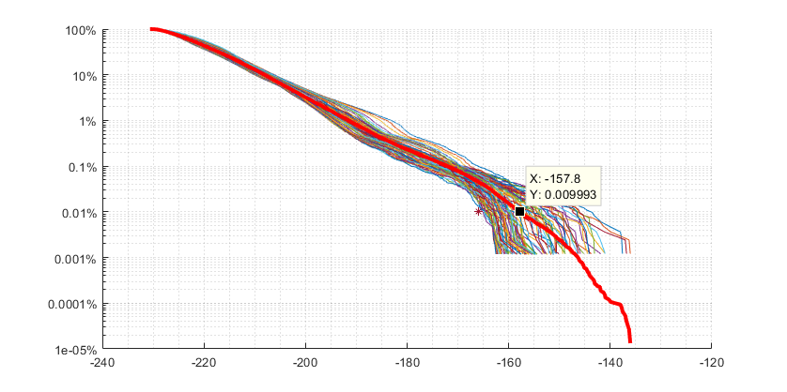

Figure 3

Interference CDFs for non-GSO ES Set B

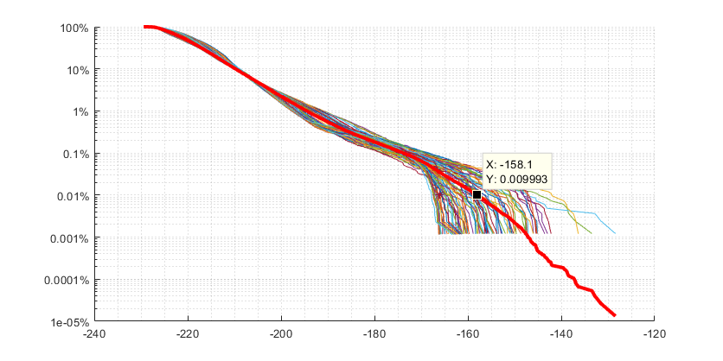

Figure 4

Interference CDFs for non-GSO ES Set C

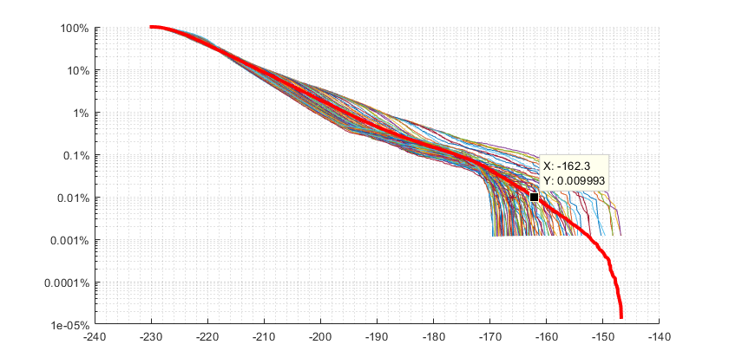

Figure 5

Interference CDFs for non-GSO ES Set D

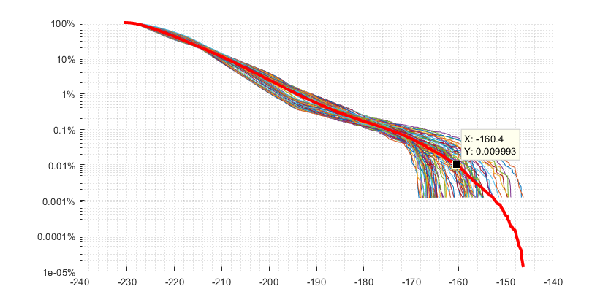

Figure 6

Interference CDFs for non-GSO ES Set E

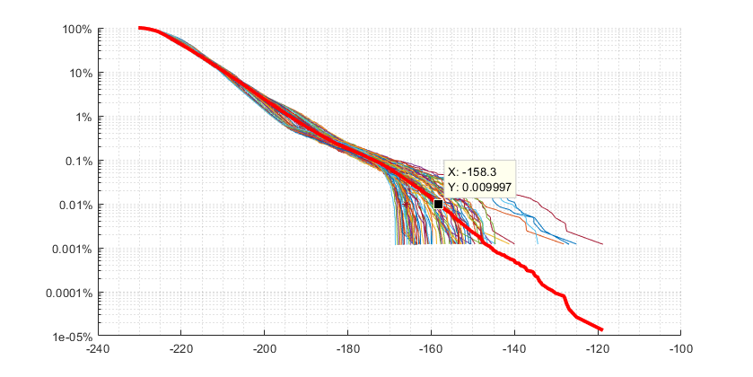

# 3 Mitigation Techniques

Studies and proposals thus far have focused on significant reductions of the power limits into FSS earth station antenna ports as the sole methodology for satisfying Res. **159 (WRC-15)**. While such an implementation may be effective, the proposed power reductions in the FSS bands in order to meet the required limits in the adjacent 50.2 – 50.4 GHz EESS band would prevent the use of a significant portion of the adjacent FSS allocation that is subject to the Resolution **750** limits by the FSS. Additional measures other than filtering may also be considered to protect the EESS (passive) in the adjacent band.

Considering that a pushbroom sensor on-board an EESS (passive) spacecraft in LEO may measure a specific point on Earth’s surface no more than 0.005% of the time, this permanent filtering methodology would seem unnecessarily severe. A possible solution that results in a more equitable and spectrally efficient solution might reduce FSS spectrum availability to around 0.005%. Two such solutions are explored herein.

## 3.1 Angular Avoidance

Given the ephemeral data of relevant EESS (passive) spacecraft, FSS non-GSO operators could implement angular avoidance at their earth stations, exactly as they already do for non-GSO-to-non-GSO coordination and for the protection of GSO FSS. An avoidance angle of 20°, for example, would impact an FSS earth station beam’s availability for about 0.1% of the time, per EESS (passive) spacecraft. During times when orbital geometry results in inline events, FSS operators could either significantly reduce power to the affected earth station beam, switch frequencies, or reorient the antenna.

The following analysis considers the technique of reorienting each interfering FSS earth station antenna in a way that achieves an avoidance angle of 48° with respect to the EESS sensor. In other words, when the EESS (passive) spacecraft is less than 20° from the boresight of an FSS earth station beam, that beam is assumed to be assigned to another FSS spacecraft that is at least 48° away from the EESS (passive) spacecraft as measured at the FSS earth station.

This was simulated by reducing the FSS earth station gain to -10 dBi, the gain value for 48° off of boresight, any time the static pointed station’s beam was within 20° of the EESS sensor. The resulting CDFs are shown below.

Figure 7

Interference CDFs for non-GSO ES Set A, 20° avoidance

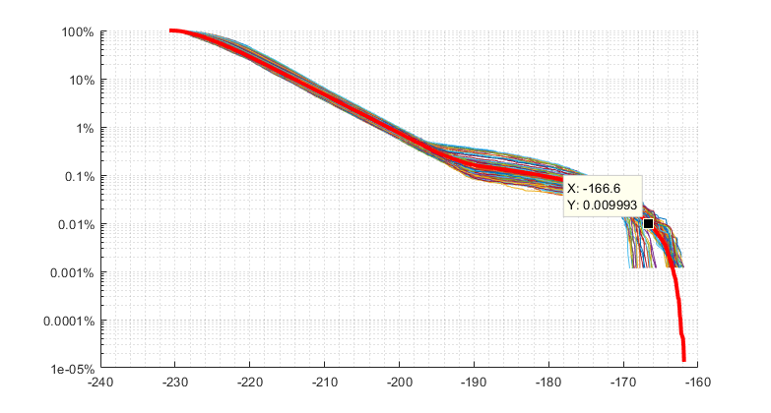

Figure 8

Interference CDFs for non-GSO ES Set B, 20° avoidance

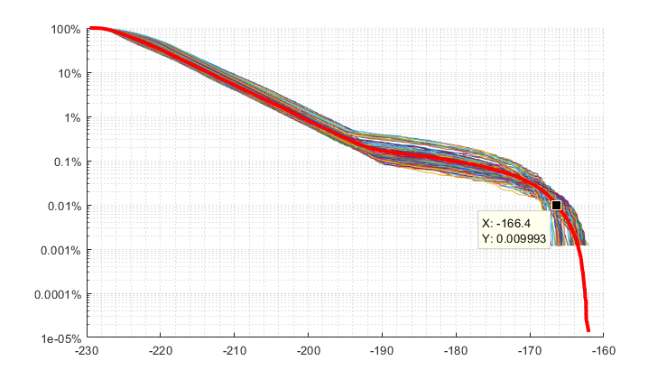

Figure 9

Interference CDFs for non-GSO ES Set C, 20° avoidance

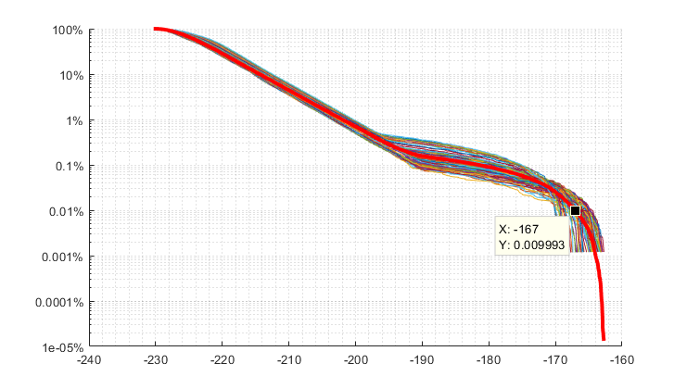

Figure 10

Interference CDFs for non-GSO ES Set D, 20° avoidance

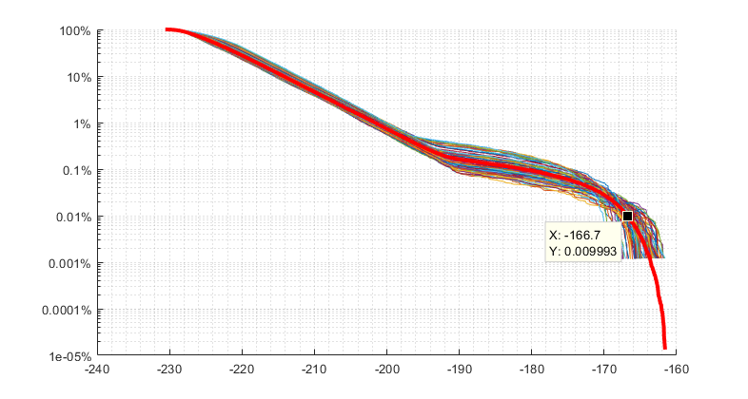

Figure 11

Interference CDFs for non-GSO ES Set E, 20° avoidance

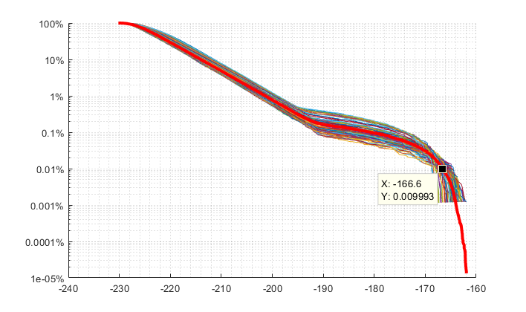

In each case, the angular avoidance technique results in sufficiently protected operations for the EESS (passive) sensor. The resulting mean interference value of -166.7 dBW / 200 MHz implies that this mitigation method, if employed, could ensure the required protection of the EESS (passive) station in this example. If desired, the resulting interference value could be further reduced by increasing the avoidance angle, greatly reducing the antenna input power to the affected FSS earth station beam (instead of reorienting it) during inline events, or having antenna sidelobes on either the FSS earth station or EESS (passive) sensor that perform better than the referenced antenna pattern masks.

## 3.2 Time Window Power Reduction

Alternatively, protection could be enabled by the provision of time windows during which the sensor might be measuring specific regions. During these time windows, non-GSO FSS operators with earth stations in the affected region would reduce the power of said earth stations.

As an example, an EESS (passive) spacecraft with a pushbroom sensor could define an area on Earth’s surface that circumscribes its footprint with an expanded region of ±5° on either side of the pushbroom perpendicular to the satellite path, as depicted by the red outline in Figure 12 below.

Figure 12

5° Protection Box for EESS (passive) Pushbroom Sensor

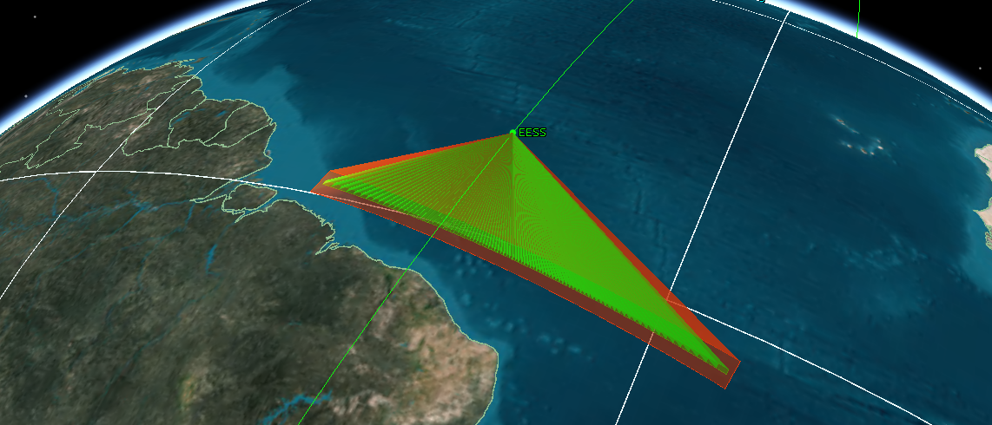

Such a box would pass over a specific point on Earth’s equator about 0.04% of the time, and about 0.07% of the time for a point at 50°N latitude. The box’s shape and size could be specifically tailored by the EESS (passive) service so as to obscure sensor characteristics, if desired.

The following analysis considers the same parameters as the above orbital avoidance, but incorporates the time window power reduction method to protect EESS (passive). When any beam of the pushbroom sensor points within 5° of the FSS earth station, the earth station is required to reduce the power of all beams by 10 dB. The resulting interference CDFs are presented below.

Figure 13

Interference CDFs for non-GSO ES Set A, 5° box provision

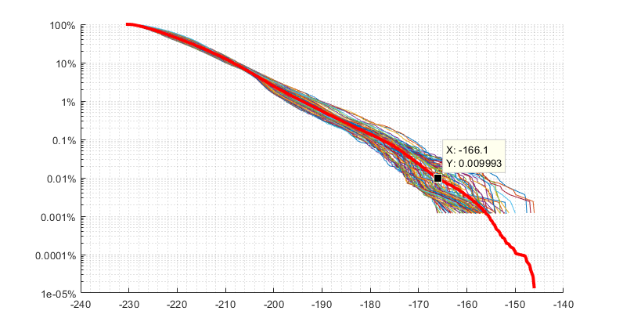

Figure 14

Interference CDFs for non-GSO ES Set B, 5° box provision

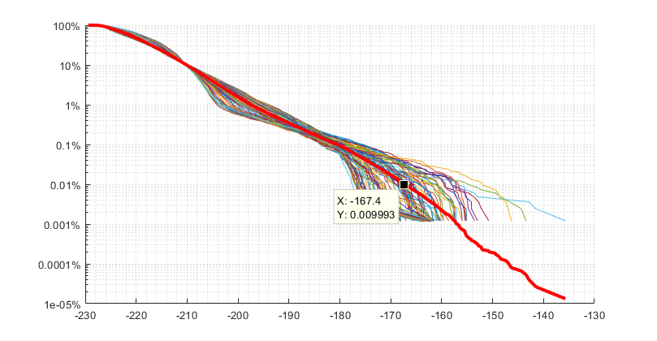

Figure 15

Interference CDFs for non-GSO ES Set C, 5° box provision

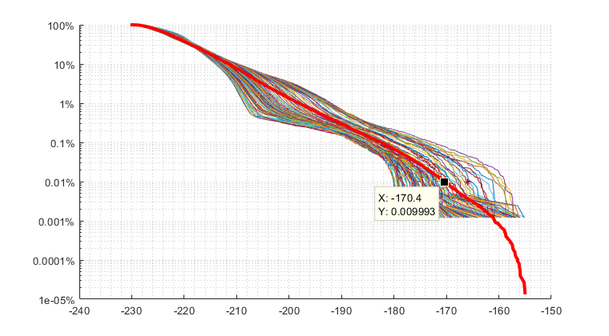

Figure 16

Interference CDFs for non-GSO ES Set D, 5° box provision

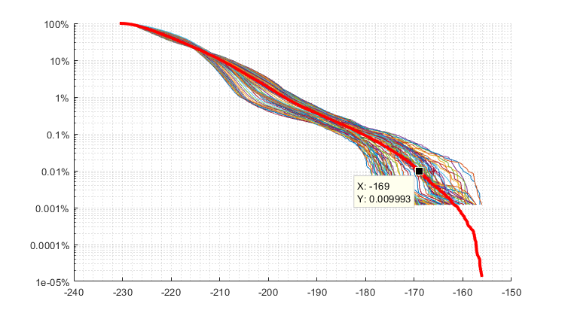

Figure 17

Interference CDFs for non-GSO ES Set E, 5° box provision

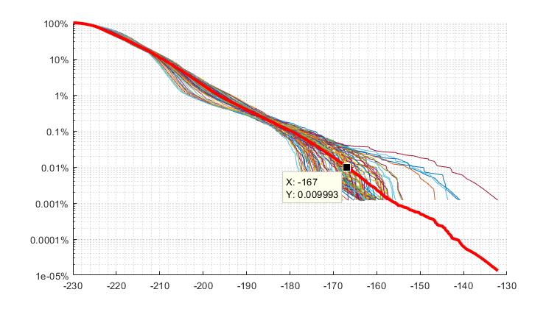

In each case, the time window power reduction technique results in sufficiently protected operations for the EESS (passive) sensor. The resulting mean interference value of -168 dBW / 200 MHz implies that this mitigation method, if employed, could ensure protection of the EESS (passive) station in this example. If desired, the resulting interference value could be further reduced by increasing the box size, reducing the power of the affected FSS earth station beams by more than 10 dB, or having antenna sidelobes on either the FSS earth station or EESS (passive) sensor that perform better than the referenced antenna pattern masks.

# 4 Conclusions

This study considered the adjacent band interference from transmitting FSS earth stations into EESS (passive) stations operating in the 50.2-50.4 GHz frequency band. The purpose was to demonstrate the effect associated with applying two different types of interference mitigation techniques to satisfy the protection criteria of the EESS (passive) sensors.

Using a hypothetical non-GSO satellite system and victim pushbroom EESS (passive) sensor, it was possible to conclude that both angular avoidance and time window power reduction provide the desired protection for the passive sensor.

It is important to note that these two mitigation techniques are not exhaustive, mutually exclusive, or mandatory to ensure protection of passive sensors. Canada believes mitigation techniques, such as those presented herein, can be implemented to ensure both the protection of passive sensors and efficient use of the spectrum in the adjacent frequency bands.

Study #2: Impact of mitigation techniques on the interference to EESS (passive) in the band 50.2‑50.4 GHz

# 1 Parameters used for dynamic simulation

## 1.1 Non-GSO FSS characteristics

The orbital and technical characteristics of the non-GSO FSS system used in this study are presented below. These are similar to the characteristics used in study #4 of the Preliminary Draft New Report ITU-R S.[50/40 GHZ ADJACENT BAND STUDIES], developed by ITU‑R Working Party 4A. The earth station characteristics have been selected to represent gateways type of use, which are necessary to implement the mitigation techniques.

Table 1: Orbital characteristics of FSS non-geostationary systems

|  |  |  |  |  |  |
| --- | --- | --- | --- | --- | --- |
| Constellation | Inclination  (degree) | Altitude  (km) | Number of Planes | Number of Satellites/plane | Total number of satellites |
| #1 | 87.5 | 1 200 | 18 | 40 | 720 |

Table 2: Earth station characteristics of FSS non-geostationary systems

|  |  |  |
| --- | --- | --- |
| **Earth Station** |  |  |
| Antenna gain (dBi) | 57.7 | 63.2 |
| Antenna diameter (m) | 1.8 | 3.4 |
| Antenna efficiency | 0.65 | 0.65 |
| Antenna pattern | Rec ITU-R S.465-6 | Rec ITU-R S.465-6 |
| Antenna beamwidth (o) | 0.23 | 0.12 |
| Transmit power (dBW) | -10 dBW into the 200 MHz of the EESS (passive) band* | -10 dBW into the 200 MHz of the EESS (passive) band* |
| **Link** |  |  |
| Tracking strategy | Highest elevation | Highest elevation |
| Minimum elevation angle (°) | 10 | 10 |
| Number of links per gateway site | 18 | 18 |

* A ‑10 dBW power lever is transmitted in the band 50.2‑50.4 GHz, as per the current limit provided in Table 1-1 of Resolution **750**

## 1.2 FSS earth station deployment

The results in the table below are based on the deployment of one gateway site with up to 18 collocated links. The gateway selects any satellites located at an elevation angle of 10° or more. This measurement area of about 2 000 000 km2 is delimited by 0° and -14° latitudes and -81° and ‑69° longitudes, and is traced in red in the figure 1 below. Note that the study does not include any rain, terrain or other local characteristics. Therefore, the location of the gateway should not have a significant impact on the results.

Figure 1: FSS earth station deployment and measurement area

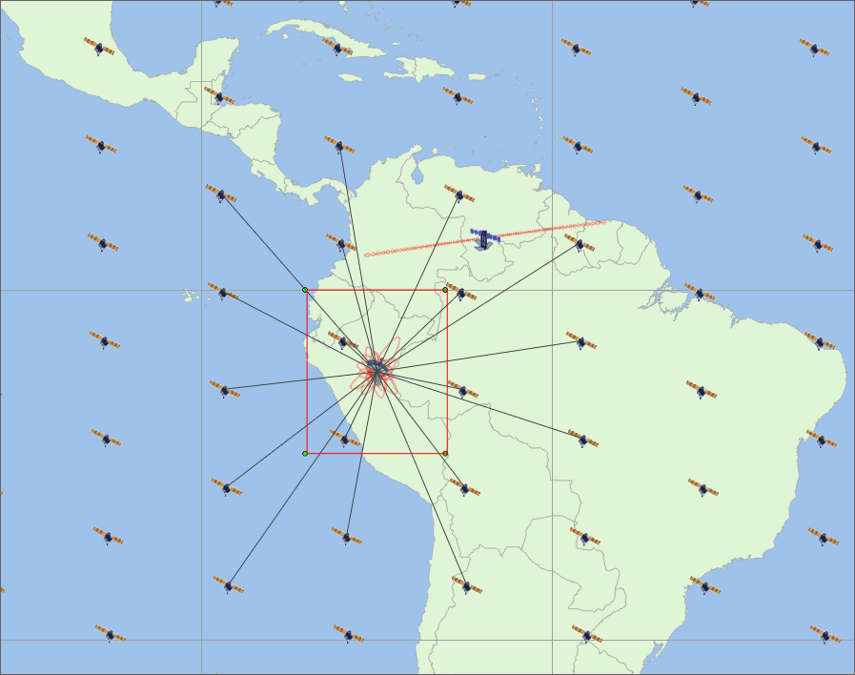

## 1.3 EESS (passive) characteristics

The parameters used to characterize the orbits, types of measurements and scanning parameters of various sensors were taken from Recommendation ITU-R RS.1861, “Typical technical and operation characteristics of Earth exploration-satellite service (passive) systems using allocations between 1.4 and 275 GHz”.

Table 3: EESS (passive) sensor characteristics in the 50.2-50.4 GHz band

|  | Sensor I1 | Sensor I2 | Sensor I3 |
| --- | --- | --- | --- |
| Sensor type | Conical scan | Mechanical nadir scan | Push-broom |
| Altitude | 828 km | 833 km | 850 km |
| Inclination | 98.7° | 98.6° | 98° |
| Eccentricity | 0 | 0 | 0 |
| Repeat period | 17 days | 9 days |  |
| Number of beams | 1 | 30 earth fields per 8 s scan period | 90 |
| Reflector diameter | 2.2 m | 0.15 m | 0.5 m |
| Maximum beam gain |  | 34.4 dBi | 45 dBi |
| −3 dB beamwidth | 0.39° | 3.3° | 1.1° |
| Instantaneous field of view | 16 km × 12 km | Nadir FOV: 48.5 km Outer FOV:  149.1 × 79.4 km | 16 km × 2 282 km |
| Off-nadir pointing angle | 46.8° | ±48.33° cross-track |  |
| Beam dynamics | 31.6 rpm | 8 s scan period | 90 resolution elements per swath |
| Incidence angle at Earth | 55.7° | 57.5° |  |
| –3 dB beam dimensions | 6 km | 48 km (at nadir) | 16 km (at nadir) |
| Swath width | 1 700 km | 2 343 km | 2 282 km |
| Sensor antenna pattern | See Rec. [ITU‑R RS.1813](http://www.itu.int/rec/R-REC-S.1813/en) *recommends* 2 | | |
| Channel bandwidth | 134 MHz centred at 50.3 GHz | 180 MHz centred at 50.3 GHz | N/A |

Recommendation [ITU-R RS.2017](http://www.itu.int/rec/R-REC-RS.2017/en) contains the interference criteria for satellite passive remote sensing. For the band 50.2‑50.4 GHz, the measurement area is a square on the Earth of 2 000 000 km2.

Table 4: Interference criteria for satellite remote sensing 50.2-50.4 GHz

|  |  |  |  |  |
| --- | --- | --- | --- | --- |
| Frequency band(s)  (GHz) | Reference bandwidth  (MHz) | Maximum interference level  (dBW) | Percentage of area or time permissible interference level may be exceeded(1)  (%) | Scan mode (N, C, L)(2) |
| 50.2−50.4 | 200 | −166 | .01 | N, C |

(1) For a 0.01% level, the measurement area is a square on the Earth of 2 000 000 km2, unless otherwise justified; for a 0.1% level, the measurement area is a square on the Earth of 10 000 000 km2 unless otherwise justified; for a 1% level, the measurement time is 24h, unless otherwise justified.

(2) N: Nadir, Nadir scan modes concentrate on sounding or viewing the Earth’s surface at angles of nearly perpendicular incidence. The scan terminates at the surface or at various levels in the atmosphere according to the weighting functions. L: Limb, Limb scan modes view the atmosphere “on edge” and terminate in space rather than at the surface, and accordingly are weighted zero at the surface and maximum at the tangent point height. C: Conical, Conical scan modes view the Earth’s surface by rotating the antenna at an offset angle from the nadir direction.

# 2 Mitigation techniques

## 2.1 Avoidance angle

The interference to EESS (passive) sensors can be reduced by avoiding transmission when the EESS spacecraft is in-line with the FSS earth station antenna by a specified angle. In the analysis below, when the FSS earth station antenna is in-line with the EESS sensor, the transmission is interrupted and the link selects another FSS satellite outside the avoidance cone. In real life, this could be implemented by using gateway diversity to maintain communication with the satellite while avoiding the in-line event. The ephemeral data of the EESS (passive) spacecraft are required to implement this mitigation technique.

The table below shows the exceedance of the interference above the -166 dBW level in the 200 MHz wide passive band for each type of sensor at 0.01% of the time.

Table 5: Required reduction of input power from current Resolution 750 limit for FSS earth stations implementing angle avoidance mitigation technique

|  |  |  |  |  |  |
| --- | --- | --- | --- | --- | --- |
| Avoidance angle (°) | Earth station antenna size (m) | Conical sensor (dB) | Nadir sensor (dB) | Push-broom sensor (dB) | Required power reduction(dB) |
| 0 | 1.8 | 21.7 | 23 | 33.1 | 33.1 |
| 2 | 1.8 | 18.7 | 16.9 | 28.6 | 28.6 |
| 5 | 1.8 | 12.5 | 14 | 24.5 | 24.5 |
| 10 | 1.8 | 14.8 | 11.8 | 20.2 | 20.2 |
| 20 | 1.8 | 12.7 | 10.5 | 18.4 | 18.4 |
|  |  |  |  |  |  |
| 0 | 3.4 | 22.3 | 22.6 | 33 | 33 |
| 2 | 3.4 | 18.7 | 17 | 28.3 | 28.3 |
| 5 | 3.4 | 16.4 | 14.2 | 23.6 | 23.6 |
| 10 | 3.4 | 14.5 | 11.5 | 20.2 | 20.2 |
| 20 | 3.4 | 13 | 10.3 | 18.4 | 18.4 |

Figure 2: Cumulative distribution function of interference into EESS sensors for an 1.8m FSS earth station without mitigation technique

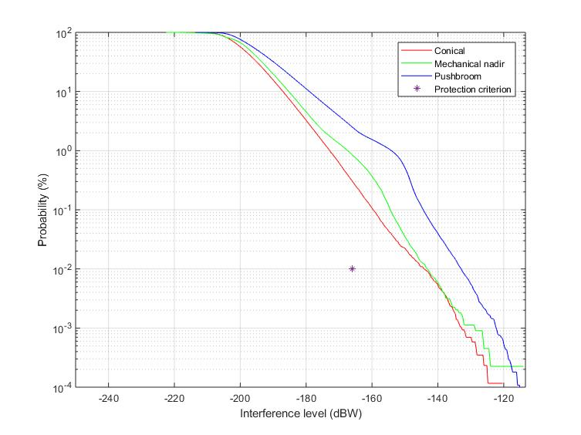

Figure 3: Cumulative distribution function of interference into EESS sensors for an 1.8m FSS earth station with a 2° avoidance angle

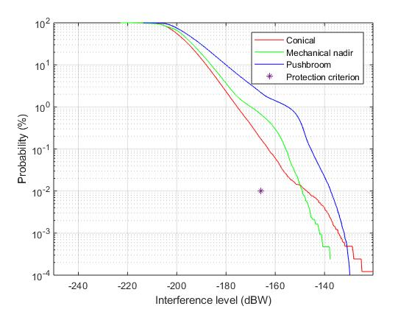

Figure 4: Cumulative distribution function of interference into EESS sensors for an 1.8m FSS earth station with a 5° avoidance angle

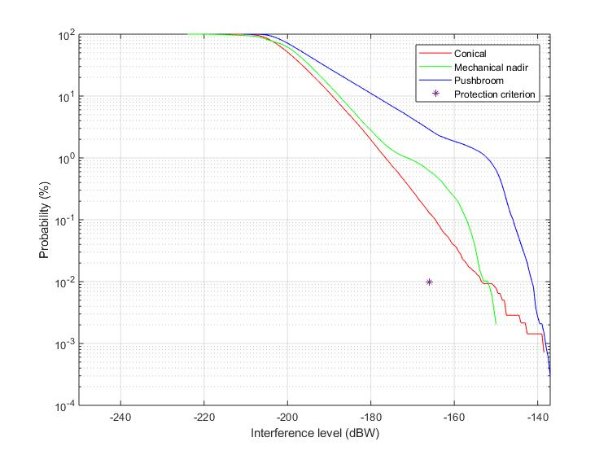

Figure 5: Cumulative distribution function of interference into EESS sensors for an 1.8m FSS earth station with a 10° avoidance angle

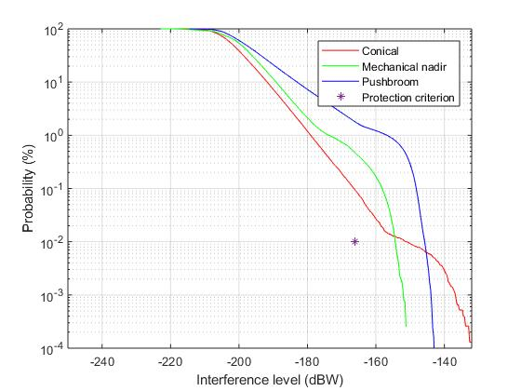

Figure 6: Cumulative distribution function of interference into EESS sensors for an 1.8m FSS earth station with a 20° avoidance angle

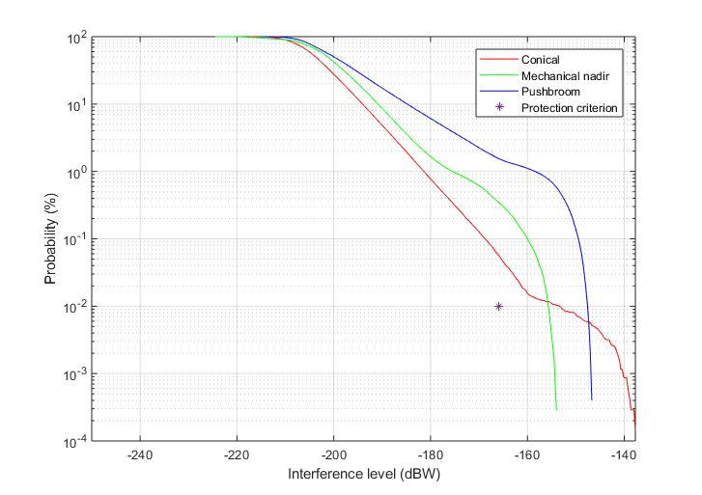

## 2.2 Power control

A second technique studied is power control of the FSS earth stations. As FSS satellites approach towards an earth station, the path loss is reduced due to the decreased distance and the increase of the earth station elevation angle. The FSS earth station can reduce its transmit power accordingly to ensure a constant power at the satellite receiver, hence reducing the power level potentially interfering with other services. For the non-GSO FSS constellation used in this study, this would result in a power reduction of up to about 6 dB. This technique does not require the ephemeral of the EESS (passive) satellites.

The table below shows the exceedance of the interference above the -166 dBW level in the 200 MHz wide passive band for each type of sensor at 0.01% of the time. The table also shows the effect of combining earth station power control with the avoidance angle mitigation technique for various avoidance angles.

Table 6: Required reduction of input power from current Resolution 750 limit for FSS earth stations implementing power control and angle avoidance mitigation techniques

|  |  |  |  |  |  |
| --- | --- | --- | --- | --- | --- |
| Avoidance angle (°) | Earth station antenna size (m) | Conical sensor (dB) | Nadir sensor (dB) | Push-broom sensor (dB) | Required power reduction (dB) |
| 0 | 1.8 | 21.1 | 21.4 | 30.4 | 30.4 |
| 2 | 1.8 | 18.7 | 16 | 25.9 | 25.9 |
| 5 | 1.8 | 16.3 | 12 | 20.8 | 20.8 |
| 10 | 1.8 | 13.8 | 10 | 17.8 | 17.8 |
| 20 | 1.8 | 11.8 | 9.5 | 17.2 | 17.2 |
|  |  |  |  |  |  |
| 0 | 3.4 | 16.9 | 18 | 24.7 | 24.7 |
| 2 | 3.4 | 14.2 | 12.4 | 20.6 | 20.6 |
| 5 | 3.4 | 12.6 | 8.5 | 16.4 | 16.4 |
| 10 | 3.4 | 11.8 | 7.3 | 14.8 | 14.8 |
| 20 | 3.4 | 10.3 | 7 | 14.8 | 14.8 |

Figure 7: Cumulative distribution function of interference into EESS sensors for an 1.8m FSS earth station implementing power control and no avoidance angle

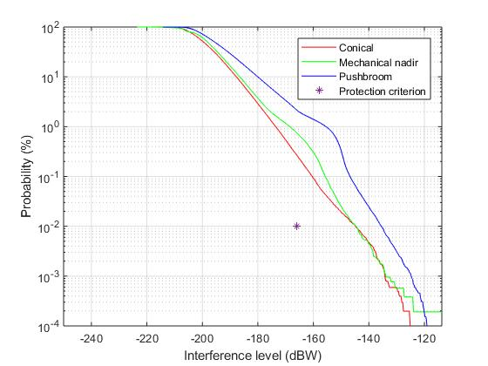

Figure 8: Cumulative distribution function of interference into EESS sensors for an 1.8m FSS earth station implementing power control and an avoidance angle of 10°

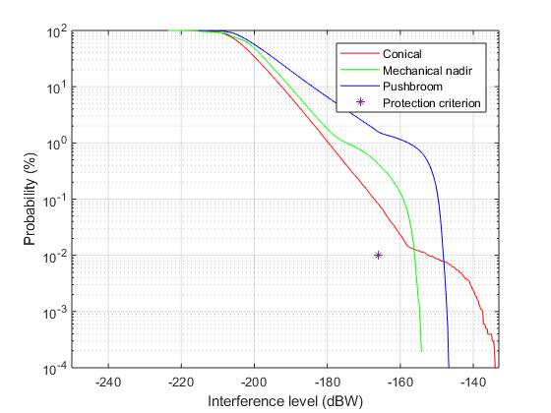

# 3 Conclusion

The results suggest that mitigation techniques are effective to reduce the interference received by EESS (passive) systems in the band 50.2‑50.4 GHz. Using a combination of mitigation techniques, the required attenuation of the current Resolution **750** limit is reduced by up to 18 dB, depending on the avoidance angle.

The mitigation techniques reduce the interference for all types of sensors. The effectiveness of these techniques depends on many factors, including the characteristics of the FSS earth stations as well as the type of EESS sensor.

The push-broom sensor is the type of sensor resulting in the highest required attenuation. Additional mitigation techniques tailored to the characteristics and geometry of the push-broom sensor could be studied further in the future and provide further reduction of interference beyond that achieved using the mitigation techniques used in this study.

________________