|  |  |
| --- | --- |
| **World Radiocommunication Conference (WRC-19) Sharm el-Sheikh, Egypt, 28 October – 22 November 2019** |  |
|  |  |
|  |  |
| PLENARY MEETING | **Revision 1 to Document 32-E** |
|  | **22 October 2019** |
|  | **Original: Russian** |
|  | |
| Russian Federation | |
| PROPOSALS IN RELATION TO AGENDA ITEM 1.13 CONCERNING CONDITIONS FOR IMT USE IN THE 24.25-27.5 GHz BAND BASED ON TEST RESULTS AND EXPERIENCE IN THE USE OF 5G NETWORKS IN THE RUSSIAN FEDERATION | |
|  | |
|  | |

This document sets out the results of the field testing of an IMT-2020[1] station using a dedicated 5G new radio (NR) base station, provided to the telecommunication operator by a global manufacturer for the construction of pilot areas, as well as statistical data comprising the notified characteristics of the IMT‑2020 networks in the pilot areas in the frequency range 25.25-27.5 GHz, planned for deployment on a provisional basis in the Russian Federation to enable technical fine-tuning and the conduct of experimental and study activities. The deployment characteristics of the IMT‑2020 networks in the pilot areas may differ from the deployment characteristics of commercial IMT-2020 networks.

The details presented in the annex point to disparities between the measured characteristics of an IMT‑2020 station, as well as the IMT-2020 network construction scenarios in the frequency range 24.25-27.5 GHz, and the corresponding characteristics of the IMT-2020 stations and IMT-2020 network deployment scenarios used within the context of Task Group (TG) 5/1 when conducting compatibility studies under WRC-19 agenda item 1.13 in order to identify possible regulatory measures to protect potentially affected services in the same and adjacent frequency bands from interference from IMT-2020 stations. Consideration of the measured characteristics of the dedicated IMT-2020 base station, as well as of the IMT-2020 network deployment scenarios in the pilot areas, points to an underestimation of the level of interference that IMT-2020 stations can cause to stations in other affected radio services.

This contribution supports the reasoning which calls for the adoption of regulatory provisions under WRC‑19 agenda item 1.13 to limit the technical characteristics of IMT-2020 stations in order to ensure protection from interference for affected satellite services, including identification of the maximum level of base station unwanted emissions in the band 23.6-24 GHz for ensuring protection to the Earth exploration-satellite service (EEES) (passive), and limitation of base station emissions in the upper hemisphere to ensure protection of the inter-satellite service (ISS) in the band 25.25-27.5 GHz and fixed-satellite service (FSS) in the band 27-27.5 GHz.

# 1 Characteristics of pilot areas for 5G networks in the Russian Federation

Set out below are statistical characteristics of the pilot areas (displayed in the form of distribution functions), obtained on the basis of open data relating to the planned deployment of pilot areas for fifth-generation networks within the territory of the Russian Federation (the parameters notified by telecommunication operators for over 370 base station sites in the band 25.25-27.5 GHz were used for calculating the statistics).

Figure 1.1

Distribution function for the notified height of the base station antenna phase centre  
relative to the Earth’s surface, in metres



**Legend** - vertical: Distribution function, % // horizontal: Height of base station, m

Figure 1.2

Distribution function for the base station notified maximum e.i.r.p., dBm/200 MHz



**Legend** - vertical: Distribution function, % // horizontal: e.i.r.p., dBm/200 MHz

Figure 1.3

Distribution function for the notified mechanical tilt angle  
from the horizon, in degrees



**Legend** - vertical: Distribution function, % // horizontal: Elevation angle, degrees

It follows from the above that:

• the number of notified base stations with maximum e.i.r.p. 48 dBm/200 MHz is less than 10% of the total number, and that at least 50% of base stations are planned for use with a maximum e.i.r.p. in excess of 67 dBm/200 MHz, with the e.i.r.p. in some instances reaching 80 dBm/200 MHz;

• the base station notified antenna height exceeds 25 m in over 50% of cases, making the obstacle attenuation model (Recommendation ITU-R P.2109) unsuitable. Excluding obstacle attenuation from the current compatibility studies could lead to a significant increase in the level of interference in the upper hemisphere to receiving space stations of existing satellite services.

# 2 Results of field testing of IMT-2020 stations

Field tests were carried out in an anechoic chamber using a dedicated 5G NR base station with the characteristics shown in the following table:

Table 1

Main characteristics of the base station for which measurements were performed

|  |  |
| --- | --- |
| Operating frequency range (GHz) | 26.5-29.5 GHz |
| Antenna array configuration | 16 × 12, 4 arrays |
| Notified maximum antenna gain (dBi) | 32.5 |
| Operating frequency (GHz) | 26.9 GHz |
| Emission bandwidth | 200 MHz |
| Operational range of scan angles in the horizontal plane | ±60 degrees |
| Operational range of scan angles in the vertical plane | ±15 degrees |

Purpose of the measurements:

• To determine the maximum level of the base station e.i.r.p. at 200 MHz.

• To determine the unwanted emission levels in the band 23.6-24 GHz.

• To determine the base station antenna radiation pattern gains in different directions according to the positioning of the base station main beam(s).

The results of these measurements are shown below.

The dedicated base station used for the studies was operating in multiple-beam antenna radiation pattern formation mode (formation of up to four beams in a co-frequency band, with the e.i.r.p. of each beam not exceeding 60.5 dBm/200 MHz).

The signal spectrum and the relative level of the unwanted emissions of one of the base station beams for a maximum e.i.r.p. value of 60.5 dBm are shown in Figures 2.1 and 2.2, respectively.

Figure 2.1

Signal spectrum in the base station beam

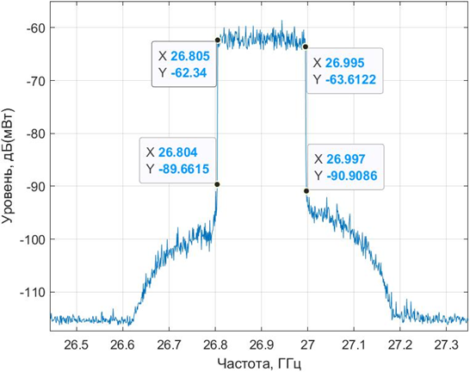

**Legend** - vertical: Level, dB(mW) // horizontal: Frequency, GHz

Figure 2.2

Relative levels of the unwanted emissions from one base station beam  
in the frequency range 1 to 40 GHz

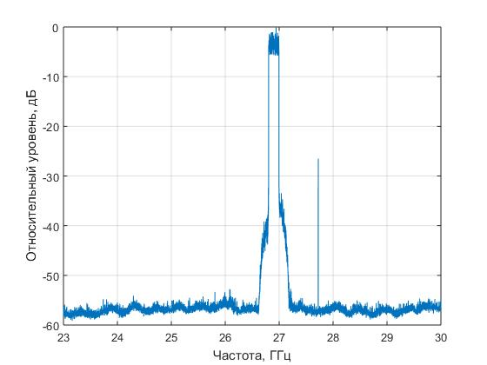

**Legend** - vertical: Relative level, dB // horizontal: Frequency, GHz

Thus, the relative level of the unwanted emissions in the band 23.6-24.0 GHz does not exceed the value −53(±2) dB. With the base station TRP limited to 31 dBm, this corresponds to an unwanted emission limitation level of −52 dB(W/200 MHz) (±2) dB.

The results of the measurements of the multi-beam antenna radiation pattern in a Cartesian coordinate system with main lobe orientation close to normal with respect to the plane of the antenna curtain are shown in Figures 2.3 to 2.5 below.

Figure 2.3

Radiation pattern in a Cartesian coordinate system (RAKURS 1)

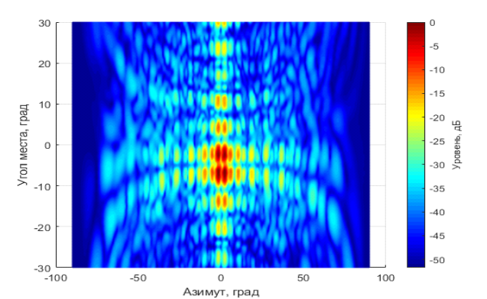

**Legend** - left side: Elevation angle, degrees / bottom: Azimuth, degrees / right: Level, dB

figure 2.4

Radiation pattern in a Cartesian coordinate system (RAKURS 2)

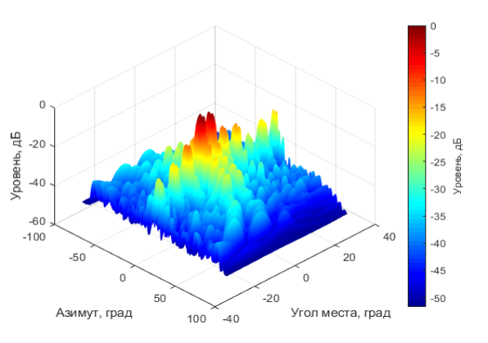

**Legend** - left: Level, dB / bottom left: Azimuth, degrees / bottom right: Elevation angle, degrees / right: Level, dB

Figure 2.5

Radiation pattern in a Cartesian coordinate system (RAKURS 3)

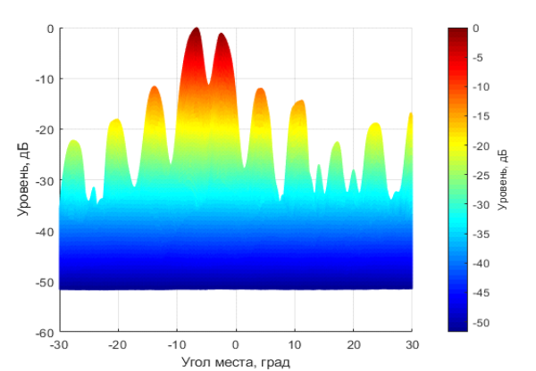

**Legend** - left: Level, dB / bottom: Elevation angle, degrees / right: Level, dB

The results of the measurements of the multi-beam antenna radiation pattern in a Cartesian coordinate system with maximum tilt of the main lobes from the normal in the vertical plane (15 degree downward electronic beam tilt from the vertical, with no tilt from the horizonal axis) are shown in Figures 2.6 to 2.8 below.

Figure 2.6

Radiation pattern in a Cartesian coordinate system (RAKURS 1)

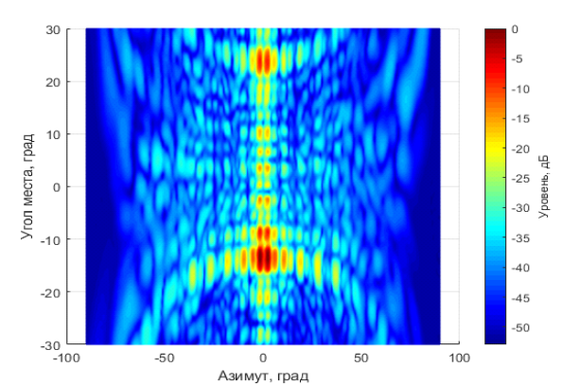

**Legend** - left: Elevation angle, degrees / bottom: Azimuth, degrees / right: Level, dB

Figure 2.7

Radiation pattern in a Cartesian coordinate system (RAKURS 2)

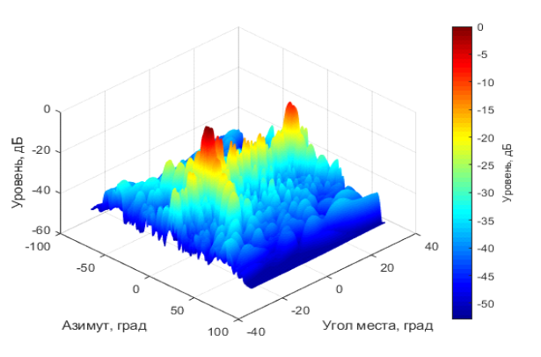

**Legend** - left: Level, dB / bottom left: Azimuth, degrees / bottom right: Elevation angle, degrees / right: Level, dB

Figure 2.8

Antenna radiation pattern in a Cartesian coordinate system (RAKURS 3)

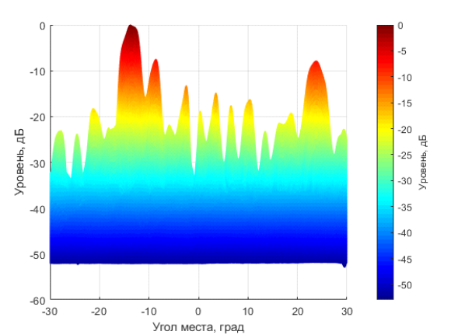

**Legend -** left: Level, dB / bottom: Elevation angle, degrees / right: Level, dB

The results of the measurements of the multi-beam antenna radiation pattern in a Cartesian coordinate system with maximum deviation of the main lobes from the normal in the horizontal plane (5 degree downward electronic beam tilt from the vertical, and 60 degree tilt to the right from the horizonal axis) are shown in Figures 2.9 to 2.12 below.

Figure 2.9

Antenna radiation pattern in a Cartesian coordinate system (RAKURS 1)

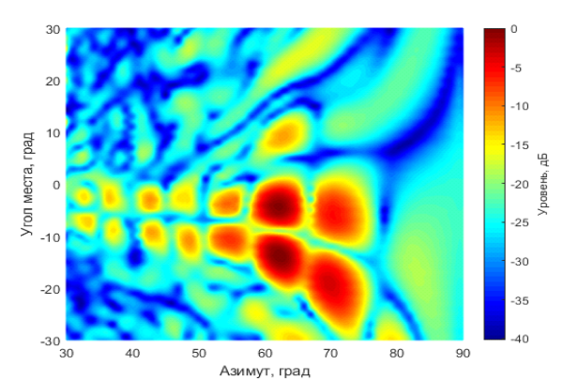

**Legend** - left: Elevation angle, degrees / bottom: Azimuth, degrees / right: Level, dB

Figure 2.10

Antenna radiation pattern in a Cartesian coordinate system (RAKURS 2)

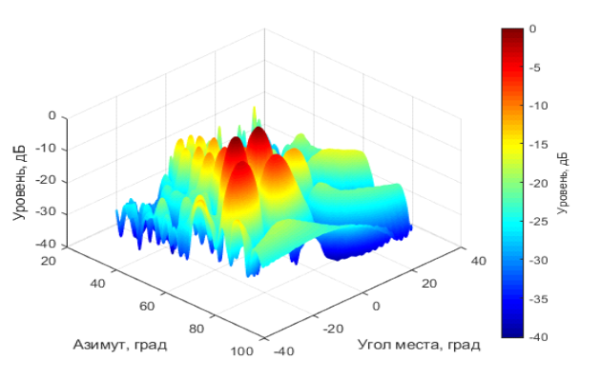

**Legend** - left: Level, dB / bottom left: Azimuth, degrees / bottom right: Elevation angle, degrees / right: Level, dB

Figure 2.11

Antenna radiation pattern in a Cartesian coordinate system (RAKURS 3)

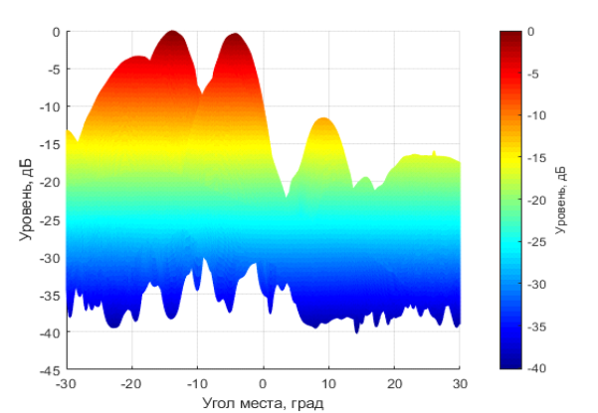

**Legend** - left: Level, dB / bottom: Elevation angle, degrees / right: Level, dB

Figure 2.12

Antenna radiation pattern in a Cartesian coordinate system (RAKURS 4)

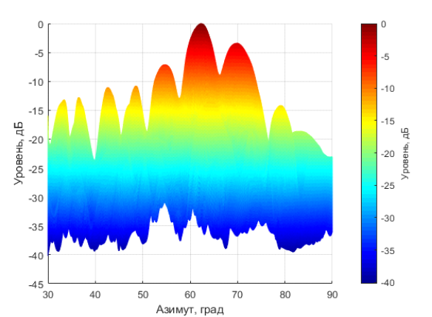

**Legend** - left: Level, dB / bottom: Azimuth, degrees / right: Level, dB

Figures 2.13 to 2.15 show a comparison of the analytical model for describing the radiation patterns of IMT‑2020 stations from Recommendation ITU-R M.2101 and the antenna radiation pattern measurements, for three different configurations of base station antenna radiation pattern main lobe orientation:

1) with zero tilt from the normal;

2) with −15 degrees vertical tilt and zero horizontal tilt;

3) with −5 degrees vertical tilt and 60 degrees horizontal tilt to the right.

Figure 2.13

Comparison of the radiation pattern in the elevation plane for orientation of the main lobes close to normal with respect to the plane of the antenna curtain

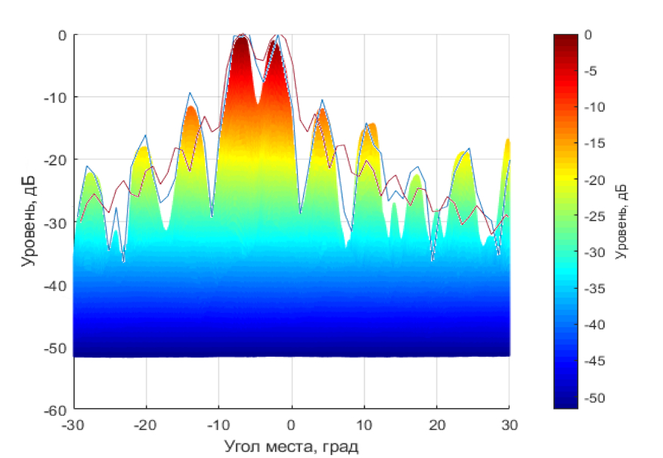

**Legend** - left: Level, dB / bottom: Elevation angle, degrees / right: Level, dB

Figure 2.14

Comparison of the radiation pattern in the azimuthal plane for an electronic beam tilt of −15 degrees with respect to the vertical axis and with no tilt with respect to the horizontal axis

**Legend** - left: Level, dB / bottom: Elevation angle, degrees / right: Level, dB

Figure 2.15

Comparison of the radiation pattern in the elevation plane for an electronic down-tilt of 5 degrees with respect to the vertical and a 60 degree right-tilt with respect to the horizontal axis

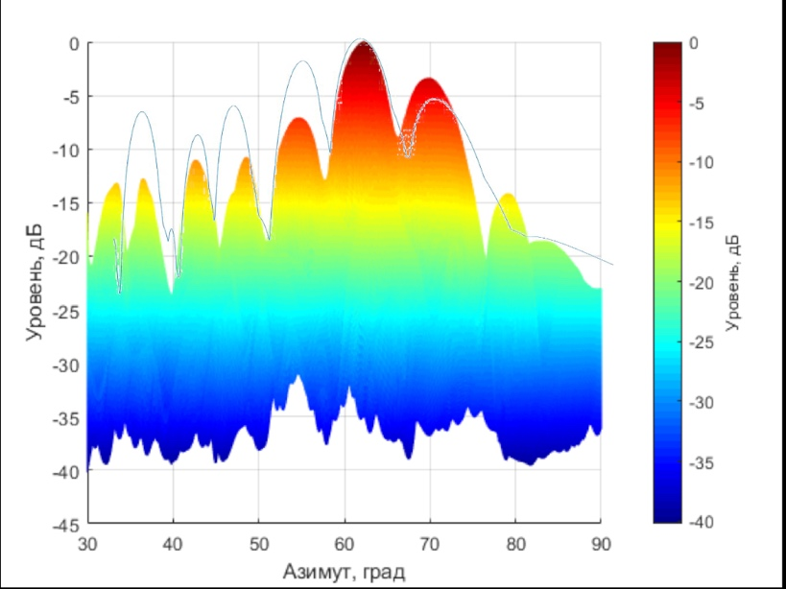

**Legend** - left: Level, dB / bottom: Azimuth, degrees / right: Level, dB

As can be seen from the above figures, the side lobes level in the measured dedicated base station radiation pattern generally exceeds the levels obtained from the analytical description presented in Recommendation ITU‑R M.2101. In particular, the antenna radiation pattern side lobe levels in the upper hemisphere may exceed the theoretical antenna radiation pattern values by a figure in the order of 10 dB, which could result in an underestimation of the level of interference to stations of affected satellite radio services.

Conclusions

The dedicated IMT-2020 base station measurement results presented above, and also the information on the notified characteristics of the pilot areas, show that there are significant disparities with respect to the deployment scenarios and characteristics of the IMT-2020 stations used within the context of TG 5/1 for the conduct of compatibility studies under agenda item 1.13.

The results have shown that the interference from actual IMT-2020 networks could be significantly higher than the interference calculated from the IMT-2020 reference networks used in the ITU‑R studies.

The results obtained confirm the need for the adoption of stricter conditions and limitations for the use of IMT-2020 stations in the band 24.25-27.5 GHz in order to ensure compatibility between IMT‑2020 systems and existing radiocommunication services, particularly space services (FSS, ISS and EESS).

By way of such conditions, it is proposed that IMT-2020 base station emissions be limited in the upper hemisphere by:

– the application of an e.i.r.p. mask in the upper hemisphere (in line with Condition A2e, Option 7, in the CPM Report); or by

– limiting the maximum total radiated power, excluding orientation angles of the base station antenna radiation pattern main lobe in the upper hemisphere, and ensuring conformity of IMT base station antennas with Recommendation ITU-R M.2101 (in line with Condition A2e, Option 1, in the CPM Report).

To ensure compatibility between IMT and EESS (passive) systems in the band 23.6-24 GHz, it is proposed to include in Resolution **750 (Rev.WRC-15)** a limitation on base station unwanted emissions of not more than −49 dB(W/200 MHz), which is achievable in practice.

______________

1. In accordance with the conditions of [SRFC decision 18-47-03/5](https://digital.gov.ru/uploaded/files/prilozhenie--5-k-resheniyu-gkrch-18-47-03.pdf) of 30.11.2018 [in Russian].