World Radiocommunication Conference (WRC-19)
Sharm el-Sheikh, Egypt, 28 October – 22 November 2019
PLENARY MEETING | Addendum 2 to  Document 67(Add.21)-E
 | 7 October 2019
 | Original: English
Papua New Guinea
Proposals for the work of the conference
Agenda item 9.1(9.1.2)
9 to consider and approve the Report of the Director of the Radiocommunication Bureau, in accordance with Article 7 of the Convention:
9.1 on the activities of the Radiocommunication Sector since WRC-15;
9.1 (9.1.2) Resolution 761 (WRC-15) - Compatibility of International Mobile Telecommunications and broadcasting-satellite service (sound) in the frequency band 1 452-1 492 MHz in Regions 1 and 3
Introduction
Pursuant to Resolution 761 (WRC-15), the regulatory and technical studies between International Mobile Telecommunications (IMT) and broadcasting-satellite service (sound) (BSS (sound)) in the frequency band 1 452-1 492 MHz in Regions 1 and 3 were conducted by ITU-R, taking into account IMT and BSS (sound) operational requirements.
The purpose of the studies is to respond to resolves to invite ITU-R as contained in the Resolution 761 (WRC-15) in order to enable WRC-19 to decide on the matter as appropriate.
The frequency band 1 452-1 492 MHz is allocated to the fixed service (FS), mobile service (MS), broadcasting service (BS) and broadcasting-satellite service (BSS). Based on the outcome of WRC-15, the frequency band 1 452-1 492 MHz is identified for use by Regions 1 and 3 administrations wishing to implement IMT in accordance with Resolution 223 (Rev.WRC-15) and Resolution 761 (WRC-15) (see Nos. 5.346 and 5.346A of the Radio Regulations (RR)). Pursuant to Resolution 528 (Rev.WRC-15), in the interim period, broadcasting-satellite systems may only be introduced within the upper 25 MHz of this frequency band in accordance with the procedures contained in Sections A to C of Resolution 33 (Rev. WRC 15), or in RR Articles 9 to 14, as appropriate (see resolves 1 and 2 of Resolution 33 (Rev. WRC-15)). The complementary terrestrial service may be introduced during this interim period subject to coordination with administrations whose services may be affected.
Currently, the coordination procedures in RR Nos. 9.11 and 9.19 are applied in order to reach the required sharing and compatibility conditions between the BSS and terrestrial services.
Under WRC-19 agenda item 9.1, issue 9.1.2, Working Party (WP) 4A and WP5D are responsible for the studies with respect to the BSS (sound) and IMT, respectively. The CPM Report was prepared and approved by the Conference Preparatory Meeting (CPM) at its Second Session held in Geneva from 18 to 28 February 2019.
Status of Technical Studies (WP4A, WP5D)
Through the studies conducted since WRC-15, there has been a lot of work, but a set of operating parameters has not been identified and agreed upon that ensure long term stability of BSS (sound) and IMT in the frequency range of 1 452-1 492 MHz.
Currently, there is a schedule for the WP4A to resume further study in April or May 2020 to continue the compatibility study.
Proposals
Considering the unresolved compatibility study, the suggestion for the ITU to act is the following:
1 The ITU to postpone taking any action on the agenda item 9.1, issue 9.1.2 BSS (sound) until the technical compatibility study is completed;
2 Leave the RR procedures as is (No Change) until the technical compatibility is completed and the results become available to make decision;
3 It should be pointed out that in Article 5, for the operating spectrum 1 452-1 492 MHz, BSS (sound), under BROADCASTING-SATELLITE, is a primary service.
Further, BSS (sound) system has been operating at GEO orbit since 2000, registered in the ITU MIFR with the ASIABSS satellite network at 105°E expiration date of September 14, 2031, and has the highest priority.
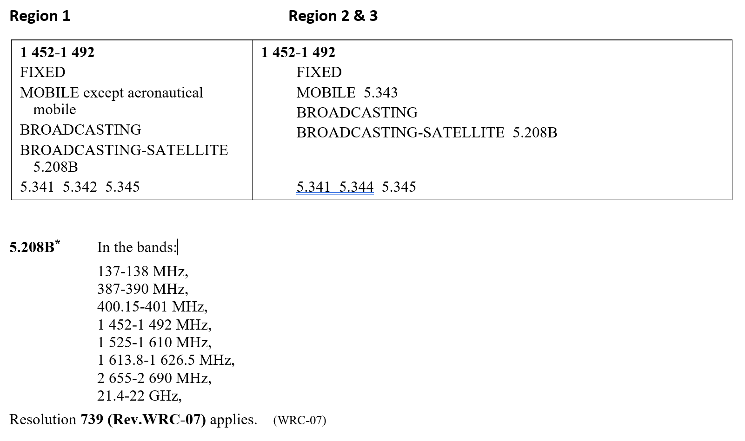
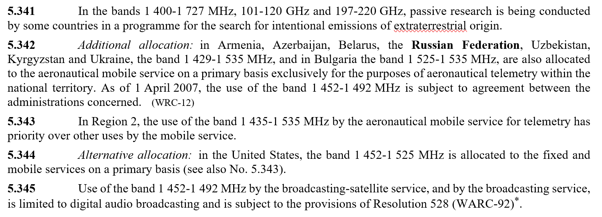

ARTICLE 5
Frequency allocations
NOC PNG/67A21A2/1
Section IV – Table of Frequency Allocations
(See No. 2.1)
Reasons: Considering that the current Radio Regulation and technical conditions could sufficiently ensure compatibility of IMT and broadcasting-satellite service (BSS) (sound) in the frequency band 1 452-1 492 MHz in Regions 1 and 3, it should be no changes to the Radio Regulations.
NOC PNG/67A21A2/2
ARTICLE 21
Terrestrial and space services sharing frequency bands above 1 GHz
Reasons: It should be noted that current coordination procedure RR No. 9.11 could provide a long-term stability for the operation of IMT systems, which could sufficiently guarantee of protection of IMT systems from receiving potential interference caused by BSS (sound) systems.
NOC PNG/67A21A2/3
APPENDIX 5 (REV.WRC-15)
Identification of administrations with which coordination is to be effected or
agreement sought under the provisions of Article 9
Reasons: The current coordination procedures in RR Nos. 9.11 and 9.19 could sufficiently guarantee the sharing and compatibility conditions between the BSS (sound) and terrestrial services.

______________

