|  |  |
| --- | --- |
| **Radio Regulations Board**  **Geneva, 16 – 20 July 2018** |  |
|  |  |
|  |  |
|  | **Document RRB18-2/DELAYED/1-E** |
| **2 July 2018** |
| **Original: English** |
| Director, Radiocommunication Bureau | |
| Submission by the Administration of Cyprus requesting a decision by the Radio Regulations Board for the brinGing into use of the frequency assignments to the KYPROS-SAT-3 (39ºE) satellite network | |

The attached submission from the Administration of Cyprus[1] requesting a decision for the bringing into use of the frequency assignments to the KYPROS-SAT-3 (39ºE) satellite network, which complements the information contained in Document [RRB18-2/2(Addendum 2)](https://www.itu.int/md/R18-RRB18.2-C-0002/en), is for the consideration of the Radio Regulations Board.

Attachment.

**Attachment**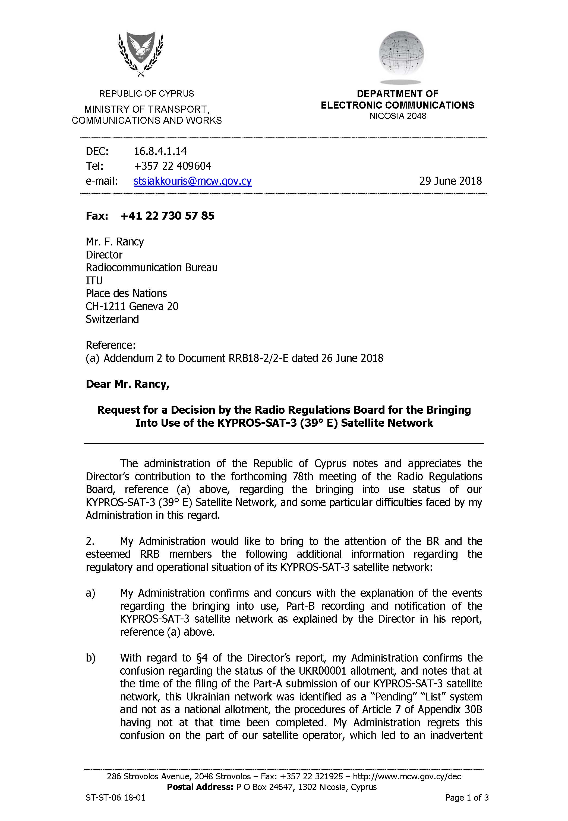

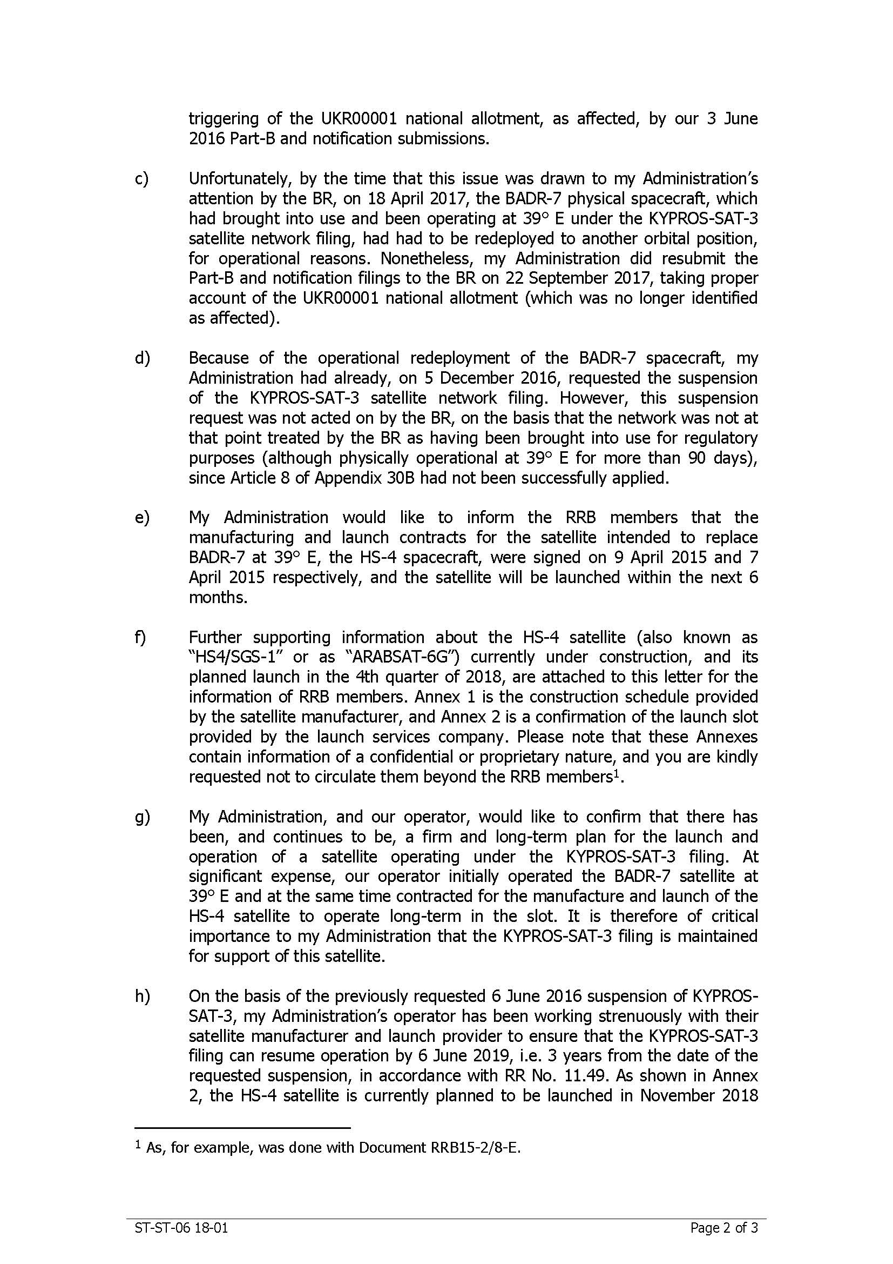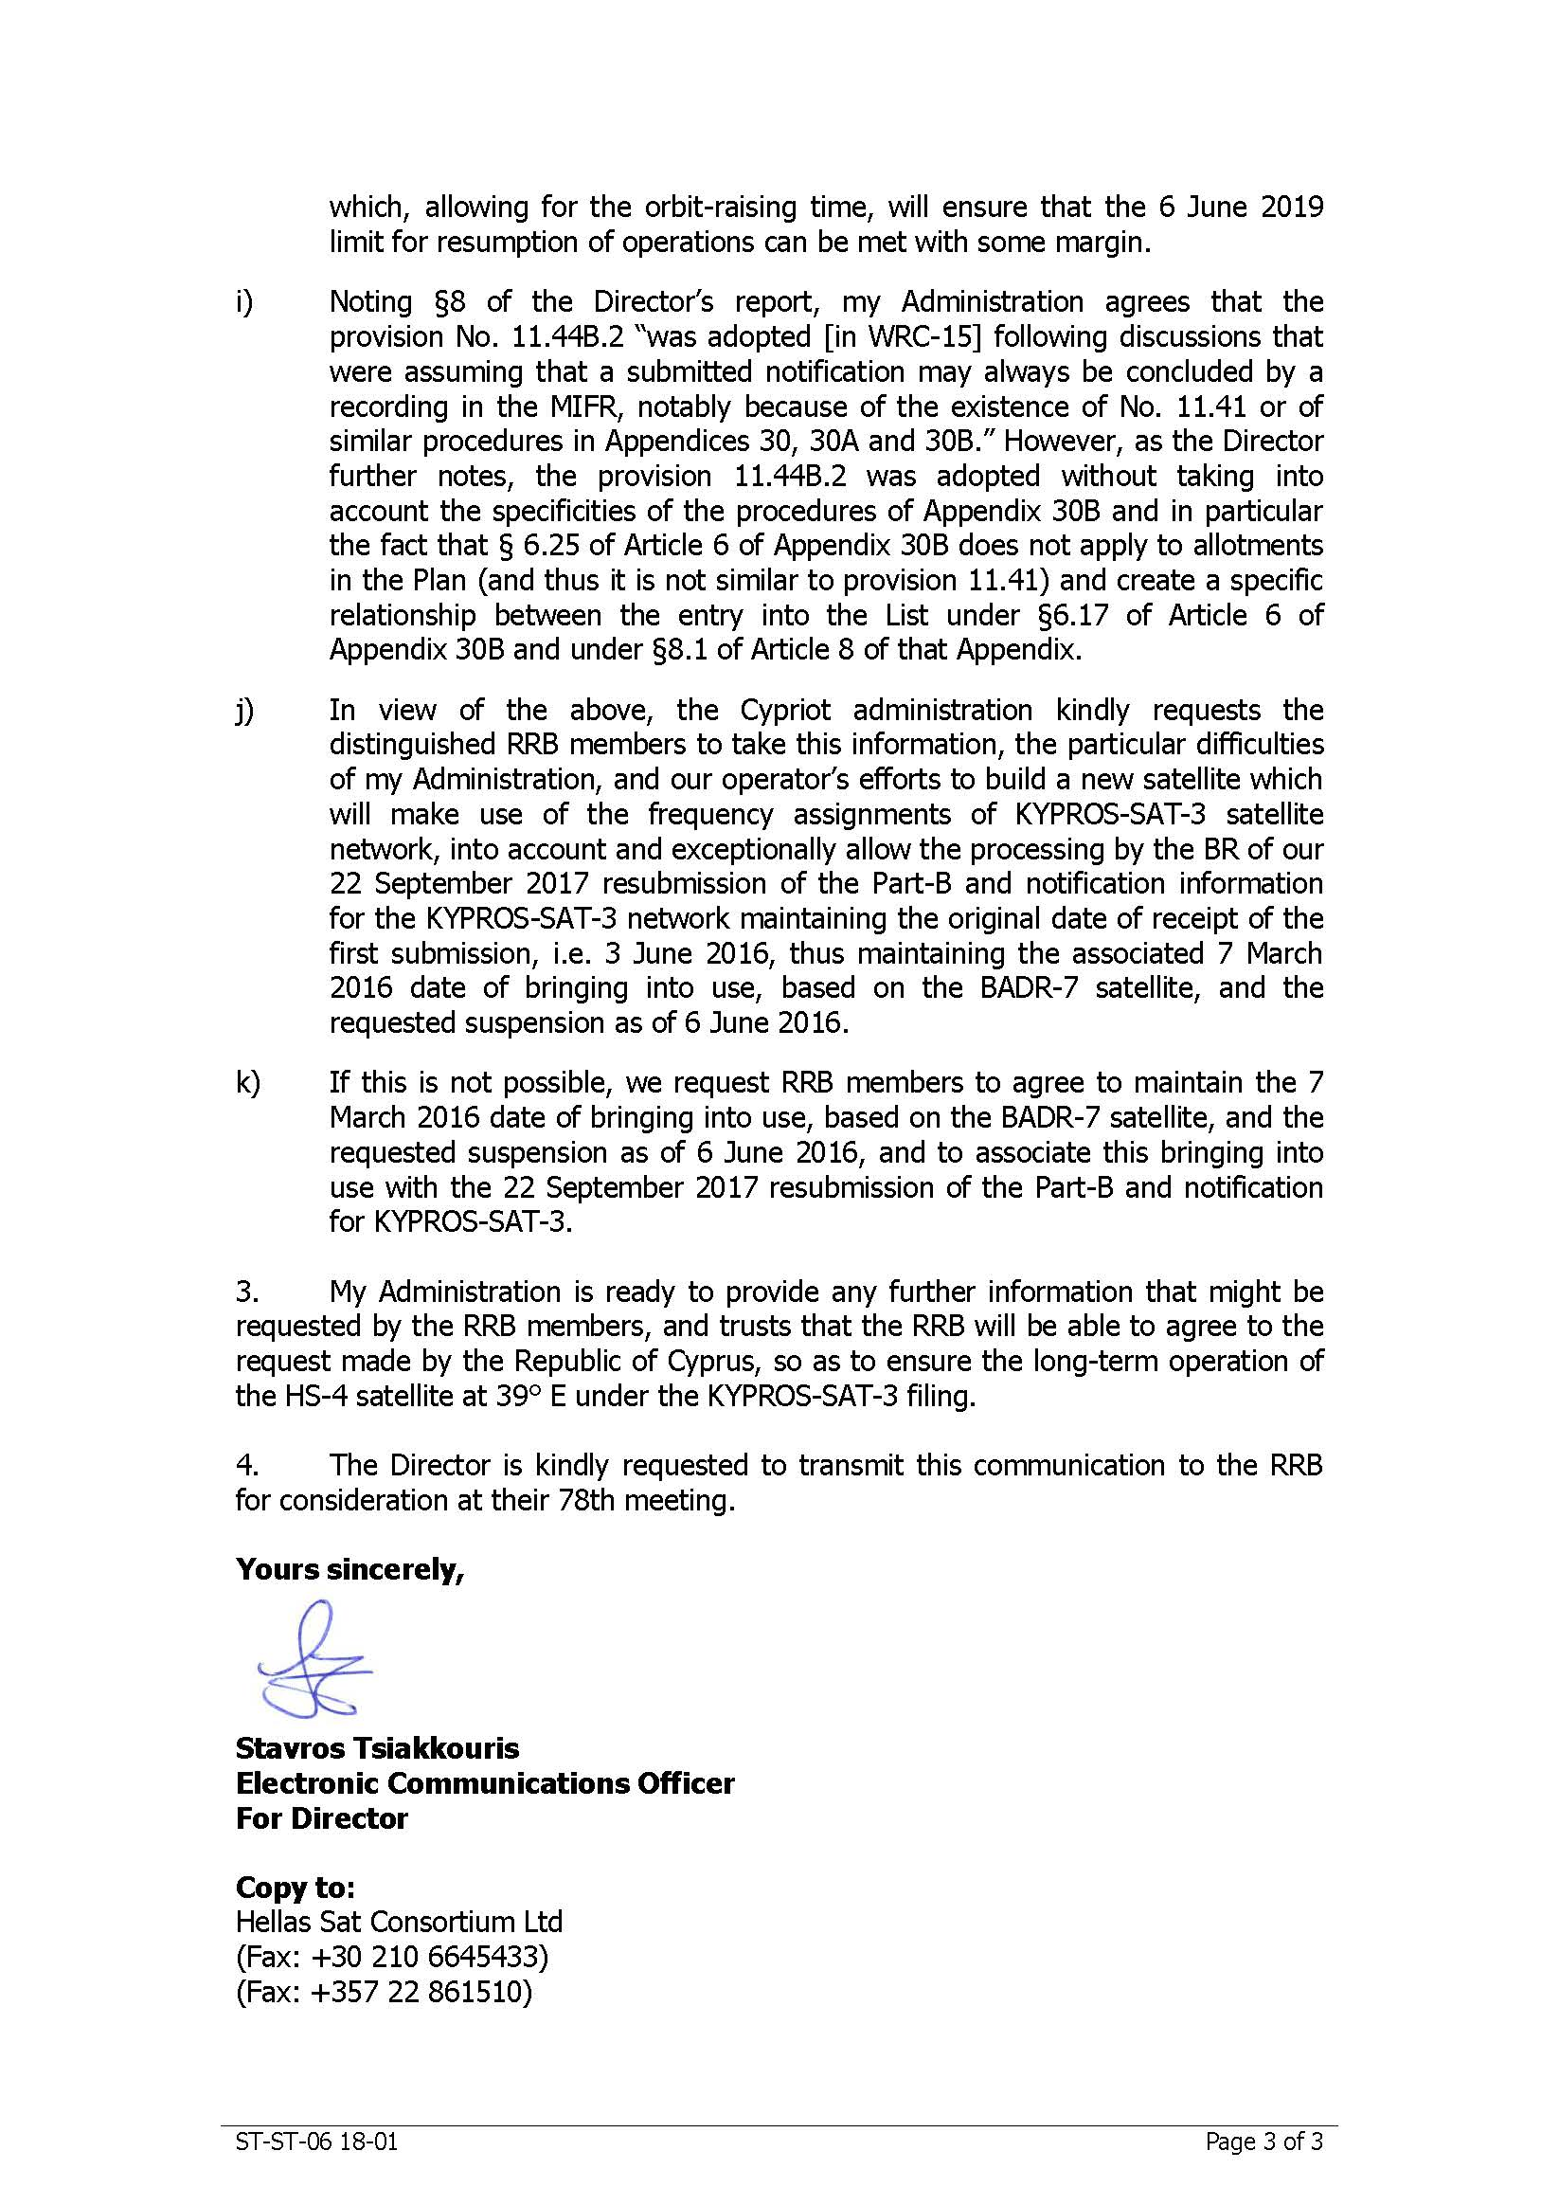

______________

1. This submission refers to annexes related to the HS-4 satellite together with its planned launch schedule, and in conformity with § 1.6 *bis* of the RRB internal arrangements and working methods (Part C of the Rules of Procedure), these annexes are not published.