|  |  |
| --- | --- |
| **Radio Regulations Board Geneva, 16 – 20 July 2018** |  |
|  |  |
|  |  |
|  | **Document RRB18-2/DELAYED/4-E** |
| **13 July 2018** |
| **Original: Russian** |
| Director, Radiocommunication Bureau | |

SUBMISSION BY THE ADMINISTRATION OF THE RUSSIAN FEDERATION REQUESTING AN EXTENSION OF THE REGULATORY TIME-LIMIT TO BRING INTO USE THE FREQUENCY ASSIGNMENTS TO THE ENSAT-23E SATELLITE NETWORK (23°E)

The attached submission from the Administration of the Russian Federation requesting an extension of the regulatory time-limit to bring into use the frequency assignments to the ENSAT-23E satellite network (23°E), which is a corrigendum to the information contained in Document [RRB18-2/12](https://www.itu.int/md/R18-RRB18.2-C-0012/en), is for the consideration of the Radio Regulations Board.

Annex

**Annex**

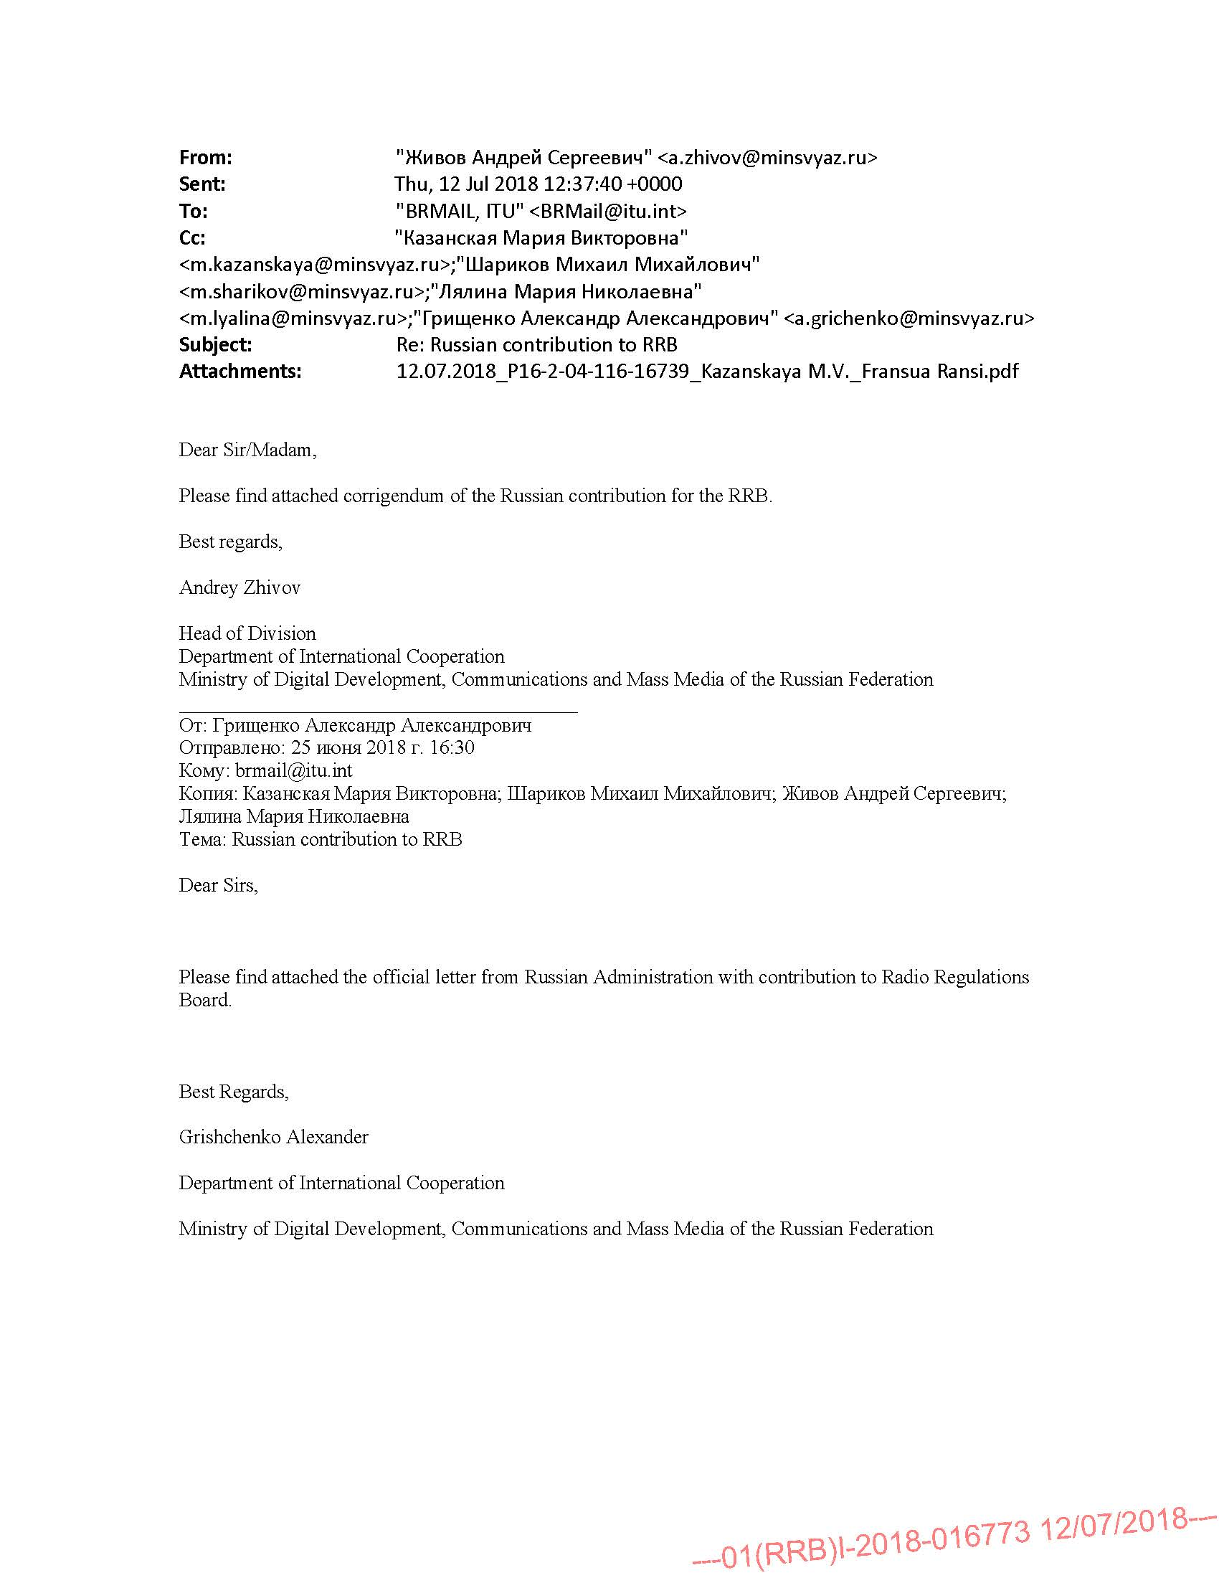

Moscow

|  |  |
| --- | --- |
| To: | Mr François Rancy  Director, ITU Radiocommunication Bureau |
| From: | Ministry of Digital Development, Communications and Mass Media of the Russian Federation |

Dear Mr Rancy,

The Administration of the Russian Federation presents its compliments and, further to letter P16-2-04-11-15148 of 25 June 2018, transmits herewith a corrected version of the Russian Administration’s contribution to the Board’s 78th meeting (16‑20 July 2018, Geneva, Switzerland). The text is supposed to read ENSAT-23E (23E) instead of ENSAT-13E (13E).

Yours sincerely,

(*signed electronically*)

M. V. Kazanskaya

Director

Department for International Cooperation

Attachment.

**REQUEST BY THE ADMINISTRATION OF THE RUSSIAN FEDERATION FOR AN EXTENSION OF THE REGULATORY TIME-LIMIT TO BRING INTO USE THE FREQUENCY ASSIGNMENTS TO THE ENSAT-23E (23E) SATELLITE NETWORK**

The Administration of the Russian Federation hereby requests that the members of the Radio Regulations Board (RRB), at the Board’s 78th meeting (16-20 July 2018), consider the question of an extension of the regulatory time-limit for bringing into service frequency assignments to the ENSAT-23E (23E) satellite network in the frequency bands 3400‑3410 MHz, 3500‑4200 MHz, 5725‑6425 MHz, 10950‑11200 MHz and 14000‑14250 MHz, to 30 April 2021, as a result of *force majeure*, namely, the malfunction of on-board systems on the Angosat satellite during flight tests at an orbital position in the geostationary orbit.

The ENSAT-23E (23E) satellite network was notified to the ITU Radiocommunication Bureau in 2011 with the aim of operating the Angosat satellite, produced for and in the interests of the Republic of Angola, for the purpose of broadcasting in the C- and Ku- frequency bands onto the territory of Angola and of other countries on the African continent. Implementation of this project in the interests of developing countries in Africa, including the Republic of Angola, should help to bridge the digital divide and promote achievement of the Sustainable Development Goals.

The operator took all the measures required under the Radio Regulations (notification of the ENSAT-23E (23E) satellite network pursuant to Article **11**, submission of Resolution **49** information, and payment of BR costs in accordance with ITU Council Decision 482).

On 26 December 2017 at 22h00 (Moscow time) the Zenit-3SLBF rocket carrying the Angosat satellite was successfully launched from the Baikonur launch site.

At the calculated time, the Fregat-SB upper stage rocket with the Angosat satellite separated from the main carrier rocket.

Once the Angosat satellite was placed at the notified orbital position, the planned flight tests began.

However, analysis of telemetry data from the satellite revealed a problem in the operation of the satellite’s electrical power system. Despite the operator’s efforts, it was unfortunately not possible to rectify the fault, as the satellite left the flight control centre’s radio visibility zone owing to natural drift westwards along the geostationary orbit.

In view of the major responsibility attaching to any manoeuvres in the geostationary orbit, it was decided not to try to actively influence the satellite before it had returned to the control centre’s radio visibility zone.

Work to restart flight tests for the Angosat satellite continued until the middle of April 2018, but even with these efforts it was not possible to restore full control and use of the satellite.

An investigation is currently under way to establish the causes of the malfunction that resulted in the satellite’s loss of operational capability.

In April-June 2018, the decision was taken to start work on the production of the Angosat-2 satellite, which will use the Angosat frequency assignments. The launch of Angosat-2 is scheduled for some time in the third or fourth quarter of 2020.

In view of the above, it is obvious that the frequency assignments to the Angosat satellite at orbital position 23E could not be brought into use before the regulatory deadline for the ENSAT-23E (23E) satellite network (11 April 2018).

The Administration of the Russian Federation recalls that WRC-12 and WRC-15 authorized RRB to consider requests for an extension of the period for the bringing into use of frequency assignments to satellite networks, especially when based on *force majeure*.

The conditions that constitute *force majeure* were outlined by the ITU Legal Adviser at the 60th meeting of RRB (10–14 September 2012):

1)The event must be beyond the control of the obligor and not self-induced.

2)The event constituting the *force majeure* must be unforeseen or, if it was foreseeable, must be inevitable or irresistible.

3)The event must make it impossible for the obligor to perform its obligation.

4) A causal effective connection must exist between the event constituting *force majeure* and the failure by the obligator to fulfil the obligation.

The Administration of the Russian Federation considers that all four conditions for *force majeure* have been fulfilled as a result of the Angosat satellite malfunction:

1. The emergency, arising from the sudden malfunction and loss of control of the Angosat satellite, was beyond the control of the operator and of any other agency concerned.

2. According to the rocket manufacturer, launch service provider and satellite manufacturer, no anomalies were detected prior to launch. Consequently, the operator could not have foreseen a launch failure. Bearing in mind the available fuel reserve needed to hold the satellite in its orbital position, the operator endeavoured to fulfil its international obligations and could not have envisaged such an emergency arising on board the satellite.

3. As a result of the emergency, the Angosat satellite left the predetermined orbital position before the end of the 90-day period stipulated by RR No. **11.44B** for the entry into use of satellite network frequency assignments, and cannot be returned to that position. With no similar satellite available to replace the malfunctioning Angosat at that orbital position before the end of the regulatory period for the entry into use of the satellite network frequency assignments, the operator is unable to bring the satellite network’s frequency assignments into use and maintain them in the MIFR without an extension of the regulatory period in question.

4. There is an obvious causal effective connection between the occurrence of the emergency and loss of the Angosat satellite and the impossibility of complying with the requirements of RR No. **11.44**.

In light of the foregoing, and given RRB’s mandate from WCR-12 and WCR-15, the Administration of the Russian Federation hereby requests that RRB extend the regulatory deadline for the bringing into use of the frequency assignments to the ENSAT-23E (23E) satellite network.

The Administration of the Russian Federation recalls that all regulatory requirements applicable to the ENSAT-23E (23E) satellite network under the Radio Regulations have been met (notification pursuant to Article **11**, submission of Resolution 49 information, and payment of ITU BR costs pursuant to ITU Council Decision 482). The Administration also, of course, strictly complies with the principles of Article **44** of the ITU Constitution and the provisions of the Radio Regulations, and does not seek to reserve orbit and spectrum capacity without actual use.

The Administration of the Russian Federation hopes that the members of the Board will look favourably on its request to extend the period for bringing into use the frequency assignments to the ENSAT-23E (23E) satellite network in the frequency bands 3400–3410 MHz, 3500–4200 MHz, 5725–6425 MHz, 10950–11200 MHz and 14000–14250 MHz to **30 April 2021,** and hopes that the Angosat project can be implemented in the interests of developing countries.

**______________**