Radiocommunication Study Groups
Source: Annex 3 to Document 4B/130  Subject: Resolution ITU-R 65 | Document IMT-2020-SAT/2-E
 | 23 November 2022
 | English only
Working Party 4B
SUBMISSION AND EVALUATION PROCESS AND CONSENSUS BUILDING FOR SATELLITE RADIO INTERFACE TECHNOLOGY
PROPOSALS OF IMT-2020
This document describes the process and activities identified for the development of the IMT-2020 satellite component radio interface Recommendation(s).

1 Time schedule
The time schedule described below applies to the first invitation for candidate RITs or SRITs. Subsequent time schedules will be decided according to the submissions of proposals.
Submission of proposals may begin at any time subsequent to the release of Circular Letter 4/LCCE/134, dated 23 November 2022. The final deadline for submissions is 16:00 hours UTC, on 31 December 2023. The evaluation of the proposed radio interface technologies by the independent evaluation groups and the consensus-building process will be performed throughout this time period and thereafter. The detailed schedule can be found in Figure A2-1.
Figure A2-1
Schedule for the development of IMT-2020 satellite radio interface Recommendations
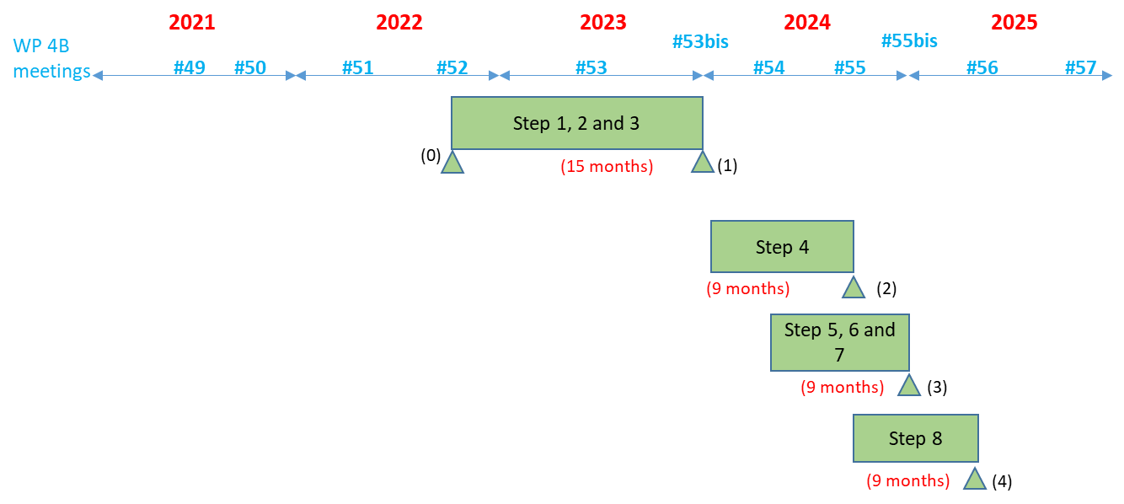
Steps in radio interface development process:
Step 1: Issuance of the circular letter
Step 2: Development of candidate RITs and SRITs
Step 3: Reception of the RIT and SRIT submissions and acknowledgement of receipt
Step 4: Evaluation of candidate RITs and SRITs by independent evaluation groups
Step 5: Review and coordination of outside evaluation activities
Step 6: Review to access compliance with minimum requirements
Step 7: Consideration of evaluation results, consensus building and decision
Step 8: Development of radio interface Recommendation(s)
Critical milestones in radio interface development process:
(0): Issue an invitation to propose RITs September 2022
(1): ITU proposed cut off for submission of candidate RIT proposals December 2023
(2): Cut off for evaluation report to ITU September 2024
(3): WP 4B decides framework and key characteristics of IMT-2020-Sat RITs and SRITs End 2024
(4): WP 4B completes development of radio interface specification Recommendation(s) May 2025

2 Process

2.1 General
Resolution ITU-R 65 on the “Principles for the process of future development of IMT for 2020 and beyond” outlines the essential criteria and principles that will be used in the process of developing the Recommendations and Reports for IMT-2020 for satellite, including Recommendation(s) for the radio interface specification.

2.2 Detailed procedure
The detailed procedure is illustrated in Figure A2-2 and is described below. Some activities are external to ITU-R and others are internal.
Figure A2-2
IMT-2020 satellite component radio interface development process
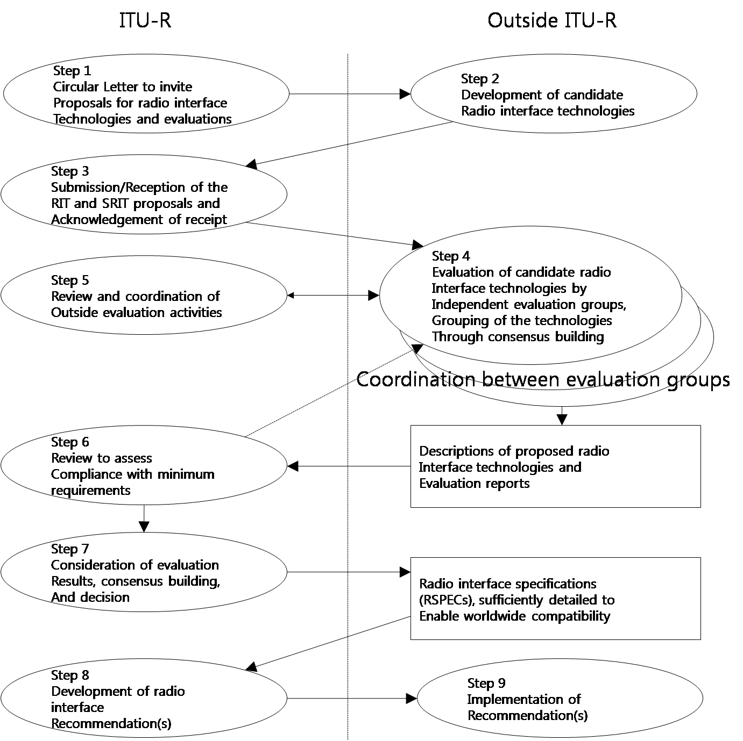
Step 1 – Circular Letter to invite proposals for radio interface technologies and evaluations
The Radiocommunication Bureau, through Circular Letter 4/LCCE/134 and its Addenda, invites the submission of candidate RITs or SRITs addressing the satellite component of IMT-2020.
Circular Letter 4/LCCE/134 and its Addenda also invite subsequent submission of evaluation reports on these candidate RITs or SRITs by any independent evaluation groups in addition to the initial evaluation report endorsed by the proponent.
Step 2 – Development of candidate RITs or SRITs
In this step, which is typically external to ITU-R, candidate satellite component RITs or SRITs are developed to satisfy a version of the minimum technical requirements and evaluation criteria of the IMT-2020 satellite component currently in force (as defined in Resolution ITU-R 65, resolves 6 g) that are described in Report ITU-R M.2514.
A RIT needs to fulfil the minimum requirements for three test environments comprising the three usage scenarios.
An SRIT consists of a number of component RITs complementing each other, with each component RIT fulfilling the minimum requirements of at least one test environment and together as an SRIT fulfilling the minimum requirements of three test environments comprising the three usage scenarios.
The Report ITU-R M.2514 includes distinct terminal types, namely: handheld, Machine Type Devices (MTD) and directional terminals. As indicated in the above Report, assessment of compliance for handheld terminals is sufficient to evaluate whether a satellite radio interface technology meets the criteria for the satellite component of IMT-2020 (see step 6 below). Other evaluations e.g., for directional and MTD devices, may be provided by the proponent though are not required.
Step 3 – Submission/reception of the RIT and SRIT proposals and acknowledgement of receipt
The proponents of RITs or SRITs may be Member States, Sector Members, and Associates of ITU-R Study Group 4, or other organizations in accordance with Resolution ITU-R 9-6.
The submission of each candidate RIT or SRIT must include completed templates (these templates are provided in Report ITU-R M.2514), together with any additional inputs which the proponent may consider relevant to the evaluation. Each proposal must indicate the version of the minimum technical requirements and evaluation criteria of the IMT-2020 satellite component currently in force that it is intended for and make reference to the associated requirements.
The entity that proposes a candidate RIT or SRIT to the ITU-R (the proponent) shall include with it either an initial self-evaluation or the proponent’s endorsement of an initial evaluation submitted by another entity. The submission will not be considered complete without an initial self-evaluation or the proponent’s endorsement of an initial evaluation submitted by another entity.
Proponents and IPR holders should indicate their compliance with the ITU policy on intellectual property rights (see Note 2 in Section A2.6 of Resolution ITU-R 1-8), as specified in the Common Patent Policy for ITU-T/ITU-R/ISO/IEC available at http://www.itu.int/ITU-T/dbase/patent/patent-policy.html.
The Radiocommunication Bureau (BR) receives the submission of technical information on the candidate RITs and SRITs and acknowledges its receipt.
Submissions should be addressed to the Counsellor for ITU-R Study Group 4, Mr. Nelson Malaguti (nelson.malaguti@itu.int). These submissions will be prepared as inputs to ITU-R Working Party 4B (WP 4B) and will also be made available on the ITU Web page for the satellite IMT-2020 submission and evaluation process.
Step 4 – Evaluation of candidate RITs or SRITs by independent evaluation groups
Candidate RITs or SRITs will be evaluated. The ITU-R membership, standards organizations and other organizations are invited to proceed with the evaluation. Organizations wishing to become independent evaluation groups are requested to register with ITU-R preferably before the end of 2022. The independent evaluation groups are kindly requested to submit evaluation reports to the ITU-R. The evaluation reports will be considered in the development of the ITU-R Recommendation(s) describing the radio interface specifications.
The evaluation guidelines, including criteria and test models, are provided in Report ITU-R M.2514.
In this step the candidate RITs or SRITs will be assessed based on Report ITU-R M.2514. If necessary, additional evaluation methodologies may be developed by each independent evaluation group to complement the evaluation guidelines in Report ITU-R M.2514. Any such additional methodology should be shared between the independent evaluation groups and sent to the BR for information to facilitate consideration of the evaluation results by ITU-R.
Coordination between the independent evaluation groups is strongly encouraged to facilitate comparison and consistency of results, to assist ITU-R in developing an understanding of differences in evaluation results achieved by the independent evaluation groups and to form some preliminary consensus on the evaluation results. Consensus building is encouraged, such as grouping and/or syntheses by proponents in order to better meet the requirements of the IMT-2020 satellite component.
Each independent evaluation group will report its conclusions to the ITU-R. Evaluation reports should be addressed to the Counsellor for ITU-R Study Group 4, Mr. Nelson Malaguti (nelson.malaguti@itu.int). Independent evaluation groups are invited to submit an interim evaluation report before the 54th meeting of WP 4B (currently planned for May 2024) to allow proponents to comment on or respond to any issues found by the independent evaluation groups during the evaluation. The final evaluation reports must be provided before the 55th meeting of WP 4B (September 2024). The evaluation reports will be prepared as inputs to WP 4B and will also be made available on the ITU Web page for the satellite IMT-2020 submission and evaluation process.
The technical requirements and evaluation criteria for the IMT-2020 satellite component are subject to reviews which may introduce changes to the technical requirements and evaluation criteria for the IMT-2020 satellite component. Proponents may request evaluation against any of the existing versions of the technical requirements and evaluation criteria that are currently in force.
Step 5 – Review and coordination of outside evaluation activities
Working Party 4B will act as the focal point for coordination between the various independent evaluation groups. In this step, WP 4B monitors the progress of the evaluation activities, and provides appropriate responses to problems or requests for guidance to facilitate consensus building.
Step 6 – Review to assess compliance with minimum requirements
In this step, WP 4B makes an assessment of the proposal as to whether it meets a version of the minimum technical requirements and evaluation criteria of the IMT-2020 satellite component currently in force as described in Report ITU-R M.2514.
In this step, the evaluated proposal for a RIT/SRIT is assessed as a qualifying RIT/SRIT, if a RIT/SRIT fulfils the minimum requirements for three test environments comprising the three usage scenarios.
Such a qualified RIT/SRIT will go forward for further consideration in Step 7.
According to the decision of the proponents, earlier steps may be revisited to complement, revise, clarify and include possible consensus-building for candidate RITs or SRITs including those that initially do not fulfil the minimum requirements of the IMT-2020 satellite component that are described in Report ITU-R M.2514.
Working Party 4B will prepare a document on the activities of this step and assemble the reviewed proposals and relevant documentation. WP 4B will keep the proponents informed of the status of the assessment.
Such documentation and feedback resulting from this step can facilitate consensus building that might take place external to the ITU-R in support of Step 7.
Step 7 – Consideration of evaluation results, consensus building and decision
In this step WP 4B will consider the evaluation results of those RITs or SRITs that have satisfied the review process in Step 6.
Consensus building is performed during Steps 4, 5, 6 and 7 with the objective of achieving global harmonization and having the potential for wide industry support for the satellite radio interfaces that are developed for IMT-2020. This may include grouping of RITs or modifications to RITs to create SRITs that better meet the objectives of the IMT-2020 satellite component.
A RIT or SRIT will be accepted for inclusion in the standardization phase described in Step 8 if, as the result of deliberation by ITU-R, it is determined that the RIT or SRIT meets the requirements of Resolution ITU-R 65, resolves 6 e) and f) for three test environments comprising the three usage scenarios. These requirements are specified in Report ITU-R M.2514.
Step 8 – Development of radio interface Recommendation(s)
In this step a (set of) IMT-2020 satellite component radio interface Recommendation(s) is developed within the ITU-R on the basis of the results of Step 7, sufficiently detailed to enable worldwide compatibility of operation and equipment, including roaming.
This work may proceed in cooperation with relevant organizations external to ITU in order to complement the work within ITU-R, using the principles set out in Resolution ITU-R 9-6.
Step 9 – Implementation of Recommendation(s)
In this step, activities external to ITU-R include the development of supplementary standards (if appropriate), equipment design and development, testing, field trials, type approval (if appropriate), development of relevant commercial aspects such as roaming agreements, manufacture and deployment of IMT-2020 satellite component infrastructure leading to commercial service.

Provides the confirmation to the sender that the submission was received by the BR and that the submission will be forwarded to WP 4B for subsequent consideration.
Independent evaluation group registration forms are available at: Satellite IMT-2020 submission and evaluation process

