|  |  |
| --- | --- |
| **Radiocommunication Study Groups** |  |
|  |  |
|  |  |
| Source: Document 5A/TEMP/104 | **Annex 17 to Document 5A/359-E** |
| **11 May 2021** |
| **English only** |
| Annex 17 to Working Party 5A Chairman’s Report | |
| Working document towards a pReliminary DRAFT  Revision of REPORT ITU-R M.2282-0 | |
| Systems for public mobile communications with aircraft | |

(2013)

*{Editor’s Note: Annex 6 to Document* [*5A/1065*](https://www.itu.int/dms_pub/itu-r/md/15/wp5a/c/R15-WP5A-C-1065!N06!MSW-E.docx) *has been amended by the 25th meeting of WP5A with content of the proposal in* [*5A/281*](https://www.itu.int/md/R19-WP5A-C-0281/en) *and* [*5A/310*](https://www.itu.int/md/R19-WP5A-C-0310/en)*. The document has not been reviewed or agreed on. Interested administrations from all Regions are invited to provide their view and related content in input contributions to the coming meetings of WP5A}*

# 1 Introduction

This Report deals with the general principles, technical characteristics and operational features of terrestrial systems for public mobile communications with aircraft. *[Editor’s note: Consider inclusion of material from the Introduction of Annex to Doc. [5A/927](https://www.itu.int/md/R15-WP5A-C-0927/en).]*

The global demand for ubiquitous wireless connectivity has grown very rapidly around the world, kicked off by the launch of the smart phone (generally credited with revolutionizing the cellular telephone market) back in June 2007. The range of smart‑phones, and their features and applications, has expanded at an incredible rate. And consumer adoption of the smart-phone[1],[2],[3] has already reached over 50% in many countries (and around 80-90% in major developed countries) – with public expectations for ‘*anywhere – anytime*’ connectivity also escalating to the point where lack of coverage, poor building penetration and even just comparatively slower bit-rates are frequently seen as a serious shortfall in service quality.

While cellular telephone systems have evolved from analogue to digital technologies, and from relatively low-rate data to the mobile broadband speeds widely deployed today, deployment of network infrastructure (i.e. base-stations) has also expanded significantly - not just in outdoor locations across the landscape, but throughout public buildings, shopping malls, and within road/rail tunnels - to provide a *ubiquitous* user experience of wireless connectivity.

Building on the growing consumer demand, a variety of public transport services now also offer free or low cost wireless connectivity to passengers. For example, many buses and trains already offer in-vehicle Wi-Fi, with the vehicle backhaul connection to the Internet being provided via public cellular networks.

But while network operators are continuously expanding the coverage ubiquity of mobile broadband service on land, subject to capital availability and economic feasibility, the provision of equivalent services on passenger ships and aircraft is still lagging behind. Today, some of the larger cruise ships are planning or have commenced fitting distributed antennas and wireless broadband base-stations supported by satellite-based backhaul to land networks.

[In contrast, despite the large number of commercial aircraft plying the skies, the connected passenger aircraft market has been slower to develop than expected, and remains rather limited – with only relatively few airlines fitting a small number of aircraft, and national operating authorizations settled in only relatively few countries. Moreover, indications are that services offered to date have fallen short of user and airline expectations – due to comparatively low data rates, frequent connection drop-outs, high user-tariffs, and excess equipment weight/aerodynamic drag impacts on efficient aircraft performance.]

# 2 General Direct-Air-to-Ground Communications Scenario

*[Editor’s note: Consider inclusion of material from the Introduction of Annex to Doc. 5A/927.]*

To enable passengers to use their smart-phones within the cabin of a passenger airliner, at minimum power levels, a compact base-station or service access point is required to be installed, along with a suitable antenna in the cabin. For convenient user terminal access, this base-station will rely on one of the frequency bands allocated to mobile services by the ITU, and commonly provisioned in today’s smart-phones. An alternative option may be to provide a Wi-Fi service within the cabin, via an on-board Wi-Fi Access Point (AP), since most modern smart-phones can also connect to Wi-Fi services.

Figure 1

General Direct-Air-to-Ground Communications Scenario

Terrestrial IMT network

Overflying passenger aircraft

Broadband air-to-ground link

On-board distributed antenna

Onboard microcell or AP

On-board Wi-Fi access points are already being used to broadcast pre-recorded news and entertainment content to passengers on many aircraft, via their tablets and smartphones. However, connections to the Internet need a broadband back-haul link to the global telecommunications network, enabling access to a wider range of applications, and to terrestrial voice and data services – to achieve equivalent seamless connectivity in the air as enjoyed by passengers on the ground going about their normal day-to-day lives, and prior to boarding the aircraft.

Back-haul for this communication can be provided by a variety of means including satellite and terrestrial systems. The terrestrial component is the focus of this document.

# 3 General operational considerations

The system should be fully compatible and capable of interfacing with the international public switched telephone network, public data network, the Internet, or any combinations thereof.

The system should have adequate bandwidth to meet the foreseeable demand for the services.

The Quality of Service should be that which meets the objectives of the system. For example, if the objective is to provide high quality voice service, then the Quality of Service should be comparable to that of the public switched network (voice and data). If the objective is to provide best-effort Internet type traffic, then typically there are no Quality of Service mechanisms being used, at least for the best-effort traffic.

The system should provide, in so far as possible, uninterrupted coverage throughout the designated service areas with the capability of coordinated operation across national borders.

The airborne equipment must be electromagnetically compatible with other aircraft systems in accordance with appropriate regulatory requirements and should have minimal impact on aircraft engineering, maintenance and operations.

The system must have no adverse influence on the safe operation of the aircraft.

The system should not cause harmful interference to other radiocommunication systems.

[Editor’s note: propose to insert material from Doc. [5A/927](https://www.itu.int/md/R15-WP5A-C-0927/en) on key technical aspects.]

[The key technical aspects of air-to-ground systems relate to:

– ensuring effective inter-working and control signalling between airborne equipment mounted within/on passenger aircraft and corresponding terrestrial and/or satellite network infrastructure relevant to each country or area over which the aircraft is flying; and

– adopting common mechanical arrangements, that satisfy relevant airworthiness certification requirements, while minimizing weight and aerodynamic drag, and simplifying maintainability including rapid swap-in/swap-out of modules; and

– agreed common wireless technology characteristics (including emission levels, receiver performance, and antenna characteristics) and equipment functionality (such as Doppler compensation, and auto-configuration based on geographic position-detection); and

## [Note: Ensure this bullet stays in Annex 11]3.1 Region-wide Systems Inter-working

To maximise seamless and transparent region-wide operations, establishing agreement on a harmonised air-to-ground technology platform is needed. The adoption of standards based broadband wireless access technologies for air-to-ground systems is already gaining broad international favour, and now appears to be the most popular and preferred choice for service operators and national administrations.

In addition, to simplify in-air operations and maximise passenger usage experience, establishing agreement on harmonised emission levels/power flux densities, out-of-band emissions, and minimum antenna elevation levels, is also necessary.

[Editor’s Note: the recommended use of circular polarization would need to be clarified]

The antenna pattern and performance may be a particularly unique feature of air-to-ground links. In general, and to provide a reliable radiocommunications link with over-flying aircraft approaching/departing from all sky directions, both the airborne and ground antennas should exhibit an illumination pattern that varies with elevation-above-horizon:

– higher gain and linear (vertical) polarization for lower elevations between about 5-25⁰ above horizon; and

– lower gain and circular polarization for higher elevations between about 25-90⁰ above horizon.

Figure 4

Antenna Elevation Angle versus Polarization

3 000 m agl

10 000 m agl

25⁰ ah

34 km

21 km

5⁰ ah

0 km



Linear pol

Circular pol

## 3.2 Mechanical and electrical aspects

Air-to-ground equipment modules developed for mounting in passenger aircraft should be sufficiently ruggedized and reliable, and include appropriate mounting/anchoring features to withstand the vibration and physical shock environment typically experienced by aircraft in flight. These mechanical aspects of the equipment are subject to formal ‘airworthiness certification’.

The equipment must also conform with standardized physical mounting methods, dimensions, and maximum weight, to enable simple and rapid fitting to a wide variety of aircraft. Further, power and electrical signalling cables must meet a range of mechanical, electrical and chemical (including smoke/fire aspects) requirements, and be terminated with standardized plugs for direct connection to other aircraft equipment. The equipment should also be designed for rapid swap-in/swap-out in the event of module failure, to minimize impact on aircraft operating schedules and ground-maintenance time.

Finally, to minimize adverse impact on aircraft fuel usage and operating costs, the air-to-ground equipment intended for mounting in/on an aircraft should be specifically designed to achieve minimum necessary size, weight and aerodynamic drag (for externally-mounted antennas).

## 3.3 Technology aspects

Several technology aspects should also be considered for possible harmonization, to ensure a uniform approach is adopted throughout the Region:

– Doppler (airspeed) compensation – while determining airspeed and consequent Doppler compensation necessary for proper receiver operation can be achieved by computational means and GNSS data within the airborne equipment, an alternative and simpler approach is to take the airspeed indication directly from the aircraft avionics data bus, and apply it as a frequency scaling correction factor;

– Altitude detection – airlines may seek use altitude information to continue the practice of prohibiting diversion of passenger attention to other activities, until the delivery of safety- related information is completed. This altitude information may also be automatically derived from the aircraft avionics data bus;

– Geo-position detection – this information may be required for purposes of implementing particular national regulatory requirements, by matching against aircraft position against geographic national border location information. While this can also be derived directly from GNSS data, it is also available from the aircraft avionics data bus.

# 4 Additional regulatory requirements

*[Editor's note: Consider deletion/revision of this Section text on legal intercept requirements as these are national matters. If this text were to be kept, it would fit into the other report rather than in the frequency usage report]*

## 4.1 Access for crime investigation

As noted earlier, many countries already require that all telecommunications traffic within their national territory can be made accessible for national crime investigation purposes. This is sometimes referred to as a ‘legal interception’ requirement, and is usually achieved via one or more terrestrial teletraffic routing nodes specifically established within each country for this purpose. Clearly, connection to these nodes is likely to be more easily achieved by terrestrial air-to-ground systems located within each country, while satellite air-to-ground systems could be used where aircraft are flying over international waters.

## 4.2 Recording of user terminal devices and traffic metadata

In some countries, aside from any interception requirement, regulatory provisions exist that require relevant metadata (such as: user terminal identity; origin/destination parties; time, date and duration of each call/session, as a minimum) to be recorded by a facility located within the borders of the relevant country for every call/session/transaction carried by a telecommunications network providing services within the national territory. Such requirements further infer that terrestrial air‑to-ground services may be more readily able to meet such requirements, while satellite air-to-ground systems are used where aircraft are flying over international waters.

[…..other matters to be determined/proposed….]

# 5 System technical characteristics and operational features

Technical characteristics and operational features of the systems for public communications with aircraft in some countries in Region 1 are given in Annex 1.

Technical characteristics and operational features of the systems for public communications with aircraft in some countries in Region 2 are given in Annex 2.

Technical characteristics and operational features of the systems for public communications with aircraft in some countries in Region 3 are given in Annex 3.

Channel propagation effects on a terrestrial air-to-ground system are given in Recommendation ITU-R P.528-3 – *Propagation curves for aeronautical mobile and radionavigation services using the VHF, UHF and SHF bands*, which provides useful information for design of systems for public mobile communications with aircraft.

**Annexes**: 3

Annex 1  
  
Systems for public communications with aircraft in some countries in Region 1

1 Broadband Direct-Air-to-Ground Communications (DA2GC) systems within the European Conference of Postal and Telecommunications (CEPT)A broadband Direct-Air-to-Ground Communications (DA2GC) system constitutes an application for various types of telecommunication services, such as Internet access and mobile multimedia services, during flights. It aims to provide access to broadband communication services during continental flights on a Europe-wide basis. The connection with the flight passengers’ user terminals on‑board aircraft is to be realized by already available mobile communication systems on‑board aircraft.

The main application field is Air Passenger Communications (APC). In addition, a broadband DA2GC system can also support Airline Administrative Communications services (AAC) and thus improve aircraft operation, resulting, in particular, in reduced Operational Expenditure (OPEX) for the airlines. Safety-relevant communications such as Air Traffic Control (ATC) and related services are not intended to be covered.

CEPT carried out extensive studies to identify the most suitable frequency band(s) to implement a DA2GC system for the entire European airspace and concluded on the bands 1 980-2 010 MHz and 2 170-2 200 MHz, building on the earlier ECC Decision 06(09) of designating these bands for Mobile Satellite Systems (MSS) including those supplemented by a Complementary Ground Component (CGC). ECC Report 233 contains compatibility studies for DA2GC systems operating in these bands. The results show that, under the recommended conditions, such systems do not create harmful interference to services operating in the adjacent bands.

*{Editor’s Note: Proponents of sections 2(see 5A/281) and new section 3 (see 5A/310) may consider the merger of their related content for the 26th meeting of WP5A}*

# 2 European Aviation Network

## 2.1 Introduction

European Aviation Network (EAN) provides aerial broadband coverage across all 27 EU states and Switzerland, United Kingdom and Norway. As shown in Fig. 3 below, EAN is a hybrid system, with an MSS path and a broadband DA2GC path configured for every aircraft. For the latter, a total of 300 Ground Stations (GS) have been deployed across the European continent.

Figure A1-1:

European Aviation Network

## 2.2 DA2GC system architecture

The broadband DA2GC system of EAN is based on 3GPP LTE Rel. 10+ specifications. In particular, synchronization algorithms of the On-board Unit (OBU) were modified compared to terrestrial mobile radio usage in order to cope with the high Doppler frequency shift caused by aircraft speed, and the Tx power was increased to enable very large cell sizes. In addition, the GS antenna adjustment was matched to cover typical aircraft altitudes between 3 and 12 kilometres by adaptation of vertical diagrams including antenna up-tilt.

The major building blocks of the DA2GC system architecture are:

– service access network infrastructure on-board the aircraft, e.g., Wi-Fi coverage and Mobile Communications on board Aircraft (MCA), both already standardized and certified for on-board implementation;

– broadband DA2GC network infrastructure on-board aircraft, e.g., modem (OBU), interface to on‑board network(s), external antenna, cabling;

– terrestrial radio access network for broadband DA2GC, consisting of GS that are configured with special DA2GC radio heads and antennas to establish high-performance radio links to aircraft. These GS are deployed on elevated sites with clear line of sight to the horizon and are furnished with broadband backhaul links;

– dedicated mobile core network for session, mobility, subscriber and security management providing IP connectivity to external packet data networks (e.g., intranet, Internet, IMS);

– central network components required for O&M, billing, etc. in the DA2GC network;

– various IP-based service delivery platforms, e.g., for passenger services or for airline or aircraft repair/manufacturer internal applications.

Figure A1-2

System architecture for the broadband DA2GC system

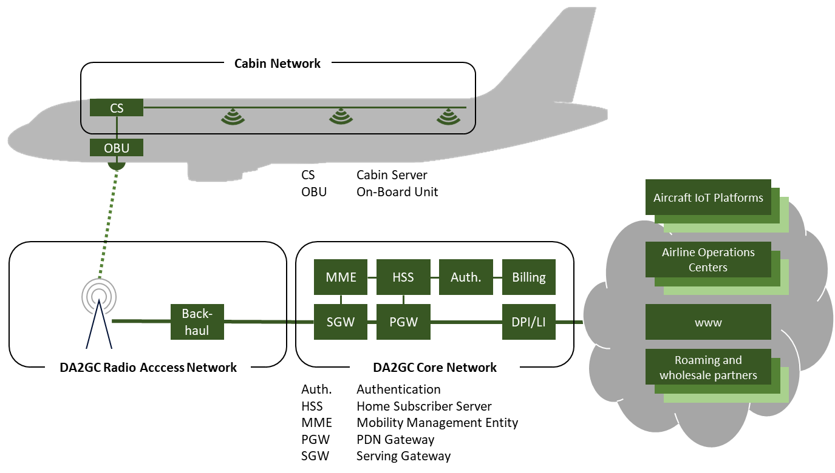

## 2.3 DA2GC spectrum aspects

Paired spectrum of 2 × 15 MHz for frequency division duplex (FDD) operation is deployed by EAN to meet the demand of the first airlines using the system. To cater for the additional capacity demand of more aircraft coming online and each aircraft consuming more data, the system could be scaled to the full 2 x 30 MHz.

## 2.4 DA2GC experience

EAN is in live commercial operations since 2018. Its DA2GC system reset the benchmark for connectivity in the skies with regards to capacity, latency, per-aircraft throughput, network densification flexibility, aircraft retrofit time, aircraft retrofit cost, and cost per bit.

Key properties of the DA2GC system include:

– The radio link between the GS and Aircraft Station (AS) is established at distances of up to 150 kilometres from the sites to the aircraft, with aircraft flying at speeds of more than 1.200 km/h and altitudes up to 12 000 metres.

– Peak data rates of up to 100 Mbit/s in the forward link (ground-to-air) and 30 Mbit/s in the reverse link (air-to-ground), as well as round-trip times of less than 50 milliseconds are consistently being achieved.

– Cell ranges are designed in consideration of local air traffic densities, spanning from 30 kilometres around the major aviation hubs to 150 kilometres in sparsely flown areas.

– The traffic mix is dominated by streaming applications and messaging applications, thus the user behaviour resembles that of terrestrial services.

{Editor’s Note: Text below not considered necessary, as meanwhile the European Aviation Network has been implemented across all of Europe, which follows the architecture of the originally proposed System 1.}

{Editor’s Note: Text below not considered necessary, as meanwhile the European Aviation Network has been implemented across all of Europe, which follows the architecture of the originally proposed System 1.}

# 3 Broadband Direct-Air-to-Ground Communications (DA2GC) systems within the Middle East

## 3.1 Introduction

A broadband Direct-Air-to-Ground Communications (DA2GC) system constitutes an application for various types of telecommunication services, such as Internet access and mobile multimedia services, during flights. It aims to provide access to broadband communication services during domestic and regional flights. With 200 million air passengers annually, the Middle East is one of the largest aviation markets and home to some of the largest airlines worldwide.

The main application field is Air Passenger Communications (APC). In addition, a broadband DA2GC system can also support Airline Administrative Communications services (AAC) and thus improve aircraft operation. Safety-relevant communications such as Air Traffic Control (ATC) and related services are not intended to be covered.

## 3.2 DA2GC system architecture

A DA2GC system is based on 3GPP LTE Rel. 10+ specifications. In particular, synchronization algorithms of the On-board Unit (OBU) are modified compared to terrestrial mobile radio usage in order to cope with the high Doppler frequency shift caused by aircraft speed, and the Tx power is increased to enable very large cell sizes. In addition, the GS antenna adjustment is matched to cover typical aircraft altitudes between 3 and 12 kilometres by adaptation of vertical diagrams including antenna up-tilt.

The major building blocks of the DA2GC system architecture are:

– service access network infrastructure on-board the aircraft, e.g., Wi-Fi coverage and Mobile Communications on board Aircraft (MCA), both already standardized and certified for on-board implementation;

– broadband DA2GC network infrastructure on-board aircraft, e.g., modem (OBU), interface to on‑board network(s), external antenna, cabling;

– terrestrial radio access network for broadband DA2GC, consisting of GS that are configured with special DA2GC radio heads and antennas to establish high-performance radio links to aircraft. These GS are deployed on elevated sites with clear line of sight to the horizon and are furnished with broadband backhaul links;

– dedicated mobile core network for a session, mobility, subscriber and security management providing IP connectivity to external packet data networks (e.g., intranet, Internet, IMS);

– central network components required for O&M, billing, etc. in the DA2GC network;

– various IP-based service delivery platforms, e.g., for passenger services or for airline or aircraft repair/manufacturer internal applications.

Figure XYZ

DA2GC system architecture



Figure XYZ: DA2GC system architecture

## 3.3 Spectrum aspects in Saudi Arabia

In April 2021, the Communications and Information Technology Commission (CITC) of Saudi Arabia has launched its Spectrum Outlook for Commercial and Innovative Use 2021-2023[4]. The spectrum outlook details Saudi Arabia's path to becoming a world leader in radiocommunication and wireless technologies by attracting investments, meeting current data and connectivity demands, and proactively anticipating future needs. Correspondingly in this outlook, CITC aims to leverage innovation in spectrum management by expanding its range of resources and services, while ensuring the digital ecosystem is ready to unlock its full potential. Drafting this outlook followed a transparent and collaborative process that involved public consultation and engagement with more than 65 wireless technology organizations from different 20 countries. The broad aim of this Spectrum Outlook is to adopt a range of measures to provide transparency and predictability for all spectrum users in the Kingdom, providing spectrum users certainty over the amount of spectrum available in different bands. One of these measures referred to the future release of the bands 1 980‑2 010 MHz and 2 170-2 200 MHz in a technology-neutral auction in 2021, which acknowledges industry interest to deploy a DA2GC system in these bands. Such a system would be compatible with the DA2GC component of the European Aviation Network, which already provides aerial broadband coverage across 30 European states.

## 3.4 DA2GC trial network and test flights in Saudi Arabia

In 2018, Saudi Arabia was the first country in the Middle East to deploy a DA2GC system for trial purposes. A total of 10 DA2GC Ground Stations and a dedicated DA2GC core network were deployed to cover the air routes between Riyadh and Jeddah, which is the busiest city pair with regards to domestic air travel.

The system architecture of the DA2GC trial system was a subset of the system architecture described above and resembled the DA2GC system architecture of EAN, including the same bands 1 980-1 995 MHz and 2 170-2 185 MHz for FDD operation. A test aircraft was equipped with Wi‑Fi access network infrastructure and DA2GC network infrastructure (OBU) and flown for 10.000 kilometres on different routes between Riyadh and Jeddah during a structured flight test campaign.

Key results of the trial included:

– Downlink (ground-to-aircraft) throughput above 90 Mbps and uplink (aircraft-to-ground) throughput above 30 Mbps

– Round Trip Time (RTT) of less than 50 milliseconds

– Various high-bandwidth-low-latency applications demonstrated, e.g., video conferencing, OTT video, social networking, and enterprise applications with VPN

– Live high definition video conference between the test aircraft and an exhibitor’s booth at the GITEX 2018 exhibition in Dubai

– Maximum distance between Ground Station and aircraft 120 kilometres

Annex 2  
  
Systems for public communications with aircraft in some countries in Region 2

# 1 System for public communications with aircraft in Canada and United States of America

In Canada[5] and the United States of America[6], the band pair 849-851 MHz and 894-896 MHz is allocated to the aeronautical mobile service for public correspondence with aircraft. These bands are designated for paired nationwide exclusive assignment to the licensee or licensees of systems providing radio telecommunication services, including voice telephony, broadband Internet and data transmission service, to persons on-board aircraft. However, fixed services and ancillary land mobile services are not permitted.

*[Editor’s note: Consider moving band plan to new Report.]*

In Canada and the United States of America, the band plan, described below in Fig. 5, is based on two block pairs: 849-850.5/894-895.5 MHz and 850.5-851/895.5-896 MHz. The band 849‑851 MHz is limited to transmissions from ground stations and the use of the band 894‑896 MHz is limited to transmissions from airborne stations.

FIGURE 5

The band plan for aeronautical mobile service in Canada and the United States



The technical rules for certification and systems deployment in the band in the United States and Canada are technology neutral. The maximum effective radiated power (e.r.p.) limits for ground stations and airborne stations are as follows:

|  |  |
| --- | --- |
| Ground station | 500 W e.r.p. |
| Airborne station | 12 W e.r.p. |

In the United States of America, the air-to-ground radiotelephone service falls under the U.S. Federal Communications (FCC) Part 22 rules, Subpart G. Commercial aviation air-ground systems may use any type of emission or technology that complies with these technical rules.

# 2 Safety-of-flight considerations

In addition to the administrations rules governing air-to-ground services, national aviation administration and aircraft operator rules and policies restrict the use of personal electronic devices (PEDs) on aircraft. The use of PEDs, which include wireless telephones, pagers, personal digital assistants, portable music players, video games and laptop computers, remains subject to national aviation administration and aircraft operator authority over in-flight safety. Providers of in-flight wireless broadband and other communications services for transmission using the air-to-ground frequencies must coordinate with airlines and comply with any national administration rules in order to offer such services. Aircraft operators undertake extensive testing and adhere to stringent safety certification protocols when installing and operating communications equipment to ensure that all avionics systems are protected from interference in accordance with national administration rules.

# 3 An example commercial aviation air-to-ground system operating in the United States consistent with IMT-2000 CDMA multi-carrier as described in Recommendation ITU-R M.1457

## 3.1 Introduction

This air-to-ground system is currently deployed and operational in continental United States and part of Alaska[7]. It operates in the 849-850.5 MHz and 894-895.5 MHz bands and offers in-flight broadband services to all Wi-Fi enabled laptops, notebooks and smartphones. It uses a modified version of the IMT-2000 CDMA[8] Multi-Carrier network to provide a high-speed connection directly from the aircraft to the ground. Some of the characteristics features of this network are: high capacity of 300 kbit/s to 500 kbit/s with peak rates of 3.1 Mbit/s, very large cell size (up to 400 km radius), modifications made to the IMT-2000 CDMA Multi-Carrier1xEV-DO air interface to accommodate extended cell coverage and airplane speed, deployment using off the shelf components such as Radio Access Networks (RANs) and Radio Network Controllers (RNCs).

## 3.2 System architecture

The overall end-to-end system architecture of this air-to-ground system is illustrated in Fig. 6.

FIGURE 6

IMT-2000 CDMA multi-carrier air-to-ground system network architecture



Each Radio Access Network (RAN) supports 1 carrier and 6 sectors. Each sector can generate about 2.2 Mbit/s peak throughput. The end users inside the airplane are on a local 802.11 access network connected to an access point (AP). The AP is connected to a 1x EV-DO card, which is the access terminal (AT) for the 1xEV-DO network and a point-to-point protocol (PPP) session is set up between the AT and the PDSN. In addition to data, VoIP can be supported as well. A cabin 2G/3G Picocell can be deployed to allow passengers place and receive voice calls on their own personal cellular phones. The authentication, authorization and accounting (AAA) server, one or more RNCs, packet data serving node (PDSN), media gateways (MGW), Softswitch which controls the MGWs, SIP Server/Registrar can all be co-located in one location.

## 3.3 Modifications to the IMT-2000 CDMA multi-carrier air-interface

The following sections describe the various enhancements made to the IMT-2000 CDMA multi-carrier 1xEV-DO air interface in order to enable its application as a viable air interface technology for air-to-ground communication.

### 3.3.1 Expanded range of Doppler shifts

Airplanes travel at speeds far greater than is usual for the operation of cellular mobile units, including high speed trains. For the worst-case orientation of a plane traveling at 340 m/s and at a carrier frequency of 850 MHz, the Doppler frequency shift seen by the airborne access terminal is approximately 964 Hz. When the terminal transmits, the Doppler shift perceived by the base station is approximately doubled to 1 928 Hz. The different searching operations at both the base station and the access terminal needed to be modified to accommodate the extended range of the observed Doppler shifts.

At the base station, the access channel searching algorithm is extended to additional frequency bins that cover the expected Doppler range of the airborne system. Furthermore, in case of handoff searching, when a sector gets added to the access terminal’s (AT) active set, the newly added sector needs to search and start demodulating the AT’s signal. However, the newly added sector may not be managed by the same base station that was already demodulating the access terminal, and hence the new base station needs to perform the same search procedure that is used for the access channel. When the access terminal tracks one sector and monitors other sectors for handoff, there could be a frequency offset differential due to different Doppler shifts between the serving sector and the candidate sectors. This means that there is an underestimation of the true SINR of the candidate pilot, because the SINR estimator suffers from phase coherence loss due to frequency error. SINR estimation for non-serving sectors needs to be compensated using estimates of Doppler frequency shifts.

### 3.3.2 Expanded cell radius

The airborne system supports cell radii of up to 400 km. The cell radii for a typical terrestrially‑based cellular system are in the order of a few kilometres. In order to cope with large cells, modifications to the baseline reverse link demodulation algorithms are needed. A larger traffic search window is required to search for multipath components, and the multipath search window is extended to 256 chips. The reasoning for this is that the existence of strong multipath components is much more unlikely in the airborne system than in typical terrestrial cellular systems due to radio propagation conditions. Nevertheless, if a signal multipath component were to exist, then the lag difference between the main line-of-sight path and the multipath will most likely be much greater than the few chips (normally less than 10) that is typical in terrestrial communications. For this reason the search window sizes should be extended to 256 chips, corresponding to ~64 kilometres. Furthermore, due to larger cell radii as compared to the conventional terrestrial cellular systems, a much bigger access channel search window is required. If the cell radius is assumed to be *R* km, then the maximum possible time of arrival difference between two airplanes inside the cell (measured in chips) is given by the following equation.



where *c* is the speed of light in m/s. For *R* = 400 km, we obtain Δ ~ 3 333chips. This quantity is how large the total access channel search window needs to be.

Changes to some search parameters are also needed on the AT side to support large cell radii. In order for the AT to find neighbouring sectors and correctly perform active and candidate set management, the neighbour search windows have to be increased. This is because with large cell radii, the differential delay between the serving sector and transmissions from candidate sectors can be quite large. Given the geometry of the network, it should be sufficient for the neighbour search windows to be expanded by a factor of 8, and this can be accomplished by reinterpreting the search window size field in the neighbour list message[9].

Additional changes need to be made for increasing the data rate control (DRC) length. In the IMT‑2000 CDMA multi-carrier 1xEV-DO system, the access terminal continuously sends its desired forward link data rate on the DRC to the base station. The DRC word can extend 1, 2, 4 or 8 reverse link slots. Right after the access terminal has finished sending a given DRC, it expects that the next forward link slot directed to it will be encoded according to its last DRC request.

The reverse link timing of the DRC channel is advanced by one-half slot with respect to the forward link timing for the base station to allow the base station enough time to process the last DRC sent by each AT. This 1 024-chip budget is more than enough for regular terrestrial communications since the cell radii are of the order of a few km. However, for the airborne system, this is insufficient since the one-way propagation delay to the edge of a base station covering 250 kilometres is already around 1 024 chips. The solution lies in choosing a long DRC length and, at the base station side, decoding the DRC word before the whole length of it has been received.

### 3.3.3 Handoff

The IMT-2000 CDMA Multi-Carrier 1xEV-DO airborne system uses multiple transmit and receive antennas on the access terminal side. The system uses four antennas, two sets of cross-polarization pairs. The access terminal has two antenna ports and a switch matrix to control multiplexing of the four antenna inputs into the two antenna ports on the access terminal. To provide spatial diversity in demodulation of the serving sector, the system combines the two antenna inputs belonging to the best or strongest polarization. Occasionally, the access terminal needs to search other antenna ports for possible transmissions from other sectors. To do so without breaking the connection to the serving sector, the access terminal effectively switches to single antenna demodulation. At the same time, the antenna port connected to the antenna with weaker input is switched to other antenna inputs to search for pilot transmissions from sectors on the AT’s neighbour list. When this brief search is done, the AT resumes dual antenna demodulation.

The purpose of the IMT-2000 CDMA multi-carrier 1xEV-DO airborne system handoff procedure is to ensure that the access terminal is communicating with the access network (AN) through the best or strongest serving sector while using its best polarization pair of antennas for forward link demodulation. At the same time, the access terminal should transmit on the reverse link using its best antenna in orientation and polarization. The complexities of the airborne handoff procedure arise from the fact that as the serving sector changes, so does the concept of best antennas on the forward and reverse links.

# 4 System for general aviation air-to-ground radiotelephone within the United States of America

*[Editor’s note: Consider moving band plan to new Report.]*

## 4.1 General aviation air-to-ground radiotelephone service

This service operates in the 454-459 MHz band and can provide a variety of telecommunication services to private aircraft such as small single engine planes and corporate jets. CFR47[10] § 22.805 contains the channel allocations for the general aviation air-to-ground service. These channels have a bandwidth of 20 kHz and are designated by their centre frequencies in megahertz.

TABLE 1

Signalling channel pair for general aviation air-ground systems

|  |  |
| --- | --- |
| Ground | Airborne mobile |
| 454.675 | 459.675 |
| a) Channel 454.675 MHz is assigned to each and every ground station, to be used only for automatically alerting airborne mobile stations of incoming calls.  b) All airborne mobile channels are assigned for use by each and every airborne mobile station. | |

Communication channel pairs

|  |  |
| --- | --- |
| Ground | Airborne mobile |
| 454.700 | 459.700 |
| 454.725 | 459.725 |
| 454.750 | 459.750 |
| 454.775 | 459.775 |
| 454.800 | 459.800 |
| 454.825 | 459.825 |
| 454.850 | 459.850 |
| 454.875 | 459.875 |
| 454.900 | 459.900 |
| 454.925 | 459.925 |
| 454.950 | 459.950 |
| 454.975 | 459.975 |

The transmitting power of ground and airborne mobile transmitters operating in the general aviation air-ground radiotelephone service on the channels listed in CFR 47 § 22.805 must not exceed:

a) Ground station transmitters:the effective radiated power of ground stations must not exceed 100 Watts and must not be less than 50 Watts, except as provided in CFR 47 § 2.811.

b) Airborne mobile transmitters:the transmitter power output of airborne mobile transmitters must not exceed 25 Watts and must not be less than 4 Watts.

Annex 3  
  
Systems for public communications with aircraft[11] in some countries in Region 3

# 1 Introduction

In some countries in Region 3, there are currently two systems aiming to provide broadband DA2GC. These are described in the sections below.

# 2 Air-to-ground communication system in China

## 2.1 Introduction

To meet the growing demand of the current and future airborne broadband communication, China has made significant effort on planning, developing, and deploying the air-to-ground (ATG) communication systems with aircraft. The system is based on the SCDMA broadband wireless access standard in Recommendation ITU-R M.1801. The SCDMA ATG wireless broadband access system contains base stations and terminals. The base stations are deployed to cover the entire flight course and communicate with the airborne terminals to achieve broadband communication between the ground and airplanes. The prototype systems have been successfully tested in trial flights at the frequency range of 1.785-1.805 GHz. The system’s ATG broadband communication capability has been successfully tested in China.

## 2.2 Operational features

The system operational features are as follows:

– Automatically connecting to the terrestrial broadband wireless network to provide air‑to‑ground communications.

– Supporting the voice, trunked voice and broadband data communication services such as providing backhaul of the on-board Wi-Fi, cellular pico-cells, and on-board wireline voice calls and Internet access.

– Supporting the seamless communication roaming and handoff on the complete flight course.

## 2.3 System architecture

The basic system architecture is shown in Fig. 7.

The system functions are as follows:

– The system includes base stations (BTS) on the ground connected to PSTN, Internet and airborne terminals with interfaces to other on-board devices such as wireline hubs, Wi‑Fi routers, pico-cells, among others.

– The radio access layer provides the radio access functions between the BTS and airborne terminals. The radio access layer performs basic radio access functions such as random access, paging, voice communications, data communications and trunked voice functions.

– The core control layer provides the control functions, such as handoff, roaming, terminal and user authentication, voice call switching, and data routing. It is between the BTS and other core network equipment such as data switches and routers, soft switches, media gateways, AAA (Authentication, Authorization, and Accounting) servers, billing servers, and HLR (Home Location Register).

– This entire ATG communication network including all layers supports separation of different data flows and also provides adequate protection on the data.

Figure 7

System architecture



## 2.4 Channelization scenario

The SCDMA radio interface supports a channel bandwidth of a multiple of 1 MHz up to 5 MHz. Sub-channelization and code spread, specially defined inside each 1 MHz bandwidth, provides frequency diversity and interference observation capability for radio resource assignment with bandwidth granularity of 8 kbit/s. The channelization also allows coordinated dynamic channel allocations among cells to efficiently avoid mutual interference. The system employs TDD to separate uplink and downlink transmission.

# 3 Air-to-ground communication system in Japan

## 3.1 Background

Demand has increased for better mobile phone and wireless local area network (LAN) access for people on-board aircraft. Now, several airlines have started cabin use of cellular phones with a system involving satellites. Meanwhile, in Japan, the air-to-ground (ATG) communication system with aircraft, which achieves over 100 Mbit/s transmission speed, is also being studied. In the system, the 40 GHz band facilitates broadband wireless communications on airplanes and on the ground. As shown in Fig. 8, airplanes fly over ground tracking antennas arranged at regular intervals.

As the aircraft passes overhead, the antennas hand over service one after another to the aircraft. The 40 GHz band is not used heavily in commercial applications and is expected to facilitate the broadband communication system.

Figure 8

Over 40 GHz wave broadband wireless direct communication system   
between air and ground operated in Japan



## 3.2 Descriptions of system architecture and communication equipment

The specifications of the proposed communication system and the airborne/ground equipment are described below. The frequency bands of the up and down links are supposed to use the 40 GHz frequency range and are tentatively given at 44 and 46 GHz bands, respectively for the prototype development. Table 2 summarizes the specification of the proposed communication system.

TABLE 2

Specifications of the communication system

|  |  |  |
| --- | --- | --- |
| Item | Specifications | Remark |
| Coverage area | 10 km ~ 50 km in radius | Depend on weather conditions and communication speed. |
| Transmission rate | Up to 100 Mbit/s or over | Variable |
| Protocol | Full-duplex |  |
| Frequency | Downlink: 44.45 GHz ± 100 MHz  Uplink: 46.8 GHz ± 100 MHz | The frequencies are tentatively allocated. |

The system uses the frequency division multiplex (FDM) method for communication.

Considering the characteristics of the millimetre wave and the spectrum efficiency, both the airborne and the ground antenna track each antenna position. Therefore, the antenna system needs to consider the characteristics of the millimetre wave and the geographical dimensions. For example, the ground-based tracking antenna must continuously track the aircraft with a high degree of accuracy. Meanwhile, the airborne antenna must track the ground-based antenna based on the aircraft attitude and position, and must be also compact and lightweight.

A) Ground station antenna

The ground station has a mechanically controlled reflector to direct the antenna beam in a specific direction by tilting the reflection disk mechanically as shown in Fig. 9. With a reflector controlling the antenna beam in the system, the mechanism provides a cost-effective, power‑efficient tracking antenna. Furthermore, a radio wave was separately transmitted at 44.55 GHz, in addition to the communication signal wave so that the system could execute the mono-pulse tracking technique by monitoring the reception level of the radio wave signal.

Figure 9

Prototype of ground tracking antenna with lens antenna

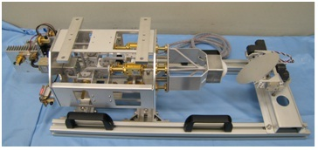

800 mm

Moving reflector

Lens antenna

B) Airborne antenna

As shown in Fig. 10, the airborne antenna consists of a transmission (left) and a reception (right) components using active phased array antenna (APAA) technology, which is capable of two‑dimensional electronic antenna scanning. The APAA is composed of 64 elements in an eight‑by-eight array. The approximate weight of the antenna is 11 kilogrammes. Each element of the APAA is connected to the transmitting/receiving module to control the antenna beam direction by changing the phase component with 4-bit resolution. In addition, the directional control of the antenna is limited to ±45 degrees as a device specification.

FIGURE 10

Appearance of transmission and reception components of active phased array antenna

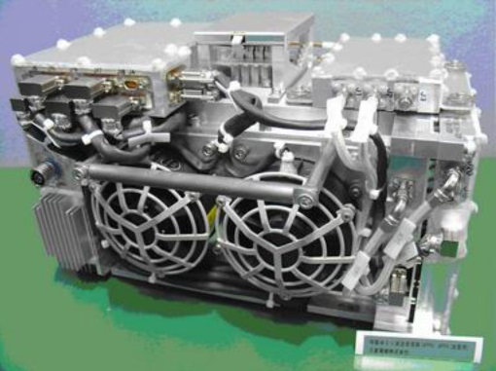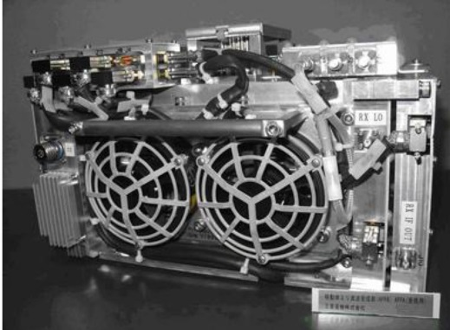

300 mm

## 3.3 Verification tests and results

To verify the overall performance of this system, several trial flights with the prototype equipment were successfully conducted in 2012. This verification was mainly for the basic property of the airborne antenna, the ground tracking antenna, access control equipment and some other equipment. An airplane with the APAA was used as the airborne station. Table 3 presents an overview of the airborne verification test, and Fig. 11 illustrates a diagram of the airborne verification test.

The transmission and reception frequencies were allocated as 46.8 GHz and 44.45 GHz, respectively, for simultaneous transmission. The data transfer rate was 141.7 Mbit/s when QPSK modulation with a symbol rate of 78 Msymbol/s was applied. The 106.3 Mbit/s transfer rate was realized when 8PSK modulation with a symbol rate of 39 Msymbol/s was applied.

The antenna control information, such as the reception level and antenna directional data, was stored in the control sections. The modem signal and the error information of Bit Error Rate (BER) or Packet Error Rate (PER) (circuit quality) were also stored in the modem sections at both the airborne and ground stations. The flight data, which consist of airplane position/attitude information, were stored only on the aircraft. The ground station treats the transmitting and receiving data through millimetre waves.

TABLE 3

Airborne verification test overview

|  |  |
| --- | --- |
| Item | Contents |
| Airborne station | Active phased array antenna |
| Ground station | Millimetre-wave transmitter/receiver with mechanical driven antenna |
| Frequency | Uplink: 46.8 GHz  Downlink: 44.45 GHz |
| Data transfer rate | 141.7 Mbit/s at 78 Msymbol/s (QPSK)  106.3 Mbit/s at 39 Msymbol/s (8PSK) |
| Acquisition data | – Control information such as reception level and antenna directional data.  – Modem signal, error information of packet error rate or bit error rate.  – Flight data (airborne status such as position/attitude information). |

Figure 11

Airborne verification test system

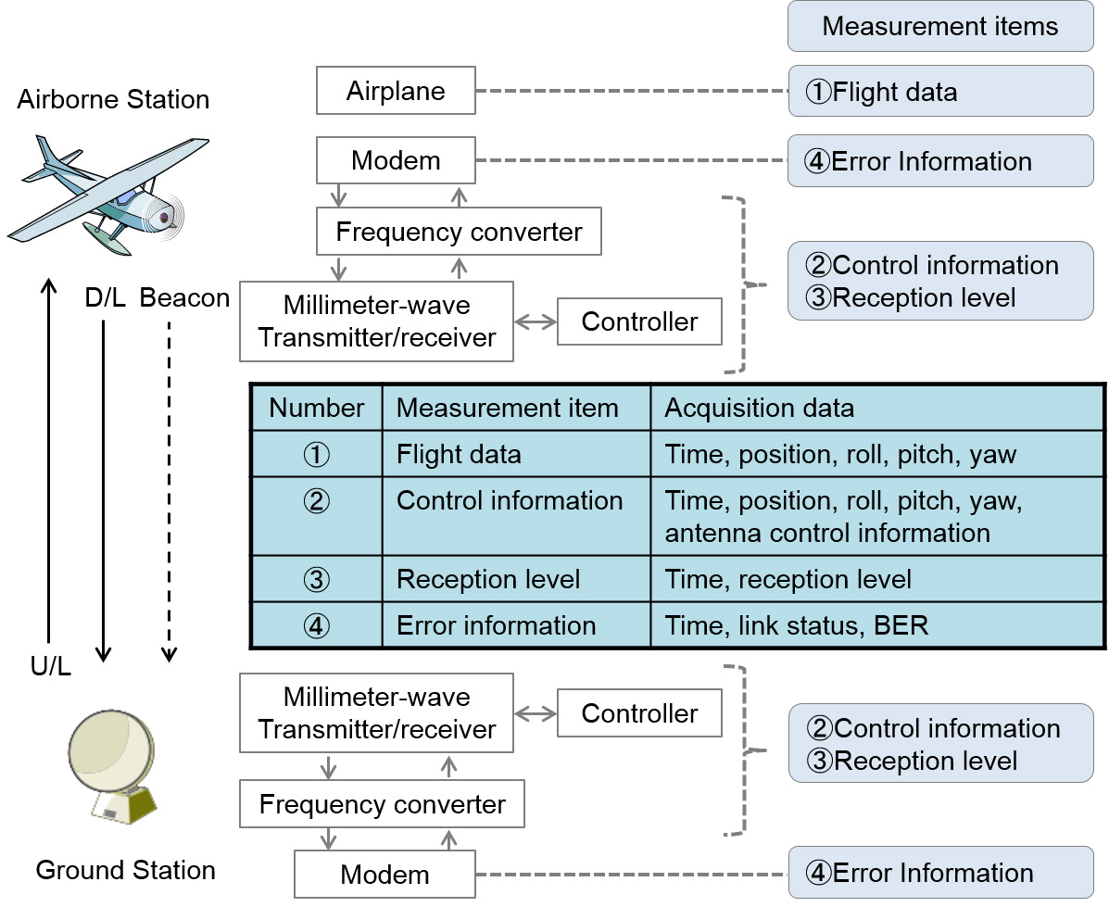

We evaluated the following items in the airborne verification test:

a) antenna pattern measurement;

b) tracking ability test;

c) communication capability test and mass volume data transfer test; and

d) communication distance test.

Finally, the results confirmed the success of the airborne verification tests as follows:

a) The beam width of the antenna was observed at about 8 degrees in the airborne tests, while it was observed at 10 degrees in an anechoic chamber. Although the width becomes approximately 2 degrees narrower than that of the designed value, the characteristics of the antenna beam were almost identical.

b) The system with tracking mode could track each antenna position correctly when the maximum angular ground speed was 229.65 km/h at an altitude of 785.47 m, which corresponds to 4.7 degrees per second in calculation.

c) Reception level and BER characteristics were measured and confirmed when the modulation types were QPSK and 8PSK and the flight altitude was approximately 2 000 m.

d) The results indicated that communication was established for a horizontal distance of 2 380 m and a flight altitude of 1 816 m, thus the communication distance was approximately 3 km. At this time, the angle of elevation sighting the airborne station from the ground station is 38 degrees, which was confirmed as a minor difference compared to the device specification of 45 degrees for the beam scan range of the APAA used on the airborne station.

Application of these results to various aircraft shall establish an environment that enables mass volume downloading with bidirectional IP communication.

1. <http://www.worldatlas.com/articles/countries-by-smartphone-penetration.html>.
2. <https://newzoo.com/insights/rankings/top-50-countries-by-smartphone-penetration-and-users/>.
3. <https://en.wikipedia.org/wiki/List_of_countries_by_smartphone_penetration>.
4. [Spectrum Outlook for Commercial and Innovative Use 2021- 2023, CITC (2021).](https://www.citc.gov.sa/en/mediacenter/pressreleases/PublishingImages/Pages/2021033001/Spectrum%20Outlook%20for%20Commercial%20and%20Innovative%20Use%202021-2023.pdf)
5. Refer to <http://www.ic.gc.ca/eic/site/smt-gst.nsf/eng/sf09134.html>.
6. Refer to: <http://www.gpo.gov/fdsys/pkg/CFR-2010-title47-vol2/pdf/CFR-2010-title47-vol2-part22-subpartG-subjectgroup-id140.pdf>.
7. <http://www.gogoair.com/gogo/cms/work.do>.
8. CDMA2000 High Rate Packet Data Interface Specifications, 3GPP2 C.S0024-A Version 1.0, March.
9. Refer to <http://www.ic.gc.ca/eic/site/smt-gst.nsf/eng/sf09134.html>, § 9.7.6.2.5.
10. Refer to: <http://www.gpo.gov/fdsys/pkg/CFR-2010-title47-vol2/pdf/CFR-2010-title47-vol2-part22-subpartG-subjectgroup-id140.pdf>.
11. APT has developed a guideline on the maximum permitted power for cellular base stations onboard aircraft. See [APT/AWF/OP-02(Rev.2)](http://www.apt.int/sites/default/files/Upload-files/AWG/APT-AWF-OP-2Rev.2APT_Opinion_on_Mobile_Technical_Guidelines_onboard_aircraft.doc): APT Guideline on “Technical conditions for the use of mobile phones on-board aircraft”.