|  |  |
| --- | --- |
| **Radiocommunication Study Groups** |  |
|  |  |
|  |  |
| Source: Document 5A/TEMP/199 | **Annex 24 to Document 5A/597-E** |
| **3 June 2022** |
| **English only** |
| Annex 24 to Working Party 5A Chairman’s Report | |
| WORKING DOCUMENT TOWARDS A PRELIMINARY DRAFT NEW  REPORT ITU-R M.[LMS.CONDITIONS>275GHz] | |
| Assessment of mitigation techniques and specific conditions to be applied to the land mobile service applications in the frequency bands 296-306 GHz, 313‑318 GHz and 333-356 GHz, to ensure the protection of earth exploration-satellite service (passive) applications in accordance with RR No. 5.564A | |

(Question ITU-R 256/5)

[Editor’s note: The development of this report and related studies have to be performed in close cooperation with WP 7C and WP 7D (see Document [5A/225](https://www.itu.int/md/R19-WP5A-C-0225/en)).]

(…)

# 1 Introduction

The objective of this Report is to address the relevant aspects of RR No. **5.564A** and assess the specific conditions necessary to ensure the protection of Earth exploration-satellite service (passive) applications in the frequency bands 296-306 GHz, 313‑318 GHz and 333-356 GHz, to be determined in accordance with RR No. **5.564A**:

***5.564A*** *For the operation of fixed and land mobile service applications in frequency bands in the range 275-450 GHz:*

*The frequency bands 275-296 GHz, 306-313 GHz, 318-333 GHz and 356-450 GHz are identified for use by administrations for the implementation of land mobile and fixed service applications, where no specific conditions are necessary to protect Earth exploration-satellite service (passive) applications.*

*The frequency bands 296-306 GHz, 313-318 GHz and 333-356 GHz may only be used by fixed and land mobile service applications when specific conditions to ensure the protection of Earth exploration-satellite service (passive) applications are determined in accordance with Resolution****731 (Rev.WRC-19)****.*

*In those portions of the frequency range 275-450 GHz where radio astronomy applications are used, specific conditions (e.g. minimum separation distances and/or avoidance angles) may be necessary to ensure protection of radio astronomy sites from land mobile and/or fixed service applications, on a case-by-case basis in accordance with Resolution****731 (Rev.WRC-19)****.*

*The use of the above-mentioned frequency bands by land mobile and fixed service applications does not preclude use by, and does not establish priority over, any other applications of radio services in the range of 275-450 GHz.      (WRC‑19)*

The results of sharing and compatibility studies between LMS and FS applications planning to operate in the frequency range 275-450 GHz and passive services (radio astronomy service and Earth exploration-satellite service (passive)) that have been done pre-WRC-19 in [Report ITU-R SM.2450](https://www.itu.int/pub/R-REP-SM.2450) remain valid; however, these studies conducted prior to WRC-19 did not seek to develop specific conditions (such as power limits, shielding requirements and/or elevation angle restrictions, etc.) that could facilitate sharing with EESS and focused on identifying spectrum for LMS/FS applications, where such restrictions would not be necessary to protect the passive services.

# 2 Related Recommendations and Reports

|  |  |
| --- | --- |
| [Recommendation ITU-R M.1825](http://www.itu.int/rec/R-REC-M.1825/en): | Guidance on technical parameters and methodologies for sharing studies related to systems in the land mobile service |
| [Recommendation ITU-R P.676](https://www.itu.int/rec/R-REC-P.676/en): | Attenuation by atmospheric gases |
| [Recommendation ITU-R P.838](https://www.itu.int/rec/R-REC-P.838/en): | Specific attenuation model for rain for use in prediction methods |
| [Recommendation ITU-R P.840](https://www.itu.int/rec/R-REC-P.840/en): | Attenuation due to clouds and fog |
| [Recommendation ITU-R P.2109](https://www.itu.int/rec/R-REC-P.2109): | Prediction of building entry loss |
| [Recommendation ITU-R RS.2017](https://www.itu.int/rec/R-REC-RS.2017/en): | Performance and interference criteria for satellite passive remote sensing |
| Report [ITU-R M.2417](https://www.itu.int/pub/R-REP-M.2417): | Technical and operational characteristics of land-mobile service applications in the frequency range 275-450 GHz |
| [Report ITU-R RS.2431](https://www.itu.int/pub/R-REP-RS.2431): | Technical and operational characteristics of EESS (passive) systems in the frequency range 275-450 GHz |
| [Report ITU-R SM.2352](https://www.itu.int/pub/R-REP-SM.2352): | Technology trends of active services in the frequency range 275‑3 000 GHz |
| [Report ITU-R SM.2450](https://www.itu.int/pub/R-REP-SM.2450): | Sharing and compatibility studies between land-mobile, fixed and passive services in the frequency range 275-450 GHz |
| … |  |

# 3 List of acronyms and abbreviations

|  |  |
| --- | --- |
| … |  |
|  |  |

# 4 System characteristics of Earth exploration-satellite service (passive) operating in the frequency range 275-450 GHz, relevant for the mobile service

## 4.1Technical characteristics

[Editor’s note: Summarize key elements from Recommendation [ITU-R RS.2017](https://www.itu.int/pub/R-REP-RS.2017).]

Table 1  
(Source: Recommendation ITU-R RS.2017)

Performance criteria for satellite passive remote sensing in the frequency range 296-306 GHz and 313-355.6 GHz

|  |  |  |  |
| --- | --- | --- | --- |
| Frequency band(s)  (GHz) | Required ΔTe (K) | Data availability(1) (%) | Scan mode  (N, C, L)(2) |
| 296-306 | 0.2/0.005(3) | 99.99/99(3) | N, L |
| 313.5-355.6 | 0.3/0.005(3) | 99.99/99(3) | N, C, L |
| (1) Data availability is the percentage of area or time for which accurate data is available for a specified sensor measurement area or sensor measurement time. For a 99.99% data availability, the measurement area is a square on the Earth of 2 000 000 km2, unless otherwise justified; for a 99.9% data availability, the measurement area is a square on the Earth of 10 000 000 km2 unless otherwise justified; for a 99% data availability the measurement time is 24 h, unless otherwise justified.  (2) N: Nadir, Nadir scan modes concentrate on sounding or viewing the Earth’s surface at angles of nearly perpendicular incidence. The scan terminates at the surface or at various levels in the atmosphere according to the weighting functions. L: Limb, Limb scan modes view the atmosphere “on edge” and terminate in space rather than at the surface, and accordingly are weighted zero at the surface and maximum at the tangent point height. C: Conical, Conical scan modes view the Earth’s surface by rotating the antenna at an offset angle from the nadir direction.  (3) First number for nadir or conical modes and second number for microwave limb sounding applications. | | | |

TABLE 2  
(Source: Recommendation ITU-R RS.2017)

Interference criteria for satellite passive remote sensing in the frequency range 296-306 GHz and 313-355.6 GHz

|  |  |  |  |  |
| --- | --- | --- | --- | --- |
| Frequency band(s)  (GHz) | Reference bandwidth (MHz) | Maximum interference level  (dBW) | Percentage of area or time permissible interference level may be exceeded(1) (%) | Scan mode  (N, C, L)(2) |
| 296-306 | 200/3(3) | −160/−194(3) | 0.01/1(3) | N, L |
| 313.5-355.6 | 200/3(3) | −158/−194(3) | 0.01/1(3) | N, C, L |

The above notes under Table 1 also applies to Table 2.

…

## 4.2Overview of EESS (passive) systems operating in the frequency range 296 GHz - 355.6 GHz

TBD

# 5 Overview of planned land-mobile service applications in the frequency range 275-450 GHz

Report ITU-R M.2417 provides the technical and operational characteristics of land-mobile service applications, both indoors and outdoors, in the frequency range 275-450 GHz for sharing and compatibility studies, including:

– Close proximity mobile systems (CPMSs)

– Kiosk downloading mobile systems

– Ticket gate downloading mobile systems

– Inter-chip communication systems

– Intra-device communications

– Wireless links for data centres

– Virtual reality systems

– Industrial systems

…

# 6 Propagation considerations

One of the propagation effects in this frequency range is gaseous attenuation (Recommendation [ITU‑R P.676](https://www.itu.int/rec/R-REC-P.676/en) for terrestrial and slant paths). Specific gaseous attenuation is shown in Figure 1 on the height of the ground level (pressure 1013 hPa, temperature 15 deg C, water vapour density 7.5 g/m3) using the methodology from Annex 1 of Recommendation ITU-R P.676-12. The figure illustrates quite different propagation conditions for different bands identified in this frequency range.

FIGURE 1

Specific atmospheric attenuation in 275-450 GHz frequency range on the ground level

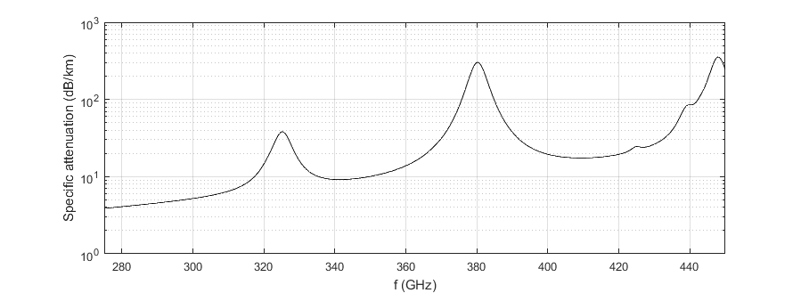

The other elements such as building entry loss and clutter loss should be considered for the system deployment of land-mobile service applications. Although prediction of those losses is provided by Recommendations [ITU-R P.2108](https://www.itu.int/rec/R-REC-P.2108/en) and [ITU-R P.2109](https://www.itu.int/rec/R-REC-P.2109/en), the maximum frequency band is limited below 100 GHz. Further studies on those issues are expected in the future work plans by the other groups.

# 7 Mitigation techniques and specific conditions to be applied to the land mobile service applications

This section provides a list of possible mitigation techniques and specific conditions to be applied to the land mobile service applications to ensure the protection of EESS (passive) applications in the frequency bands 296-306 GHz, 313-318 GHz and 333-356 GHz.

For each mitigation technique under consideration, together with their application conditions, if any, a detailed description is made including the way it is expected to improve sharing with EESS (passive) systems. In addition, an assessment of their effectiveness is also made, including relevant additional sharing studies in comparison to the previous studies given in [Report ITU-R SM.2450](https://www.itu.int/pub/R-REP-SM.2450).

[Editor’s note: the abovementioned assessment and sharing studies have to be performed in close cooperation with WP 7C and WP 7D (see Document [5A/225](https://www.itu.int/md/R19-WP5A-C-0225/en))].

The following possible mitigation techniques and specific conditions are assessed:

– Technique A,

– Technique B.

– …/…

[Editor’s note: The intent is to narrow down the list of possible mitigation techniques described below (from Recommendation ITU-R M.1825) and keep only those that may be worthwhile studying for this application]

[Recommendation ITU-R M.1825](http://www.itu.int/rec/R-REC-M.1825/en) outlines several mitigation techniques that can be investigated, among others, to assess their applicability for the applications above 275 GHz.

The following is a list of various existing interference mitigation techniques. Not all techniques in Recommendation ITU-R M.1825 are applicable to all types of systems, for example site shielding can be helpful for fixed systems but may not be used for mobile terminals. Similarly, some of these techniques are useful at both ends of an interfering link, while other techniques can only be applied to the interfering transmitter or to the victim receiver.

For the land-mobile service applications summarized in Section 5 that are indoors or under cover and the communicating devices are stationary and in close proximity, site selection and physical shielding may be effective mitigation techniques and are worth to be further studied:

*Site selection* – Choosing a site to minimize potential interference.

*Physical shielding* – Using natural terrain, buildings, special purpose fencing to block signal in undesired directions.

The use of cross-polarization between the land mobile transmitters and the EESS (passive) is worth studying as a mitigation technique:

*Cross-polarization* – The use of cross polarization can be used to introduce additional isolation between systems (see further discussion in Section 7.1).

*[Editor’s Note: The discrimination due to cross polarization depends on the polarization and the characteristics of the systems under study.]*

*[Synchronized time division* – The mitigation brought by ensuring the active systems avoids transmission during the time interval when the passive system is receiving.]

[Editor’s Note: Further discussion is needed to determine if and to what extent this technique is relevant to the scenarios covered in this report]

*Transmitter and receiver filtering* – Filtering is the ideal technique for avoiding, causing, or receiving adjacent channel interference.

[Editor’s Note: Further discussion is needed to determine if and to what extent this technique is relevant to the scenarios covered in this report]

For smart antenna systems (e.g., for AAS the antenna parameters would need to be carefully chosen):

*Smart antennas* – A smart antenna system combines multiple antenna elements with a signal-processing capability to optimize its radiation and/or reception pattern automatically in response to the signal environment. The benefit from the use of smart antennas on sharing is due to the fact that the RF energy radiated by antenna arrays is both lower than that from conventional antennas for the same e.i.r.p. and focused in limited, specific regions of a cell rather than wide sectors.

NOTE 1 – The two major categories of smart antennas, based on the choice of transmit strategy, are adaptive antennas and switched-beam antennas.

*Dynamic channel selection techniques* – The radio system can potentially use one of a number of channels within a band for each transmission. [The radio system listens on all of those channels to determine which ones are occupied and dynamically chooses the channel to be used accordingly. Such techniques include for example Dynamic Frequency Selection or Detect and Avoid mechanisms.]

[Editor’s Note: It has to be taken into account that EESS (passive) is receive-only.]

*Spread spectrum techniques* – As defined in Recommendation ITU-R SM.1055, the average energy of the transmitted signal is spread over a bandwidth which is much wider than the information bandwidth.

*Adaptive power control* – Systems using adaptive power control transmit using just enough power for a signal to go through. This minimizes the total amount of radio power that could potentially interfere with other systems and allows systems to adapt to poor conditions by temporarily increasing the transmitted power level.

Different technical solutions for mitigation may offer a different level of mitigation to devices of the same kind as compared to devices of a different kind. The level of mitigation may depend on the technology used and often on a combination of technical requirements.

[Editor’s note: Other mitigation techniques for consideration beyond those in Rec. ITU-R M.1825 may be added here].

…

These mitigation techniques are discussed further in sections below.

## 7.1 Cross-polarization discrimination

The isolation between interfering (LMS) and victim (EESS (passive)) stations which may be obtained with transmission on different polarizations depends on factors such as: types of polarizations used, cross-polarization characteristics and mutual placement of the polarization planes of both antennas, propagation conditions.

To assess the level of isolation between systems a following characteristic may be used if we compare with the received interference level without taking into account polarizations (illustration in Figure 2):

$I=\frac{P_{r all copolar}}{P_{r with cross-polarization}}=\frac{P*G_{max tr}*G_{max r}/L}{P_{r with cross-polarization}}$ (1)

where $P_{r all copolar}$ is a received interference power without taking into account polarizations (see Figure 2), $P$– power of the transmitter of interference station, $G_{max tr}$– antenna gain of interfering station antenna, $G_{max r}$– antenna gain of victim station, $L$– basic transmission loss. Arrows in Figure 2 and in figures below are polarizations. For simplicity we will consider the case when antennas of interfering and victim stations are aligned, but this can be replaced by real co-polar and cross-polar gains. Also it may be taken into account that for some types of antennas maximum cross-polar radiation may take place not in the direction of the main beam but in the diagonal planes.

FIGURE 2

Interference path without polarization discrimination

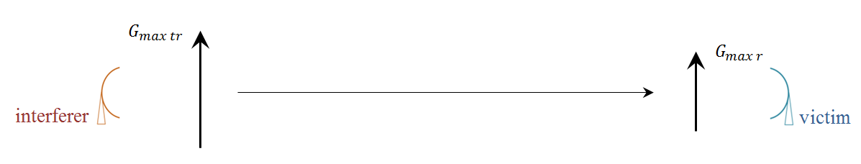

In general case equation (1) depends on a large number of factors, but two simple cases may be investigated if we take an assumption that both antennas use orthogonal linear polarizations and antennas are placed in parallel planes.

There are quite different definitions for some polarization characteristics but for the purposes of this document the following terms will be used, antenna cross-polarization and depolarization along the propagation path will be considered separately.

According to Recommendation [ITU-R P.530](https://www.itu.int/rec/R-REC-P.530/en), ‘cross-polarization isolation’ has the following definition: ‘For two radio waves transmitted with the same frequency with the same power and orthogonal polarization, the ratio of the co-polarized power in a given receiver to the cross-polarized power in that receiver’. Here this term will be used to describe antenna properties only:

$XPI=\frac{G_{max}}{G_{cross}}$, (2)

where $G_{max}$– antenna gain in the intended polarization, $G_{cross}$– antenna gain in the orthogonal polarization.

To assess depolarization along the propagation path a ‘cross-polarization discrimination’ may be used which has the following definition in Recommendation ITU-R P.530: ‘For a radio wave transmitted with a given polarization, the ratio at the reception of the power received with the expected polarization to the power received with the orthogonal polarization’. But we will use this term excluding impact of the cross-polarization characteristics of antenna:

$XPD=\frac{P_{copolar}}{P_{crosspolar}}$ (3)

where $P_{copolar}$ is the power received by ideal antenna having no cross-polarization, $P_{crosspolar}$– the power received by the same antenna but placed so that it is aligned with cross-polarization.

The first case is when propagation medium is isotropic (not depolarizing) and isolation between systems depends only on antennas (Figure 3).

FIGURE 3

Interference path with orthogonal polarizations without depolarization

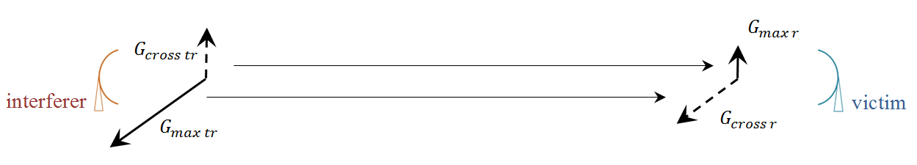

If an assumption is made that basic transmission loss will be the same for both polarizations we can write equation (1) in the following way:

$I=\frac{G_{max tr}G_{max r}}{G_{cross tr}G_{max r}+G_{max tr}G_{cross r}}=\frac{{XPI}_{tr}{XPI}_{r}}{{XPI}_{tr}+{XPI}_{r}}$, (4)

where ${XPI}_{tr}$ is cross-polarization isolation of interfering station antenna and ${XPI}_{r}$– cross-polarization isolation of victim station antenna. Isolation between systems calculated with equation (4) for different cross-polarization isolations of antennas is presented in Figure 4.

FIGURE 4

Isolation between systems when there is no depolarization on the path

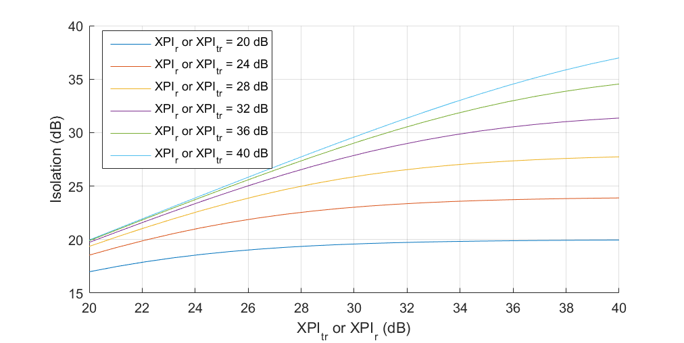

The second case is when ‘part of the power of a radio wave transmitted with a defined polarization is transferred to another polarization’ (definition of ‘depolarization’ from Recommendation ITU-R P.530) (Figure 5). Depolarization on Earth-space paths may be induced as by hydrometeors, as well as by Faraday rotation. Faraday rotation may be ignored at frequencies more than about 10 GHz. Depolarization on terrestrial paths may be due to multiple reflections by multipath propagation. Depolarization due to hydrometeors is caused by anisotropic propagation medium (raindrops or ice crystals) that produce different attenuations and phase shifts on radiowaves with different polarizations due to non-spherical form of raindrops and ice crystals, but the ITU-R model provided in Recommendation [ITU-R P.618](https://www.itu.int/rec/R-REC-P.618/en) is valid only up to 55 GHz.

FIGURE 5

Interference path with orthogonal polarizations with depolarization

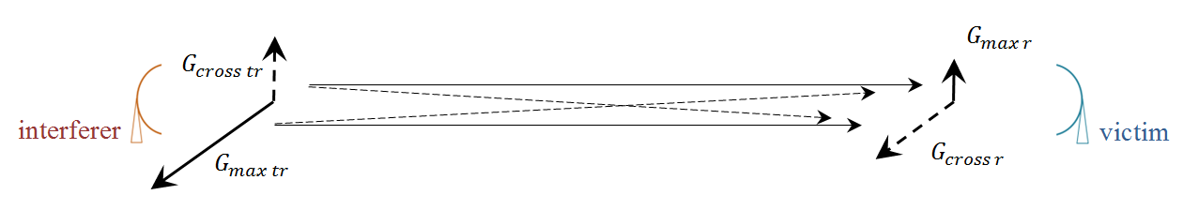

Isolation for systems with depolarization along the propagation path will take the following form (an assumption is made that basic transmission losses are the same for all four paths):

$$I=\frac{G_{max tr}G_{max r}}{G_{cross tr}G_{max r}\frac{{XPD}_{1}}{\sqrt{1+{XPD}_{1}^{2}}}+G_{cross tr}G_{cross r}\frac{1}{\sqrt{1+{XPD}_{1}^{2}}}+G_{max tr}G_{cross r}\frac{{XPD}_{2}}{\sqrt{1+{XPD}_{2}^{2}}}+G_{max tr}G_{max r}\frac{1}{\sqrt{1+{XPD}_{2}^{2}}}}$$

$I=\frac{{XPI}_{tr}{XPI}_{r}\sqrt{{1+XPD}_{1}^{2}}\sqrt{1+{XPD}_{2}^{2}}}{{XPI}_{r}{XPD}_{1}\sqrt{1+{XPD}_{2}^{2}}+\sqrt{1+{XPD}_{2}^{2}}+{XPI}_{tr}{XPD}_{2}\sqrt{1+{XPD}_{1}^{2}}+{XPI}_{tr}{XPI}_{r}{XPD}_{1}\sqrt{1+{XPD}_{1}^{2}}}$, (5)

where subscript ‘1’ for $XPD$ is for transfer of energy from the polarization co-polar for victim station to the orthogonal polarization and ‘2’ is for vice versa.

In Figures 6 and 7 the results are shown for abstract values of $XPD$ equal to 40 and 30 dB, respectively. It is evident that the most impact on isolation has the transfer of energy from cross-polar to copolar components in respect to victim polarization (${XPD}_{2}$).

FIGURE 6

Isolation when propagation medium is depolarizing, ${XPD}_{2}=40$ dB

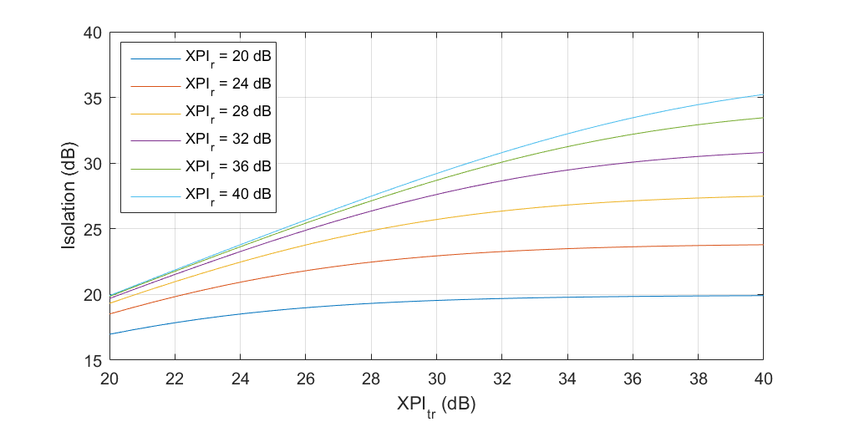

FIGURE 7

Isolation when propagation medium is depolarizing, ${XPD}_{2}=30$ dB

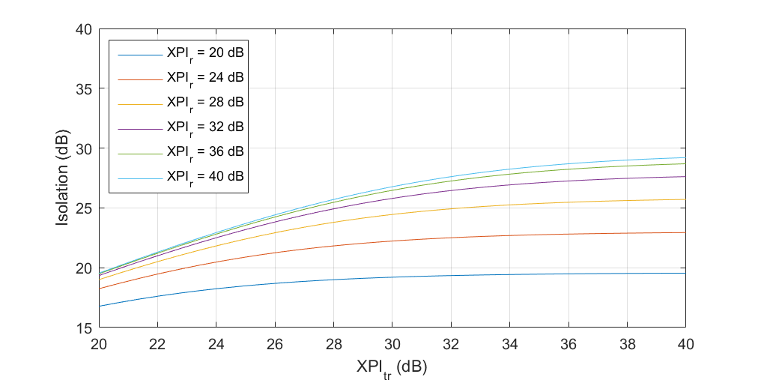

From Figures 6 and 7 it can be concluded that depolarization along the propagation path further decreases isolation between interfering and victim stations.

From the provided in this section results for linear polarization the following general conclusions may be drawn. The simplest case when interfering and victim antennas are located in parallel planes and there is no depolarization on the path shows that:

– firstly, isolation between the stations depends on crosspolar characteristics of both antennas;

– secondly, isolation between the stations compared with calculations without taking into account polarizations is worse than the lowest cross-polarization isolation of the two antennas (Figure 4).

The isolation will be further reduced if the propagation path is depolarizing one but it cannot be assessed due to the lack of depolarization models for the considered frequencies. However it should be taken into account that with increase of depolarization due to hydrometeors attenuation also will be significantly increased.

In reality antennas of interfering and victim stations are placed in the arbitrary planes with respect to each other so isolation between systems will be further reduced. Before a value of isolation between systems may be determined additional studies are needed in order not to make a mistake when assessing interference level.

## 7.2 [TBD]

______________