Radiocommunication Study Groups
Source: Document 5A/TEMP/258(Rev.1)  Subject: WRC-23 agenda item 9.1, topic b)  Resolution 774 (WRC-19) | Annex 6 to  Document 5A/708-E
 | 28 November 2022
 | English only
Annex 6 to Working Party 5A Chairman’s Report
Preliminary Draft New
Recommendation ITU-R M.[AS Guidance]
Guidance on technical and operational measures for the use of the frequency band 1 240-1 300 MHz by the amateur and amateur-satellite service in order to protect the radionavigation-satellite service (space-to-Earth)
Scope
This Recommendation provides guidance on technical and operational measures for administrations authorizing stations operating in the amateur and amateur-satellite services to protect the radionavigation satellite service (space-to-Earth) in the frequency band 1 240-1 300 MHz. The relevant measures are contained in the Annex to this Recommendation.
Keywords
Radionavigation satellite-service (RNSS), amateur service, amateur-satellite service,
Abbreviations/Glossary
RNSS: Radionavigation-satellite service
IARU: International Amateur Radio Union
ATV: Amateur Television
Related ITU Recommendations and Reports
Report ITU-R M.2513-0 – Studies regarding the protection of the primary RNSS (space-to-Earth) by the secondary amateur and amateur-satellite services in the frequency band 1 240-1 300 MHz.
Report ITU-R M.[AMATEUR.CHARACTERISTICS] – Amateur and amateur-satellite services characteristics and usage in the 1 240-1 300 MHz frequency band.
Report ITU-R M.2458 – RNSS applications in the 1 164-1 215 MHz, 1 215-1 300 MHz and 1 559-1 610 MHz frequency bands.
Recommendation ITU-R M.1902 – Characteristics and protection criteria for receiving earth stations in the RNSS (space-to-Earth) operating in the band 1 215-1 300 MHz.
Recommendation ITU-R M.1787 – Description of systems and networks in the RNSS (space-to-Earth and space-to-space) and technical characteristics of transmitting space stations operating in the bands 1 164-1 215 MHz, 1 215-1 300 MHz and 1 559-1 610 MHz.
Recommendation ITU-R M.2030 – Evaluation method for pulsed interference from relevant radio sources other than in the RNSS to the RNSS systems and networks operating in the 1 164-1 215 MHz, 1 215 1 300 MHz and 1 559-1 610 MHz frequency bands.
Recommendation ITU-R M.1732 – Characteristics of systems operating in the amateur and amateur-satellite services for use in sharing studies.
Handbook ITU-R 52 – Amateur and amateur-satellite services.
The ITU Radiocommunication Assembly,
considering
a) that the IARU develops, maintains and publishes detailed band plans for the operation and development of the amateur and amateur-satellite services in all three Regions;
b) that Report ITU-R M.[AMATEUR.CHARACTERISTICS] provides information on the applications and operational characteristics of the use of the band 1 240-1 300 MHz by the amateur and amateur satellite services;
c) that Report ITU-R M.2513-0 provides studies and measurements regarding the amateur and amateur-satellite services transmissions and their potential to cause harmful interference to RNSS (space-to-Earth), that, may under certain conditions, exceed the protection criteria given in Recommendation ITU-R M.1902;
d) that RNSS systems using the frequency band 1 240-1 300 MHz are operational, or becoming operational, worldwide, with the aim of supporting a wide range of new satellite positioning applications;
[e) that administrations wishing to implement this recommendation may need a transition period to make the necessary changes to their national amateur and amateur satellite services authorizations,]
recognizing
a) that the frequency band 1 240-1 300 MHz is allocated to the radionavigation-satellite service (space-to-Earth) on a primary basis;
b) that the frequency band 1 240-1 300 MHz is allocated to the amateur service on a secondary basis;
c) that under provision No. 5.282, the frequency band 1 260-1 270 MHz is allocated to the amateur-satellite service (Earth-to-space) on a secondary basis;
d) that the frequency band 1 240-1 300 MHz is also allocated worldwide to the earth exploration-satellite service (active), radiolocation service (Nos. 5.329 applies) and the space research service on a primary basis;
e) that the relation between the services mentioned in recognizing a), b), c) and d) above is stipulated in the provisions of Nos. 5.23 to 5.33 and these provisions shall continue to apply with respect to RNSS despite this recommendation;
f) that additional services are also allocated in some countries under No. 5.330 (fixed and mobile services) and No. 5.331 (radionavigation service) within the frequency band 1 215-1 300 MHz;

g) that the amateur and amateur-satellite services continually develop their use of the frequency band 1 240-1 300 MHz in accordance with No. 1.56 and 1.57;
h) that the maximum power of amateur stations is fixed by the administrations concerned as stipulated in No. 25.7;
20221123 Ed: this (i) text requires clarification and participants are encouraged to provide new input.
[i) that Administrations licensing the stations of the amateur and amateur-satellite services for domestic use and assigning relevant frequencies, are responsible for the compliance of those applications with the relevant provisions of the RR, especially the protection of primary services in neighbouring countries,]

recommends

1 that in order to facilitate coexistence between the services, administrations wishing to authorize the amateur and amateur-satellites services and RNSS across their territory in the frequency band 1 240-1 300 MHz, should use the technical and operational measures described in Annex 1 as guidance.

20221123 Ed: The meeting decided that a single annex was appropriate, and that the three existing annexes would be kept for now so that checks could be made to ensure that all points had been transferred to the new single annex. The old annexes are for reference only and will not be considered for meetings past the next WP 5A session.

Annex 1
Guidance on preferred frequency blocks and associated power levels for the amateur and amateur-satellite services use of the band 1 240-1 300 MHz
To avoid harmful interference into the RNSS (space-to-Earth), the following preferred frequency blocks and associated transmitter power levels are {identified}{ should be considered and should be implemented in the frequency band 1 240-1 300 MHz by the amateur and amateur-satellite service.}
1) For narrowband applications in the amateur service:
a) Block A1: [1 296 – 1 298 MHz]; [Maximum transmitter power = 150W]
Block A2: 1 298 – 1 300 MHz; Maximum transmitter power = 150W
b) [Block B: [1 254 – 1 258 MHz]; [Maximum transmitter power = 100W]
Block B: [1 255 – 1 257 MHz ]: [Maximum transmitter power = 100W]]
c) [Block A’: [1 293 – 1 294 MHz]; [Maximum transmitter power = 1W]
[Block A’ [1 293.845 – 1 294.345 MHz][ 10W EIRP ] [Maximum transmitter power = 1W]
Preferred frequency block A’ identified above should only be used for narrowband repeater station user input applications.
2) For broadband applications in the amateur service:
a) [Block B: [1 254 – 1 258 MHz ]; [Maximum transmitter power = 100W][100W/1MHz]]
[Block B: [1 255 – 1 257 MHz ]: [Maximum transmitter power = 100W][100W/1MHz]]
3) For narrowband applications operating in the amateur satellite service (Earth-to-space):
a) Block C: [1 260 – 1 262 MHz]; [Maximum transmitter power = 20W][ 100 W eirp @ 18 dBi dir]
Block C: [1 262 – 1 264 MHz]; [Maximum transmitter power = 20W][ 100 W eirp @ 18 dBi dir]
Block C: [1 261 – 1 263 MHz]; [Maximum transmitter power = 20W][ 100 W eirp @ 18 dBi dir]
Block C: [1 261 – 1 262 MHz]; [Maximum transmitter power = 20W][ 100 W eirp @ 18 dBi dir]
4) Outside these preferred frequency blocks, very low power experimental applications in the amateur and amateur-satellite-services may operate with a maximum power =[500mW][5mW]{TBD].
5) exclusion of the frequency bands [1 263.75-1 293.75] MHz and [1 259.25-1 277.25] MHz for national licensing and assignments of ATV.
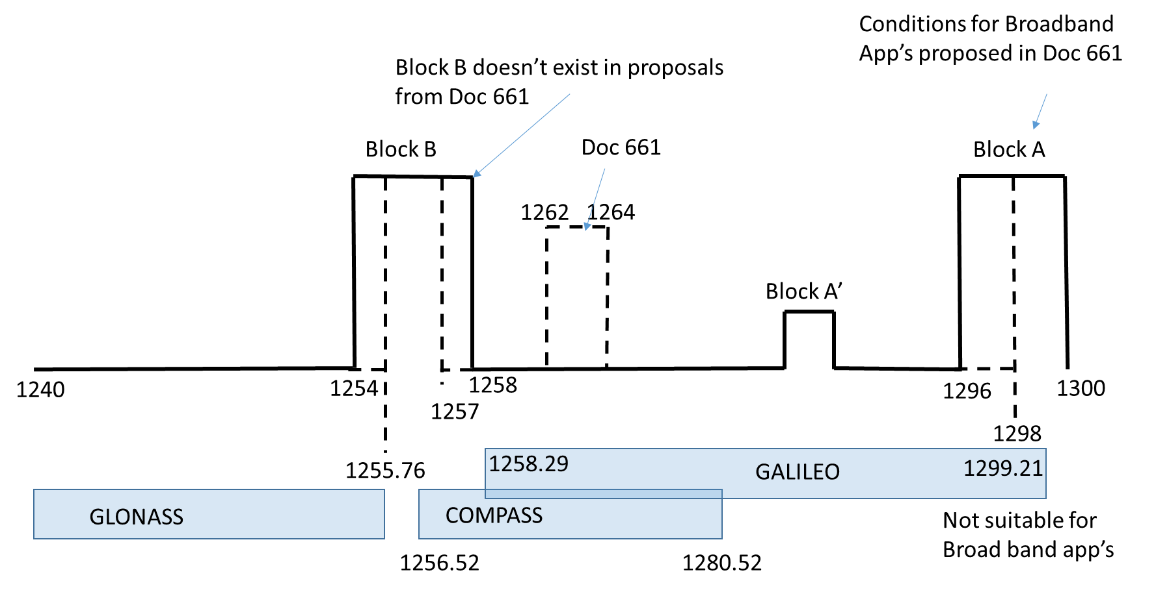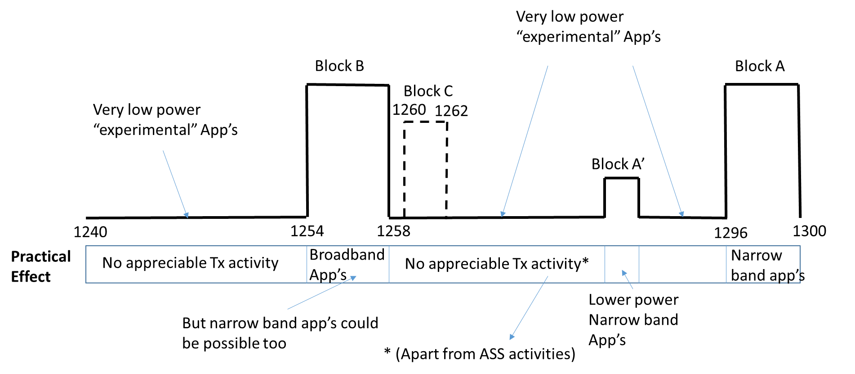
Editor’s note: a single figure can be finalised once the frequency block boundaries are agreed.
Other General Proposals (extracted from Composite working doc)
• [do not deploy such amateur stations at a distance of less than 20 km from airports;
• administrations should be mindful about the location of amateur stations in order to avoid pointing of the station antenna pattern peak in the direction of airports and air corridors for aircraft flights;
• do not direct the main lobe of the amateur station antenna pattern in the ±30º sector towards the airport, located at less than 100 km from such amateur station;
• do not direct the main lobe of the amateur station antenna pattern in the ±10º sector towards the airport, located at less than 120 km from such amateur station; (For ASS uplink)]
20221121 ed: for next WP 5A meeting in 2023: Frequency ranges? Particular RNS service? Are these for the recommendation or are they more appropriate for national regulations? Definition of ‘airport’ etc.
• when amateur /amateur satellite station antennas are installed at large antenna heights compared to the typical values contained in Report ITU-R M.2513-0, additional constraints or limitations may need to be considered by administrations, in particular for cases of the amateur station category referred to as “permanent installations”.
[
• limitation of the national licensing and assignments to narrowband repeater (permanent) stations to the frequency band [1 298-1 300 MHz] with a maximum allowed e.i.r.p of 100W.
• limit the operating duration of each amateur satellite uplink transmitter within 30 minutes per day.
• in case of rapid increase of amateur satellites in the frequency band 1 260-1 270 MHz, additional measures on the time length of transmitter usage may be needed.
• due to the known interference cases and the immediate roll-out of dedicated mass-market RNSS receivers in the frequency band 1 240-1 300 MHz, administrations are invited to also consider changes to the existing assignments of domestic broadband ATV stations, already in operation.]
20221123 ed: this entire section needs more work to clarify the details.
20221123 Ed: old annexes here for reference only
Annex 1
Guidelines for the use of broadband applications in the amateur service
in the frequency band 1 240-1 300 MHz
In order to avoid harmful interference from broadband applications in the amateur service, including Amateur Television (ATV) into the RNSS (space-to-Earth), the following measures are proposed:
a) discourage the use of amateur national assignments of broadband applications including ATVs from the frequency band 1 257-1 298 MHz 1 240-1 298 ,
b) limit the allowed output power density for broadband amateur applications to 5 mW/MHz in the frequency band 1 257-1 298 MHz in all Regions;
or
b) limit the allowed e.i.r.p. density for broadband amateur applications to -5 dBW/MHz in the frequency band 1 257-1 298 MHz in all Regions;
or b) limitation of the allowed e.i.r.p. for broadband applications at -5 dBW/MHz in the band 1 240-1 298 MHz
c) limit the allowed output power density for broadband amateur applications to 100 W/MHz in the frequency band 1 298-1 300 MHz in all Regions;
or
c) limit the allowed e.i.r.p. density for broadband amateur applications to 38 dBW/MHz in the frequency band 1 298-1 300 MHz in all Regions;
or c) c) limitation of the allowed e.i.r.p. for broadband applications at 38 dBW/MHz in the bands 1 298-1 300 MHz;
d) due to the known interference cases and the immediate roll-out of dedicated mass-market RNSS receivers in the frequency band 1 240-1 300 MHz, administrations are invited to also consider retro-active changes of conditions to the assignments of domestic broadband ATV stations, already in operation.
- limitation of the allowed output power for amateur satellite uplink applications at 100 W/MHz in the 1 298-1 300 MHz;
- do not deploy such amateur stations at a distance of less than 20 km from airports;
- do not direct the main lobe of the amateur station antenna pattern in the ±30º sector towards the airport, located at less than 100 km from such amateur station;
- when amateur station antennas are installed at large antenna heights compared to typical values, additional constraints or limitations may need to be considered by administration.
Note: Due to the known interference cases and the starting roll-out of dedicated mass-market RNSS receivers in the bands 1 240-1 300 MHz, Administrations are invited to also consider the retro-active changes to the assignments of amateur narrowband applications, already in place

Annex 2
Guidelines for the use of narrow band applications in the amateur service in the frequency band 1 240-1 300 MHz
In order to avoid harmful interference from narrow band applications in the amateur service into the RNSS (space-to-Earth), the following measures are proposed:

a) discourage the use of narrow band applications in the amateur service from the frequency band 1 257-1 298 MHz in all Regions;
a) discourage the use of narrow band applications in the amateur service from the frequency bands 1 240-1 298 MHz;
b) limitation of the allowed e.i.r.p. for narrowband amateur applications at -5 dBW in 20 kHz in the band 1 240-1 298 MHz;
b) limit the allowed output power for narrow band amateur applications to 5 mWin the frequency band 1 257-1 298 MHz in all Regions;
or
b) limit the allowed e.i.r.p. for narrow band amateur applications to -5 dBW in the frequency band 1 257-1 298 MHz in all Regions;

b) limitation of the national licensing and assignments to narrowband repeater (permanent) stations to the frequency band 1 298-1 300 MHz with a maximum allowed e.i.r.p of 100W.
c) limit the allowed output e.i.r.p. for narrow band amateur applications at 38 dBW in 20 kHzin the 1 298-1 300 MHz

- limitation of the allowed output power for amateur satellite uplink applications at
100 W in 20 kHz in the 1 298-1 300 MHz;

e) do not deploy such amateur stations at a distance of less than 20 km from airports;
f) do not direct the main lobe of the amateur station antenna pattern in the ±10º sector towards the airport, located at less than 120 km from such amateur station;
g) when amateur or amateur-satellite station antennas are installed at large antenna heights compared to typical values, additional constraints or limitations may need to be considered by administration.

d) due to the known interference cases and the starting roll-out of dedicated mass-market RNSS receivers in the frequency band 1 240-1 300 MHz, administrations are invited to also consider the retro-active changes of conditions to the assignments of amateur narrowband applications, already in operation.

Annex 3
Guidelines for the use of applications in the amateur-satellite service in the frequency band 1 260-1 270 MHz
In order to avoid harmful interference from applications in the amateur-satellite service into the RNSS (space-to-Earth), the following measures are proposed:

- discourage the use of amateur-satellite uplink applications from the frequency band 1 262-1 270 MHz, in all Regions;
or
- discourage the use of amateur-satellite uplink applications from the frequency bands 1260-1262 MHz and1 264-1 270 MHz,;
- limit the allowed output power density for amateur satellite uplink applications to 5 mW/MHz in the frequency band 1 262-1 270 MHz in all Regions;
or
b) limit the allowed e.i.r.p. density for amateur satellite uplink applications to -5 dBW/MHz in the frequency band 1 262-1 270 MHz in all Regions;
or
- limitation of the allowed e.i.r.p. for amateur satellite uplink applications at -5 dBW/MHz in the 1260-1262 MHz and 1 264-1 270 MHz;
c) limit the allowed output power density for amateur-satellite uplink applications to 100 W/MHz in the frequency band 1 260-1 262 MHz in all Regions ;
or
- limit the allowed e.i.r.p. density for amateur-satellite uplink applications to 38 dBW/MHz in the frequency band 1 260-1 262 MHz in all Regions;
- limitation of the allowed e.i.r.p. for amateur satellite uplink applications at 38 dBW/MHz in the 1 262-1 264 MHz
- limitation of the allowed output power for amateur satellite uplink applications at 100 W/MHz in the 1 262-1 264 MHz ;
- limit the operating duration of each amateur satellite uplink transmitter within 30 minutes per day.
- administrations should be mindful about the location of amateur stations in order to avoid pointing of the station antenna pattern peak in the direction of airports and air corridors for aircraft flights;
- when amateur-satellite station antennas are installed at large antenna heights compared to typical values, additional constraints or limitations may need to be considered by administration;

in case of rapid increase of amateur satellites in the frequency band 1 260-1 270 MHz, additional measures on the time length of transmitter usage may be needed.

i) due to the known interference cases and the starting roll-out of dedicated mass-market RNSS receivers in the frequency band 1 240-1 300 MHz, administrations are invited to also consider the retro-active changes of conditions to the assignments of amateur-satellite uplink applications, already in operation.
Guidelines for using stations in amateur and amateur-satellite
in the frequency band 1 240-1 300 MHz
The following measures should be taken to avoid interference to RNSS from applications in the amateur and amateur-satellite service:
1 limitation of allowable e.i.r.p. for stations to no more than −1 dBW/MHz; ;[This in effect closes the band to any realistic amateur service operation and is against the spirit of the AI which is to not remove the amateur services allocations]]
Comment: It is severe limitation in terms of power and if it is applied for all frequency range 1 240-1 300 MHz, the operation of amateur service is severely limited.
Concerned Administrations comment: It doesn’t seem to be such a limitation in terms of power because the e.i.r.p depends on the amateur antenna gain. For a gain of 18 dBi, you will obtain a power of about 12 mW in order to have an eirp density of -1 dBW/MHz. Considering the results of studies, for 12 mW, the RNSS will still receive interference till even 2.3 km with an IEL of arriving till even 15 dB at 1 km from the RNSS station which is not negligible. Still, it is agreeable on the fact that the frequency band proposed might need some adjustments.
[
2 avoid pointing of the station antenna pattern peak in the direction of airports and air corridors for aircraft flights [Unworkable – e.g. which airports? Large/small/airfields/]
Comment: It seems to be a vague requirement. Protection area to apply this limitation should be defined. It might be more suitable to leave this kind of limitation to each administration.
Concerned Administrations comment: If the concern is about the fact that this proposed guidance should be applied depending on Administrations then a different wording could be agreed upon, like: “Administrations should be mindful about the location of amateur stations in order to avoid pointing of the station antenna pattern peak in the direction of airports and air corridors for aircraft flights”. This proposal should be added to each Annex.
or
3 discourage the use the frequency bands [1 240-1 255.76] MHz, [1 263.75-1 293.75] MHz and [1 259.25-1 277.25] MHz for national assignments to stations in the amateur and amateur-satellite services. Could some elements of this be combined with the French proposal for 1254 to 1258MHz? e.g. 1254-1259.25?]
or

This Recommendation should be brought to the attention of the International Amateur Radio Union (IARU).

